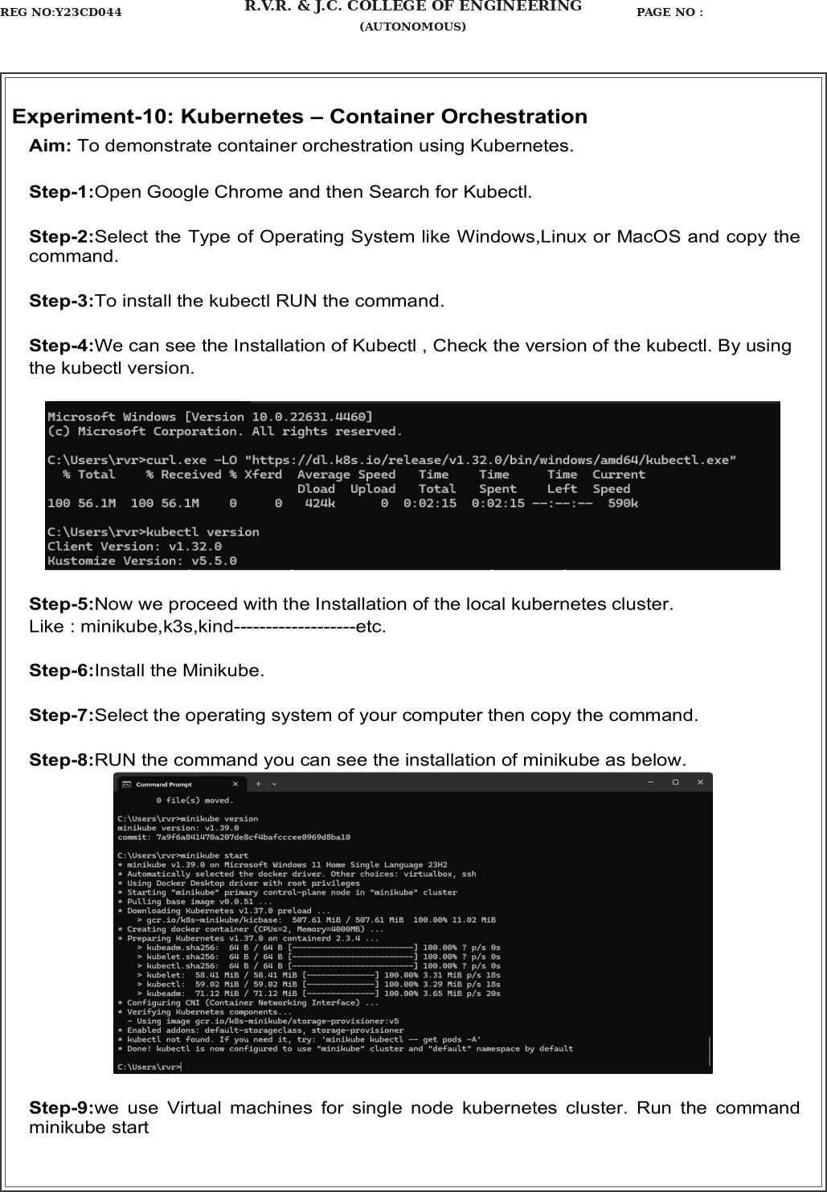
REG NO:Y23CD044
R.V.R. & J.C. COLLEGE OF ENGINEERING
(AUTONOMOUS) PAGE NO :

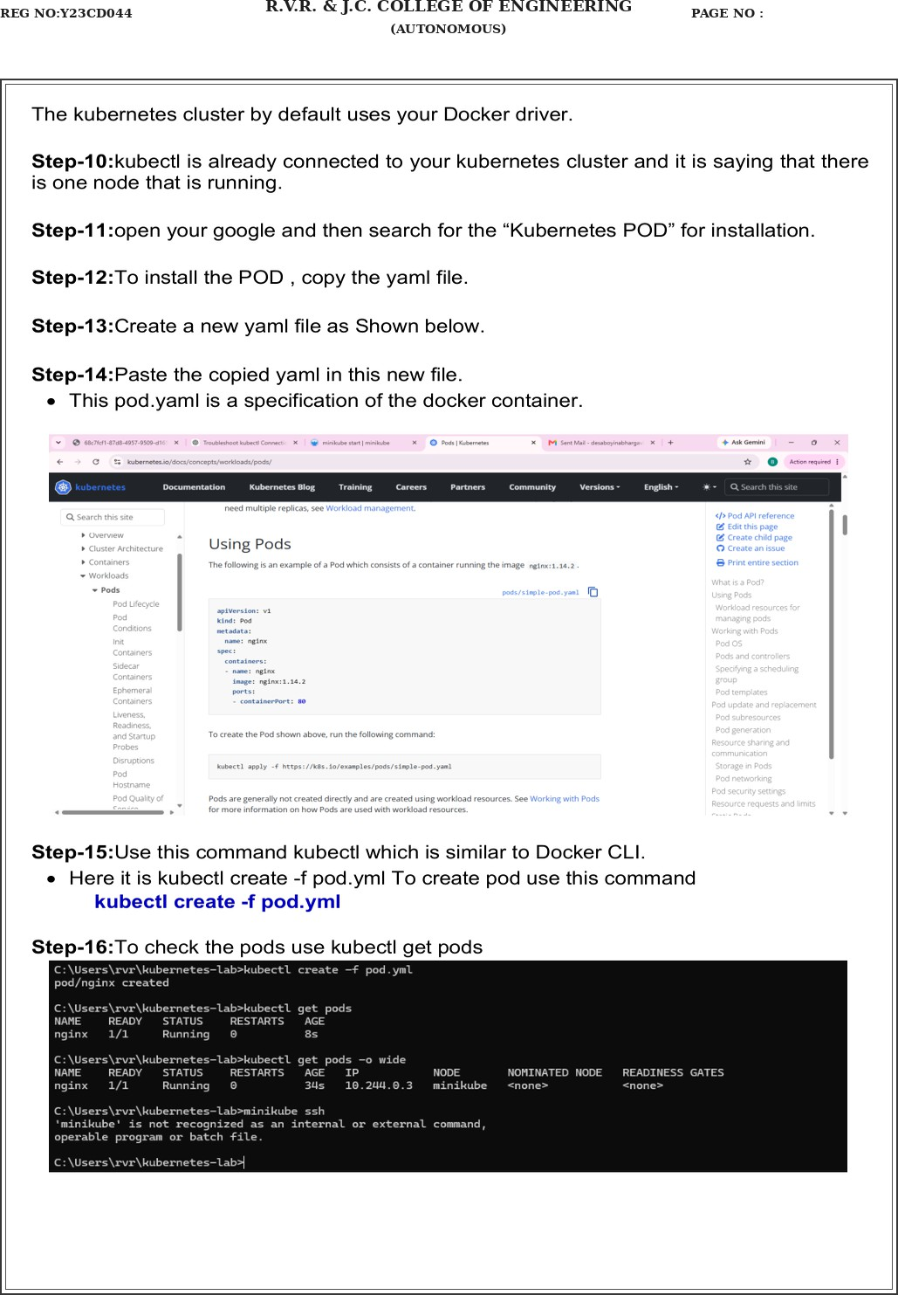
REG NO:Y23CD044
R.V.R. & J.C. COLLEGE OF ENGINEERING
(AUTONOMOUS) PAGE NO :

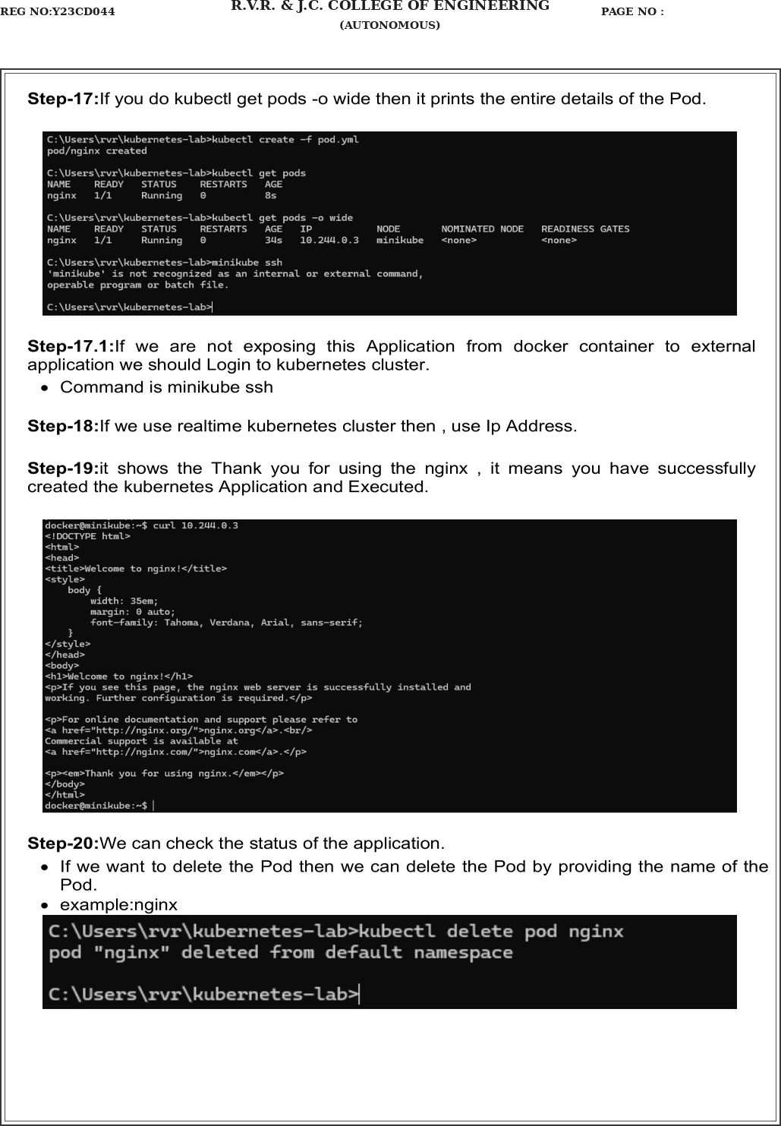
REG NO:Y23CD044
R.V.R. & J.C. COLLEGE OF ENGINEERING
(AUTONOMOUS) PAGE NO :

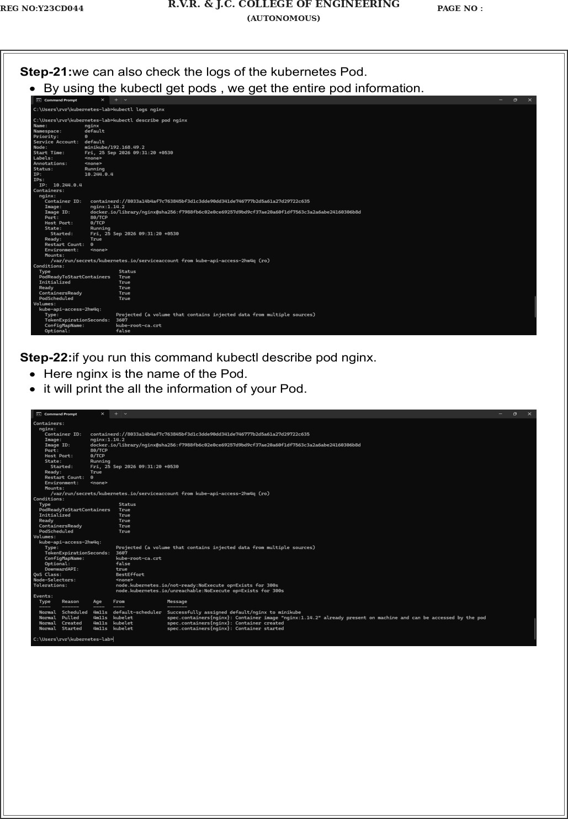
REG NO:Y23CD044
R.V.R. & J.C. COLLEGE OF ENGINEERING
(AUTONOMOUS) PAGE NO :

