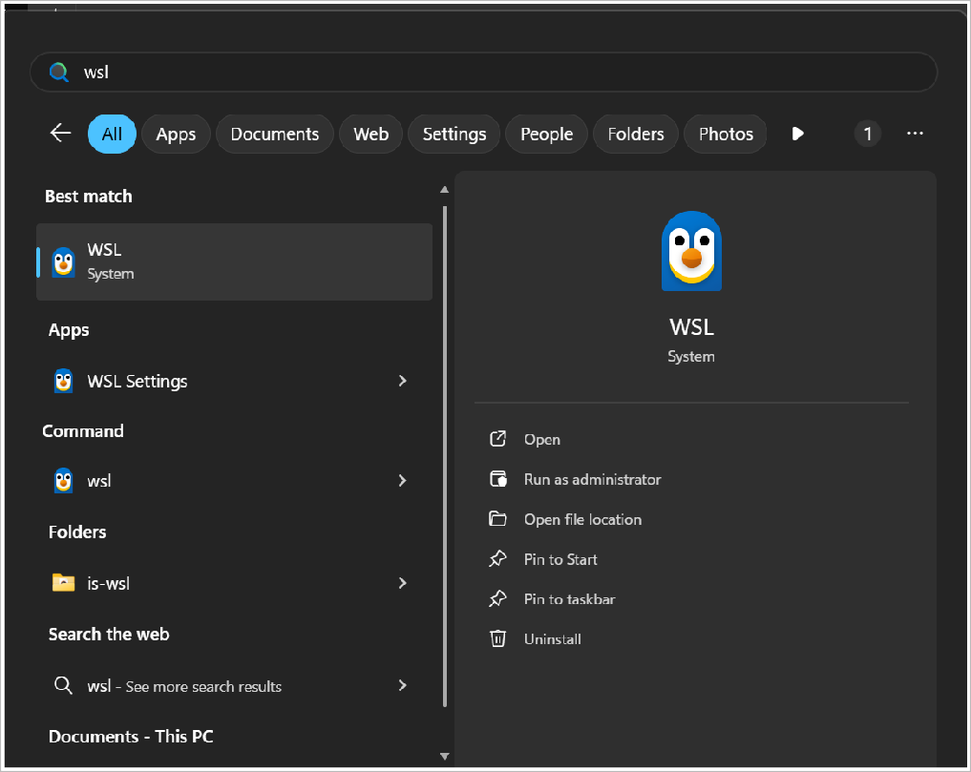
Experiment-11: Ansible – Configuration Management
Aim: To automate configuration management using Ansible.
Step by Step Process:

- Install WSL (Windows Subsystem for Linux):

Run the following commands in cmd
wsl --install wsl --update
wsl --set-default-version 2
Open the WSL after installing.

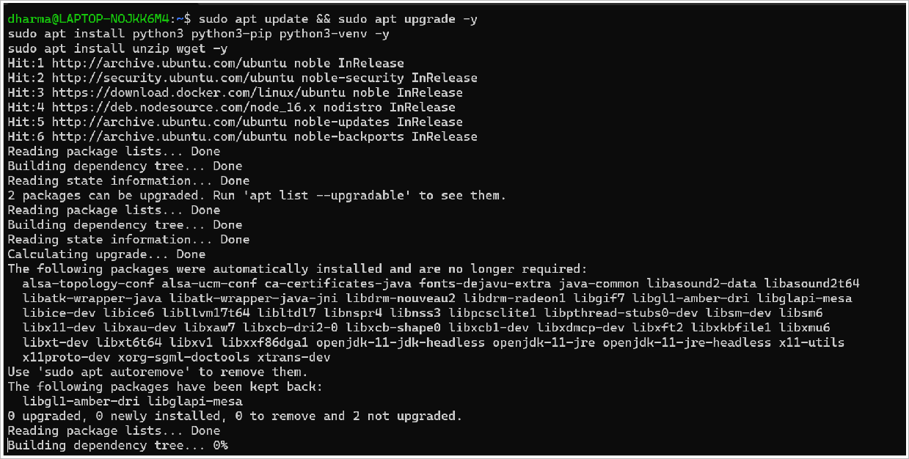
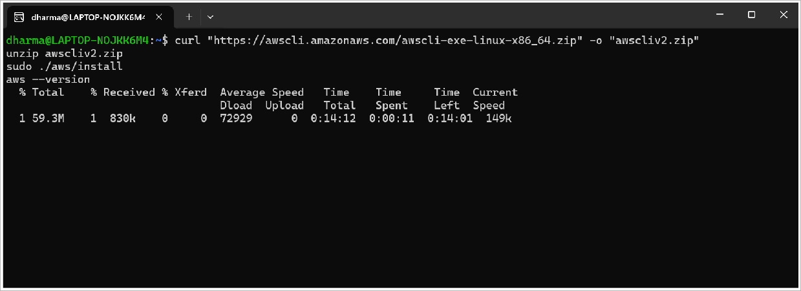
- Update Ubuntu and Install Dependencies:

Run the following commands in the Linux shell
sudo apt update && sudo apt upgrade -y
sudo apt install python3 python3-pip python3-venv -y sudo apt install unzip wget -y

- Install AWS CLI:

Run the following commands in the Linux shell
curl "https://awscli.amazonaws.com/awscli-exe-linux-x86_64.zip" -o "awscliv2.zip" unzip awscliv2.zip
sudo ./aws/install aws --version

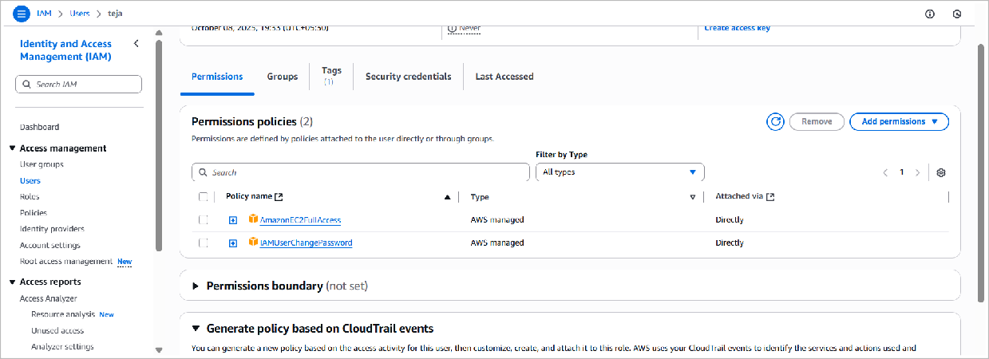
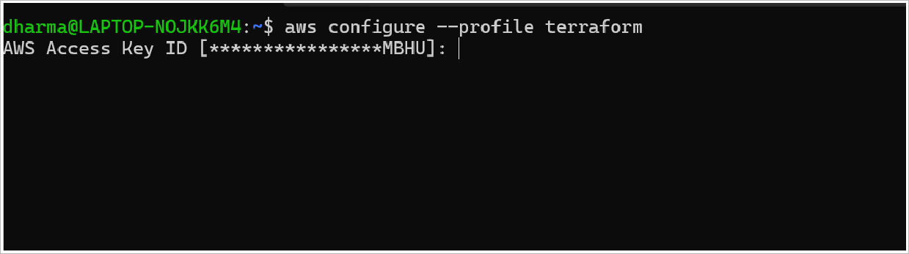
- Create a User in AWS IAM and create Access Key with EC2 access:

- Configure AWS CLI:

Run:
aws configure --profile terraform
Enter the details from the previous step in the shell.

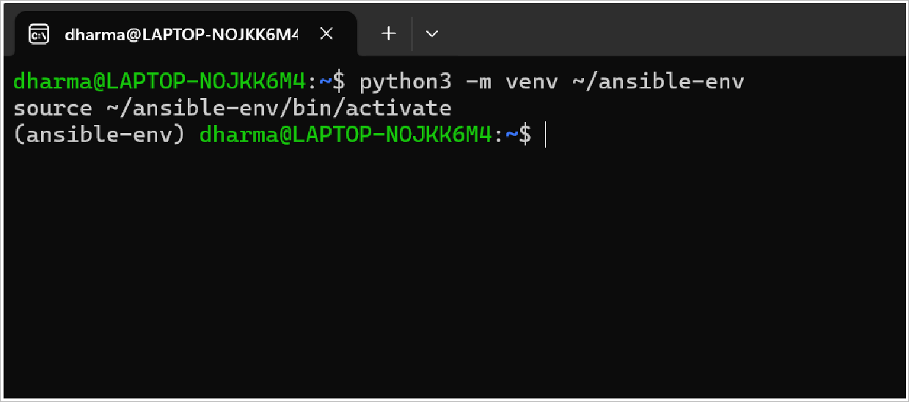
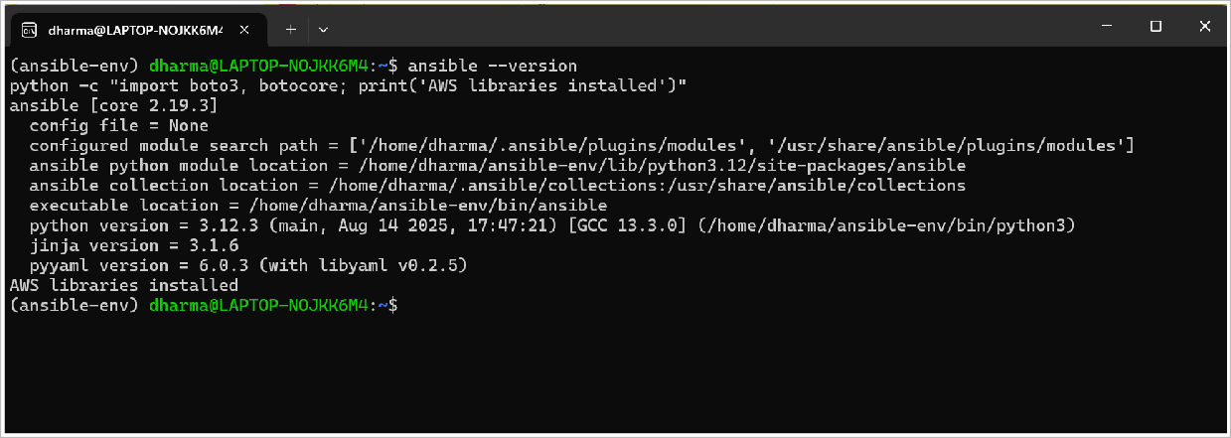
- Set up Ansible:
  - Create a Python virtual environment

Run the following commands in the Linux shell
python3 -m venv ~/ansible-env source ~/ansible-env/bin/activate

  - Install Ansible and AWS Python libraries

Run the following commands in the Linux shell
pip install --upgrade pip
pip install ansible boto3 botocore amazon.aws

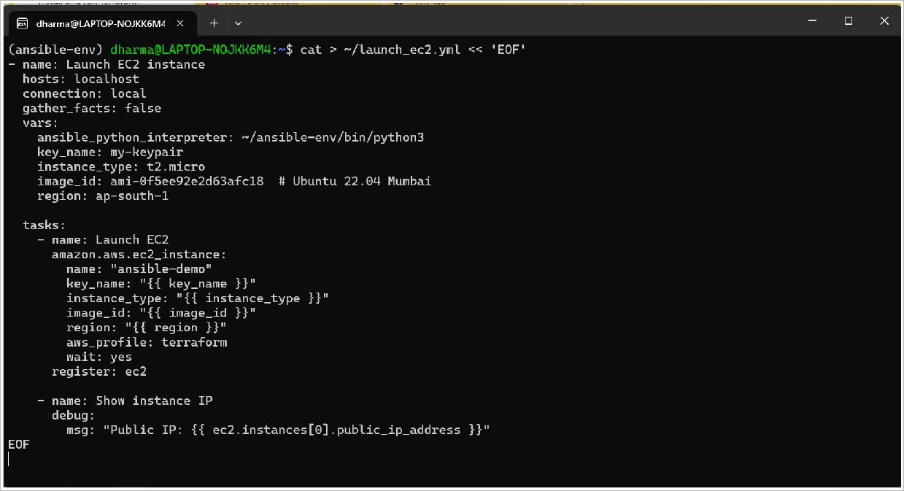
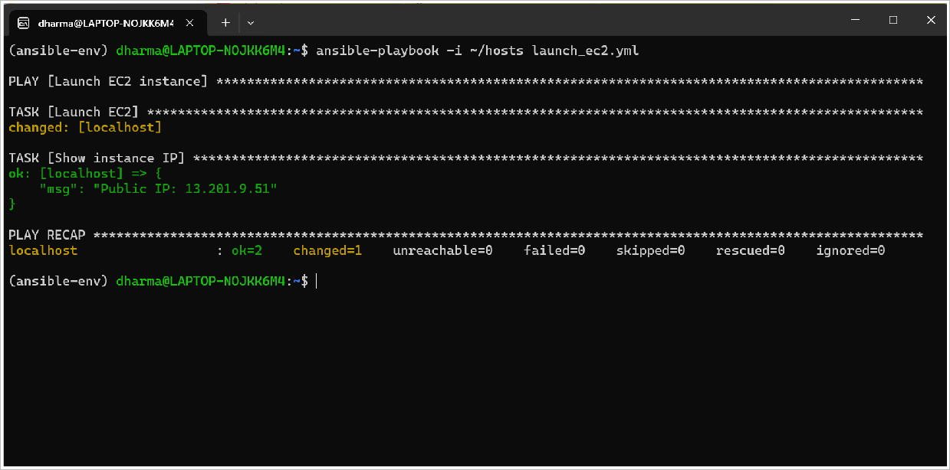
- Create an Ansible hosts file:

Run:
echo "localhost ansible_connection=local" > ~/hosts

- Create Ansible playbook to launch EC2:

- Launch the EC2 instance:

Run:
ansible-playbook -i ~/hosts launch_ec2.yml

- Ansible playbook to install Docker on your EC2 instance:
---
- name: Quick Docker installation using convenience script hosts: all
gather_facts: false vars:
remote_user: ubuntu tasks:
  - name: Update package index ansible.builtin.apt:
update_cache: yes become: yes
  - name: Install curl ansible.builtin.apt:
name: curl state: present
become: yes
  - name: Download and run Docker installation script ansible.builtin.shell:
cmd: |
curl -fsSL https://get.docker.com -o get-docker.sh sh get-docker.sh
args:
warn: false become: yes
  - name: Start and enable Docker service ansible.builtin.systemd:
name: docker state: started enabled: yes
become: yes
  - name: Add user to docker group ansible.builtin.user:
name: ubuntu groups: docker append: yes
become: yes
  - name: Test Docker installation ansible.builtin.command:
cmd: docker run hello-world register: docker_test
become: yes
  - name: Show test result debug:
msg: "{{ docker_test.stdout }}"

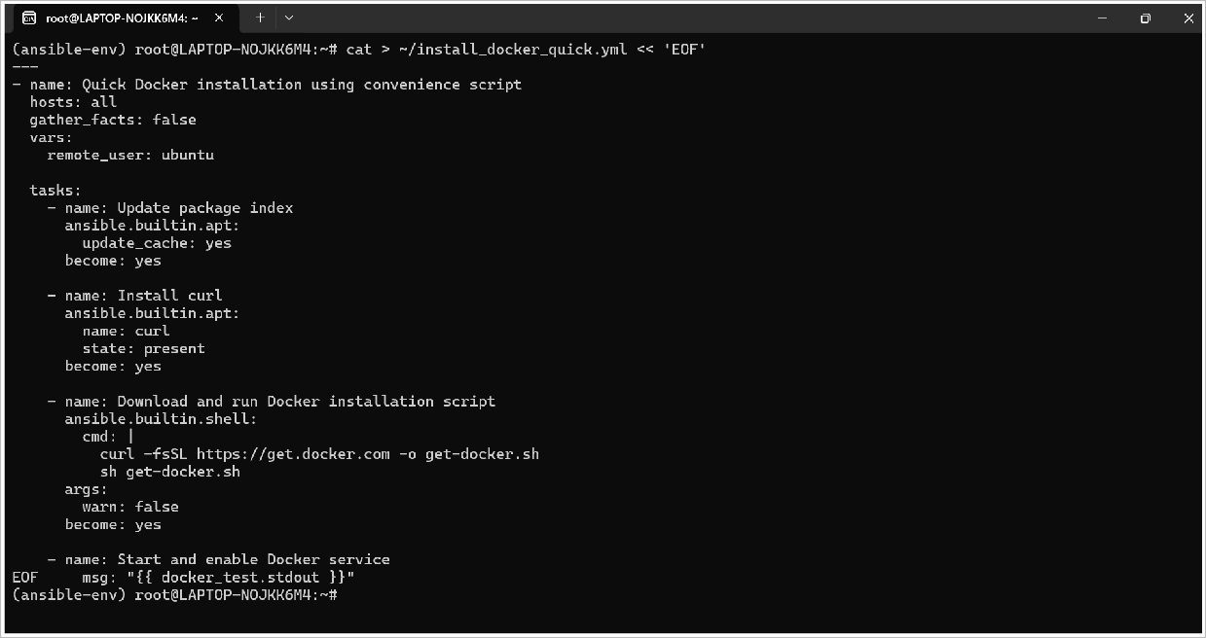
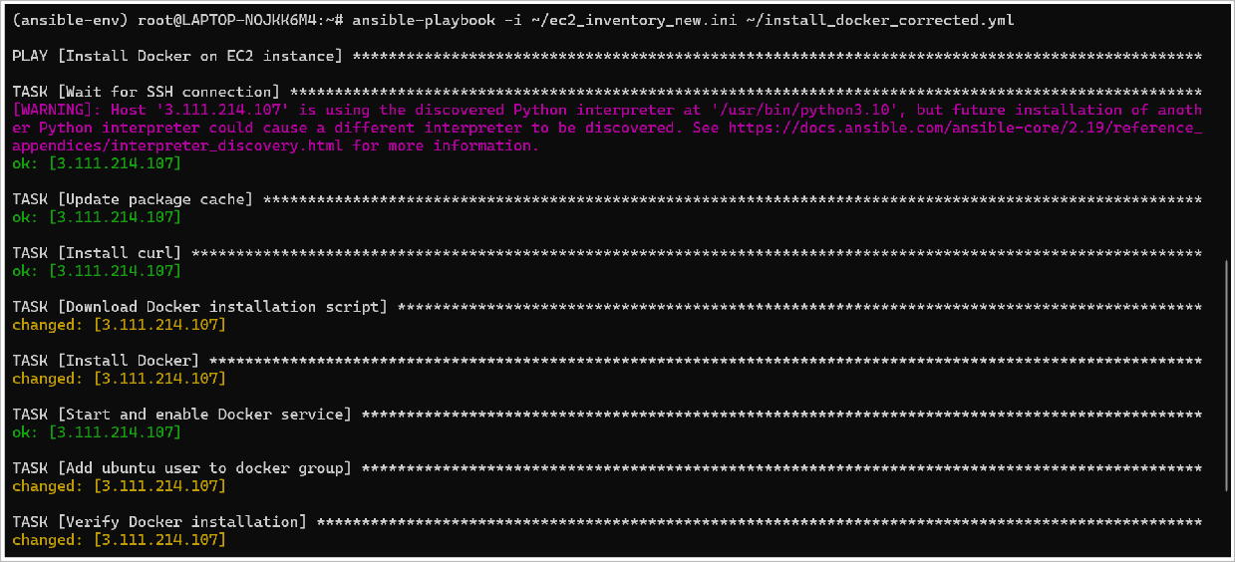

- Run the Docker installation:

Run:
ansible-playbook -i ~/ec2_inventory_new.ini ~/install_docker_quick.yml

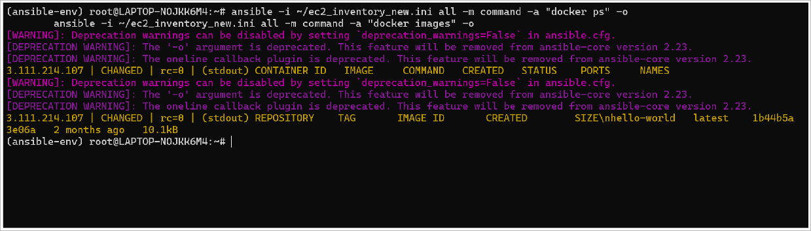
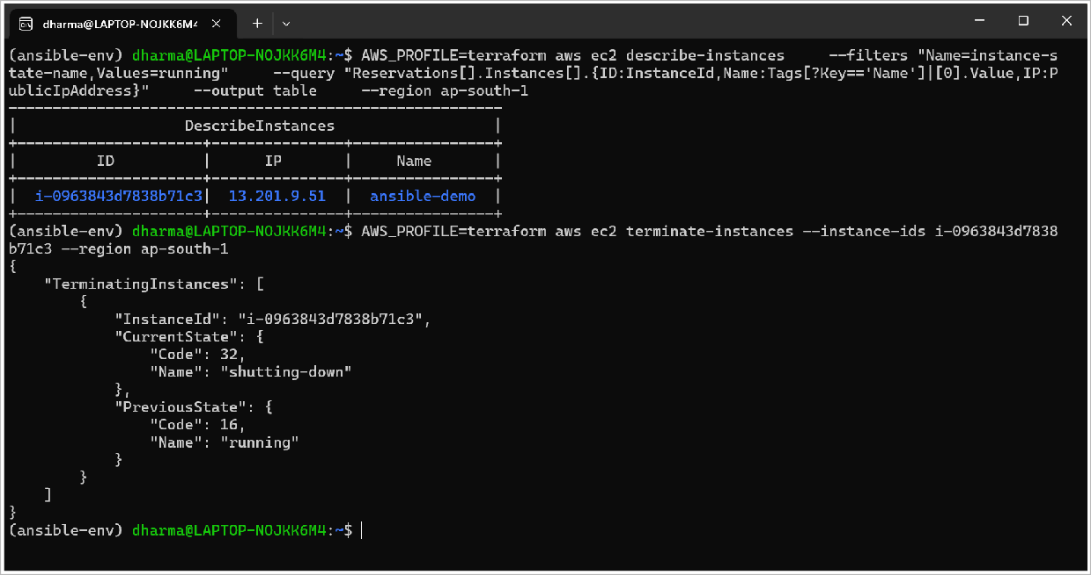
- Test Docker on the instance:

Run:
ansible -i ~/ec2_inventory_new.ini all -m command -a "docker ps" -o ansible -i ~/ec2_inventory_new.ini all -m command -a "docker images" -o

- Terminate (destroy) the EC2 instance:

Run:
AWS_PROFILE=terraform aws ec2 terminate-instances \
--instance-ids <INSTANCE_ID> --region ap-south-1

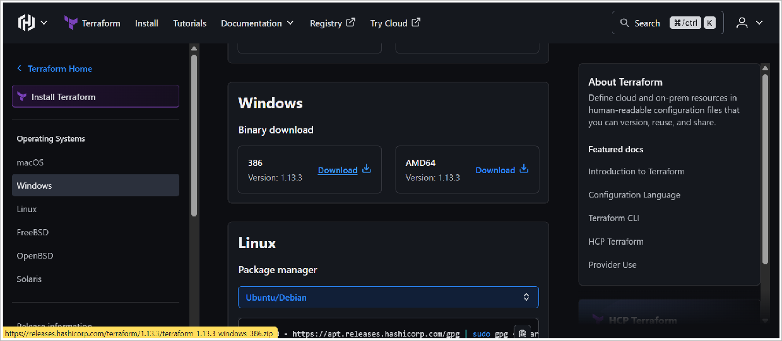

Experiment-12: Terraform – Infrastructure as Code
Aim: To demonstrate infrastructure provisioning using Terraform.
Step by Step Process:

- Install Terraform:
  - Go to this website:
https://developer.hashicorp.com/terraform/install
and download the zip for your OS/arch from HashiCorp releases.

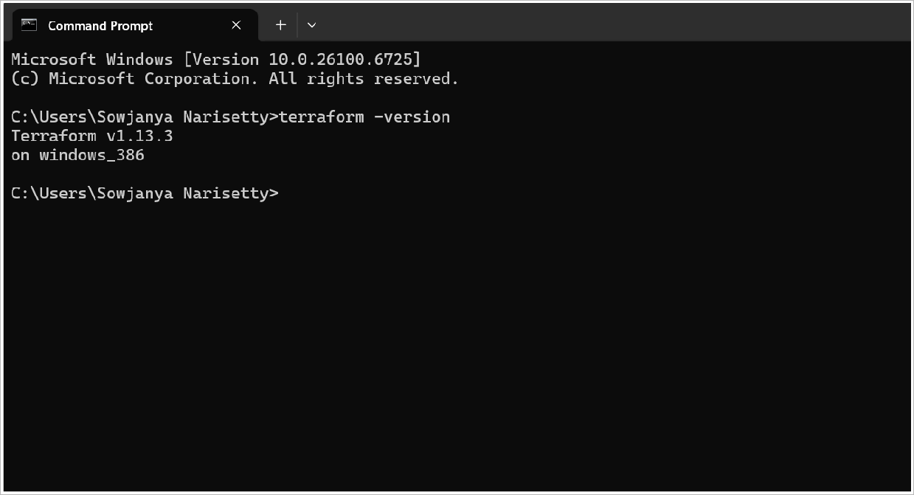
  - Unzip and move the terraform (or terraform.exe) to a directory on your PATH and add the path to Environment variables in Windows.
- Verify Terraform:

Run:
terraform -version
(in cmd)

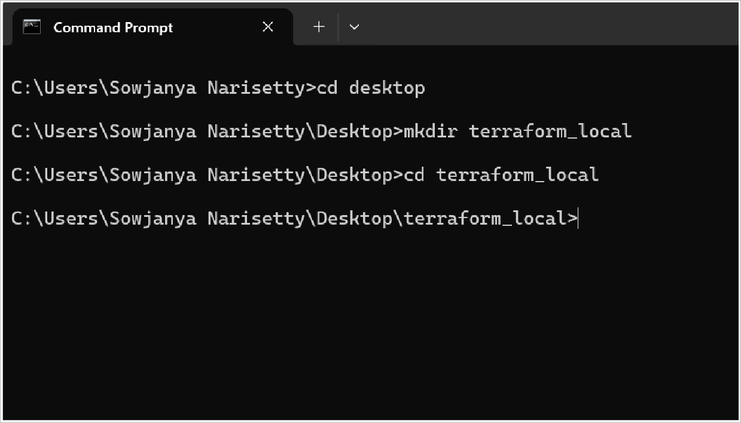
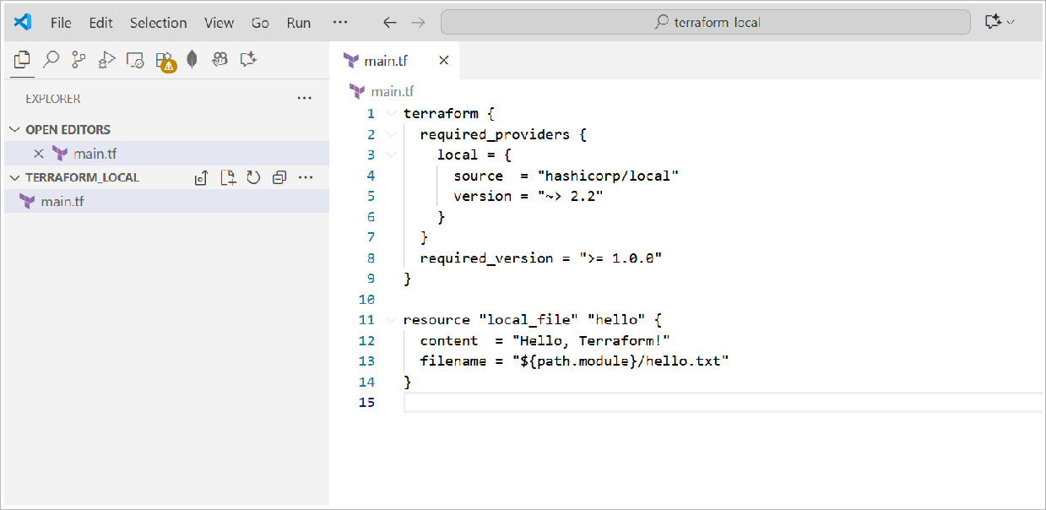
- Running Terraform Locally:
  - Create a project directory

  - Create a main.tf file in this folder

  - Run the standard Terraform workflow:
    - terraform init

initialize - downloads provider plugins, creates .terraform/
    - terraform validate

validate config
    - terraform plan -out=tfplan

see what will change

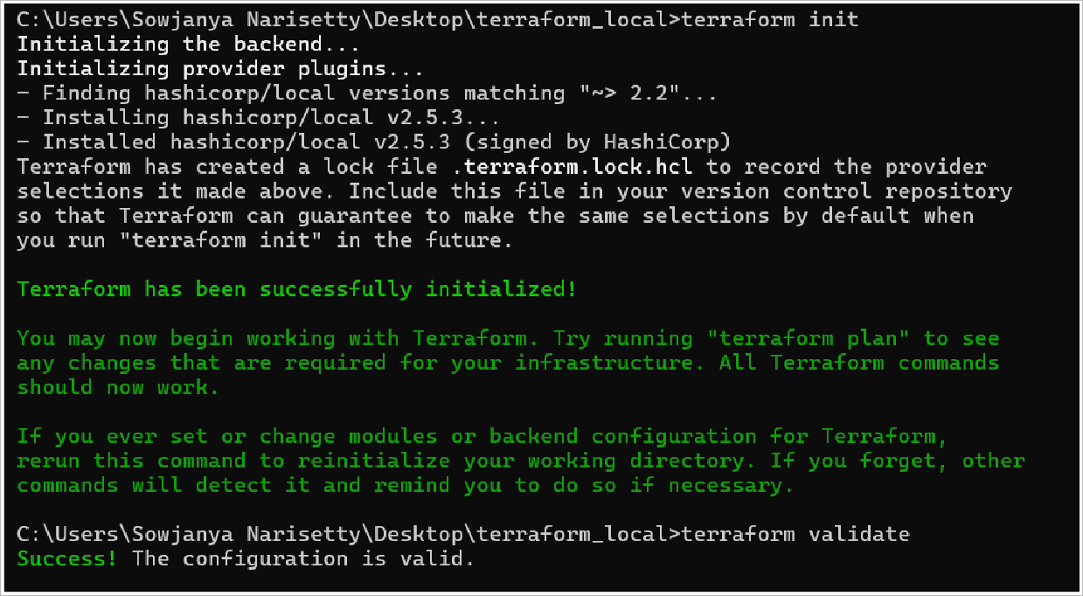
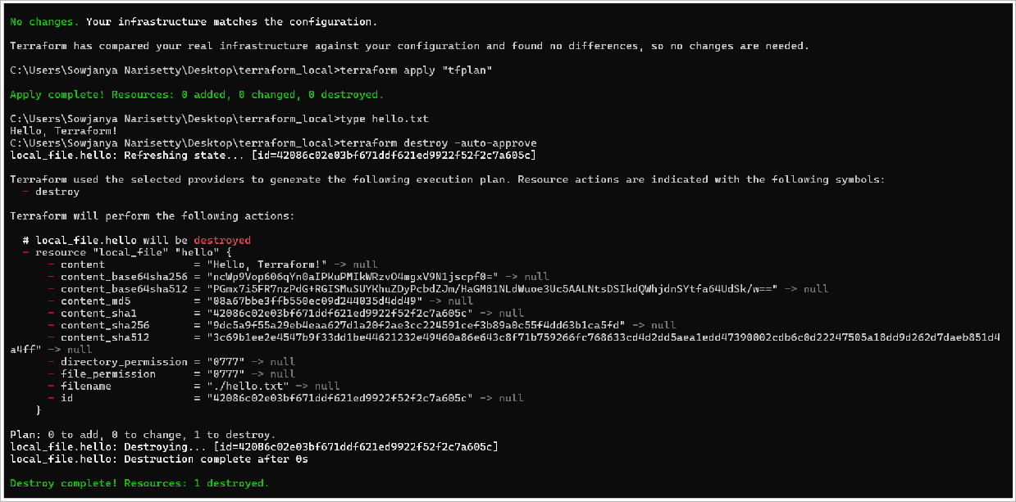
    - terraform apply "tfplan"

apply the saved plan (no interactive prompt if you prefer: terraform apply -auto-approve)
    - type hello.txt

verify file created and view its content
    - terraform destroy -auto-approve
      - when done, destroy created resources

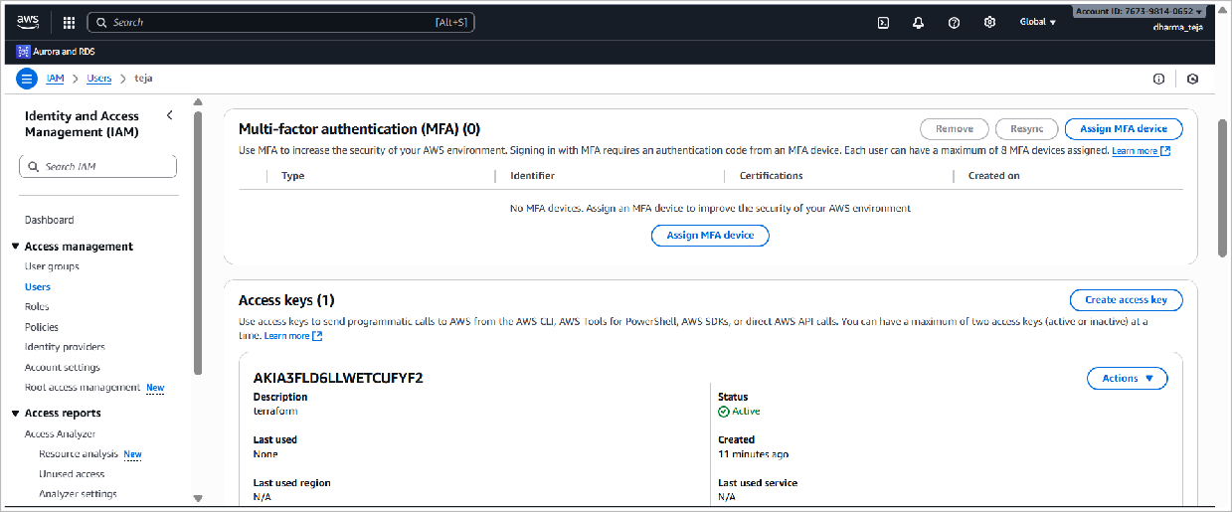
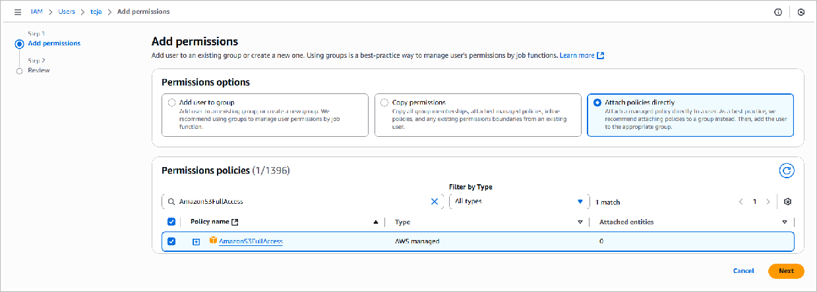
- Creating Cloud Resources in AWS using Terraform:
  - Install AWS CLI from the following link and set up AWS Credentials:
https://docs.aws.amazon.com/cli/latest/userguide/getting-started-install.html

  - In the IAM Console, create a User and Access key

  - Add S3 Permissions

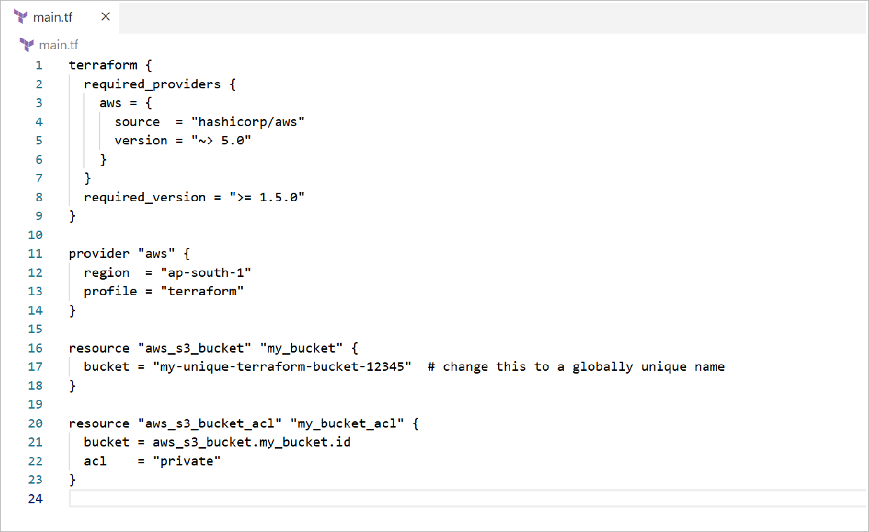
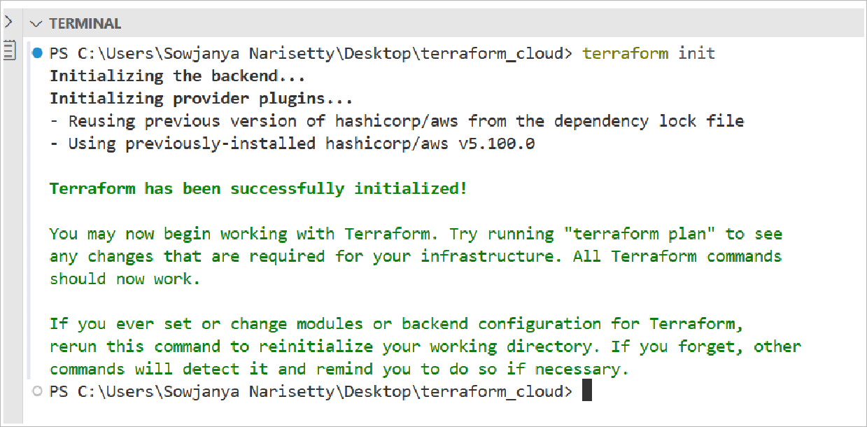
  - Verify AWS CLI configuration

Run:
aws sts get-caller-identity --profile terraform
(in cmd) to verify.
  - Create Terraform configuration file

  - Initialize Terraform

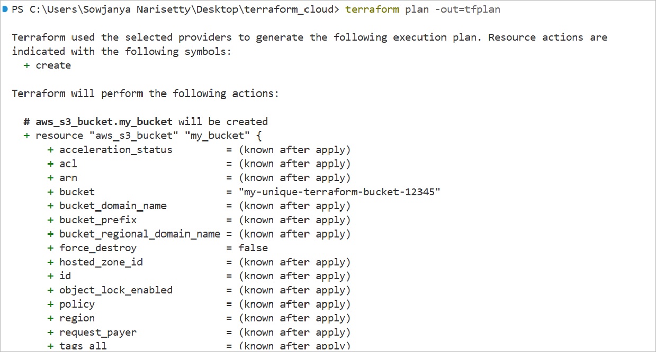
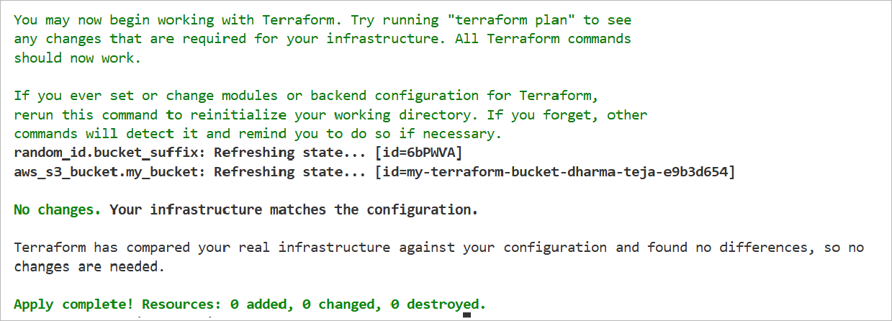
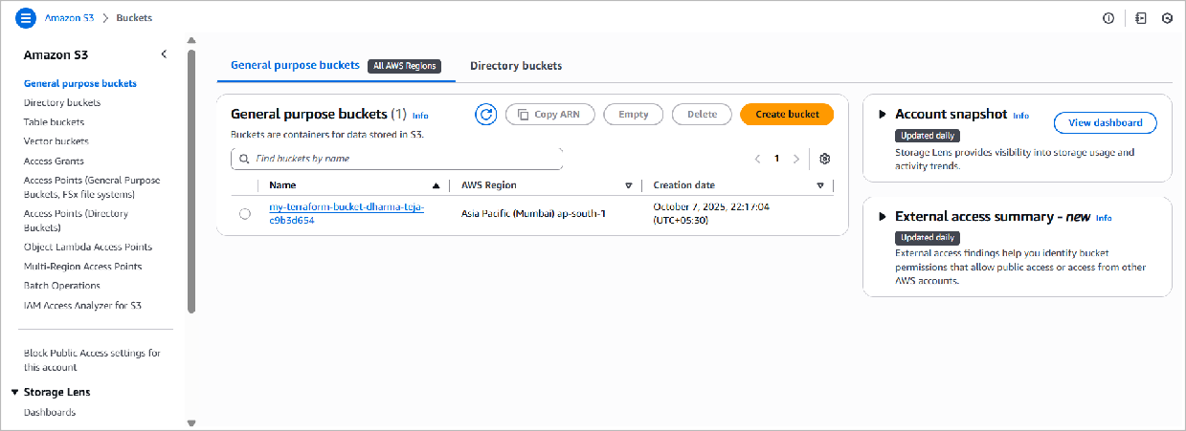
  - Plan your changes

  - Apply the plan

  - Verify the S3 Bucket in AWS

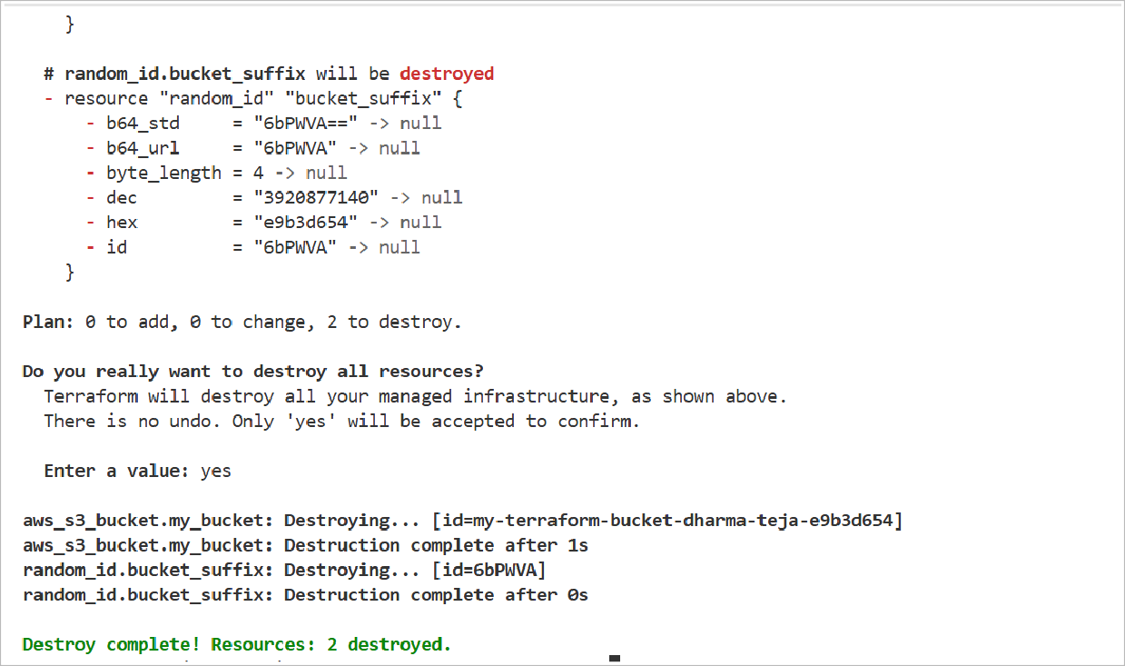
  - Clean up

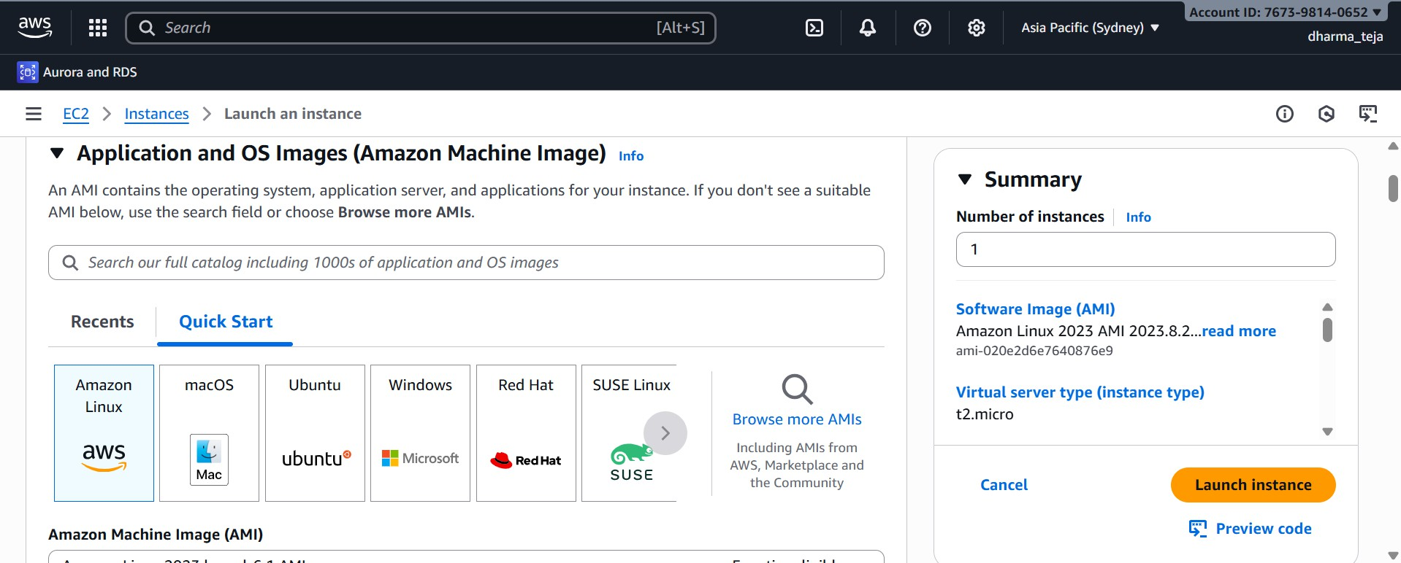
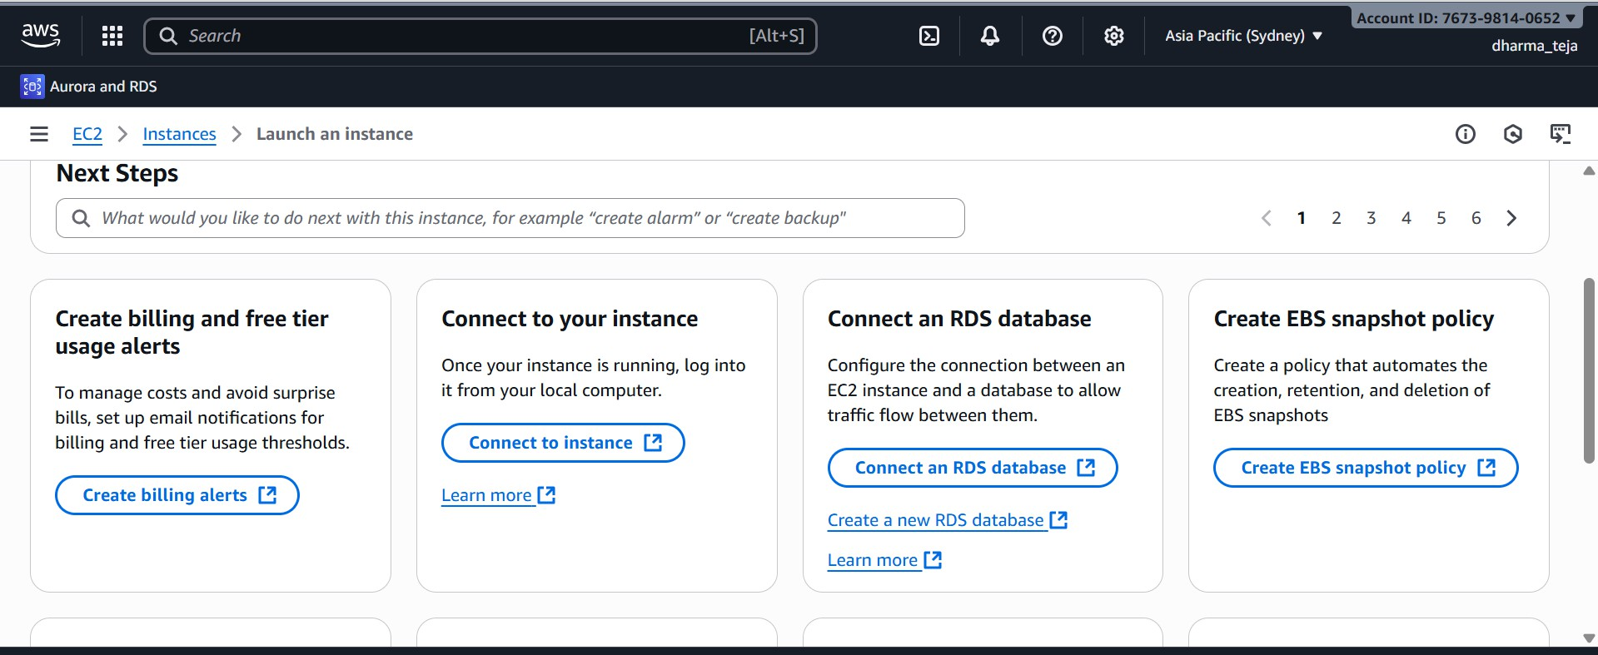

Experiment-2: Jenkins Integration in AWS
Aim: To demonstrate integration of Jenkins with AWS for continuous integration and deployment.

Launch the EC2 Instance
  - Navigate to the EC2 dashboard in the AWS Management Console.
  - Click on Launch an instance and Amazon Machine Image (AMI), such as Amazon Linux 2, Amazon Linux 2023, or Ubuntu LTS.
  - Select the desired instance type, t2.micro (eligible for the AWS Free Tier).

  - Complete the launch process and wait for the instance to enter the Running state.

Configure Security Groups
  - Go to the Security Groups section associated with your instance.
  - Edit the inbound rules
  - Add a rule for Jenkins:
    - Type: Select Custom TCP.
    - Port range: Enter 8080.
    - Source: Set this to 0.0.0.0/0 (or your specific IP range for better security) to allow access from anywhere.

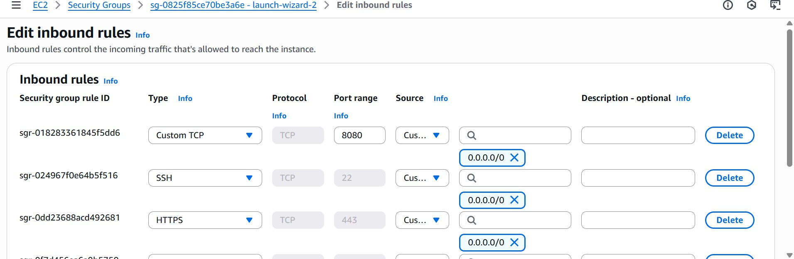
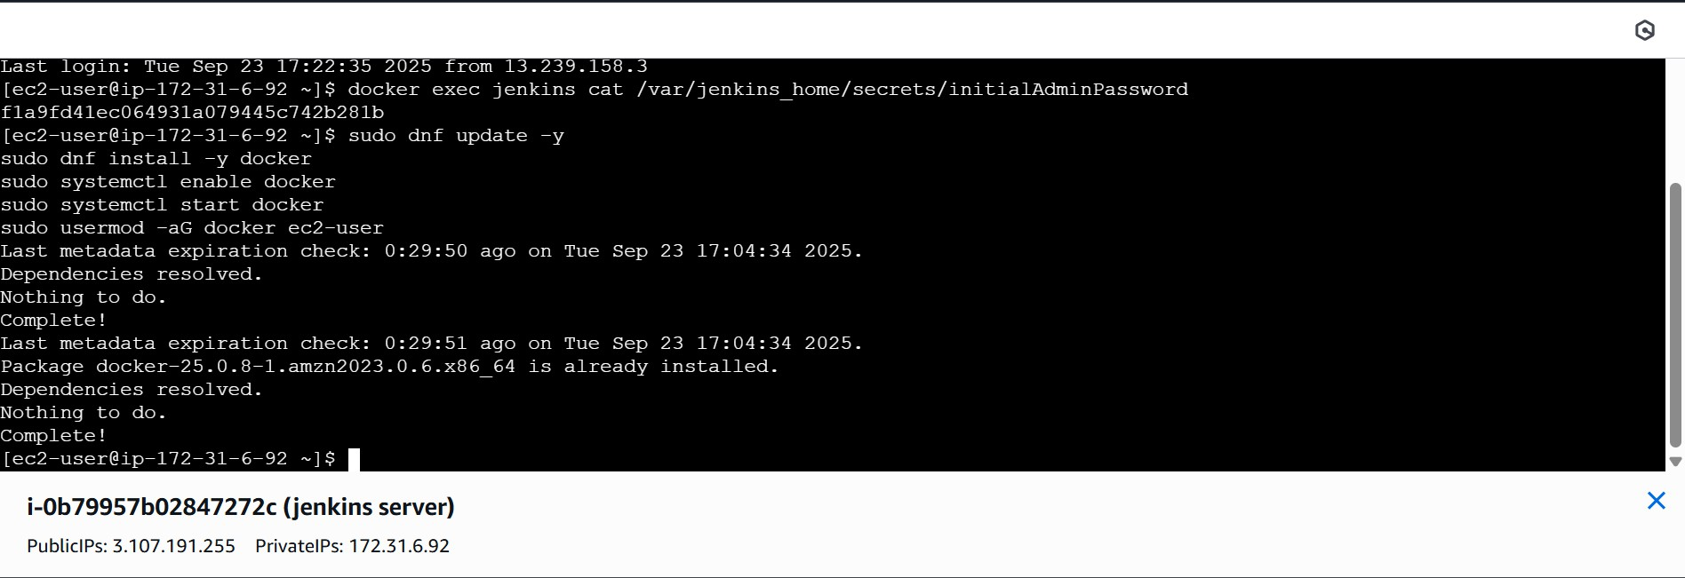
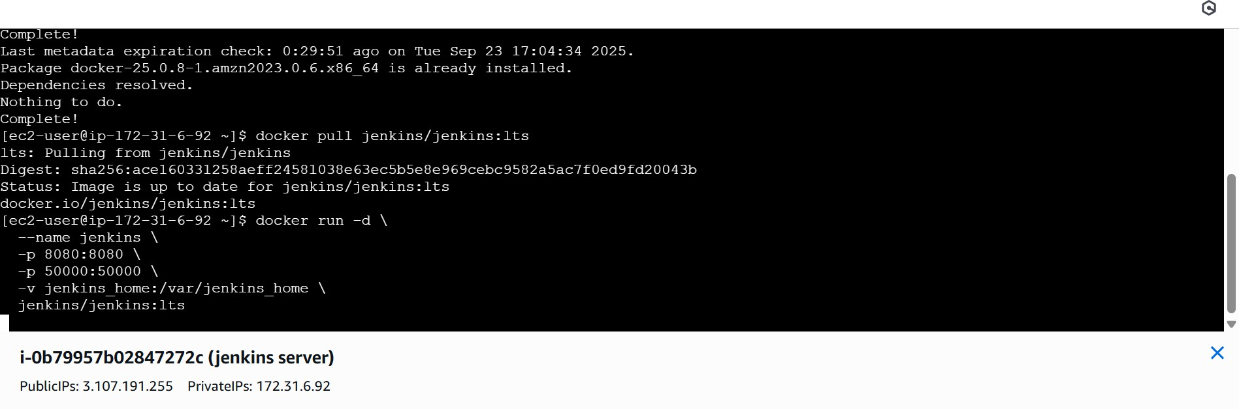
  - Ensure a rule for SSH on port 22 is already present to allow you to connect to the instance.
  - Save the inbound rules.

Connect and Install Software
  - Connect to your instance using SSH or the AWS EC2 Instance Connect tool.
  - Install Docker: Run the following commands to update the system and install Docker:
sudo dnf update -y
sudo dnf install -y docker
  - Start and Enable Docker:

Deploy Jenkins using Docker
  - Pull the Jenkins LTS image: docker pull jenkins/jenkins:lts
  - Run the Jenkins container: This command runs Jenkins in the background (-d), names it jenkins, maps the host port 8080 to the container port 8080, and mounts a volume (-v) to persist data in
/var/jenkins_home.

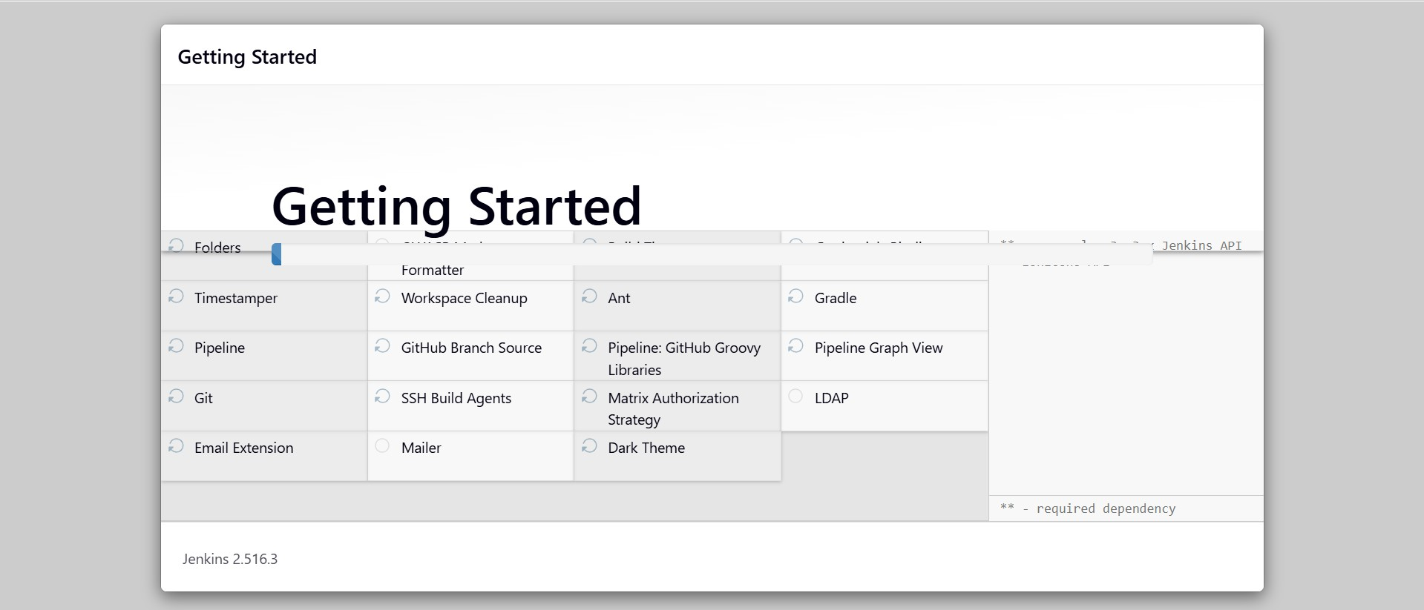
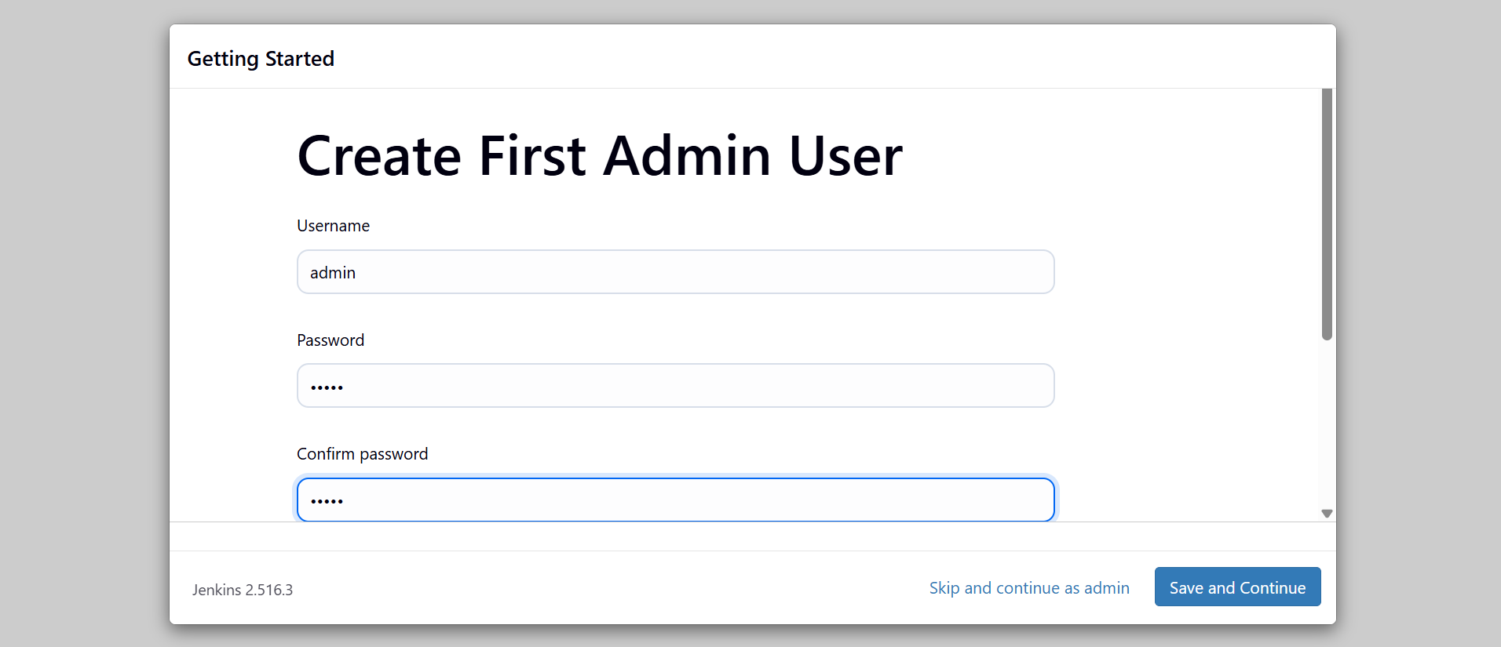

Access and Configure Jenkins
  - Access the Jenkins Web UI: Open your web browser and navigate to http://<EC2-public-ip>:8080. Replace <EC2-public-ip> with the Public IP address of your EC2 instance.
  - Retrieve the Initial Admin Password: Run the following command on your EC2 instance's command line to get the initial security password needed to unlock Jenkins:

Complete Setup:
    - Enter the password retrieved in the previous step.
    - Follow the on-screen instructions, typically by installing suggested plugins.

Create and Run a Sample Job

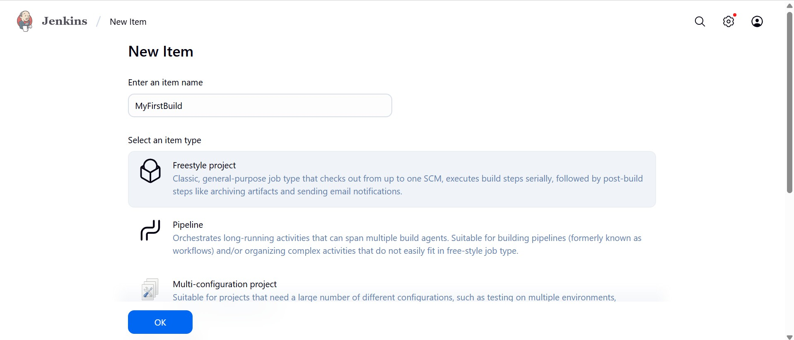
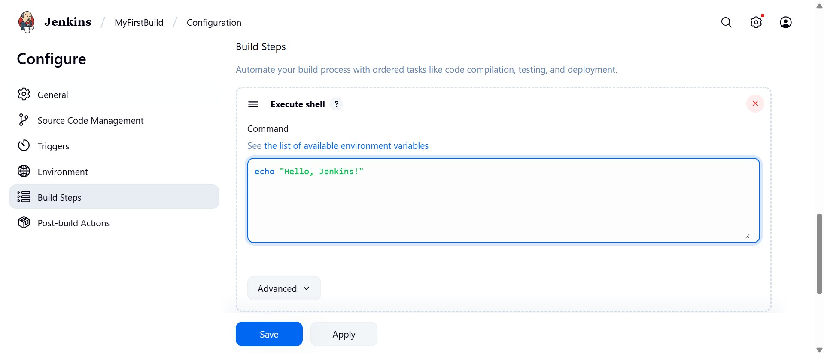
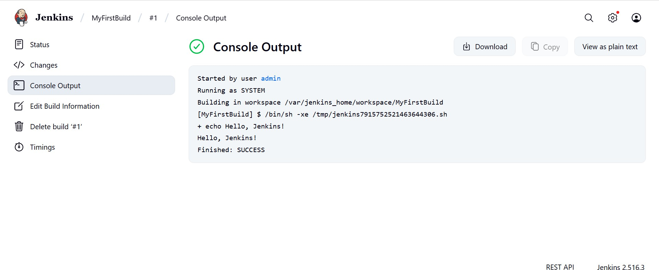
  - Create a New Item

  - Add Build step

  - Run the Build and check the output in Console

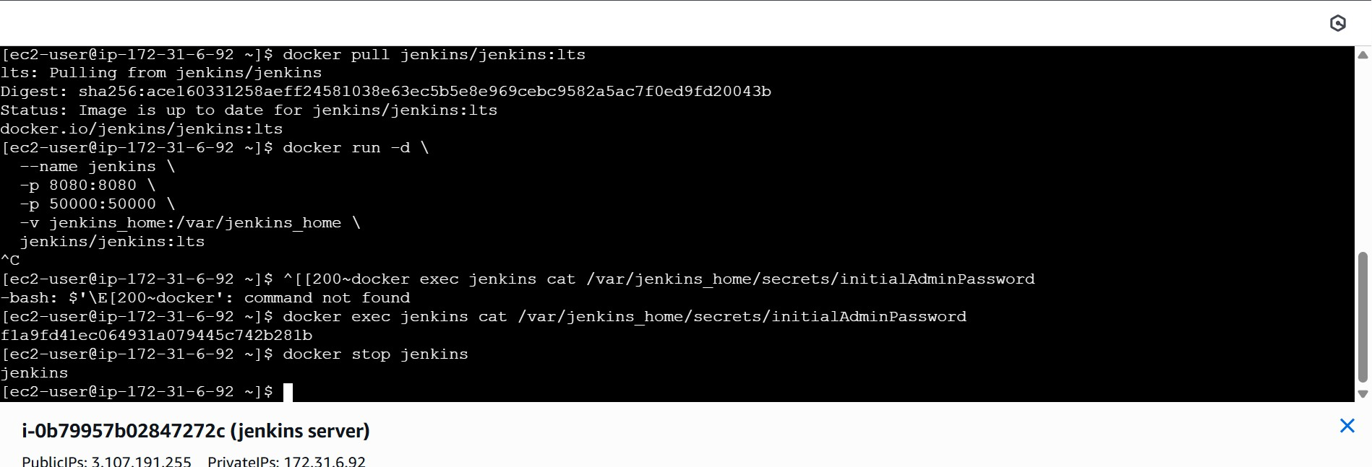
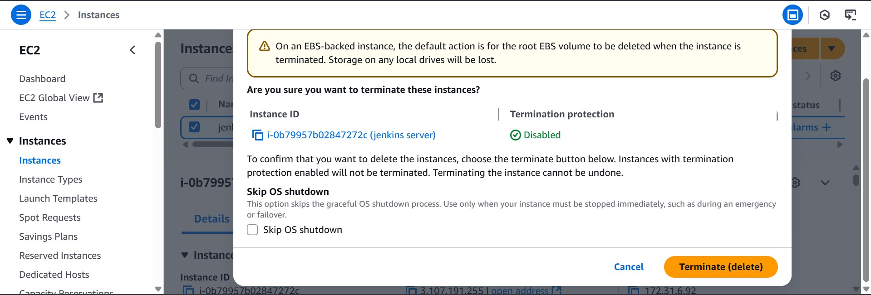

Cleanup and Termination
  - Stop Jenkins

  - Terminate the EC2 instance and exit

