Ques 1: what is controller?

Solution:

The Rails controller is the logical center of your application. It coordinates the interaction between the user, the views, and the model.
A controller's purpose is to receive specific requests for the application. Routing decides which controller receives which requests. A view's purpose is to display this information in a human readable format. An important distinction to make is that it is the controller, not the view, where information is collected.
Often, there is more than one route to each controller, and different routes can be served by different actions. Each action's purpose is to collect information to provide it to a view.

syntax:

$ rails generate controller controller_name

example:

$ rails generate controller Employees

note: The naming convention of controllers in Rails favors pluralization of the last word in the controller's name.

It creates a file called app/controllers/employees_controller.rb

Based on your requirement, you could define any number of functions in this file.

class EmployeesController < ApplicationController
def create
@employees = Employee.new(employee_params)
if @employees.save
redirect_to '/index'
else
abort(@employees.errors.inspect)
end
end

def new
@employees = Employee.new
end

def index
@employees = Employee.all
end

def edit
@employees =Employee.find_by_id(params[:id])
end

def update
@employees = Employee.find_by_id(employee_params[:id])
if employee_params[:email].present?
@employees.update_attributes(employee_params)
end
if @employees.save
redirect_to '/index'
else
abort(@employees.errors.messages.inspect)
end
end

def destroy
@employees = Employee.find_by_id(params[:id])
if @employees.present?
@employees.destroy
redirect_to '/index'
end

end

private
def employee_params
params.require(:employee).permit(:id, :emp_code, :first_name, :last_name, :email, :password)
end

end
Ques 2: what is models?

Solutions 2:

Rails Active Record is the Object/Relational Mapping (ORM) layer supplied with Rails.
Rails Active Records provide an interface and binding between the tables in a relational database and the Ruby program code that manipulates database records. Ruby method names are automatically generated from the field names of database tables.
Each Active Record object has CRUD (Create, Read, Update, and Delete) methods for database access.

Creating Active Record Files (Models)
Syntax:
rails generate model model_name

example:
rails generate model book

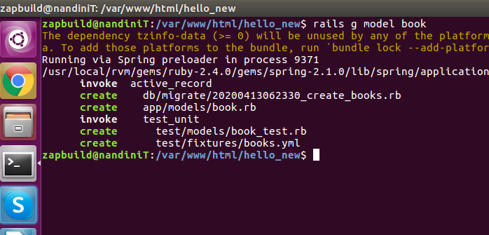
Apart from creating many other files and directories, this will create files named book.rb containing a skeleton definition in the app/models directory.
Content available in book.rb −
class Book < ApplicationRecord
end
Ques 3: what is the role of applicationcontrollers?

Solution:
Controller classes inherit from ApplicationController, which is the other file in the controllers folder: application.rb.
The ApplicationController contains code that can be run in all your controllers and it inherits from Rails ActionController::Base class.

Ques 4: has many association

Solution:
A has_many association indicates a one-to-many connection with another model. You'll often find this association on the "other side" of a belongs_to association. This association indicates that each instance of the model has zero or more instances of another model.

Example:
class Subject < ApplicationRecord
has_many :users
end
class User < ApplicationRecord
belongs_to :subject
end
Ques 5: has one association
Solution:
A has_one association also sets up a one-to-one connection with another model, but with somewhat different semantics (and consequences). This association indicates that each instance of a model contains or possesses one instance of another model.
Example:
class Admin < ApplicaztionRecord
has_one :account
end

