Ques 1: How to set root route?

Solution:

- create a rails app
syntax: rails new app_name
eg: rails new hello_new

- fter you create the blog application, switch to its folder
eg: cd hello_new

- create a controller for rails app
syntax: rails g controller name_of_controller
eg: rails g controller welcome

- add your new homepage file
- add a file into app/views/welcome/
eg: index.html.erb
- Delete all of the existing code in the file, and replace it with some basic text
eg: “hello world”

- wire up the controller
- open app/contollers/welcome_controller.rb
- fill it with
class EmployeesController < ApplicationController
def index
end
end
- tweak tha routes file
- finally open uthe routes file and add this line
Rails.application.routes.draw do
root to: "pages#home"
end

Ques 2: check all the request methods

solution:

GET - how a client machine tells a server that it wants information about the item identified by the URI. Because GET requests are all about asking for information, they are not permitted to have request bodies. You still have the URI query string available to you if you need to send data from the client to the server on a GET request.
POST- how a client tells a server to add an entity as a child of the object identified by the URI. The entity that the client expects the server to add is transmitted in the request body.

PATCH- how a client tells a server it wants to modify an object identified by the URI the request is sent to.

DELETE- as you might guess, how a client tells a server to remove an object identified by the URI the request is sent to.
PUT- you want to update/replace every resource in the entire collection.
Ques 3: when we can use match in routes?

Solution:
match : Matches a URL pattern to one or more routes.
You should not use the match method in your router without specifying an HTTP method.
If you want to expose your action to both GET and POST, use:
Example:
match ':controller/:action/:id', via: [:get, :post]
If you want to expose your action to GET, use get in the router:
Instead of:
match “:contorller/:action/:id”
Do:
get “:controller/:action/:id”
Ques 4: What is the difference between collection routes and member routes in Rails?

Solution:
A member route will require an ID, because it acts on a member.

Example:
resources :photos do
member do
get :preview
end
end
A collection route doesn't because it acts on a collection of objects.

Example:
resources :photos do
collection do
get :search
end
end
Preview is an example of a member route, because it acts on (and displays) a single object.
Search is an example of a collection route, because it acts on (and displays) a collection of objects.

Ques 5: Difference b/w scope, namespace and resource routes

Solution:

- scope: scope is a bit more complex - but the advantage is that it gives you more options to fine-tune exactly what you want to do.
- No Options: When using scope without any options and only a scope name, it will just change the resources path.
Example:
scope :admin do
resources :employees
end
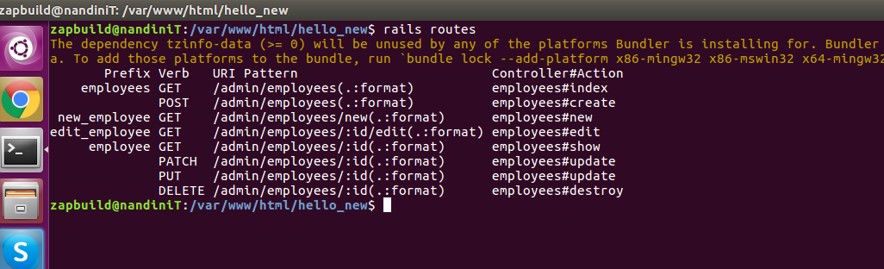

With Options: scope supports three options: module, path and as.
Module: module lets us define in which module the controller for the embedded resources will live.
Example:
scope module: 'admin' do
resources :employees
end

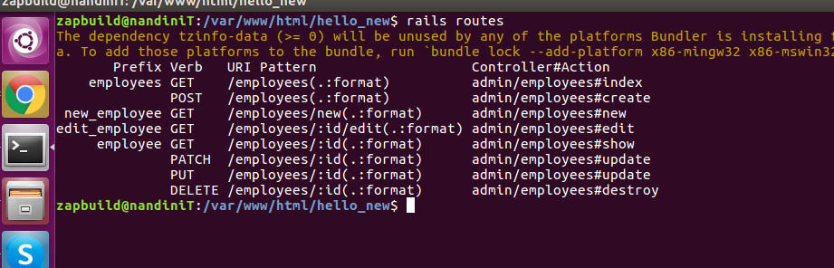
Path: path allows us to set the prefic that will appear in the url, before the resource name
Example:
scope module: 'admin', path: 'company' do
resources :employees
end
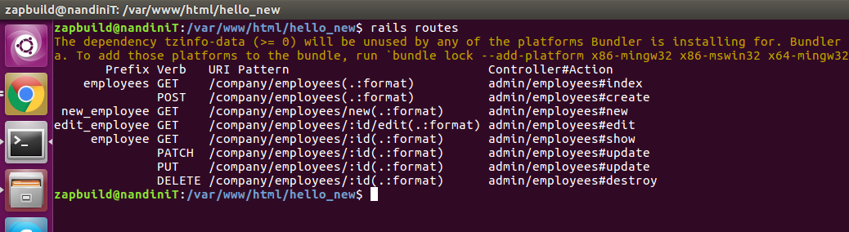
as: as can be used to change the name of the path method used to identify the resources.
Example:
scope module: 'admin', path: 'company', as: 'cool' do
resources :employees
end
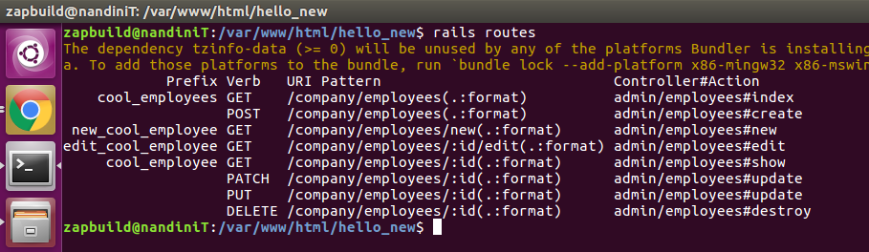
B) Namespaces: it will prefix the URL path for the specified resources, and try to locate the controller under a module named in the same manner as the namespace.
Example:
namespace :admin do
resources :employees
end
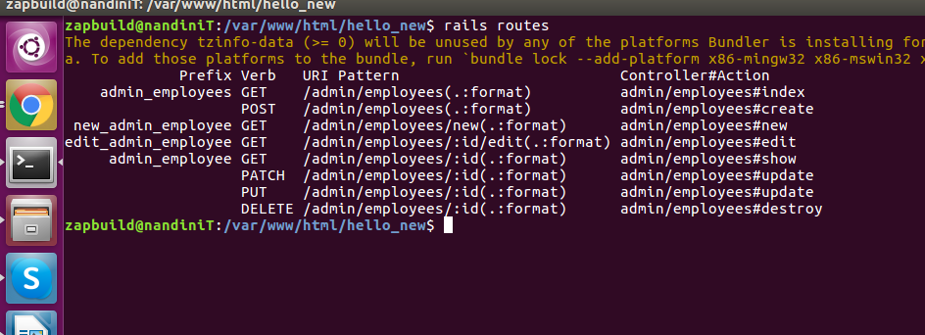

C) Recources:
Example:
resources :employees
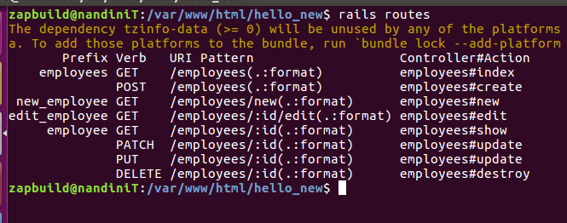

Ques 6: How to set nested resources?
Solution:
It's common to have resources that are logically children of other resources
Example:
class Subject < ApplicationRecord
has_many :users
end
class User < ApplicationRecord
belongs_to :subject
end

Nested routes allow you to capture this relationship in your routing. In this case, you could include this route declaration:
resources :subject do
resources :users
end
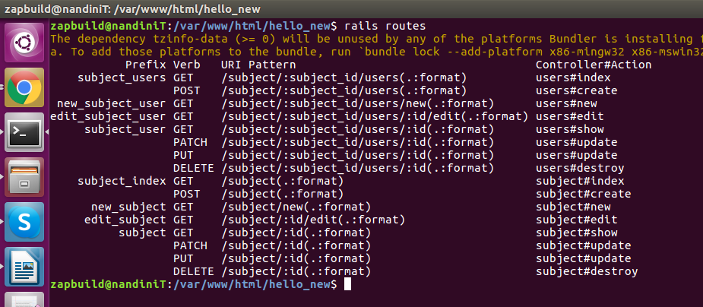

limits to nesting
You can nest resources within other nested resources if you like. For example:
Example:
resources :admins do
resources :subjects do
resources :users
end
end
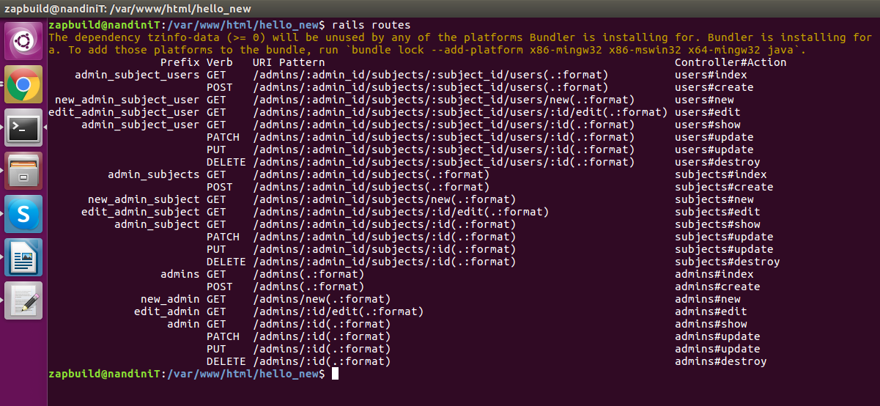
the application would recognize paths such as:
/admins/1/subjects/3/users/8
Ques 7: What is shallow nested routes?
Solution:
to only build routes with the minimal amount of information to uniquely identify the resource
Example:
resources :admins do
resources :subjects, only: [:index, :new, :create]
end
resources :subjects, only: [:show, :edit, :update, :destroy]

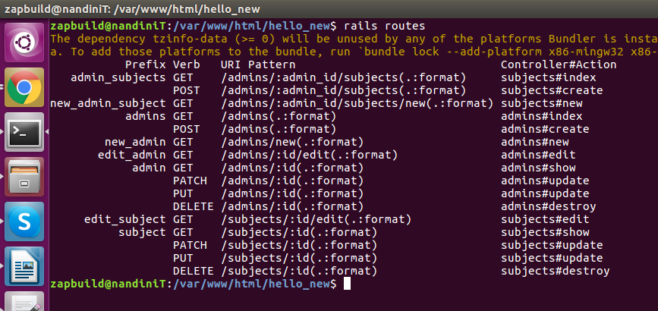
There exists shorthand syntax to achieve just that, via the :shallow option:
Example:
resources :admins do
resources :subjects, shallow: true
end
This will generate the exact same routes as the first example.
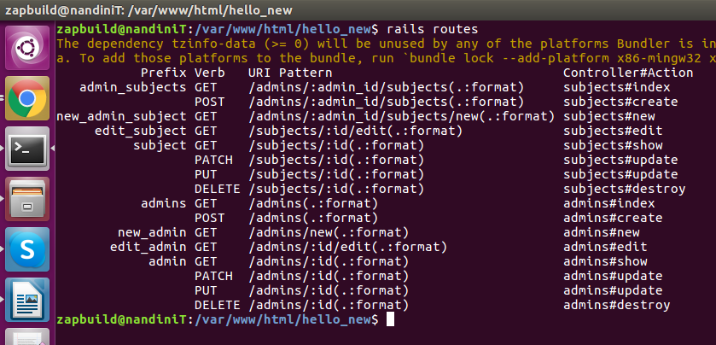
There exist two options for scope to customize shallow routes. :shallow_path prefixes member paths with the specified parameter:
Example:
scope shallow_path: "secret" do
resources :subject do
resources :users, shallow: true
end
end
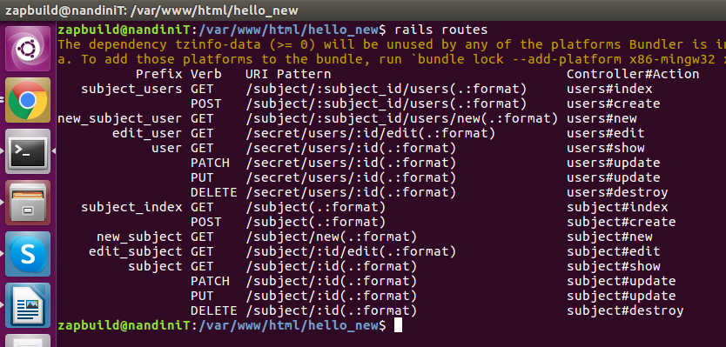

The :shallow_prefix option adds the specified parameter to the named route helpers:
Example:
scope shallow_prefix: "secret" do
resources :subject do
resources :users, shallow: true
end
end
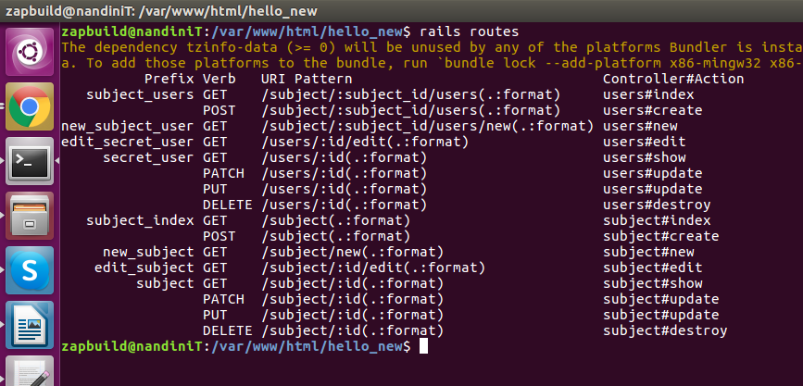

Ques 8: What is concern routing in rails?
Solution:
Routing concerns allow you to declare common routes that can be reused inside other resources and routes. To define a concern:
Example:
concern :user_detail do
resources :user, only: [:destroy, :index]
end
concern :employee do
resources :employee, only: :index
end
These concerns can be used in resources to avoid code duplication and share behavior across routes:
Example:
resources :subject, concerns: :user_detail
resources :admin, concerns: [:user_detail, :employee]
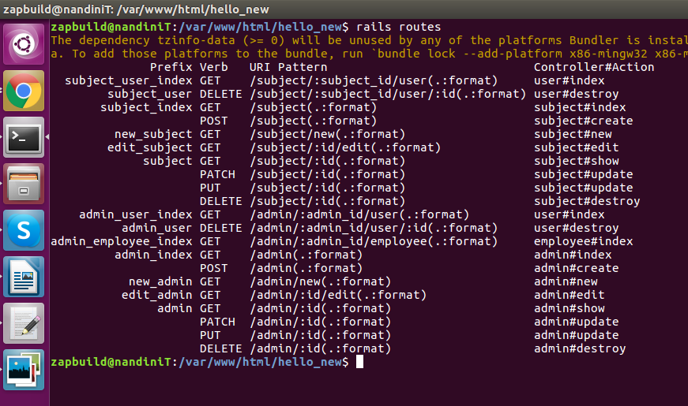
Ques 9: How to use redirection routes in rails?
Solution:
You can redirect any path to another path using the redirect helper in your router:
Example:
get ‘/stories’, to: redirect(‘/article’)
Ques 10: How to set direct routes?
Solution:

Ques 11: how to list the existing application routes?
Solution:
To get a complete list of the available routes in your application, visit http://localhost:3000/rails/info/routes in your browser while your server is running in the development environment.
You can also execute the rails routes command in your terminal to produce the same output.

