DBSE&DBD SEC-3
G. NANDINI ROLL NO-2520030300
STEP 1: CREATE PHYSICIAN TABLE
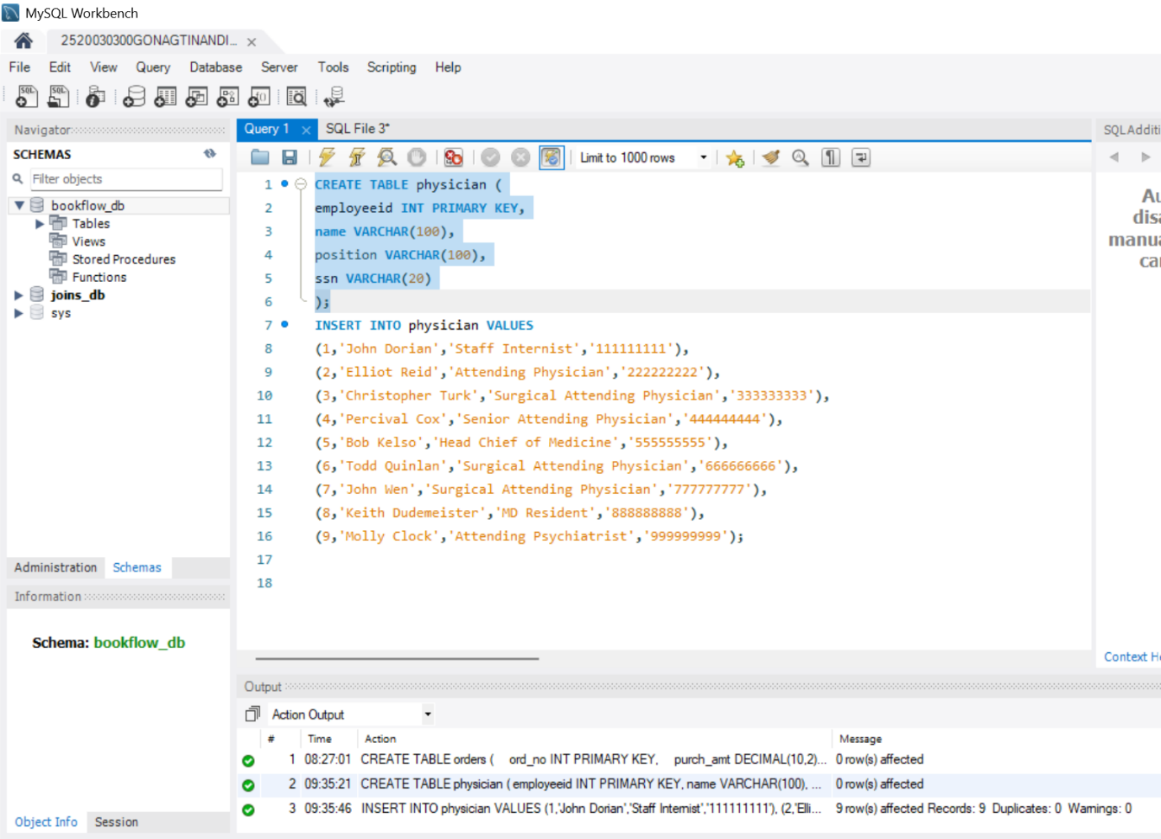
STEP 2: INSERT DATA INTO PHYSICIAN
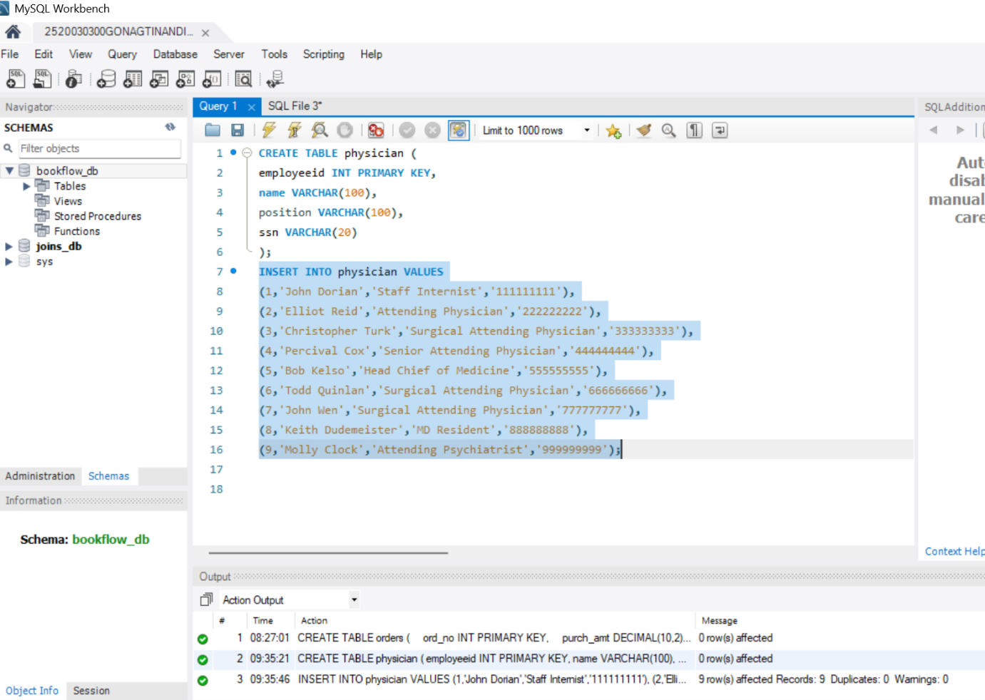
STEP 3: CREATE DEPARTMENT TABLE

STEP 4: INSERT DATA INTO DEPARTMENT
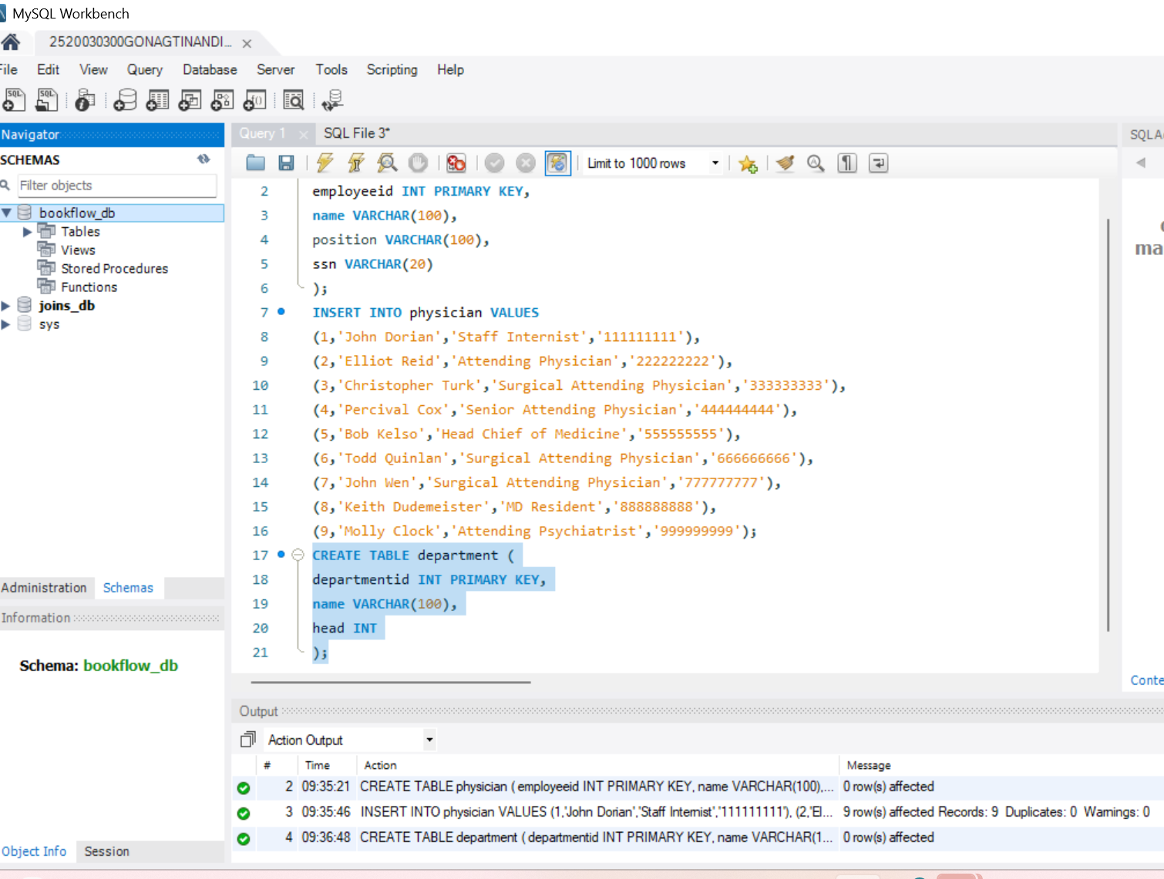
STEP 5: QUESTION 1 - INNER JOIN
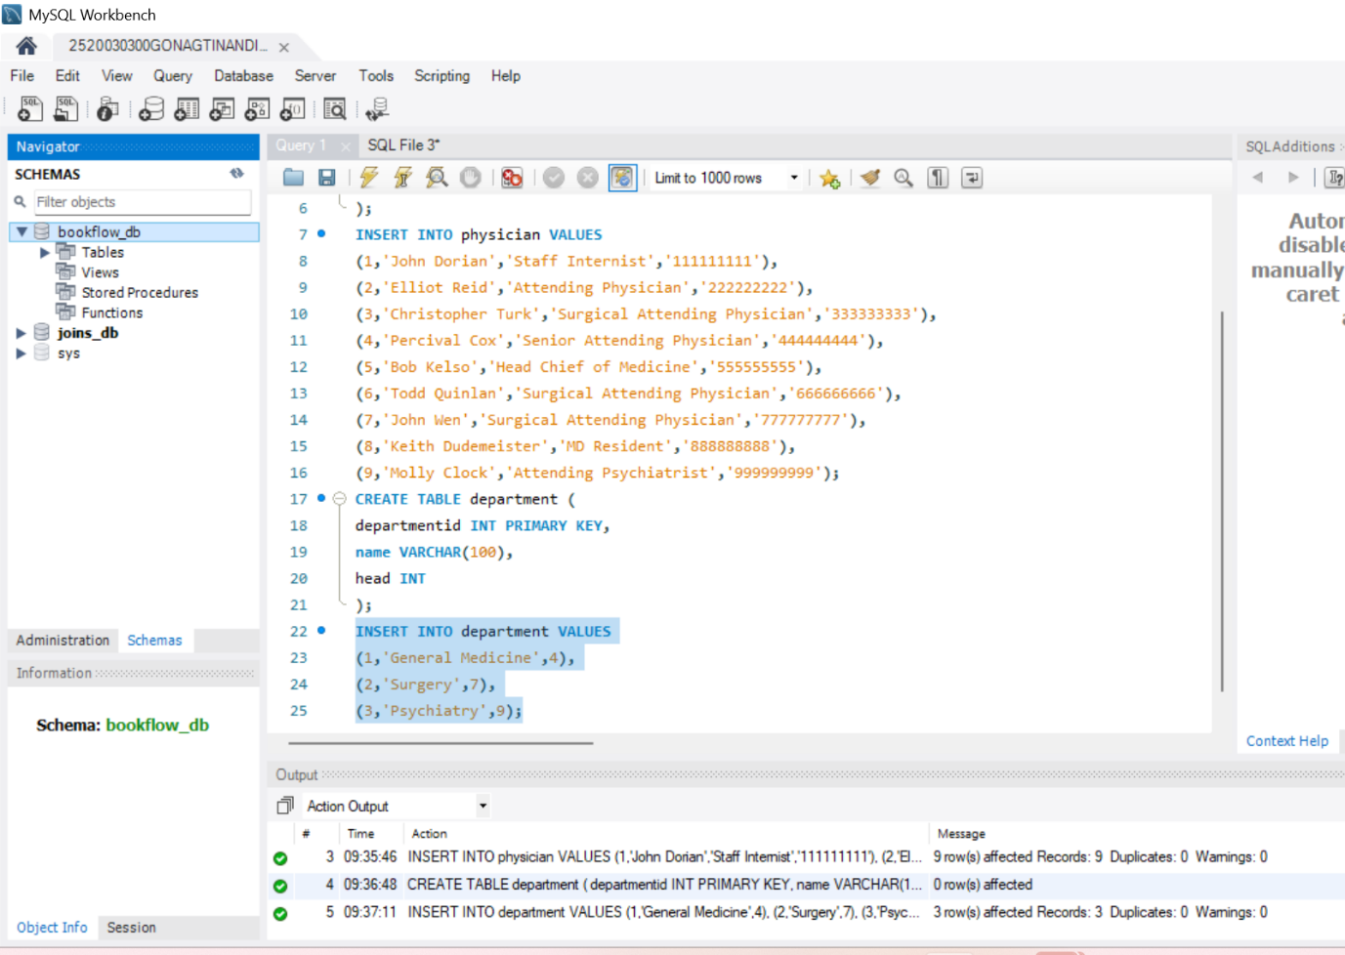
STEP 6: QUESTION 2 - WHERE CLAUSE
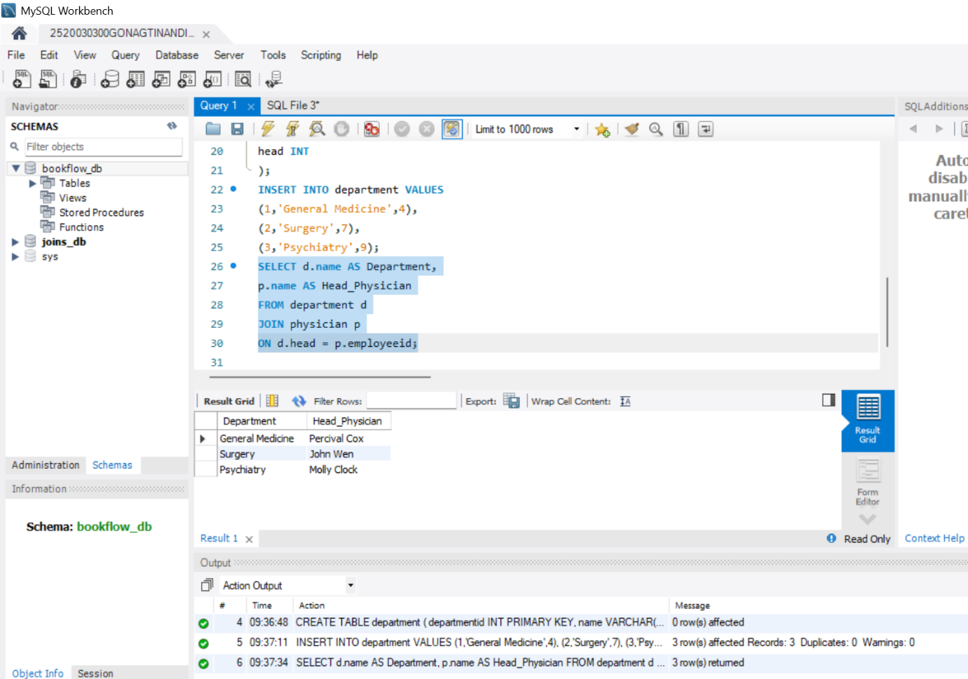
STEP 7: QUESTION 3 - WHERE + LIKE
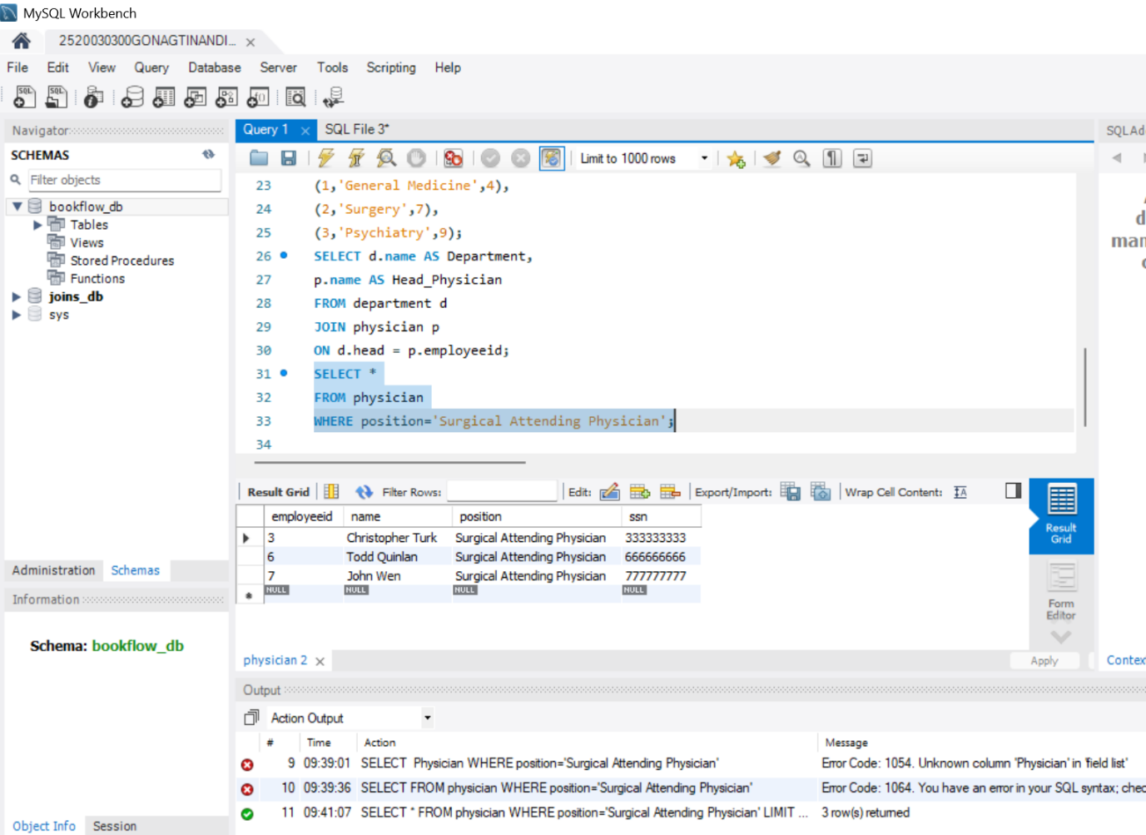
STEP 8: QUESTION 4 - COUNT()
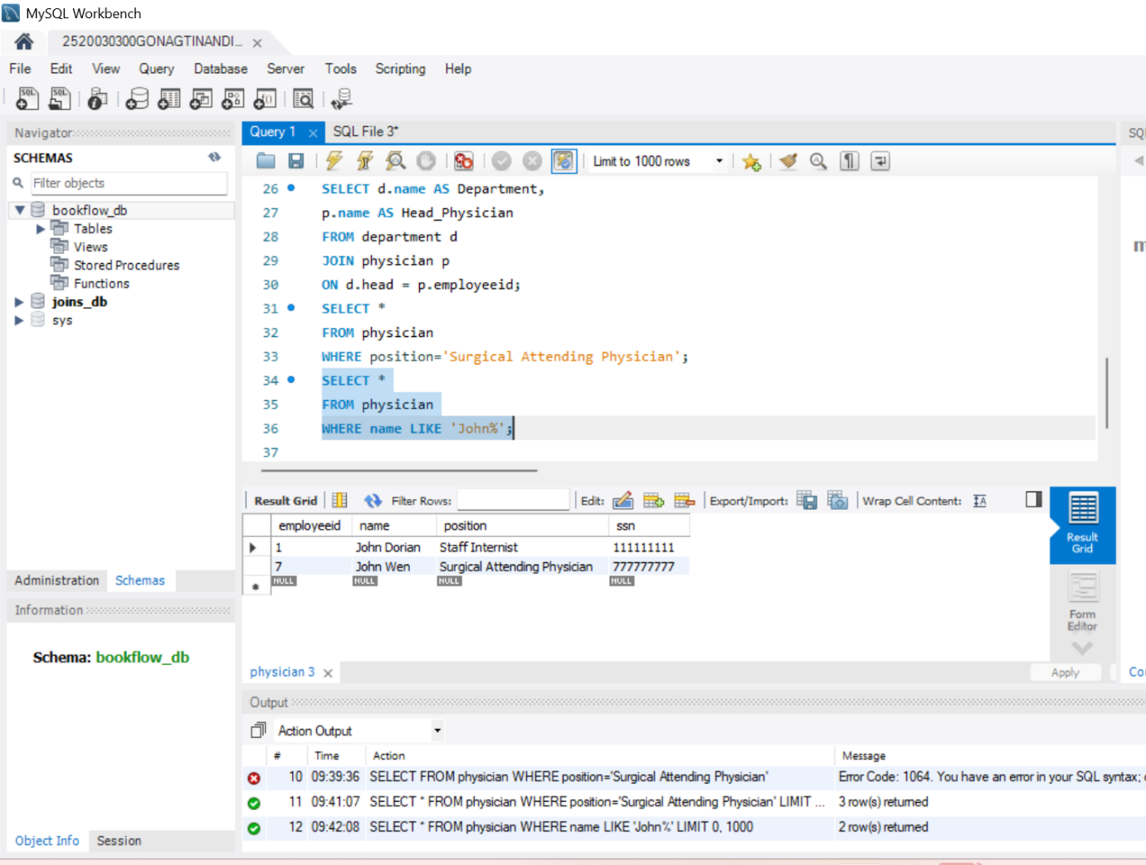
STEP 9: QUESTION 5 - COUNT DISTINCT
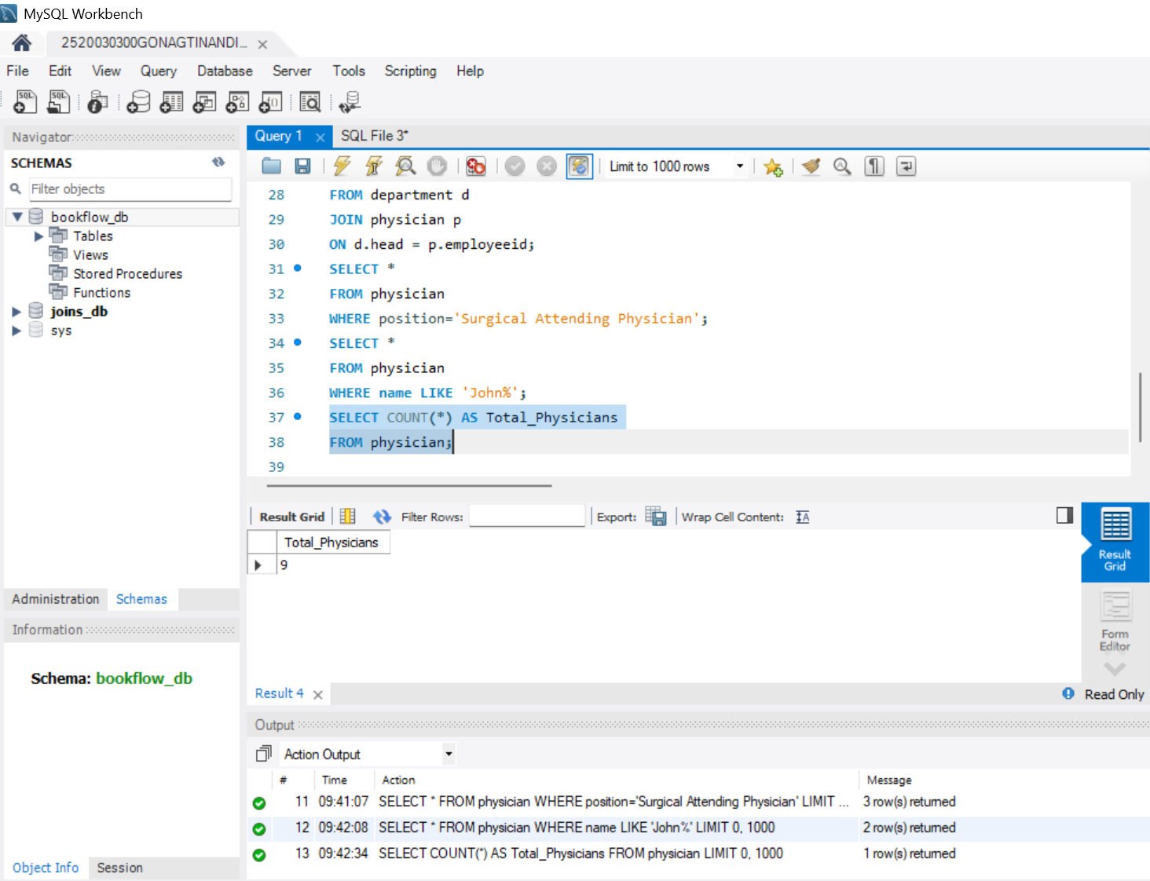
STEP 10: QUESTION 6 - GROUP BY
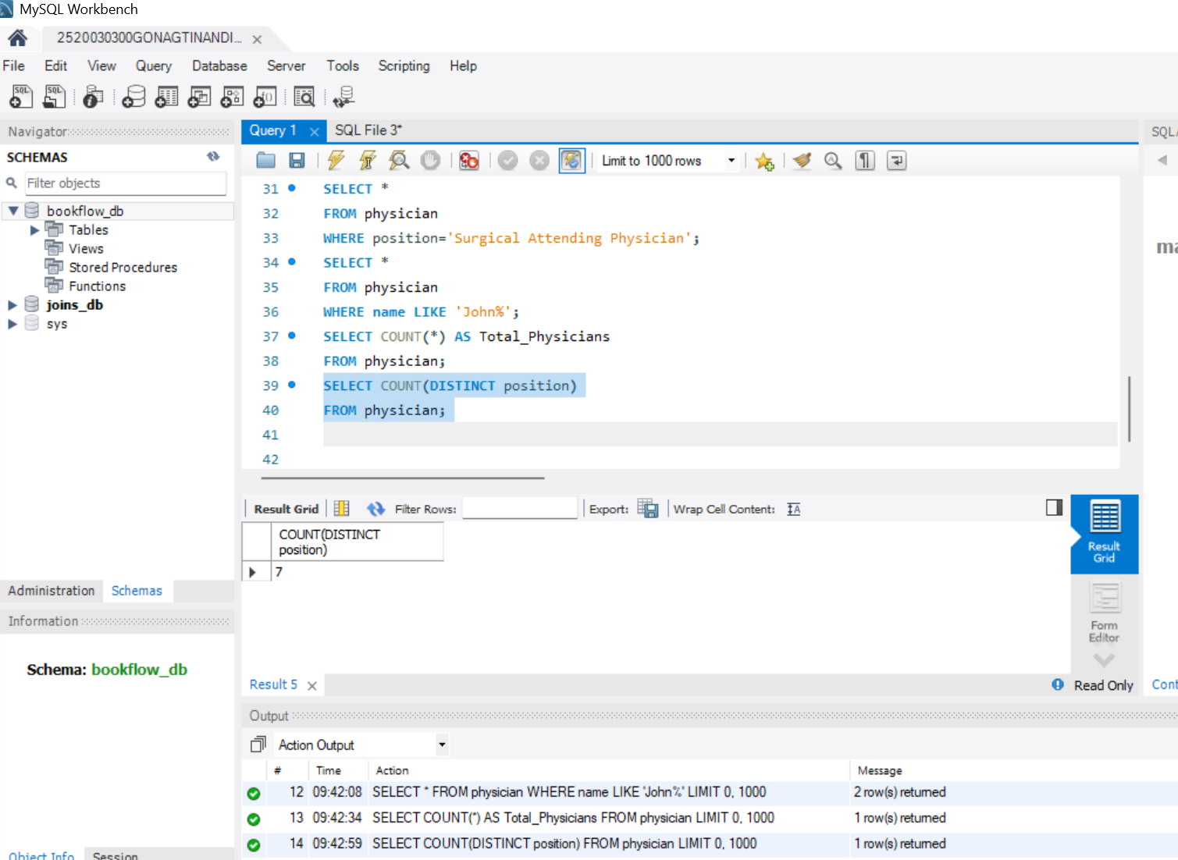
STEP 11: QUESTION 7 - GROUP BY + HAVING
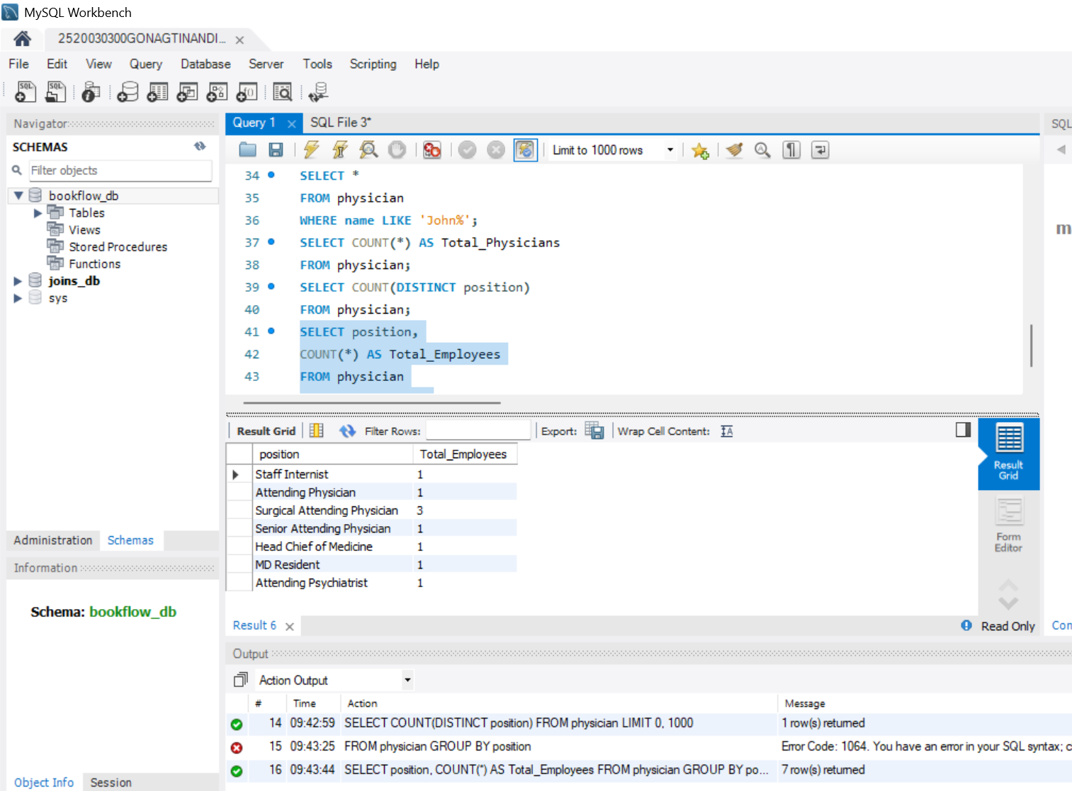
STEP 12: QUESTION 8 - ORDER BY
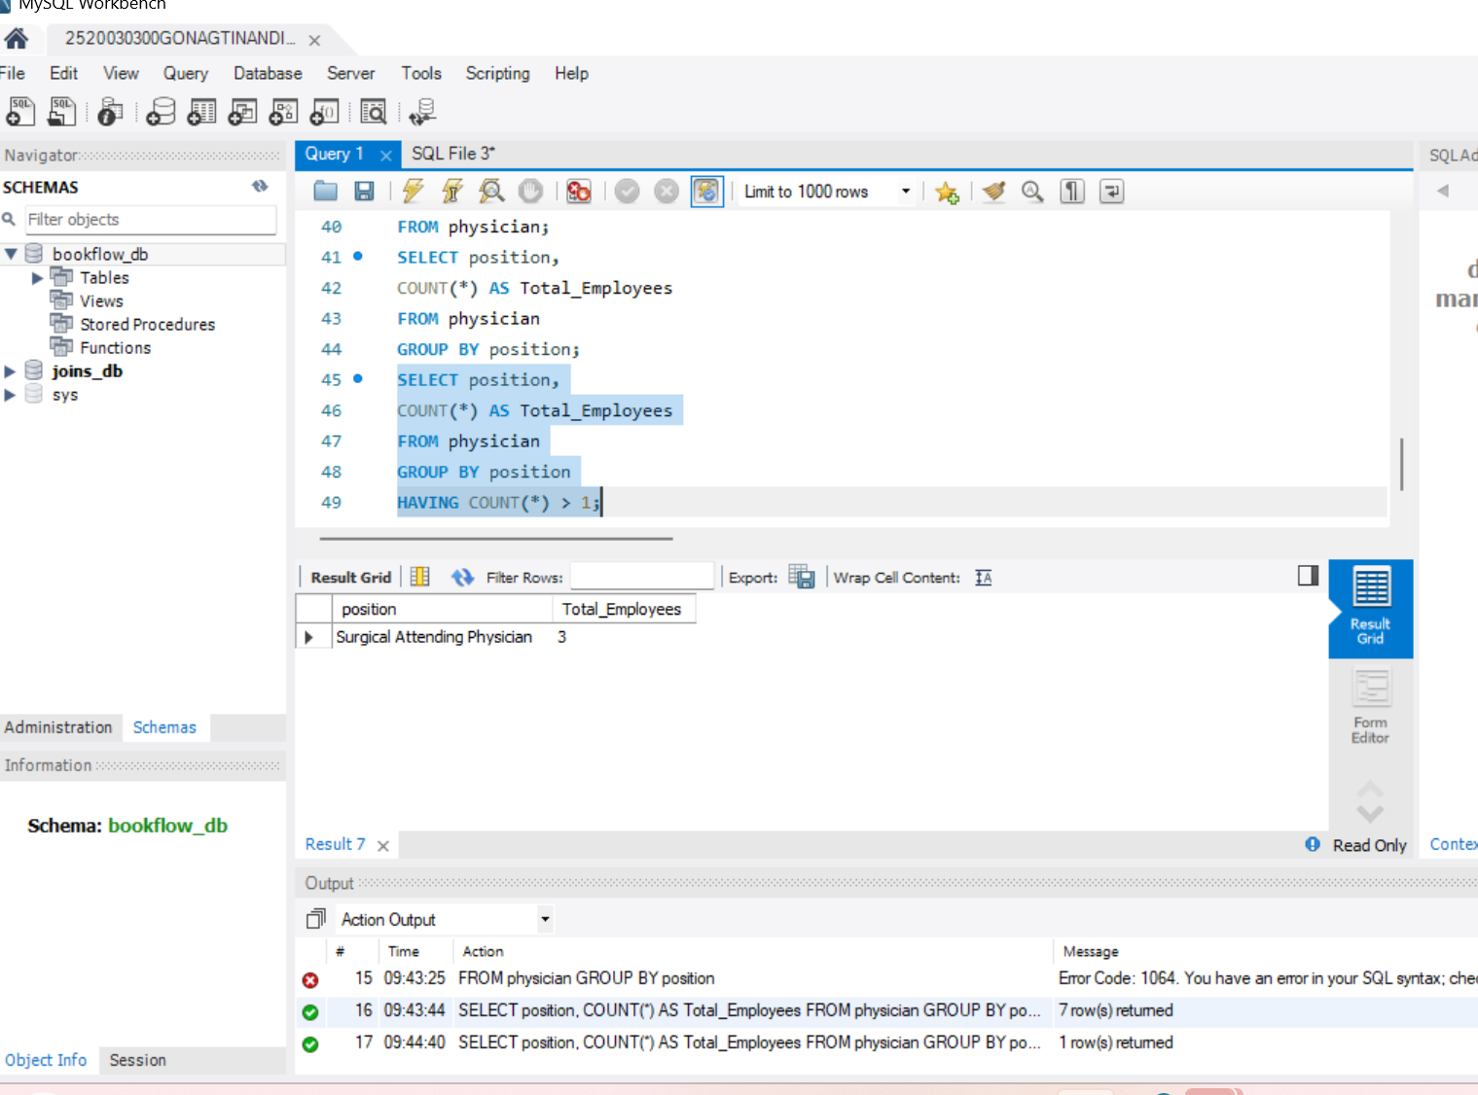
STEP 13: QUESTION 9 - ORDER BY DESC
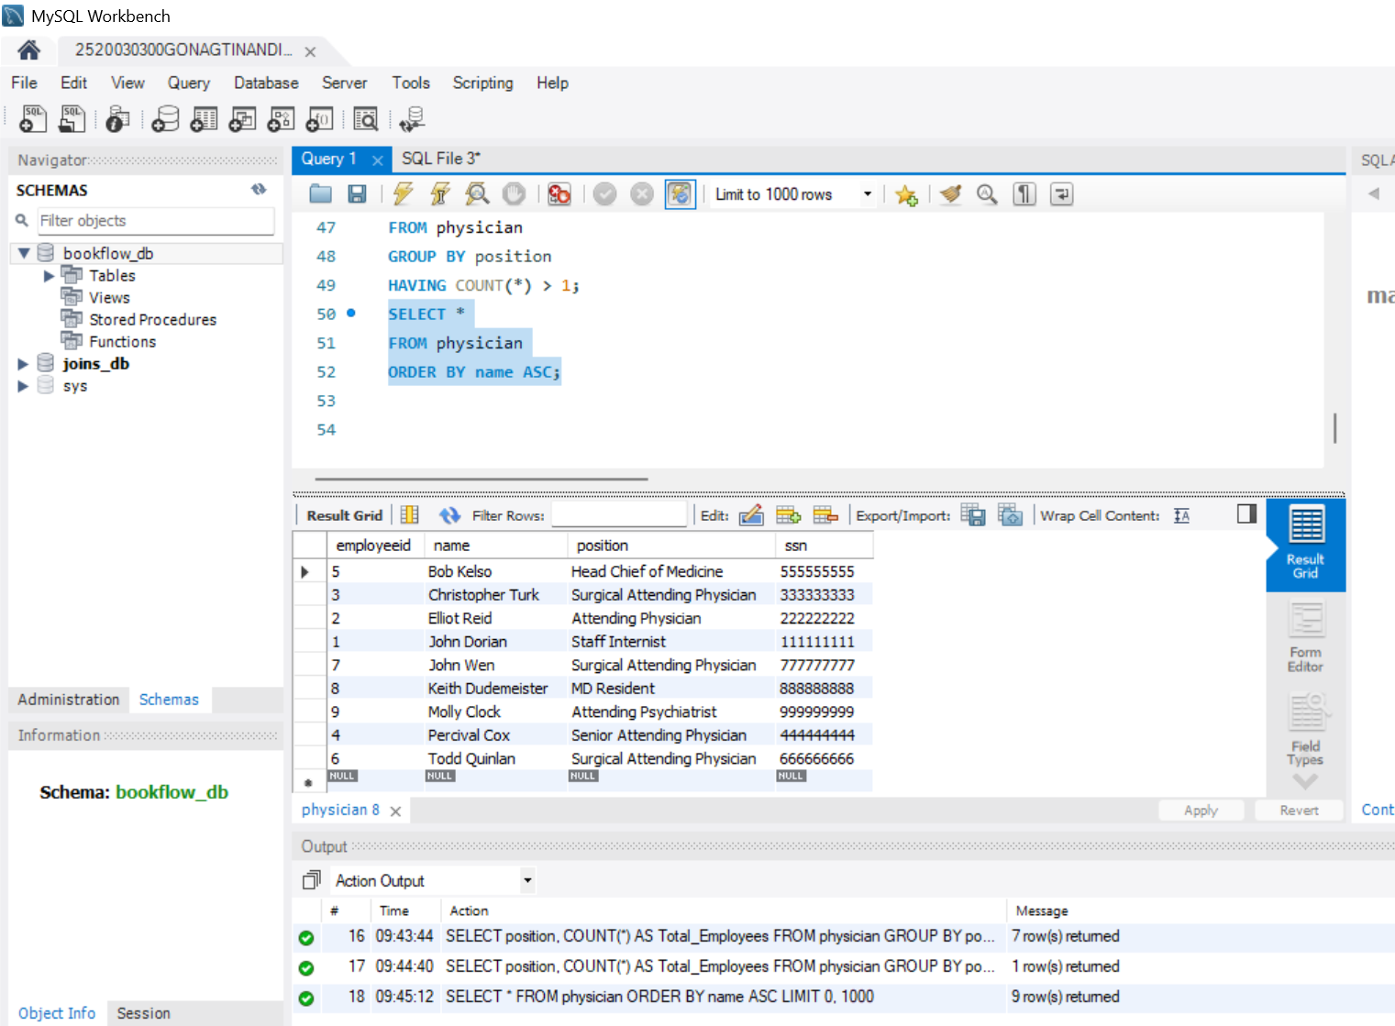
STEP 14: QUESTION 10 - WHERE + IN
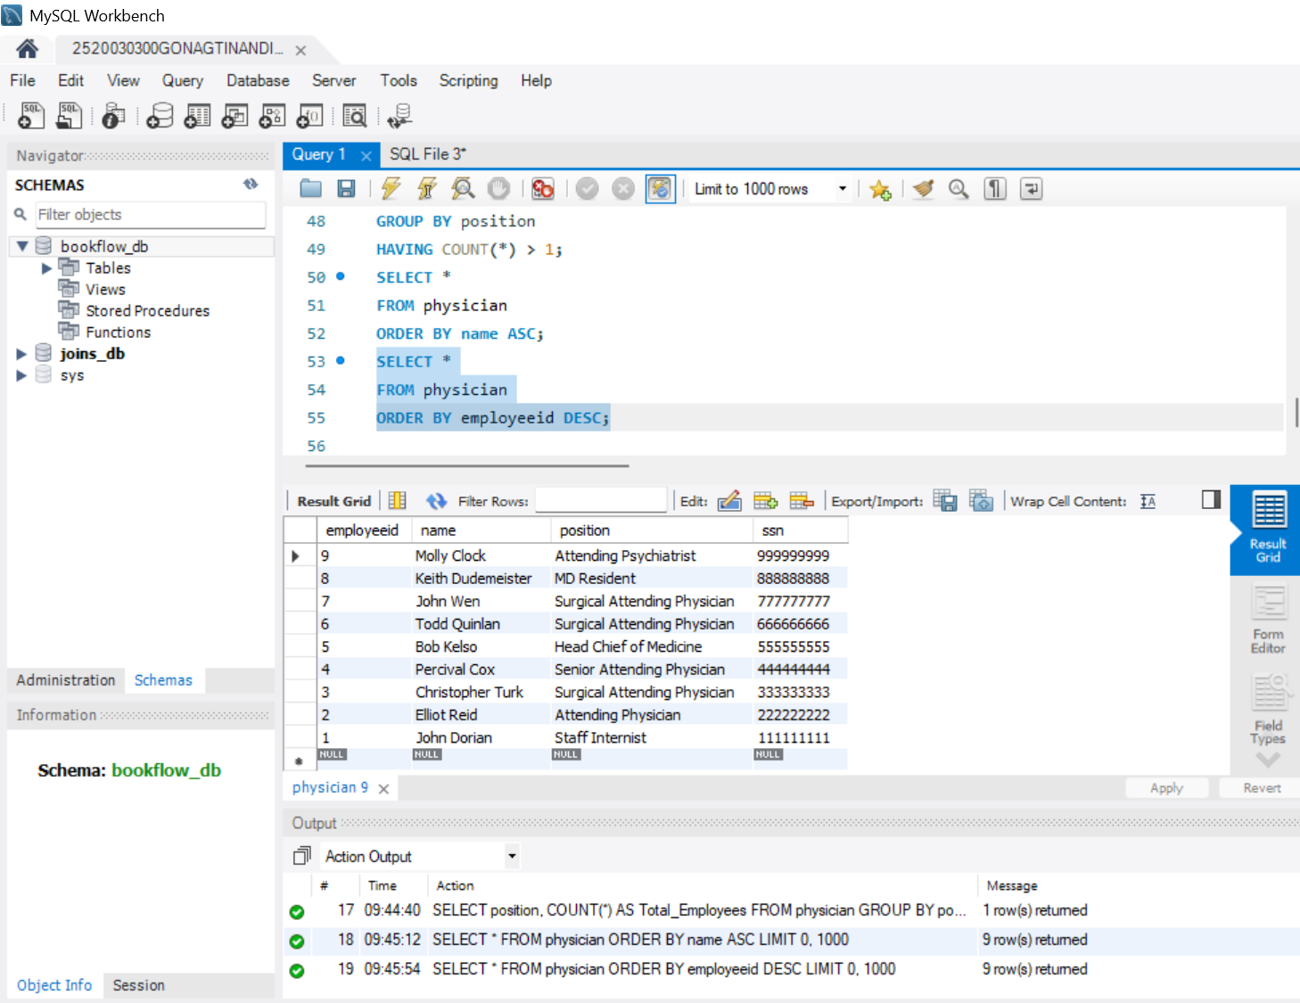
STEP 15: QUESTION 11 – SUBQUERY
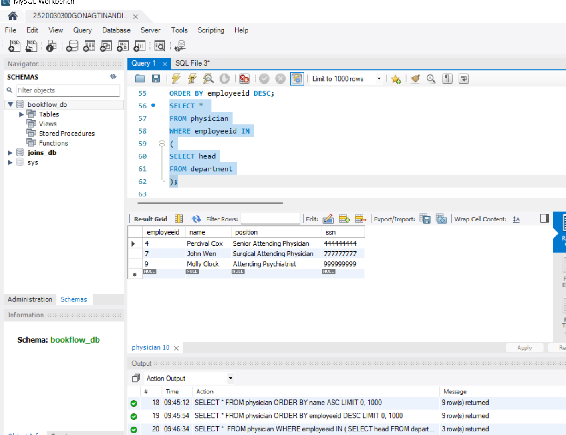

STEP 16: QUESTION 12 - GROUP BY + ORDER BY
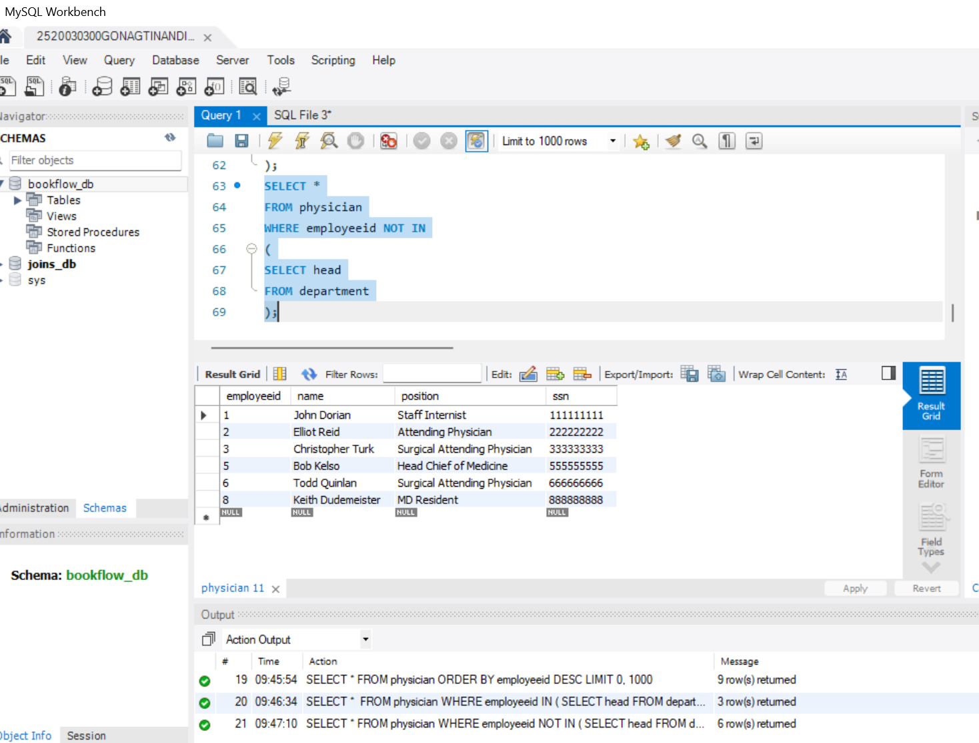
STEP 17: QUESTION 13 - WHERE + LIKE
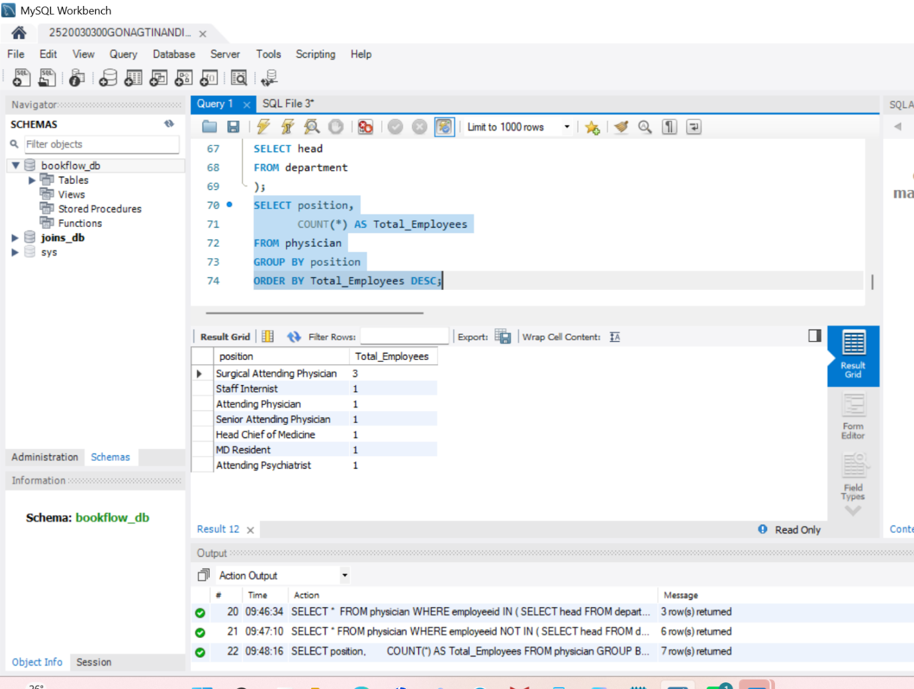
STEP 18: QUESTION 14 - JOIN + WHERE
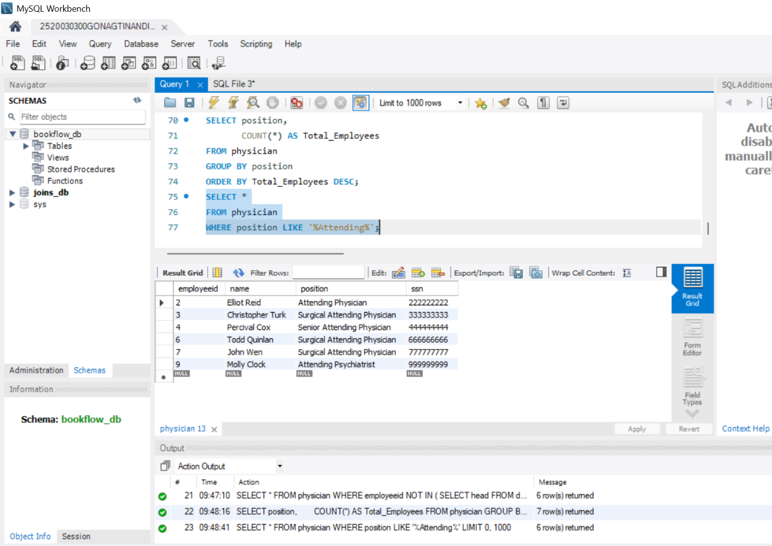

STEP 19: QUESTION 15 - JOIN + ORDER BY
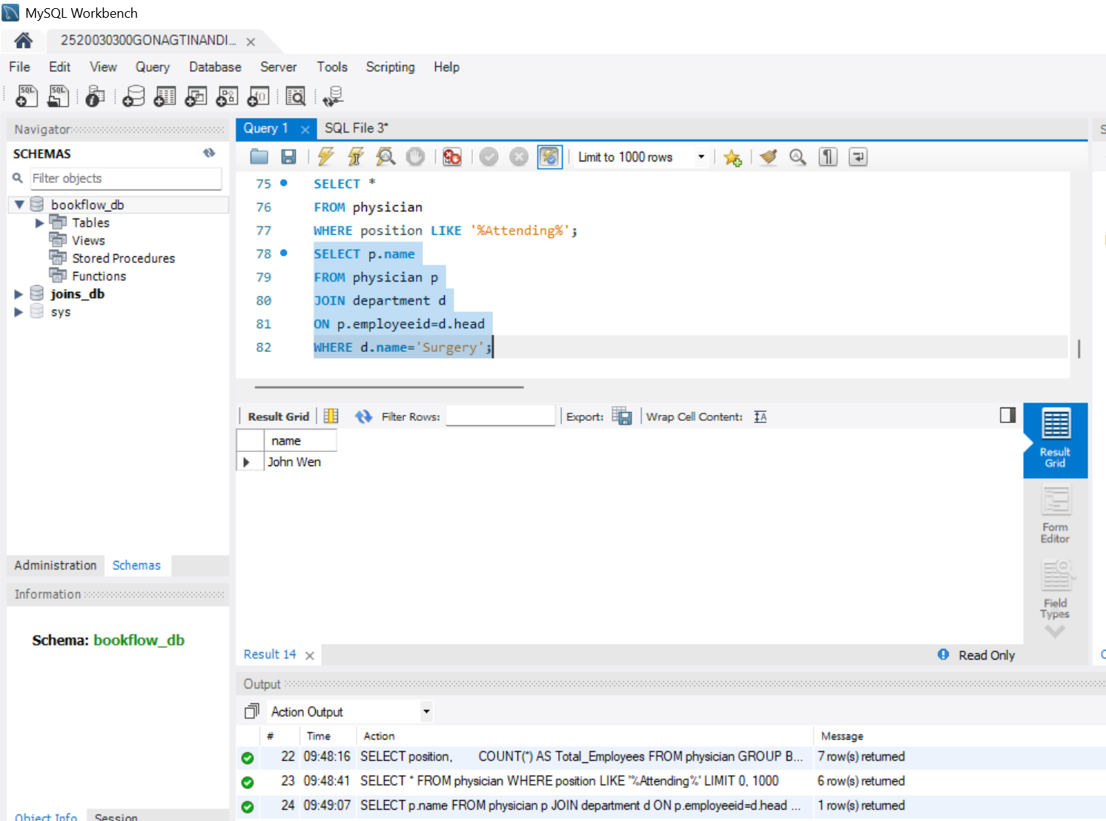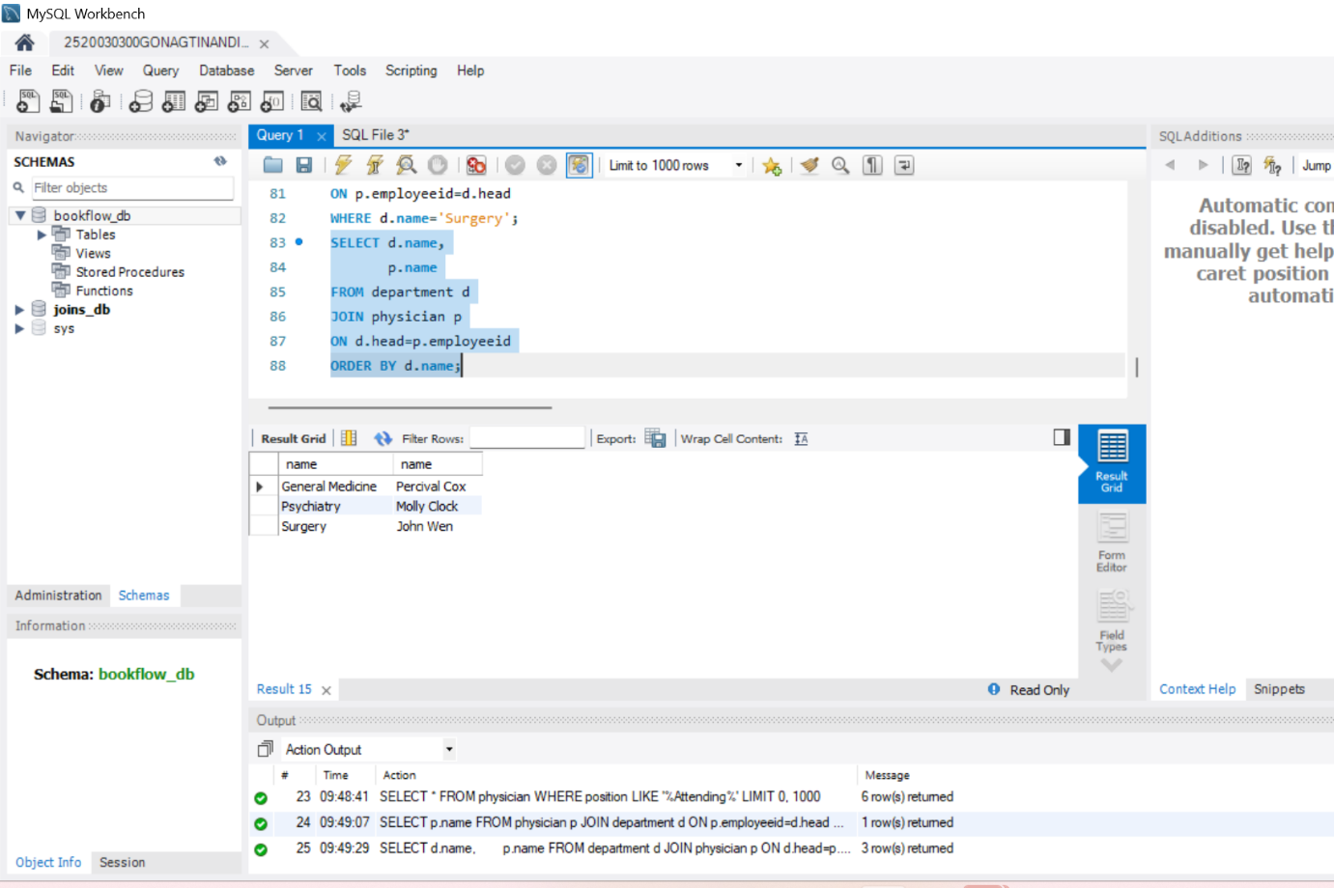
STEP 20: QUESTION 16 - WHERE + NOT LIKE
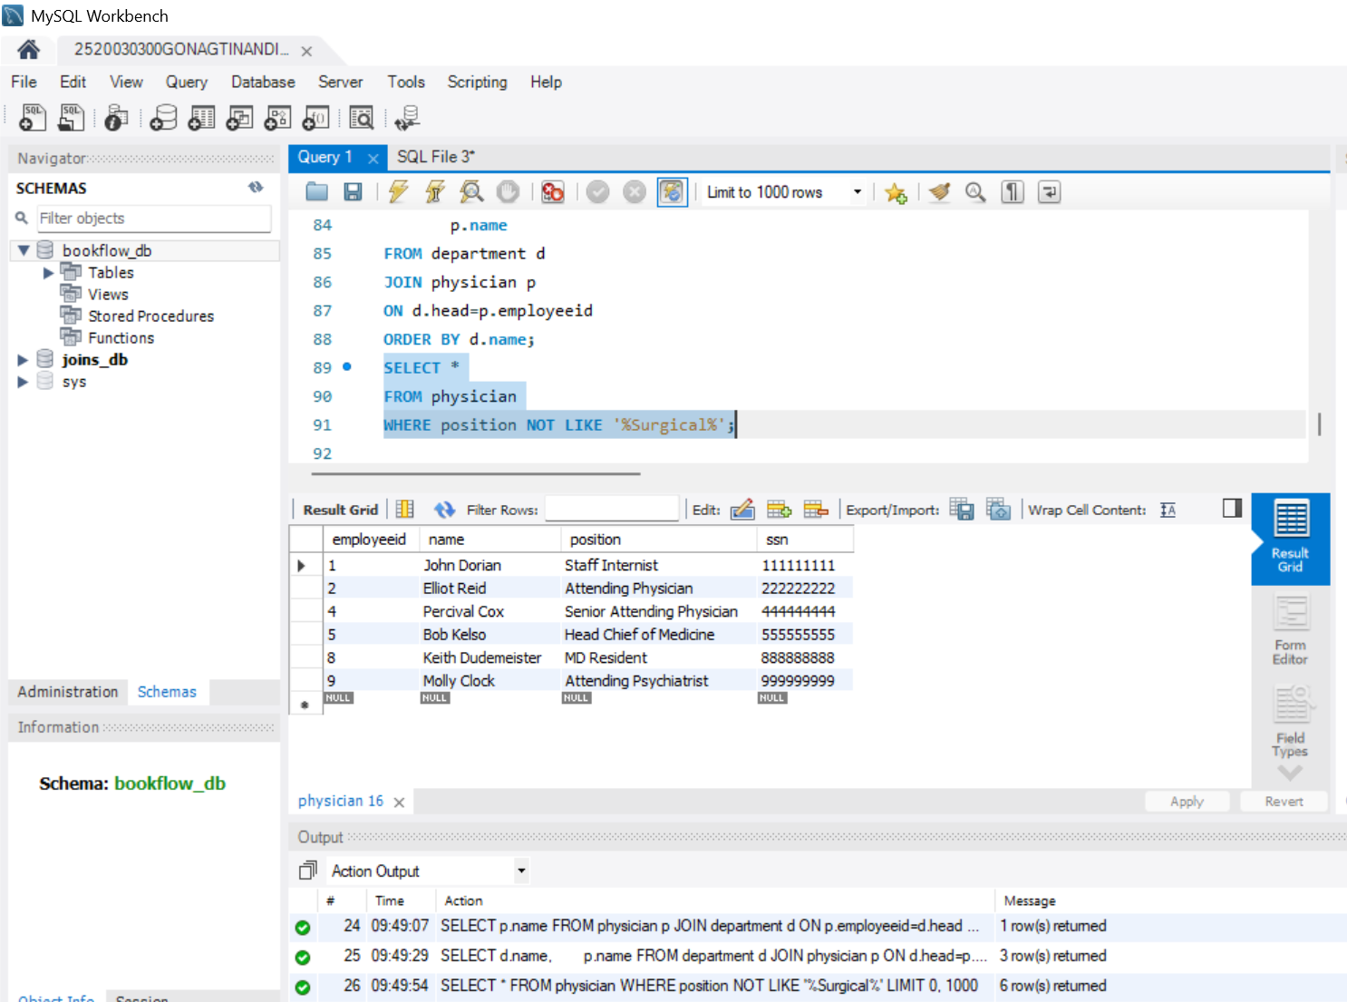
STEP 21: QUESTION 17 - COUNT + HAVING
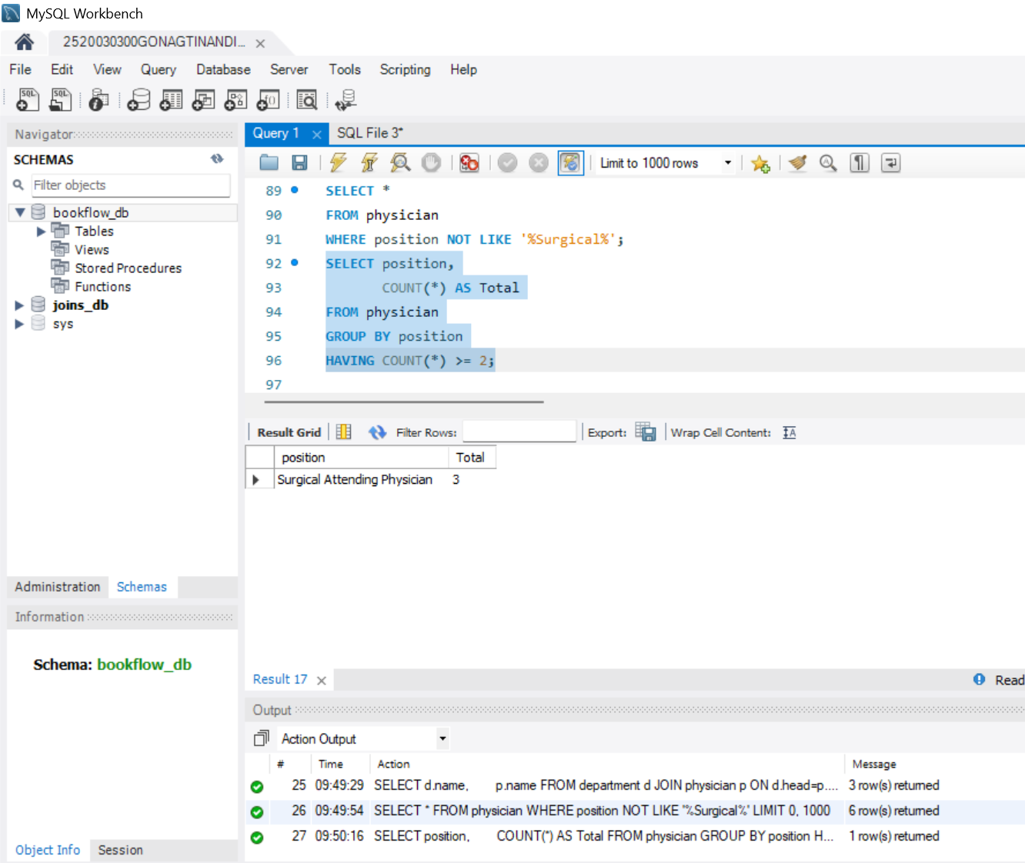
STEP 22: QUESTION 18 - EXISTS
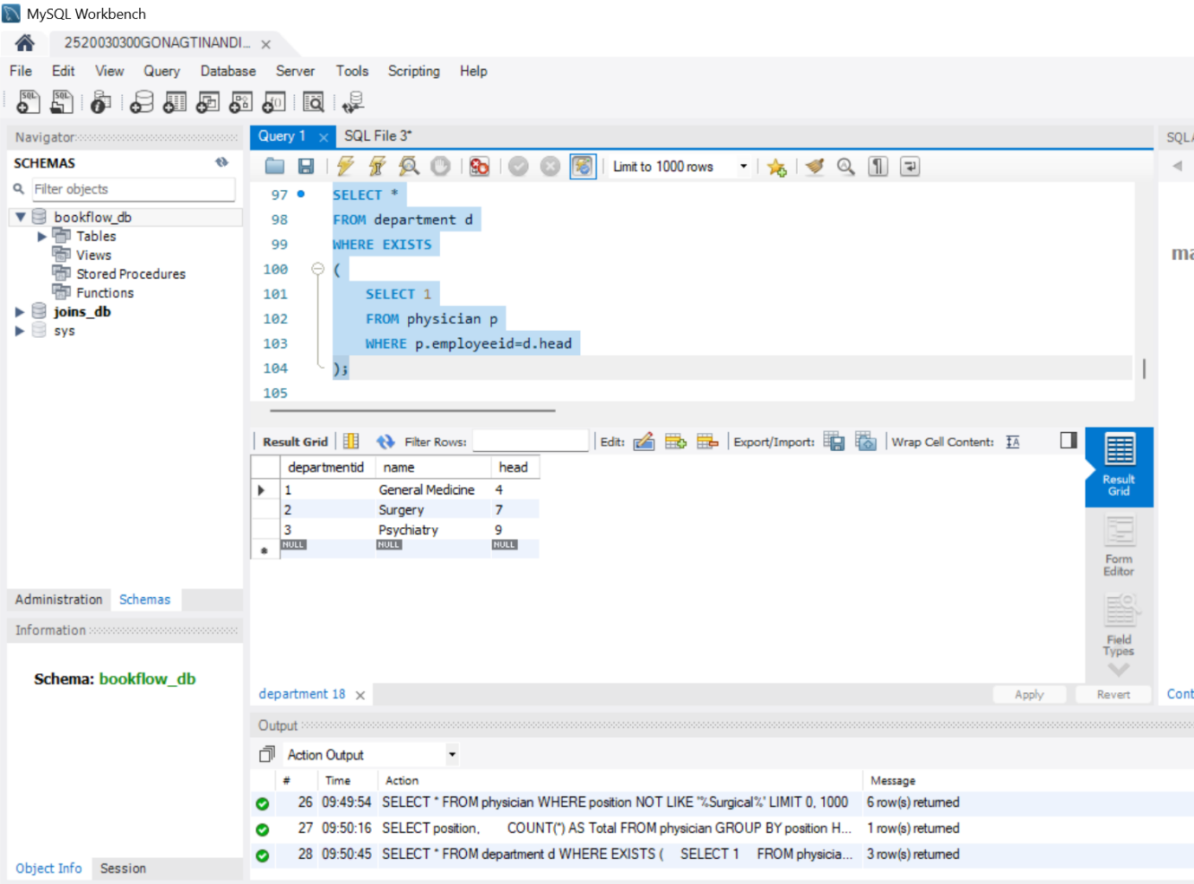
STEP 23: QUESTION 19 - MAX()
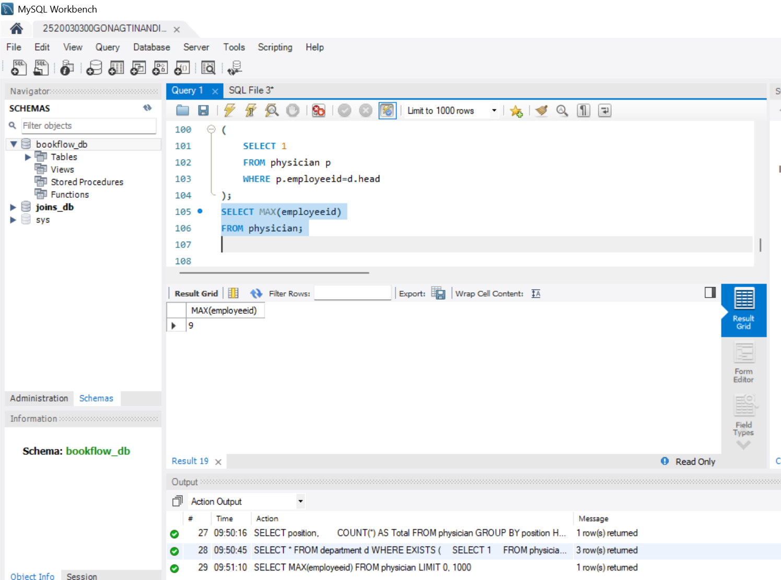
STEP 24: QUESTION 20 - MIN()
