EXAMPLE
2520030300
G.NANDINI
STEP-1: CREATE PHYSICIAN TABLE
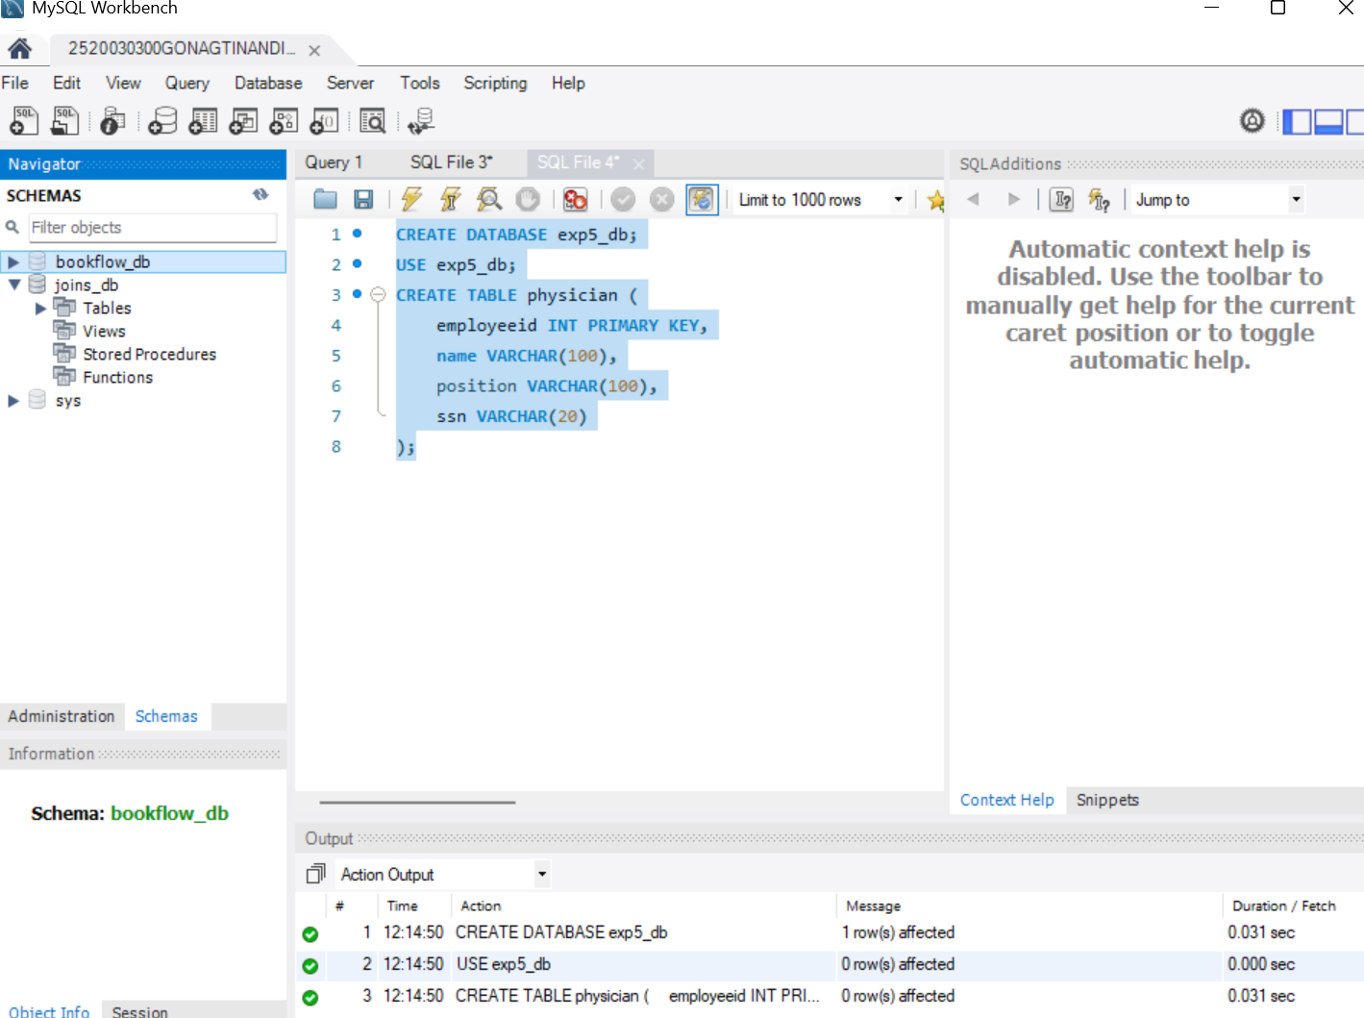
STEP-2: INSERT DATA INTO PHYSICIAN
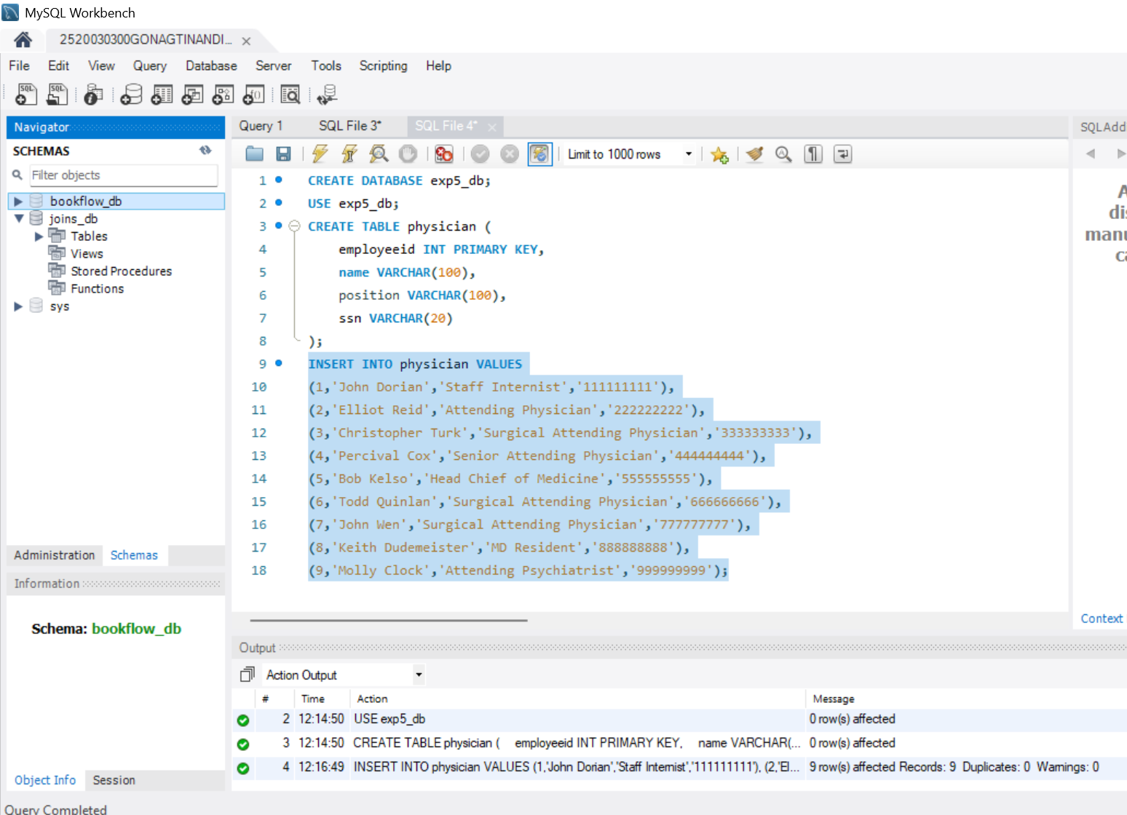
STEP-3: CREATE DEPARTMENT TABLE
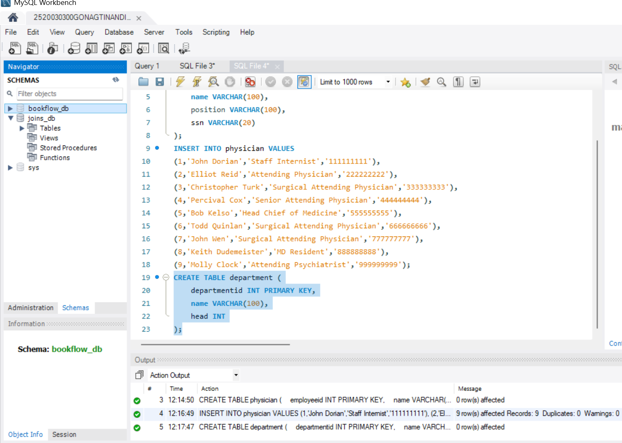
STEP-4: INSERT DATA INTO DEPARTMENT
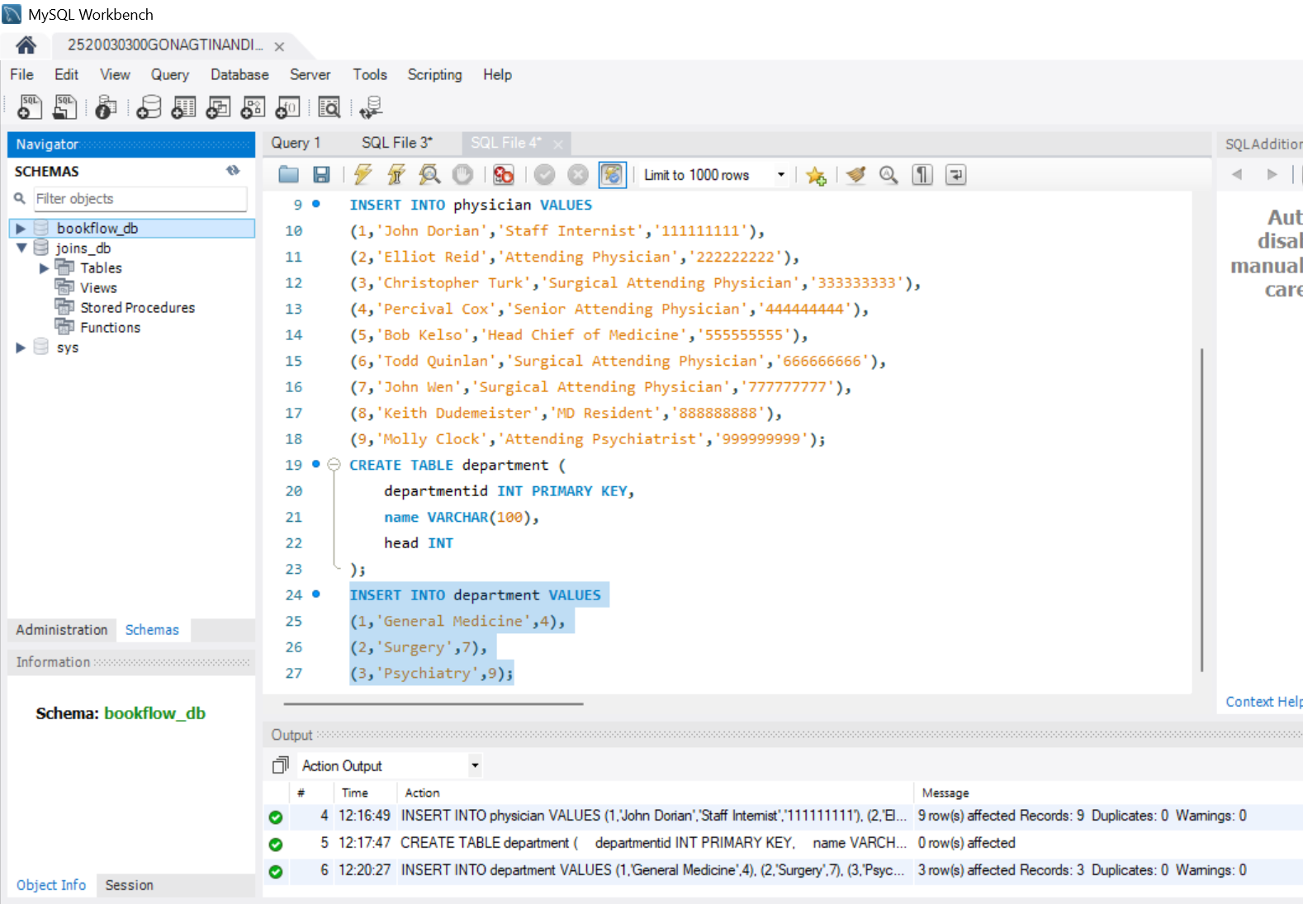
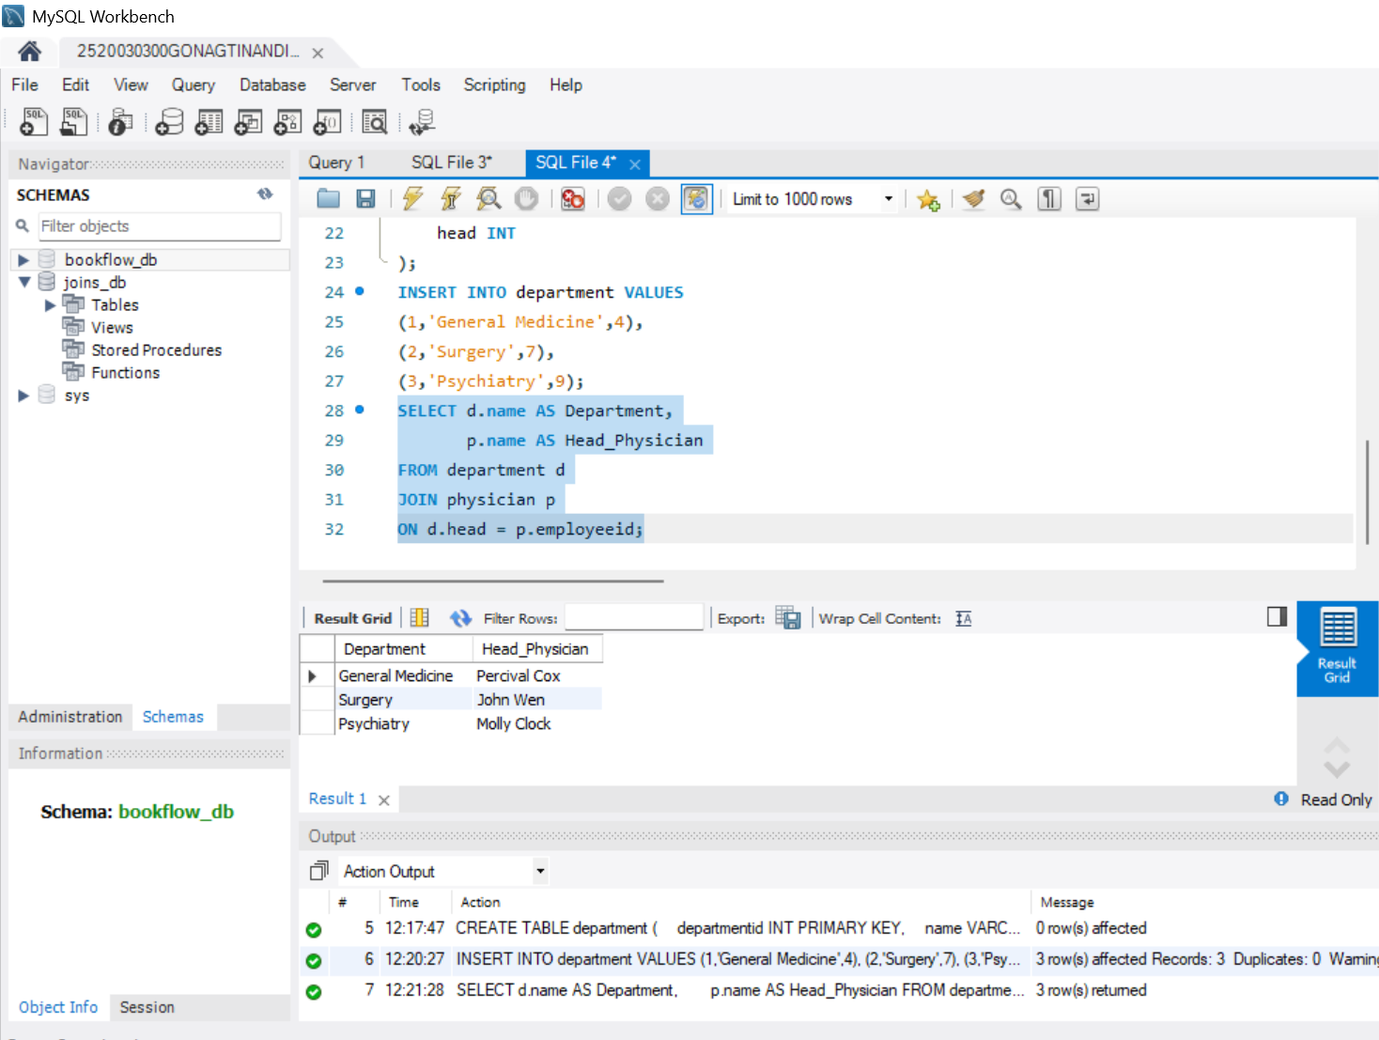
STEP-5: QUESTION 1 - INNER JOIN
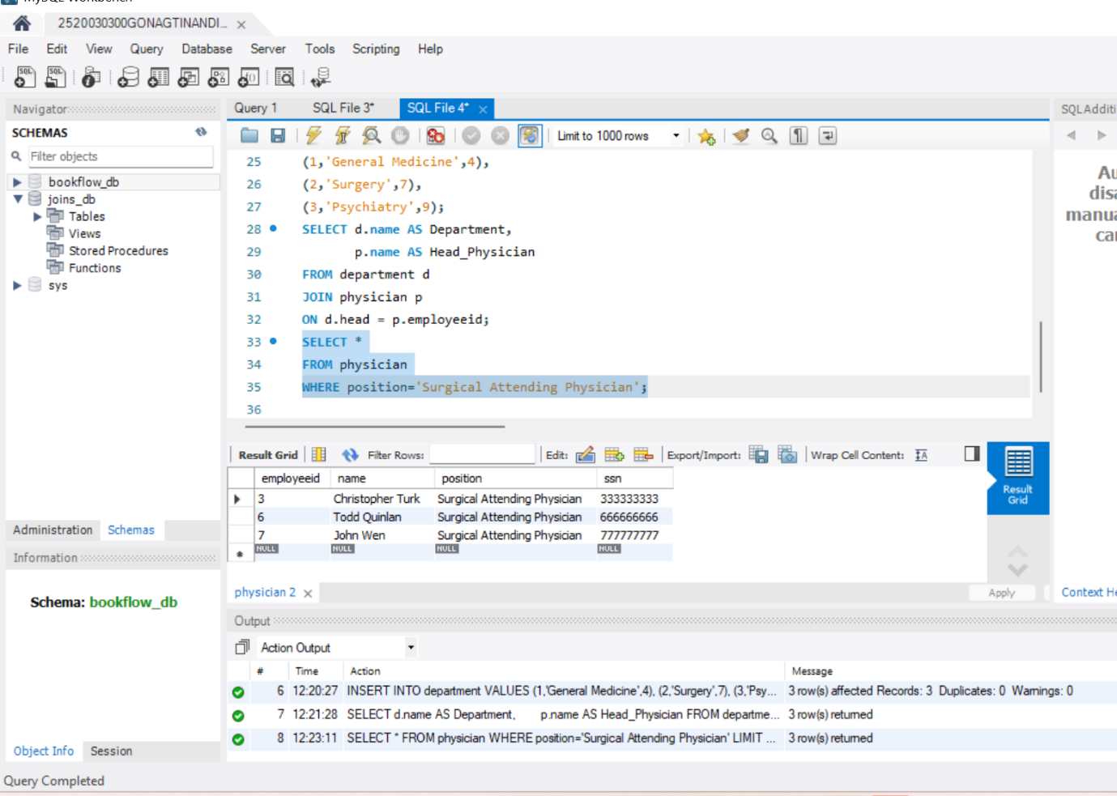
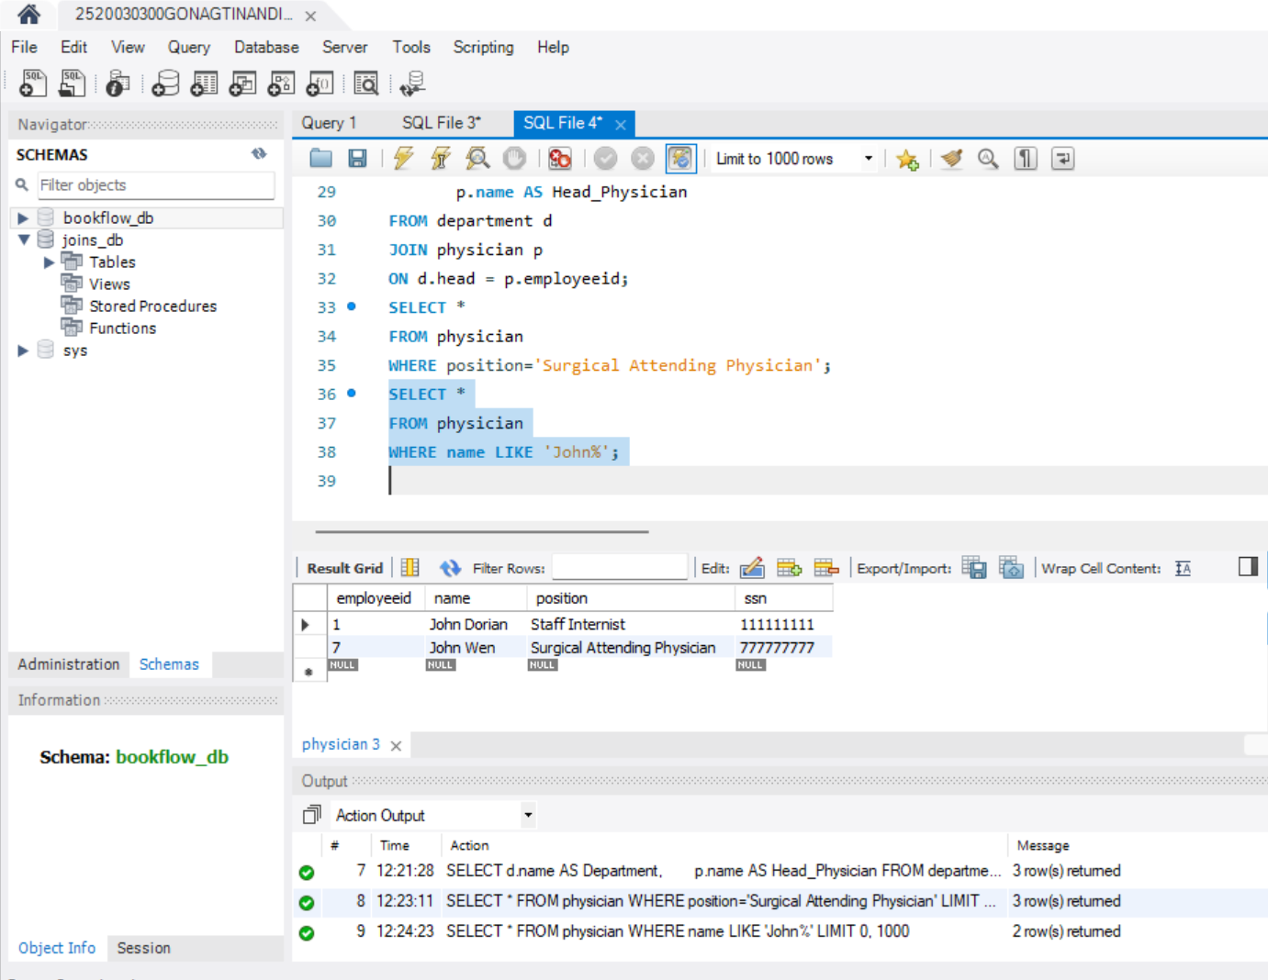
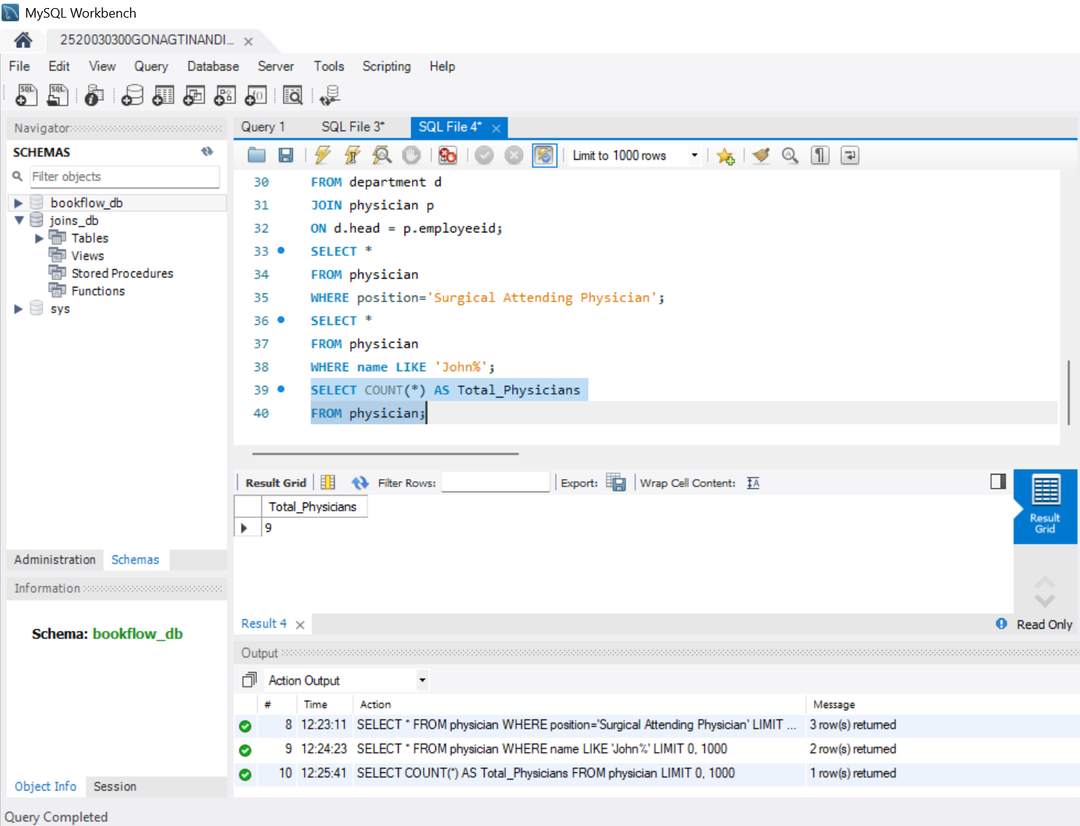
STEP-9: QUESTION 5 - COUNT DISTINCT

STEP-10: QUESTION 6 - GROUP BY
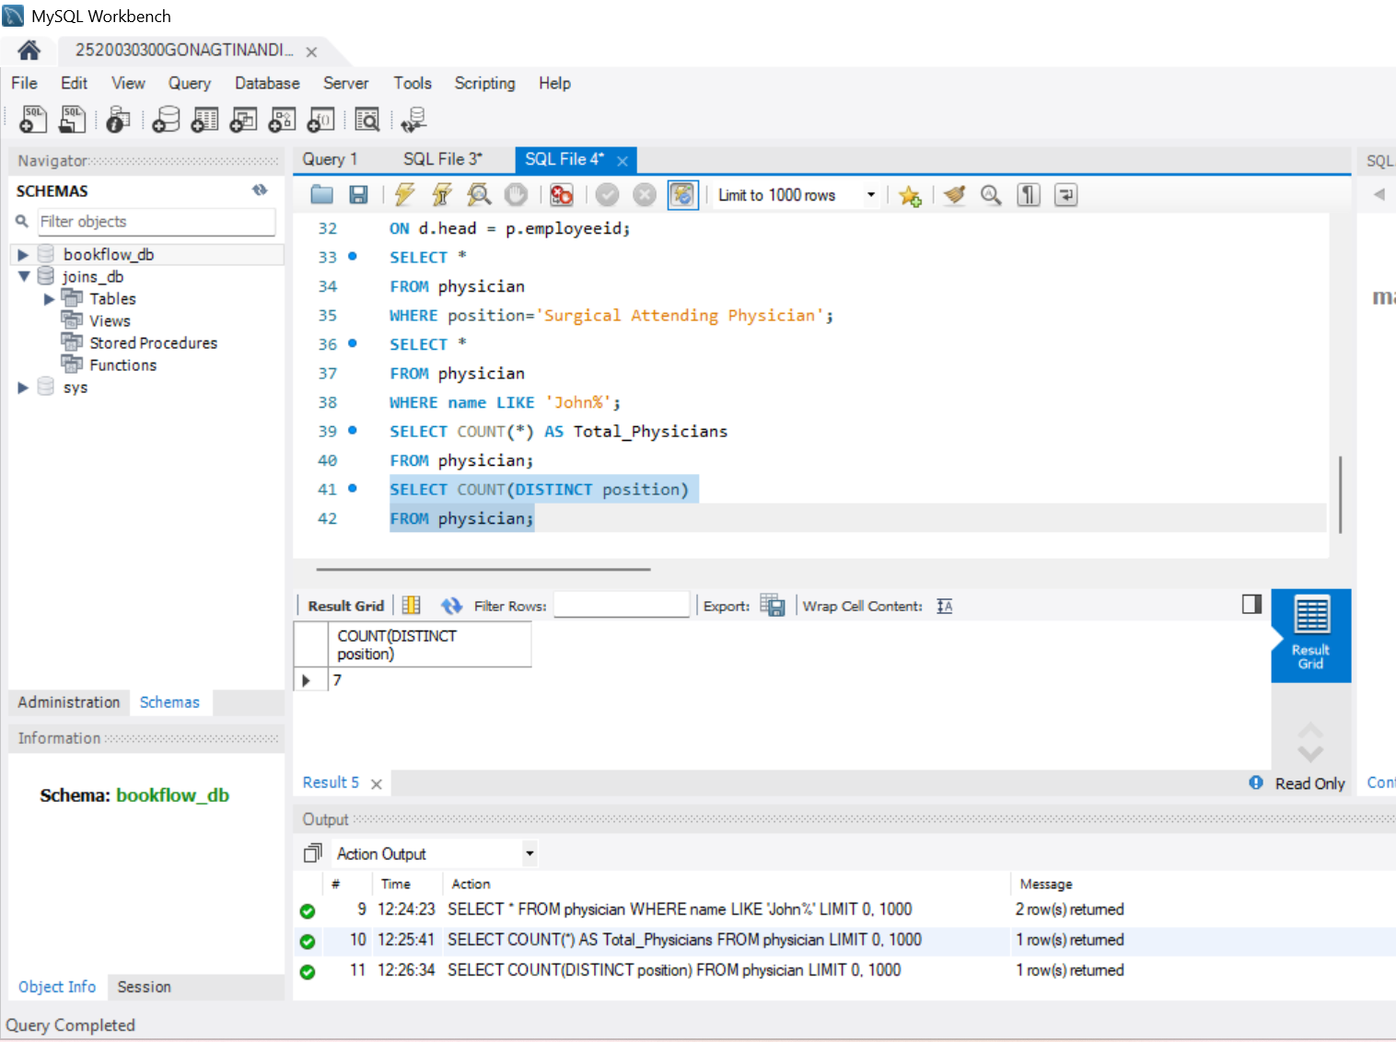
STEP-11: QUESTION 7 - GROUP BY + HAVING
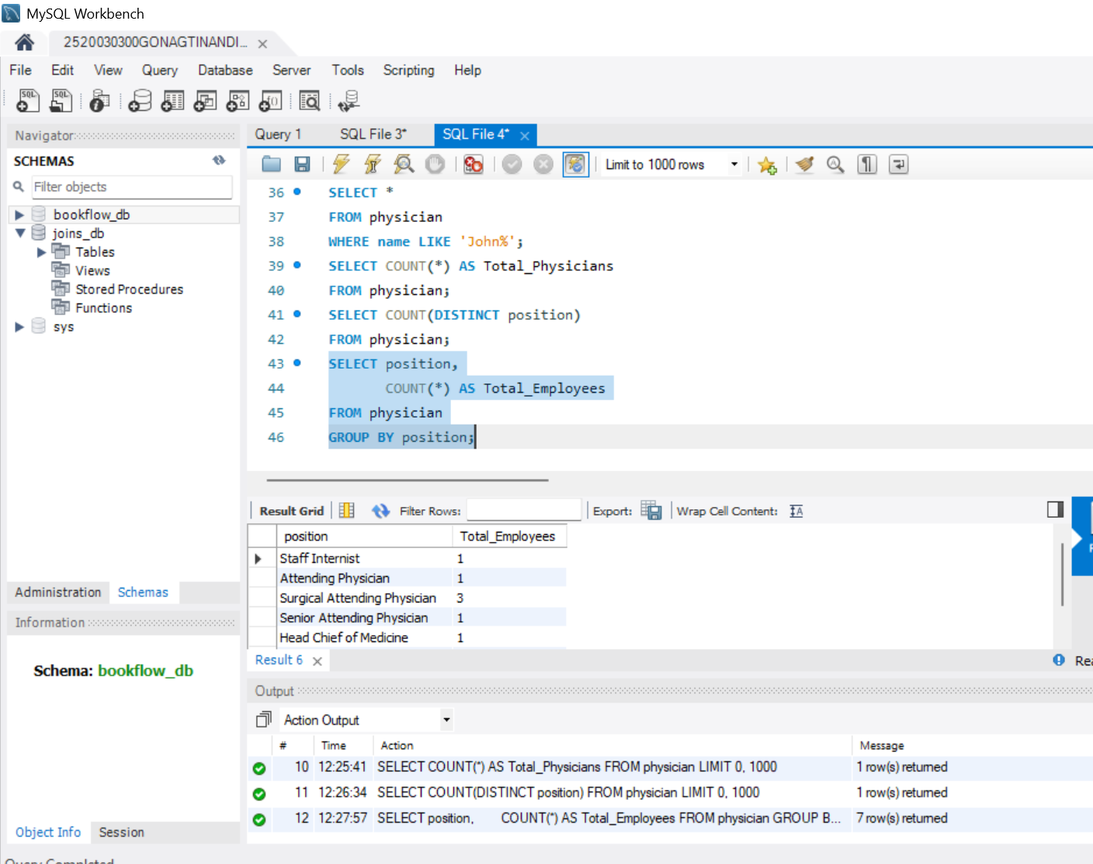
STEP-12: QUESTION 8 - ORDER BY
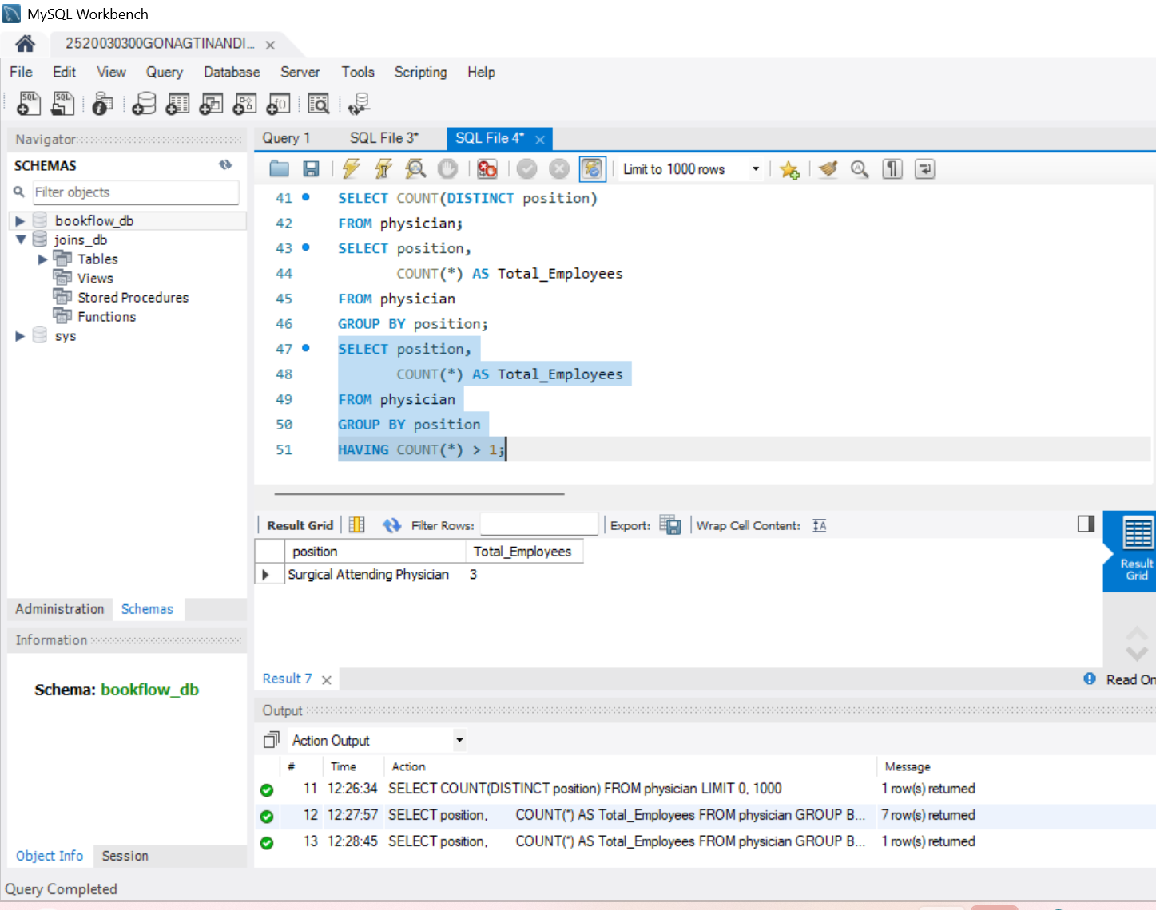
STEP-13: QUESTION 9 - ORDER BY DESC
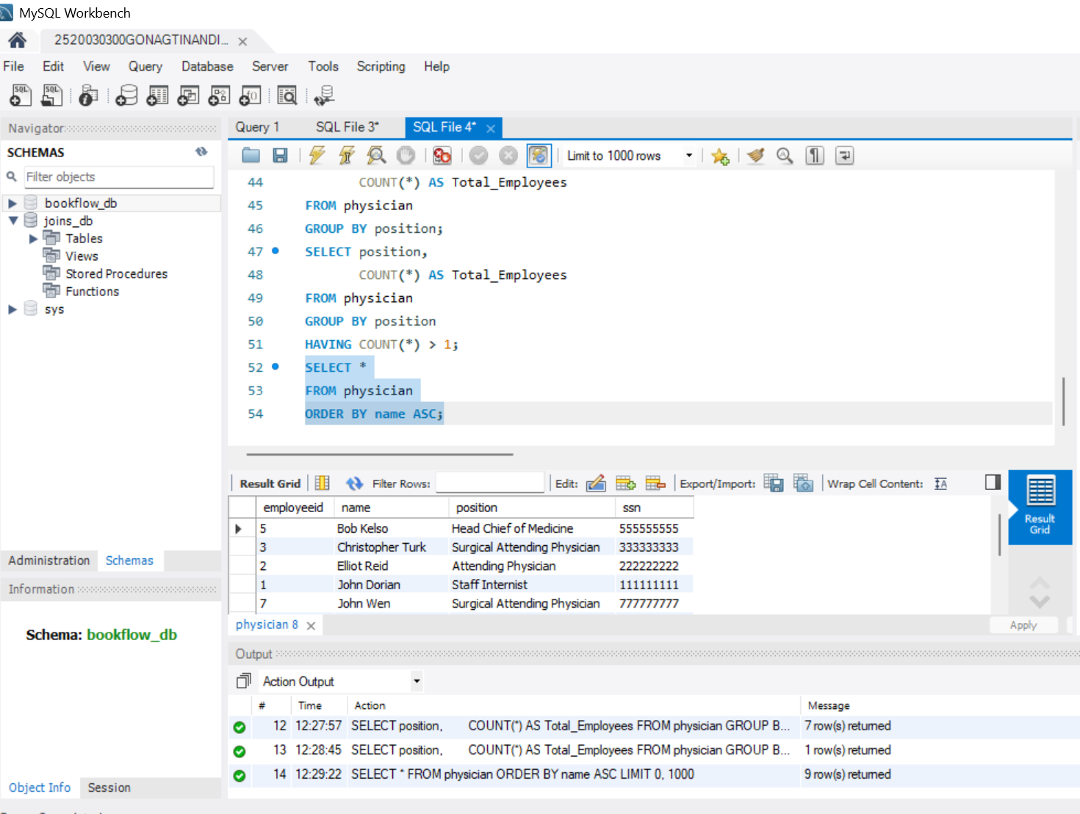
STEP-14: QUESTION 10 - WHERE + IN
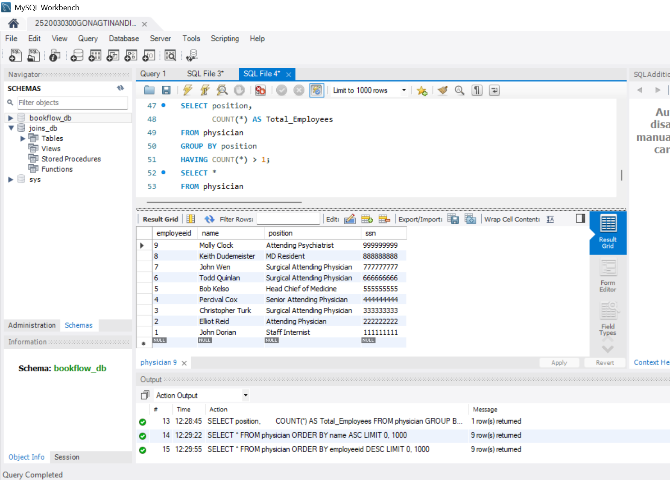
STEP-15: QUESTION 11 – SUBQUERY
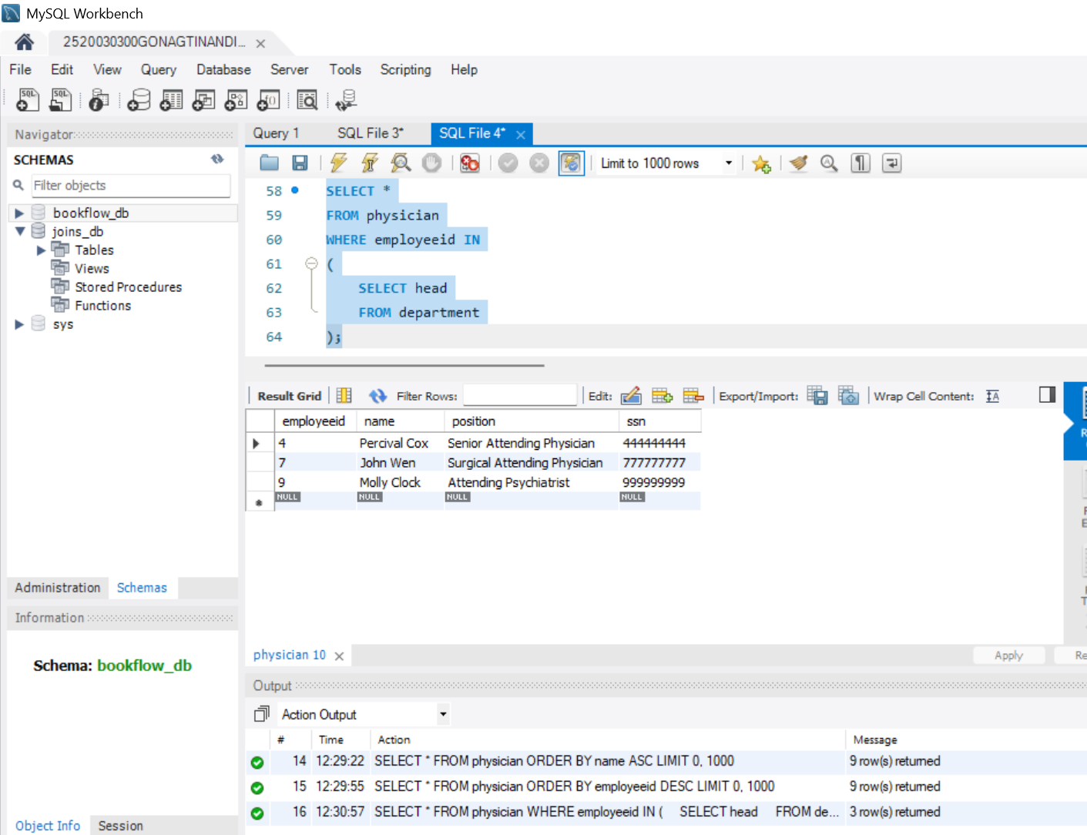
STEP-16: QUESTION 12 - GROUP BY + ORDER BY
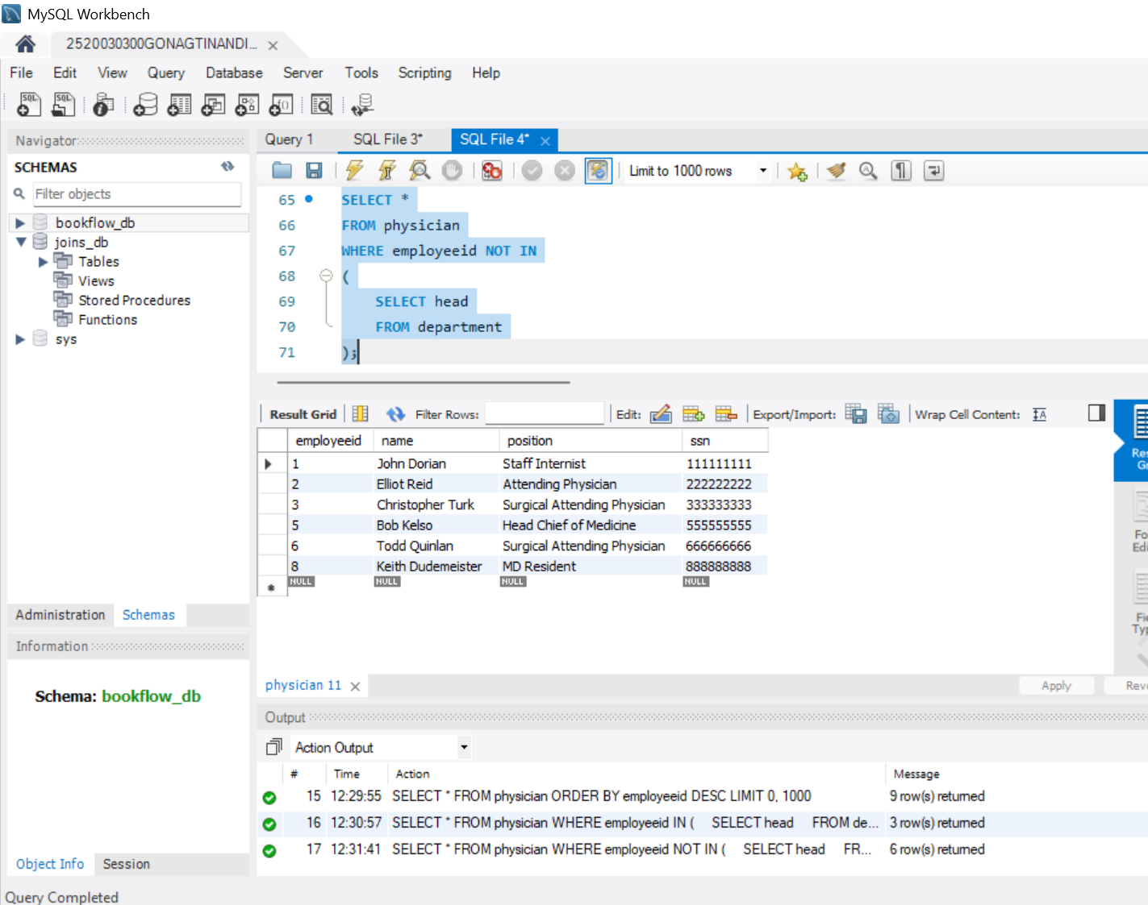
STEP-17: QUESTION 13 - WHERE + LIKE
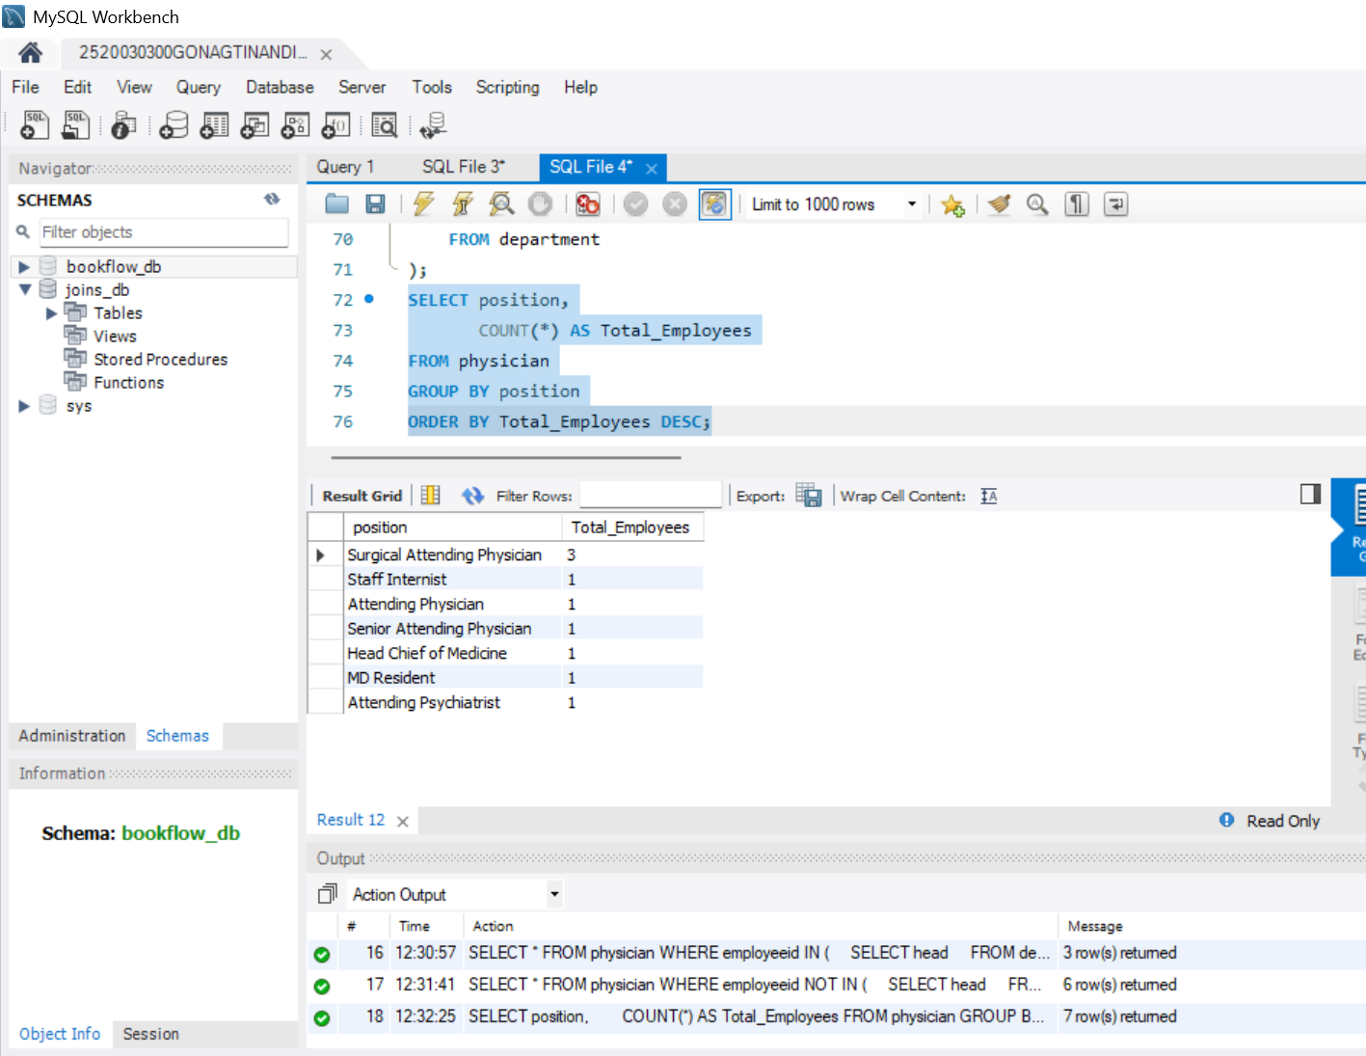
STEP-18: QUESTION 14 - JOIN + WHERE
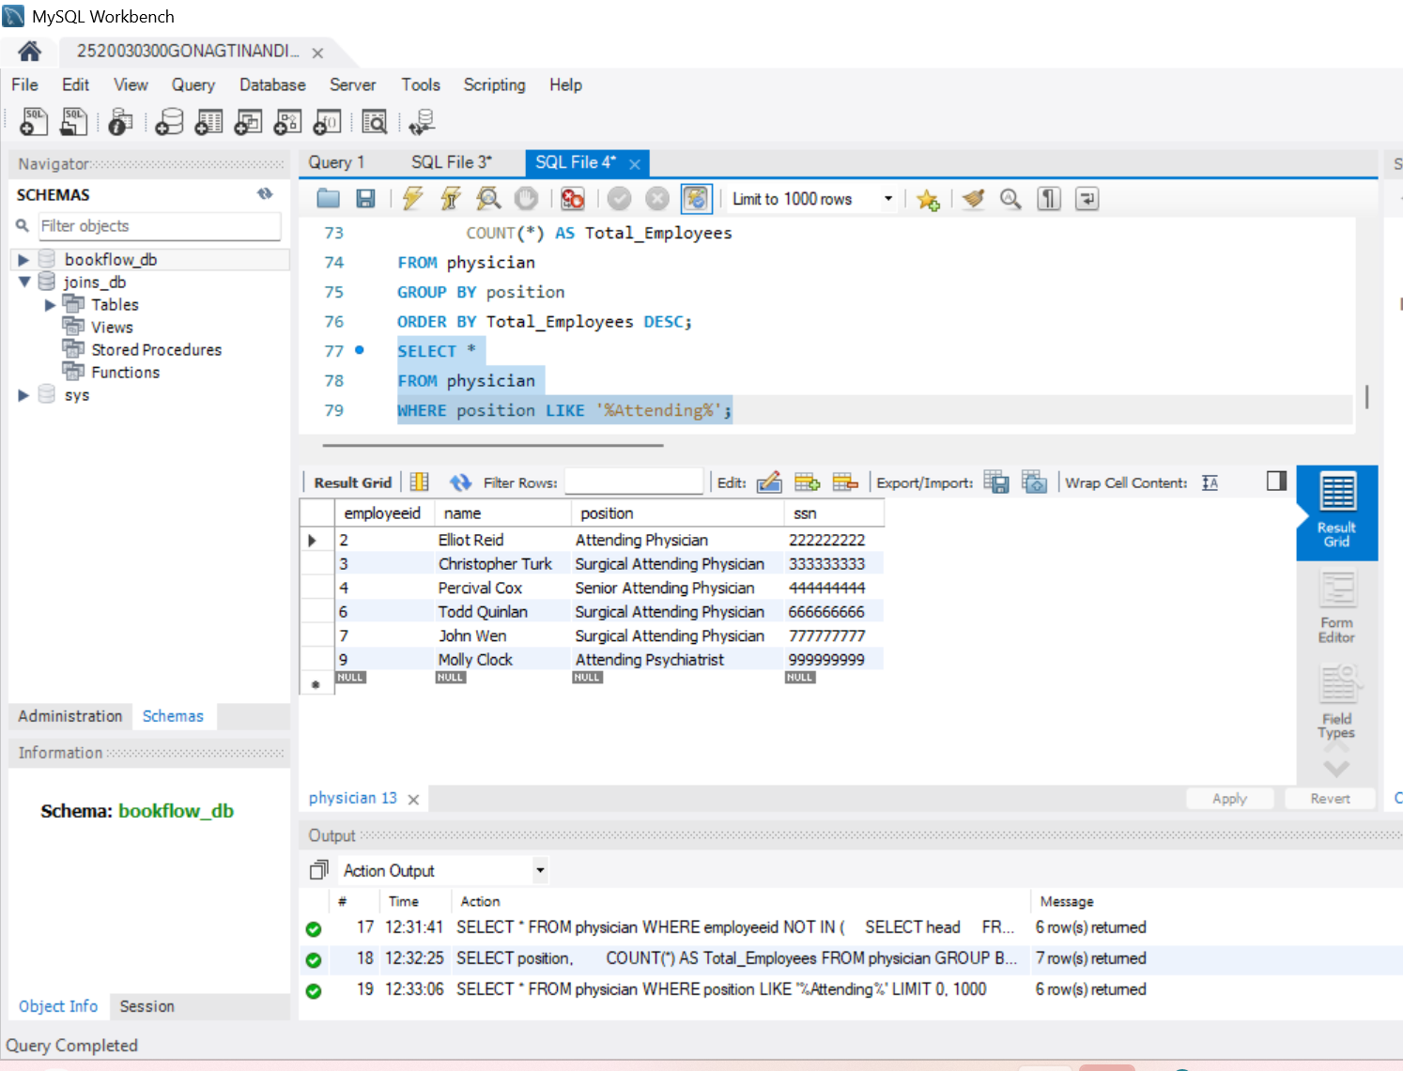
STEP-19: QUESTION 15 - JOIN + ORDER BY
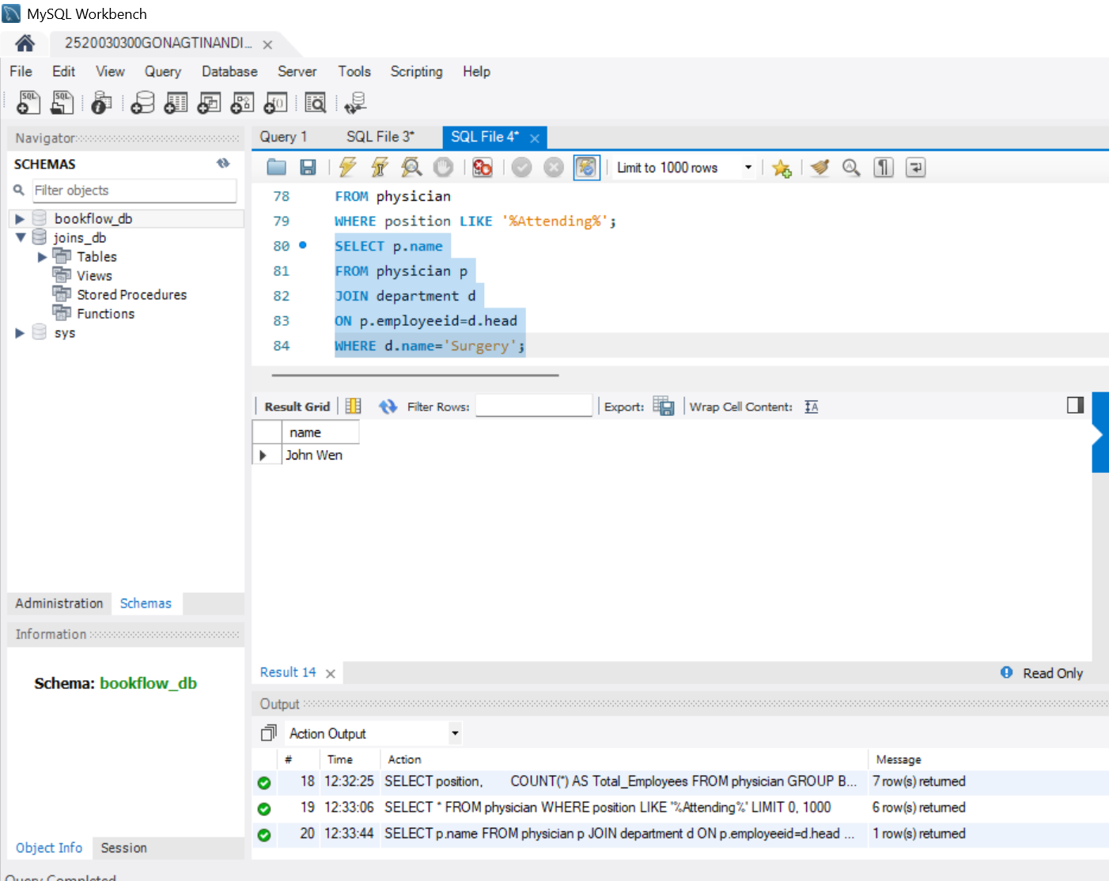
STEP-20: QUESTION 16 - WHERE + NOT LIKE
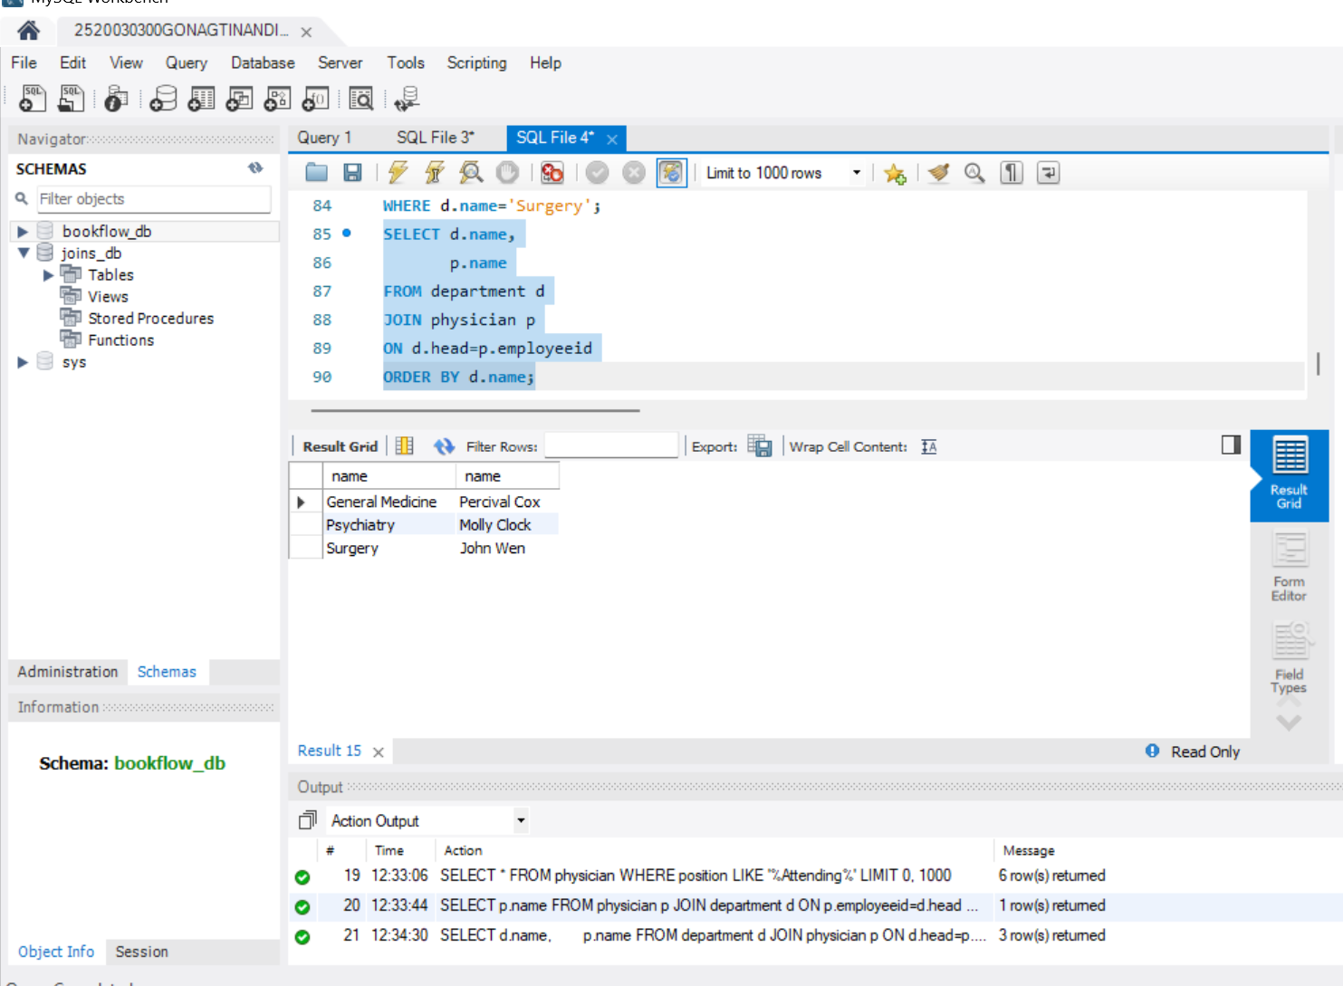
STEP-21: QUESTION 17 - COUNT + HAVIN
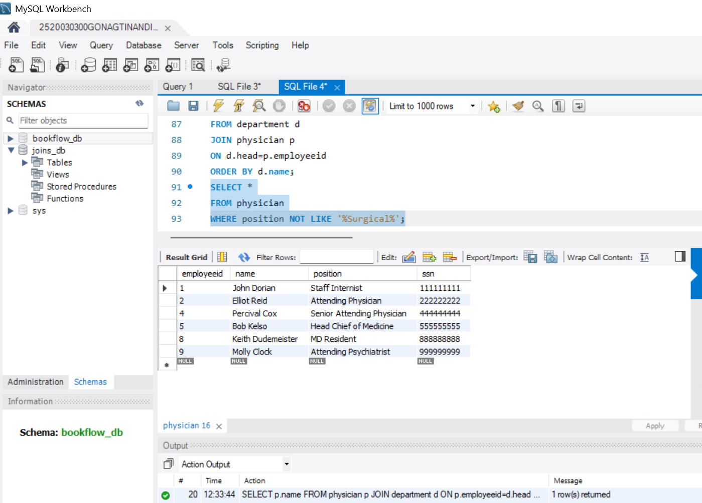
STEP-22: QUESTION 18 – EXISTS
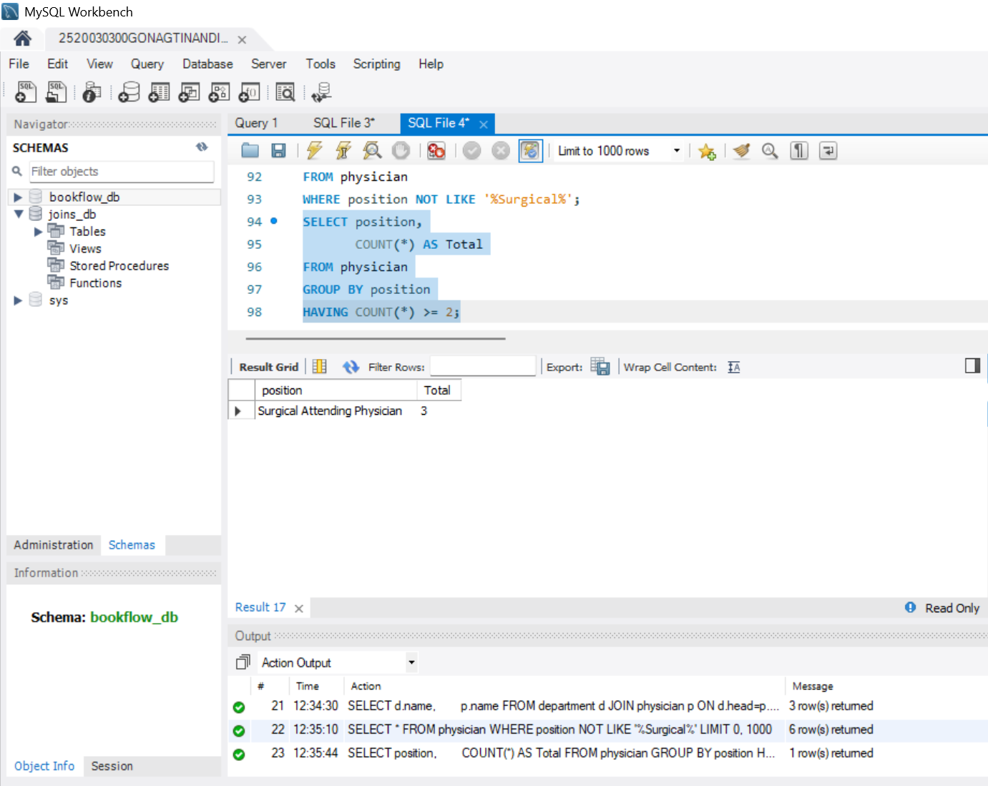
STEP-23: QUESTION 19 - MAX()
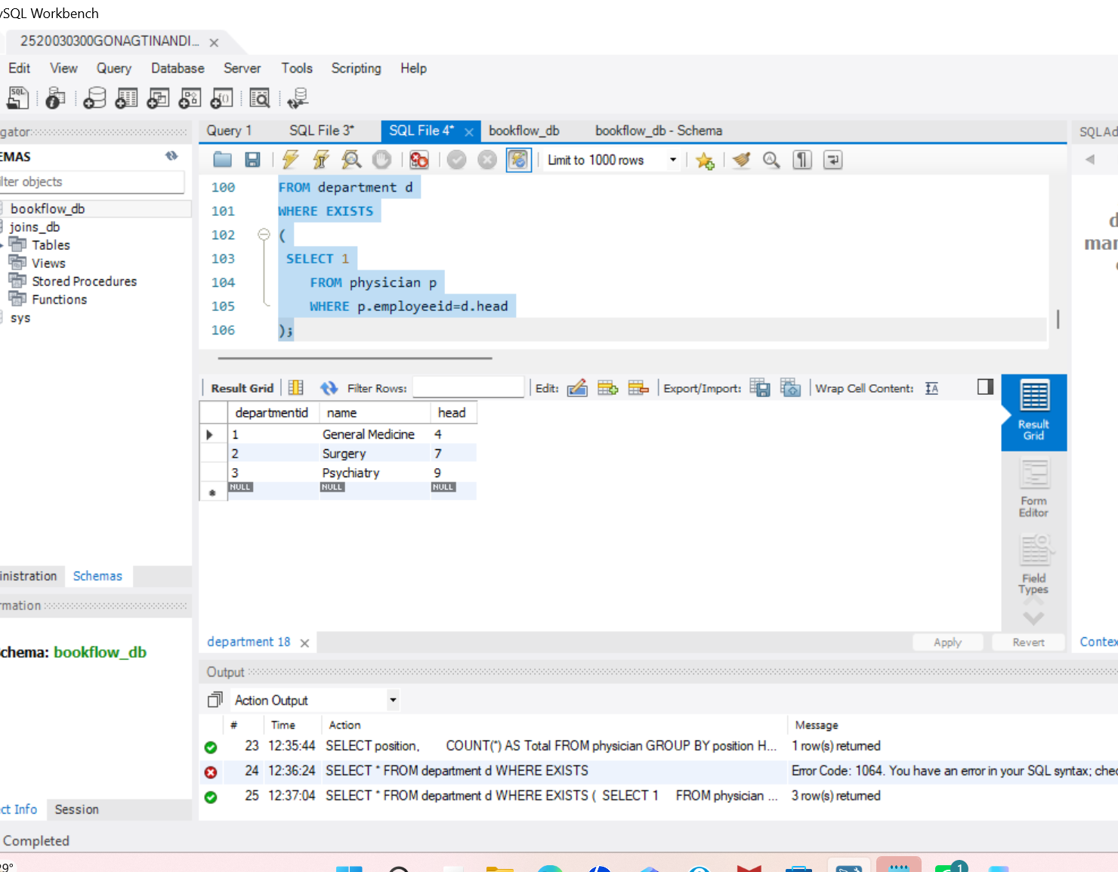
STEP-24: QUESTION 20 - MIN()

