- DDL (DATA DEFINITION LANGUAGE)
- 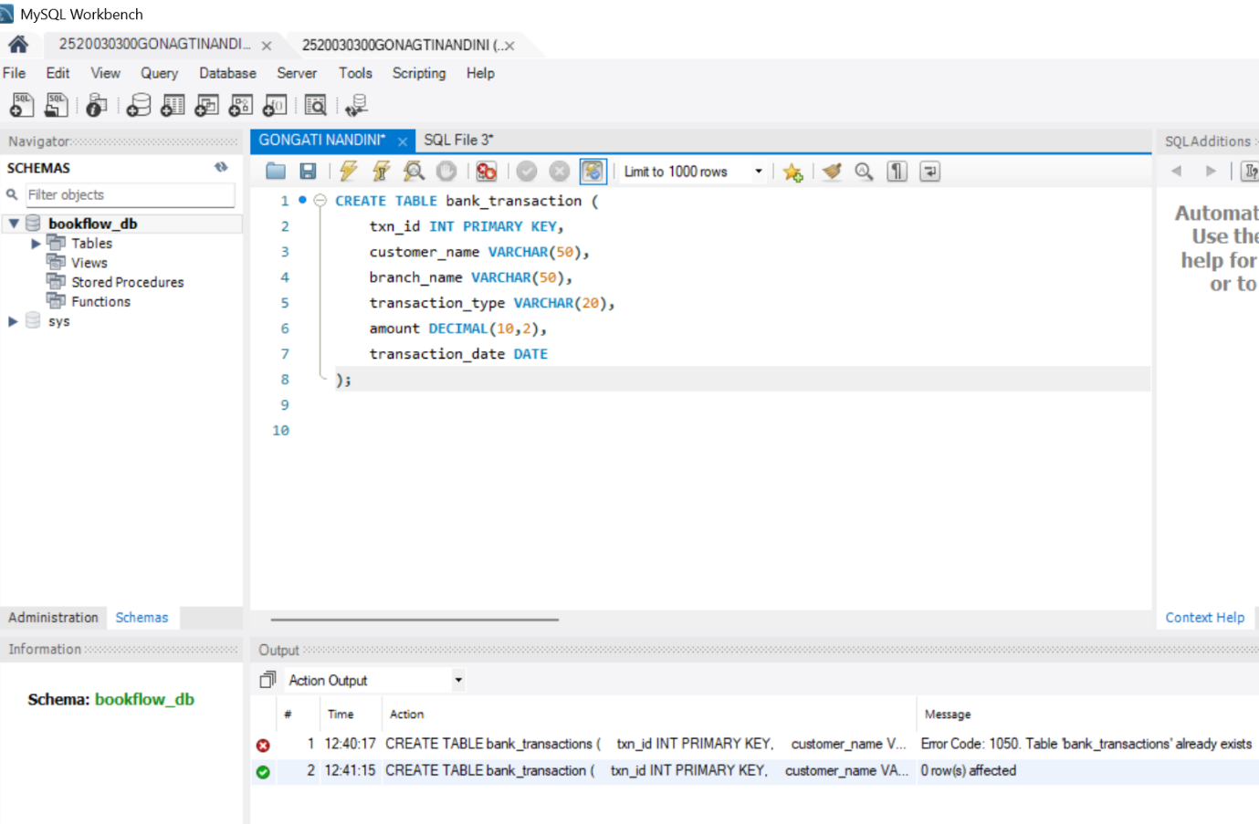

STEP-2: ALTER TABLE ADD COLUMN
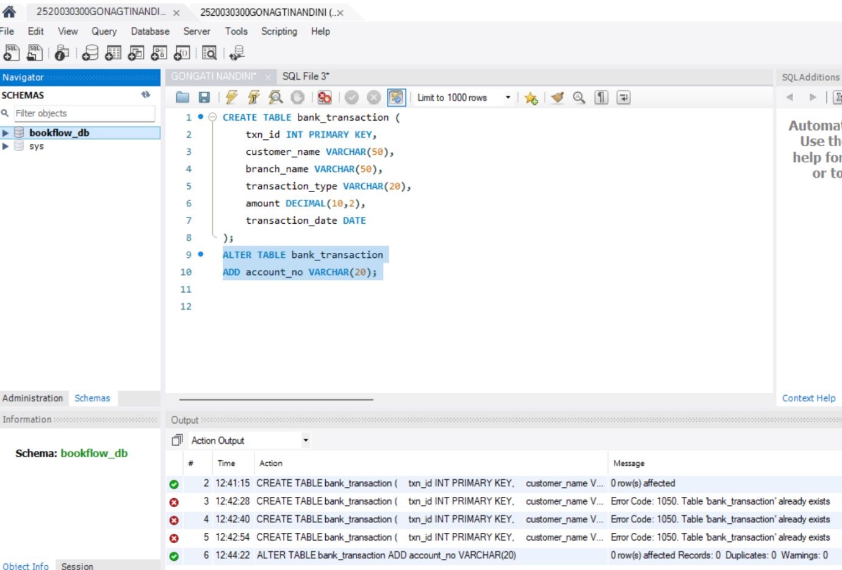
STEP-3: ALTER TABLE MODIFY COLUMN
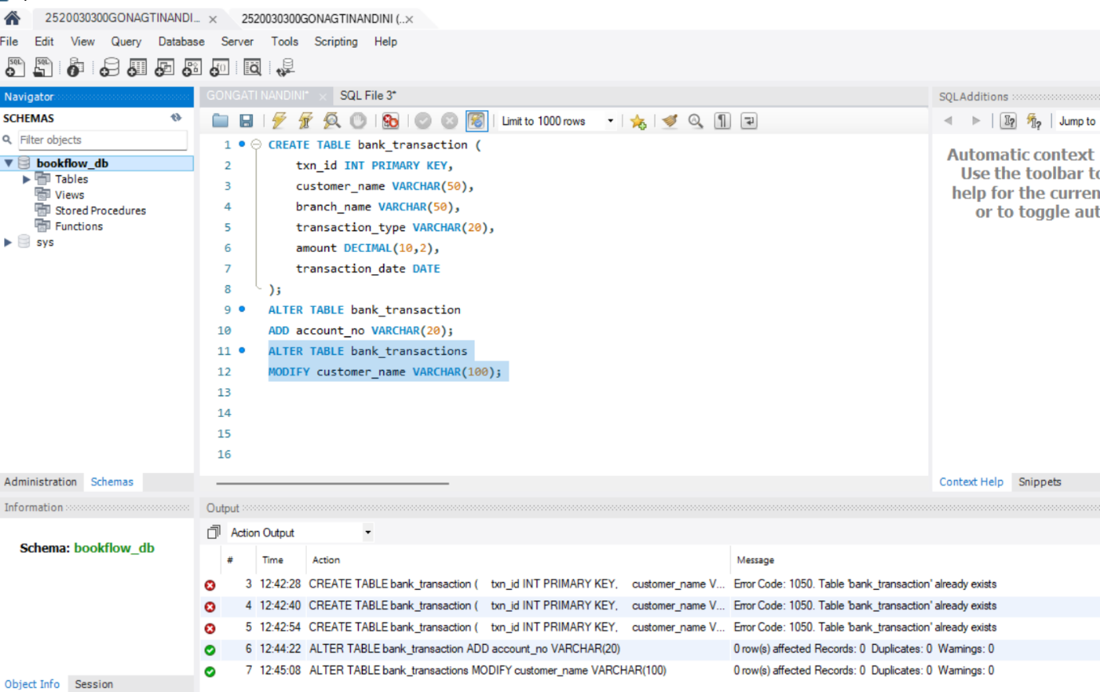
STEP-4: RENAME TABLE
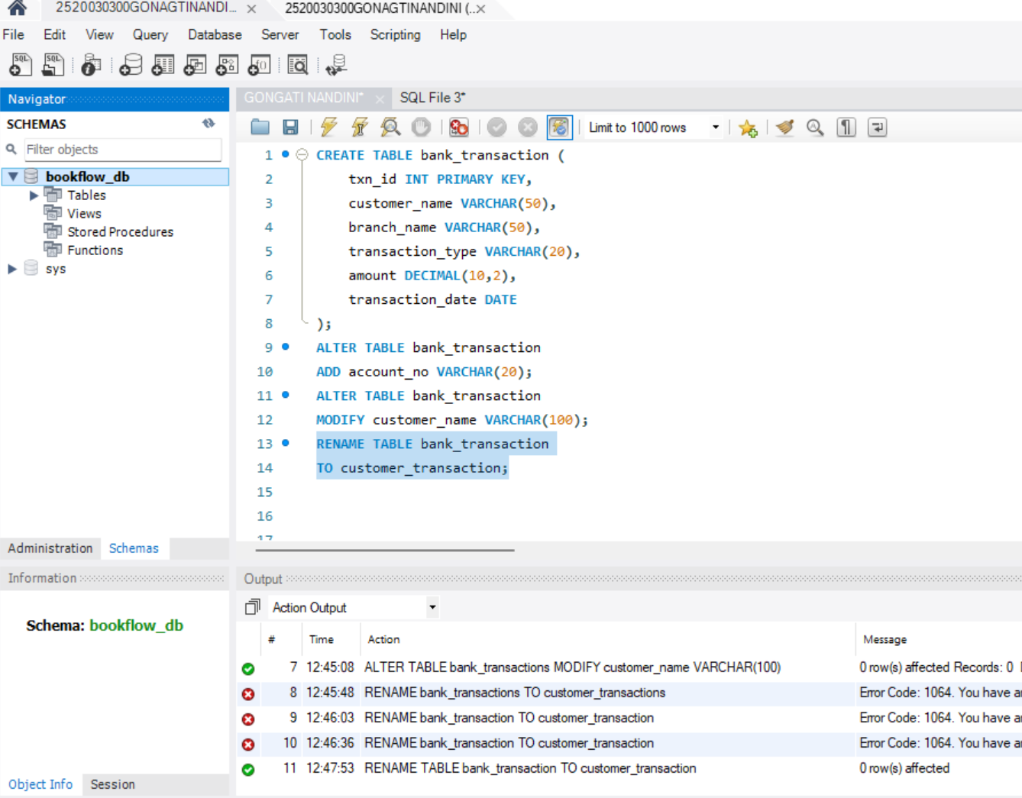
STEP-5: TRUNCATE TABLE
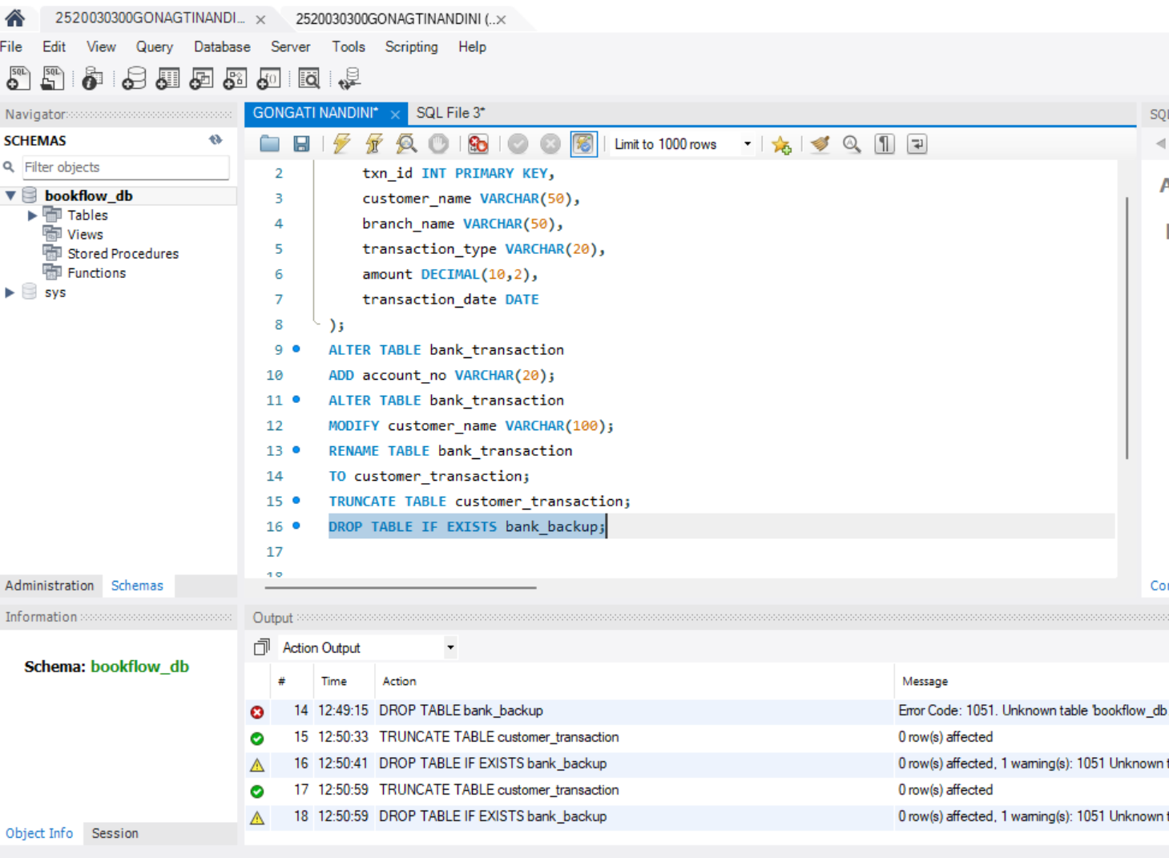
STEP-6: DROP TABLE

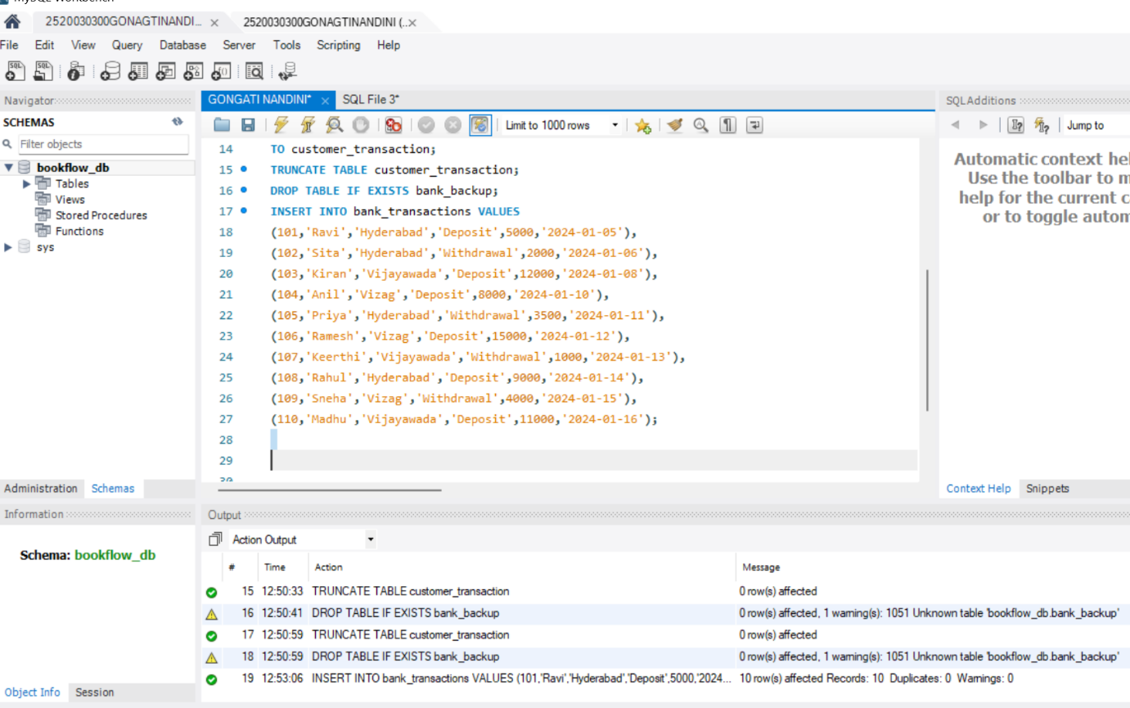

DML (DATA MANIPULATION LANGUAGE)
STEP-7: INSERT SAMPLE DATA

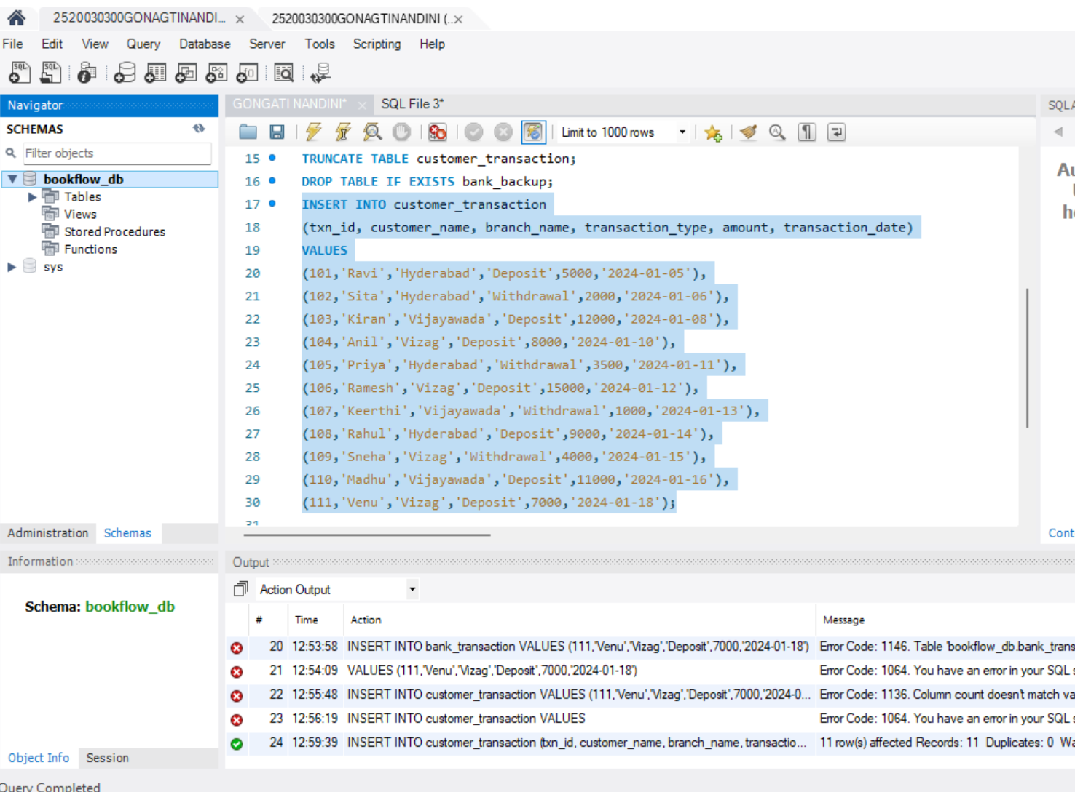
STEP-8: INSERT
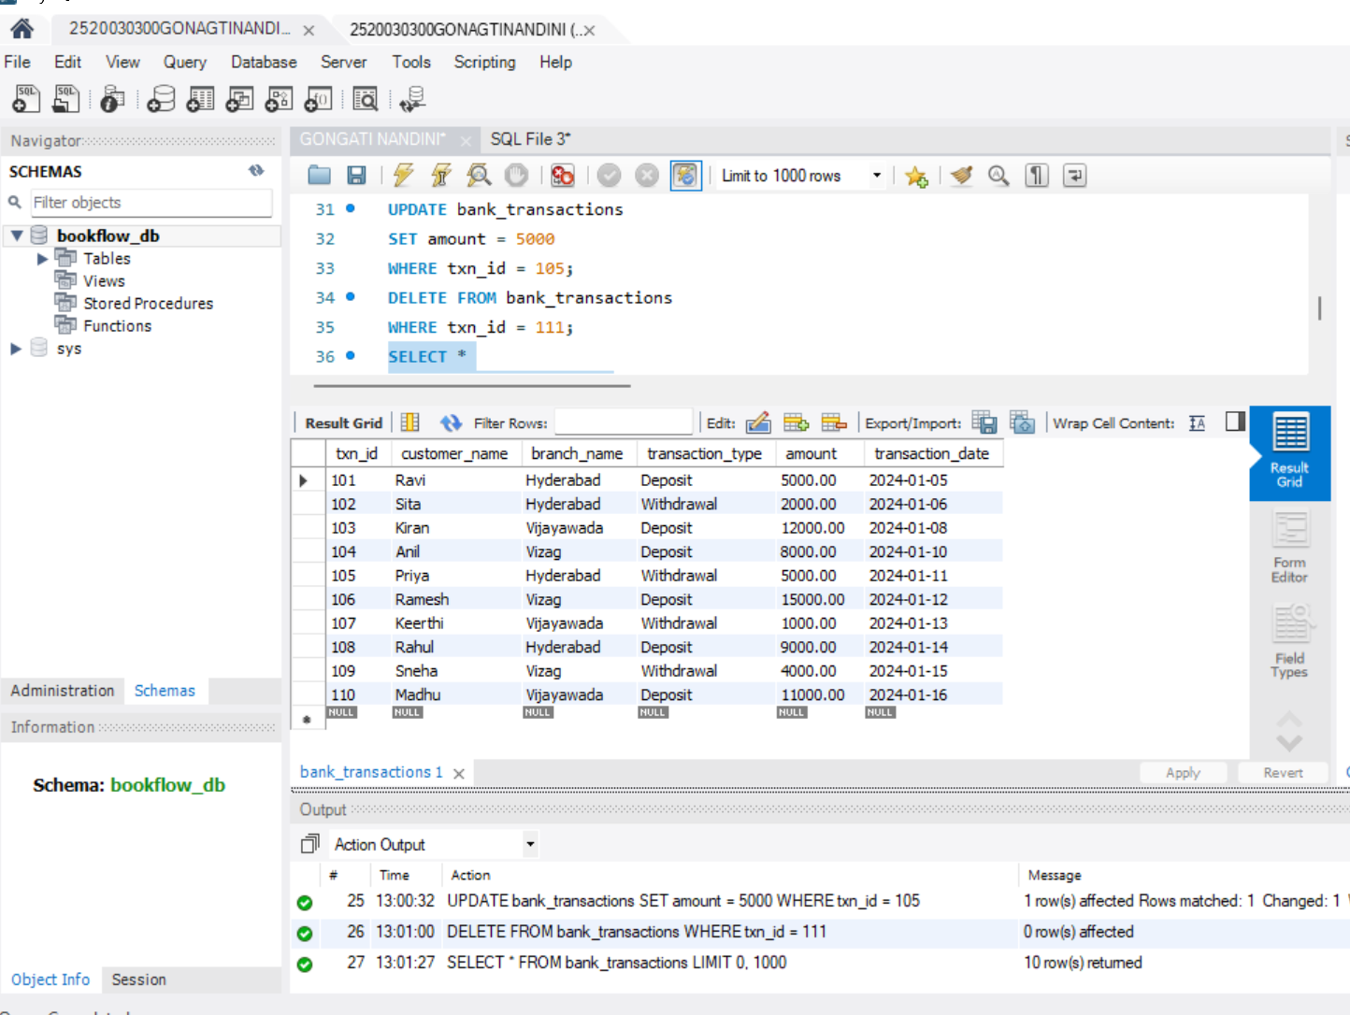
STEP-9: UPDATE
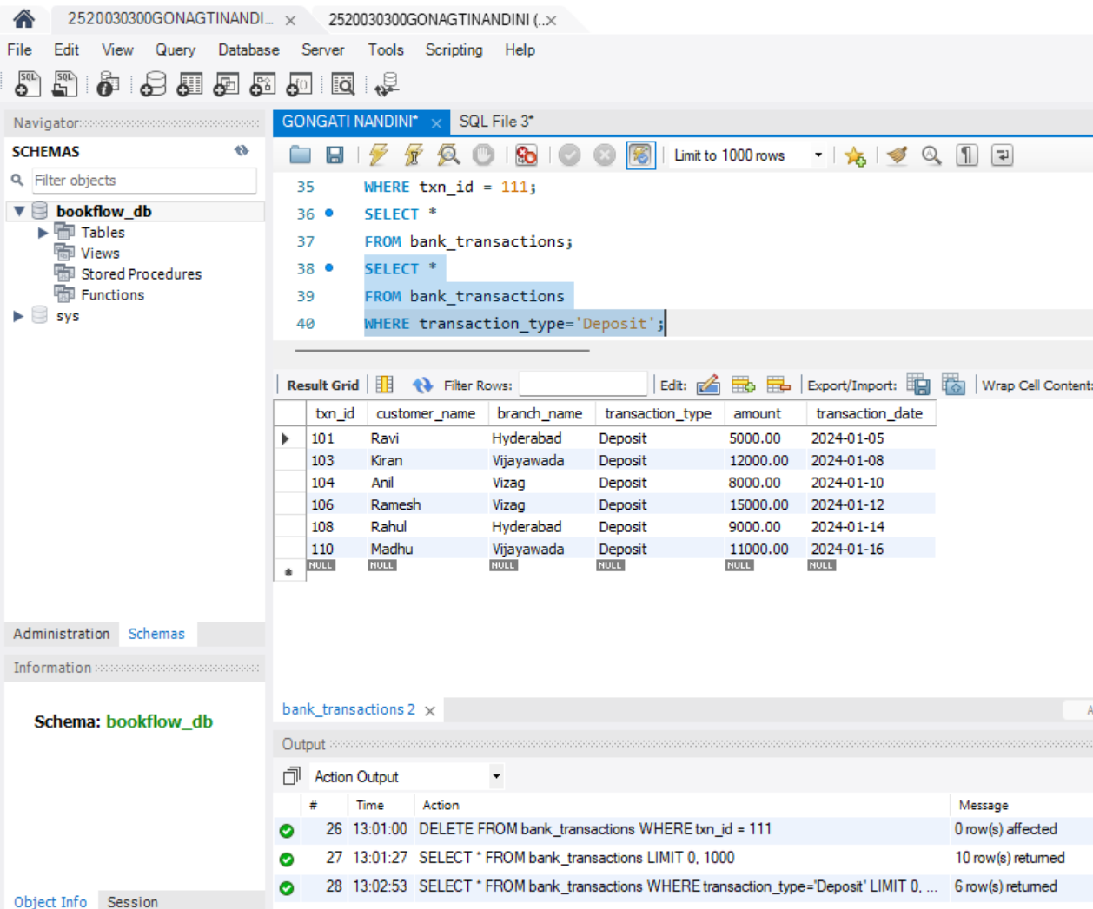
STEP-10: DELETE
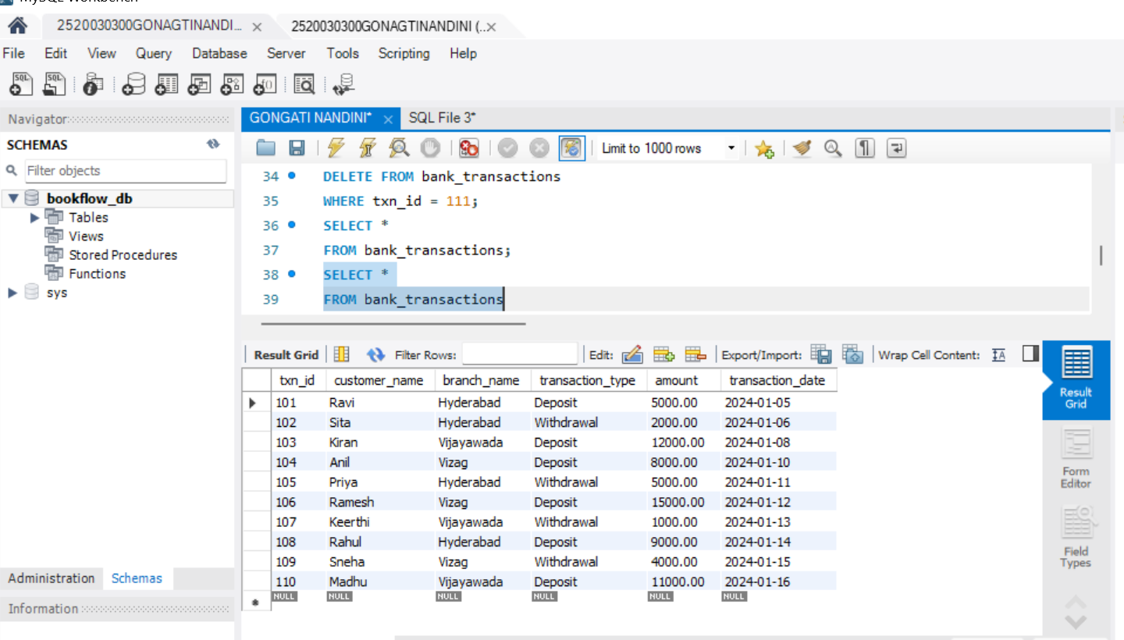
STEP-11: SELECT
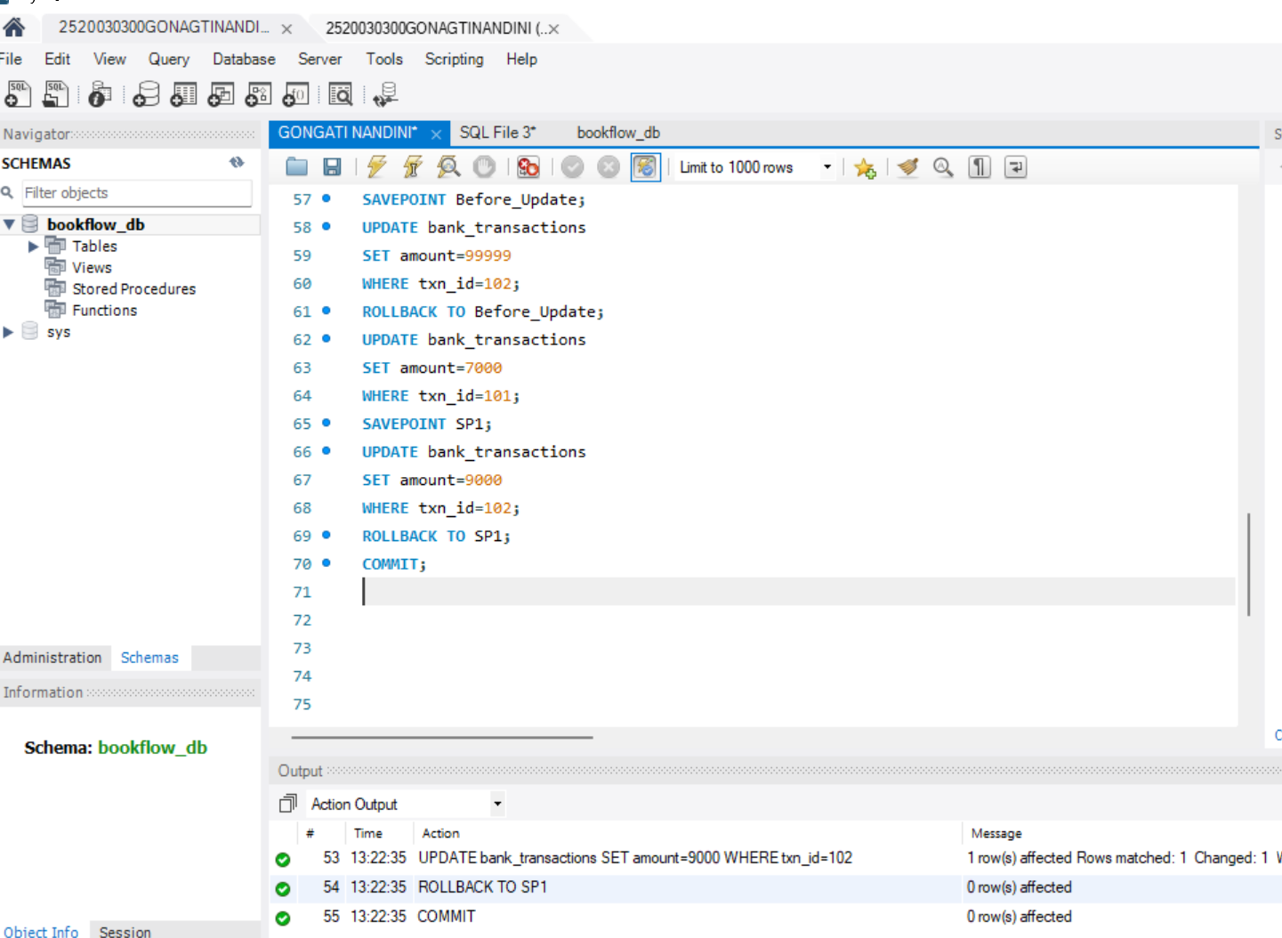
STEP-12: SELECT WITH WHERE

STEP-13: SELECT WITH ORDER BY



