**SeleniumGrid Guidelines**

This section will guide you to:

* Set up Selenium Grid, which includes setup of Hub and Nodes

This lab has three subsections, namely:

2.5.1 Setting up Selenium Grid hub

2.5.2 Setting up Selenium Grid Nodes

2.5.3 Pushing the code to your GitHub repositories

**Step 2.5.1:** Setting up Selenium Grid hub

1. Download Selenium standalone Server jar file from <https://www.seleniumhq.org/download/> link

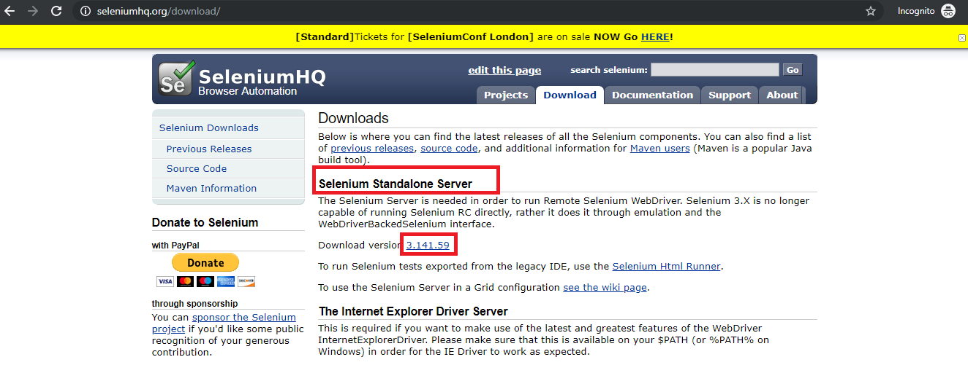

1. Save it in a folder
2. Go to command prompt
3. Navigate to folder structure where you have saved the Selenium standalone Server jar file
4. Type the below command in command prompt

**Java -jar selenium-server-standalone-3.141.59.jar -role hub -port 4545** and click on **Enter** button

1. Open the Chrome browser
2. Enter URL as **http://localhost:4545/grid/console** and click on **Enter**
3. Grid console page is loaded as below

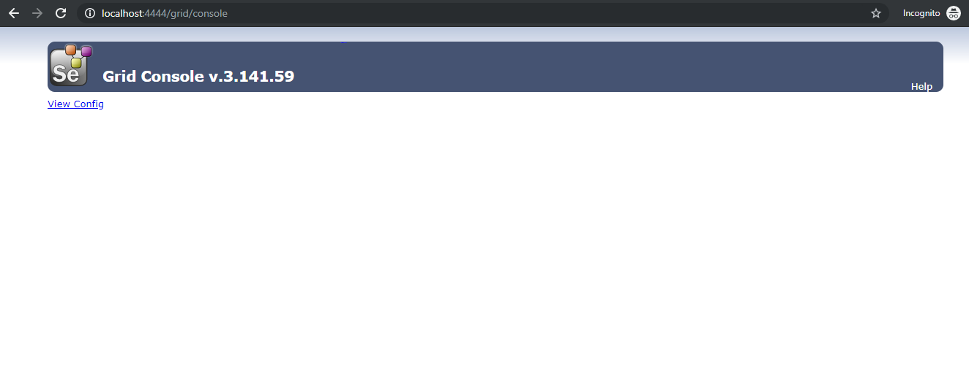

**Step 2.5.2:** Setting up the Selenium Grid Nodes

1. Once the Selenium Grid Hub is set up, the next step is to set up Selenium Grid nodes.
2. Open the new command prompt
3. Navigate to the folder structure where you have saved the Selenium standalone server jar file
4. Type the below command in command prompt

**java -jar selenium-server-standalone-3.141.59.jar -role node -hub** [**http://localhost:4545/grid/register**](http://localhost:4545/grid/register) and click on E**nter** button, which looks like

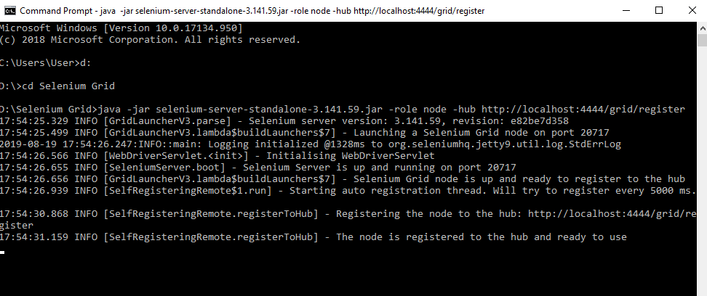

1. Open the browser
2. Enter URL as **http://localhost:4545/grid/console** and click on E**nter**
3. Grid console page is loaded below, which shows **Browsers** by default

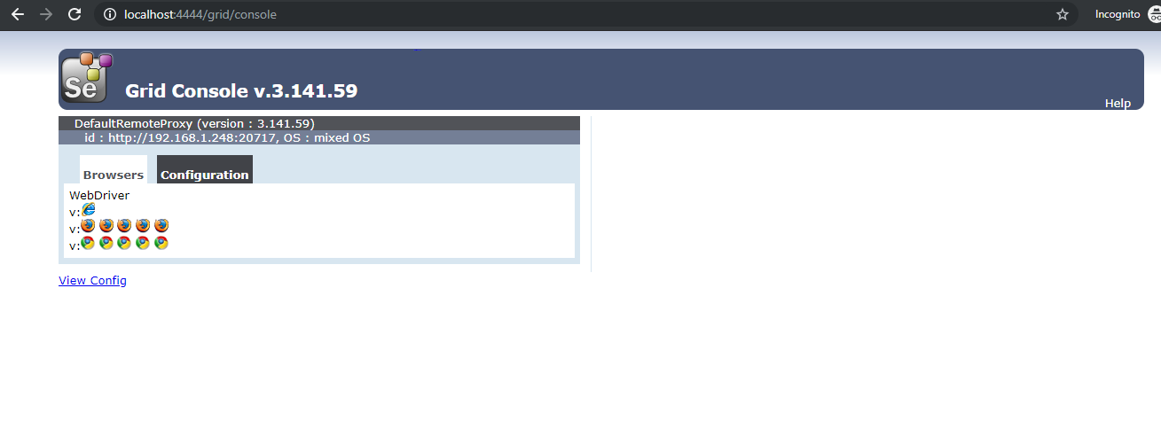

1. Click on **Configuration,** which shows Configuration details 