Category:

Heritage Destination

Popular Destination

Spiritual Destination

State and Union Territories

All Destination

--------------

Popular Destination:

Silliguri:

EVAM buddhist Montastery-

The vibrant and intricate architecture, tranquil meditation halls, and lush gardens, give you the rare opportunity and a conducive environment to learn and practice the teachings of Buddha, guided by experienced monastic teachers. As a centre of Buddhist education and practice, the EWAM Monastery serves as a place of hope and inspiration, illuminating the path towards inner peace and compassion.

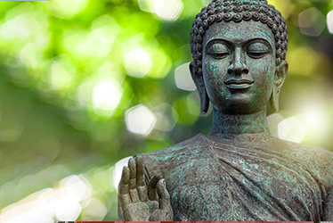

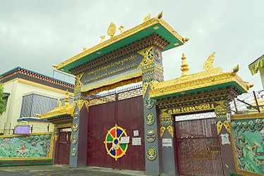

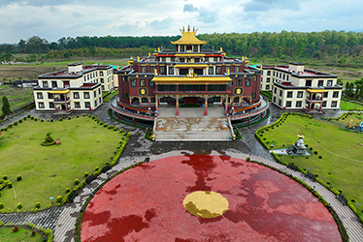

AGRA:

Mughal emperor Shah Jahan, the creator of the Taj Mahal, said that the beauty of the monument made “the sun and the moon shed tears from their eyes”. It has also been described as a “teardrop on the cheek of eternity” by Nobel laureate Rabindranath Tagore. Every year, thousands of tourists from around the world make a beeline for this breathtakingly ethereal marble monument, considerd by many as the most beautiful building constructed by man. The monument was built as a memorial by Mughal emperor Shah Jahan for his deceased wife, Mumtaz Mahal. It is one of the seven wonders of the world and is a monument of pride for not just Agra but also India.

A UNESCO World Heritage Site, it is featured in almost all literature about India and is one of the most enduring images of the country. Its name is believed to have been drawn from the Persian language: ‘taj’ means crown and ‘mahal’ means palace, thus making this the palace of the crown. Interestingly, the queen it was built in memory of, originally named Arjumand Begum, held the name Mumtaz Mahal, which meant the crown of the palace. Although it is best known as a symbol of love, a grieving emperor’s ode to his deceased queen, another legend sees the Taj Mahal as an embodiment of Shah Jahan’s vision of kingship. The story goes that he sought to build something akin to heaven on earth, a spectacular, unbelievably beautiful monument that reinforced the power as well as the perceived divinity of the monarch as next only to the Almighty.

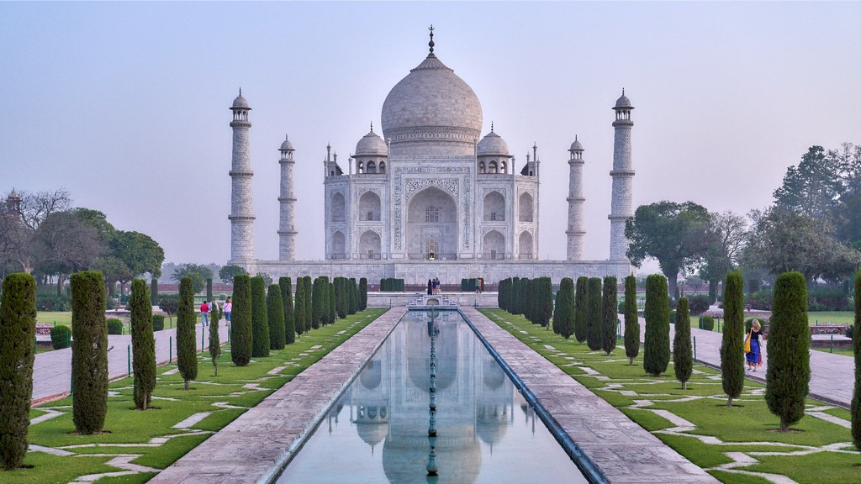

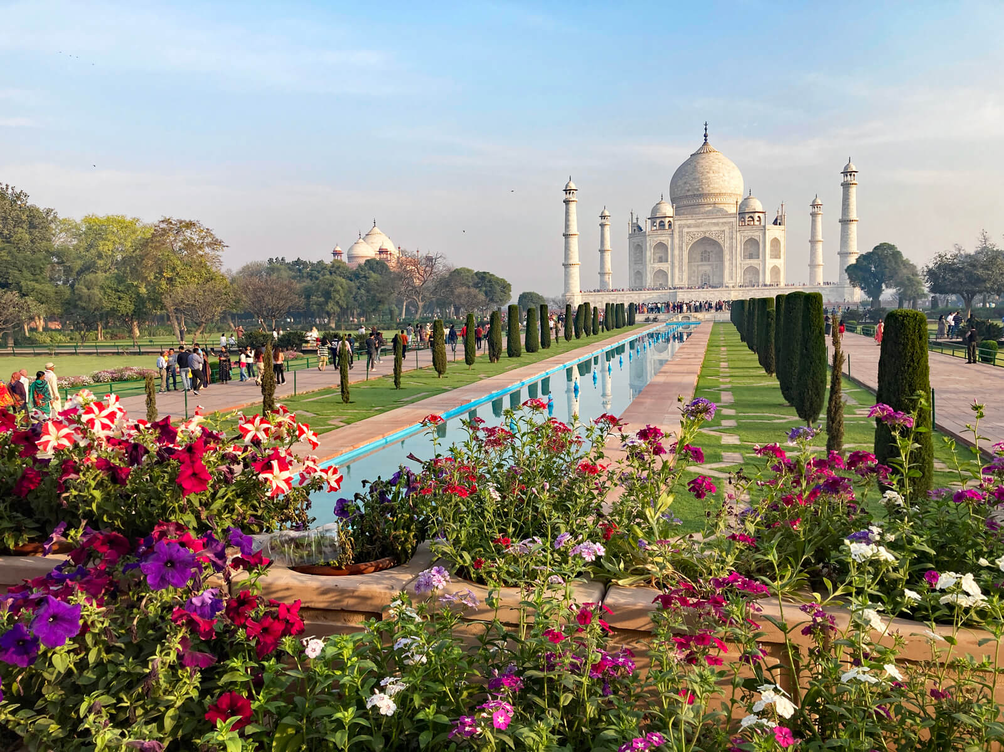

Varanasi:

One of the oldest living inhabitations of the world, the sacred city of Varanasi or Benaras, nestled on the banks of the holy Ganges river, has been attracting pilgrims for centuries. Celebrated author Mark Twain, who visited India in the last decade of the 19th century, described the city as “older than history, older than tradition, older even than legend.”

Believed to be the abode of Lord Shiva, Varanasi is among the seven sacred cities in the country. Centuries of history, art and tradition have conflated to add colourful layers to Varanasi's aura, which is most spectacularly evident at its ghats (stepped banks of a river). An abode of travellers in search of holiness and divine providence, the ghats of the Ganges are the highlight of the spiritual scene of Varanasi. From the famous Ganga arti (a fire ritual) to cremation ceremonies, the ghats are the site of time-honoured rituals that are performed to this day.

Legend has it that Lord Shiva channelled the celestial Ganga on earth, and that is why the river is considered holy. Thousands of devotees from all over the country come to bathe in its waters as it is believed that taking a dip in the holy Ganges absolves one of their sins. It is also believed that those cremated here achieve moksha (salvation). For many, the sacred Kashi Yatra (pilgrimage to Kashi, as Varanasi was earlier called) is one of the most important rituals to undertake during their lifetime.

In recent years, the city has turned into a purveyor of philosophy, yoga, the ancient medicinal science of Ayurveda, and astrology.

Chennai:

Ancient temples, vibrant arts, natural wonders and a bustling culinary scene make  Chennai, the capital of Tamil Nadu, one of the most popular tourist destinations in the southern fringes of the country. Located on the Coromandel Coast, this busy metropolis was formerly called Madras. From the resplendent classical dance form of bharatnatyam to the rich flavours of its iconic cuisine and from the lustrous silk sarees traded here to the gorgeous temples and churches, Chennai is the gatekeeper of South Indian art, culture and traditions. The city is also the perfect base from which trips to other locales in Tamil Nadu can take off.

Alongside heritage, flourish natural and contemporary highlights: sprawling beaches with natural and man-made wonders, a bustling seaport, quirky cafes, a multi-transport system, theme parks, industrial hubs, hi-tech parks and universities. Its population is a heterogenous mix of locals, expats and people from the rest of India. Chennai is widely known as the “Detroit of India”, a moniker it earned because of the high concentration of automobile factories located in and around here.

Kolkata:

Almost like a colonial matriarch nurturing her heritage roots, the city of Kolkata, the capital of West Bengal, holds culture and tradition close to its heart. While it would give any Indian metropolis a run for its money with its grand structures, bustling markets, vibrant culinary scene, exquisite crafts and cultural sites, its historical legacy reigns supreme. Once the capital of British-India, Kolkata's colonial charm blends with its modern culture.

From slow-moving trams (the oldest in Asia) meandering around the city, racing iconic black and yellow cabs, women dressed in handwoven cotton sarees, antique tea and coffee houses hosting lengthy sessions of adda (discussions on various subjects like politics and society), legendary football clubs and old markets spilling over with products, the bustling metropolis has the laid-back soul of a quaint town. The city of joy, as Kolkata is fondly called, throbs with liveliness and festivities, which can be enjoyed throughout the year. Be it the opulent Durga Puja pandals strewn across the city or the humbly sweet Christmas celebrations at Bow Barracks or the colourful Chinese New Year festivities at Chinatown, festivals make the city a joy to visit.  
To get a taste of the times gone by, visitors can sign on to heritage walks that take you through history, spirituality and colonial treks of the city. Gaze in awe at the sprawling Victoria Memorial, a pristine white beauty, as it sits proudly amidst neatly manicured lawns or take a tour of the ancestral home of poet and Nobel laureate Rabindranath Tagore, there are many interesting tidbits to mine from the heritage gold of Kolkata.

Mumbai:

Mumbai, the capital of Maharashtra, attracts dreamers with sky-high ambitions from every corner of the country. It is a unique place where the past is mixed with the future and history meets modernity, a city that lies at the cross section of business and entertainment and beats to a pulsating rhythm of its own. Located by the Arabian Sea, Mumbai is an amalgamation of heritage and culture and glitz and glamour. So from historic art deco buildings, which are recognised by the UNESCO, to plush new-age homes of the super rich, Mumbai has it all!

India's financial capital, Mumbai is home to the most important financial institutions of the country such as the Reserve Bank of India, the National Stock Exchange of India, the Bombay Stock Exchange, SEBI and is the corporate headquarters of numerous Indian companies and multinational corporations. It is also home to some of India’s premier scientific and nuclear institutes.

Mumbai is the epicentre of Hindi cinema thanks to its flourishing filmmaking industry, popularly known as Bollywood. Every year, many new faces arrive in this city eager to make a name for themselves in the glitzy movie world. Mumbai is an oasis of truly vibrant working class cosmopolitanism including - entrepreneurs, traders, artists, industrialists, software engineers and labourers.

Heritage Destination

Tirupati:

Among the most popular global pilgrimage places, Tirupati, in Andhra Pradesh, is a stopover for those seeking spirituality and sanctity. Situated at the foot of Tirumala Hills, this lively pilgrim place attracts devotees all year round. Tirupati Balaji or the Lord Venkatesha Temple is the main attraction here. Said to be one of the richest temples in the country, it sees an estimated footfall of 60,000 every day. Devotees donate their hair and various riches in the temple in order to please the god.

Though the temple is an overwhelming presence in the town, Tirupati also houses one of the oldest and the rarest geological formations in the world – a natural stone arch. Lying in close proximity to the temple, the stone arch or Sila Thoranam (garland or festoon of rocks) has been categorised as Precambrian and is believed to be 1,500 million years old!

Tirupati has been ruled by various kingdoms such as the Pallavas around the 9th century, Cholas in the 10th century, and Vijayanagara between the 14th and 15th centuries. It is believed that the rituals in this temple town were formulated by Shri Ramanujacharya, a Hindu theologian and philosopher, in the 11th century.

Mahaballipuram:

Sitting along the Coromandel Coast of the Bay of Bengal, the seaport town of Mamallapuram or Mahabalipuram, in Tamil Nadu, is a beautiful beach destination that is slowly becoming the surfing hub of the country. Speckled with several UNESCO World Heritage Sites, courtesy of the ancient Pallava dynasty (3rd - 9th century BC), who were great patrons of art and crafts, Mamallapuram holds a baffling visual treat around every corner. Its awe-inspiring cave temples, sculptures and monuments leave one marvelling at the skill of the craftsmen of that time. With its striking bas reliefs and rock-cut temples, Mamallapuram is practically an open-air museum. Many of the temples, built with granite, relate the stories from the Hindu epic Mahabharata. Once a thriving port, Mamallapuram is now a UNESCO World Heritage Site complex, also famous for its seashell jewellery, seafood, cafes and markets and a breathtaking ocean-front. While you can soak in history visiting various historical sites, Mamallapuram's pristine beaches fringed by lush groves with a warm sun, invite surfers. With perfect sea waves between June and September, the beaches host surfing training sessions conducted by experts. The town is also a major stopover for visitors coming from Chennai and Puducherry.

Jaipur:

The city of palaces and forts, interspersed with historical monuments and gardens that testify the grandeur of the Rajput kings, Jaipur is the gateway to the royal heritage of India. Also called Pink City, the capital of Rajasthan, remains suspended in time, with its heritage preserved in the overwhelming Hawa Mahal that gazes down at the bustling streets of Johari Bazaar.

A little away from the city centre, which is resplendent with state-of-the-art cinemas/ movie theatres, eateries, multiplexes, museums and parks, lies the arid hilly country dotted with forts that earlier stood as armoured sentinels of Jaipur. The biggest and the most awe-inspiring is the Amber Fort, which leaves one humbled with its expansive fortifications and grandeur.

Founded by Maharaja Jai Singh II in 1727 AD, Jaipur was the stronghold of the Rajputs, who gave it its everlasting legacy in the form of various heritage sites, arts and crafts, culinary curations etc. Typical Rajasthani cuisine, comprising lal maas, dal-bati-churma, ker sangri and other uncountable recipes, all hold limelight in the culinary culture of India. These can be enjoyed in the quintessential Rajasthani style of sitting cross-legged on mats on the floor and digging in in the sumptuous thali, which features up to 20 dishes.

Jodhpur:

With a sea of sapphire-blue painted houses and guarded by the gorgeous Mehrangarh Fort, the city of Jodhpur, the second-largest in Rajasthan, is an architectural marvel. A labyrinth of medieval lanes, interspersed with vibrant markets, criss-cross the city, which enjoys a languid pace of life.

To experience the soul of the city, head to its bustling bazaars that offer a fine selection of the spiritual Pichwai paintings, Jodhpuri pants or breeches, exquisite bandini or bandhej (tie and dye) sarees, beautiful badla embroidered lehengas and morchang, a popular Rajasthani folk music instrument. The city boasts a busy culinary scene and sampling local delicacies like the savoury pyaz-ki-kachori, the spicy mirchi bada and the thick and sweet makhaniya lassi, is an unforgettable experience.As you explore further, Jodhpur charms you with its rich royal legacy that is evident in notable landmarks like the opulent Umaid Bhawan Palace, the majestic Jaswant Thada and the scenic Mandore Gardens, all of which were built by the city's erstwhile rulers. A 10-km-long wall with eight huge gates divides the old and the new parts of the city, giving tourists an opportunity to experience the unique features of Jodhpur's ancient past rubbing shoulders with its cosmopolitan present.For an authentic Rajasthani rural life experience, tourists can explore Khichan Village, which is a favourite stopover for migratory birds.

Khajuraho:

If stones could speak, the Khajuraho temples would create melodies! Situated in Madhya Pradesh and cradled by the Vindhya mountain range, the heritage town of Khajuraho is famed for being home to the UNESCO World Heritage Site listed temple complex that features Hindu and Jain houses of worship. These temples are famous for their stunning intricate sculptures depicting different aspects of life: spirituality, love, friendship, sports, royalty and most significantly, awe-inspiring art. Based on their geographical location, the temples are categorised into three groups: Eastern, Western and Southern. Believed to have been built in a relatively short period of time spanning over 100 years, i.e. between 950-1050 AD, the complex boasts 22 temple structures that remain from the initial group of 85. Forgotten for centuries, they were rediscovered in the 1850s and restored.

The temples were conceived and built under the rule of the Chandela dynasty. The ornate craftsmanship transforms the life-like sculptures on the temple walls into works of art and is an ode to life, love and joy.

Chittorgarh:

Perched on a dramatic uprise of hills, Chittorgarh, in Rajasthan, is the largest fort complex in India, sprawling as far as the eye can see. Nestled in the Aravalli range and flanked by the pristine Berach river, Chittorgarh echoes with the tales of Rajput gallantry and the melodious tunes of saint-queen Meera Bai's devotional songs. The historical grandeur of the city is reflected in its majestic monuments, a legacy of the Sisodia Rajputs of Mewar, who made the region their capital. Fortified under the patronage of the Rajputs, who would rather die in battle than surrender, Chittorgarh was attacked three times (1303, 1535, and 1567-68) with the enemy becoming stronger and more skilful every time. While the victory was not achieved every time, the sacrifices of these brave souls left a deep imprint on the history of the region. The men fought till the last drop of their blood while the women performed jahaur ( self-immolation by jumping into a holy fire). The first attack in 1303 was by Alauddin Khilji while the second attack in 1535 was by Bahadur Shah of Gujarat and finally by Akbar who seized the fort in 1568. After the last of the attacks, Rana Udaisingh escaped to Udaipur to establish a new capital for Mewar. However, under Mughal emperor Jahangir (Jehangir), Chittor was returned to the Rajputs in 1616.

SPRITUAL DESTINATION

Haridwar

Bustling with devotees, its air filled with the sweet smell of incense sticks and clanging of temple bells, the city of Haridwar at the foothills of the Himalayas, is one of Hinduism’s holiest destinations.It sees thousands of people taking a dip in the holy waters of River Ganges, which emerges from the Himalayas here. Devotees, sadhus (saffron-clad men) and saints throng the river’s ghats (stepped banks), to take a dip in its sacred waters and, according to Hindu beliefs, wash away their sins. The most famous ghat, the bustling and colourful Har ki Pauri, sees a large number of bathers throughout the year, but more during festivals.

Every morning and evening, the ghat witnesses the blissful Ganga arti (a fire ritual), which also attracts devotees and tourists. The evening ritual being more popular, it makes for a mesmeric sight to see the river being venerated with loud and rhythmic chants and tall lamps, their lights lightening up the darkening waters. Soak in the spiritual fervour of the city, as you watch the spectacular sight of thousands of small diyas (earthen lamps) floating on the river.

Haridwar is among the seven Indian cities considered sacred by Hindus. It is also one of the four venues for the holy Kumbh Mela that is organised once in 12 years. A visit to the city during this time is a must. Apart from the much-revered temples, there are many ashrams as well, which provide meditation and yoga sessions.

RISHIKESH:

Nestled in the Himalayan foothills, Rishikesh is one of the most sacred cities in northern India. Located in the state of Uttarakhand, Rishikesh is the hub of sages, yoga practitioners and pilgrims, who throng the ghats (stepped banks of a river) and temples. In recent times, it has also become a centre point of adventure sports, offering activities like white water rafting, bungee jumping, canoeing and others. Ever since the Beatles arrived at Maharishi Mahesh Yogi’s ashram here in the 1960s, looking for peace and inspiration for their music, Rishikesh has been a favourite destination for soul-seeking. Often called the yoga capital of the world, the tranquil forested slopes on the city’s outskirts are dotted with ashrams (places of spirituality and meditation), yoga institutes and luxurious spa resorts. The city sees a flurry of activity during February-March, as it plays host to dignitaries and yoga enthusiasts who come to take part in the International Yoga Week, organised by the State Tourism Department. Rishikesh is also noted for Ayurveda, and is home to several institutes offering education in the same. It is also known for its yoga schools, some of which are highly esteemed.

A city of temples, legends abound at every turn in Rishikesh. According to one such lore, the great Hindu saint Raibhya Rishi performed prolonged penance on the banks of the Ganges. As a reward to the saint’s penance, Lord Vishnu appeared to him in his incarnation of Lord Hrishikesh. Another legend says that Lakshmana, the brother of Lord Rama, crossed the Ganges river here on a bridge he built with jute ropes. It is said the Lakshman Jhula, a famous attraction, stands at the same spot. The city is also the starting point of treks to several Himalayan pilgrimage centers such as Badrinath, Kedarnath, Gangotri, and Yamunotri.

KEDARNATH:  
Ensconced in the snow-capped Garhwal Himalayas, surrounded by a lush cover of alpine meadows and brushed by the pristine and holy Mandakini river, Kedarnath is a prominent pilgrimage spot. One of the char dhams, which are considered important pilgrimage destinations by Hindus, Kedarnath is said to be the abode of Lord Shiva, who is worshipped in the main shrine. Thousands of devotees from all over the country, undertake an arduous but devotional journey to reach this 3,584-m-high temple, which is the highest of the 12 jyotirlingas (devotional shrines of Lord Shiva) in India.

Crystal clear lakes, curative hot springs and colourful valley beds of rhododendrons, make Kedarnath a nature lover's delight. For those who want to hike their way into the heart of the Himalayas, there are trekking options galore. The most popular of these is the trek from the sacred Gaurikund to the temple and from the temple to the serene Vasuki Lake.

AMRITSAR:

A bustling city with an indomitable spirit, Amritsar holds one of the holiest of Sikh ethos at its heart - the Golden Temple. Covered in 400 kg of gold and surrounded by a serene sarovar (pond), one is immediately swamped by the humbling sight of the glistening structure, which is also home to one of the biggest community kitchens (langar) in the country that serves about 20,000 people a day.

Though visitors often make a beeline for the temple, the old-world charm of the city slowly sneaks up on them, making them fall in love with a city that buzzes with spirited and lively nuances. Be it the bullet-ridden walls of Jallianwala Bagh or the energetically charged scene of the Wagah Border, one has to step into the city to feel the passion of thousands of people who laid down their lives for the country. The many Indo-British style buildings that dot the city's landscape stand as a testimony to its rich history and significant contribution to the Indian freedom movement.  
  
Moreover, the city is known for its food pilgrimage that is undertaken in its frenetic and fantastic bazaars that win you over with their diversity and vibrancy. From an array of dishes like butter-drenched paranthas (Indian flatbread), creamy lassi (a drink made of yoghurt), dahi-balla and aloo-tikki (deep-fried savouries), the city's food is rife with flavours and aromas. However, what makes travelling to the city truly unforgettable is the warmth of its people.

AJMER:

Encircled by the craggy Aravalli Hills that overlook the scenic expanse of the Ana Sagar Lake, the city of Ajmer, nestled in Rajasthan, is a symphony of diverse religions and cultures. A popular stopover for pilgrims, it is renowned as the home of Ajmer-e-Sharif, the Dargah (a shrine built over a grave) of Khwaja Muin-ud-din Chishti, the founder of the Chishti order, the main Sufi sect in India. While the Dargah draws devotees all year round, it looks resplendent during the festival of Ramadan and on the death anniversary of the saint, when a sea of people arrive to pay homage.

Being the erstwhile seat of the Chauhan kings, who established the city, Ajmer is speckled with grand forts, ancient temples and a vibrant history that can be seen in its arts and crafts. The city is also the gateway to the town of Pushkar, which is considered a major Hindu pilgrimage spot. Sprawled around the serene Pushkar Lake, with a dramatic landscape of sand dunes, lakes, hills and forests, Pushkar is noted for its famous fair held during the months of October and November that draws more than 2,00,000 footfalls.

Ajmer boasts a richly woven history, from when it founded by Raja Ajaypal Chauhan to when Prithviraj Chauhan was killed by Muhammad of Ghor in the 12th century. It was later conquered by the Marwar dynasty in 1532, followed by the rule of Mughal dynasty under Akbar in 1559. It was emperor Akbar who gave Ajmer the status of a full-fledged province. Mughals continued to rule Ajmer until 1770 when it was surrendered to the Marathas. Finally, in 1818 Ajmer was passed on to the East India Company by the Marathas.

Read Less

BASALICA BOM JESUS CHURCH:

The **Basilica of Bom Jesus** ([Portuguese](https://en.wikipedia.org/wiki/Portuguese_language): ***Basílica do Bom Jesus***; [Konkani](https://en.wikipedia.org/wiki/Konkani): *Borea Jezuchi Bajilika*) is a [Catholic](https://en.wikipedia.org/wiki/Catholic_Church) basilica located in Goa, in the [Konkan region](https://en.wikipedia.org/wiki/Konkan_region" \o "Konkan region) of [India](https://en.wikipedia.org/wiki/India). The iconic church is a [pilgrimage](https://en.wikipedia.org/wiki/Pilgrim) centre and recognised by [UNESCO](https://en.wikipedia.org/wiki/UNESCO) as a [World Heritage Site](https://en.wikipedia.org/wiki/World_Heritage_Site).[[1]](https://en.wikipedia.org/wiki/Basilica_of_Bom_Jesus#cite_note-1)[[2]](https://en.wikipedia.org/wiki/Basilica_of_Bom_Jesus#cite_note-2) The basilica is located in [Old Goa](https://en.wikipedia.org/wiki/Old_Goa), the former capital of [Portuguese India](https://en.wikipedia.org/wiki/Portuguese_India), and holds the [mortal remains](https://en.wikipedia.org/wiki/Relic) of [St Francis Xavier](https://en.wikipedia.org/wiki/St_Francis_Xavier).[[3]](https://en.wikipedia.org/wiki/Basilica_of_Bom_Jesus#cite_note-3)

*Bom Jesus* (meaning, "Good/ Infant Jesus" in [Portuguese](https://en.wikipedia.org/wiki/Portuguese_language)) is the name used for the [*Ecce Homo*](https://en.wikipedia.org/wiki/Ecce_Homo) in countries of the [Lusosphere](https://en.wikipedia.org/wiki/Lusosphere" \o "Lusosphere). This [Jesuit](https://en.wikipedia.org/wiki/Jesuit) church is India's first [minor basilica](https://en.wikipedia.org/wiki/Minor_basilica), and is considered to be one of the best examples of [baroque architecture](https://en.wikipedia.org/wiki/Baroque_architecture) and [Portuguese colonial architecture](https://en.wikipedia.org/wiki/Portuguese_colonial_architecture) in India. It is one of the [Seven Wonders of Portuguese Origin in the World](https://en.wikipedia.org/wiki/Seven_Wonders_of_Portuguese_Origin_in_the_World).

[Pope Pius XII](https://en.wikipedia.org/wiki/Pope_Pius_XII) raised this sanctuary to the status of basilica via the Pontifical decree “Priscam Goae” on 20 March 1946. The decree was signed and notarized by Cardinal [Giovanni Battista Montini](https://en.wikipedia.org/wiki/Giovanni_Battista_Montini).

UNION TERRITORIES:

ANDAMAN \_ NICOBAR:  
The Andaman and Nicobar Islands, located in the east of the Indian mainland geographically, is a splendid island in the Bay of Bengal. Once a hill range extending from Myanmar to Indonesia, these picturesque undulating islands, islets numbering around 572, are covered with dense rain-fed, damp and evergreen forests and endless varieties of exotic flora and fauna.  
The Andaman and Nicobar Islands have been declared as two of the 218 endemic bird area of the world. As many as 270 species and sub-species of birds have been reported existing in these islands, 106 of them being endemic. The Andaman Wood Pigeon, Andaman Padauk and Dugong are declared as State Bird, State Tree and State Animal respectively. There are about 96 Wildlife Sanctuaries, nine National Parks and one Biosphere Reserve in the islands. These islands are blessed with the bounties of both south-west and north-east monsoons.

Most of these islands (about 550) are in the Andaman Group, 28 of which are inhabited. The smaller Nicobars, comprise some 22 main islands (10 inhabited). The Andaman and Nicobars are separated by the Ten Degree Channel which is 150 Kms. wide.  These islands also boast of freedom fighting days’ historically significant landmarks viz. Cellular Jail, Ross Island, Viper Island, Hopetown and Mount Harriet.

Andaman and Nicobar Islands have been recognised as an eco-friendly tourist’s destination.

DAMAN AND DADRANAGAR HAVELI:

The Union Territory of Dadra and Nagar Haveli lies near the western coast of India and consists of two separate parts. Of these, Dadra is surrounded by the state of Gujarat, and Nagar Haveli lies on the border of Maharashtra and Gujarat. The territory has hilly terrain especially towards the north-east and east where it is surrounded by ranges of Sahyadri Mountains (Western Hills). River Daman Ganga and its three tributaries cut across this territory. The most prominent tribes are Dhodia, Kokna and Varli, with small groups of Koli, Kathodi, Naika and Dubla scattered across the territory.

On 11 August 1961, it became a part of the India and was announced to be a Union Territory.

As it shares borders with both Gujarat and Maharashtra, the languages spoken here are Gujarati, Hindi, Marathi, Konkani, Bhilodi and Bhili.

**Dress**:

Traditionally, the Varli men wear a loincloth, a turban and a waist-long coat. The women drape lugden around their waist that goes down to the knee and adorn themselves with silver and white metal ornaments.

**Food**:

The cuisine of the area comprises different types of pulses, vegetables, which include wild mushrooms and bamboo shoots. Rice, nagli (raagi) and jowar flour are used to make chapattis. Karanda berries, ajoola leaves, ambada leaves and raw mangoes are used to make chutneys.

**Barash**:  
Barash is mostly celebrated by the Varli and Kokna tribes and is quite similar to the biggest Hindu festival, Diwali.

**Music and Dance:**

DIU – DAMAN:

Union Territory of Daman and Diu comprises of two districts namely Daman and Diu. Both Districts are situated on western coast of India at a distance of about 700 kms. Daman is the Head Quarter of this Union Territory. Daman is on the main land, while Diu is an island!!  Diu is a tiny island of breeze and beauty in the Western coast of India. The climate here is pleasant throughout the year making it an all season tourist spot. A perfect blend of the Sun, Sand and Sea this serene island is situated off the tip of Saurashtra peninsula of Gujarat. Lapped by the Arabian sea Diu has some superb beaches and a fascinating history of the colonial past. The branching palms of Diu, known as Hoka trees were introduced by the Portuguese from faraway of Africa!!

The historical Portuguese monuments, the golden beaches, unpolluted blue water, various water sports and friendly people make Diu a perfect gateway at any time of the year.

Nestling near the mouth of Damanganga River as it embraces the Arabian Sea, the Union Territory of Daman is easily your dream destination. Its picture postcard loveliness never fails to charm the innumerable tourists who visit here. Far from the madding crowd, its beauty, variety and tranquillity weaves a unique magic on the traveller. This picturesque fort town has retained its old world charm, vestiges of the Portuguese colonial rule. Even today history whispers through the walls of its forts and churches. A beautiful lighthouse, fort, beach, churches and proximity to Mumbai and Surat make Daman a convenient gateway. Sun, sand, surf and life at languorous pace, Daman is a place to slow down and relax.   Daman is best in the winter, though a monsoon visit with greenery around the city and approaching roads is wonderful.  Recently, a helicopter service is connecting Daman and Diu, which is added attraction for visiting both the places.

Read Less

GOA:

When in Goa, do as the Goans do; leave your watch at home. For honestly speaking, time is not of too much importance in this small state of India. Goa, an emerald land, is a ‘state’ of mind. A mind that is completely relaxed, content and jubilant. Located on the West Coast of India in the Konkan Region, Goa is a major tourist attraction for domestic and foreign tourists alike. Panaji, a picturesque city by the river Mandovi is the capital of Goa.  With endless stretches of white sand, palm fringed beaches, brightly painted houses and Portugese heritage, Goa is breathtaking. Water sports, river cruises, ayurvedic massage centres, live music, restaurants, mouth watering sea food, Goa has it all.

A variety of accommodation options ranging from luxury hotels, beautiful villas to moderately priced hotels and bed & breakfast units, is another feature of Goa which makes it a destination of choice for all.

Dudhsagar waterfalls tumbling from a staggering height are a must visit. Spice farms, old heritage Portugese villas, churches, temples, architecture are other riveting aspects of Goa. Myriad experiences of Goa promise to make your holiday an everlasting experience.

LADAKH:

A surreal landscape surrounded by the sky-piercing peaks of the snow-capped Himalayan, Zanskar and Karakoram ranges, and adorned with crystal waters of the Shyok, Zanskar and Indus rivers, Ladakh is one of the coldest deserts in the world. Perched at a height of over 11,000 ft above sea level, it is a haven of adventure sports. Its rugged terrain and gushing rivers provide ripe opportunities for activities like trekking, river rafting, camping, mountain climbing and biking. As the winter months approach, the Union Territory is enveloped in a blanket of snow, making it a paradisiacal setting for winter sports. The renowned Chadar Trek starts from the village of Chilling, 66 km away, and mostly covers the frozen area of River Zanskar. Throughout the adventure, trekkers are walking on precarious icy formations, staying in caves filled with stalactites and stalagmites and encountering other snowy landscape.  
   
Ladakh boasts three gorgeous high-altitude lakes, Tso Moriri, Tso Kar and Pangong Tso that look like sapphires embedded in the ground. A natural wonder that leaves tourists in awe is the Magnetic Hill. It is said to defy gravity as it tends to pull vehicles upwards. Ladakh is a prominent Buddhist centre and is dotted with several important monasteries. Tourists can set on a monastery trail and admire the ancient cultures of the region come alive in various paintings adorning the walls while indulging in meditation and other therapeutic and spiritual activities.

PUNDUCHERRY:

Pristine beaches, spiritual retreat, multi-cultural and well-planned township reminiscent of French colonial rule... Pondy is your perfect weekend getaway. Some places have the power to lure you back again and again. Pondicherry is one such place. Natural beauty with blue waters on one side and greenery on the other, multi-cuisine restaurants, virgin beaches and cheap beer... for all this and more, Puducherry is definitely one helluva place, perfect for a weekend getaway. And the best thing is that being a small town, you don't need a guide and can explore it on your own. Be it the architecture of the buildings or even the patterns of the streets, one can't help but marvel at the colonial style. You can spend half a day admiring many heritage buildings and monuments in Puducherry.  Nothing like lazing around by the sea. The place has quite a few stunningly picturesque beaches. Pondy is also the place for those who love to try exciting stuff of adventurous sports like scuba diving, snorkeling, surfing, etc. Do away with taxis and autos. For a change, hire a bicycle to go round the small town. It's not just cost effective, but eco-friendly too.  And, it's also the best way to take in the sights and sounds of the place.  The Union Territory with its tranquil surroundings, quiet lanes and places like Aurobindo Ashram, Manakula Vinayagar Temple and Matri Mandir (located inside Auroville) is a perfect escape for those seeking spiritual gratification. Another place for the spiritual soul is definitely the church of the Sacred Heart of Jesus. The town has an interesting amalgamation of food — sea food, organic food, Italian, Mexican, French, Continental and Chinese food — you name it and its there! Pondy offers innumerable accommodation options — hotels, homestays with kitchenette, cottages. You could either opt to stay by the sea or in the city limits where food is more accessible. Lodging is available for every budget, and in some cases, you can book online as well.

NATURE AND WILD\_LIFE:

Wildlife Sanctuaries :

**Sariska Wildlife Sanctuary, Rajasthan**  
The former hunting reserve of the maharaja of Alwar, the Sariska valley is home to a variety of flora and fauna. The park has populations of tigers, nilgai, sambar, chital etc. One can spot Indian porcupine, striped hyenas, leopards during evenings. The place is a paradise for bird lovers as it shelters a large population of Indian peafowl, crested serpent eagles, sand grouse, golden-backed woodpeckers, great Indian horned owls, tree pies, vultures and many others.

**Kumbhalgarh Wildlife Sanctuary, Rajasthan**  
One of the most popular attractions for tourists, the Kumbhalgarh Wildlife Sanctuary stretches over an area of 610 sq km across the Aravalli range. The sanctuary is home to a number of endangered species and is the only one in the state of Rajasthan to trace wolves engaged in their activities. More than 40 wolves are believed to call the sanctuary their home. Other animals that one can sight here include leopards, sloth bear, hyena, jackal, sambar, nilgai, chausingha (the four-horned antelope), chinkara and hare. It also houses a variety of flora with a number of trees and medicinal plants. One can enjoy a safari in the sanctuary to get a glimpse of wildlife in the natural habitat. The sanctuary also includes the Kumbhalgarh Fort, which is a delight to visit.

**Hemis Wildlife Sanctuary, Ladakh**  
Named after the Hemis Monastery, Hemis Wildlife Sanctuary is spread across an area of 600 sq km. Comprising the catchments of Markha, Rumbak and Sumdah nalas, it is located on the west bank of the River Indus. Spotted with rocks and boulders, the Hemis Sanctuary's terrain is characterised by rugged valleys that have vast tracts of grasslands and several dense patches of shrubs and trees. The sanctuary has been identified as a snow leopard reserve and is also known for beasts that are usually found at such altitudes like the rare shapu, bharal, wolf, Pallas' cat, ibex, Tibetan argali and the Ladakh urial. Since the bharal and urial are found in large numbers here, it is easy to sight them. Over 30 species of avifauna have been spotted here, of which the most common are the Himalayan snowcock and the Chukar partridge.

**Brahmagiri Wildlife Sanctuary, Karnataka**Comprising lush vegetation of shoal forest patches, evergreen and semi-evergreen forests and bamboo trees, this wildlife sanctuary is home to faunae like tigers, elephants, macaques, gaurs, leopards, wild boars, sloth bears, Nilgiri langurs, etc. This sanctuary was established in 1974 and is surrounded by coffee and cardamom plantations. You can also find diverse avifauna here, including Malabar trogon, emerald dove and black bulbul.

**Benog Wildlife Sanctuary, Uttarakhand**Teeming with wildlife like leopards, mountain quails, red-billed blue magpie, deer, etc., this sanctuary is one of the most gorgeous retreats in Mussoorie. The avifauna is rich and diverse here, making it a birdwatcher's paradise. The sanctuary is also called Vinog Mountain Quail Sanctuary as it is home to the almost-extinct mountain quails.

**Kawal Wildlife Sanctuary, Andhra Pradesh** Established in 1965, Kawal Wildlife Sanctuary was the erstwhile hunting ground of the Nizams rulers. The main attraction here is the tiger.  
Rollapadu Wildlife Sanctuary, Andhra Pradesh  
Spanning an area of 614sq km, Rollapadu Wildlife Sanctuary was set up in 1988. It is best known for sheltering a sizeable population of the great Indian bustard and lesser florican. Other faunae that you can spot here are blackbucks, bonnets, sparrows, mynas, Indian rollers, Indian cobras, Russell's vipers, etc.

Nature:

Mountains Ranges:

The Indian peninsula is home to many majestic and mighty mountain peaks and ranges. The most prominent among these are the Great Himalayas that boast almost all the high peaks in the world. The Mount Everest is the highest point, reaching an elevation of almost 8,848 m. [Leh-Ladakh](https://prod.incredibleindia.gov.in/content/incredible-india-v2/en/destinations/leh-ladakh.html" \t "_blank) lying in the northern part of the Great Himalayas is a surreal tourist destination, where one can visit to admire natural retreats, soak in serenity and spirituality, and indulge in adventure sports like trekking, mountain biking, mountain climbing etc. Moreover, the meadows of [Tapovan](https://prod.incredibleindia.gov.in/content/incredible-india-v2/en/destinations/gangotri/tapovan.html" \t "_blank) in Uttarakhand provide enchanting views of the peaks of the Garhwal Himalayas. To explore the Kumaon Himalayas, head to [Munsiyari](https://prod.incredibleindia.gov.in/content/incredible-india-v2/en/destinations/pithoragarh/munsiyari.html" \t "_blank), a tiny hill town, which makes an excellent vantage point to sight the spectacular Panchachuli group of peaks.

The Karakoram range borders India on the north-west and is home to the maximum glaciers on the planet, save the polar regions. The Siachen and the Biafo glaciers are also located in this range and are believed to be among the largest glaciers in the world.

Desert:

From cold to hot to salt, the landscape of India has many deserts lying within its vast expanse. The Thar Desert also called the Great Indian Desert, is a region of endless sand hills and lies in the state of Rajasthan in the north-western part of the country. It is sprawled over an area of 200,000 sq km and hosts some of the most beautiful cities like [Jaisalmer](https://prod.incredibleindia.gov.in/content/incredible-india-v2/en/destinations/jaisalmer.html" \t "_blank), which is also called the gold city owing to the golden sand dunes in it. Besides exploring havelis and temples, tourists can take a camel safari through the vast [desert](https://prod.incredibleindia.gov.in/content/incredible-india-v2/en/destinations/jaisalmer/desert-safari-at-sam-sand-dunes.html) here or camp under the star-lit sky. Located in the midst of the desert is another splendid city, that of [Bikaner](https://prod.incredibleindia.gov.in/content/incredible-india-v2/en/destinations/bikaner.html). Besides its captivating palaces and forts, the city also finds appeal as a major [camel-breeding centre](https://prod.incredibleindia.gov.in/content/incredible-india-v2/en/destinations/bikaner/camel-breeding-farm.html). Known as the gateway to Thar, [Jodhpur](https://prod.incredibleindia.gov.in/content/incredible-india-v2/en/destinations/jodhpur.html) is another gem hidden in the mysterious Thar Desert.

One of the most pristine places in the country is the [Rann of Kutch](https://prod.incredibleindia.gov.in/content/incredible-india-v2/en/destinations/bhuj/rann-of-kutch.html" \t "_blank), which is a vast expanse of white salt desert. As far as the eye goes, one can see undulating stretches of white land. Lying in the Kutch district of Gujarat, it is one of the largest salt deserts in the world.

Beaches:

From the undulating golden beaches that make for an ideal vantage point to watch the sun dipping into the sea, to the sandy expanses that see the hatching of a thousand Olive Ridley Turtles, beaches stroke both the eastern and western coasts of the Indian peninsula. The tail of India, [Kanyakumari](https://prod.incredibleindia.gov.in/content/incredible-india-v2/en/destinations/kanyakumari.html" \t "_blank), boasts some of the calmest and cleanest beaches in the country, like the [Sanguthurai Beach](https://prod.incredibleindia.gov.in/content/incredible-india-v2/en/destinations/kanyakumari/listicle/things-to-do/sanguthurai-beach.html" \t "_blank). One can also witness the breathtaking sight of the Indian Ocean, Bay of Bengal and the Arabian Sea merging into one another at the [Kanyakumari Beach](https://prod.incredibleindia.gov.in/content/incredible-india-v2/en/destinations/kanyakumari/kanyakumari-beach.html" \t "_blank) that is located in the heart of the city.

The beaches of the country also act as sentinels of the rich cultural heritage of India and host many temples, memorials and monuments. The [Eliott Beach](https://prod.incredibleindia.gov.in/content/incredible-india-v2/en/destinations/chennai/things-to-do/elliots-beach.html" \t "_blank) in Chennai is a fine example that boasts many memorials, while [Fort Kochi Beach](https://prod.incredibleindia.gov.in/content/incredible-india-v2/en/destinations/kochi/fort-kochi-beach.html) in Kochi houses spiritually significant sites.

While talking of beaches, it would be hard to ignore [Goa](https://prod.incredibleindia.gov.in/content/incredible-india-v2/en/destinations/goa/nature.html),

Lakes:

When the renowned English author Rudyard Kipling saw [Lake Pichola](https://prod.incredibleindia.gov.in/content/incredible-india-v2/en/destinations/udaipur/lake-pichola.html) in Udaipur, he wrote in his book, Letters of Marque (1899), "If the Venetian owned the Pichola Lake, he might say with justice, ‘See it and die’." The lake so enticed a maharaja (king) that he established a whole city around it. Lake Pichola is only one of the wondrous lakes that the country boasts. From the backwaters of [Kerala](https://prod.incredibleindia.gov.in/content/incredible-india-v2/en/destinations/alappuzha/houseboat-cruise.html) to the glorious pools of Srinagar, and not to forget the clear and surreal lakes of Leh, the hydro treasures of India are uncountable, and each one merits a place of its own on the map.

India is home to both man-made and natural lakes. The desert state of Rajasthan is particularly renowned for both. [Jaisamand lake](https://prod.incredibleindia.gov.in/content/incredible-india-v2/en/destinations/udaipur/jaisamand-lake.html" \t "_blank), located in Udaipur, is the second-largest artificial lake in Asia. Furthermore, [Kaylana lake](https://prod.incredibleindia.gov.in/content/incredible-india-v2/en/destinations/jodhpur/kaylana-lake.html" \t "_blank) in Jodhpur is another beautiful spot, enclosed by a garden. Its clear waters, reflecting the blue sky, make it an ideal and serene destination for boating.

Hill Station:

It would not be an understatement to say that the hill stations of India so enraptured the British that they sought to discover more and more of them and mint them after themselves. [Dalhousie](https://prod.incredibleindia.gov.in/content/incredible-india-v2/en/destinations/dalhousie.html) in Himachal Pradesh, named after Lord Dalhousie, the then governor-general of India, or [Horsely Hills](https://prod.incredibleindia.gov.in/content/incredible-india-v2/en/destinations/tirupati/horsley-hills.html" \t "_blank) Andhra Pradesh, which gets its name from the district collector of Cuddappah district, WD Horsely, are only two of the many hill stations that the British favoured in India. Even today, the hill stations of India remain stunningly beautiful destinations for globe-trotters. From the snow-capped Himalayas in Uttarakhand to the exotic hills of Darjeeling in the east, the Indian sub-continent has no dearth of delightful hilly towns that rarely fail to mesmerise a visitor.