CineScope

A PROJECT REPORT
Submitted by
Nandini Kumari (26MCD10077)
in partial fulfillment for the award of the degree of
Masters of Computer Applications
IN

Data science



2026-28


Chandigarh University ·
[2026-28]

BONAFIDE CERTIFICATE

Certified that this project report titled "CineScope" is the bonafide work of Nandini Kumari (UID: 26MCD10077) who carried out the project work under my/our supervision in partial fulfillment of the requirements for the award of the degree of Master of Computer Applications at Chandigarh University.

SIGNATURE | SIGNATURE
Name: Nandini Kumari | Name: Er. Prabhjot Kaur
UID: 26MCD10077 | Designation: Assistant Professor
Class: MCD 2-A | E-Code: E17274

ACKNOWLEDGEMENT

The successful completion of this project would not have been possible without the guidance, support, and encouragement of several individuals and organizations. It is a matter of great pleasure and privilege for me to express my sincere gratitude to all those who contributed directly or indirectly towards the completion of this project titled "Netflix Data Analysis."
First and foremost, I would like to express my heartfelt gratitude to Chandigarh University for providing me with the opportunity to undertake this project as a part of my academic curriculum. The university has provided an excellent learning environment, modern facilities, and valuable resources that helped me gain practical knowledge and technical skills throughout the course of this project.
I would like to convey my deepest appreciation to my project supervisor, Ms. Tanisha, for constant guidance, constructive suggestions, and continuous motivation during every stage of the project. Their insights, technical expertise, and willingness to share knowledge played a crucial role in the successful completion of this work.
I am also thankful to the Head of the Department, faculty members, and staff of the Department of Computer Applications for their support and cooperation throughout the project duration. Their academic guidance and timely feedback helped me understand the practical applications of data analysis, data cleaning and visualization using Python.
Special thanks are extended to my friends and classmates who continuously encouraged me and shared valuable suggestions throughout the development process. Their discussions, feedback, and moral support helped me improve various aspects of the project and remain motivated during challenging phases of implementation.

TABLE OF CONTENTS
Chapter | Title | Section
Chapter 1 | Introduction | 1.0
 | Problem Statement & Client Identification | 1.1
 | Objectives of the Project | 1.2
 | Scope of the Project | 1.3
Chapter 2 | System Architecture & Design Flow | 2.0
 | Analysis Workflow Overview | 2.1
 | Dataset Design & Structure | 2.2
 | Data Flow & Processing Pipeline | 2.3
Chapter 3 | Implementation & Major Modules | 3.0
 | Data Loading & Cleaning (Pandas) | 3.1
 | Data Transformation (Feature Preparation) | 3.2
 | Visualization (Seaborn & Matplotlib) | 3.3
Chapter 4 | Project Showcase (Visual Walkthrough) | 4.0
 | Content Composition & Growth | 4.1
 | Audience, Origin & Genres | 4.2
 | Creators & Movie Duration | 4.3
Chapter 5 | Testing & Validation | 5.0
 | Data Validation & Result Verification | 5.1
 | Test Cases & Results | 5.2
Chapter 6 | Future Scope & Conclusion | 6.0
 | Proposed Enhancements | 6.1
 | Key Findings, Conclusion & References | 6.2

LIST OF FIGURE / TABLES

Type | Number | Title
Figure | 2.1 | Data Analysis Pipeline
Figure | 4.1 | Distribution of Movies and TV Shows
Figure | 4.2 | Netflix Titles Released by Year
Figure | 4.3 | Netflix Titles Added by Year
Figure | 4.4 | Distribution of Netflix Content Ratings
Figure | 4.5 | Top 10 Countries by Number of Titles
Figure | 4.6 | Top 10 Netflix Genres
Figure | 4.7 | Top 10 Directors on Netflix
Figure | 4.8 | Distribution of Movie Durations
Table | 2.1 | Analysis Workflow Stages
Table | 2.2 | Dataset Columns and Missing Values
Table | 3.1 | Cleaning and Transformation Operations
Table | 3.2 | Analysis Modules and Chart Types
Table | 5.1 | Test Cases and Results

Chapter 1: Introduction

1.1 Problem Statement & Client Identification
Netflix is one of the largest streaming platforms in the world, and its catalog of movies and TV shows has grown rapidly over the last decade. For anyone who needs to understand that catalog, whether a content strategist, a marketer or a student of data science, the raw listing is hard to read: it holds thousands of titles with varying ratings, genres, countries of origin, durations and dates of addition, and several fields are incomplete or hold more than one value in a single cell. Without structured analysis it is difficult to say what kind of content dominates the platform, how quickly the library has expanded, and where the content comes from.
The problem addressed in this project is how to turn the publicly available Netflix titles dataset (netflix_titles.csv, 8,807 records and 12 columns) into clear, evidence-based answers to a set of business-style questions using Python. The primary clients are content and business analysts who want a quick view of catalog composition and growth, and learners who want a worked example of an end-to-end exploratory data analysis (EDA) with pandas, Matplotlib and Seaborn.

1.2 Objectives of the Project
The primary objective of this project is to perform an exploratory data analysis of the Netflix catalog and to present its findings through clean tables and charts that can be read without technical knowledge.
Functional objectives
- Determine how many Movies and TV Shows are available on the platform.
- Study how the number of titles has changed by release year and by the year they were added to Netflix.
- Identify the most common content ratings, the top 10 contributing countries, the top 10 genres and the top 10 directors.
- Understand the distribution of movie running times.
- Summarize the results as a short list of key findings.
Technical objectives
- Inspect the dataset for size, data types, missing values and duplicate records before analysis.
- Clean the data by removing rows that lack fields required for the analyses.
- Use pandas operations such as value_counts(), str.split() and explode() to count multi-valued fields correctly.
- Produce publication-quality charts with Seaborn and Matplotlib and save them as 300-dpi PNG files.

1.3 Scope of the Project
The functional scope covers eight analyses: Movies vs TV Shows, release-year trend, content-rating distribution, top 10 countries, top 10 genres, top 10 directors, movie-duration distribution and titles added by year. The technical scope is a Python notebook (Jupyter) that uses Python, Pandas, NumPy, Matplotlib and Seaborn.

Chapter 2: System Architecture & Design Flow

2.1 Analysis Workflow Overview
The project follows a layered analysis workflow that separates data acquisition, quality inspection, cleaning, transformation, analysis and presentation. Each stage takes the output of the previous one and keeps its own responsibility clear, which makes the notebook easy to read, re-run and extend. Table 2.1 lists the stages, the tools used and what each stage does.
Stage | Tool / Library | Responsibility
Data source | netflix_titles.csv | Raw catalog of 8,807 titles with 12 columns
Loading | Pandas (read_csv) | Read the CSV into a DataFrame; set the Seaborn whitegrid theme
Inspection | Pandas (head, shape, info, describe, isnull, duplicated) | Understand size, data types, summary statistics, missing values and duplicates
Cleaning | Pandas (dropna) | Remove rows that lack date_added, rating or duration
Transformation | Pandas (str.split, explode, to_datetime, astype) | Split multi-valued fields, parse dates and convert durations to numbers
Analysis | Pandas (value_counts, sort_index) | Aggregate counts for each business question
Visualization | Seaborn, Matplotlib | Draw bar, line and histogram charts and save them to the images folder

Table 2.1 — Analysis Workflow Stages

2.2 Dataset Design & Structure
The dataset is a single flat table with one row per title. It contains 8,807 rows and 12 columns: eleven text columns and one numeric column (release_year). The summary statistics show that titles in the file were released between 1925 and 2021, with a mean release year of about 2014, a median of 2017 and a standard deviation of about 8.8 years, meaning the library is dominated by recent content. No fully duplicated rows exist. Several columns, however, contain missing values, and director is missing in nearly a third of the records (Table 2.2).
Column | Type | Notes (raw data)
show_id | Text | Unique identifier of the title; no missing values
type | Text | Movie or TV Show; no missing values
title | Text | Name of the title; no missing values
director | Text | Missing in 2,634 rows (29.91%); may list more than one director
cast | Text | Missing in 825 rows (9.37%)
country | Text | Missing in 831 rows (9.44%); may list several countries separated by commas
date_added | Text → datetime | Missing in 10 rows (0.11%); converted to a datetime for year extraction
release_year | Integer | Year of original release; range 1925 to 2021; no missing values
rating | Text | Content rating such as TV-MA or PG-13; missing in 4 rows (0.05%)
duration | Text | Minutes for movies (e.g. "90 min"), seasons for TV shows; missing in 3 rows (0.03%)
listed_in | Text | Comma-separated genre categories; no missing values
description | Text | Short synopsis; no missing values

Table 2.2 — Dataset Columns and Missing Values
Because director, cast and country are not required by every analysis, rows with missing values in those columns are kept and only the missing entries are skipped for the specific analysis (for example, dropna() is applied to the country and director columns inside the relevant calculation). Rows missing date_added, rating or duration are removed globally, since three of the analyses depend on those fields.

2.3 Data Flow & Processing Pipeline
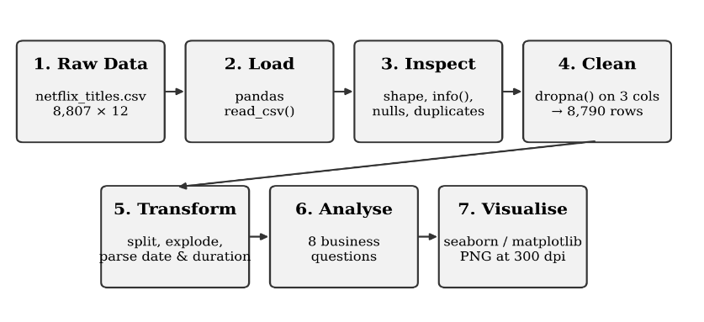
The data flows through the notebook in a single direction. The raw CSV is loaded, inspected for quality problems and cleaned. The cleaned DataFrame (8,790 rows) is then reshaped for each question: multi-valued columns are split and exploded, the duration text is converted to integers and the date column is converted to a datetime. Each aggregated result is plotted and the chart is saved as an image, so the figures used in this report are exactly the ones produced by the notebook. Figure 2.1 summarizes the pipeline.
Figure 2.1 — Data Analysis Pipeline

Chapter 3: Implementation & Major Modules

3.1 Data Loading & Cleaning (Pandas)
The notebook starts by importing Pandas, NumPy, Matplotlib and Seaborn, applying the Seaborn whitegrid theme and reading netflix_titles.csv into a DataFrame. An images folder is created once, and every chart is saved there with plt.savefig().
Inspection. The data is examined with df.head(), df.shape, df.columns, df.info(), df.describe(), df.isnull().sum() and df.duplicated().sum(). This confirmed 8,807 rows and 12 columns, zero duplicate rows, and the missing-value counts listed in Table 2.2. Missing values were also expressed as percentages of the total rows to judge how serious each gap is.
Cleaning. Rows missing date_added, rating or duration were dropped with df.dropna(subset=[...]). Using the subset argument limits the check to these three required columns instead of discarding a row for any missing value. The shape after cleaning is 8,790 rows, so 17 rows (about 0.19%) were removed. A second null count confirmed that the three target columns are now complete, while director (2,621), cast (825) and country (829) still contain gaps that are handled analysis by analysis.

3.2 Data Transformation (Feature Preparation)
Several columns cannot be counted directly and need transformation first. Table 3.1 summarizes the operations used.
Column | Problem | Operation used | Result
country | Several countries in one cell ("Country A, Country B") | dropna() → str.split(", ") → explode() → value_counts() | Each country is counted individually; top 10 selected with head(10)
listed_in | Several genres in one cell | str.split(", ") → explode() → value_counts() | Each genre is counted individually
duration | Text such as "90 min"; TV shows use seasons | Filter type == "Movie", str.replace(" min", ""), astype(int) | Numeric duration_minutes for movies only
date_added | Dates written in mixed formats | pd.to_datetime(format="mixed", errors="coerce") and dt.year | New added_year column; unparseable dates become NaT instead of failing
release_year | Needs chronological order | value_counts().sort_index() | Counts ordered by year for a line plot

Table 3.1 — Cleaning and Transformation Operations
Note on counting. Because a title can list several countries or genres, the counts for countries and genres add up to more than the number of titles. A co-produced title contributes one count to each of its countries, and a title with three genres contributes one count to each genre.

3.3 Visualization (Seaborn & Matplotlib)
Every analysis ends with a chart. The notebook uses Seaborn for statistical charts (count plots, bar plots, histogram) and Matplotlib for line plots and layout. Count labels are added on top of bars with bar_label() so that values can be read directly from the chart, titles and axis labels are set on every figure, and tight_layout() prevents clipping. Each figure is exported at 300 dpi with bbox_inches="tight". Table 3.2 lists the eight analysis modules.
No. | Analysis (Business Question) | Chart type | Key technique
1 | Movies vs TV Shows: how many of each? | Count plot (vertical bars) | sns.countplot, palette Set2
2 | Release year: how did titles change by release year? | Line plot with markers | value_counts().sort_index()
3 | Content rating: which ratings are most common? | Count plot (horizontal bars) | Ordered by frequency, palette viridis
4 | Top 10 countries by number of titles | Horizontal bar plot | Split and explode, palette magma
5 | Top 10 genres | Horizontal bar plot | Split and explode, palette Set2
6 | Top 10 directors | Horizontal bar plot | dropna() then value_counts(), palette crest
7 | Movie duration distribution | Histogram (30 bins) | Minutes parsed from text
8 | Titles added to Netflix by year | Line plot with markers | to_datetime and dt.year

Table 3.2 — Analysis Modules and Chart Types

Chapter 4: Project Showcase (Visual Walkthrough)
This chapter presents the output of the completed analysis. Each subsection shows the chart produced by the notebook, the business question it answers and the observation drawn from it. All counts are based on the cleaned dataset of 8,790 titles unless stated otherwise. Values read from line charts are approximate.

4.1 Content Composition & Growth
Business question: How many Movies and TV Shows are available on Netflix? Netflix contains 6,126 Movies and 2,664 TV Shows, so movies make up about 70% of the catalog and TV shows about 30%, a ratio of a little over two movies for every TV show.
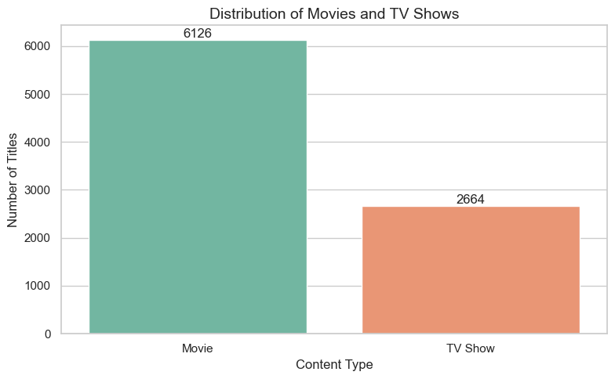
Figure 4.1 — Distribution of Movies and TV Shows
Business question: How has the number of titles changed by release year? Few titles in the library were released before 2000. The count rises sharply after about 2010, reaching a peak of roughly 1,100 titles for releases in 2018, and then falls through 2019 to 2021. The drop after 2018 should be read with care: the dataset is a snapshot, so recent release years are incomplete and the last year is only partly covered.
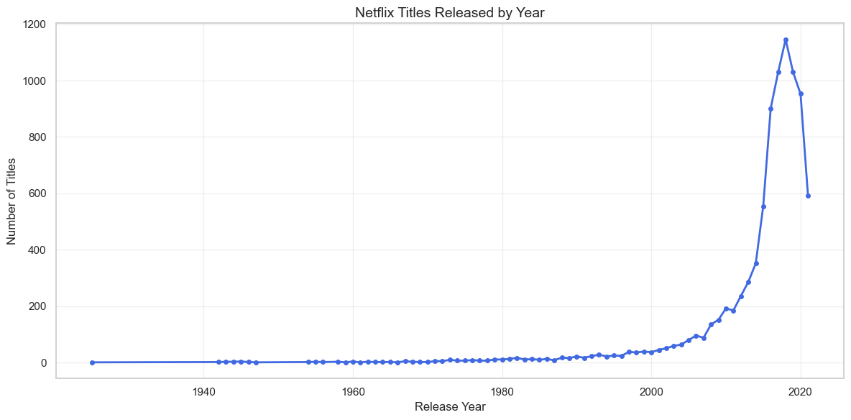
Figure 4.2 — Netflix Titles Released by Year
Business question: How has the number of titles added to Netflix changed over the years? Additions were negligible until about 2015 and then grew rapidly: from a few hundred titles in 2016 to more than 1,600 in 2018 and a peak of about 2,000 in 2019. Additions remained high in 2020 (about 1,900) and 2021 (about 1,500, a partial year), which shows an aggressive expansion of the library between 2016 and 2020.
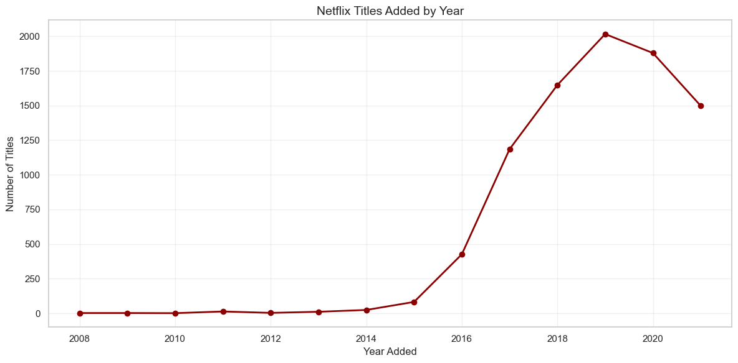
Figure 4.3 — Netflix Titles Added by Year

4.2 Audience, Origin & Genres
Business question: What are the most common content ratings? TV-MA is the most common rating with 3,205 titles (about 36% of the catalog), followed by TV-14 with 2,157 titles (about 25%). Together these two mature and teen ratings cover roughly 61% of all titles. TV-PG (861) and R (799) follow, while family-oriented ratings such as TV-Y (306), TV-G (220) and G (41) are comparatively rare.
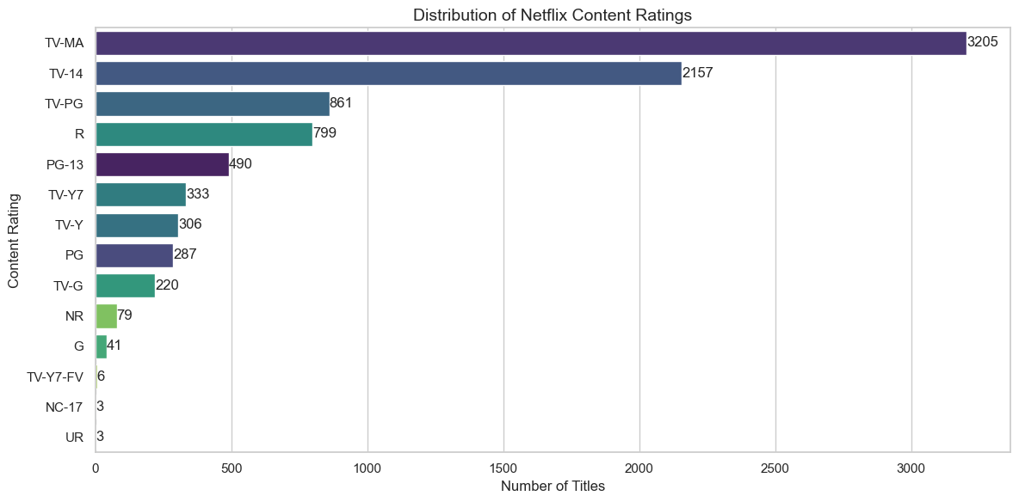
Figure 4.4 — Distribution of Netflix Content Ratings
Business question: Which countries contribute the most titles? The United States leads clearly with 3,680 titles, followed by India (1,046) and the United Kingdom (803). Canada (445), France (393), Japan (316), Spain (232), South Korea (231), Germany (226) and Mexico (169) complete the top 10. The United States alone has more than three times as many titles as India. Counts are per country, so co-productions are counted once for every participating country.
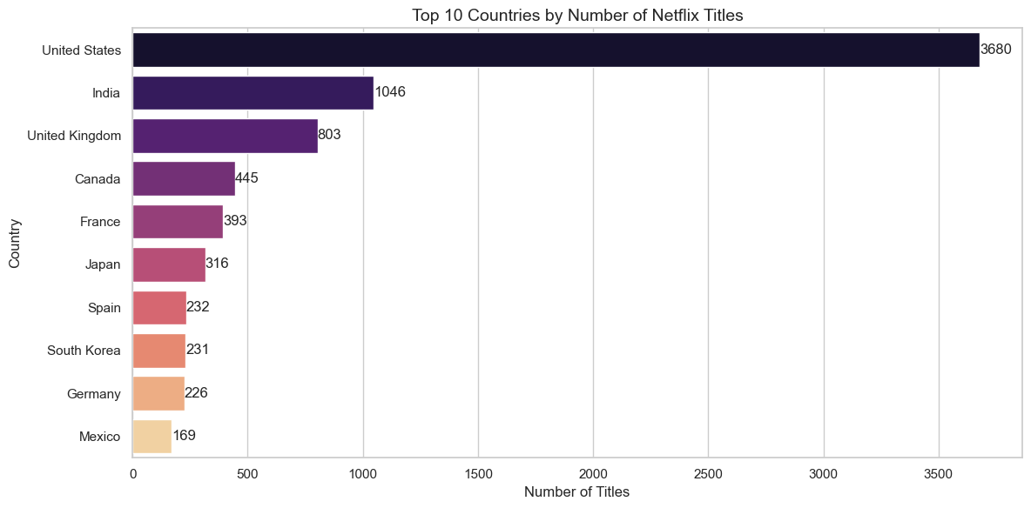
Figure 4.5 — Top 10 Countries by Number of Titles
Business question: Which genres are the most common? International Movies is the largest category with 2,752 titles, followed by Dramas (2,426) and Comedies (1,674). International TV Shows (1,349), Documentaries (869), Action & Adventure (859), TV Dramas (762), Independent Movies (756), Children & Family Movies (641) and Romantic Movies (616) complete the top 10. Drama-related categories and international content therefore dominate the library.
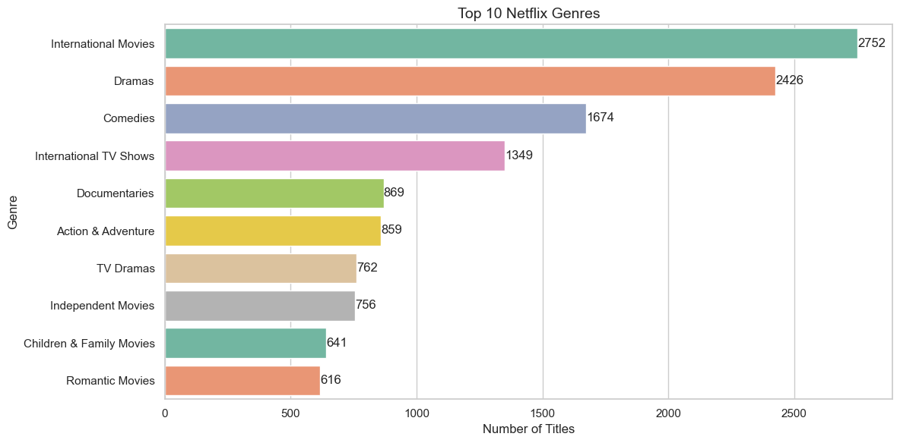
Figure 4.6 — Top 10 Netflix Genres

4.3 Creators & Movie Duration
Business question: Which directors have the most titles? Rajiv Chilaka has the highest number of titles with 19, followed by the co-directing pair Raúl Campos and Jan Suter (18), Suhas Kadav and Marcus Raboy (16 each) and Jay Karas (14). Well-known directors such as Martin Scorsese (12) and Steven Spielberg (11) also appear in the top 10. Note that 29.9% of titles in the raw data have no director listed, and joint credits appear as a single entry.
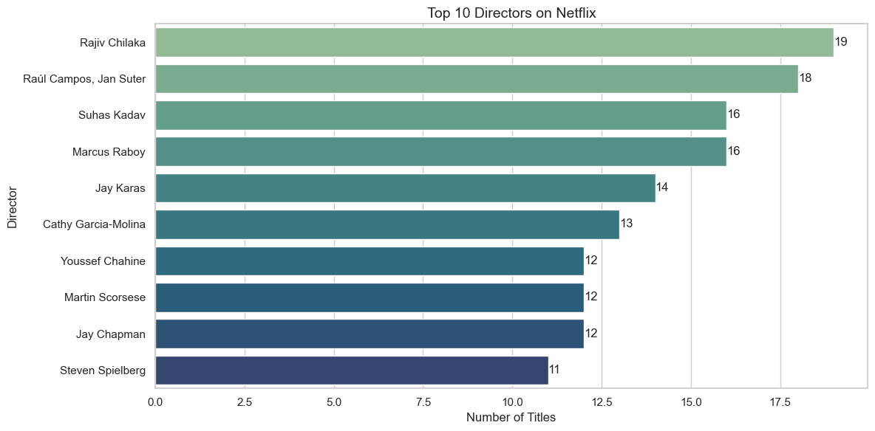
Figure 4.7 — Top 10 Directors on Netflix
Business question: What is the distribution of movie durations? The histogram is roughly bell-shaped and centered near 90 to 100 minutes, with the tallest bar covering about 1,280 movies. Most movies run between approximately 80 and 120 minutes, and only a small number are shorter than 40 minutes or longer than 180 minutes. TV shows are excluded from this analysis because their duration is stored as a number of seasons.
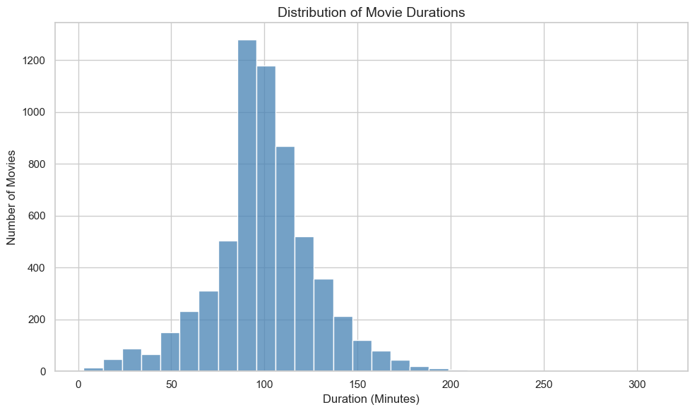
Figure 4.8 — Distribution of Movie Durations

Chapter 5: Testing & Validation

5.1 Data Validation & Result Verification
For a data-analysis project, testing means confirming that the data is loaded completely, that cleaning and transformation behave as intended, and that the numbers shown in the charts are consistent with each other. Validation was carried out by inspecting the output of each notebook cell. Data-quality checks (shape, null counts, duplicate count) were run before and after cleaning, transformation steps were checked by confirming that they executed without errors and produced the expected columns, and chart outputs were checked for correct titles, labels and value annotations.
Consistency checks also hold across analyses. The Movie and TV Show counts (6,126 + 2,664) add up to 8,790, the size of the cleaned dataset, and the rating counts shown in Figure 4.4 cover every remaining row. Country and genre counts are intentionally larger than the number of titles because multi-valued fields are exploded.

5.2 Test Cases & Results
The notebook was checked against the following test cases. The Status column reflects the output observed when the notebook was executed.
Test Case ID | Module | Description | Expected Result | Status
TC-01 | Data Loading | Load netflix_titles.csv into a DataFrame | 8,807 rows and 12 columns | Pass
TC-02 | Data Quality | Count fully duplicated rows | 0 duplicate rows found | Pass
TC-03 | Data Quality | Count missing values per column | Gaps identified: director 2,634, cast 825, country 831, date_added 10, rating 4, duration 3 | Pass
TC-04 | Data Cleaning | Drop rows missing date_added, rating or duration | 8,790 rows remain; the three columns have 0 missing values | Pass
TC-05 | Analysis 1 | Count titles by type | Movie 6,126 and TV Show 2,664, totalling 8,790 | Pass
TC-06 | Transformation | Split and explode country and listed_in | Each country and genre counted individually; top 10 lists produced | Pass
TC-07 | Transformation | Convert movie duration text to integer minutes | No conversion error; histogram plotted | Pass
TC-08 | Transformation | Parse date_added with mixed formats and extract the year | added_year created; yearly counts plotted for 2008 to 2021 | Pass
TC-09 | Visualization | Render all eight charts with titles, labels and value annotations | Eight charts displayed correctly | Pass
TC-10 | Export | Save every chart to the images folder at 300 dpi | Eight PNG files created | Pass

Table 5.1 — Test Cases and Results
A key validation rule in this project is that rows are removed only when a field required by an analysis is missing, and that every removal is measured. Only 17 of 8,807 rows (about 0.19%) were dropped, so the cleaned data remains representative of the full catalog.

Chapter 6: Future Scope & Conclusion

6.1 Proposed Enhancements
The current study is descriptive and based on one snapshot of the catalog. The notebook structure allows easy extension. Proposed future work includes:
- Genre and Country Trends over Time: Track how the share of each genre or country changes by year added, instead of looking only at overall totals.
- Movies vs TV Shows by Region: Compare the movie-to-TV-show ratio across countries and across rating categories.
- Handling Missing Data: Reduce the 30% gap in director information and the gaps in cast and country by enriching the data from an additional source.
- Text Analysis of Descriptions: Apply NLP techniques such as keyword extraction or topic modelling to the description column to find themes.
- Cast and Collaboration Analysis: Analyse the most frequent actors and director–actor pairs using the cast column.
- Recommendation System: Build a content-based recommender using genres, cast, director and description similarity.
- Interactive Dashboard: Present the analyses in an interactive dashboard (for example Streamlit or Power BI) with filters for type, country, rating and year.
- Fresher Data: Repeat the analysis on a newer snapshot to confirm whether the post-2019 slowdown in additions continues.

6.2 Key Findings, Conclusion & References
Key findings
- Netflix has more Movies (6,126) than TV Shows (2,664) in its content library, about 70% to 30%.
- The number of titles increased significantly after 2015, showing rapid growth of the platform.
- TV-MA is the most common content rating (3,205 titles), followed by TV-14, indicating a large focus on mature and teen audiences.
- The United States contributes the highest number of titles (3,680), followed by India and the United Kingdom.
- International Movies, Dramas and Comedies are the three largest genre categories.
- Most Netflix movies run between about 80 and 120 minutes.
- Netflix added a large number of titles between 2016 and 2020, showing aggressive content expansion during this period.
Netflix Data Analysis demonstrates how a raw, partly incomplete catalog file can be turned into clear business insight with a short, reproducible Python workflow. By inspecting data quality, cleaning only what was necessary, correctly handling multi-valued columns and presenting results through well-labelled charts, the project answers eight practical questions about the Netflix library: what it contains, how fast it has grown, who it targets, where it comes from and how long its movies are. The study meets its academic objectives by applying Pandas for data wrangling and Seaborn and Matplotlib for visualization, and it provides a solid foundation for deeper analysis such as trend modelling, text analysis and recommendation.
References
- Shivam Bansal, Netflix Movies and TV Shows. Kaggle dataset. https://www.kaggle.com/datasets/shivamb/netflix-shows
- The pandas development team, pandas Documentation. https://pandas.pydata.org/docs/
- NumPy Developers, NumPy Documentation. https://numpy.org/doc/
- The Matplotlib Development Team, Matplotlib Documentation. https://matplotlib.org/stable/
- Michael Waskom, seaborn: statistical data visualization. https://seaborn.pydata.org/
- Project Jupyter, Jupyter Notebook Documentation. https://jupyter.org/documentation

SOURCE CODE: nandiniitech/Cine_Scope

