Farm Irrigation Network Optimization

A PROJECT REPORT
Submitted by
Nandini Kumari (26MCD10077)
in partial fulfillment for the award of the degree of
Masters of Computer Applications
IN

Data science



2026-28

Chandigarh University ·
[2026-28]

BONAFIDE CERTIFICATE

Certified that this project report titled "Farm Irrigation Network Optimization" is the bonafide work of Nandini Kumari (UID: 26MCD10077) who carried out the project work under my/our supervision in partial fulfillment of the requirements for the award of the degree of Master of Computer Applications at Chandigarh University.

SIGNATURE | SIGNATURE
Name: Nandini Kumari | Name: Ms. Divyanshi Sharma
UID: 26MCD10077 | Designation: Assistant Professor
Class: MCD 2-A | E-Code: E17438

ACKNOWLEDGEMENT

The successful completion of this project would not have been possible without the guidance, support, and encouragement of several individuals and organizations. It is a matter of great pleasure and privilege for me to express my sincere gratitude to all those who contributed directly or indirectly towards the completion of this project titled "Farm Irrigation Network Optimization."
First and foremost, I would like to express my heartfelt gratitude to Chandigarh University for providing me with the opportunity to undertake this project as a part of my academic curriculum. The university has provided an excellent learning environment, modern facilities, and valuable resources that helped me gain practical knowledge and technical skills throughout the course of this project.
I would like to convey my deepest appreciation to my project supervisor, Ms. Tanisha, for constant guidance, constructive suggestions, and continuous motivation during every stage of the project. Their insights, technical expertise, and willingness to share knowledge played a crucial role in the successful completion of this work.
I am also thankful to the Head of the Department, faculty members, and staff of the Department of [Department Name] for their support and cooperation throughout the project duration. Their academic guidance and timely feedback helped me understand the practical applications of design and analysis of algorithms, graph algorithms and Python programming.
Special thanks are extended to my friends and classmates who continuously encouraged me and shared valuable suggestions throughout the development process. Their discussions, feedback, and moral support helped me improve various aspects of the project and remain motivated during challenging phases of implementation.

TABLE OF CONTENTS
Chapter | Title | Section
Chapter 1 | Aim | 1.0
Chapter 2 | Objective and Problem Definition | 2.0
 | Problem Statement | 2.1
 | Graph Model | 2.2
 | Objectives | 2.3
Chapter 3 | Programming Language and Tools | 3.0
Chapter 4 | Block Diagram and Design Flow | 4.0
 | Module Summary | 4.1
Chapter 5 | Algorithms and Pseudocode | 5.0
 | Prim's Algorithm (Minimum Spanning Tree) | 5.1
 | Dijkstra's Algorithm (Shortest Path) | 5.2
 | Complexity Analysis | 5.3
 | Why the Greedy Choice is Correct | 5.4
Chapter 6 | Implementation | 6.0
 | Graph Data Structure | 6.1
 | Prim's Algorithm | 6.2
Chapter 7 | Output | 7.0
 | Option 1: Display the Farm Network | 7.1
 | Option 3: Prim's Minimum-Cost Network | 7.2
 | Option 4: Dijkstra's Shortest Route | 7.3
 | Option 5: Performance Analysis | 7.4
 | Option 2: Adding Pipelines | 7.5
 | Input Validation and Edge Cases | 7.6
Chapter 8 | Conclusion | 8.0
Chapter 9 | Future Framework | 9.0
Chapter 10 | Learning Outcomes | 10.0

LIST OF FIGURE / TABLES

Type | Number | Title
Table | 2.1 | Sample Farm Pipelines and Installation Costs
Table | 3.1 | Tools and Libraries Used
Table | 4.1 | Menu Option and Module Summary
Table | 5.1 | Prim's Algorithm Dry Run
Table | 5.2 | Dijkstra's Algorithm Dry Run
Table | 5.3 | Time and Space Complexity
Table | 7.1 | Input Validation and Edge Cases
Table | 9.1 | Future Framework Areas

Aim
The aim of this project is to design and implement a menu-driven Python program that plans an economical irrigation pipeline network for a farm, using two classic graph algorithms from Design and Analysis of Algorithms: Prim's algorithm for the cheapest way to connect every location, and Dijkstra's algorithm for the cheapest route between any two locations.

Objective and Problem Definition

Problem statement
A farm has one water source, a storage tank and four fields (A to D). Pipelines can be laid between certain pairs of locations, and each possible pipeline has an installation cost. Given this layout, the project must answer two questions:
- What is the cheapest set of pipelines that connects every location to the water supply?
- What is the cheapest route for water to travel between two chosen locations?

Graph model
The farm is modelled as a weighted, undirected graph G = (V, E). Each location is a vertex, each possible pipeline is an edge, and the edge weight is the installation cost. Pipelines carry water in both directions, so the graph is undirected and every edge is stored twice, once per endpoint. The sample farm has V = 6 locations and E = 9 pipelines.
Pipeline (edge) | Installation cost
Water Source – Storage Tank | 4
Water Source – Field A | 6
Storage Tank – Field A | 2
Storage Tank – Field B | 5
Pipeline (edge) | Installation cost
Field A – Field B | 3
Field A – Field C | 7
Field B – Field C | 4
Field B – Field D | 6
Field C – Field D | 2
The two questions map onto well-known graph problems. The first is the minimum spanning tree (MST) problem: pick V − 1 edges that connect all vertices with the smallest total weight. The second is the single-pair shortest path problem on a graph with nonnegative weights.

Objectives
Represent the farm network with an adjacency list stored as a dictionary of dictionaries.
Display the network and let the user add new pipelines and new locations at run time. Compute the minimum-cost pipeline network with Prim's algorithm and report the pipelines chosen and the total cost.
Compute the minimum-cost route between two locations with Dijkstra's algorithm and print the path.
Detect a disconnected network and tell the user which locations are unreachable. Validate input: empty names, self-loops, non-numeric costs and non-positive costs are rejected.
Time the spanning-tree computation and print the theoretical time and space complexity of each algorithm.

Programming Language and Tools
The project is written in Python 3 and uses only the standard library, so it runs on any machine with Python installed and needs no extra packages.
Component | Purpose in the project
Python 3 | Main language: readable syntax, built-in dictionaries and sets, fast to prototype algorithms
Component | Purpose in the project
heapq module | Binary min-heap used as the priority queue in both Prim's and Dijkstra's algorithms
time module | perf_counter() gives a high-resolution timer for the performance analysis
dict of dicts | Adjacency-list representation of the graph, with O(1) average edge lookup
set | Tracks visited vertices with O(1) average membership tests
Console (CLI) | Menu-driven text interface using input() and print()

Block Diagram and Design Flow
The program loads the farm graph once, then repeats a menu loop until the user chooses Exit. Each of options 1 to 5 runs one module and returns to the menu.
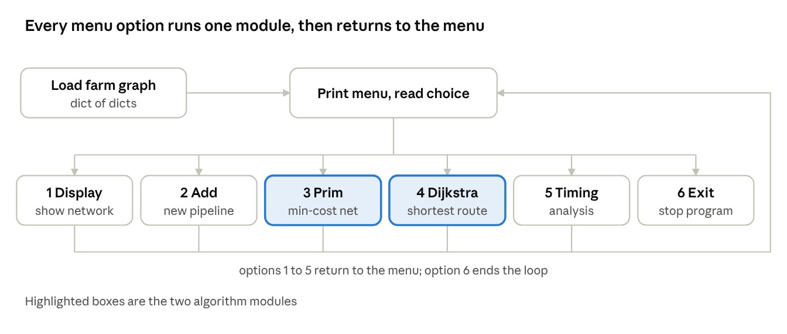
The graph is the only shared data. Options 1, 3, 4 and 5 only read it; option 2 is the only module that changes it, which is why a new pipeline shows up in every later Prim, Dijkstra and timing run.

Module summary
Option | Function | Technique | Input | Output
1 | display_network() | Dictionary traversal | None | Every location with its pipelines and costs
2 | add_pipeline() | Validation, setdefault , symmetric update | Two names and a cost | Confirmation or an error message
3 | prim_mst() | Prim with a minheap | None | Chosen  pipelines, total cost, connectivity result
4 | dijkstra() | Dijkstra with a min-heap | Source and destination | Cheapest  route and its cost
5 | performance_analysis() | Timed Prim run with  perf_counter() | None | V, E, MST cost, execution time, complexities
6 | main() | Loop exit | None | Goodbye message

Algorithms and Pseudocode
Both algorithms are greedy: at each step they commit to the cheapest available choice and never undo it. Both use a min-heap so the cheapest candidate is found in O(log n) time.

Prim's algorithm (minimum spanning tree)
Prim's algorithm grows a single tree from a starting vertex. At every step it adds the cheapest edge that joins a vertex inside the tree to a vertex outside it. After V − 1 such steps every vertex is connected at the smallest possible total cost.
PRIM-MST(G):
start <- any vertex of G visited <- empty set
heap <- [(0, start, none)] // (edge cost, vertex, parent) total <- 0 tree_edges <- empty list
while heap is not empty AND |visited| < |V|: (cost, u, parent) <- extract-min(heap)
if u in visited: continue // stale entry, skip
add u to visited if parent is not none: append (parent, u, cost) to tree_edges
total <- total + cost for each neighbour v of u with weight w:
if v not in visited: insert (w, v, u) into heap
if |visited| < |V|: report "disconnected" and list unreachable vertices else: return tree_edges, total
The program uses lazy deletion: instead of lowering a key inside the heap, it inserts a new entry and discards stale ones when they are popped (the if u in visited: continue test). This keeps the code simple and does not change the complexity.

Dry run on the sample farm, starting at Water Source
Step | Vertex added | Edge used | Cost | Running total
1 | Water Source | (start) | 0 | 0
2 | Storage Tank | Water Source – Storage Tank | 4 | 4
3 | Field A | Storage Tank – Field A | 2 | 6
4 | Field B | Field A – Field B | 3 | 9
5 | Field C | Field B – Field C | 4 | 13
6 | Field D | Field C – Field D | 2 | 15
The tree has 5 edges for 6 vertices and costs 15. The rejected pipelines (Water Source – Field A at 6, Storage Tank – Field B at 5, Field A – Field C at 7 and Field B – Field D at 6) would each close a loop and only add cost.

Dijkstra's algorithm (shortest path)
Dijkstra's algorithm finds the cheapest route from one source to every other vertex when all edge weights are non-negative. It keeps a distance estimate for each vertex and repeatedly finalises the unfinalised vertex with the smallest estimate, then relaxes its outgoing edges. The program stops early once the destination is finalised.
DIJKSTRA(G, source, destination):
for each vertex v: dist[v] <- infinity, prev[v] <- none dist[source] <- 0 heap <- [(0, source)]
while heap is not empty: (d, u) <- extract-min(heap)
if d > dist[u]: continue // stale entry, skip if u = destination: break // early exit for each neighbour v of u with weight w: if d + w < dist[v]: // relaxation
dist[v] <- d + w prev[v] <- u
insert (dist[v], v) into heap
if dist[destination] = infinity: report "no route" else: rebuild path by following prev[] back from destination, reverse it

Dry run: Water Source to Field D
Vertex finalised | Distance | Updates made
Water Source | 0 | Storage Tank = 4, Field A = 6
Storage Tank | 4 | Field B = 9 (Field A stays 6, since 4 + 2 = 6 is not an improvement)
Field A | 6 | Field C = 13 (Field B stays 9)
Field B | 9 | Field D = 15 (Field C stays 13)
Field C | 13 | none (13 + 2 = 15 is not an improvement)
Field D | 15 | destination reached, stop
Following the prev pointers back from Field D gives Field D, Field B, Storage Tank, Water
Source. Reversed, the route is Water Source, Storage Tank, Field B, Field D, at a cost of 15.

Complexity analysis
Let V be the number of locations and E the number of pipelines.
Part | Time | Space | Reason
Graph storage (adjacency list) | – | O(V + E) | One entry per vertex plus two per edge
Prim's algorithm | O(E log V) | O(V + E) | Each edge can push at most 2 heap entries; each push or pop costs O(log E) = O(log V)
Dijkstra's algorithm | O((V + E) log V) | O(V + E) | Each relaxation can push one entry; each push or pop costs O(log V); V  vertices are finalised
Path reconstruction | O(V) | O(V) | Follows at most V parent pointers
For a connected graph E is at least V − 1, so O((V + E) log V) and O(E log V) are the same order, and both are far below the exponential cost of trying every subset of pipelines.

Why the greedy choice is correct
Prim: by the cut property, the cheapest edge crossing any cut that separates the tree from the rest of the graph belongs to some minimum spanning tree. Each step adds exactly such an edge, so the final tree is optimal.
Dijkstra: with non-negative weights, when a vertex is removed from the heap with the smallest estimate, no other path can reach it more cheaply, because any other path must pass through a vertex that is not cheaper. This is why the program rejects pipeline costs of zero or below at input time.

Implementation
The program is a single Python file of about 360 lines, organised into six parts: the graph data, four functional modules, a performance module and the main menu. The graph data and the two algorithm modules are listed in full below; the display, input, timing and menu modules are summarised in the module table in Section 4, and their complete code is in the project's source file.

Graph data structure
The network is a dictionary whose keys are location names. Each value is another dictionary mapping a neighbouring location to the pipeline cost. Because the graph is undirected, every pipeline appears under both endpoints, so Water Source lists Storage Tank and Storage Tank lists Water Source.
import heapq import time
graph = {
"Water Source": {"Storage Tank": 4, "Field A": 6},
"Storage Tank": {"Water Source": 4, "Field A": 2, "Field B": 5},
"Field A": {"Water Source": 6, "Storage Tank": 2,
"Field B": 3, "Field C": 7},
"Field B": {"Storage Tank": 5, "Field A": 3,
"Field C": 4, "Field D": 6}, "Field C": {"Field A": 7, "Field B": 4, "Field D": 2},
"Field D": {"Field B": 6, "Field C": 2} }

Prim's algorithm
prim_mst() starts from the first location in the dictionary. The heap holds tuples of (cost,
vertex, parent), and Python compares tuples element by element, so the cheapest edge is always popped first. The parent is stored so the chosen pipeline can be printed as a pair of locations. If the loop ends with fewer vertices visited than the graph holds, the network is disconnected, and the function lists the unreachable locations instead of printing a misleading partial result.
def prim_mst(): start = next(iter(graph))
visited, min_heap = set(), [(0, start, None)] total_cost, selected_pipelines = 0, []
while min_heap and len(visited) < len(graph):
cost, current, parent = heapq.heappop(min_heap) if current in visited: continue # stale entry
visited.add(current) if parent is not None: selected_pipelines.append((parent, current, cost)) total_cost += cost for neighbour, weight in graph[current].items(): if neighbour not in visited: heapq.heappush(min_heap, (weight, neighbour, current))
if len(visited) != len(graph): # disconnected network
unreachable = set(graph) - visited print("The network is disconnected!")
print("Unreachable locations:", ", ".join(sorted(unreachable))) return
The listing is shortened: the empty-network check and the print statements are left out.
6.3 Dijkstra's algorithm dijkstra() asks for a source and a destination and checks that both exist. It keeps two
dictionaries: distances , initialised to infinity, and previous , initialised to None. The if current_distance > distances[current] test skips stale heap entries, and the loop exits as soon as the destination is popped, since its distance is final at that point. The route is rebuilt by following previous from the destination back to the source and reversing the list.
def dijkstra():
source = input("Enter source location: ").strip() destination = input("Enter destination location: ").strip() # ... checks that both locations exist ...
distances = {location: float("inf") for location in graph} previous = {location: None for location in graph} distances[source] = 0 min_heap = [(0, source)]
while min_heap: current_distance, current = heapq.heappop(min_heap) if current_distance > distances[current]:
continue # stale entry if current == destination:
break # early exit for neighbour, weight in graph[current].items():
new_distance = current_distance + weight if new_distance < distances[neighbour]: distances[neighbour] = new_distance previous[neighbour] = current
heapq.heappush(min_heap, (new_distance, neighbour))
if distances[destination] == float("inf"):
print("No route exists between these locations.")
return
path, current = [], destination # rebuild the route while current is not None: path.append(current) current = previous[current] path.reverse()
# ... print the route, its cost and the complexity

Output
The outputs below were captured by running the program on the sample farm. The sixoption menu from Section 4 is printed before every choice.

Option 1: display the farm network
==========
FARM IRRIGATION NETWORK
==========
Location: Water Source

->
Storage Tank: Pipeline cost =
4

->
Field A: Pipeline cost =
6
Location: Storage Tank

->
Water Source: Pipeline cost =
4

->
Field A: Pipeline cost =
2

->
Field B: Pipeline cost =
5
... (
Field A to Field D are listed in the same format
)
Total locations: 6
=============================================

Option 3: Prim's minimum-cost network
==========
PRIM'S ALGORITHM
==========
Minimum-cost pipeline network:
Water Source -> Storage Tank: Cost = 4
Storage Tank -> Field A: Cost = 2
Field A -> Field B: Cost = 3
Field B -> Field C: Cost = 4
Field C -> Field D: Cost = 2
Total minimum installation cost: 15
Total pipelines selected: 5
Total locations connected: 6
Time Complexity: O(E log V)
Space Complexity: O(V + E)
======================================

Option 4: Dijkstra's shortest route
Input: source = Water Source, destination = Field D.

Option 5: performance analysis
==========
PERFORMANCE ANALYSIS
==========
Number of locations (V): 6
Number of pipelines (E): 9
Network status: Connected
Minimum spanning tree cost: 15
Execution time: 0.000007110 seconds
Theoretical Complexity:
Prim's Algorithm: O(E log V)
Dijkstra's Algorithm: O((V + E) log V)
Graph Storage: O(V + E)
===========================================
==========
DIJKSTRA'S ALGORITHM
==========
Shortest route:
Water Source -> Storage Tank -> Field B -> Field D
Minimum route cost: 15
Time Complexity: O((V + E) log V)
Space Complexity: O(V + E)
==========================================

Option 2: adding pipelines
Adding a pipeline from Water Source to Field D at cost 0.5, then a new location Field E linked to Field B at cost 3.5:
Pipeline added successfully!
Field D <-> Water Source, Cost = 0.5
Pipeline added successfully!
Field E <-> Field B, Cost = 3.5

Running Prim's algorithm again now covers 7 locations and picks 6 pipelines. The cheap new pipeline replaces the Water Source – Storage Tank link, and the new field is attached through its only pipeline (Field B – Field E, cost 3.5). The new run selects 6 pipelines across 7 locations at a total cost of 15.
The total stays at 15 because the saving from the 0.5 pipeline (4 replaced by 0.5, a drop of 3.5) is cancelled by the 3.5 spent to connect Field E.

Input validation and edge cases
Input | Program response
Pipeline from Field A to Field A | A pipeline cannot connect a location to itself.
Pipeline cost typed as abc | Invalid cost. Enter a number.
Dijkstra source Field X (not in the network) | Source location does not exist.
Input | Program response
Dijkstra with source and destination both Field A | Shortest route: Field A, Minimum route cost: 0
Menu choice outside 1 to 6 | Invalid choice. Please select 1-6.

Conclusion
The project turns a practical farming decision into a graph problem and solves it with two standard algorithms. Prim's algorithm finds that the six locations of the sample farm can all be connected with five pipelines for a total installation cost of 15. Dijkstra's algorithm finds that the cheapest route from the Water Source to Field D runs through the Storage Tank and Field B, also at a cost of 15.
The program is also robust for everyday use. It validates all user input, detects disconnected networks, handles decimal costs, lets the farm be extended at run time and reports execution time next to the theoretical complexity. Building it showed how a greedy strategy, a good data structure and a clear correctness argument combine to give an efficient and provably optimal answer.

Future Framework
The current program is a console tool with in-memory data. The following extensions would take it closer to a real farm-planning system.
Area | Possible extension
Persistence | Save and load the network from a JSON or CSV file so the farm survives between runs
Editing | Add options to delete or update a pipeline and to remove a location
Visualisation | Draw the farm graph and highlight the chosen pipelines with matplotlib or NetworkX
Algorithms | Add Kruskal's algorithm with union-find and compare it with Prim; add A* search for large grids
Cost model | Compute cost from pipe length, diameter, soil type and elevation instead of typing it by hand
Area | Possible extension
Hydraulics | Add water flow capacity and pressure, moving from spanning trees to a maximum-flow formulation
Directed edges | Support one-way pipelines or pumps where flow depends on elevation
Scale testing | Generate random graphs of increasing size and plot measured time against E log V
Interface | Build a web or mobile app where the farmer clicks fields on a map
IoT integration | Read soil-moisture and weather sensors and adjust water allocation automatically
Reliability | Add redundant pipelines, so a single broken pipe does not cut off a field

Learning Outcomes
By completing this project the following were learned:
Graph modelling: how to turn a real situation into a weighted undirected graph, and how to choose between an adjacency list and an adjacency matrix.
Greedy strategy: how Prim's and Dijkstra's algorithms make the locally best choice at each step, and why that gives a globally optimal result.
Data structures: how a binary min-heap ( heapq ) works as a priority queue, and how lazy deletion replaces the decrease-key operation.
Algorithm comparison: the difference between a minimum spanning tree and a shortest path, and why the two answers can differ.
Complexity analysis: how to derive O(E log V) and O((V + E) log V) and relate them to measured running time.
Correctness reasoning: the cut property for Prim, and the non-negative-weight requirement for Dijkstra.
Robust programming: validating input, handling disconnected graphs and empty data, and writing a menu-driven program in modules.
Testing and reporting: tracing algorithms by hand, checking the code against the trace, and presenting results clearly.
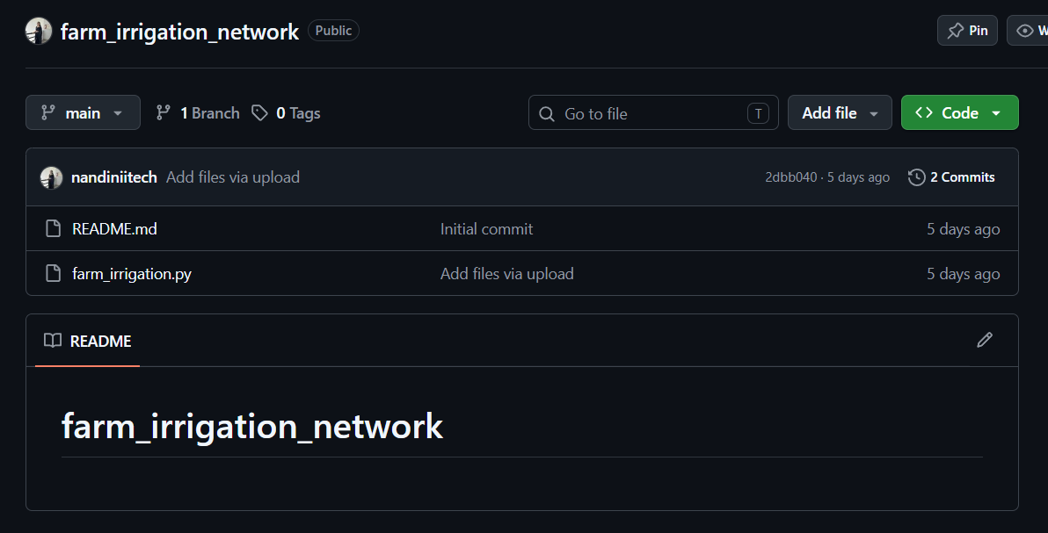
GitHub Repository: nandiniitech/farm_irrigation_network

