**Analysis of Patient Wait Times at a Clinic**



By: Nandini Jagtiani

1. Introduction

Efficiently managing patient wait times in clinics is essential for improving patient satisfaction and ensuring smooth hospital operations. Long wait times can cause frustration for patients, lead to overcrowding, and increase stress for healthcare providers, ultimately affecting the quality of care.

The study examines patient wait times from entry to the completion of consultation. It considers factors such as doctor type, financial class, and time of day to see how they impact wait times. The goal is to find areas where the clinic can make improvements to reduce wait times and improve efficiency.

1. Objectives

The primary objective of this study is to analyze patient wait times in the clinic and identify the key factors affecting them. By understanding these factors, we can provide insights to improve patient flow and operational efficiency. Some of the specific objectives are: -

1. Calculate the average patient wait time and its distribution.
2. Determine if doctor type affects wait times.
3. Investigate the impact of financial class on wait times.
4. Analysis and Results
5. Calculate the average patient wait time and its distribution

To understand the overall distribution of patients wait times, descriptive statistics were calculated, and visualizations were created using a histogram and goodness of fit test were conducted to know the distribution.

Table 1: Descriptive Statistics of Patient wait times in minutes

The descriptive statistics in *Table 1* provide a comprehensive overview of the patient wait times. The mean wait time is approximately 43.82 minutes, with a median of 30.95 minutes, indicating that half of the patients wait less than 31 minutes. The substantial standard deviation of 44.40 minutes highlights significant variability in the wait times, with some extreme cases waiting as long as 733.53 minutes.

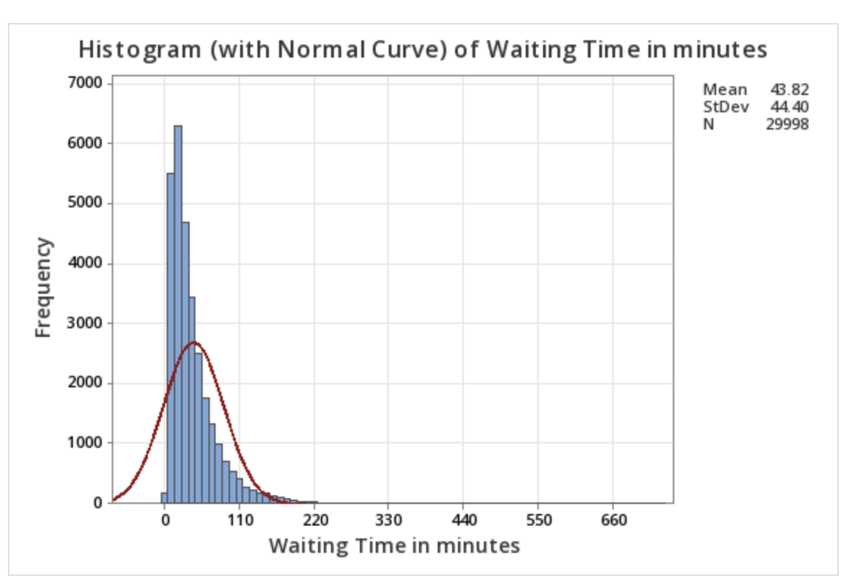

Figure 1: Histogram of Patient Wait Time in minutes

The histogram in *Figure 1* displays the distribution of patient wait times. The distribution is right-skewed, indicating that while most patients experience shorter wait times, there are a smaller number of patients who experience significantly longer wait times. The peak of the histogram shows that the most common wait times are concentrated in the lower range, around 30 to 40 minutes.

Table 2: Goodness of Fit Test for Patient Wait Time in minutes

To determine the best-fit distribution for the patient wait time data, a goodness-of-fit test was conducted in *Table 2*. The results indicated that the log-logistic distribution provided the best fit among the tested distributions. This is consistent with the right-skewed nature of the histogram. The log-logistic distribution is often used to model data with similar characteristics, where most observations cluster around a lower value, but there is a long tail of higher values.

1. Determine if doctor type affects wait times

In clinic settings, the type of doctor providing care can potentially influence the wait times experienced by patients. Different specializations may have varying workflows, patient handling capacities, and consultation durations. Understanding whether doctor type affects wait times is crucial for identifying bottlenecks and optimizing scheduling and resource allocation. This analysis employs One-Way ANOVA and visualizes the results with a boxplot to investigate the impact of doctor type on patient wait times, providing insights into whether certain types of doctors are associated with longer or shorter wait times.

Table 3: ANOVA Patient Wait Times by Doctor Type

*Table 3* presents the results of the One-Way ANOVA test conducted to determine if there are significant differences in patient wait times based on doctor type. The analysis reveals a highly significant p-value (<0.001), indicating that the type of doctor significantly affects patient wait times. The F-value of 439.98 indicates substantial differences among the groups.

The table details the following:

* Degrees of Freedom (DF): 2 for Doctor Type and 29,995 for Error.
* Adjusted Sum of Squares (Adj SS): 1,685,487 for Doctor Type and 57,453,342 for Error.
* Adjusted Mean Squares (Adj MS): 842,744 for Doctor Type and 1,915 for Error.
* F-Value: 439.98, showing the ratio of the variance between the groups to the variance within the groups.
* P-Value: <0.001, confirming the statistical significance of the differences observed.

This analysis confirms that the type of doctor plays a significant role in influencing patient wait times. This suggests that further investigation into specific doctor types may be needed to understand the underlying causes of these differences.

Figure 2: Boxplot of Patient Wait Times by Doctor Type

The boxplot in *Figure 2* displays the distribution of patient wait times across different doctor types (Anchor, Floating, and Locum). Each box represents the interquartile range (IQR), where the middle 50% of the data lies, and the line inside the box marks the median wait time. The whiskers extend to the smallest and largest values within 1.5 times the IQR from the lower and upper quartiles, respectively. Outliers are shown as individual points beyond the whiskers.

The boxplot highlights noticeable differences in median wait times and the spread of wait times across the different doctor types. Patients treated by "Anchor" doctors tend to have higher median wait times and a wider range of wait times compared to those treated by "Floating" and "Locum" doctors. This visualization supports the ANOVA results, indicating that doctor type significantly affects patient wait times.

1. Investigate the Impact of Financial Class on Wait Times

Financial class refers to the categorization of patients based on their method of payment or insurance type. Different financial classes may experience varying wait times due to differences in processing times, eligibility checks, or other administrative procedures. Understanding the impact of financial class on wait times can help identify potential inequalities and areas for process improvement. This analysis uses One-Way ANOVA to assess whether there are significant differences in patient wait times across different financial classes and visualizes the results with a bar graph.

Table: 4 ANOVA Results for Wait Time by Financial Class

The ANOVA results in *Table 4* indicate that there is a statistically significant difference in wait times based on financial class (p-value = 0.000). The F-value of 34.39 suggests substantial differences among the financial classes. This implies that financial class is an influential factor affecting patient wait times.

Figure 3: Mean Wait Times by Financial Class

The bar graph in *Figure 3* visually compares the mean wait times for each financial class. The chart shows that Medicare patients have the longest mean wait times, while HMO and Private patients experience shorter mean wait times. This visualization highlights the differences in wait times across financial classes, supporting the ANOVA results and indicating that financial class plays a significant role in determining patient wait times.

1. Conclusion and Recommendations

The analysis of patient wait times in the clinic provided valuable insights into the factors influencing these times and identified areas for potential improvement. The study revealed that the average patient wait time is approximately 43.82 minutes with a standard deviation of 44.40 minutes, and the distribution is right-skewed. This indicates that while most patients experience shorter wait times, a smaller subset of patients endures significantly longer waits, suggesting potential inefficiencies or specific factors contributing to these extended times.

The impact of doctor type on patient wait times was found to be significant, as determined by the One-Way ANOVA analysis (p-value = 0.000). This suggests that different doctor types, such as specialists versus general practitioners, have varying impacts on wait times. Addressing the underlying causes for these differences could involve optimizing scheduling practices or reallocating resources to ensure a more balanced workload among doctors.

Additionally, the financial class of patients was identified as a significant factor affecting wait times (p-value = 0.000). The analysis indicated that patients with different insurance types or payment methods experience varying wait times. This finding points to potential administrative inefficiencies or biases that need to be addressed to ensure equitable treatment for all patients, regardless of their financial class.

To improve patient wait times and overall efficiency in the clinic, the following recommendations are proposed:

* **Resource Allocation:** Adjusting resource allocation and doctor scheduling to balance the patient load more effectively, especially for doctor types associated with longer wait times.
* **Process Optimization:** Streamlining administrative processes related to financial class verification and patient intake to minimize delays.
* **Continuous Monitoring:** Implementing a system for ongoing monitoring and analysis of patient wait times to identify and address emerging issues promptly.

By implementing these recommendations, the clinic can enhance operational efficiency, reduce patient wait times, and improve patient satisfaction. Continued focus on data-driven decision-making will be crucial in maintaining and furthering these improvements.