Diagnostic Plots

https://seaborn.pydata.org/examples/residplot.html
import numpy as np
import seaborn as sns
sns.set(style="whitegrid")
# Make an example dataset with y ~ x
rs = np.random.RandomState(7)
x = rs.normal(2, 1, 75)
y = 2 + 1.5 * x + rs.normal(0, 2, 75)
# Plot the residuals after fitting a linear model
sns.residplot(x, y, lowess=True, color="g")
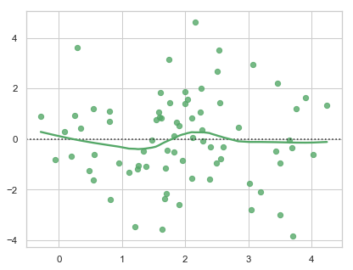

- https://zhiyzuo.github.io/Linear-Regression-Diagnostic-in-Python/
- https://medium.com/@neuralnets/statistical-data-visualization-series-with-python-and-seaborn-for-data-science-5a73b128851d
- https://medium.com/@emredjan/emulating-r-regression-plots-in-python-43741952c034
- https://robert-alvarez.github.io/2018-06-04-diagnostic_plots/

import scipy as sp
fig, ax = plt.subplots(figsize=(6,2.5))
_, (__, ___, r) = sp.stats.probplot(residual, plot=ax, fit=True)
r**2
0.9523990893322951
