Lab1: Write a Pandas program to split the following data frame into groups based on Class and count the number of students in that particular class. Also generate a bar chart based on the result and explain the conclusion.

Input:

student_data = pd.DataFrame({'school_code': ['s001','s002', 's003','s001','s002','s004'],

'class': ['V', 'VI', 'VI', 'VI', 'V', 'VI'],

'name': ['Alberto Franco', 'Gino Mcneill', 'Ryan Parkes', 'Eesha Hinton', 'Gino Mcneill', 'David Parkes'],

'age': [12, 12, 13, 13, 14, 12],

'height': [173, 192, 186, 167, 151, 159], 'weight': [35, 32, 33, 30, 31, 32], 'address': ['street1', 'street2', 'street3', 'street1', 'street2', 'street4']},)

__________________________________________________________________________________

import pandas as pd

import matplotlib.pyplot as plt

student_data = pd.DataFrame({

'school_code': ['s001', 's002', 's003', 's001', 's002', 's004'],

'class': ['V', 'VI', 'VI', 'VI', 'V', 'VI'],

'name': ['Alberto Franco', 'Gino Mcneill', 'Ryan Parkes', 'Eesha Hinton', 'Gino Mcneill', 'David Parkes'],

'age': [12, 12, 13, 13, 14, 12],

'height': [173, 192, 186, 167, 151, 159],

'weight': [35, 32, 33, 30, 31, 32],

'address': ['street1', 'street2', 'street3', 'street1', 'street2', 'street4']})

# Group by Class and count the number of students

class_count = student_data.groupby('class').size()

print(class_count)

# Generate a bar chart

class_count.plot(kind='bar')

plt.title('Number of Students in Each Class')

plt.xlabel('Class')

plt.ylabel('Number of Students')

plt.show()

OUTPUT:

class

V 2

VI 4

dtype: int64

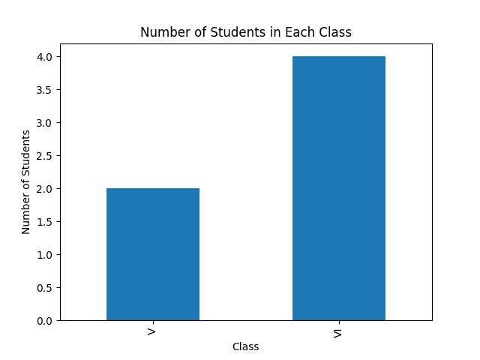

Lab2: Write a Pandas program to split the following data frame into groups and calculate monthly purchase amount.Also generate a bar chart based on the result and explain the conclusion.

Input:

df = pd.DataFrame({

'ord_no': [70001,70009,70002,70004,70007,70005,70008,70010,70003,70012,70011, 70013],

'purch_amt':[150.5,270.65,65.26, 110.5,948.5,2400.6,5760, 1983.43,2480.4,250.45, 75.29,3045.6],

'ord date':

['05-10-2012','09-10-2012', '05-10-2012','08-17-2012','10-09-2012','07-27-2012','10-09- 2012','10-10-2012','10-10-2012', '06-17-2012','07-08-2012', '04-25-2012'],

'customer_id':[3001,3001,3005,3001,3005,3001,3005,3001,3005,3001,3005,3005],

'salesman_id': [5002,5005,5001,5003,5002,5001,5001,5006,5003,5002,5007,5001]

})

Import pandas as pd

import matplotlib.pyplot as plt

# Given data frame

df = pd.DataFrame({

'ord_no': [70001, 70009, 70002, 70004, 70007, 70005, 70008, 70010, 70003, 70012, 70011, 70013],

'purch_amt': [150.5, 270.65, 65.26, 110.5, 948.5, 2400.6, 5760, 1983.43, 2480.4, 250.45, 75.29, 3045.6],

'ord_date': ['05-10-2012', '09-10-2012', '05-10-2012', '08-17-2012', '10-09-2012', '07-27-2012', '10-09-2012', '10-10-2012', '10-10-2012', '06-17-2012', '07-08-2012', '04-25-2012'],

'customer_id': [3001, 3001, 3005, 3001, 3005, 3001, 3005, 3001, 3005, 3001, 3005, 3005],

'salesman_id': [5002, 5005, 5001, 5003, 5002, 5001, 5001, 5006, 5003, 5002, 5007, 5001]

})

# Convert 'ord_date' column to datetime

df['ord_date'] = pd.to_datetime(df['ord_date'], format='%m-%d-%Y')

# Group by month and calculate monthly purchase amount

monthly_purch_amt = df.groupby(df['ord_date'].dt.strftime('%Y-%m'))['purch_amt'].sum()

print(monthly_purch_amt)

# Generate a bar chart

monthly_purch_amt.plot(kind='bar')

plt.title('Monthly Purchase Amount')

plt.xlabel('Month')

plt.ylabel('Purchase Amount')

plt.show()

OUTPUT:

ord_date

2012-04 3045.60

2012-05 215.76

2012-06 250.45

2012-07 2475.89

2012-08 110.50

2012-09 270.65

2012-10 11172.33

Name: purch_amt, dtype: float64

