Simple Restaurant Management Using Flask framework
ABSTRACT: -
The project Simple Restaurant Management System with Flask Web Framework aims to develop a basic web application to manage restaurant operations using Flask without relying on an external database management system. Flask, a lightweight and flexible web framework in Python, will be used to facilitate the implementation of CRUD (Create, Read, Update, Delete) functionalities for managing restaurant data, such as menu items, orders, and staff information. The application will feature a user-friendly interface accessible through a web browser, enabling restaurant owners or managers to efficiently handle essential tasks like adding new menu items, updating existing entries, viewing orders, and removing outdated records. The data will be stored within the application itself, providing a lightweight and standalone solution suitable for small-scale restaurant operations. The project will involve setting up Flask routes and views to manage different restaurant-related tasks, creating intuitive forms for data input, designing visually appealing templates using HTML for frontend displays, and incorporating basic error handling and input validation.

EXSISTING SYSTEM | PROPOSED SYSTEM
- Tkinter is a standard Python library used for creating graphical user interfaces (GUIs) in desktop applications. It is one of the most popular and widely-used libraries for building interactive and visually appealing desktop applications due to its simplicity and integration with Python. Tkinter provides a robust set of tools, widgets, and functionalities that allow developers to design user-friendly interfaces with minimal effort. These widgets include buttons, labels, text boxes, menus, checkboxes, radio buttons, and canvas elements, which can be customized to suit the requirements of the application. Tkinter’s event-driven programming model enables developers to create dynamic and responsive applications by defining events and binding them to specific actions. With its ability to integrate seamlessly with Python’s functionality, Tkinter makes it possible to handle complex back-end processes while providing an intuitive front-end interface. Additionally, Tkinter supports layout management through geometry managers like pack, grid, and place, allowing developers to organize widgets effectively. Its cross-platform compatibility ensures that applications built with Tkinter can run on Windows, macOS, and Linux without requiring significant modifications. Whether for creating simple tools or more complex desktop applications, Tkinter is a powerful choice for developers seeking to build interactive and functional GUIs in Python. | - Flask is a lightweight and versatile web framework for Python, emphasizing simplicity and ease of use in web development. It provides the essential tools and libraries for building web applications rapidly and efficiently, while maintaining flexibility to accommodate diverse use cases.  - Following the "micro-framework" philosophy, Flask keeps its core simple and extensible, empowering developers to incorporate only the components necessary for their particular project needs. With its minimalist design and modular architecture, Flask allows developers to create scalable and customizable web applications, making it a popular choice for projects of all sizes and complexities within the Python ecosystem.  - Unlike full-stack frameworks that come with predefined tools for handling every aspect of a web application, Flask provides just the essentials, such as a routing system, a built-in development server, templating engine (Jinja2), and session management. This allows developers the freedom to choose third-party libraries or components for specific tasks like form validation, database interaction, authentication, and more. The flexibility of Flask ensures that it can scale from simple applications to more complex, large-scale web platforms by seamlessly integrating with various extensions like Flask-SQLAlchemy for database management, Flask-Login for user authentication, and Flask-Mail for email functionalities.
EXISTING ALGORITHM  - Tkinter | PROPOSED ALGORITHM: -  - Flask
The Discrete Fourier Transform (DFT) is a fundamental tool in audio signal processing and watermarking because it converts signals from the time domain to the frequency domain. This transformation is critical because it allows audio data to be represented as a series of frequency components, which can be more effectively manipulated for embedding information, such as digital watermarks. In watermarking schemes, DFT is used to modify specific frequency components of the audio signal in such a way that the watermark data is hidden within the audio without causing noticeable distortions. The process works by altering the frequency coefficients—values that represent the magnitude and phase of different frequencies within the audio. Since the human ear is less sensitive to subtle changes in certain frequency bands, modifying these coefficients enables the embedding of watermark information in a way that is largely imperceptible to listeners, thus preserving the quality of the audio while securing it with the embedded data.  However, while DFT has been widely adopted for its ease of use in frequency domain watermarking, it is not without its limitations. One of the major vulnerabilities of DFT-based watermarking systems is their susceptibility to attacks such as noise addition and compression. These attacks can disrupt the frequency coefficients that have been modified to contain watermark data.  In addition to the DFT, the Signal-to-Error Ratio (SER) is another critical aspect of audio watermarking systems, serving as a key metric for evaluating the quality of the watermarked signal. SER is used to measure the extent to which the watermarking process has affected the original audio signal. | ALGORITHM DEFINITION: -  - Flask's architecture is designed to follow the principles of WSGI (Web Server Gateway Interface), ensuring that it can work with different web servers and platforms, making it highly portable. Its routing system is intuitive, allowing developers to map URL paths to functions easily, facilitating the creation of RESTful APIs and dynamic web pages. Flask also supports a variety of templating options, most notably the Jinja2 templating engine, which allows developers to separate logic from the presentation layer for cleaner and more maintainable code. The framework's flexible configuration system makes it easy to manage different environments, such as development, testing, and production, enabling seamless transitions between them.  - Flask's popularity also stems from its supportive and active community. With a wealth of tutorials, documentation, and third-party extensions available, developers can find resources to implement nearly any feature they need. This broad community support, combined with Flask’s extensive compatibility with other Python libraries, makes it an ideal choice for both beginners and experienced developers. Furthermore, its compact size and low overhead make Flask particularly well-suited for microservices architecture, rapid prototyping, and projects that demand speed and flexibility without a steep learning curve. Whether building a small personal project or scaling up to a complex web application, Flask provides the tools, flexibility, and extensibility required to meet a wide range of development needs.
DRAWBACKS: -  - Limited Widget Variety: Compared to other GUI frameworks, Tkinter has a limited selection of widgets, making it challenging to design highly sophisticated or feature-rich interfaces. Developers may need to implement custom solutions for advanced requirements.  - Performance Limitations: Tkinter is not optimized for high-performance applications, particularly those involving complex graphics or heavy animations. This can result in slower response times and less fluid user experiences compared to modern frameworks.  - Cross-Platform Inconsistencies: While Tkinter is cross-platform, its appearance and behavior can vary between operating systems, leading to inconsistencies in user experience and additional development effort to ensure uniformity. | ADVANTAGES: -  - Lightweight and Minimalistic: Flask follows the "micro-framework" philosophy, providing the essential tools needed for web development without unnecessary bloat. It focuses on simplicity, making it easy to learn and use, especially for developers who are new to web development.  - Highly Flexible and Extensible: Flask is modular and allows developers to integrate only the components they need, without being forced into a rigid framework structure. Developers can choose libraries and extensions that best suit their project's requirements, whether for database management, form handling, authentication, or other features.  - Easy to Learn and Use: Flask’s simple core design makes it beginner-friendly. It offers clear and concise documentation, making it easy for new developers to understand the framework quickly. This ease of use allows for rapid development and prototyping.  - Built-in Development Server: Flask comes with a built-in development server that allows developers to test their applications locally before deploying them to a production server. This feature speeds up development and simplifies debugging.

SYSTEM ARCHITECTURE:
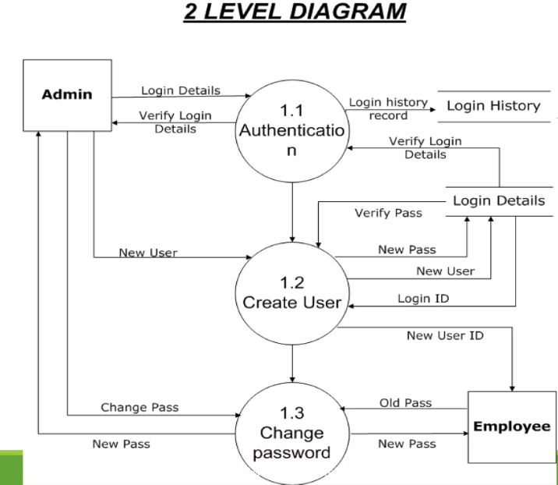

Fig: - proposed model

MINIMUMSYSTEM REQUIREMENTS
HARDWARE REQUIREMENTS
- PROCESSOR : Pentium i3 Processor
- RAM : 4GB DD RAM
- HARD DISK : 500 GB

SOFTWARE REQUIREMENTS
- BACK END : PYTHON
- OPERATING SYSTEM : WINDOWS 10
- IDE : Spyder3

