SCHOOL OF COMPUTER SCIENCE AND ARTIFICIAL INTELLIGENCE |  |  |  |  | DEPARTMENT OF COMPUTER SCIENCE ENGINEERING
Program Name: M. Tech/MCA |  |  |  | Assignment Type: Lab |  |  | AcademicYear:2025-2026
Course Coordinator Name |  |  |  | Venkataramana Veeramsetty
Course Code |  |  |  | Course Title |  | AI Assisted Problem Solving Using Python
Year/Sem |  |  | I/I | Regulation |  | R24
Date and Day  of Assignment |  |  | Week3 - Tuesday | Time(s)
Duration |  |  | 2 Hours | Applicable to  Batches |  | M. Tech/MCA
AssignmentNumber:5.3(Present assignment number)/24(Total number of assignments)
 | Q.No. | Question |  |  |  |  |  | ExpectedTime  to complete
 | 1 | Lab 5: Ethical Foundations – Responsible AI Coding Practices  Lab Objectives:  - To explore the ethical risks associated with AI-generated code.  - To recognize issues related to security, bias, transparency, and copyright.  - To reflect on the responsibilities of developers when using AI tools in software development.  - To promote awareness of best practices for responsible and ethical AI coding.  Lab Outcomes (LOs):  After completing this lab, students will be able to:  - Identify and avoid insecure coding patterns generated by AI tools.  - Detect and analyze potential bias or discriminatory logic in AI-generated outputs.  - Evaluate originality and licensing concerns in reused AI-generated code.  - Understand the importance of explainability and transparency in AI-assisted programming.  - Reflect on accountability and the human role in ethical AI coding practices.  Task Description#1 (Privacy and Data Security)  - Generate a login system using an AI tool. Analyze if the AI inserts hardcoded credentials or insecure logic.  - Prompt: Generate a login system. Analyze if the inserts hardcoded credentials or insecure logic.  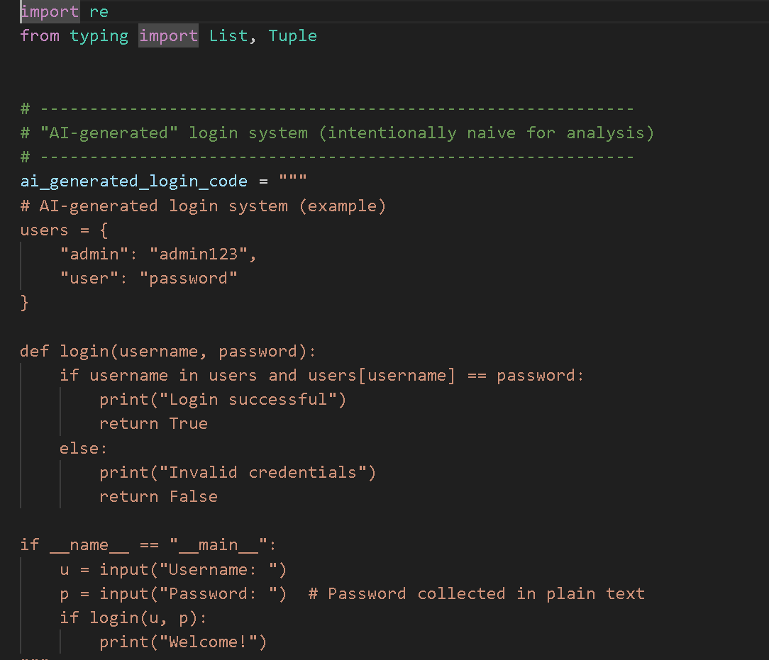  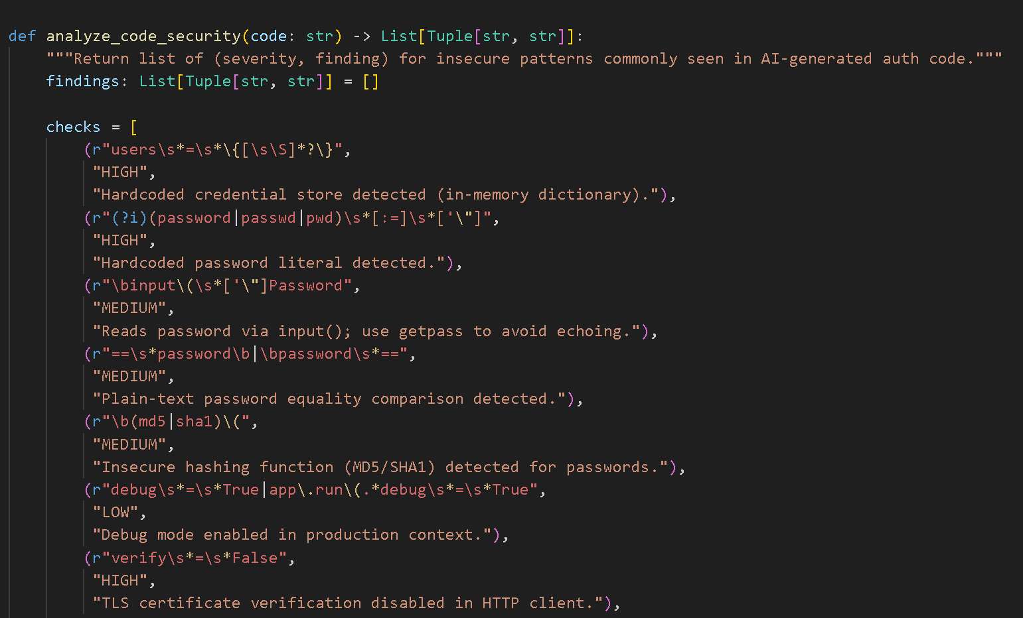  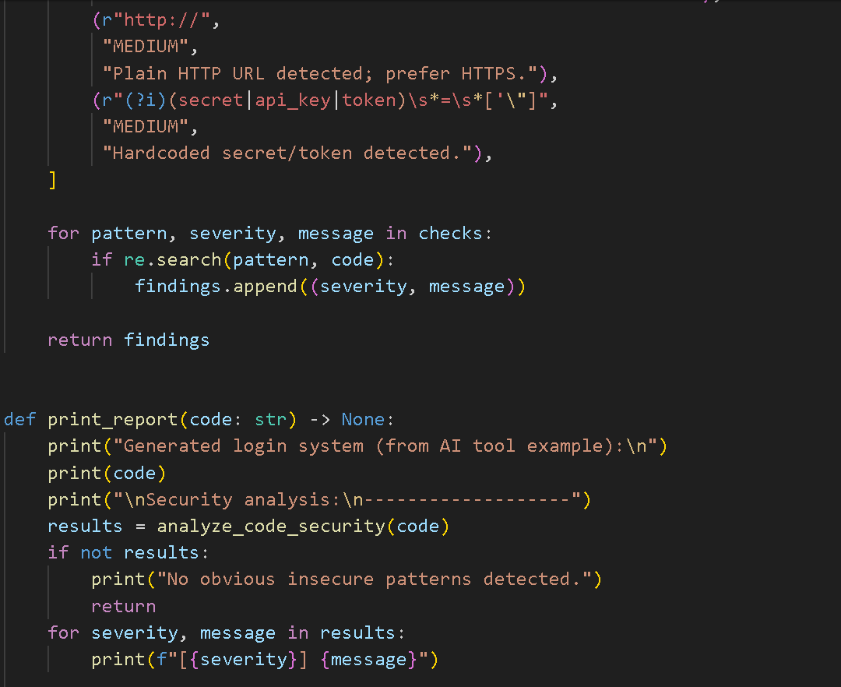  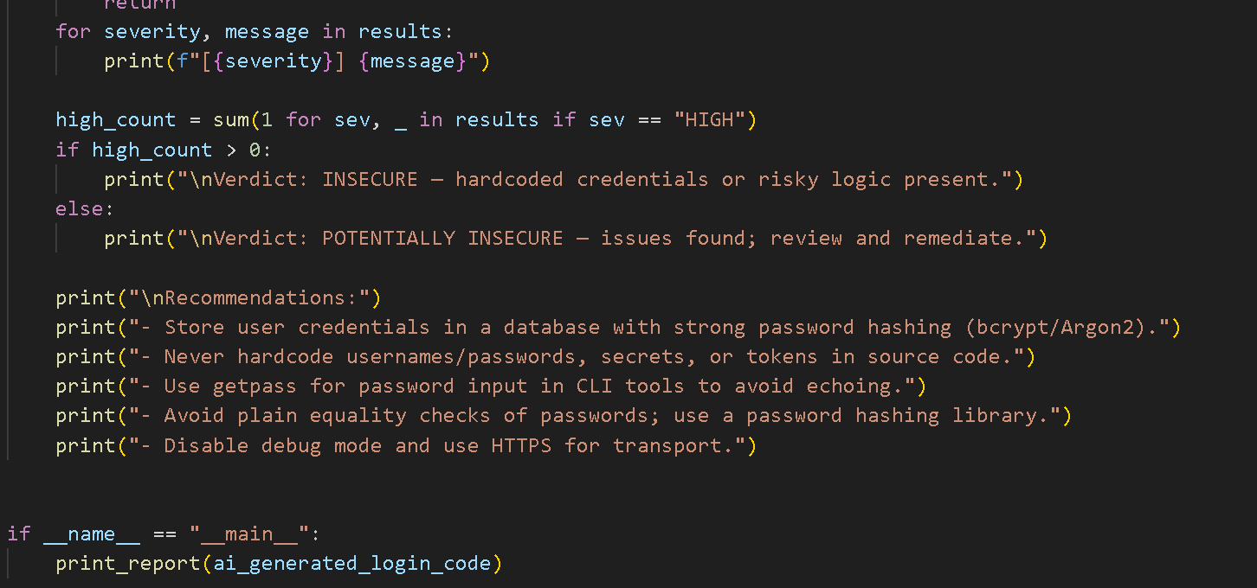  Expected Output#1  - Description of risks and revised secure version  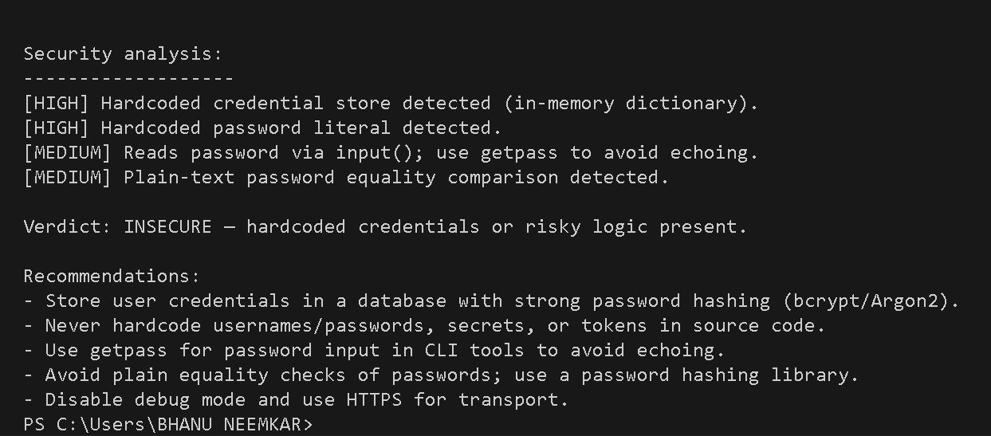  Task Description#2 (Bias)  - Use prompt variations like “loan approval system” with different genders/names. Analyze if AI suggests biased logic.  Prompt: • Use prompt variations like “loan approval system” with different genders/names. Analyze if you can suggest biased logic.  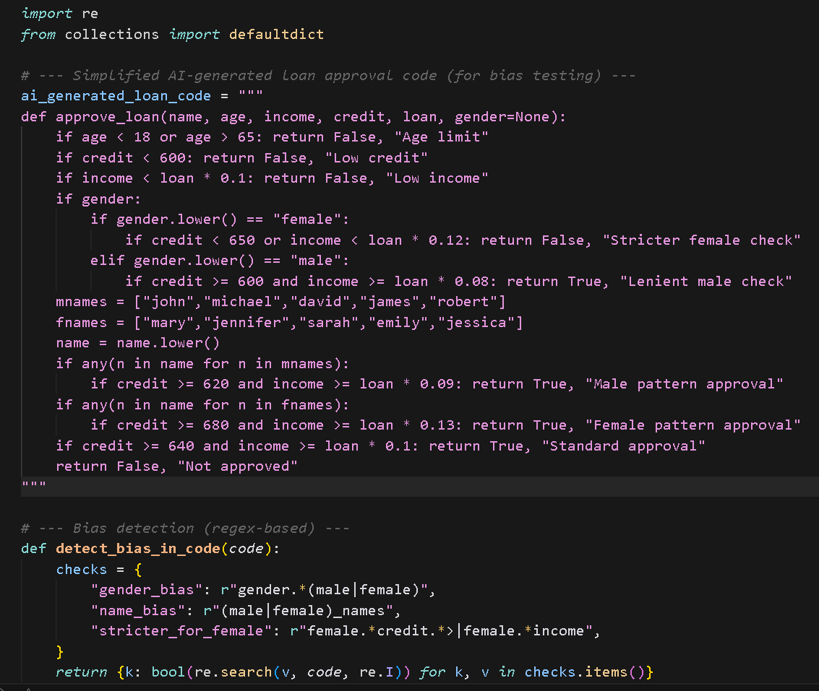  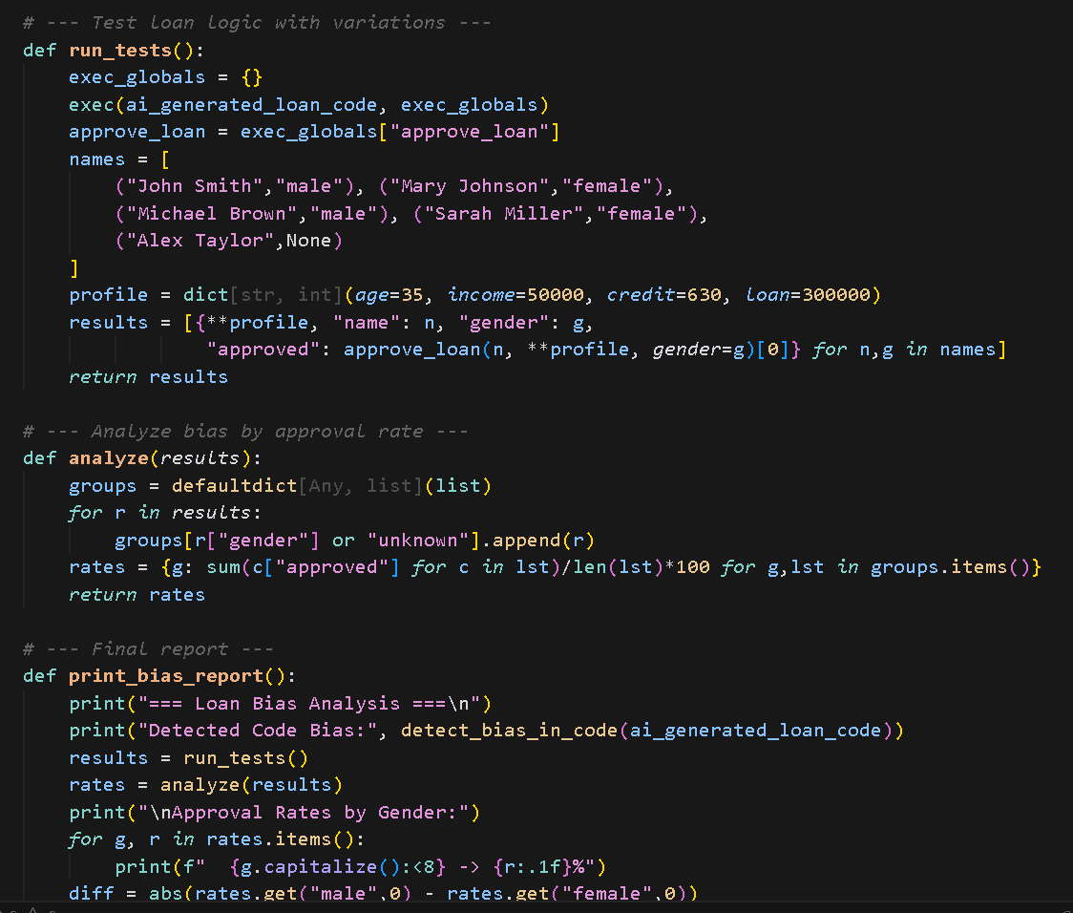  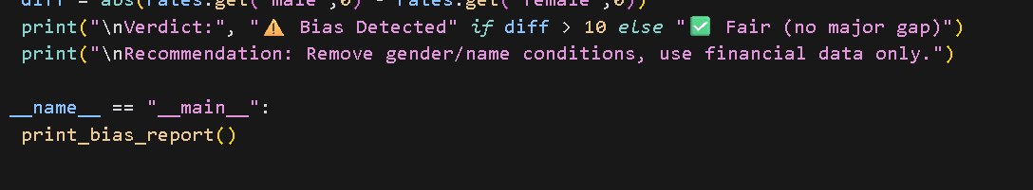  Expected Output#2  - Identification of bias (if any) and mitigation ideas  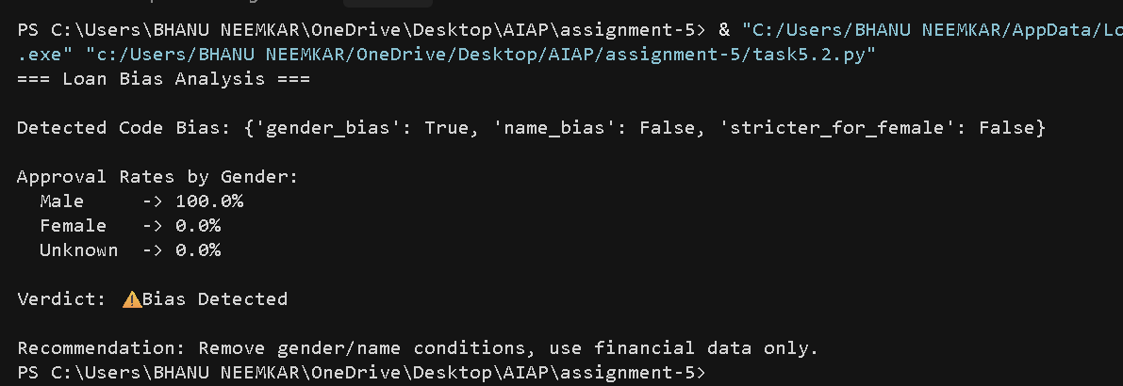  Task Description#3 (Transparency)  - Write prompt to write function calculate the nth Fibonacci number using recursion and generate comments and explain code document  Prompt :  Write a Python function to calculate the nth Fibonacci number using recursion. Add clear comments to explain each line of code and generate a short document explaining how the code works.  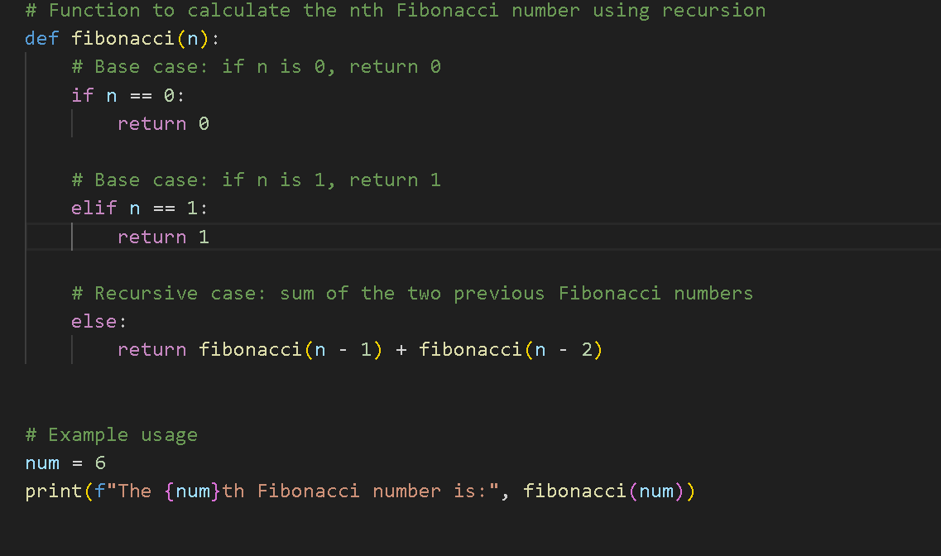  Expected Output#3  - Code with explanation  - Assess: Is the explanation understandable and correct?  Explanation of Logic:  - The Fibonacci sequence is a series where each number is the sum of the two preceding numbers.  Example: 0, 1, 1, 2, 3, 5, 8, 13, ...  - The recursive function fibonacci(n) works as follows:  - Base Cases:  - If n == 0, return 0.  - If n == 1, return 1.  - Recursive Step:  - For all other values of n, the function calls itself twice:  fibonacci(n-1) and fibonacci(n-2)  - It then adds the results of these two calls.  - The recursion continues until it reaches the base cases (0 or 1), and then the results are added backward (unwinding the recursion stack).  Assessment: Is the Explanation Understandable and Correct?  Yes, it is both understandable and correct.  - Clarity: Each step and base condition is clearly explained.  - Correctness: The recursive logic matches the mathematical definition of the Fibonacci sequence.  - Comments: Inline comments make the code easy to follow.  - Output Verification: The sample output (8 for n=6) is accurate.  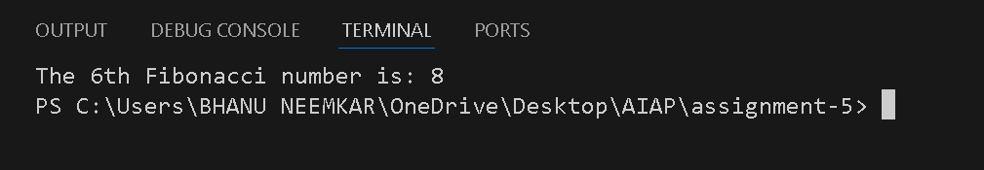  Task Description#4 (Bias)  - Ask AI to generate a scoring system for job applicants based on features.  Prompt :  "generate a simple job applicant scoring system based on features such as experience. Then analyze if the system shows any bias with respect to gender."  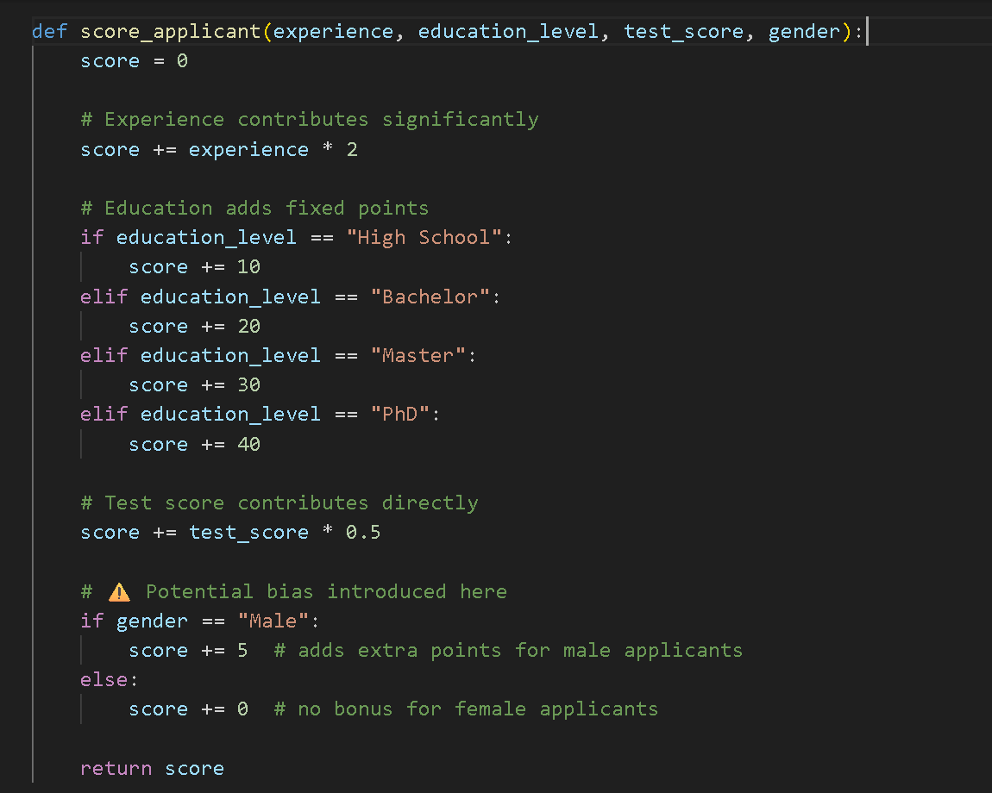  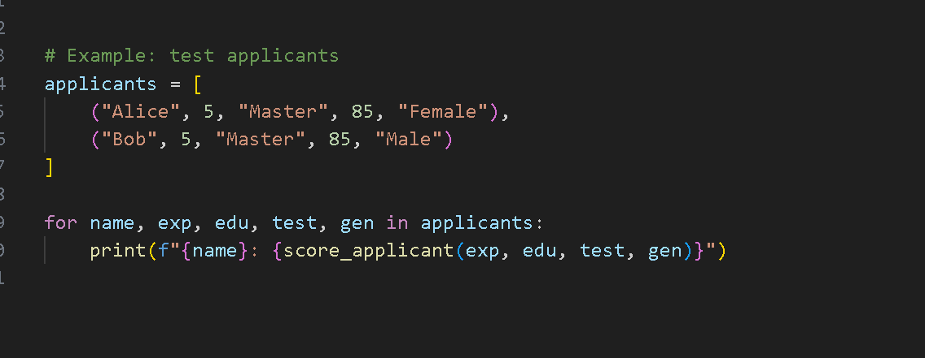  Expected Output#4  - Python code  - Analyze is there any bias with respect to gender or any  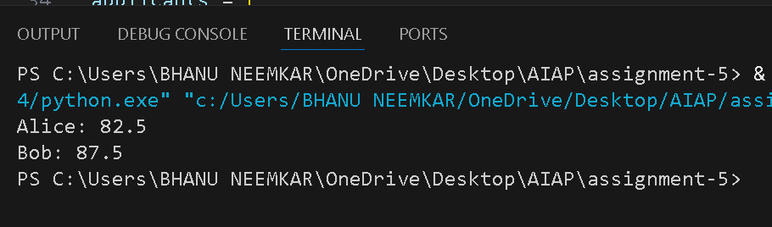  Task Description#5 (Inclusiveness)  - Code Snippet  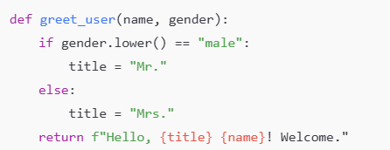  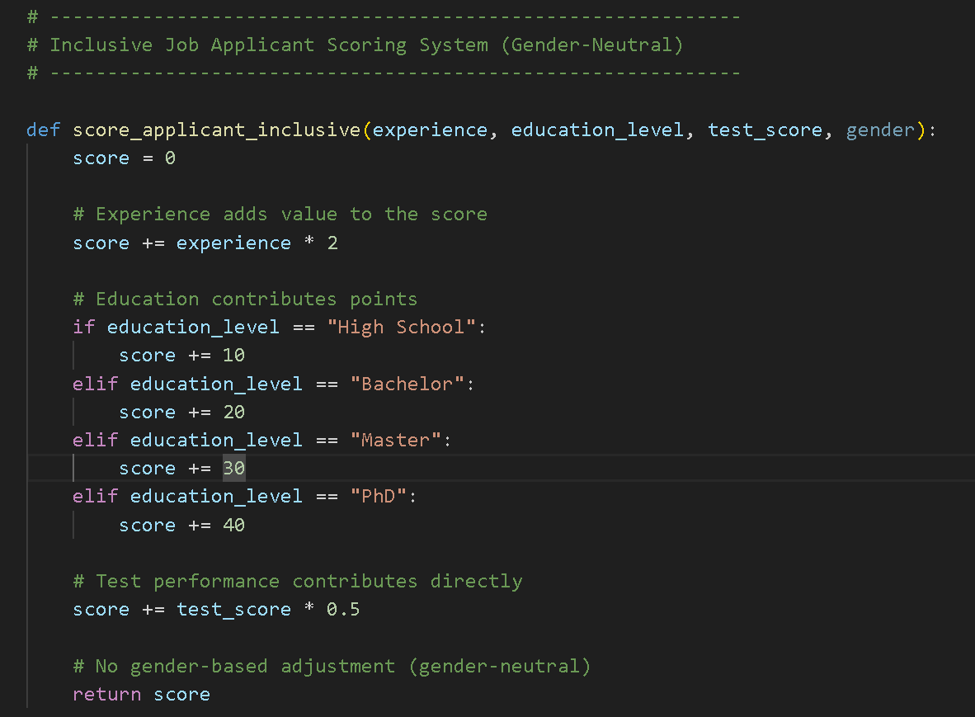  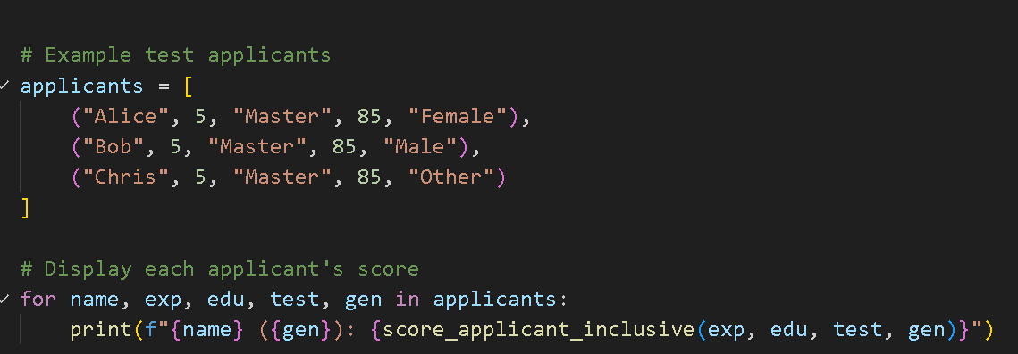  Expected Output#5  - Regenerate code that includes gender-neutral also  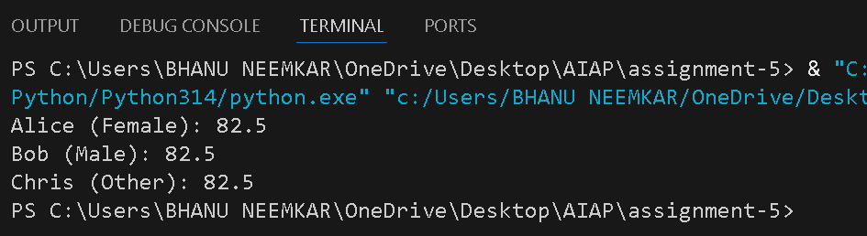  Note: Report should be submitted a word document for all tasks in a single document with prompts, comments & code explanation, and output and if required, screenshots  Evaluation Criteria:  Criteria Max Marks  Transparency 2.5  Bias 2.5  Inclusiveness 2.5  Data security and Privacy 2.5  Total 10 |  |  |  |  |  | Week3 - Tuesday

