Query 1: creating tables
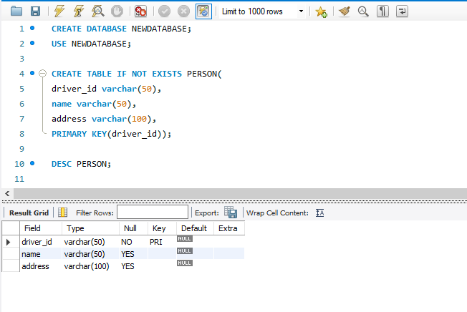

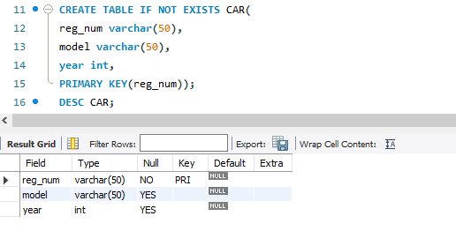
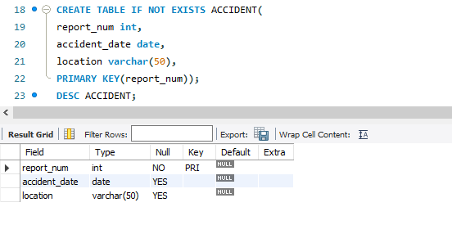
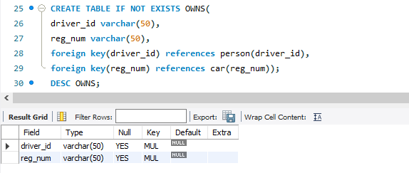

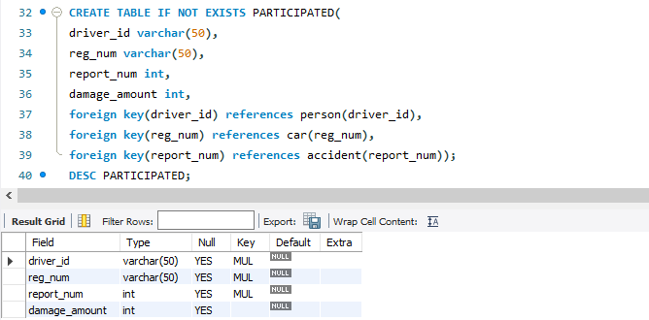

Query 2: inserting values into tables
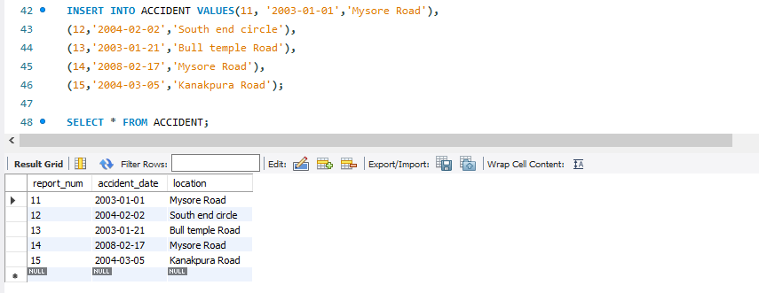

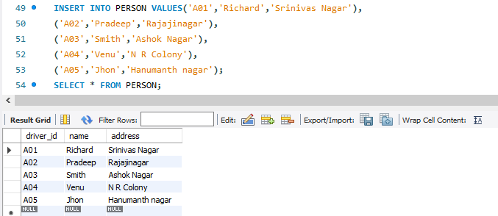

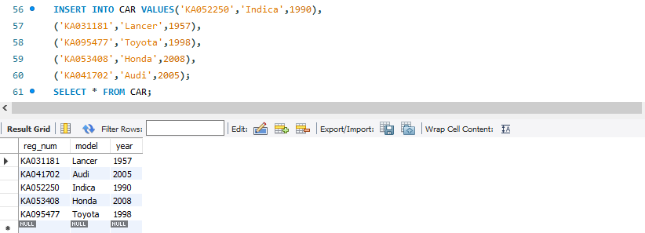
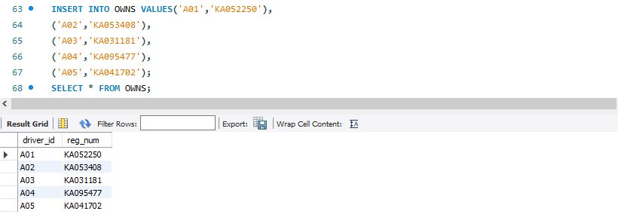

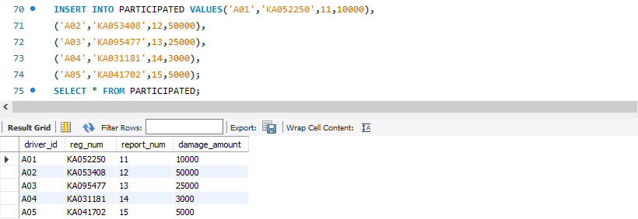

Query 3: Update the damage amount to 25000 for the car with a specific reg-num (example 'KA053408' ) for which the accident report number was 12.

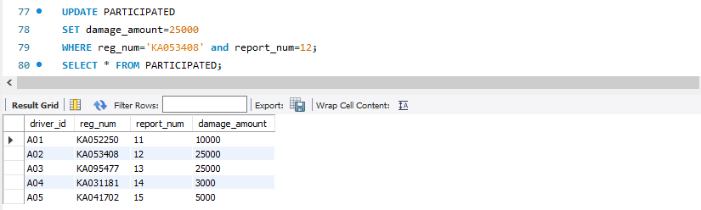

Query 4: Find the total number of people who owned cars that were involved in accidents in 2008.

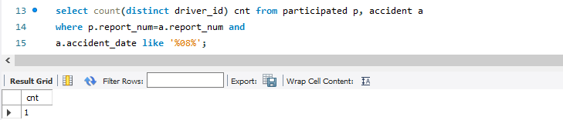

Query 5: Adding a new accident to the database.
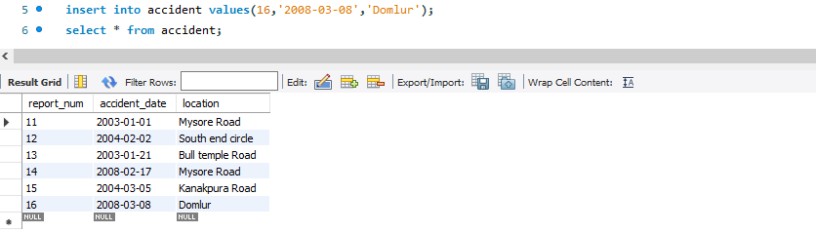

Query 6: Display Accident date and location

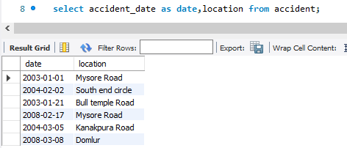
Query 7: Display driver id who did accident with damage amount greater than or equal to Rs.25000

