ANUDIP FOUNDATION
A Project Report on
ONLINE ART GALLERY
By
Batch: ANP-C7344
Student ID: AF0368266
Name: Nandini Saka
Student ID: AF0368589
Name: Akanksha Mamdyal
Under the Guidance of
Mrs. Rajshri Chandrabhan Thete

ONLINE ART GALLERY

Online Art gallery management system project helps the owner of the art gallery to maintain the details of the artists, paintings, clients, orders, stock etc.

ENTITIES:
- Customer
- Order
- Arts
- Order list
- Category

VARIOUS ENTITIES:

- Customer

- Customer_id
- Customer_name
- Contact
- Address
- Amount Spent

- Order

- Order_id
- Painting_id
- Customer_id
- Price
- Date
- Phone
- Confirmation

- Artists

- Name
- Birthplace
- Style
- Age
- Artist_id

- Order List

- Title
- Quantity
- Price
- Category_id
- Artist_id

- Category

- Name
- Category_id

ENTITY RELATIONSHIP DIAGRAM – ONLINE ART GALLARY

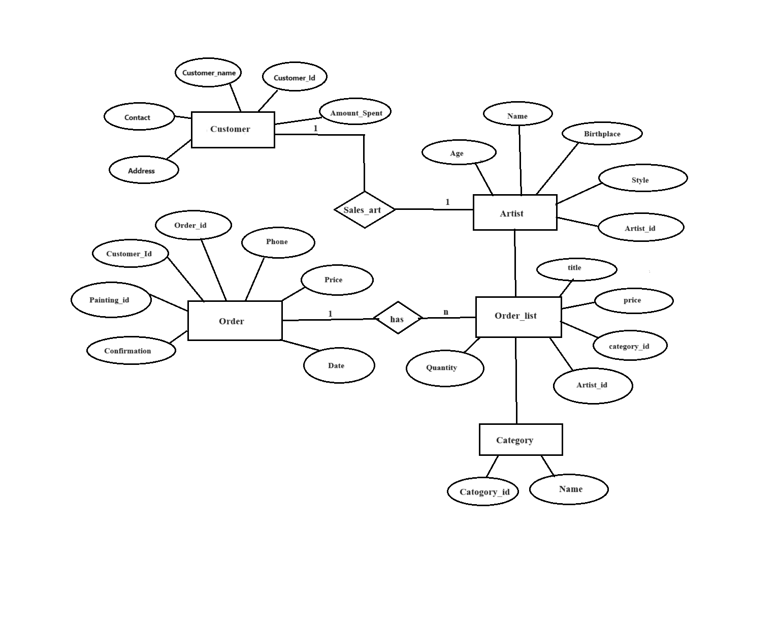

CLASS DIAGRAM FOR ONLINE ART GALLARY

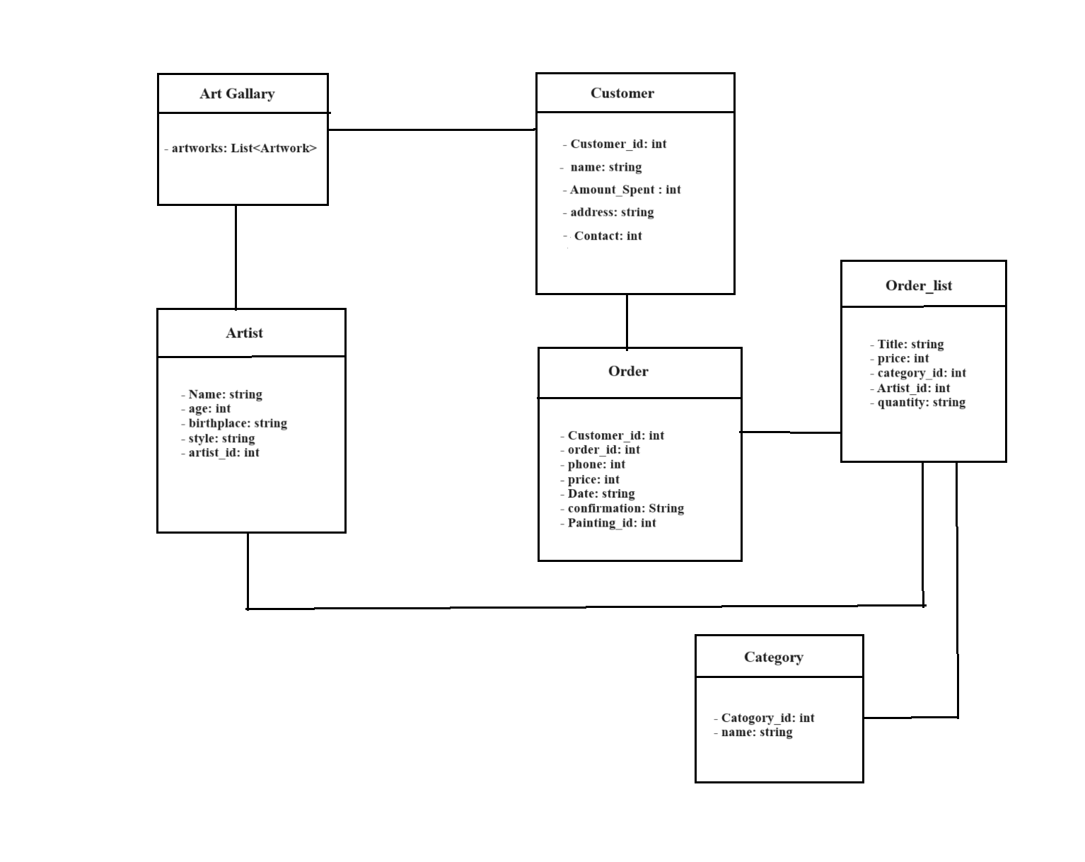

CONCLUSION

In conclusion, the emergence of online art galleries marks a transformative chapter in the history of art appreciation. These digital platforms transcend geographical limitations, making art accessible to a global audience. The customer journey map underscores the importance of a seamless, engaging, and personalized experience, while empathy elevates this experience, connecting visitors to the artists and their creative narratives.
As technology continues to evolve, the potential for even more immersive and interactive online art galleries is immense. The fusion of art and technology allows us to redefine how we perceive, understand, and connect with creative expressions. Whether through VR experiences or interactive storytelling, the online art gallery is a testament to human innovation and our enduring relationship with art.

