NAME :NANDINI.S.KUMAR

AMAZON SIMPLE STORAE(S3)
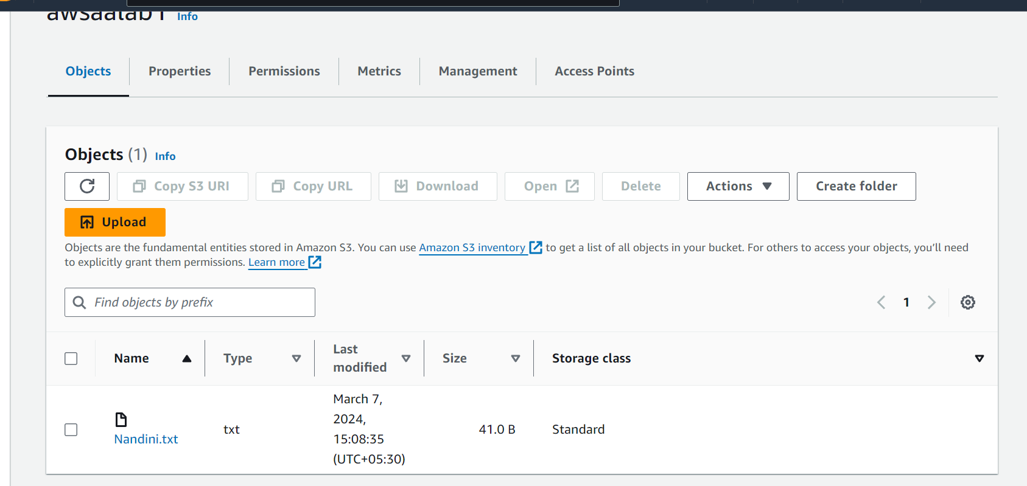

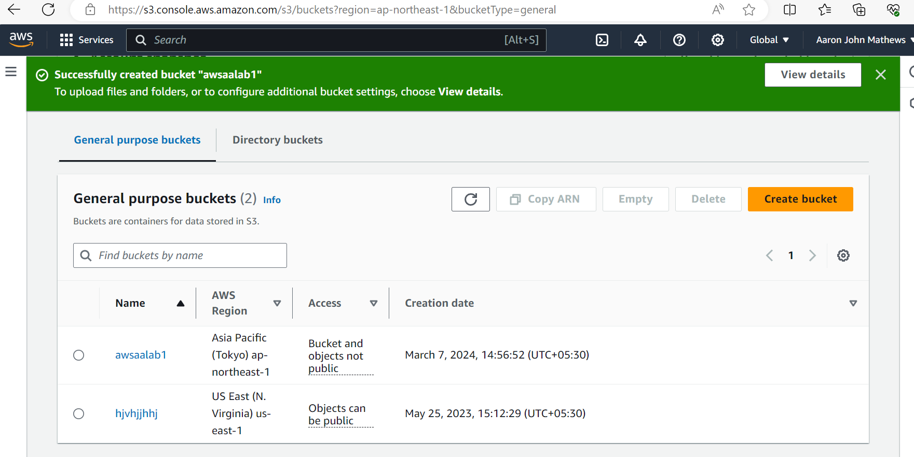
LAB-3 AMAZON ELASTIC COMPUTE CLOUD
LAUNCH AN EC2 INSTANCE
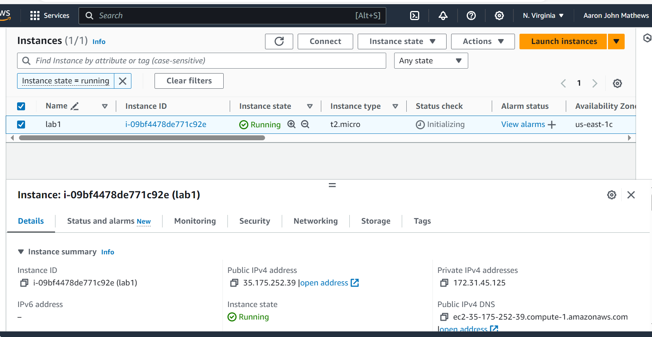
Task 2: Allocate and Associate an Elastic IP Address with your EC2 Instance
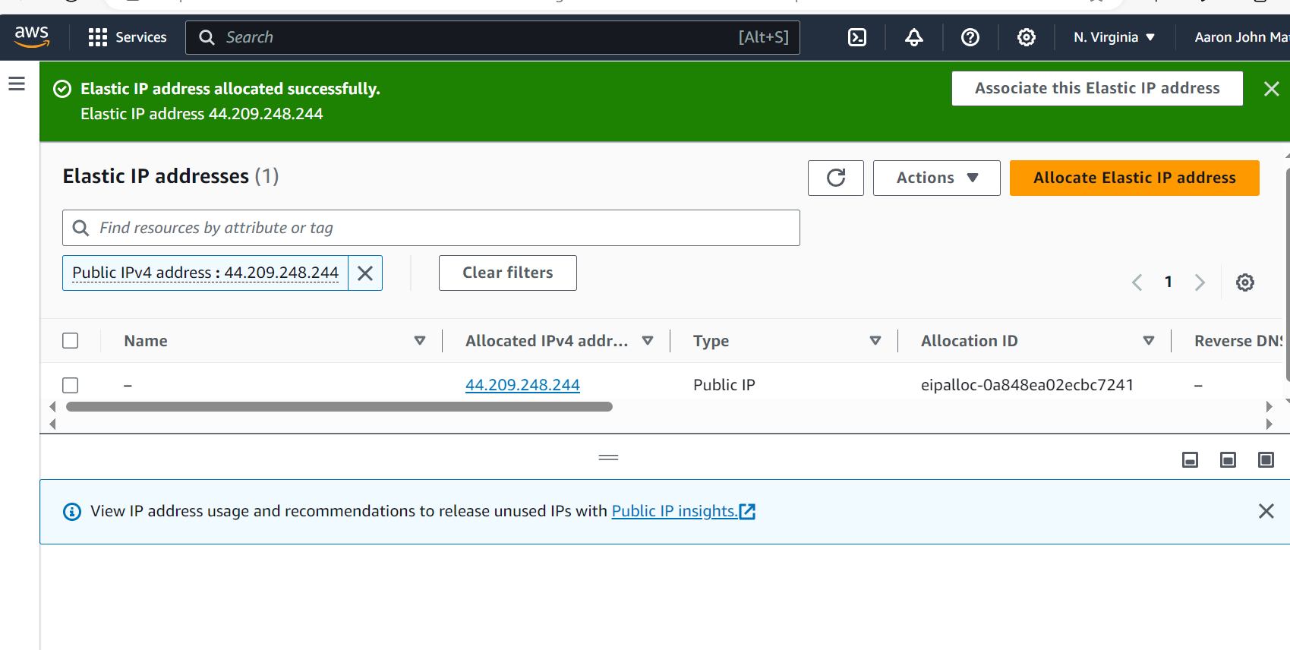
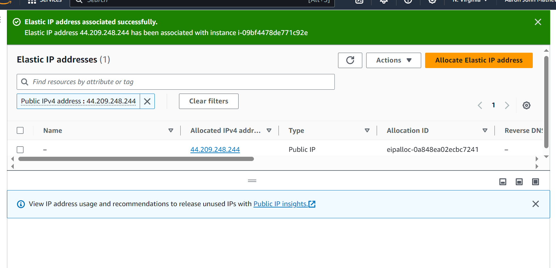

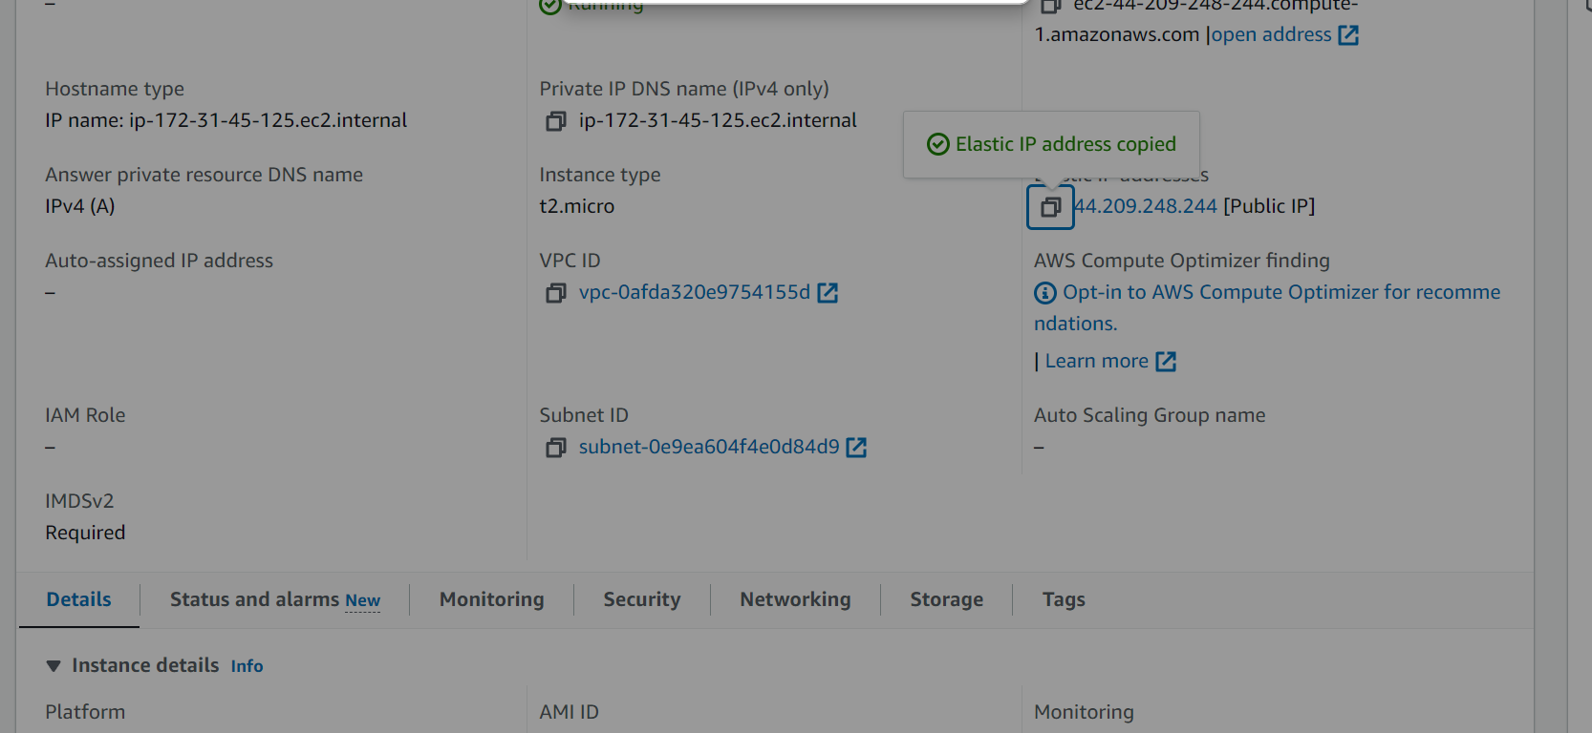
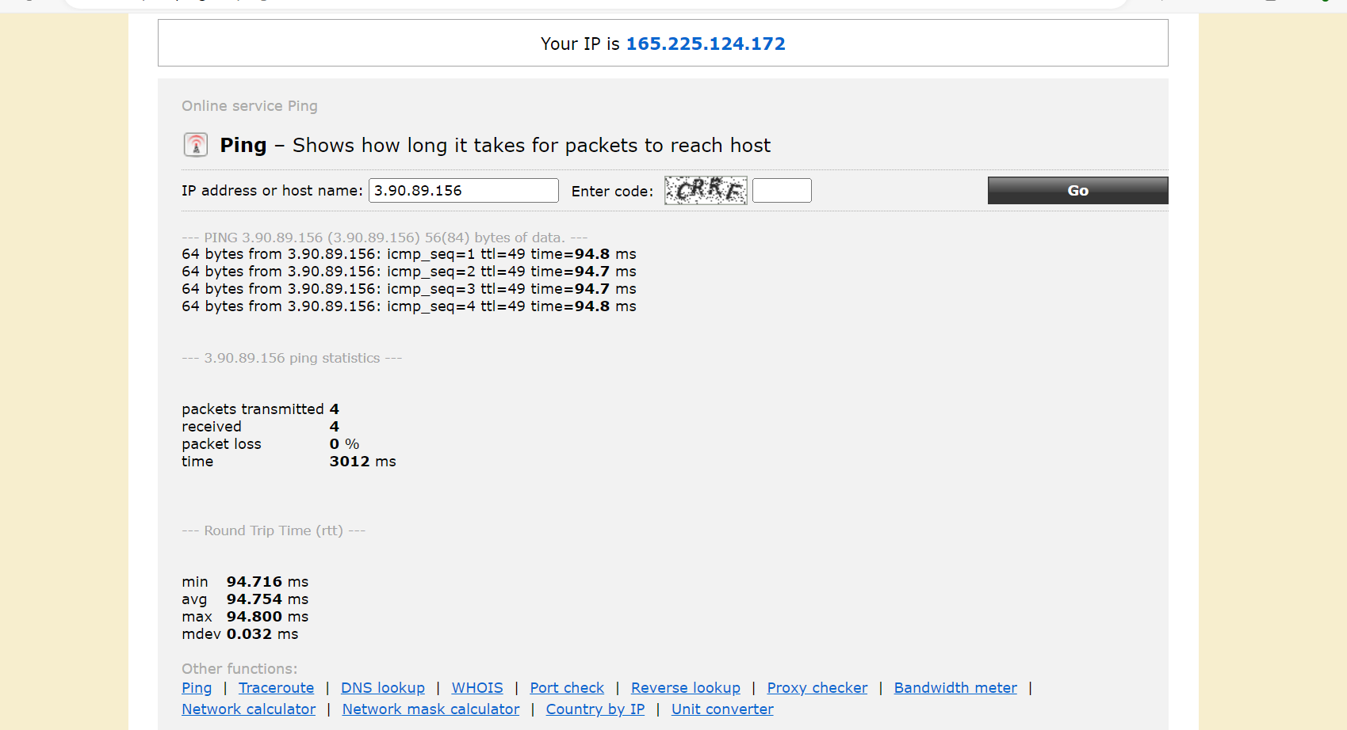
Lab 4: Creating a Lambda function that gets triggered when image is uploaded into S3 bucket folder
