Macro-Economic Causal Modeling with Vector Autoregression (VAR)
Week 8 Task: Stationarity, AIC Lag Selection, VAR Estimation and Impulse-Response Analysis
Data note: the series in this report are simulated for illustration (quarterly, 1990Q1 to 2024Q4) so that the full pipeline is demonstrated end to end. Replace the data-loading step with real GDP, inflation and interest-rate series (e.g. FRED, RBI or MOSPI) and re-run the code in Section 8; all tables and figures will update, and the interpretation must then be rewritten for the real results.

1. Objective
Model the joint dynamics of output, inflation and interest rates with a VAR, and use impulse-response functions (IRFs) to understand how shocks propagate and what they imply for corporate and market conditions. The workflow is: (i) verify stationarity, (ii) choose the lag length by AIC, (iii) estimate the VAR, (iv) validate it, (v) run Granger causality, IRF and variance decomposition, (vi) forecast.

2. Model and Method
A VAR(p) for a vector y of k variables is:
y_{t} = c + A₁ y_{t-1} + ... + A_{p} y_{t-p} + e_{t}, e_{t} ~ (0, Σ)
Stationarity. The ADF test has a unit root as its null hypothesis; the KPSS test has stationarity as its null. A series is treated as stationary only if ADF rejects (p < 0.05) and KPSS does not reject (p > 0.05). Non-stationary series are differenced.
Lag selection. AIC(p) = ln|Σ̂(p)| + 2pk²/T. The lag with the smallest AIC is chosen; BIC and HQIC are reported for robustness.
Impulse responses. Orthogonalised (Cholesky) IRFs trace the effect of a one-standard-deviation shock to one variable on all variables. The ordering used is GDP growth, then inflation change, then interest-rate change (output is assumed not to react contemporaneously to prices or rates; the policy rate reacts to both).

3. Data
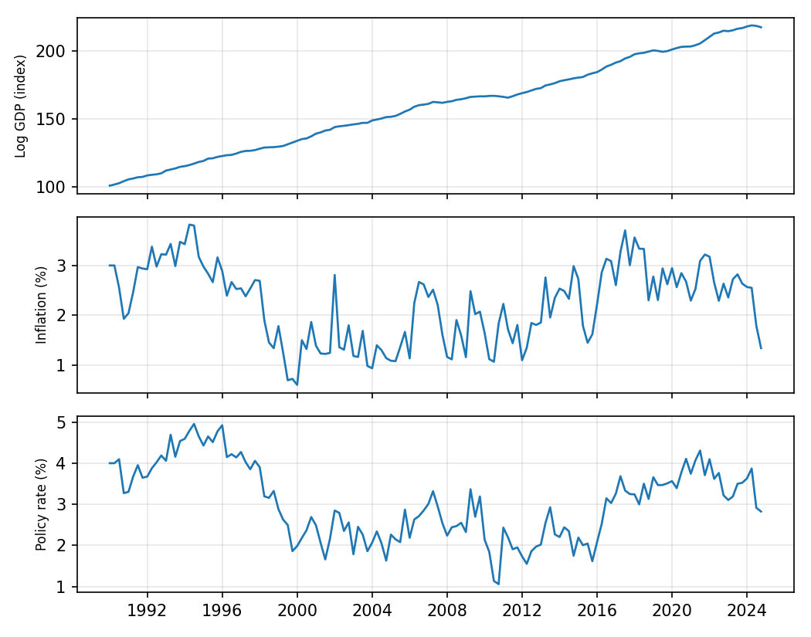

4. Stationarity Tests
In levels:
Series | ADF p | KPSS p | Verdict
log_gdp | 0.914 | 0.010 | Non-stationary
inflation | 0.026 | 0.100 | Stationary
rate | 0.201 | 0.037 | Non-stationary

After transformation (GDP: log-difference, i.e. growth; inflation and rate: first difference):
Series | ADF p | KPSS p | Verdict
gdp_growth | 0.000 | 0.100 | Stationary
d_inflation | 0.000 | 0.100 | Stationary
d_rate | 0.000 | 0.100 | Stationary

Log GDP and the policy rate fail the joint test in levels. Inflation passes narrowly in this sample, but it is differenced as well for consistency (persistent inflation is often near-unit-root in real data). All three transformed series pass, so the VAR is estimated on the transformed (stationary) variables.

5. Lag Selection and Estimation
Lag | AIC | BIC | HQIC
1 | -4.781 | -4.526 | -4.677
2 | -4.795 | -4.348 | -4.613
3 * | -4.838 | -4.195 | -4.577
4 | -4.706 | -3.866 | -4.365
5 | -4.656 | -3.618 | -4.234
6 | -4.565 | -3.327 | -4.062
7 | -4.502 | -3.061 | -3.916
8 | -4.377 | -2.731 | -3.709

AIC is minimised at p = 3 (marked *). A VAR(3) is fitted on 139 observations. Stability check: all characteristic roots lie inside the unit circle (stable).

6. Granger Causality
Cause | Effect | F-test p | Significant (5%)
d_inflation | gdp_growth | 0.107 | No
d_rate | gdp_growth | 0.975 | No
gdp_growth | d_inflation | 0.365 | No
d_rate | d_inflation | 0.939 | No
gdp_growth | d_rate | 0.284 | No
d_inflation | d_rate | 0.058 | No

Granger causality means that past values of the cause improve prediction of the effect; it indicates predictive precedence, not structural causation.

7. Impulse-Response and Variance Decomposition
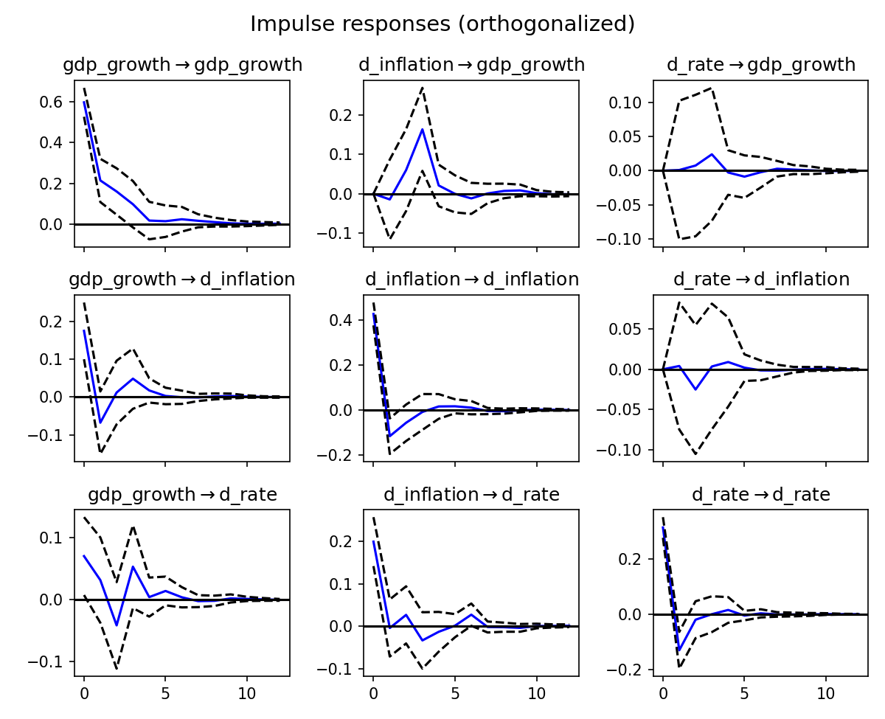
Orthogonalised IRFs with 95% bands (12 quarters).
Reading the results. GDP growth is zero on impact in response to a rate shock by construction (Cholesky ordering). Afterwards the response is tiny (largest value -0.009 at quarter 5) and the 95% band includes zero throughout, so in this simulated sample there is no statistically meaningful effect of interest-rate shocks on output. The clearest dynamics are own-shock persistence and the inflation-to-GDP response around quarters 2-3. All responses die out within about 8 quarters, consistent with a stable VAR. With real data, report which responses are significant and at what horizon.
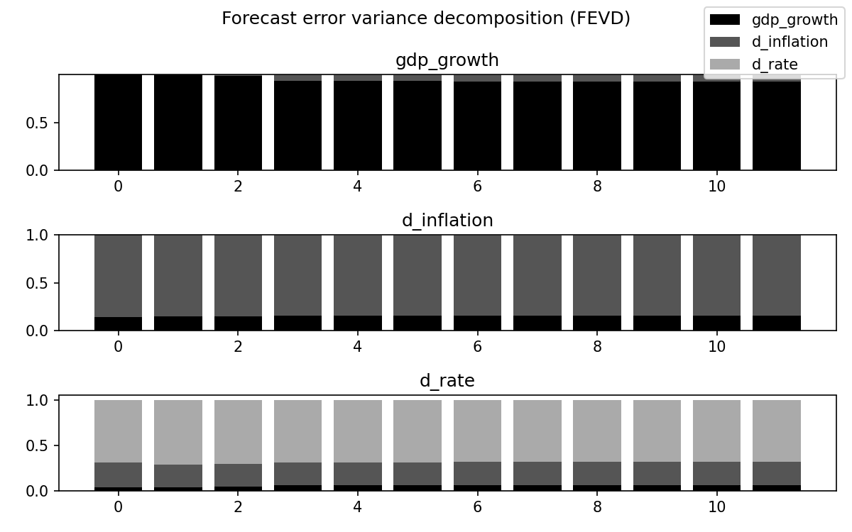
Forecast error variance decomposition: share of each variable's forecast uncertainty attributable to each shock.

Forecast and Corporate Implications
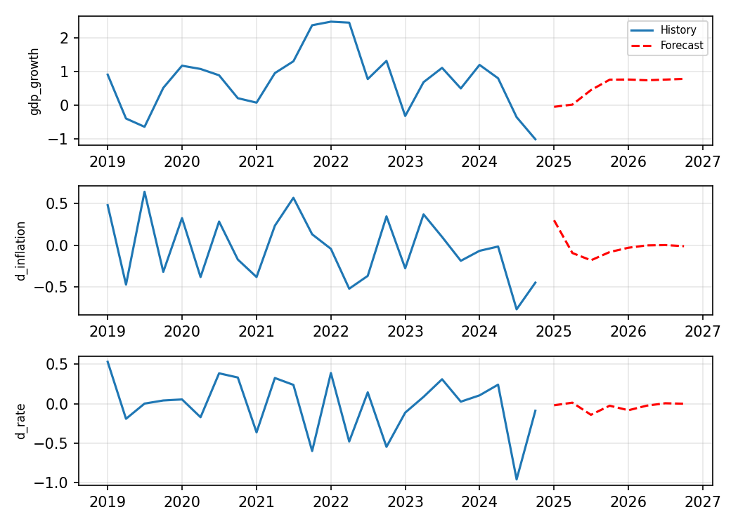
Business interpretation (framework). Monetary tightening that lowers output growth with a lag signals weaker demand, margin pressure and lower earnings for rate-sensitive and cyclical sectors (real estate, autos, capital goods), while higher funding costs squeeze leveraged firms. A positive output-growth shock supports revenue growth and investment. Firms can use IRF timing (the quarter of peak response) to plan hedging, pricing and capex. Re-state these conclusions using your real-data IRFs.

Limitations
Cholesky ordering affects IRFs; small samples make AIC lag choice noisy; structural breaks (2008, 2020) can invalidate stable-parameter assumptions; Granger causality is not structural causation.

8. Reproducible Code
import pandas as pd, numpy as np
from statsmodels.tsa.stattools import adfuller, kpss
from statsmodels.tsa.api import VAR

df = pd.read_csv("macro.csv", index_col=0, parse_dates=True) # log_gdp, inflation, rate
def check(s):
return adfuller(s.dropna(), autolag="AIC")[1], kpss(s.dropna(), nlags="auto")[1]
data = pd.DataFrame({"gdp_growth": df["log_gdp"].diff(),
"d_inflation": df["inflation"].diff(),
"d_rate": df["rate"].diff()}).dropna()
model = VAR(data)
p = model.select_order(maxlags=8).aic
res = model.fit(p)
print(res.summary(), res.is_stable())
irf = res.irf(12); irf.plot(orth=True, signif=0.05)
res.fevd(12).plot()
print(res.forecast(data.values[-p:], steps=8))

