# **Stock Portfolio Optimizer**

**Date:** 6th june 2024

**Submitted by:** TiruvalluriNandini – 22KQ1A0733

**Details of Project:** I’m implementing this project by using Python Programming Language.

**Code:**

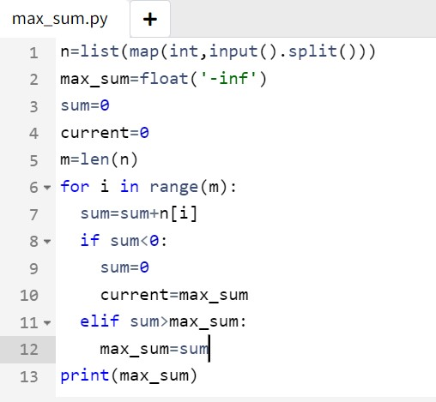

**Input and output:**

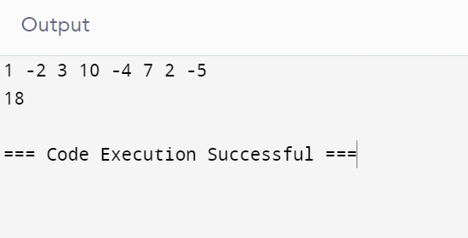

**Explanation:**

In this program I have implemented project name which is nothing but stock portfolio optimizer. This program finds the maximum sum of a subarray within a given array of integers. It uses Kadane’s algorithm, Which iterates through the array . Initially read input from the user.we take ‘max_sum’ as ‘-inf’ (negative infinity)because we want to ensure that the first sum we calculate will be greater than it.This is because we’re looking for the maximum sum,and ‘-inf’ is the smallest possible value and also sum is initially taken as zero. Adding each element to a running sum. If the sum becomes negative, it resets to 0.The maximum sum found is stored and printed at the end.

**Conclusion:**

Finally I have got the desired output maximum sum subarray is :

1 -2 3 10 -4 7 2 -5

18