NANDINI WADHWA
Leadership, Fashion & Performing Arts Portfolio
Lady Shri Ram College For Women | Sanskriti School, Chanakyapuri, New Delhi
nandiniwadhwanw@gmail.com | +91-73036 47715

1. Nazaakat — President, Fashion Society of LSR
LSR's first and only fashion society | President, 2024–25 | Lady Shri Ram College For Women, New Delhi

About Nazaakat & LSR
Lady Shri Ram College For Women (LSR) is one of India's most prestigious women's colleges — ranked consistently in the top 3 nationally, holding a NAAC A++ accreditation and a NIRF Top 10 ranking. With approximately 4,000 students across arts and sciences, LSR is widely regarded as one of the most competitive and culturally vibrant institutions in the University of Delhi circuit.
Nazaakat (नज़ाKat — meaning elegance, refinement, grace) is the first and only fashion society ever established at LSR. The society was founded to create a formal, multidisciplinary platform for fashion design, styling, editorial photography, and creative expression within one of India's most academically rigorous institutions — a genuinely historic initiative.

Nazaakat LSR on Instagram (@nazaakat.lsr)

My Role as President
I was elected President of Nazaakat — leading a first-of-its-kind fashion society at a Top 10 national institution with no prior fashion body. The role demanded building institutional credibility and administrative legitimacy from near-scratch, managing a multi-vertical executive team, producing high-quality flagship events, and positioning Nazaakat as a respected creative force within Delhi University's student fashion circuit — all while being a full-time first-year student.

Strategic Leadership & Vision
- Helmed LSR's first-ever fashion society as President — directing a cross-functional executive team spanning programming, PR, design, photography, styling, and sponsorship
- Set the society's annual vision, creative theme calendar, and full event roadmap — building Nazaakat's institutional identity from an early-stage organisation into a recognised DU fashion body
- Navigated significant institutional complexity: secured faculty support, administrative recognition, and inter-departmental collaboration for a society with no precedent at LSR
- Represented Nazaakat at inter-college events, establishing the society as a credible collaborator within Delhi's student fashion ecosystem and receiving invitations from brands, designers, and partner societies

Flagship Showcase Production
- Architected and delivered Nazaakat's annual flagship fashion showcase — the society's highest-profile event of the academic year — achieving 200+ cumulative footfall across the season's events
- Managed the full creative and operational production pipeline: concept development, set and aesthetic direction, model casting, stylist and photographer coordination, music and lighting briefs, and day-of show management
- Oversaw editorial shoot production for the showcase — directing models, photographers, and designers across multiple themed looks and collection presentations
- Ensured every event reflected Nazaakat's brand identity: polished, intentional, and forward-looking in aesthetic approach — setting a benchmark for fashion-forward programming at LSR

Brand Partnerships & Sponsorship
- Spearheaded Nazaakat's brand outreach strategy — cold-pitching, negotiating, and onboarding fashion labels, emerging Delhi-based designers, and lifestyle brands as partners
- Secured multi-brand partnerships for seasonal showcases, establishing Nazaakat as a credible partner for brands seeking access to LSR's high-engagement student and alumni audience
- Managed the end-to-end partnership lifecycle: outreach, pitch decks, negotiation, activation deliverables, and post-event reporting
- Positioned Nazaakat's sponsorship model as sustainable for future presidencies — setting commercial infrastructure that outlasts the year

Community & Digital Presence
- Built and scaled a multidisciplinary creative community at LSR — bringing together students passionate about fashion, design, styling, photography, content creation, and modelling
- Ran structured recruitment, onboarding, and creative brief processes to develop member skills and foster a collaborative, high-standard culture within the society
- Managed Nazaakat's Instagram presence (@nazaakat.lsr) — overseeing content strategy, editorial shoot posts, event coverage, and brand partner content to grow the society's digital footprint across the DU circuit

Key Metrics & Achievements
Role | President — Nazaakat, Fashion Society of LSR
Institution | Lady Shri Ram College For Women (NAAC A++, NIRF Top 10, ranked #1 in BA by India Today 2025)
Society Significance | First and only fashion society ever at LSR
Flagship Showcase | 200+ cumulative footfall across the season's events
Brand Partnerships | Multi-brand partnerships secured for seasonal showcases
Team | Cross-functional executive team — programming, PR, design, photography, sponsorship
Social Media | @nazaakat.lsr — active presence in Delhi University fashion circuit

Modelling Portfolio — Nazaakat Shoots & Editorial Work
As President and a model for Nazaakat, I participated in and directed editorial shoots produced by the society. I also have an independent modelling portfolio developed through campus showcases and personal editorial projects — spanning Indo-western styling, contemporary fashion, and lifestyle editorial.

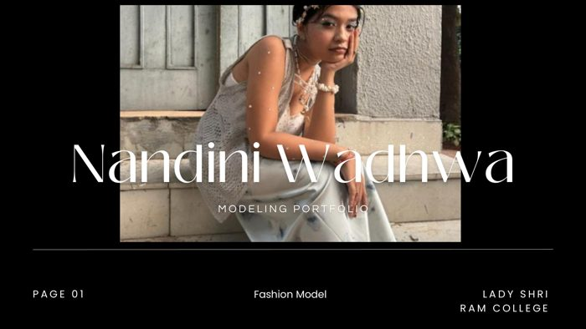
Modeling Portfolio — Cover | Nandini Wadhwa, Fashion Model, LSR
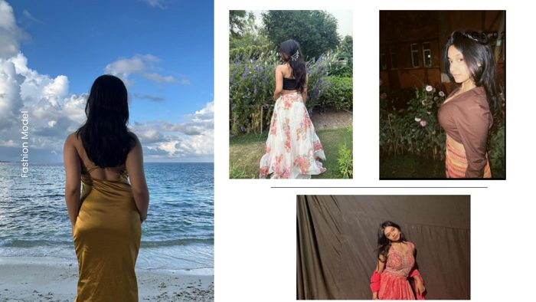
Editorial Shoots — Beach, Garden & Studio Looks
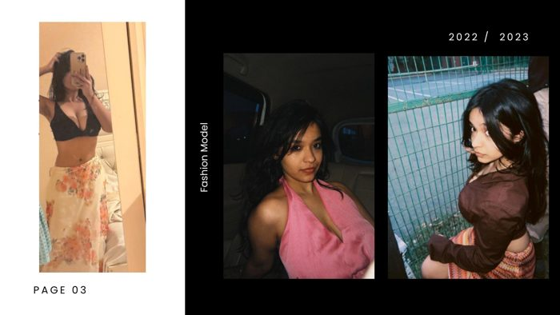
2022 / 2023 Campaign — Editorial & Lifestyle Photography
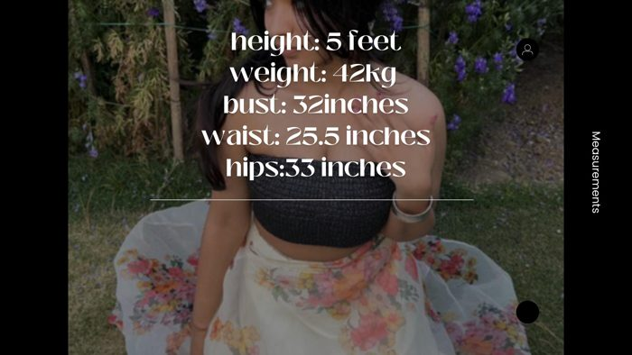
Model Measurements Card

Model Measurements
Height | 5 feet
Weight | 42 kg
Bust | 32 inches
Waist | 25.5 inches
Hips | 33 inches

2. Spotlight — President, English Debate & Theatre Club
Sanskriti School, Chanakyapuri, New Delhi | CBSE Top 10, Central Delhi | President, Spotlight | Grades 10–12

About Sanskriti School
Sanskriti School is one of Delhi's most distinguished co-educational CBSE day schools, located in the diplomatic enclave of Chanakyapuri on Dr. S. Radhakrishnan Marg. Founded in 1998 under the Civil Services Society — an NGO led by senior IAS officers and their families — the school is a premier institution with approximately 2,859 students from nursery through Class XII, consistently ranked among the Top 10 private schools in Central Delhi.
The school is architecturally centred around a 600-seat amphitheatre — the heart of its cultural life — used for assemblies, investiture ceremonies, theatre productions, and its iconic inter-school competition StageKraft: an annual debate, theatre, and choreography festival that draws participants from DPS RK Puram, The Mother's International School, Mayo College Girls' School, Ajmer, Future Foundation School Kolkata, and other leading schools from across India.

Sanskriti School Official Website

About Spotlight
Spotlight is Sanskriti School's flagship English debate and theatre club — the most visible co-curricular society in the school's cultural ecosystem. It represents Sanskriti in parliamentary debate circuits, theatrical productions at StageKraft, Model United Nations conferences, and public speaking competitions at the district, state, and national level. Holding the presidency of Spotlight at Sanskriti is among the most selective and high-profile student leadership roles in the school.

My Role as President
I was elected President of Spotlight during my senior years, overseeing the club's competitive debate programme, theatrical productions, MUN delegation, membership training, and inter-school competition strategy. The role demanded creative vision, institutional authority, and the ability to coach and lead a high-achieving cohort of students across multiple simultaneous programmes.

Competitive Debate Leadership
- Led Spotlight's competitive English debate programme — training members across parliamentary, Asian parliamentary, British parliamentary, and MUN formats
- Designed preparation timelines, ran weekly debate training sessions, built teams for specific competition formats, and managed Sanskriti's entry into the inter-school circuit
- Achieved state-level debater status — representing Sanskriti at the highest tier of school debating in Delhi, competing against institutions like DPS RK Puram, Springdales, and Modern School
- Directed Sanskriti's delegation to Harvard Model United Nations (HMUN) — one of the most prestigious and competitive international MUN conferences — managing delegate selection, position paper development, committee preparation, and conference logistics
- Served simultaneously as Director for MUN at the school level — running Sanskriti's internal MUN programme and coaching delegates for external conferences
- Mentored junior members through structured sessions on argumentation, rebuttal, cross-examination, and oratory — building the next generation of Spotlight debaters

Theatre Production
- Produced and directed theatrical performances at StageKraft — Sanskriti's flagship annual inter-school competition in debate, theatre, and choreography, which attracts national participation including schools from Kolkata, Chandigarh, Ajmer, and Varanasi
- Sanskriti School competed in StageKraft's Shakespeare Musical and theatrical categories against DPS RK Puram (who enacted King Lear), The Mother's International School, and other top-ranked school theatre programmes
- Managed end-to-end production from the president's chair: script selection and direction, casting, rehearsal scheduling, costume briefing, set design coordination, and live performance management in Sanskriti's 600-seat amphitheatre
- Led internal school theatrical productions for Annual Day, Investiture Ceremony, and inter-house competitions — ensuring Spotlight's productions were consistently the most polished on campus

Student Council & Institutional Leadership
- Selected for Sanskriti's prestigious student council body — a competitive process with a less than 5% selection rate from the student body
- As President of Spotlight, built and led a cross-functional club team covering debate, theatre, MUN, content, and logistics — managing schedules, faculty relationships, and inter-society coordination
- Set Spotlight's annual calendar, maintained the club's reputation as one of Sanskriti's most active and respected societies, and ensured institutional continuity for future leadership cohorts

Academic Achievement (Concurrent)
Alongside leading Spotlight, I maintained exceptional academic performance at Sanskriti School — consistently scoring above 95% in CBSE board examinations at both Class 10 and Class 12, topping 3 out of 5 subjects, and receiving the school's Academic Excellence Award for being in the top 1% of my batch.

Key Metrics & Achievements
Role | President — Spotlight, English Debate & Theatre Club
Institution | Sanskriti School, Chanakyapuri (Top 10 CBSE, Central Delhi; ranked in Top private schools in Delhi)
Student Council | Selected — less than 5% selection rate from entire student body
Debate Achievement | State-level debater; parliamentary, Asian parliamentary, British parliamentary formats
MUN | Director — Sanskriti MUN & Harvard MUN (international)
Theatre | StageKraft inter-school competition (national participation); Annual Day; Investiture Ceremony
Academic Excellence | 95%+ CBSE Class 10 & 12; topped 3/5 subjects; Academic Excellence Award, Top 1%

— End of Document —
Nandini Wadhwa | nandiniwadhwanw@gmail.com | +91-73036 47715

