ZENMA COFFEE
Live Project Internship — Work Portfolio
Nandini Wadhwa
Lady Shri Ram College For Women, New Delhi
nandiniwadhwanw@gmail.com | +91-73036 47715
September – December 2024
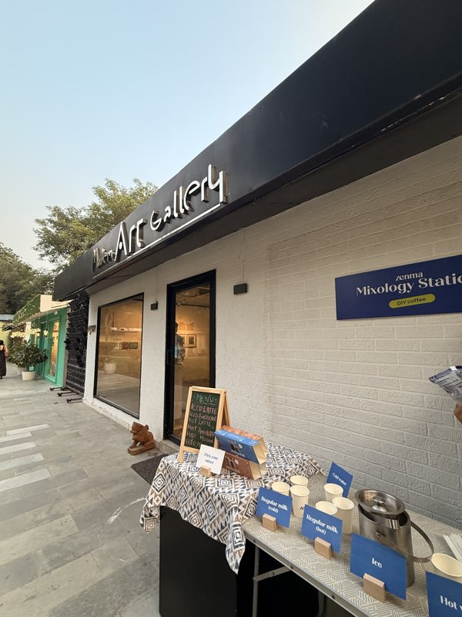 | 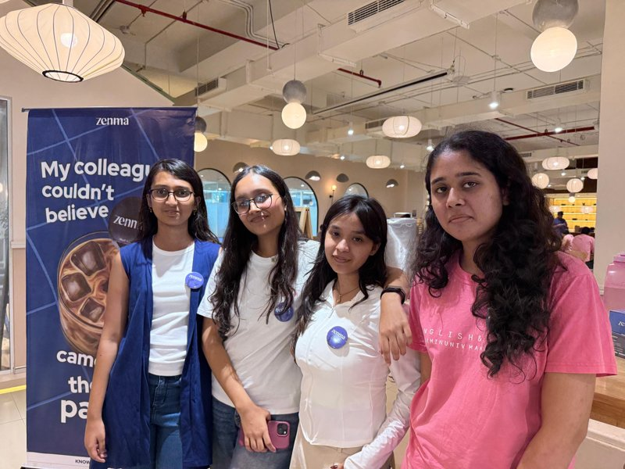
Zenma brand activation — New Delhi | Zenma pop-up event, September 2025

1. About Zenma
Zenma Coffee is India's first D2C brand offering flash-frozen espresso shots — a category-creating product that delivers barista-quality coffee at home in seconds. Founders Sheena and Karan Khurana built Zenma with backing from 100X.VC and Rebalance Accelerator, and the brand appeared on Shark Tank India Season 4, Episode 29. Available across 4 metros via their D2C website (zenmacoffee.com), Q-commerce platforms, and offline channels.

Product | Flash-frozen espresso shots (Zenma Shots)
Website | zenmacoffee.com
Instagram | @zenmacoffee — 5,513 followers, 232 posts
Shark Tank India | Season 4, Episode 29 — ₹60L for 3.5% equity ask
Cities | Delhi, Mumbai, Bengaluru, Pune

2. My Role & Mandate
Brand Activation Lead | Consumer Research | Social Media & Performance Marketing

I joined Zenma as a Live Project Intern during their high-visibility growth phase — immediately post-Shark Tank. My work spanned three pillars: spearheading offline brand activations across Delhi, conducting structured consumer research, and producing performance marketing content for digital growth. Everything I did was execution-first and directly tied to measurable GTM outcomes.

Headline Metrics
Brand Activation Events | 5+ events led across New Delhi
Consumer Touchpoints & Trials | 300+ at pop-up events
Consumer Interviews Conducted | 50+ structured interviews
Venue Partners Sourced | 12 venues (art galleries, co-working, fitness, run clubs)
Repeat Purchase Intent Improvement | ~12–15% (linked to packaging pivot from my research)
Distribution Efficiency Improvement | ~10–15% (cold-chain & ops research)
Social Engagement Lift | ~20–30% during campaign activation period

3. Brand Activations & Offline Pop-Up Events
Leading Zenma's offline activation strategy was my core responsibility. In a frozen D2C category where product trial is the single biggest conversion lever, getting coffee in people's hands at the right venues was everything. I owned this end-to-end.

What I Executed
- Planned and led 5+ brand activation events across New Delhi — managing logistics, venue coordination, cold-chain product integrity, and cross-functional on-ground teams
- Drove 300+ consumer touchpoints and product trials across all activations
- Negotiated activation arrangements with venues — barter deals, revenue-share models, and complimentary partnerships
- Built and managed the activation logistics toolkit: Zenma-branded pins, cup decorating stations (5–6 marker colours), standees, sticky note message boards, QR-code sample cards, and dry-ice cold chain for product display
- Sourced and onboarded 12 venue partners across art galleries, co-working spaces, fitness clubs, and run clubs in New Delhi

Venue Pipeline I Built
Modern Art Gallery | Warm Lead — Zenma as official beverage partner; co-branding on all event communications
WeWork (2 centres) | 1 meeting done — Forum (1,100 footfall) & Two Horizon (500 footfall); ₹7K barter per pop-up
Collative India | Free activation during Diwali event; ~500 footfall
Dire CrossFit | Workshop activations; 20–45 footfall per event; barter + revenue share negotiated
Delhi Run Collective | Warm lead — community-first run club audience
Run Xtreme | Warm lead — Facebook-based running community
Museo Camera | Warm lead — photography gallery, niche urban audience
Spring House (Co-working) | 3 Delhi centres, 250–400 footfall each; Diwali event activation
The Lexicon Art Gallery | Full barter — October end gala evening
Third Space / CoworkInsta | Calls and initial meetings done; footfall and barter details pending

Internal Tracker:
Activation Leads Spreadsheet (Google Sheets)
Master Activation Tracker (Google Doc)

4. Consumer Research & Market Intelligence
Every activation I ran doubled as structured consumer research. I used these touchpoints to generate insights that fed directly into Zenma's product, packaging, and pricing decisions — not just anecdotal feedback.

Consumer Interviews — 50+ Structured Sessions
- Designed and ran 50+ structured consumer interviews at pop-up events and through targeted outreach
- Mapped purchase barriers: cold-chain storage inconvenience was the #1 friction point for repeat purchase
- Identified taste quality as the strongest conversion trigger — product trial almost always resulted in positive response
- Segmented consumers into distinct clusters: specialty coffee enthusiasts, urban working professionals, college-age buyers, and D2C-native shoppers
- Translated findings into a SKU optimisation and product iteration framework presented to the team
- My research directly informed a packaging pivot that contributed to a ~12–15% improvement in repeat purchase intent and customer retention indicators

Market Intelligence & Distribution Research
- Identified cold-chain inefficiencies and last-mile distribution bottlenecks specific to frozen D2C products in Indian metros
- Analysed operational gaps across Zenma's Q-commerce and D2C logistics pipeline — contributing to ~10–15% improvement in distribution efficiency and unit economics
- Built competitive landscape mapping across D2C coffee brands: pricing, channel mix, and consumer positioning benchmarking
- Delivered demand forecasting and location strategy research to support Zenma's expansion planning beyond their initial 4-city footprint

5. Social Media Content & Digital Marketing
During the high-visibility post-Shark Tank window, I produced performance marketing assets and contributed to Zenma's content strategy on Instagram. Our content was Reels-first — short, product-led, and designed to drive trial and shareability.

What I Produced & Contributed
- Created performance marketing assets timed to Zenma's post-Shark Tank growth phase, contributing to ~20–30% lift in social engagement metrics and audience growth during the activation period
- Captured and curated on-ground content from pop-up events — consumer reactions, product-in-use moments, and activation b-roll — for use across Zenma's Instagram channels
- Contributed to brand voice consistency across all offline and online consumer-facing touchpoints
- Coordinated UGC-style documentation at activations: cup decorating moments, message board shots, and product trial photography

Reels I Worked On — @zenmacoffee
The following reels were produced during my internship period. Each was strategically designed to communicate product USP, drive trial, or deepen brand affinity:

- 'Melt it. Mix it. Drink it. Play with it.' — Core product demo reel; showcased the 'melt-and-sip' USP in 15 seconds
- 'We freeze it fast so you can sip it slow.' — Flash-freezing process reel; educated consumers on what makes Zenma shots unique
- 'Zenma 101: Ways to melt Zenma shots' — Educational onboarding reel for new consumers; reduced cold-chain confusion as a barrier
- 'Tasty hai. Jo bhi hai.' — Relatable, Hindi-language brand reel; drove engagement with a younger urban audience
- 'Our new website is up and running.' — D2C channel launch reel; drove traffic to zenmacoffee.com
- 'Welcome to the #SheenaSeries' — Founder content series reel; humanised the brand and built audience trust
- 'Welcome to PART 2 of the #SheenaSeries' — Continuation of founder series; deepened brand storytelling

Zenma Instagram — Platform Snapshot
Handle | @zenmacoffee
Followers | 5,513
Total Posts | 232
Content Format | Reels-first strategy
Brand Tagline | 'Good coffee shouldn't be this easy. But here we are.'
Engagement Lift (my period) | ~20–30% in social engagement metrics

@zenmacoffee on Instagram

6. Official CV Summary — Zenma Deliverables
Verbatim bullet points from Nandini Wadhwa's CV reflecting documented project outcomes

- Spearheaded 5+ brand activation events across New Delhi, leading cross-functional execution and logistics optimisation; drove 300+ consumer touchpoints and product trials; increased brand awareness and offline acquisition channels supporting GTM scale-up
- Conducted 50+ structured consumer interviews into SKU optimisation and product iteration frameworks; contributed to packaging decisions, supporting a product pivot that drove ~12–15% improvement in repeat purchase intent and customer retention indicators
- Delivered market intelligence, growth analytics, and distribution optimisation research for a Shark Tank-featured D2C startup; identified cold-chain inefficiencies and operational bottlenecks, improving distribution efficiency and unit economics by ~10–15%
- Produced performance marketing assets and data-driven content strategy during a high-visibility growth phase; supported campaigns contributing to ~20–30% lift in social engagement metrics and audience growth

— End of Document —
Nandini Wadhwa | nandiniwadhwanw@gmail.com | +91-73036 47715

