**CME 466 Lab 1: Design an IoT Edge Node**

**Nandish Jha (naj474)**

**Python Code**

All code is included in the ZIP file submitted with this report. You will find 4 major files in this ZIP archive.

1. **a_temp_sensor.py**

This file contains code for initializing the ADC module and the analog temperature sensor. The loop() function in this file/class will keep checking the temperature with frequency of 1 second.

1. **button.py**

This file contains code for initializing a simple pushbutton. The on() function in this file/class will constantly poll the button to see whether to power on the system or not.

1. **main.py**

This file contains code for initializing and creating object instances of all the other classes in other files. The **main.py** combines all the modules into one to make it work together, coherently.

1. **rgb_led_module.py**

This file contains code for initializing the big RGB module. There are 2 major functions in this file/class, setColor() and destroy(). The setColor() takes in one parameter which sets the color of the RGB led. The destroy() turns off and stops sending any and all signals to the RGB led.

**Circuitry**

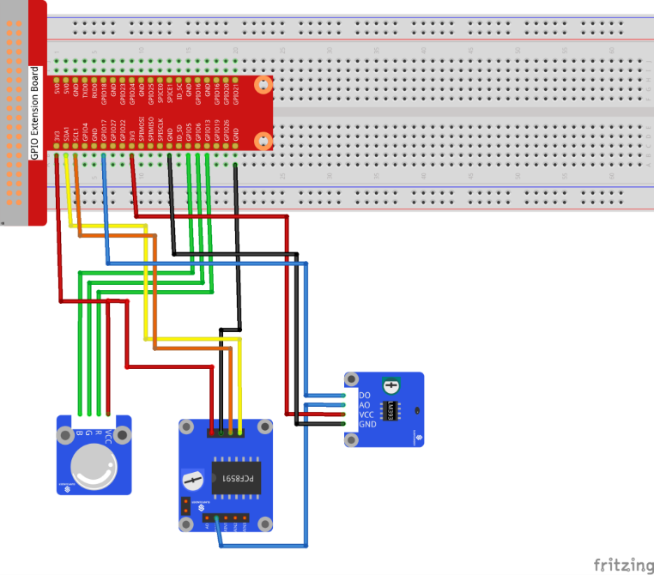

**List of Python Packages**

1. PCF8591.py for the Analog to Digital Converter (ADC) module.
2. RPi.GPIO for interacting with the GPIO pins in various modes.
3. The time library for delays and sleeps times.
4. The math library for doing calculations in the temperature files.

-x-