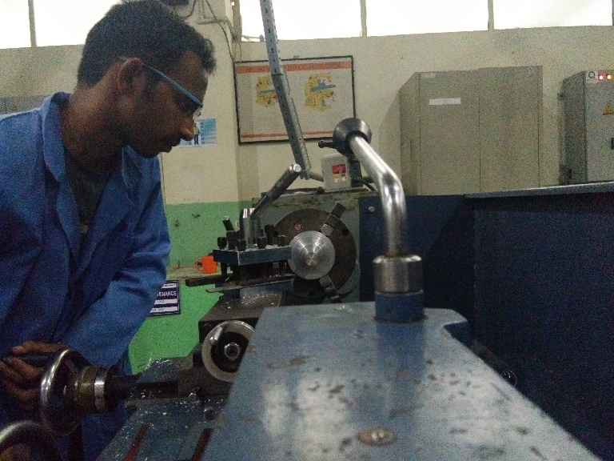

3.

Operator – Seenu Sunil Kumar (2nd Year mechanical)

Front Hub manufacturing is started, so before putting it in the VMC for complete machining, we are preparing the specimen with required quality. We can see that turning operation is being performed on the conventional lathe machine.

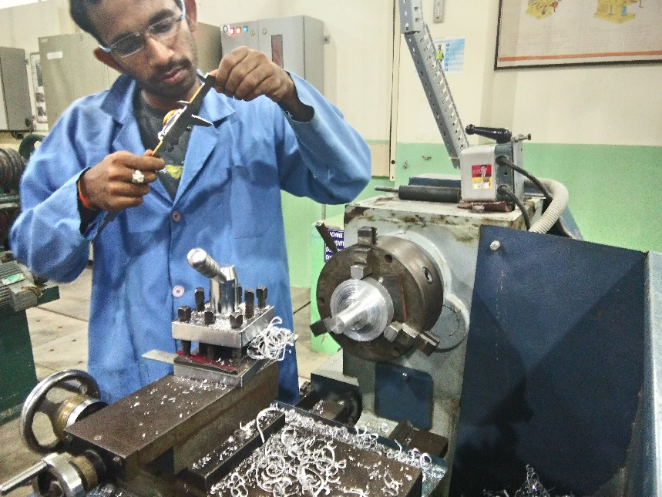

4.

Operator- Seenu Sunil Kumar

Front Hub manufacturing: performing taper turning operation on the specimen. We can see the use of Vernier callipers to get the taper accurately. All the tools and equipment are provided by our University.

5.

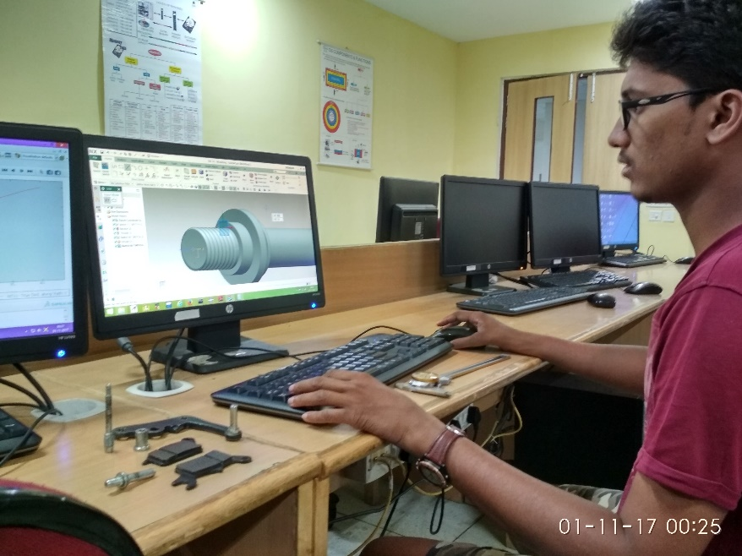

Operator- Dinesh Sai Kumar Bypilla

Assembling: we have completed designing of individual components, so as our manufacturing is started we are also working on doing complete system assemblies and documentation.

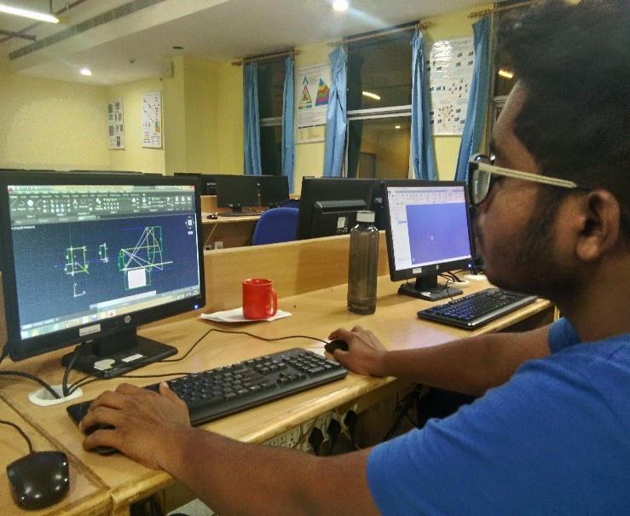

Operator- Suraj Chatakondu

Reviewing the designs before preparing the machining codes. We have completed designing but the main problem arises when we donot get the desired components for our parts. So we need to be careful and make sure such component is there in india and then review the dimensions, design, program for machining and then perform. So we are following PDCA process. We are even concentrating on optimisation of resources.

2.

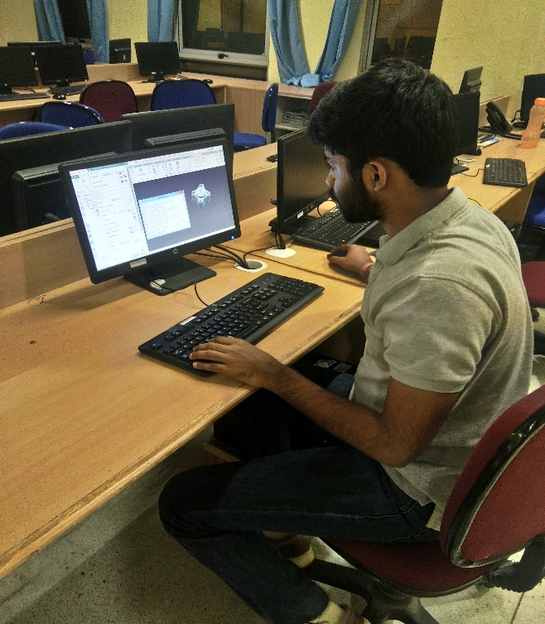

Operator- Hira Agarwal

Verifying the machining codes before the process and coming up with more efficient techniques and the best tool for a particular job. He is the main designer and developer of this project.

1.

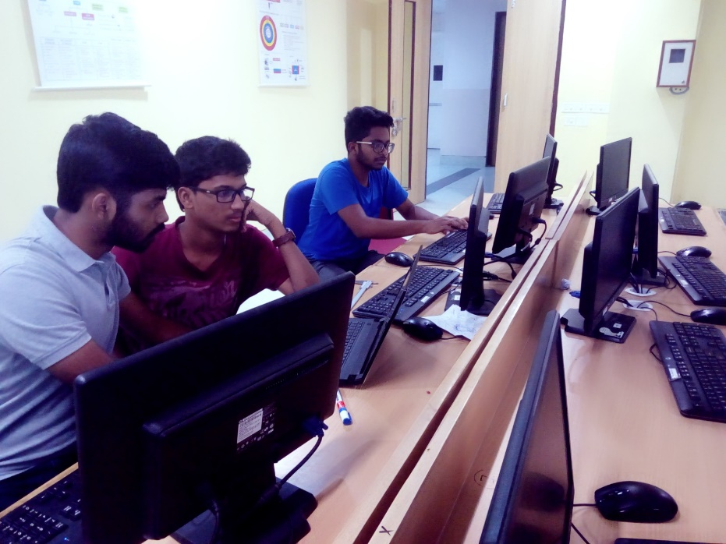

Operators- Hira Agarwal, Dinesh sai Kumar Bypilla & Suraj Chatakondu

In Computer Lab :Working on Modelling, Assembling and CAM. We are trying to make the best use of the resources available at our hand. We as a team make sure to achieve highest FTR percentage.

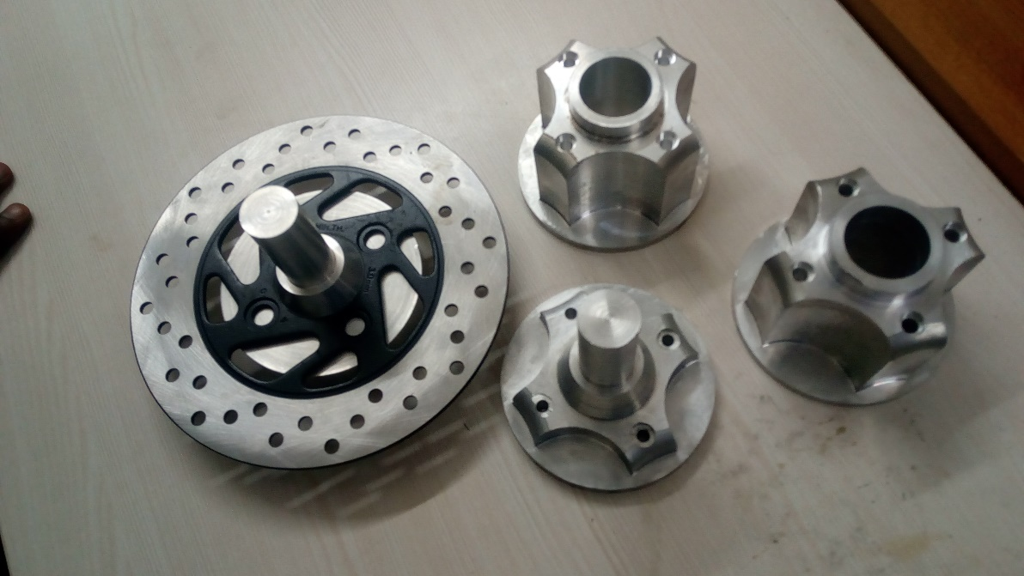

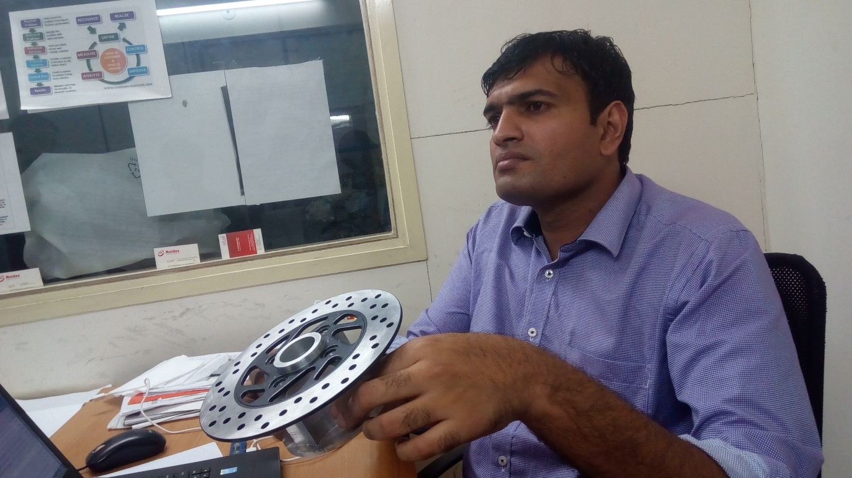

Front and Rear hubs. We can see the disc set to a front hub. We are using aluminium alloy for manufacturing most of the components. We are presenting every component after the machining for evaluation to our Mentor Mr. Govarthanan Prabhu .

7.

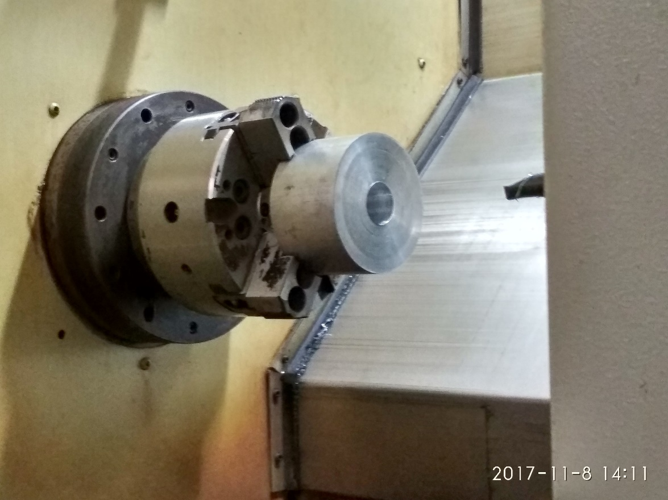

Aluminium alloy Block is mounted on the CNC HTL machine for machining. It is being made into a Rear Hub. Code is already generated through Siemens NX.

8.

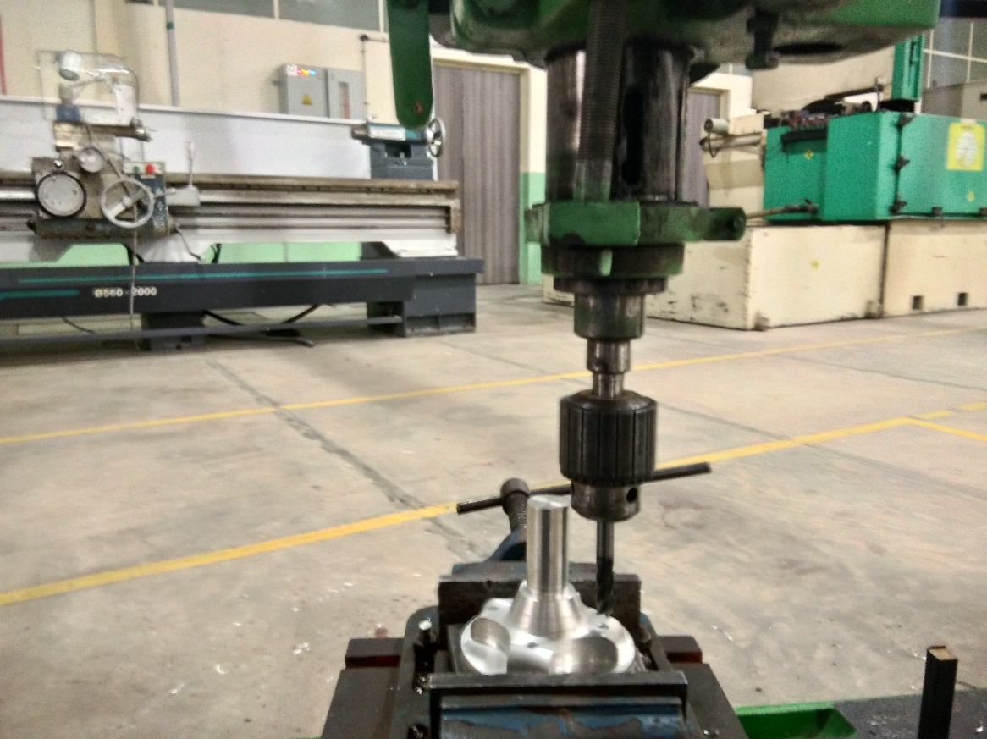

Drilling is being done on the specimen which came out of vmc. We couldn’t drill the complete hole in vmc so we are using radial drilling machine for that purpose.

6.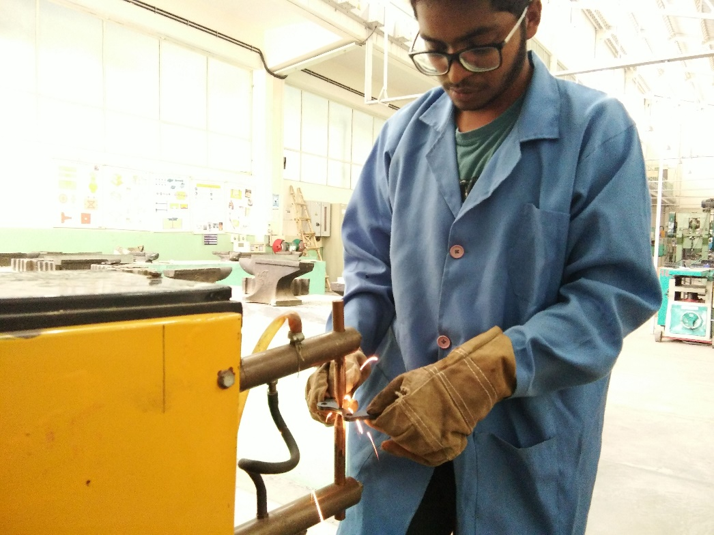

Operator- Suraj Chatakondu

Manufacturing of Brake Calliper Mountings: we designed our calliper mountings and we got it manufactured using laser cutting and then aligning two plates for making a single mount by spot welding. Then finally performed Tapping for getting inside threading. This is the first part we manufactured in this project.

9.

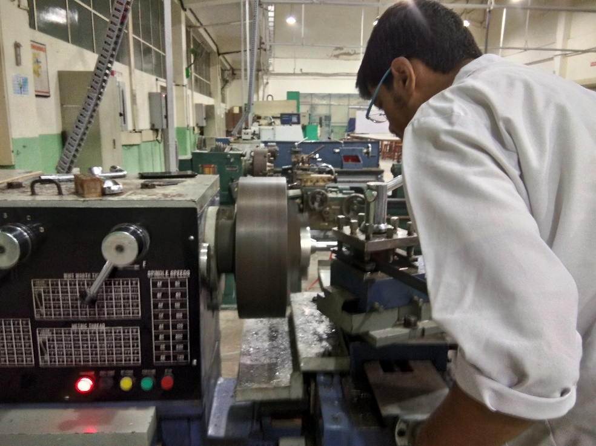

Operator- Sreeram Kotha

Performing turning and facing operation on conventional lathe. We make sure to abide by all the safety rules prescribed by the university while manufacturing.

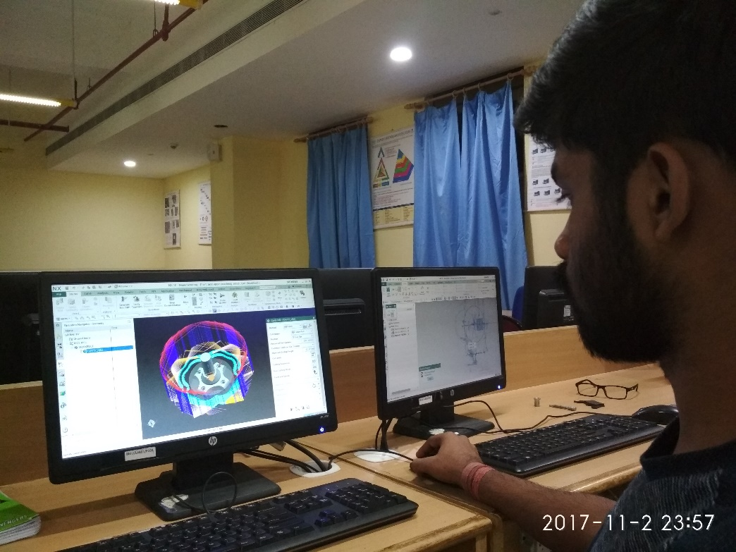

Operator- Hira Agarwal

Working in Computer lab on CAM by Siemens NX to generate code for machining Rear Hub in VMC.

We are using Siemens NX for CAD and CAM and FEMAP for Analysis

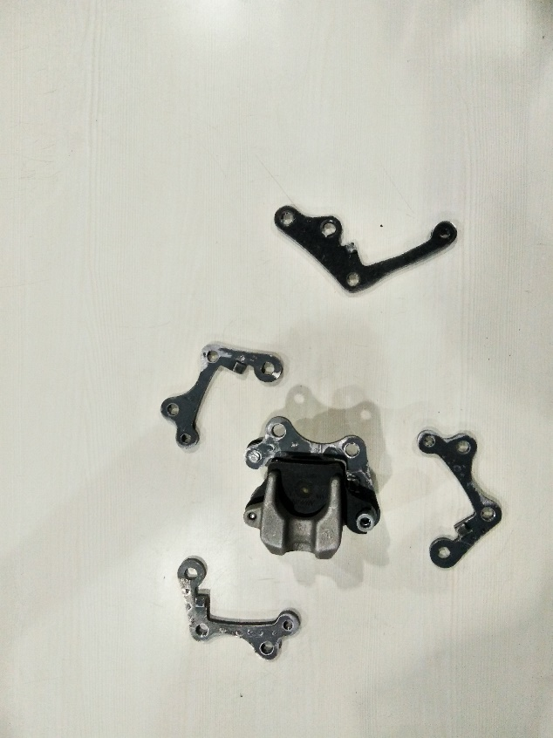

Brake Calliper Mounts after manufacturing. We have designed the calliper mounts.