CED19I056

Venkata Sai Nandita M

Ques1:

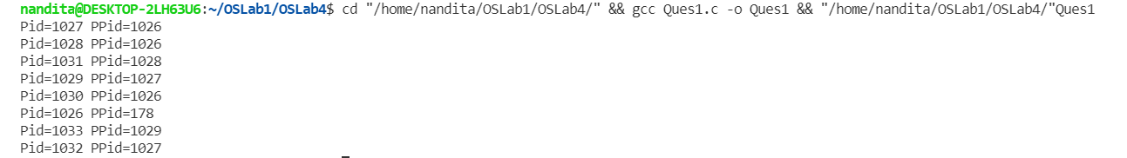

Ques2:

Content of directory



Process tree

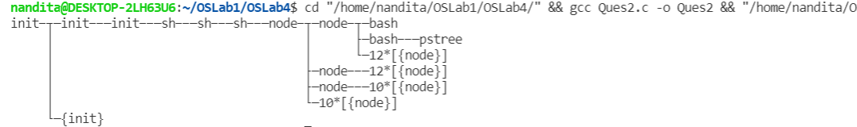

Ques3.1:

* execl()



* execlp()



* execv()

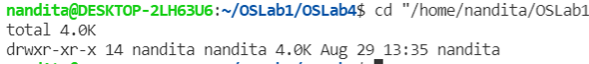

* execvp()



* Wait:



Ques4:

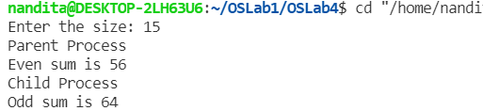

Ques5:

