1.

SELECT A.CUSTOMER_ID, A.ACCOUNT_TYPE, A.ACCOUNT_NO, B.BANK_NAME FROM BANK_INFO B INNER JOIN ACCOUNT_INFO A ON B.IFSC_CODE=A.IFSC_CODE;

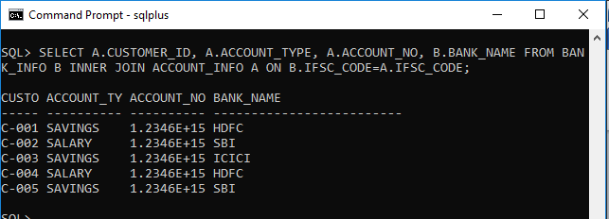

2.

SELECT A.CUSTOMER_ID, A.ACCOUNT_TYPE, A.ACCOUNT_NO FROM ACCOUNT_INFO A INNER JOIN BANK_INFO B ON A.IFSC_CODE=B.IFSC_CODE WHERE A.REGISTRATION_DATE BETWEEN '12-JAN-2012' AND '04-APR-2012' AND B.BANK_NAME='HDFC';

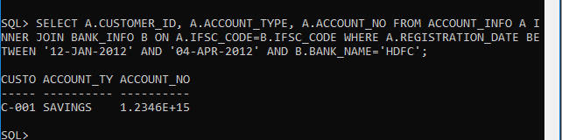

3.

SELECT C.CUSTOMER_ID, C.CUSTOMER_NAME, A.ACCOUNT_NO, A.ACCOUNT_TYPE, B.BANK_NAME FROM BANK_INFO B INNER JOIN ACCOUNT_INFO A ON B.IFSC_CODE=A.IFSC_CODE INNER JOIN CUSTOMER_PERSONAL_INFO C ON C.CUSTOMER_ID=A.CUSTOMER_ID WHERE A.ACCOUNT_NO IS NOT NULL;

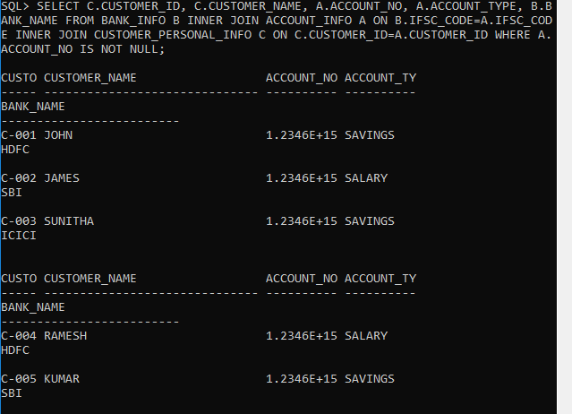

4.

SELECT CUSTOMER_ID, CUSTOMER_NAME, GENDER, MARITAL_STATUS, CUSTOMER_NAME || '_' || GENDER || '_' || MARITAL_STATUS AS UNIQUE_REF_STRING FROM CUSTOMER_PERSONAL_INFO ORDER BY CUSTOMER_ID DESC;

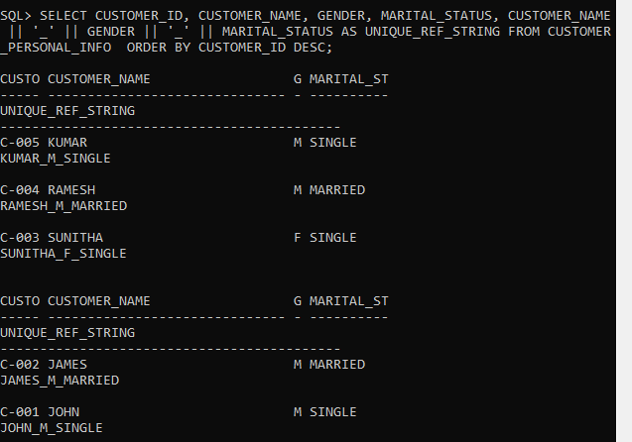

5.

SELECT ACCOUNT_NO, CUSTOMER_ID, REGISTRATION_DATE, INITIAL_DEPOSIT FROM ACCOUNT_INFO WHERE INITIAL_DEPOSIT BETWEEN 15000 AND 25000;

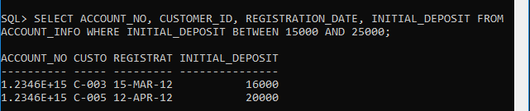

6.

SELECT CUSTOMER_ID, CUSTOMER_NAME, DATE_OF_BIRTH, GUARDIAN_NAME FROM CUSTOMER_PERSONAL_INFO WHERE CUSTOMER_NAME LIKE 'J%';

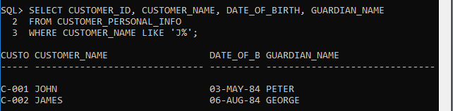

7.

SELECT CUSTOMER_ID, ACCOUNT_NO, SUBSTR(CUSTOMER_ID, -3,3) || SUBSTR(ACCOUNT_NO, -4,4) AS PASSCODE FROM ACCOUNT_INFO;

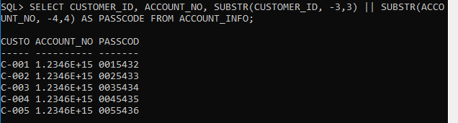

8.

SELECT CUSTOMER_ID, CUSTOMER_NAME, DATE_OF_BIRTH, MARITAL_STATUS, GENDER, GUARDIAN_NAME, CONTACT_NO, MAIL_ID FROM CUSTOMER_PERSONAL_INFO WHERE GENDER='M' AND MARITAL_STATUS='MARRIED';

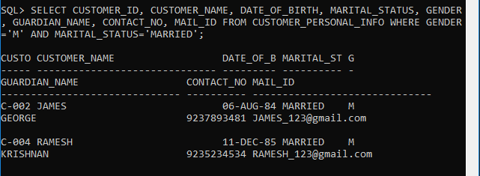

9.

SELECT C1.CUSTOMER_ID, C1.CUSTOMER_NAME, C1.GUARDIAN_NAME, C2.REFERENCE_ACC_NAME AS FRIEND FROM CUSTOMER_PERSONAL_INFO C1 INNER JOIN CUSTOMER_REFERENCE_INFO C2 ON C1.CUSTOMER_ID=C2.CUSTOMER_ID;

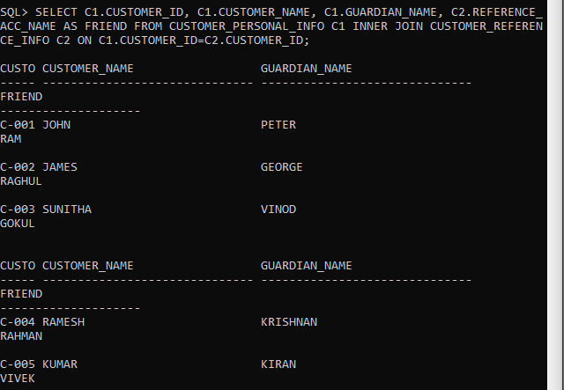

10.

SELECT CUSTOMER_ID, ACCOUNT_NO, '$’ || ROUND(INTEREST,0) AS INTEREST_AMT FROM ACCOUNT_INFO ORDER BY INTEREST_AMT;

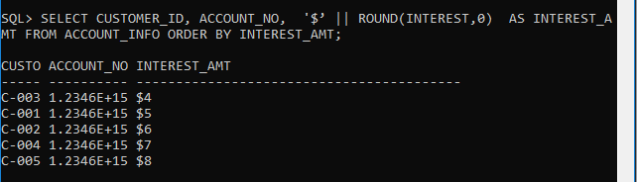

11.

SELECT C.CUSTOMER_ID, C.CUSTOMER_NAME, A.ACCOUNT_NO, A.ACCOUNT_TYPE, A.ACTIVATION_DATE, B.BANK_NAME FROM CUSTOMER_PERSONAL_INFO C INNER JOIN ACCOUNT_INFO A ON C.CUSTOMER_ID=A.CUSTOMER_ID INNER JOIN BANK_INFO B ON B.IFSC_CODE=A.IFSC_CODE WHERE A.ACTIVATION_DATE='10-APR-2012';

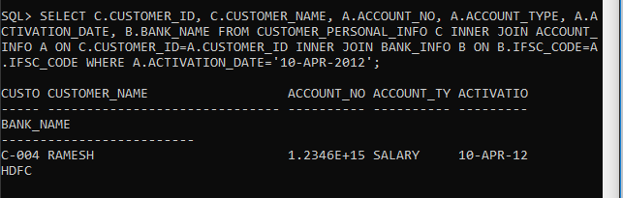

12.

SELECT A.ACCOUNT_NO, C.CUSTOMER_ID, C.CUSTOMER_NAME, B.BANK_NAME, B.BRANCH_NAME, B.IFSC_CODE, C.CITIZENSHIP, A.INTEREST, A.INITIAL_DEPOSIT FROM CUSTOMER_PERSONAL_INFO C INNER JOIN ACCOUNT_INFO A ON C.CUSTOMER_ID=A.CUSTOMER_ID INNER JOIN BANK_INFO B ON B.IFSC_CODE=A.IFSC_CODE

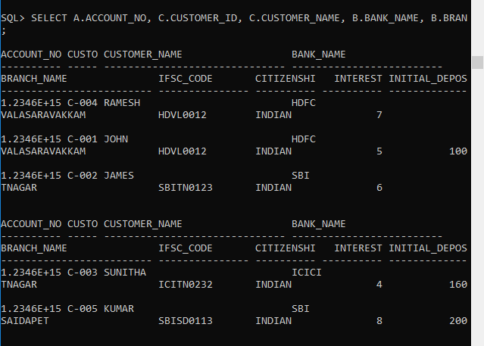

13.

SELECT C1.CUSTOMER_ID, C1.CUSTOMER_NAME, C1.DATE_OF_BIRTH, C1.GUARDIAN_NAME, C1.MAIL_ID, C2.REFERENCE_ACC_NAME FROM CUSTOMER_PERSONAL_INFO C1 INNER JOIN CUSTOMER_REFERENCE_INFO C2 ON C1.CUSTOMER_ID=C2.CUSTOMER_ID WHERE C1.IDENTIFICATION_DOC_TYPE='PASSPORT';

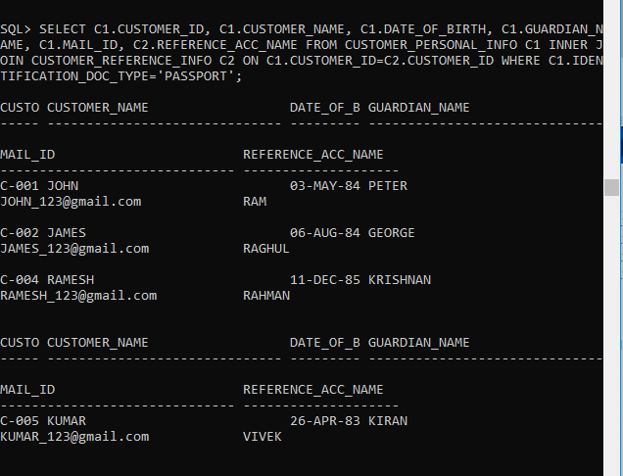

14.

SELECT C1.CUSTOMER_ID, C1.CUSTOMER_NAME, C2.ACCOUNT_NO, C2.ACCOUNT_TYPE, C2.INITIAL_DEPOSIT, C2.INTEREST FROM CUSTOMER_PERSONAL_INFO C1, ACCOUNT_INFO C2 WHERE C1.CUSTOMER_ID=C2.CUSTOMER_ID AND INITIAL_DEPOSIT=(SELECT MAX(INITIAL_DEPOSIT) FROM ACCOUNT_INFO);

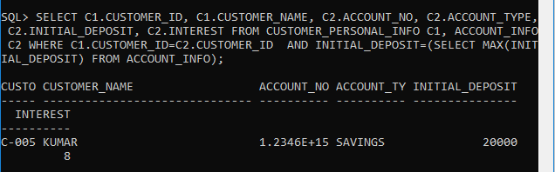

15.

SELECT C1.CUSTOMER_ID, C1.CUSTOMER_NAME, C2.ACCOUNT_NO, C2.ACCOUNT_TYPE,C2.INTEREST, BANK_NAME, INITIAL_DEPOSIT FROM CUSTOMER_PERSONAL_INFO C1, ACCOUNT_INFO C2, BANK_INFO C3 WHERE C1.CUSTOMER_ID=C2.CUSTOMER_ID AND C2.IFSC_CODE=C3.IFSC_CODE AND INTEREST IN (SELECT MAX(INTEREST) FROM ACCOUNT_INFO);

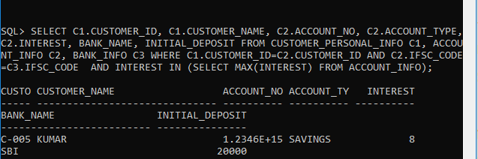16.

SELECT C.CUSTOMER_ID, C.CUSTOMER_NAME, A.ACCOUNT_NO, B.BANK_NAME, B.BRANCH_NAME, C.CONTACT_NO, C.MAIL_ID FROM CUSTOMER_PERSONAL_INFO C INNER JOIN ACCOUNT_INFO A ON C.CUSTOMER_ID=A.CUSTOMER_ID  INNER JOIN BANK_INFO B ON B.IFSC_CODE=A.IFSC_CODE WHERE C.ADDRESS LIKE '%BANGALORE';

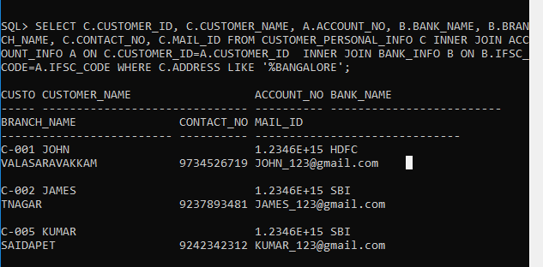

17.

SELECT C.CUSTOMER_ID, B.BANK_NAME, B.BRANCH_NAME, B.IFSC_CODE, A.REGISTRATION_DATE, A.ACTIVATION_DATE FROM CUSTOMER_PERSONAL_INFO C INNER JOIN ACCOUNT_INFO A ON C.CUSTOMER_ID=A.CUSTOMER_ID  INNER JOIN BANK_INFO B ON B.IFSC_CODE=A.IFSC_CODE WHERE TO_CHAR(ACTIVATION_DATE,’MON’)=’MAR’;

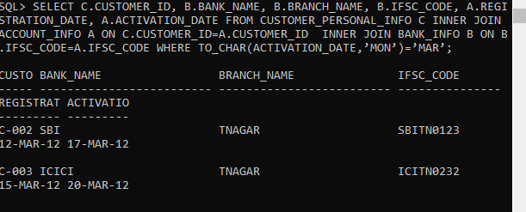

18.

SELECT ((INTEREST/100)*INITIAL_DEPOSIT) AS INTEREST_AMT, C.CUSTOMER_ID, C.CUSTOMER_NAME, A.ACCOUNT_NO, A.ACCOUNT_TYPE, A.INTEREST, A.INITIAL_DEPOSIT FROM CUSTOMER_PERSONAL_INFO C INNER JOIN ACCOUNT_INFO A ON C.CUSTOMER_ID=A.CUSTOMER_ID;

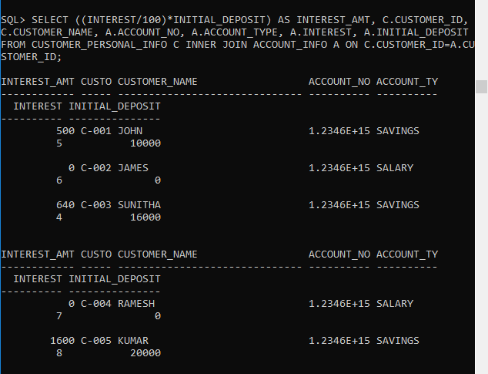19.

SELECT C1.CUSTOMER_ID, C1.CUSTOMER_NAME, C1.DATE_OF_BIRTH, C1.GUARDIAN_NAME, C1.CONTACT_NO, C1.MAIL_ID, C2.REFERENCE_ACC_NAME FROM CUSTOMER_PERSONAL_INFO C1 INNER JOIN CUSTOMER_REFERENCE_INFO C2 ON C1.CUSTOMER_ID=C2.CUSTOMER_ID WHERE C2.REFERENCE_ACC_NAME='RAGHUL';

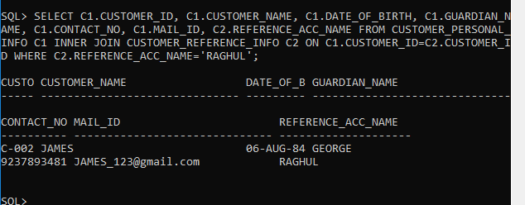20.

SELECT CUSTOMER_ID, CUSTOMER_NAME, '+91-' || SUBSTR(CONTACT_NO,1,3) || '-' || SUBSTR(CONTACT_NO,4,3) || '-' || SUBSTR(CONTACT_NO,-4) AS CONTACT_ISD FROM CUSTOMER_PERSONAL_INFO ORDER BY CUSTOMER_ID DESC;

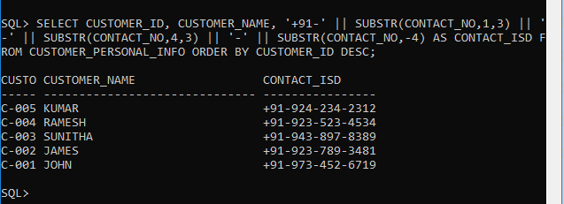

21.

SELECT A.ACCOUNT_NO, A.ACCOUNT_TYPE, P.CUSTOMER_ID, P.CUSTOMER_NAME, P.DATE_OF_BIRTH, P.GUARDIAN_NAME, P.CONTACT_NO, P.MAIL_ID, P.GENDER, R.REFERENCE_ACC_NAME, R.REFERENCE_ACC_NO, A.REGISTRATION_DATE, A.ACTIVATION_DATE, (ACTIVATION_DATE- REGISTRATION_DATE) AS NoofdaysforActivation, B.BANK_NAME, B.BRANCH_NAME, A.INITIAL_DEPOSIT FROM CUSTOMER_PERSONAL_INFO P INNER JOIN ACCOUNT_INFO A ON P.CUSTOMER_ID=A.CUSTOMER_ID INNER JOIN BANK_INFO B ON B.IFSC_CODE=A.IFSC_CODE INNER JOIN CUSTOMER_REFERENCE_INFO R ON R.CUSTOMER_ID=P.CUSTOMER_ID;

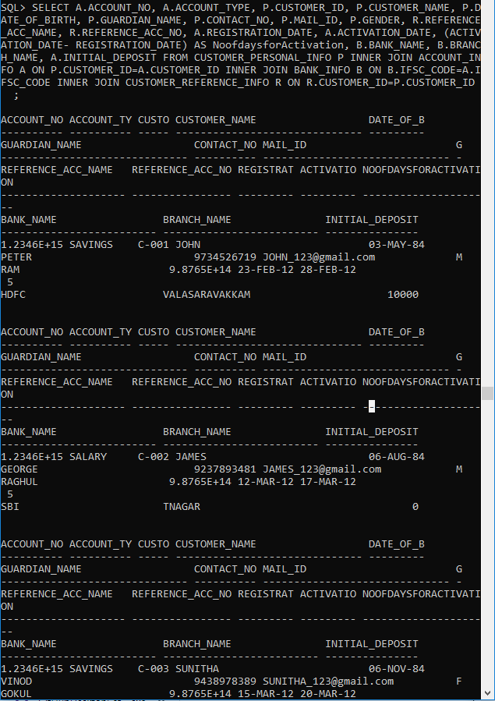

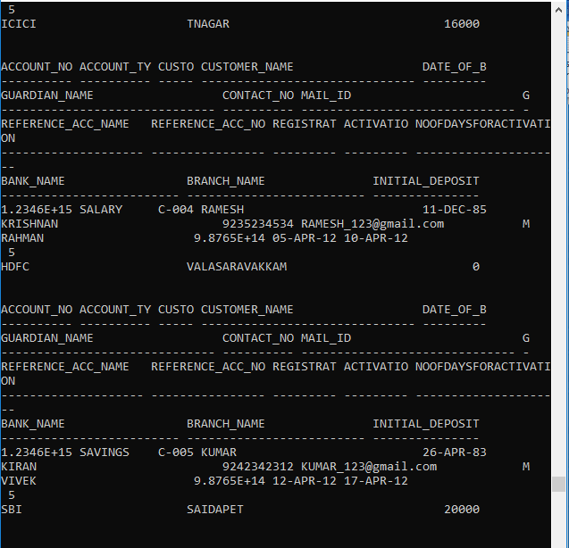

22.

SELECT F.CUSTOMER_ID, F.CUSTOMER_NAME, F.GUARDIAN_NAME, F.IDENTIFICATION_DOC_TYPE, R.REFERENCE_ACC_NAME, A.ACCOUNT_TYPE, B.IFSC_CODE, B.BANK_NAME, TRUNC((INITIAL_DEPOSIT+INTEREST),0) AS CURRENT_BALANCE FROM CUSTOMER_PERSONAL_INFO F INNER JOIN ACCOUNT_INFO A ON F.CUSTOMER_ID=A.CUSTOMER_ID INNER JOIN BANK_INFO B ON B.IFSC_CODE=A.IFSC_CODE INNER JOIN CUSTOMER_REFERENCE_INFO R ON R.CUSTOMER_ID=F.CUSTOMER_ID WHERE ACCOUNT_TYPE='SAVINGS'  ;

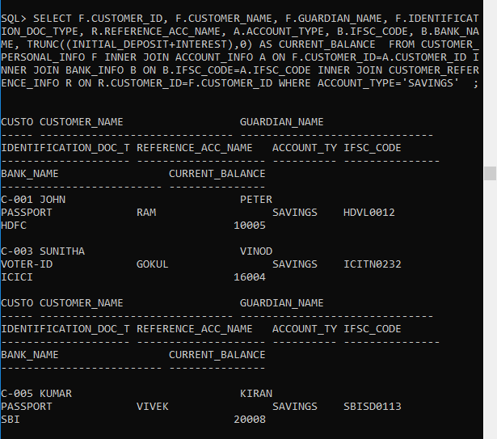

23.

SELECT C.CUSTOMER_ID, C.CUSTOMER_NAME, A.ACCOUNT_NO, A.ACCOUNT_TYPE, A.INTEREST, A.INITIAL_DEPOSIT, CASE WHEN INITIAL_DEPOSIT=20000 THEN 'high' WHEN INITIAL_DEPOSIT=16000 THEN 'moderate' WHEN INITIAL_DEPOSIT=10000 THEN 'average' WHEN INITIAL_DEPOSIT=5000 THEN 'low' WHEN INITIAL_DEPOSIT=0 THEN 'very low' ELSE 'invalid' END DEPOSIT_STATUS FROM CUSTOMER_PERSONAL_INFO C INNER JOIN ACCOUNT_INFO A ON C.CUSTOMER_ID=A.CUSTOMER_ID;

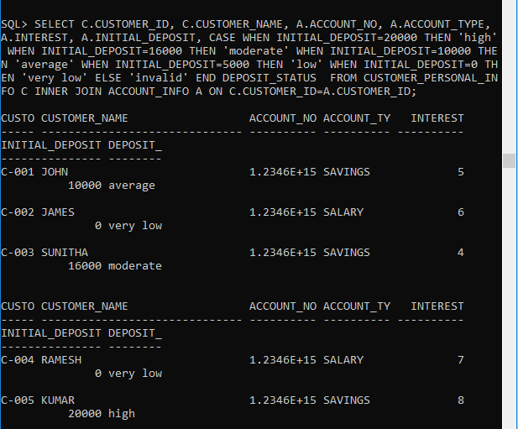24.

SELECT C.CUSTOMER_ID, C.CUSTOMER_NAME, A.ACCOUNT_NO, A.ACCOUNT_TYPE, B.BANK_NAME, B.IFSC_CODE, A.INITIAL_DEPOSIT, CASE WHEN ACCOUNT_TYPE='SAVINGS' THEN ROUND((INTEREST+(INTEREST*10/100)),2) ELSE INTEREST END NEW_INTEREST FROM CUSTOMER_PERSONAL_INFO C INNER JOIN ACCOUNT_INFO A ON C.CUSTOMER_ID=A.CUSTOMER_ID INNER JOIN BANK_INFO B ON B.IFSC_CODE=A.IFSC_CODE WHERE C.CUSTOMER_NAME LIKE 'J%';

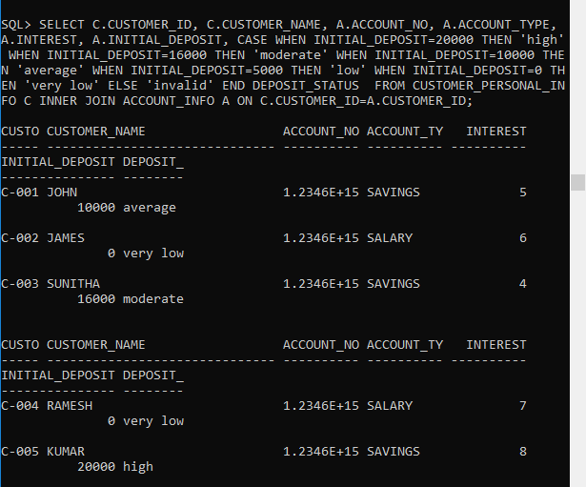

25.

SELECT C.CUSTOMER_ID, C.CUSTOMER_NAME, A.ACCOUNT_NO, A.INITIAL_DEPOSIT, CASE WHEN INITIAL_DEPOSIT=0 THEN '0%' WHEN INITIAL_DEPOSIT<=10000 THEN '3%' WHEN INITIAL_DEPOSIT>10000 AND INITIAL_DEPOSIT<20000 THEN '5%' WHEN INITIAL_DEPOSIT>=20000 AND INITIAL_DEPOSIT<=30000 THEN '7%' WHEN INITIAL_DEPOSIT>30000 THEN '10%' END taxPERCENTAGE FROM CUSTOMER_PERSONAL_INFO C INNER JOIN ACCOUNT_INFO A ON C.CUSTOMER_ID=A.CUSTOMER_ID;

