Temperature effect on LM: Notes

1. **Database notes:**

* Login to ssh -X [G2Muon@g2gateway01.fnal.gov](mailto:G2Muon@g2gateway01.fnal.gov) from any vm
* For temp studies database login details/cmd:

psql -U postgres -h g2db-priv -d gm2_online_prod -p 5433

* Database wiki page:

<https://cdcvs.fnal.gov/redmine/projects/g-2/wiki/Muon_g-2_Database>

* Command to copy temperatures (60 hr time) of optical table and room to a csv file:

select value[1], value[2], time from g2sc_values where time>'2018-04-22 12:58:57' and time<'2018-04-25 02:00:04' and channel= 'mscb174_Temp_P7' ORDER by time ASC \g 'temp_60h_1.csv'

1. If I use Mathias fcl file to generate root files……

* Latest setup file in /gm2/app/users/nandita to source is setup_offline.sh
* This sets everything in /gm2/app/users/nraha. Root trees in calo_tree
* Fcl file location /gm2/app/users/mwsmith2/sharing/caloRootTrees.fcl copied to my location fcl_files
* Path for root files of production runs… /pnfs/gm2/daq/run1/reconstruct/run1_5031B/runs_15000/15344/gm2offline_reco_59*00000.root
* Finally command for producing LM (can include SM too) plots:

gm2 -c fcl/caloRootTrees.fcl –s **/pnfs/gm2/daq/run1/reconstruct/**run1_5031B/runs_15000/15344/gm2offline_reco_59*00000.root -T test.root

FCL file for source monitors: srcs/gm2analyses/fcl/rootTrees.fcl

Local monitor notes:

* Wiki page for correspondence b/w LM channels and Calo:

<https://cdcvs.fnal.gov/redmine/projects/g-2/wiki/Laser_HardwareMaps>

* The map: 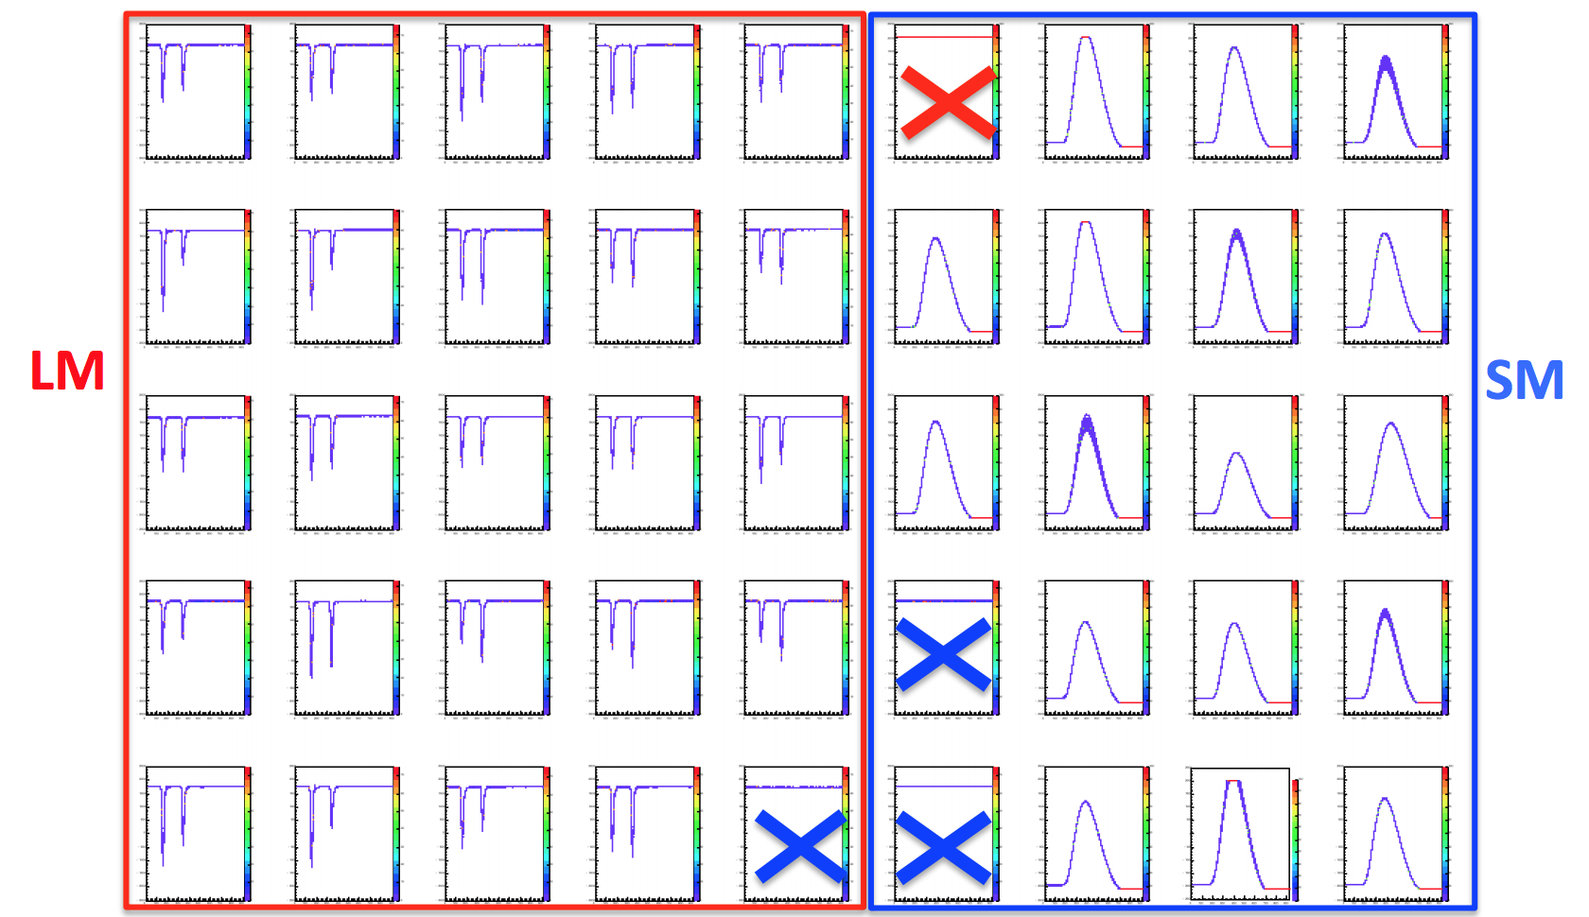
* Important note about the maps – for new PMTs, HVch are the channel numbers, but for old PMTs WFD ch are the channel numbers.

Next 60 hr dataset:

Initial time (CST): 22nd April 1:09:50 PM (unix time stamp of 1524420590)

Final time (CST): 25th April 02:21:40 AM Unix time:1524640900

Calo 18, 20 – 24 are west of laser room and to be read by mscb174_Temp_P5 (1st or 2nd values)

Calo 11, 12 and 13 … in opposite direction (almost) read by mscb174_Temp_P5 (3rd value)

'mscb174_Temp_P7 for laser hut and laser optical table

Note: Offset – channel 0 is laser hut and channel 1 is optical table

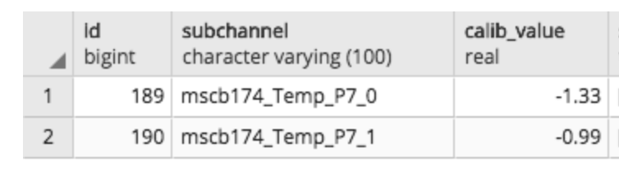

**Special runs for LM analysis:**

Carlo took runs from 18031 onwards.

Mail of 7/7:

> I installed three new couple of fibers on the LM, which collect light  
> from  
> an integrating sphere, for stability test purpose. Someone should  
> analyze  
> the signals...  
>  
> 1) CH24 of DQM: 20m of Silica fiber (unknown mod) + 60 m of PMMA  
> 2) CH 28: 2 m PMMA + 50 m PMMA  
> 3) CH 29: 2 m PMMA + 50 m Silica 0.6 mm (like LM fibers)  
>  
> N.B. HV of CH 28 and 29 was 1000 V and now is 810 V.  
>  
> Run 18031 and following, all fibers outside the laser table.

Mail of 8/7:

run 18050 should be interesting, I hope.  
  
After 10 min I removed 4 panels from the optical table (interlock loched,  
NO SM and LM signal but the three with long fibers, see previous mail). I  
forgot the light on in the laser hut during that 10 minutes.  
  
The temperature dropped immediately. Surprisingly, not only in the optical  
table, but also in the laser hut. From this behavior I deduce that the air  
comes out from the orange tubes of the launch and LM fibers, increasing  
the heat exchange between laser hut and hall.  
  
After 1.5 h I put the panels back in place. Moreover, I disconnected the  
fan of the optical table, in order to increase the differential  
temperature between table and laser hut. The temperature immediately rose  
again.  
  
Could you please analize that file? Hopefully we can obtain the  
temperature dependance of the PMMA and the Silica fibers.  
  
What I learned: we need to increase the holes in the laser hut, in order  
to reduce the temperature. Also, one more fan on the optical table could  
helps.

Hi Nandita,  
thank you.  
  
My comments:  
1) the thernal coefficient is the same for the two fibers (Silica and  
PMMA, blue curves)  
  
2) In both cases the ratio depends on temperature by a factor 0.2% for  
about 1 degC variation.  
  
As soon as possible I will do more test.  
  
Cheers,  
Carlo

Some most useful codes (noted because I forgot what I wrote in each file):

1. temp_area_overlap.C – great for viewing temp and amp overlaid (use modify V1).
2. ped_diff_trace_single_pulse.C – difference in P2-P1 for one waveform
3. channel0_traces.C – Graph of p2-p2 for all waveforms channel zero. Takes very long.
4. temp_graphs.C – a simple graph of sql temp data.
5. LM_temp_area_oneCh.C – Temp Vs. A2:A1, A1 and A2 for an old channel (or any one channel)
6. amp_temp_all_channels.C – It plots a graph of temp dependence with A1, A2 and A2:A1 for all channels.
7. LM_temp_ch_old_new.C – Plots ratio of ratios of areas
8. amplitude_profile.C – plots profiles of A1 and A2 for all channels of LM – very useful to save space and time
9. LM_amplitudes – Plots A1, A2, and A2:A1 of any input chanel
10. LM_ratio_ratio_temp.C – plots temp vs. ratio of ratios

Required short term:

First Path for 18422: /pnfs/GM2/scratch/users/nraha/run1/daq/2018-08-15-06-46-02/

2nd path for 18422: /pnfs/GM2/scratch/users/nraha/run1/daq/2018-08-14-05-34-33/

Huge temperature variations times/dates Chicago – probably May

Data sets (9 days) description link to redmine:

<https://redmine.fnal.gov/redmine/projects/g-2/wiki/9d_Datasets>

Root files for temp studies saved in gm2vm path:

/gm2/data/users/nraha/root_files/