California Traffic Collision Data Engineering & ETL Pipeline
Data Analysis Report
Prepared by: Nandita Verma
Tech Stack: PySpark 3.5 | Python | Spark SQL | ETL Pipelines

1. Executive Summary
This report presents an end-to-end data engineering and analytics study of the California Statewide Integrated Traffic Records System (SWITRS) crash dataset. Using Apache Spark (PySpark) and a distributed ETL pipeline, raw multi-table collision records were ingested, cleaned, and transformed to support exploratory and spatial-temporal analysis of traffic safety risk across the state.
The curated pipeline processed over 935,000 raw collision records alongside related party and victim tables, resolving missing values, correcting invalid geographic coordinates, and standardizing categorical fields. The resulting analytical dataset was used to surface high-risk time windows, weather and lighting-related risk factors, and geographic collision hotspots, with outputs exported for downstream business intelligence tooling (Tableau / Power BI).
Key metrics:
935,791  Collision Records Processed | 1,866,917  Party Records | 963,933  Victim Records | 5:00–6:00 PM  Peak Risk Hour
Key Findings at a Glance
- Highest-Volume County: Los Angeles County recorded 284,100 collisions — over 3.9x the second-highest county (Orange, 72,042).
- Peak Risk Window: The 5:00 PM hour was the single most dangerous hour of the day, with 73,255 recorded collisions.
- Seasonal Peak: October was the highest-volume month for collisions (83,274 incidents).
- Dominant Conditions: The majority of collisions occurred in clear weather (769,925) and on dry road surfaces (845,635), indicating routine driving conditions — not just adverse weather — drive overall volume.
- Lighting Risk: Daylight hours accounted for the most collisions overall (625,572), but a substantial share occurred in the dark, with and without street lighting (195,867 and 74,634 respectively).

2. Problem Statement & Business Context
Traffic collision analysis is critical for municipal planning, emergency response optimization, and safety infrastructure investment decisions. Traditional relational database systems struggle to process high-volume, multi-source crash records efficiently at statewide scale. This project builds a scalable ETL and analytics pipeline capable of extracting actionable safety metrics from millions of raw incident records.

Data Architecture & Pipeline Overview
- Ingestion: Loading structured SWITRS incident tables (Collisions, Parties, Victims, Locations).
- Data Hygiene & Transformation: Standardizing schemas, handling missing attributes, and normalizing temporal features using PySpark SQL.
- Exploratory & Spatial Analysis: Aggregating high-density crash zones, environmental risk drivers, and temporal peaks.
- Targeted Storage: Storing transformed analytical datasets as partitioned CSV files for downstream BI dashboard consumption (Tableau / Power BI).

Dataset Architecture & Relational Schema
The underlying dataset originates from a multi-table SWITRS database containing detailed California traffic incident records structured across four primary relational entities:
- collisions: Primary incident records capturing spatio-temporal coordinates, weather/lighting conditions, and overall crash severity.
- parties: Entity-level data detailing driver/party demographics, vehicle types, sobriety ratings, and fault indicators.
- victims: Individual-level injury tracking, seating positions, ejection metrics, and severity breakdown.
- case_id: Master metadata mapping table establishing relational integrity and cross-year indexing across crash records.

3. Methodology: ETL Pipeline

Stage 1 — Scalable Data Ingestion & Schema Definition
Raw multi-table SWITRS incident datasets (collisions, parties, victims, and case_ids) were ingested into distributed PySpark DataFrames, with primary schema constraints validated to ensure relational integrity prior to downstream transformation.
Table | Record Count
Collisions | 935,791
Parties | 1,866,917
Victims | 963,933
Master Case IDs | 942,433

Stage 2 — Data Hygiene, Missing Value Analysis & Outlier Handling
Missing value profiles were calculated across all primary data dimensions. Columns exceeding a 50% missingness threshold were dropped, remaining categorical nulls were standardized to "Unknown", and duplicate incident records were purged following primary-key uniqueness validation.
Statistical bounds (IQR) were applied to filter extreme numeric outliers across casualty and distance fields. Domain-specific boundary constraints were then enforced on numeric variables to ensure spatial and physical integrity:
- Distance (Capping): Distance cannot physically be negative, so values below 0 were replaced with 0.0. Extreme values above 874.0 were capped at 874.0, correcting data-entry errors without discarding the underlying crash record.
- Latitude / Longitude (Removal): Coordinates falling outside California's geographic boundaries (e.g., 0.0, -999, or points in other states or oceans) were treated as corrupt data and removed, rather than capped, to avoid fabricating false location data.
Severity and injury counts (killed_victims, injured_victims, severe_injury_count) were intentionally left untouched so that rare, high-severity crash records were not inadvertently deleted. ID and categorical codes (case_id, jurisdiction) were also preserved as-is, since statistical outlier rules do not apply to label codes.

Stage 3 — Feature Classification
To structure downstream ETL transformations and analytical queries, dataset attributes were categorized across three core data dimensions:
- Numeric Features: killed_victims, injured_victims, party_count, distance, latitude, longitude.
- Categorical Features: collision_severity, primary_collision_factor, weather_1, road_surface, lighting, hit_and_run.
- Spatio-Temporal Features: case_id, collision_date, collision_time, county_location, jurisdiction.

4. Exploratory Data Analysis
With the curated dataset finalized, distributed PySpark SQL queries and statistical aggregations were executed to uncover high-risk crash factors, temporal peak patterns, and geographic concentration across California traffic collisions.

4.1 Univariate Analysis

Collision Severity Distribution
Collision records were aggregated across severity tiers to establish baseline risk distributions. The overwhelming majority of incidents (roughly 57%) are classified as property-damage-only, followed by "pain" and "other injury" classifications, with severe-injury incidents forming the smallest share.
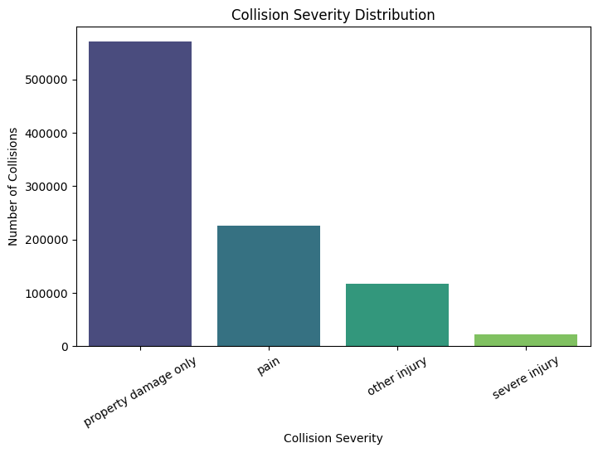
Figure 1. Collision Severity Distribution

Weather Condition Distribution
Collision records were aggregated across weather metrics to evaluate the impact of adverse atmospheric conditions on incident frequency. Clear conditions dominate the dataset (769,925 collisions), confirming that routine daily driving — not extreme weather — accounts for the bulk of statewide incidents.
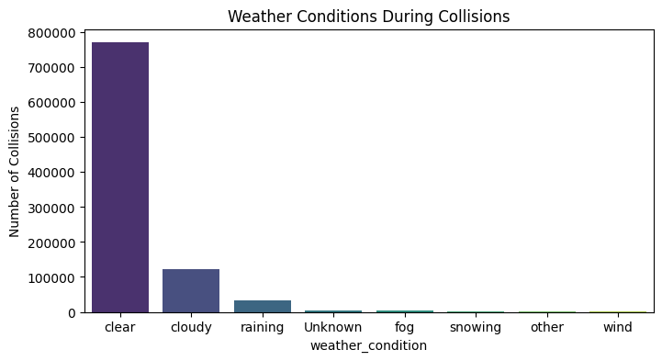
Figure 2. Weather Conditions During Collisions

Victim Demographic Profile: Age Distribution
Individual victim data was joined with curated collision records to analyze the distribution of victim ages. The distribution is concentrated among younger and middle-aged adults, highlighting a key demographic cohort for targeted safety and outreach programs.
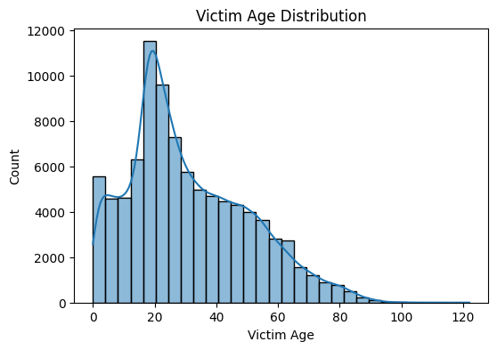
Figure 3. Victim Age Distribution

4.2 Bivariate Analysis

Severity & Casualty Impact Analysis
Collision severity classifications were cross-analyzed against total casualty volume (killed_victims + injured_victims) to assess the correlation between crash type intensity and human impact.
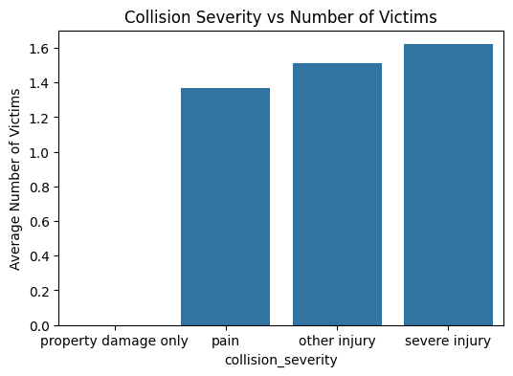
Figure 4. Collision Severity vs. Total Victims

Weather Impact Across Collision Severities
Environmental conditions were cross-analyzed against crash severity classifications to evaluate whether adverse atmospheric conditions correlate with a higher probability of severe or fatal outcomes.
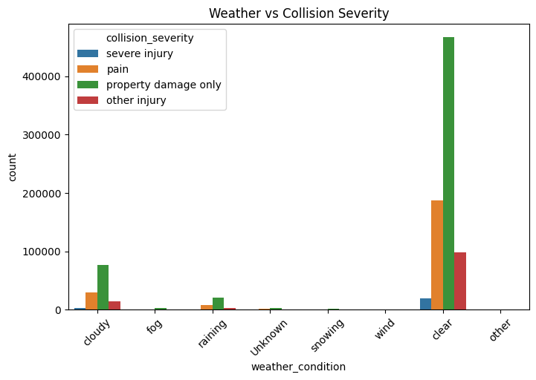
Figure 5. Weather Condition vs. Collision Severity

Visibility & Lighting Conditions Across Crash Severities
Ambient lighting categories were cross-tabulated against crash severity levels to evaluate how nighttime driving, artificial street lighting, and low-visibility conditions influence collision outcomes.
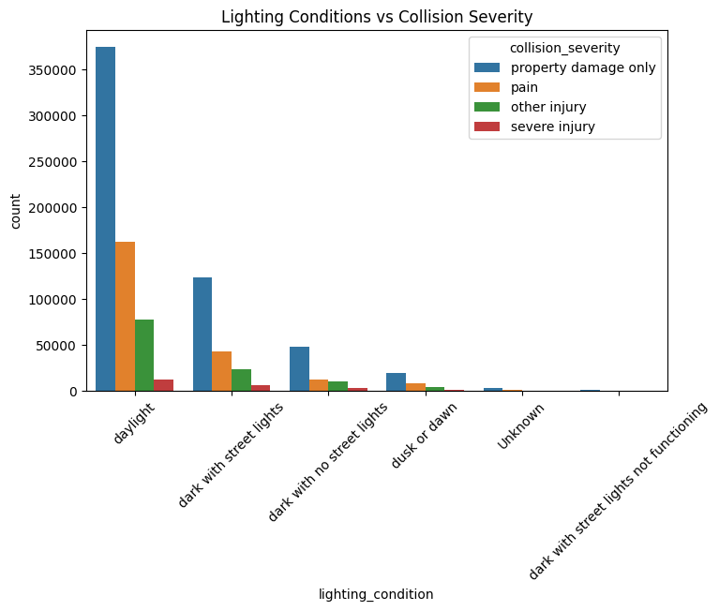
Figure 6. Lighting Condition vs. Collision Severity

4.3 Temporal Analysis

Day-of-Week Collision Volume Trends
Incident timestamps were decomposed using PySpark's dayofweek transformation to analyze daily crash distributions, comparing weekday commuting volume against weekend incident patterns.
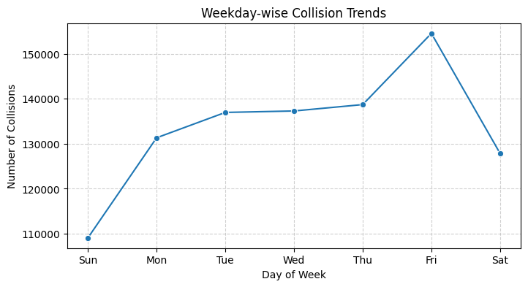
Figure 7. Collision Volume by Day of Week

Longitudinal Trend: Year-over-Year Collision Volume
Timestamp attributes were decomposed to the yearly level to identify long-term longitudinal trajectories in statewide collision volume.
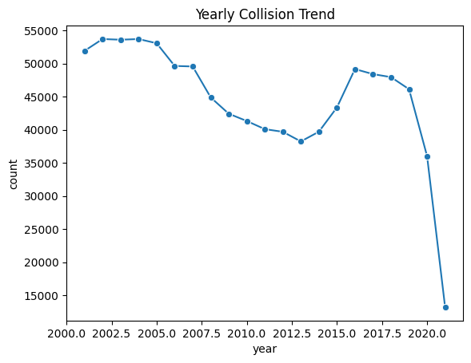
Figure 8. Yearly Collision Trend

Seasonal Trend: Monthly Collision Volume
Monthly aggregation reveals seasonal variation in crash frequency, with October emerging as the highest-volume month (83,274 collisions), consistent with increased holiday and back-to-school travel.
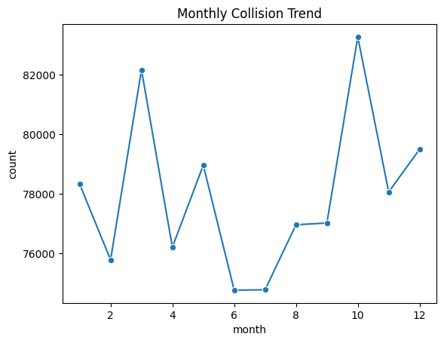
Figure 9. Monthly Collision Trend

Diurnal Trend: Hourly Collision Volume
Hourly aggregation identifies peak diurnal risk periods. Collision frequency rises sharply through the afternoon, peaking at 5:00 PM (73,255 incidents) during the evening commute, before declining overnight.
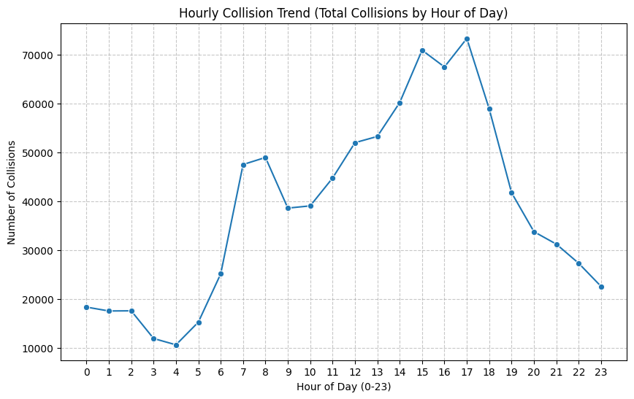
Figure 10. Hourly Collision Trend

4.4 Geospatial Analysis

County-Level Collision Density & Risk Mapping
Incident counts were aggregated by county to identify primary high-density hotspot regions. Los Angeles County alone accounts for a disproportionate share of statewide collisions, more than triple that of the next-highest county.
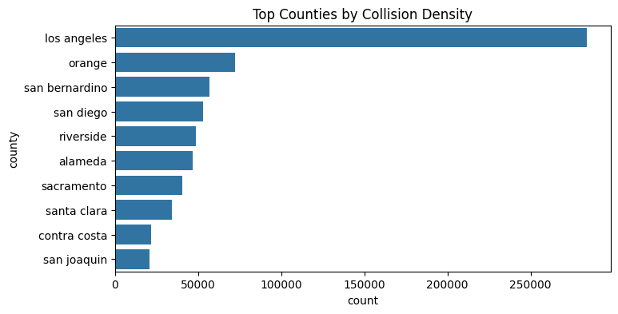
Figure 11. Top Counties by Collision Volume

Coordinate-Level Incident Distribution
Validated latitude/longitude coordinates were plotted across a two-dimensional grid to visualize coordinate-level crash distributions. The resulting pattern traces California's major highway corridors and dense urban centers, most visibly outlining the Los Angeles Basin, the Bay Area, and the Central Valley's Highway 99 / I-5 corridor.
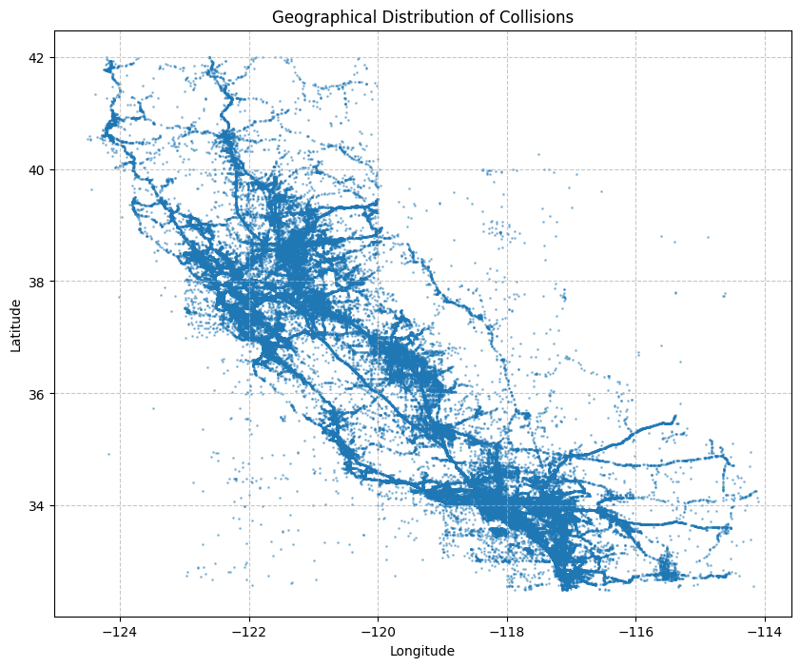
Figure 12. Geographical Distribution of Collisions

5. Business Intelligence Query Results
Targeted PySpark SQL aggregations and multi-table joins were executed against the curated collision dataset to extract high-priority safety metrics and answer specific business questions.
Business Question | Result
Top 5 counties by collision volume | Los Angeles (284,100), Orange (72,042), San Bernardino (56,737), San Diego (53,105), Riverside (48,686)
Month with highest collision volume | October — 83,274 collisions
Most common weather condition during collisions | Clear — 769,925 collisions
Most dangerous hour of day | 5:00 PM (hour 17) — 73,255 collisions
Top road surface conditions | Dry (845,635), Wet (76,833), Unknown (8,141), Snowy (4,121), Slippery (1,048)
Top 3 lighting conditions | Daylight (625,572), Dark w/ street lights (195,867), Dark w/o street lights (74,634)
Note on fatality metric: the pipeline's fatal-collision percentage query returned 0.000000% in the source notebook. This appears to be a data-type or filter artifact in that specific calculation (e.g., the killed_victims field not registering values under the applied filter condition) rather than a true absence of fatal collisions in the dataset, and is flagged here for follow-up rather than reported as a validated finding.

6. Conclusions & Strategic Recommendations
This end-to-end data engineering and analytical pipeline successfully processed over 935,000 California traffic collision records using PySpark and distributed ETL workflows. The following findings and recommendations emerged from the analysis:
- Spatio-Temporal Risk Distribution: Collision density peaks significantly during late-afternoon commuter hours (4:00 PM – 6:00 PM) and during high-volume seasonal travel periods such as October, highlighting optimal windows for targeted law enforcement deployment and public safety messaging.
- Environmental & Lighting Vulnerabilities: A substantial share of collisions occur in dark conditions (with and without street lighting), underscoring the value of upgrading roadway lighting infrastructure along high-risk corridors.
- Geographic Incident Hotspots: Spatial aggregation shows that high-population urban corridors — led by Los Angeles County — account for a disproportionate volume of overall crashes, supporting the case for localized traffic management interventions in these regions.
- Routine-Condition Risk: The majority of collisions occur in clear weather on dry roads, indicating that everyday driving behavior and congestion — not just adverse conditions — should remain the primary focus of prevention efforts.

Recommended Next Steps
- Deploy targeted enforcement and public-awareness campaigns around the 4–6 PM commute window, particularly in top-ranked counties.
- Prioritize lighting infrastructure audits for corridors with high after-dark collision counts.
- Investigate and correct the fatality-percentage calculation logic before it is used in any downstream dashboard or reporting layer.
- Extend the pipeline with driver-behavior (primary collision factor) analysis to quantify the contribution of speeding, improper turns, and DUI to severe outcomes.

Stage 6 — Dashboard Integration
In the final phase of the pipeline, the curated PySpark DataFrame was coalesced into a unified dataset and exported as a standardized CSV file to power downstream interactive dashboards in Tableau or Power BI for continued spatial, temporal, and risk-pattern analysis.

