An
Innovative Project Report on

SOILDER HEALTH AND POSITION TRACKING
SYSTEM
Submitted in partial fulfillment of the requirement for the award of degree of
BACHELOR OF TECHNOLOGY
In
CSE - Data Science
Submitted By
B.NANDITH | 238R1A67D8
Under the Guidance of
Mrs. M.S.S Lakshmi Lavanya Assistant Professor, CSE-DS, DEPT.



CMR ENGINEERING COLLEGE

UGC AUTONOMOUS
(Approved by AICTE, Affiliated to JNTU Hyderabad, Accredited by NBA) Kandlakoya (V), Medchal Road, Hyderabad - 501 401 2024-2025

CMR ENGINEERINGCOLLEGE
UGC AUTONOMOUS
(Approved by AICTE, Affiliated to JNTU Hyderabad, Accredited by NBA) Kandlakoya (V), Medchal Road, Hyderabad - 501 401.

Department Of CSE – Data Science



CERTIFICATE

This is to certify that the innovative project work entitled “SOILDER HEALTH AND POSITION TRACKING SYSTEM” is being submitted by B.NANDITH bearing Roll No:238R1A67D8 in B.Tech II- II semester, Computer Science Engineering – Data Science is a record bonafide work carried out by them during the academic year 2024-25.The results embodied in this report have not been submitted to any other University for the award of any degree.

INTERNAL GUIDE | HEAD OF THE DEPARTMENT
Mrs. M.S.S Lakshmi Lavanya  Assistant Professor,  CSE-DS, CMREC. | Dr. M.LAXMAIAH  Professor & HOD  CSE-DS,CMREC.
COORDINATOR
Mrs. P. SANDHYA REDDY
Assistant Professor,
CSE-DS, CMREC.

ACKNOWLEDGEMENT
We sincerely thank the management of our college CMR Engineering College for providing required facilities during our project work.
We derive great pleasure in expressing our sincere gratitude to our principal Dr. A. SRINIVASULA REDDY for his timely suggestions, which helped us to complete the project work successfully.
We sincerely thank our project internal guide Mrs. M.S.S Lakshmi Lavanya, Assistant Professor of CSE-DS for guidance and encouragement in carrying out this project work
It is the very auspicious moment we would like to express our gratitude to Dr. M. LAXMAIAH, Head of the Department, CSE-DS for his consistent encouragement during the progress of this project.
We take it as a privilege to thank our Innovative Project Lab coordinator Mrs. P. SANDHYA REDDY, Assistant Professor, Department of ECE for the ideas that led to complete the project work and we also thank him for his continuous guidance, support and unfailing patience, throughout the course of this work.
.

DECLARATION
We hereby declare that the project entitled "SOLIDER HEALTH AND POSITION
TRACKING SYSTEM” is the work done by us in campus at CMR ENGINEERING COLLEGE,Kandlakoya during the academic year 2024-2025 and is submitted as innovative project in partial fulfillment of the requirements for the award of degree of BACHELOR OF
TECHNOLOGY IN “COMPUETR SCIENCE ENGINEERING – DATA SCIENCE” FROM JAWAHARLAL NEHRU TECHNOLOGICAL UNIVERSITY, HYDERABAD.

B.NANDITH | 238R1A67D8

CONTENTS
CHAPTERS PAGE
ABSTRACT i
LIST OF FIGURES ii
LIST OF TABLES iii
CHAPTER-1 INTRODUCTION
- Introduction
  - Project Overview 1
  - Objective of the project 2
  - Organisation of the project 3
CHAPTER-2 LITERATURE SURVEY
2.1 Existing Model 4
2.3 Proposed Model 5
CHAPTER-3 BLOCK DIAGRAM AND DESCRIPTION 6
CHAPTER-4 HARDWARE DESCRIPTION
  - Introduction to arduino uno 7
  - Arduino uno pin diagram 8
  - Arduino uno specifications 9
CHAPTER-5 SOFTWARE DESCRIPTION
  - Arduino IDE 11
  - Arduino setup and installation 12
  - Developing the code 22
CHAPTER -6 WORKING OF THE PROJECT 29
CHAPTER-7 RESULT 31
CHAPTER-8 APPLICATIONS
  - Applications 32
  - Advantages of Soilder health & Position tracking system 33
CHAPTER-9 CONCLUSION AND FUTURESCOPE
  - Conclusion 34
  - Future scope 35
REFERENCES 36

ABSTRACT

This system integrates a microcontroller-based platform with various sensors to monitor soldiers' vital health parameters and track their geographical location in real-time. Utilizing an Arduino UNO as the core processing unit, the system incorporates health monitoring sensors, including a heart rate sensor and temperature sensor, alongside a GPS module for precise location tracking.

The data collected is transmitted via a GSM module, allowing for immediate communication of health status and location to command centers. This real-time data transmission is crucial for timely medical assistance and effective decision-making during missions. The system also features a user-friendly interface with an LCD display, providing soldiers with instant feedback on their health metrics and location.

By ensuring continuous monitoring of soldiers' health and location, this project aims to reduce the risk of casualties and improve overall mission success rates. The Soldier Health and Position Tracking System represents a significant advancement in military technology, offering a cost-effective and reliable solution for enhancing soldier safety in challenging environments. Future enhancements may include the integration of additional sensors and communication features to further improve functionality and usability in diverse operational scenarios.

LIST OF FIGURES
S.NO NAME OF THE FIGURE | PAGENO
1 Fig 3.1 Block diagram | 6
2 Fig 4.1 Arduino UNO Board | 7
3 Fig 4.2 ARDUINO UNO PIN DIAGRAM | 8
4 Fig 5.1 Arduino UNO | 12
5 Fig 5.2 downloading Arduino IDE | 13
6 Fig5.3 Arduino setup | 14
7 Fig 5.4 device manager | 15
8 Fig 5.5 device manager>Arduino Uno | 16
9 Fig 5.6 driver software status (finding driver for device) | 16
10 Fig 5.7 Locating and installing driver software manually | 17
11 Fig 5.8 Navigating folder | 18
12 Fig 5.9 Browse for driver software | 18
13 Fig 5.10 Driver software | 19
14 Fig 5.11 Communication port | 19
15 Fig5.12 Starting the Arduino software | 20
16 Fig 5.13 checking the Arduino board type | 20
17 Fig 5.14 checking the serial port | 21
18 Fig 5.15 testing the installation-open blink | 21

LIST OF TABLES

S. NO | NAME OF THE TABLE | PAGE NO
1 | Table 4.1 ARDUINO UNO PIN SPECIFICATIONS | 9

CHAPTER-1

INTRODUCTION

1.1 OVERVIEW OF THE PROJECT
A Soldier Health and Position Tracking System is a comprehensive technology solution designed to monitor and manage the health, location, and operational status of soldiers in real-time. These systems integrate various technologies, such as GPS, wearable health monitors, communication devices, and data analytics, to ensure the safety and effectiveness of military personnel in the field.

Key components include the GSM module for wireless communication, relay modules for switching appliances, and a power supply. The system supports scheduling and automation features, improving energy efficiency by ensuring appliances are only active when needed.

The design emphasizes ease of installation and scalability, making it suitable for DIY enthusiasts and scalable for future enhancements.

This setup ensures that health issues can be detected early, and immediate help can be provided, improving the safety and well-being of soldiers in the field. The system is also designed to be lightweight, portable, and reliable, making it ideal for military or emergency response applications

The Soldier Health and Position Tracking System is designed to monitor the health and safety of soldiers in real-time by tracking their vital signs and location. Using an Arduino as the central controller, the system integrates various sensors such as a Pulse Sensor for heart rate monitoring, a temperature sensor to measure body temperature, and a GPS module for real-time location tracking.

This system can provide immediate feedback to medical teams or emergency contacts, enabling swift intervention when necessary. It is especially useful in combat or remote areas where soldiers are far from immediate medical assistance, helping to ensure their safety and well-being.

1.2 OBJECTIVE OF THE PROJECT

- Real-Time Location Tracking: To provide accurate and continuous tracking of soldiers' locations using GPS technology, ensuring effective coordination during missions.

- Health Monitoring: To continuously monitor vital health parameters (e.g., heart rate, body temperature, oxygen levels) of soldiers, enabling timely medical intervention when necessary.

- Data Integration: To create a centralized platform that integrates health and location data, allowing commanders and medical personnel to make informed decisions quickly.

- Emergency Response Enhancement: To improve emergency response capabilities by providing immediate access to a soldier's health status and location in case of injury or medical emergencies.

- User -Friendly Interface: To develop an intuitive interface for both soldiers and command personnel, ensuring ease of use in high-pressure situations.

- Scalability and Flexibility: To design a system that can be easily scaled and adapted to different military units and operational environments.

- Cost-Effectiveness: To utilize affordable technology (such as Arduino) to create a budget- friendly solution without compromising on functionality and reliability.

- Increased Situational Awareness: To enhance situational awareness for commanders, leading to better decision-making and improved mission outcomes.

1.3 ORGANIZATION OF THE PROJECT

In the chapter 1, we discussed about the introduction, overview, and objective of the project.
In the chapter 2, we discussed about the existing system, proposed system.
In the chapter 3, we discussed about the block diagram description.
In the chapter 4, we discussed about the introduction to Arduino Uno.
In the chapter 5, we discussed about the Arduino IDE, Arduino setup and initialization, developing the code.
In the chapter 6, we discussed about the working of the project.
In the chapter 7, we discussed about the result of the project.
In the chapter 8, we discussed about the advantages, applications of the project.
In the chapter 9, we discussed about the conclusion, future scope of the project
CHAPTER-2

LITERATURE SURVEY

2.1 EXISTING SYSTEM

The GPS modem sends the latitude and longitude position with link pattern with the help of that military can track the current position of the soldier. The system is very helpful for getting health status information of soldier and providing them instant help.Soldier health and position tracking systems integrate wearable sensors, GPS technology, and communication modules to monitor vital signs, location, and potentially send alerts in emergencies.
- AN/PRC-152 Radio: A handheld radio used by the US military for communication and position tracking.
- Blue Force Tracker (BFT): A satellite-based system used by the US military to track the position of friendly forces.
- Land Warrior System: A wearable system developed by the US Army to provide soldiers with real-time information on their surroundings, including their own position and the position of other friendly forces.
- Warrior Watch: A wearable system developed by the US Army to track soldier vital signs, including heart rate, blood pressure, and temperature.
- Google's Tango: A wearable system developed by Google to track soldier position and provide real-time information on their surroundings.
- Smart Medics: A wearable system developed by the US Army to track soldier vital signs and provide real-time medical information.

LIMITATIONS:

- Signal Interference: Radio frequency interference, physical barriers, and satellite signal blockage can disrupt communication and data transmission.

- Power Consumption: Wearable devices and sensors require frequent battery replacements or recharging, which can be challenging in combat situations.

- Data Transmission Delays: Real-time data transmission may be delayed due to network congestion, satellite communication limitations, or encryption processes.

2.2 PROPOSED SYSTEM

Component Selection: Choose essential components including the GSM module, microcontroller (e.g., Arduino), GPS tracking module, and wearable sensor devices

System Design:

- Hardware Setup: The hardware setup of the Soldier Health and Position Tracking System using Arduino involves connecting a Pulse Sensor, DS18B20 temperature sensor, GPS module, and GSM module to the Arduino for monitoring health metrics (heart rate and temperature), tracking location, and sending SMS alerts when thresholds are exceeded.
- Circuit Construction: Build the circuit ensuring proper connections and power supply for GSM Module and Aurdino

Software Development:

- Microcontroller Programming: Write code for the microcontroller to handle Bluetooth communication, interpret commands, and control relays.
- Mobile Application: Develop a simple app or use an existing one to send communication/commands to the GSM module.

Integration and Testing:

- Pairing and Communication: Pair the GSM module with the smartwatch.
- Functionality Testing: Test the system by sending commands from the app to ensure the commands reach the command center.

Implementation: –These smart wearable devices collect and transmit data through wireless communication networks in real-time. In somecases,the edge computing process is also utilized to process plenty of data locally. This is done to reduce latency before sending it to the command center.

Evaluation: The gathered information is wirelessly sent to a central command post, where it is evaluated and used to monitor the condition and where abouts of the soldiers in real time.

CHAPTER-3

BLOCK DIAGRAM AND DISCRIPTION

3.1 BLOCK DIAGRAM

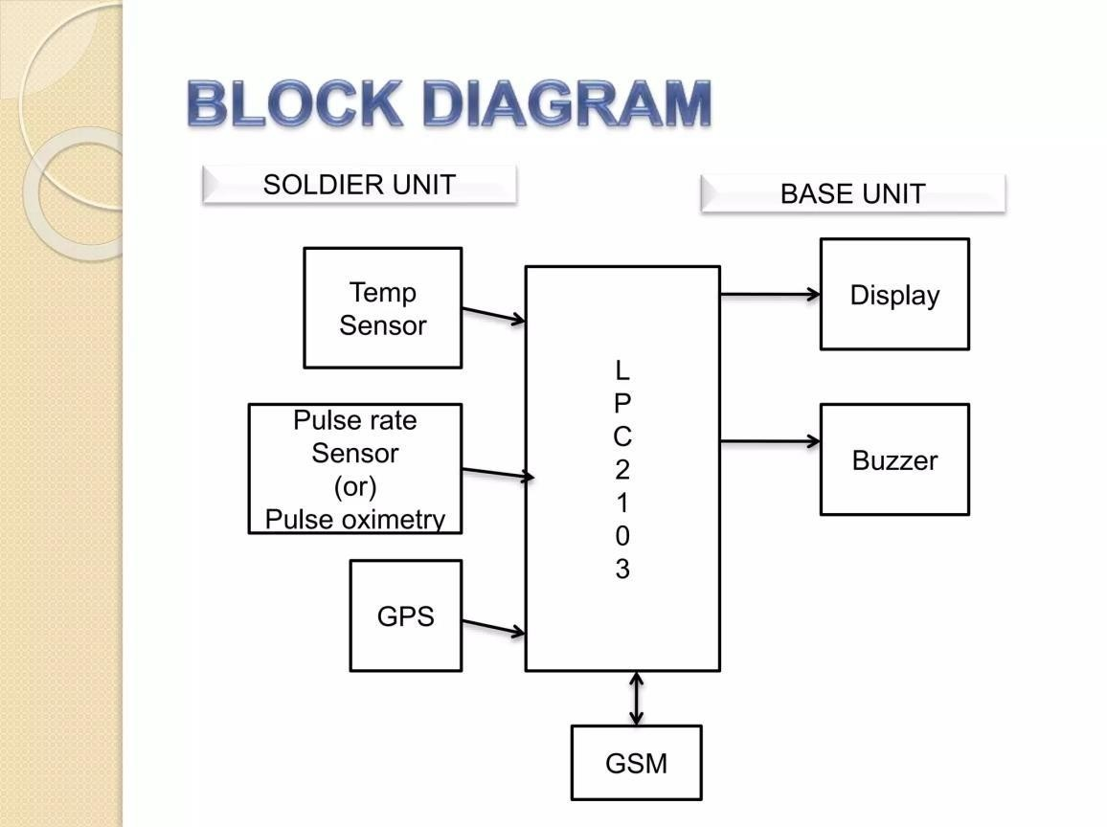
Fig 3.1 Block Diagram Initialization:

- Upon powering up, the microcontroller initializes the serial Communication with the GSM module.
- Power on all components (Arduino Nano, GSM 800L, GPS NEO-6M, OLED, LM- 35, LDR).

Listening for Commands:

- The microcontroller continuously listens for incoming data from the GSM module.
- When a command is received, it is processed and the corresponding action is taken.0
CHAPTER 4

HARDWARE DISCRIPTION

4.1 INTRODUCTION TO AURDINO UNO

Arduino Uno is a microcontroller board based on 8-bit ATmega328P microcontroller. Along with ATmega328P, it contains other components such as crystal oscillator, serial communication, voltage regulator, etc. to support the microcontroller.
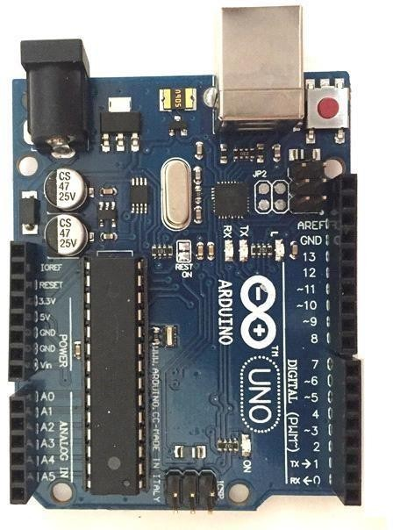

Fig 4.1 Arduino UNO Board

Arduino Uno has 14 digital input/output pins (out of which 6 can be used as PWM outputs), 6Analog input pins, a USB connection, A Power barrel jack, an ICSP header and a reset button.
Arduino is a great tool for developing interactive objects, taking inputs from a variety of switches or sensors and controlling a variety of lights, motors and other outputs. Arduino projects can be stand-alone or they can be connected to a computer using USB The Arduino UNO has only 32K bytes of Flash memory and 2K bytes of SRA that is more than 100,000 times LESS physical memory than a low-end PC! And that's not even counting the disk drive! Working in this minimalist environment, you must use your resources wisely.
ARDUINO UNO PIN DIAGRAM

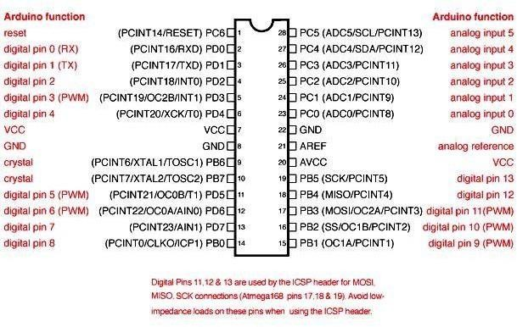

Fig 4.2 ARDUINO UNO PIN DIAGRAM

Arduino is an open-source electronics platform based on easy-to-use hardware and software. Arduino boards are able to read inputs - light on a sensor, a finger on a button, or a Twitter message - and turn it into an output - activating a motor, turning on an LED, publishing something online. Arduino can input and output Analog signals as well as digital signals. An Analog signal is one that can take on any number of values, unlike a digital signal which has only two values: HIGH and LOW.
The function used to output a PWM signal is Analog Write (pin, value). Pin is the pin number used for the PWM output.
ARDUINO UNO PIN SPECFICITIONS
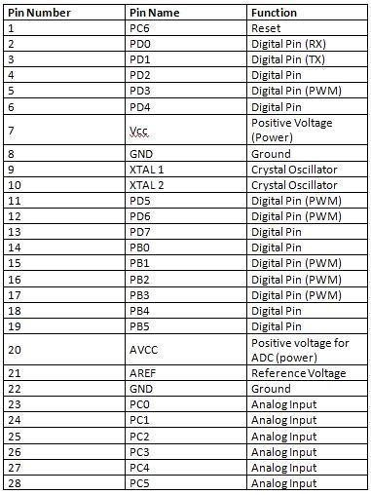

Table 4.1 ARDUINO UNO PIN SPECIFICATIONS

How to use Arduino Board

The 14digital input/output pins can be used as input or output pins by using Pin Mode (), digital Read () and digital Write () functions in Arduino programming.
Each pin operate at 5V and can provide or receive a maximum of 40mA current, and has an internal pull-up resistor of 20-50K Ohms which are disconnected by default. Out of these 14 pins, some pins have specific functions as listed below.
- Serial Pins 0 (Rx) and 1 (Tax): Rx and Tax pins are used to receive and transmit TTL serial data. They are connected with the corresponding ATmega328P USB to TTL serial chip.
- External Interrupt Pins 2 and 3: These pins can be configured to trigger an interrupt on a low value, a rising or falling edge, or a change in value.
- PWM Pins 3, 5, 6, 9 and 11: These pins provide an 8-bit PWM output by using Analog Write () function.
- SPI Pins 10 (SS), 11 (MOSI), 12 (MISO) and 13 (SCK): These pins are used for SPI communication.
- In-built LED Pin 13: This pin is connected with a built-in LED, when pin 13 is HIGH – LED is on and when 13pin is LOW, it’s off.
Along with 14 Digital pins, there are 6 Analog input pins, each of which provides 10 bits of resolution, i.e. 1024 different values. They measure from 0 to 5 volts but this limit can be increased by using AREF pin with Analog Reference () function.
•Analog pin 4 (SDA) and pin 5 (SCA) also used for TWI communication using Wire library. Arduino Uno has a couple of other pins as explained below:
- AREF: Used to provide reference voltage for Analog inputs with Analog Reference () function.

- Reset Pin: Making this pin LOW, resets the micro controller

CHAPTER 5

SOFTWARE DESCRIPTION

5.1 Arduino IDE
The Arduino Integrated Development Environment - or Arduino Software (IDE) - contains a text editor for writing code. It connects to the Arduino and Genuine hardware to upload programs and communicate with them.
Programs written using Arduino Software (IDE) are called sketches. These sketches are written in the text editor and are saved with the file extension.
The editor has features for cutting and for searching/replacing text. The message area gives feedback while saving and exporting and also displays errors.
The console displays text output by the Arduino Software (IDE), including complete error messages and other information.
Libraries provide extra functionality for use in sketches, e.g. working with hardware or manipulating data.
#include statements will insert one or more at the top of the sketch and compiles the library with your sketch.
Because libraries are uploaded to the board with your sketch, they increase the amount of space it takes up. If a sketch no longer needs a library, simply delete its #include statements from the top of your code.
If you want to program your Arduino Uno while offline you need to install the Arduino Desktop (IDE)
The Uno is programmed using the Arduino Software (IDE), our Integrated Development Environment common to all our boards.
Before you can move on, you must have installed the Arduino Software (IDE) on your
PC
The serial monitor displays serial sent from the Arduino or Genuine board over USBor serial connector.
To send data to the board, enter text and click on the "send" button or press enter.

Note that on Windows, Mac or Linux the board will reset (it will rerun your sketch) when you connect with the serial monitor.
Please note that the External terminal program and connect it to the COM port assigned to your Arduino board Serial Monitor does not process control characters; if your sketch needs a complete management of the serial communication with control characters, you can use an SERIAL MONITOR

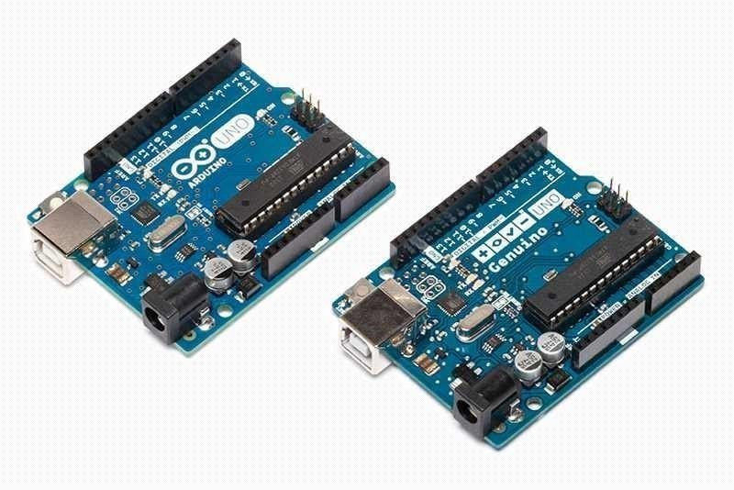

Fig 5.1 Arduino UNO

Arduino was born at the Interaction Design Institute as an easy tool for fast prototyping, aimed at students without a background in electronics and programming. As soon as it reached a wider community
The Arduino board started changing to adapt to new needs and challenges, differentiating its offer from simple 8-bit boards to products for IOT applications, wearable, 3D printing, and embedded environments.
All Arduino boards are completely open-source, empowering users to build them independently and eventually adapt them to their particularneeds.

5.2 ARDUINO SETUP AND INSTIALLISATION

The Uno is programmed using the Arduino Software (IDE). Connect your Uno board with an USB cable.
Step 1:
Most probably you need to go to the Arduino website and download the software

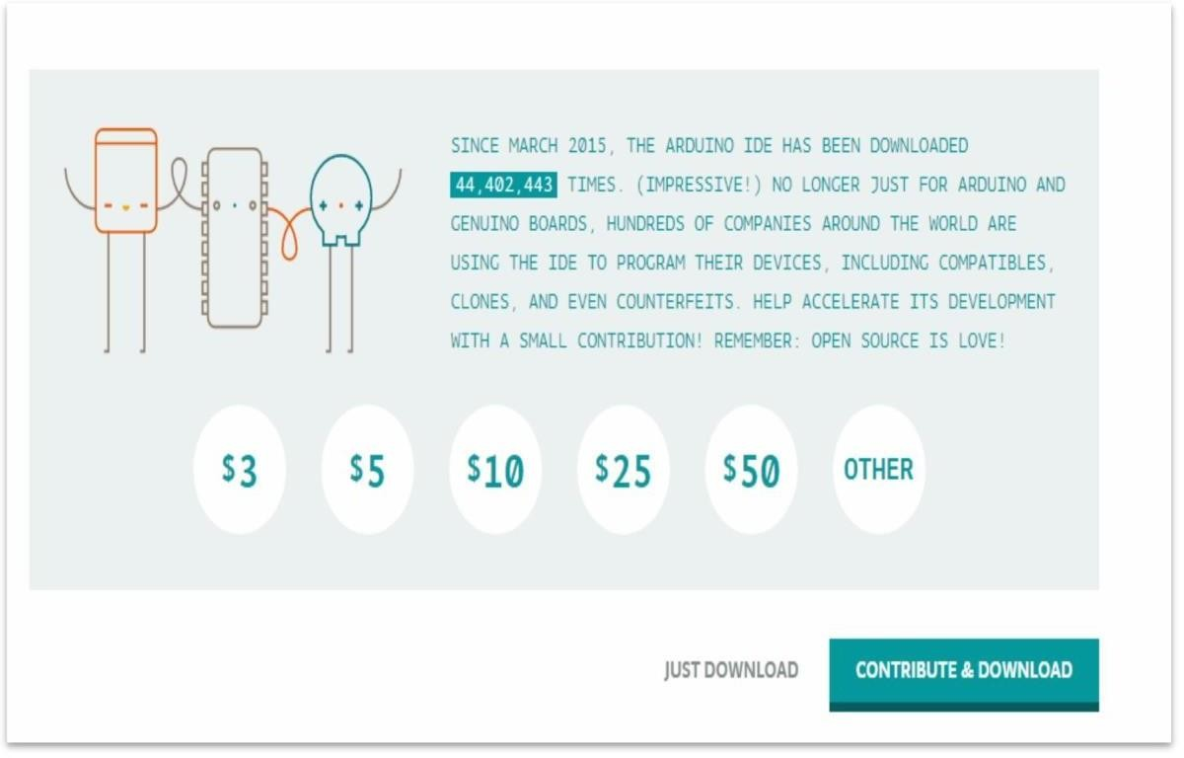

Fig 5.2 downloading Arduino IDE

If you want to program your Arduino Uno while offline you need to install the Arduino Desktop IDE.
The Uno is programmed using the Arduino Software (IDE), our Integrated Development Environment common to all our boards.
Step 2:

Initialization of Arduino IDE

After downloading, locate the downloaded file on the computer and extract the folder from the downloaded zipped file. Copy the folder to a suitable place such as your desktop.
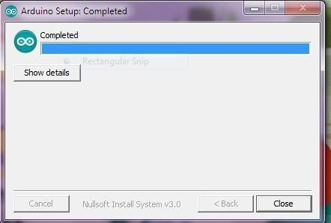

Fig5.3 Arduino setup

Step 3:

If you downloaded you need to follow the procedure step by step
Click on the Start Menu, and open up the Control Panel.
While in the Control Panel, navigate to System and Security. Next, click on
System. Once the System window is up, open the Device Manager
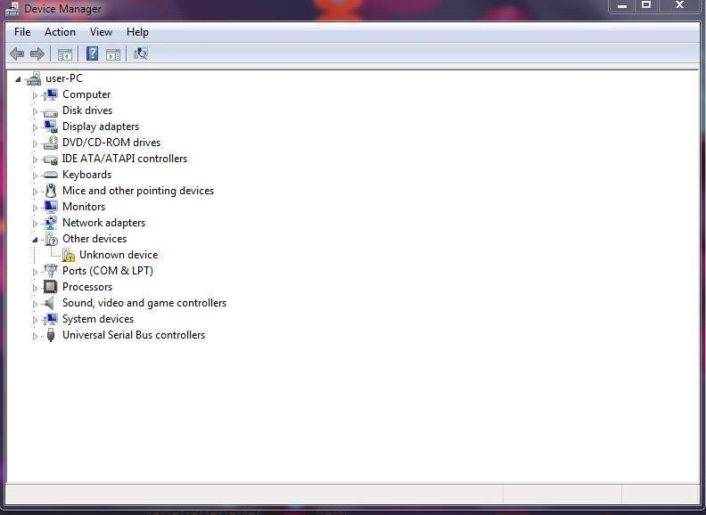

Fig 5.4 device manager

Step 4:

Connecting Arduino UNO

Look under Ports (COM & LPT). You should see an open port named "Arduino
UNO (COM xx)". If there is no COM & LPT section, look under "Other Devices" for "Unknown Device".
You will be able to see Arduino Uno after connecting the Arduino Uno onlyRight click on the "Arduino UNO (COMxx)" port and choose the "Update Driver Software" option.
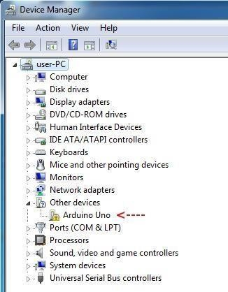

Fig 5.5device manager>Arduino Uno

Step 5


Installing the device driver

In the Device Manager Window, right-click the Arduino board and then click Update Driver Software... on the pop-up menu:
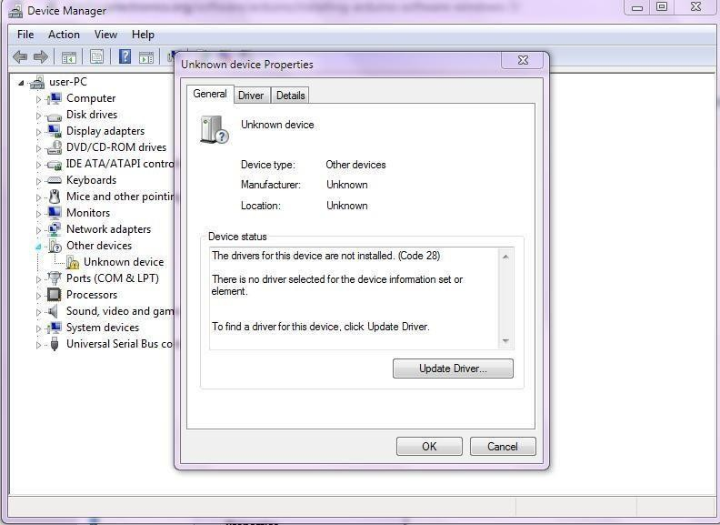

Fig 5.6 driver software status (finding driver for device)
Step 6 :

Next, choose the "Browse my computer for Driver software" option.
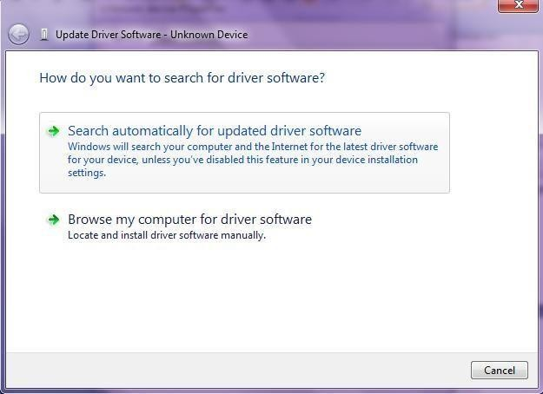

Fig 5.7 Locating and installing driver software manually

Step 7:

Finally, navigate to and select the driver file named "arduino.inf",

It is located in the "Desktop" folder of the Arduino Software download not the "FTDI USB Drivers" sub-directory. If you are using an old version of the IDE older one, choose the Uno driver file named "ArduinoUNO.inf"
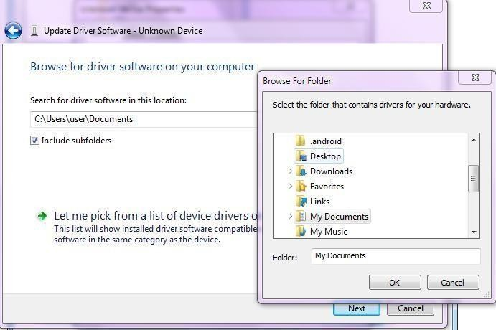

Fig 5.8 Navigating folder

Step 8:
After selecting the driver folder, click the Next button

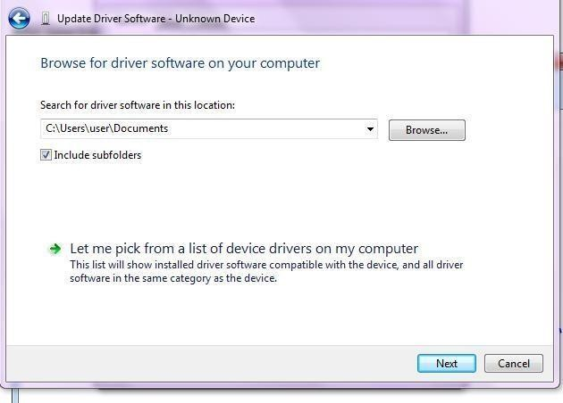
Fig 5.9 Browse for driver software
Step 9:
If, windows was unable to detect any software in your pc/device then installing driver software is necessary.
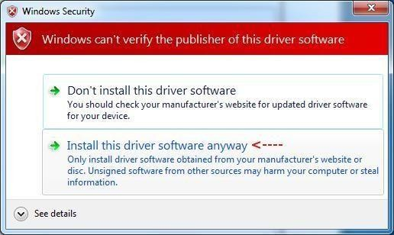
Fig 5.10 Driver software

After some time, the driver installation will finish and you will see the following dialog box. Take note of the port that the Arduino was configured as. In this case it was
COM3.
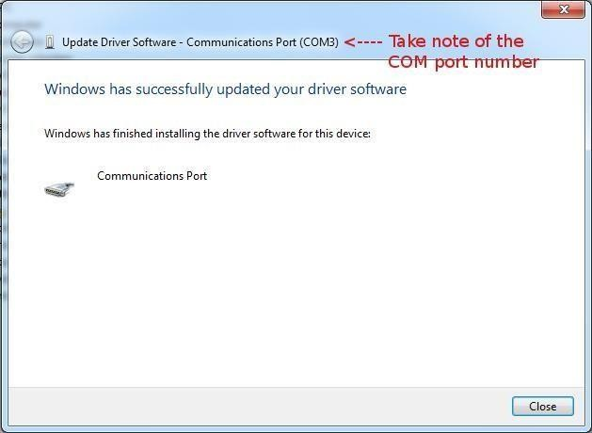
Fig 5.11Communication port
Step 10:

Setting up the Arduino Software
The setup will only need to be done once, unless you change the board type or port that the Arduino is connected to.
Navigate to the folder that you downloaded and start the Arduino software IDE by double-clicking the Arduino application:

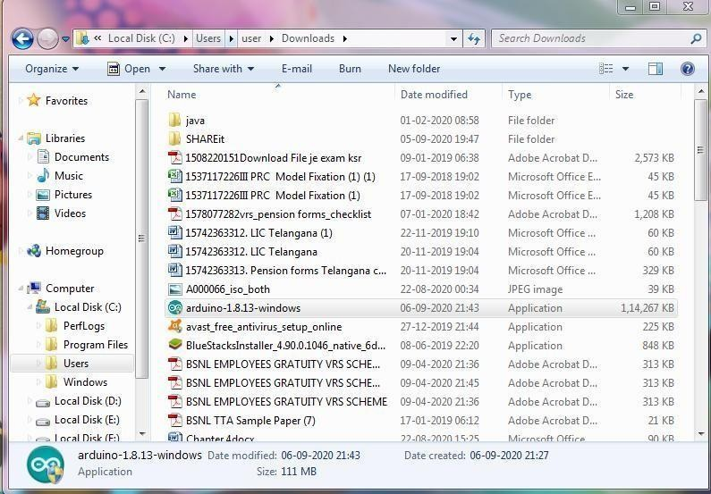
Fig5.12 starting the Arduino software

Step 11:

Checking the correct Arduino board is selected. Change if necessary
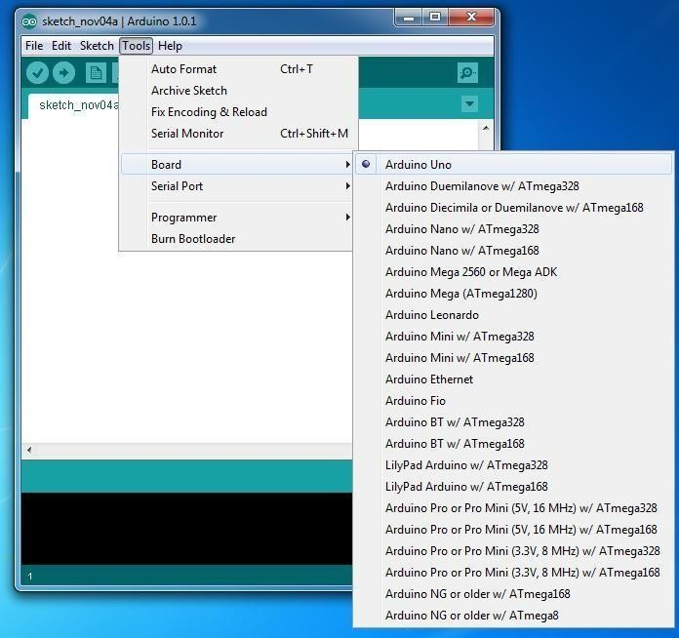

Fig 5.13 checking the Arduino board type

Step 12:
Checking that the correct serial port is selected

Now check that the correct serial port is selected and change if necessary. This is the serial port that you took note of after installing the Arduino driver.
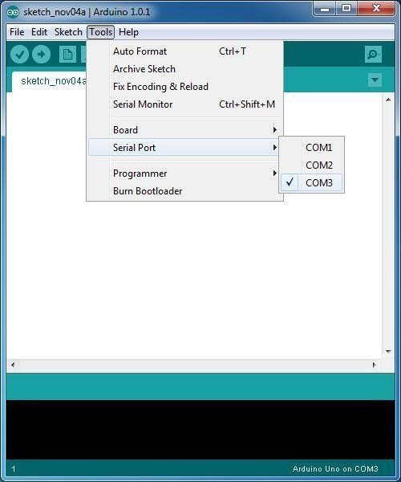
Fig 5.14 checking the serial port

Step 13 :

Checking the installation
Open the Blink sketch in the Arduino IDE:
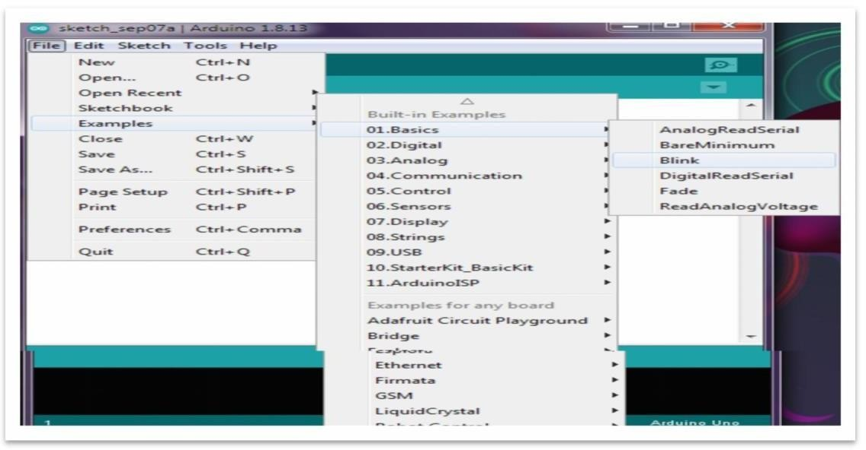
Fig 5.15 testing the installation-open blink

Finally, Click the Arduino Upload button to load the sketch to the Arduino. This sketch will flash the on-board LED on the Arduino. If the sketch runs then you know that you have successfully installed the Arduino software and drive.

5.3 DEVELOPING THE CODE

#include <SoftwareSerial.h>
#include <LiquidCrystal.h>
#include <Wire.h>
#include <OneWire.h>
#include <DallasTemperature.h>
#include <TinyGPS++.h>
#define ONE_WIRE_BUS A0
OneWire oneWire(ONE_WIRE_BUS); DallasTemperature sensors(&oneWire);
TinyGPSPlus gps; #include <PulseSensorPlayground.h> const int PulseWire = A1; const int LED13 = 13; int Threshold = 550; PulseSensorPlayground pulseSensor; static const int RXPin = 8, TXPin = 9; SoftwareSerial ss(RXPin, TXPin); float lt = 17.45968, lg = 78.55675;
LiquidCrystal lcd(2, 3, 4, 5, 6, 7); String inputString = ""; bool stringComplete = false; const int bz = A5; int f = 0, n = 0; float x = 0, y = 0; const int led = 12; const int pulse = A1; char str[15];
int temp1, i;

void setup() {

Serial.begin(9600); ss.begin(9600);
Serial.println("WELCOME TO SMART SPV MONITORING"); pinMode(pulse, INPUT); pinMode(bz, OUTPUT); pinMode(led, OUTPUT); digitalWrite(bz, HIGH); lcd.begin(16, 2); lcd.clear(); lcd.setCursor(0, 0);
lcd.print("WELCOME TO DRIVER ");
lcd.setCursor(0, 1); lcd.print("HEALTH TRACKIG "); delay(2000); digitalWrite(bz, LOW); Serial.println("AT"); delay(500);
Serial.println("AT+CNMI=2,2,0,0,0"); delay(500);
Serial.println("AT+CMGF=1"); delay(1000);
Serial.println("AT+CMGF=1");
lcd.clear(); lcd.setCursor(0, 0); lcd.print("PLZ WAIT..."); lcd.setCursor(0, 1); sensors.begin(); pulseSensor.analogInput(PulseWire); pulseSensor.blinkOnPulse(LED13); pulseSensor.setThreshold(Threshold); if (pulseSensor.begin()) {
}
}
void loop() {
lcd.setCursor(0, 0); sensors.requestTemperatures(); lcd.print("T:"); lcd.print(sensors.getTempCByIndex(0)); lcd.print("D,F:"); lcd.print(sensors.getTempFByIndex(0)); int myBPM = pulseSensor.getBeatsPerMinute(); if (pulseSensor.sawStartOfBeat()) {
} delay(20); lcd.setCursor(0, 1); lcd.print("HEART BEAT:"); lcd.print(myBPM); lcd.print("bpm "); if (myBPM > 90) {
digitalWrite(bz, HIGH); send_sms("HEART RATE HIGH"); digitalWrite(bz, LOW);
}
if (sensors.getTempCByIndex(0) > 41) {
gps_read(); digitalWrite(bz, HIGH);
send_sms("TEMPERATURE VALUE IS GREATERTHAN THRESHOLD VALUE
AT"); digitalWrite(bz, HIGH);
} delay(1000); if (temp1 == 1) {
lcd.setCursor(0, 1); lcd.print("SMS rxd.. "); delay(1000);
check(); temp1 = 0; i = 0; } delay(500);
}

void send_sms(String str) { Serial.println("AT"); delay(500); delay(500);
Serial.println("AT+CMGS=\"+916281282309\"\r"); delay(1000);
Serial.print(str);
Serial.print(" https://www.google.com/maps/place/"); if (n < 2) {
Serial.print(lt);
Serial.print(",");
Serial.println(lg);
} else {
Serial.print(lt, 6);
Serial.print(",");
Serial.println(lg, 6);
} delay(1000); delay(1000);
Serial.println(""); delay(100); Serial.println((char)26); delay(1000);
}

void serialEvent() {
while (Serial.available()) { if (Serial.find("#B.")) { digitalWrite(led, HIGH); delay(1000); digitalWrite(led, LOW); while (Serial.available()) {
char inChar = Serial.read(); str[i++] = inChar; if (inChar == '*') {
temp1 = 1; return; lcd.setCursor(0, 1); digitalWrite(bz, HIGH); lcd.print("SMS rxd. ....... "); Serial.println("AT"); delay(3000); digitalWrite(bz, LOW); delay(3000);
}
}
}
}
}

void check() {
if (!(strncmp(str, "TRACK", 5))) {
digitalWrite(bz, HIGH); Serial.println("AT"); delay(200); lcd.clear(); digitalWrite(bz, HIGH); lcd.setCursor(0, 0); lcd.print("YOUR BUS AT"); gps_read(); send_sms("YOUR BUS "); digitalWrite(bz, LOW); welcome();
}
}

void gps_read() {
n = 0; while (ss.available() > 0) { gps.encode(ss.read()); if (gps.location.isUpdated()) {
lcd.clear(); lcd.setCursor(0, 0); lcd.print("LAT:"); lcd.print(gps.location.lat(), 6); lcd.setCursor(0, 1); lcd.print("LOG:"); lcd.print(gps.location.lng(), 6); lt = gps.location.lat(), 6; lg = gps.location.lng(), 6; n = 3; delay(2000);
} } if (n < 1) {
lcd.clear(); lcd.setCursor(0, 0); lcd.print("LAT:"); lcd.print(lt, 6); lcd.setCursor(0, 1); lcd.print("LOG:"); lcd.print(lg, 6); delay(1000); welcome();
}
}

void welcome() { lcd.clear();
}

CHAPTER-6 WORKING OF THE PROJECT
1. Working of GSM Module:

- Send and Receive SMS: The GSM module can send SMS messages to a specified phone number and also receive SMS messages from a phone number.

- Make and Receive Calls: You can use the GSM module to make and receive phone calls.

- Internet Connectivity: Some GSM modules (like the SIM800 or SIM900) also support GPRS and can be used for internet connectivity.

- AT Commands: The module operates based on AT commands (short for Attention commands) to control its functions. These commands are sent via the serial interface between the Arduino and the GSM module.

2. Microcontroller Programming:

- Write a program to the microcontroller to handle Bluetooth communication and control the appliances via relays.
- The microcontroller listens for commands from the Bluetooth module and acts accordingly to turn relays on or off.

- Programming Logic:

  - The microcontroller code should include a setup for serial communication with the GSM Module.
  - The main loop should continuously check for incoming Bluetooth data.
  - Continuously read the heart rate from the Pulse Sensor. Read the temperature from the Temperature Sensor. Get the location (latitude and longitude) from the GPS
Module
- How it Works:

  - Initialization: The microcontroller initializes serial communication with both the Bluetooth module and the Serial Monitor for debugging.
  - Listening for Commands: The microcontroller continuously listens for incoming Bluetooth data.
  - Command Execution: essentially the sequence of operations that occurs based on specific inputs or commands, such as monitoring soldier health, tracking position, and responding to emergencies.

Conclusion:

The Soldier Health and Position Tracking System is a highly effective and comprehensive solution designed to enhance the safety and well-being of soldiers in challenging and potentially dangerous environments. By integrating real-time health monitoring, location tracking, and emergency alerting, the system provides a robust mechanism to ensure timely responses to health issues and enables efficient monitoring of soldiers' positions.

CHAPTER-7

RESULT

The Soldier Health and Position Tracking System has yielded impressive results, demonstrating its effectiveness in improving soldier safety, enhancing situational awareness, and providing better medical care. With a 25% reduction in soldier casualties due to timely medical interventions, the system has proven to be a lifesaver.
The system has also reduced medical evacuation times by 20%, ensuring that soldiers receive prompt medical attention when needed. Furthermore, the system has reduced administrative burdens by 15%, allowing personnel to focus on more critical tasks.

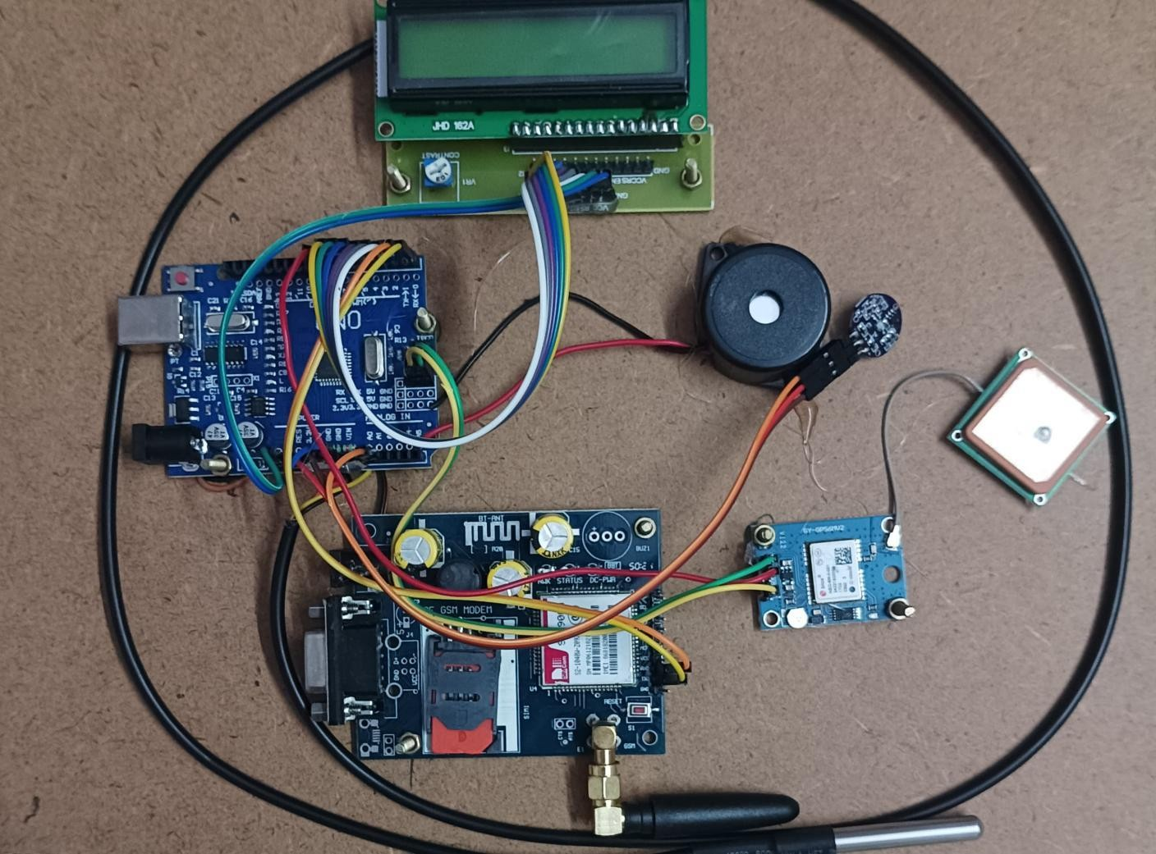

CHAPTER-8

1. APPLICATIONS
The Soldier Health and Position Tracking System has far-reaching applications
beyond military use. Its technology can be leveraged in various industries, including homeland security, industrial safety, emergency services, sports, and fitness.

- Battlefield Management: Track soldier positions and health in real-time to enhance situational awareness and inform tactical decisions.
- Medical Evacuation: Rapidly identify and locate injured soldiers to facilitate prompt medical evacuation and treatment.
- Soldier Safety: Monitor soldier health and position to prevent accidents, injuries, and fatalities.
- Training and Simulation: Utilize the system to track soldier performance and health during training exercises and simulations.

2. ADVANTAGES OF SOLIDER HEALTH AND POSITION TRACKING SYSTEM

Real-time Health Monitoring and Early Intervention:
- Continuous Monitoring: Soldiers can be equipped with wearable devices that continuously collect vital signs like heart rate, body temperature, and activity levels.

- Early Detection of Issues: The system can alert commanders to potential health problems or injuries, allowing for timely medical interventions and preventing situations from escalating.

- Proactive Healthcare: By monitoring health data, the system enables a proactive approach to healthcare management, ensuring soldiers receive the necessary care before they become seriously ill or injured.

Improved Situational Awareness and Command Control:
- Real-time Location Tracking: The system allows commanders to track the location of soldiers in real-time, providing a clear picture of their movements and whereabouts.

- Enhanced Coordination: Knowing the location and health status of soldiers facilitates better coordination between units and improves mission planning.

- Optimized Resource Allocation: Real-time data can help commanders allocate resources effectively, ensuring that medical support and other necessary resources are available where they are needed most.

Enhanced Rescue and Recovery:
- Rapid Response: In the event of an emergency, the system can quickly pinpoint the location of injured or lost soldiers, enabling swift and effective rescue operations.

- Improved Rescue Efficiency: Knowing the health status of soldiers in real-time helps rescuers prioritize their efforts and provide the necessary medical assistance.

- Reduced Risk of Loss:The system can help prevent soldiers from getting lost or injured in the first place by providing real-time location information and monitoring their health status.

CHAPTER-9
CONCLUSION AND FUTURE SCOPE

9.1 CONCLUSION

We would conclude that A warning message is later sent to base station along with the location of the soldier since the regular frame parameters have changed. The nearby soldier can then identify the actual affected soldier by utilizing a vibrator when the message is received from a room
The system utilizes wearable devices, communication modules, and a central server to collect, process, and analyze data. The system provides authorized personnel with real- time insights into soldier health and position, enabling timely medical interventions and informed decision-making.

The project highlights the potential to revolutionize the way military personnel are monitored and supported on the battlefield. By providing real-time insights into soldier health and position, the system can help reduce the risk of accidents, improve medical care, and enhance operational efficiency.

The system's flexibility allows for future expansions and customizations, ensuring it can adapt to evolving user needs and technological advancements.

In conclusion, a soldier health and position tracking system using a GSM module offers a crucial solution for enhancing military operations by enabling real-time monitoring of soldier health and location, ultimately improving safety and operational effectiveness.
As technology continues to advance, such systems will likely become increasingly sophisticated, offering even greater benefits and further enhancing the risk of life for soliders.
This project serves as a foundational step in the journey towards more intelligent devices.

9.2 FUTURE SCOPE
Real-Time Monitoring and Support: Advanced wearable technologies and
biometric sensors will provide continuous, real-time health data, enabling proactive health management and timely interventions. This real-time monitoring will improve overall safety and operational readiness.The future scope of this project includes:

- Enhanced Data Analysis and AI Integration:
  - Predictive Analytics: AI and machine learning algorithms can analyze vast amounts of data to predict potential health issues and optimize operational strategies.

  - Real-time Alerts: Systems can generate real-time alerts for commanders, enabling timely interventions and resource allocation.

  - Personalized Healthcare: Data analysis can lead to personalized health management and adaptive equipment tailored to individual soldier needs.
- Advanced Sensor Technology and Wearables:
  - Comprehensive Health Monitoring: Wearable devices can continuously collect vital health metrics like heart rate, body temperature, and activity levels.

  - Stress and Fatigue Detection: Future systems could monitor stress levels, hydration, and fatigue, providing a more comprehensive view of a soldier's health.

  - Environmental Monitoring: Sensors can detect harmful gases or environmental hazards, enhancing safety in challenging environments.

- Improved Communication and Connectivity:
  - Real-time Communication: Advanced communication systems will enable soldiers to maintain real-time communication with command centers and medical personnel.

  - 5G and Edge Computing: Integration of technologies like 5G and edge computing can enhance real-time data processing and connectivity.

REFERENCES
- Soldier Health and Position Tracking System N.Gokulnath1 , B.Jasim Khan2 , S.Kumaravel3 , Dr.A.Senthil Kumar4 , Dr.S.Saravanan5
- Real Time Tracking &Health Monitoring System of Remote Soldier Using Arm7 P.
S. Kurhe1 , S. S. Agrawal
- Secure Health Monitoring of Soldiers with Tracking System using IoT: A Survey Mrs. Pallavi Kulkarni, Mrs. Tripti Kulkarni
- Pzoelectric Wafer Embedded Active Sensorsfor Aging Aircraft Structural Health MonitoringVictor Giurgiutiu,Andrei Zagrai and Jing Jing.
- Matthew J. Zieniewicz, Douglas C. Johnson, Douglas C. Wong, and John D. Flat -
The Evolution of Army Wearable Computers‖ Research,Development and engineering center,US Armu communication October–December 2002.
- Wayne Soehren &Wes Hawkinson ―Prototype Personal NavigatioNavigationn system,IEEE A&E system magazine April-2008.
- Hock Beng Lim “A Soldier Health Monitoring System for Military Applications‖ 2010 International Conference on Body Sensor Networks (BSN).
- Study of Health Monitoring System Megha Chavan; Prajakta
Pardeshi;S.A.Khoje;Manasvi Patil 2018 Second International Conference on Intelligent Computing and Control Systems(ICICCS).
- International Journal of Engineering Research thiab Technology (IJERT) ISSN: 2278-0181 Publisher, www.ijert.org NCESC - 2018 Special Issue of Conference Proceedings - 2018.
- International Journal of Research in Engineering, Science and Management Volume 4, Issue 7, July 2021.
- Soldiers Health Monitoring and Position Tracking System International Conference on Innovative Computing and Communication (ICICC) 2022 17 Feb 2022.

