Creating Our Own Wheel Package File: [.whl]
Overview
By organizing these functions into a package, we make it easier for users to import and use them in their projects.
Additionally, packaging your code allows us to distribute it more easily and share it with others who may find it useful for their image processing tasks.

Process
1. Organize the Code
- Create a project directory named my_package.
- Add the following files:
  - filters.py: Contains functions like gaussian_filter and sobel_filter.
  - __init__.py: This can be empty or include import statements.
  - my_module.py: For additional functions, if needed.
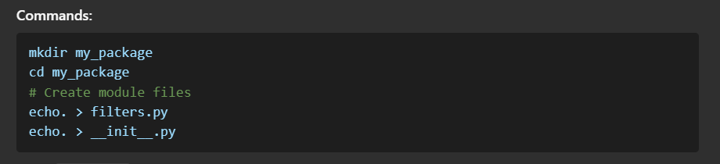
Open filters.py in your editor (e.g., VS Code) and define your functions.

2. Create a setup.py File
- Create a setup.py file in the root directory of the project.
- This file defines metadata about the package and instructions for distribution.
Example setup.py:
from setuptools import setup, find_packages
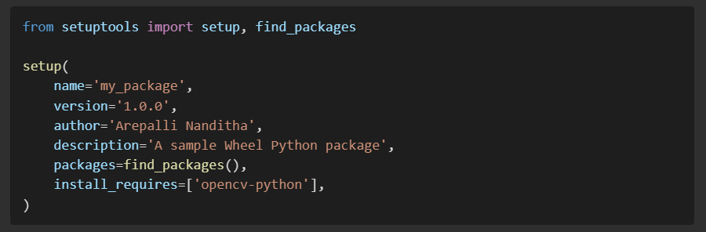
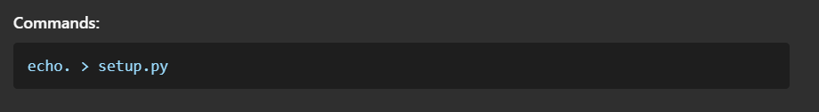

3. Install Required Dependencies
- Ensure that setuptools and wheel are installed.
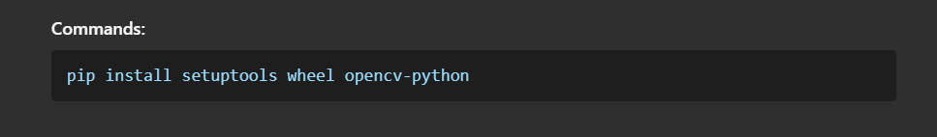

4. Build the Package
- Generate the distribution files (.tar.gz and .whl) in the dist directory.
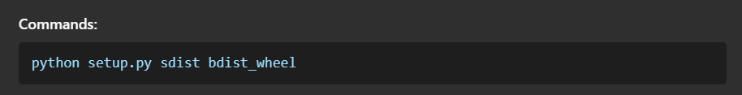
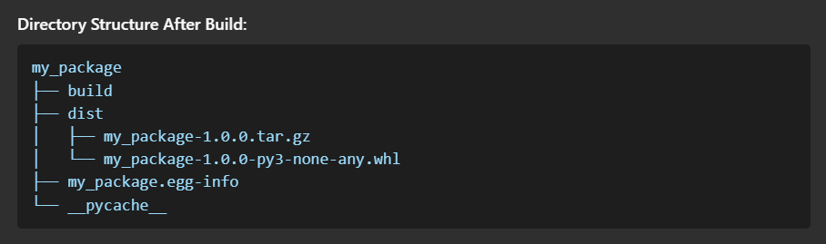

5. Test the Package Locally
- Install the package locally to test its functionality.
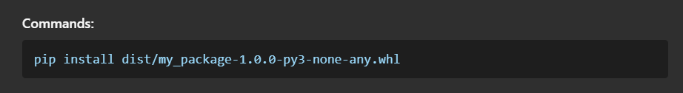
- Create a test_filters.py file to test the functions in filters.py.

6. Upload to PyPI (Optional)
For public distribution, upload the package to PyPI.
Steps:
- Register an account on PyPI.
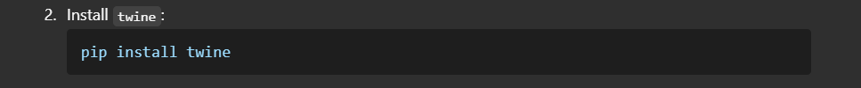
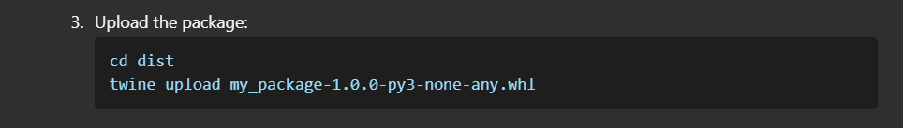
Troubleshooting:
If you encounter a 403 Forbidden error, ensure:
- The API token is correct.
- Authentication details are valid.

Final Package Structure
After completing the process, the my_package directory should contain:
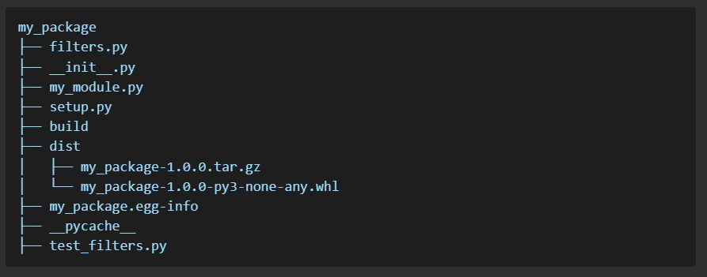By following these steps, you can create, build, and distribute your own Python wheel package for efficient image processing.

