NLP-Based Resume and Job Description Matching Using TF-IDF and Cosine Similarity

1. Problem Statement
Recruiters usually have to go through many resumes to find suitable candidates for a job. Checking each resume manually takes a lot of time and effort. This project aims to develop an NLP-based system that compares resumes with a given job description and ranks them according to their similarity.

2. Objectives
• To clean and preprocess resume and job description text.
• To convert text into numerical form using TF-IDF.
• To calculate similarity between resumes and job descriptions using Cosine Similarity.
• To rank resumes based on their similarity scores.
• To display the Top-K matching resumes for a given job description.

3. Dataset
The dataset used for this project is the Resume-Job Fit Merged Dataset from Hugging Face.
The original dataset contains 80,017 training records and 13,716 test records. It contains resume text, job descriptions, fit labels, source information, and domain information.
For this project, 1,000 records were selected from the training data so that the NLP processing and similarity calculations could be performed efficiently.
The main fields used are:
• Resume – Candidate's resume text
• JD – Job description
• Label – Resume-job fit category
• Resume Domain – Domain of the resume
• JD Domain – Domain of the job
The dataset has three labels:
• Good Fit – Strong match
• Potential Fit – Partial match
• No Fit – Poor match

4. Methodology
The system follows these steps:
Resume and Job Description
↓
Text Preprocessing
↓
TF-IDF
↓
Cosine Similarity
↓
Similarity Score
↓
Resume Ranking
↓
Top Matching Resumes

4.1 Text Preprocessing
First, the resume and job description text is cleaned. The text is converted into a suitable form by applying basic NLP preprocessing such as lowercasing, removing unnecessary characters, tokenization, stopword removal, and lemmatization.

4.2 TF-IDF
After preprocessing, TF-IDF is used to convert the text into numerical vectors. The project uses up to 10,000 features and includes both unigrams and bigrams.

4.3 Cosine Similarity
Cosine Similarity is used to compare the job description with the resumes. A higher score means that the resume has more textual similarity with the given job description.

4.4 Resume Ranking
The resumes are sorted according to their similarity scores. The system returns the Top-K most similar resumes.

5. Implementation
The project was implemented using Python.
Libraries Used:
• Pandas
• NumPy
• NLTK
• Scikit-learn
• Matplotlib
• Hugging Face Datasets
NLP techniques used:
• Text preprocessing
• Tokenization
• Stopword removal
• Lemmatization
• TF-IDF
• Cosine Similarity
The TfidfVectorizer was used to create the TF-IDF representation, and Cosine Similarity was used to compare the job description with the resumes.

6. Results
The developed system was tested using a sample Data Analyst / NLP Intern job description.
The test job description included skills such as Python, SQL, Pandas, NumPy, machine learning, data analysis, data visualization, and Scikit-learn.
The system compared this job description with the selected resumes and ranked them according to their similarity scores.
The final output displays the Top-10 matching resumes with their similarity scores and match percentages.

Dataset Preview
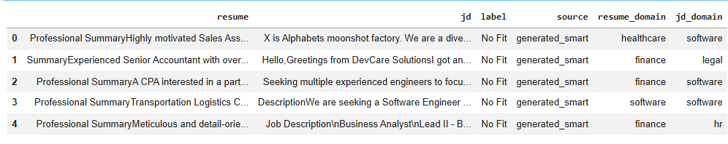

TF-IDF Vectorization
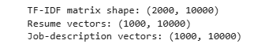
Test Output – Top-10 Matching Resumes
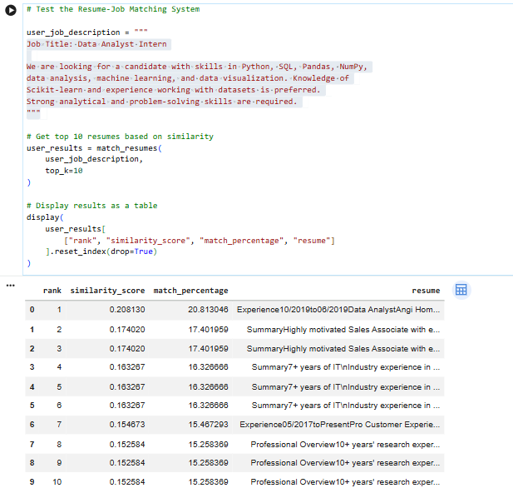
Test Input: A Data Analyst Intern job description requiring Python, SQL, Pandas, NumPy, data analysis, machine learning, data visualization, and Scikit-learn was used to test the resume matching system.

7. Limitations
• TF-IDF mainly looks at word overlap and may not understand the actual meaning of the text.
• Synonyms may not be matched effectively.
• Poorly formatted or noisy resumes can affect the results.
• The results depend on the quality of the dataset.
• Only 1,000 records were used in this project.
• Dataset bias may affect the results.
• The system should be used as a screening aid and not as the final hiring decision.
8. Future Scope
• Use a larger dataset.
• Use advanced models such as BERT or sentence embeddings.
• Add automatic skill extraction.
• Combine skill matching with text similarity.
• Create a web application for recruiters.
• Support multiple languages.
• Improve evaluation using a larger test dataset.
9. Conclusion
This project developed a simple NLP-based system for matching resumes with job descriptions. The system uses text preprocessing, TF-IDF, and Cosine Similarity to find and rank resumes that are similar to a given job description.
The project shows how basic NLP techniques can be used to make the initial resume screening process faster and easier.

