OUTPUT SCREENSHOTS AND EXPLANATION REPORT

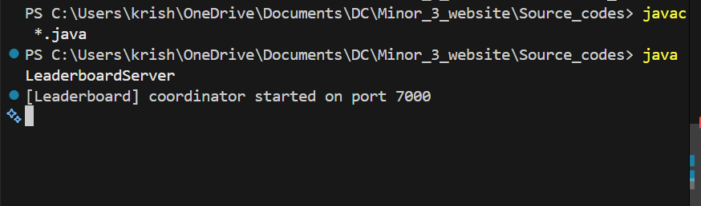
Starting LeaderboardServer. This takes care of the shared leaderboard
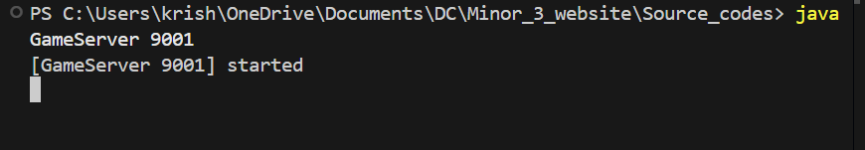
Starting GameServers, creating 3 for now. We can create how many ever we like but they have to be passed when running Loadbalancer.
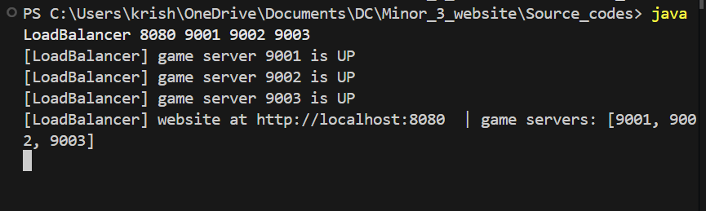
Starting the loadbalancer. This will distribute the players among the servers available.
Then we go to a browser and type in localhost:8080
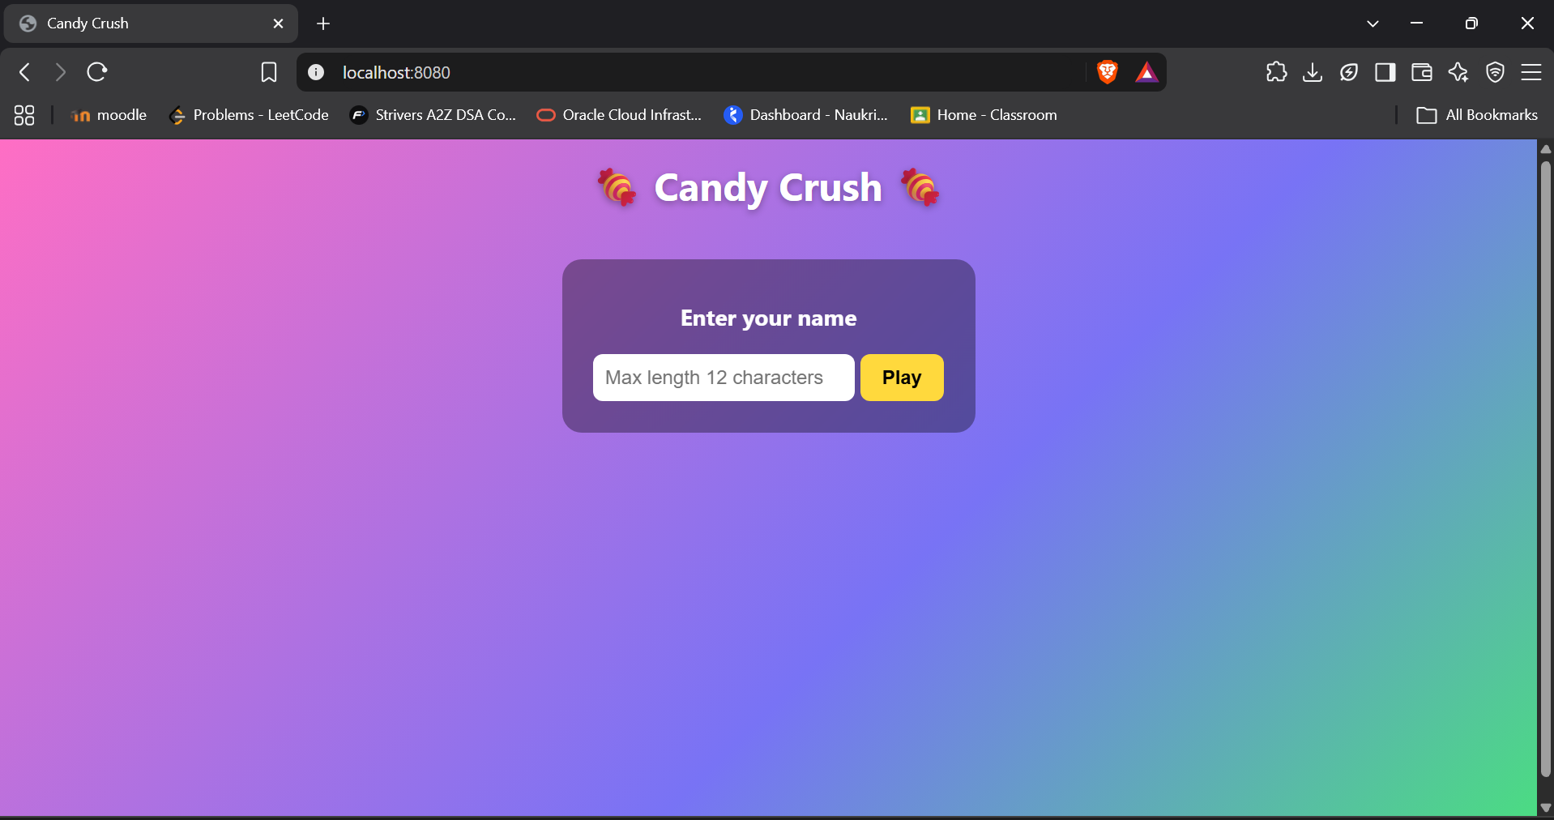
One of the tab
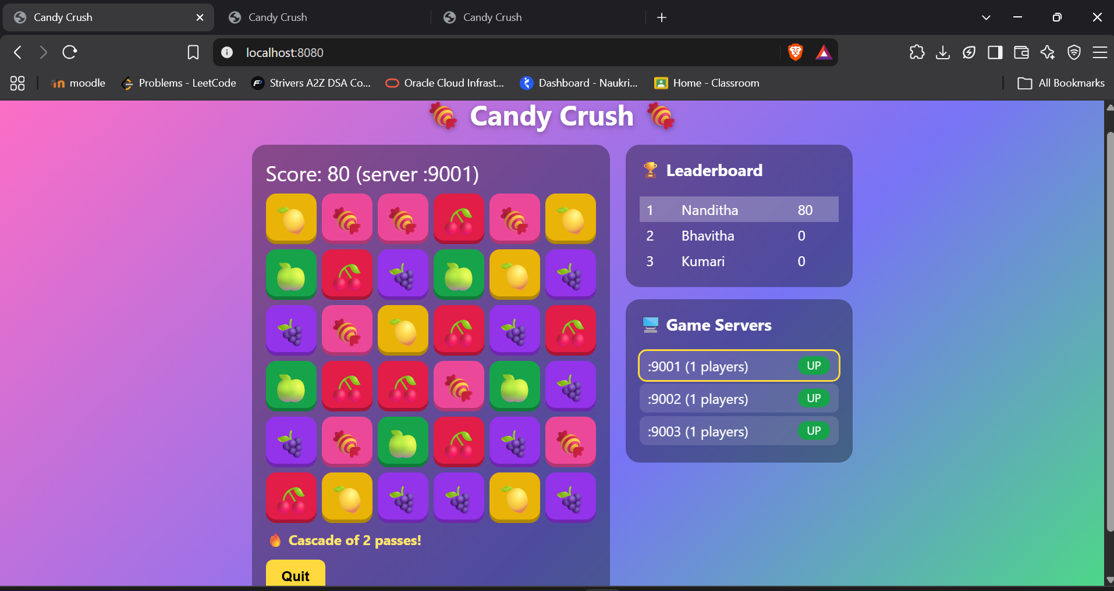
The other two tabs are for other users
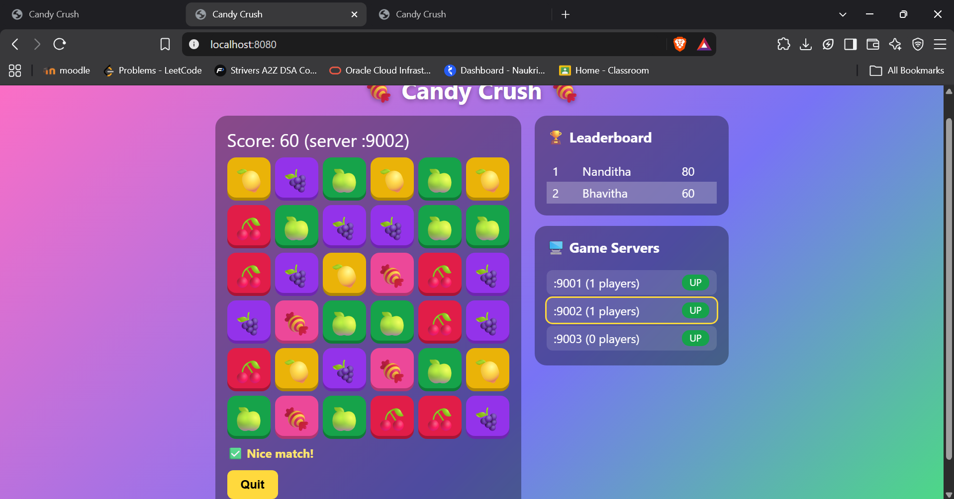
Now the other player(Kumari) is gone because there was an inactivity(I set it to 90 seconds, after that the player is removed), as we can see :9003 server is up but there are no players in that.
But the browser tab keeps it(the inactive tab),but when made a move it doesn’t accept, it says “not joined”. This is expected behavior.
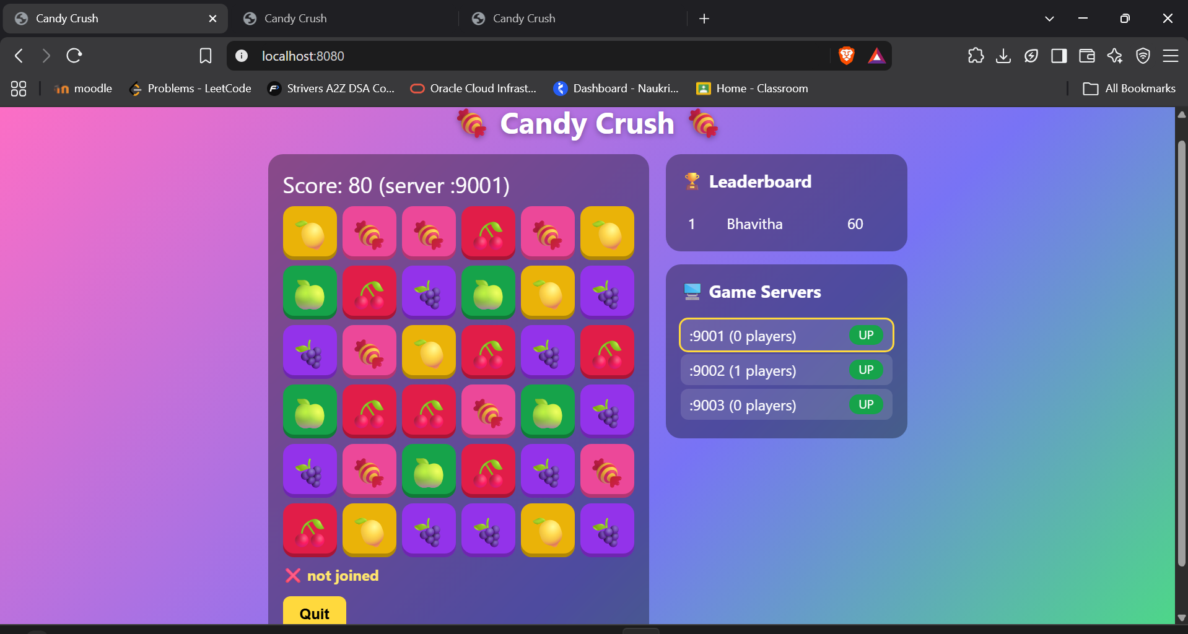
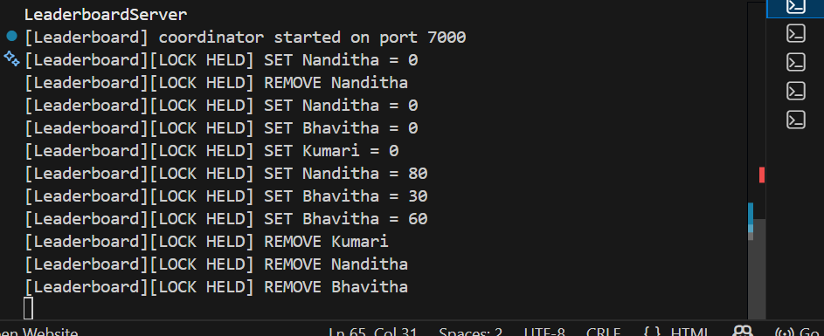
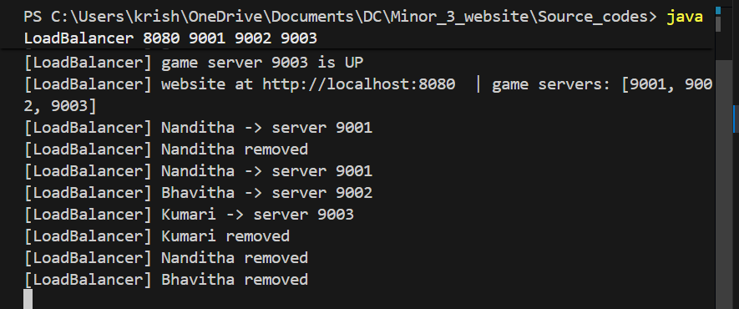
It removes them.
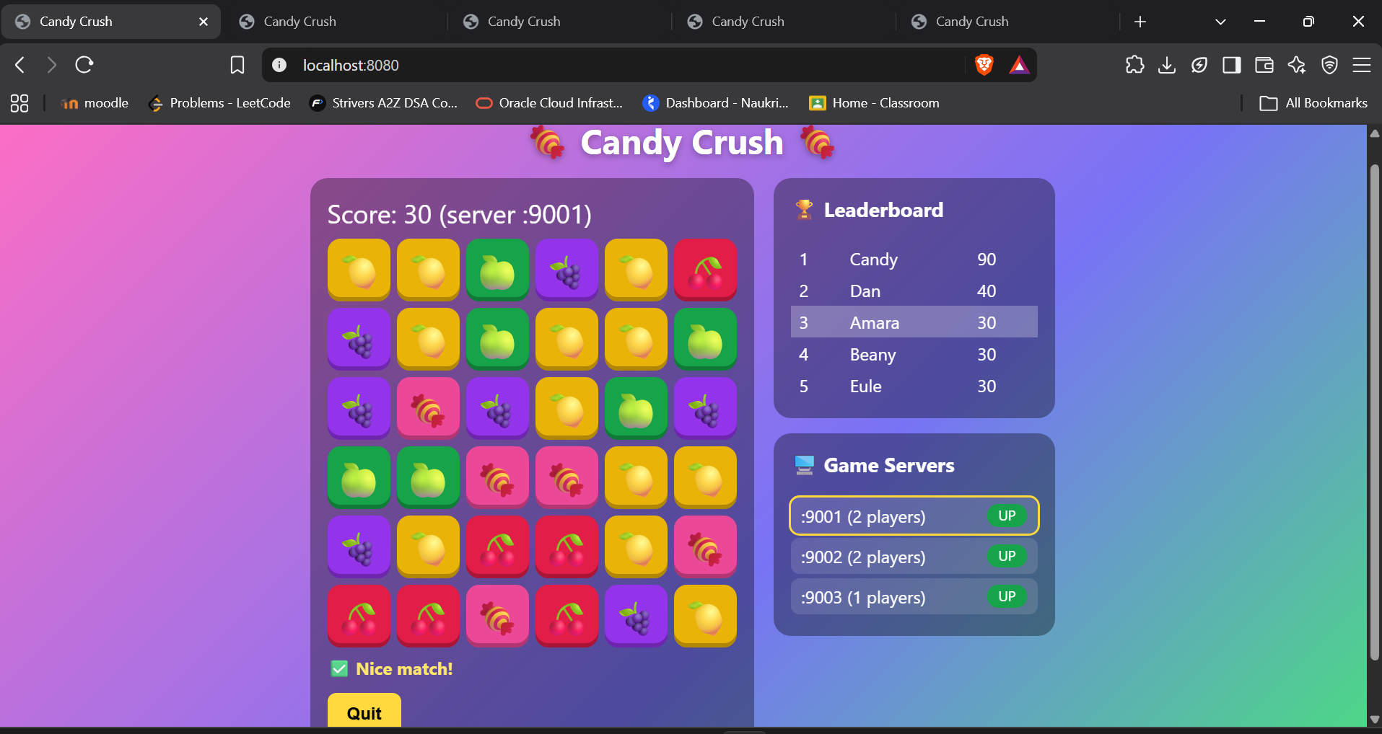
Now there are 5 players shared between 3 game servers, and they can play their games concurrently.
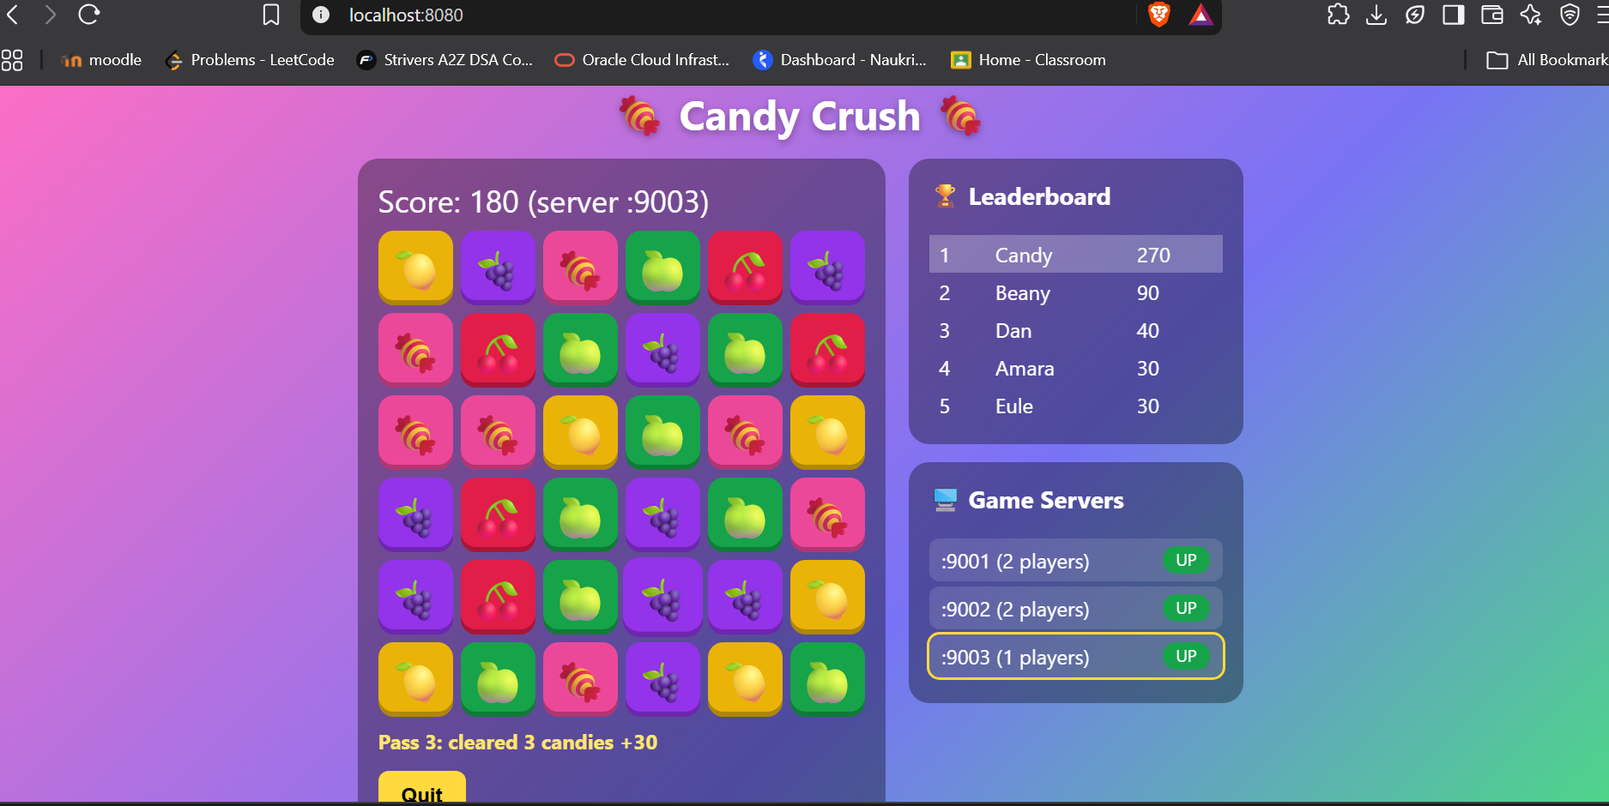
This is one of the intermediate steps when there is a cascade(automatic chain matching) happening, couldn’t capture all of them because random candies are falling fast and matches happen fast. Passes happen when there is a cascade.
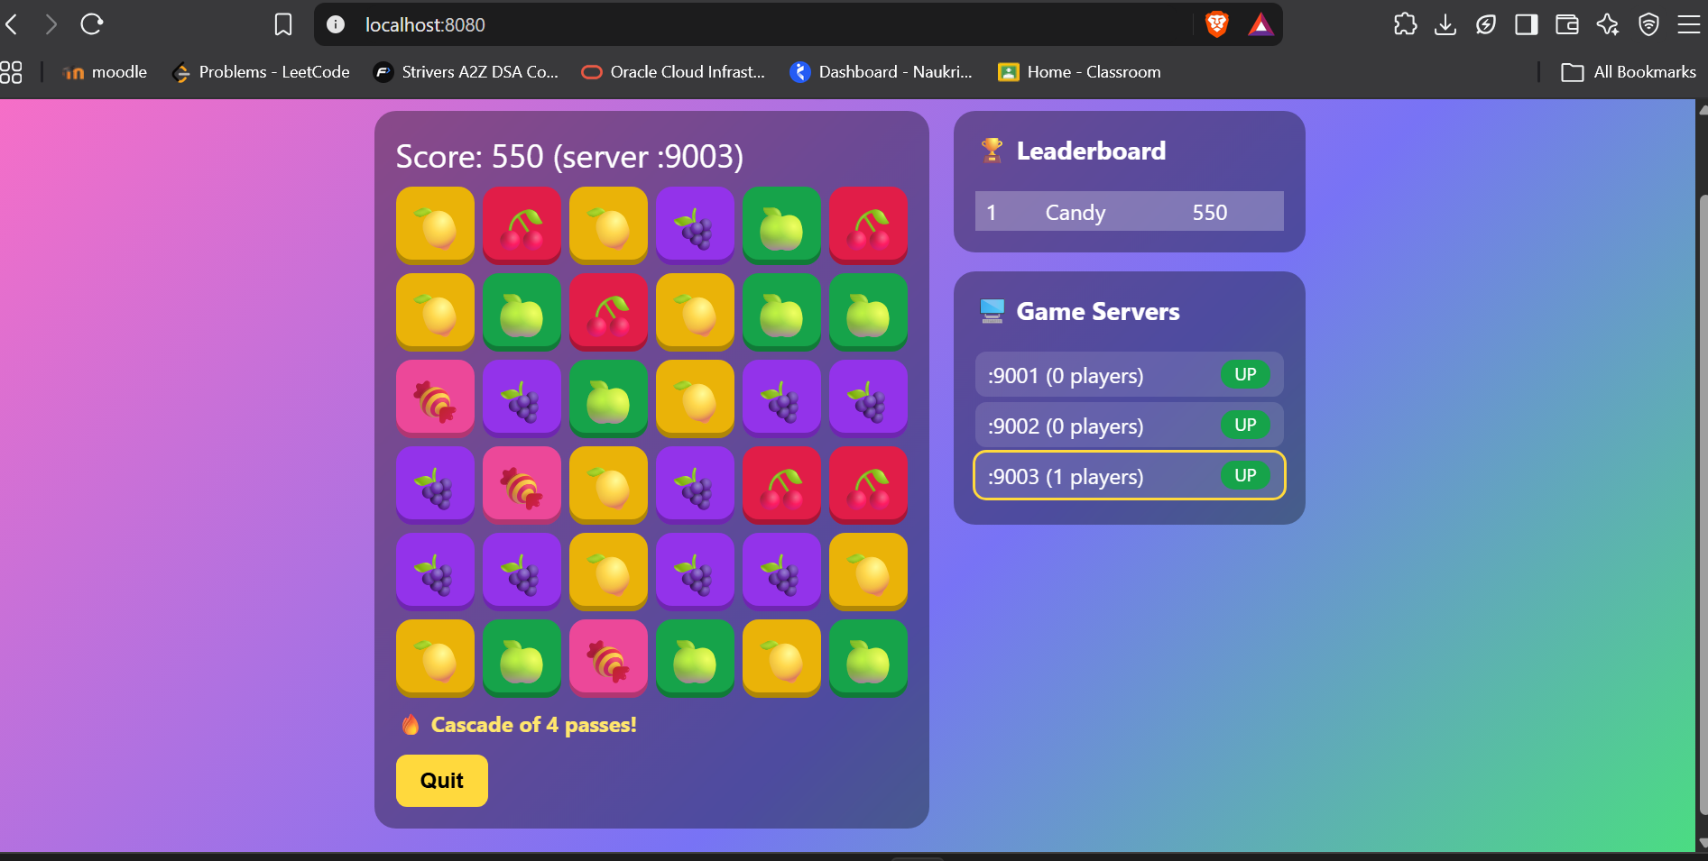
This is how it looks when a cascade occurs(all the score achieved during each pass of the cascade is added to the score).
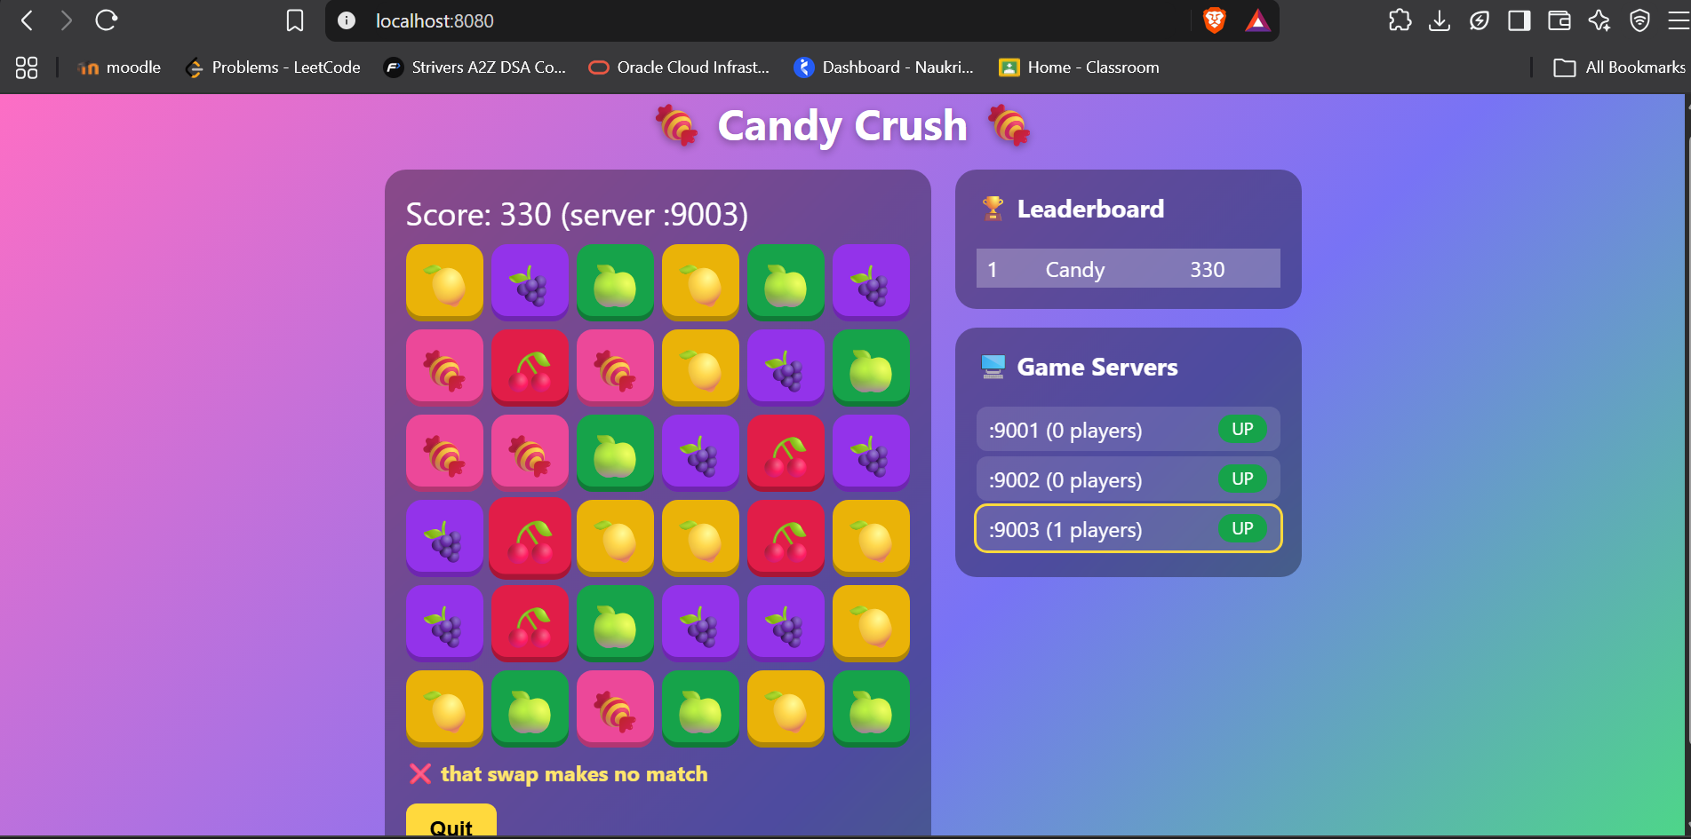
This is what happens when I make an invalid match, like not swapping with neighbours or trying to swap with a candy that doesn’t match.
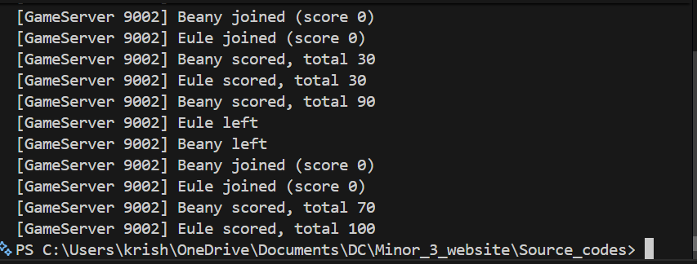
I turned off one of the game servers
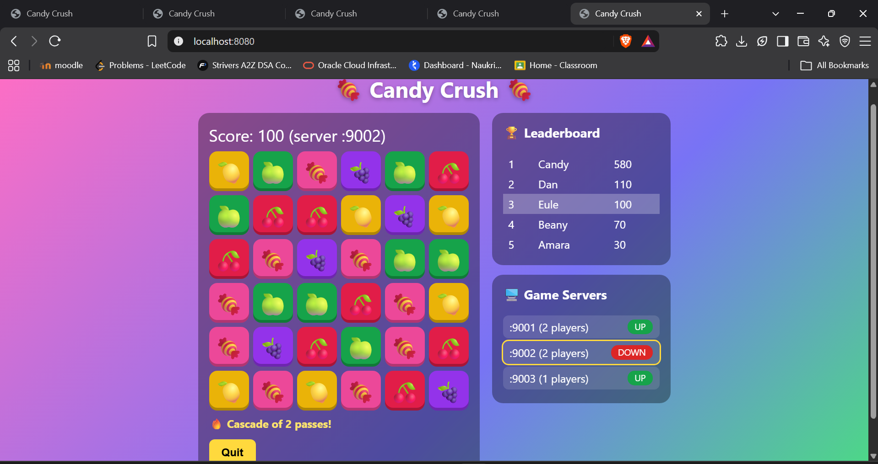
As we can see its showing that server is down, so we are detecting a failure server
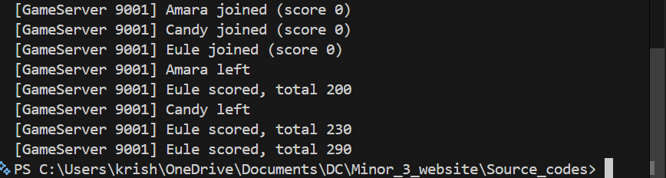
Turned off game server 9001
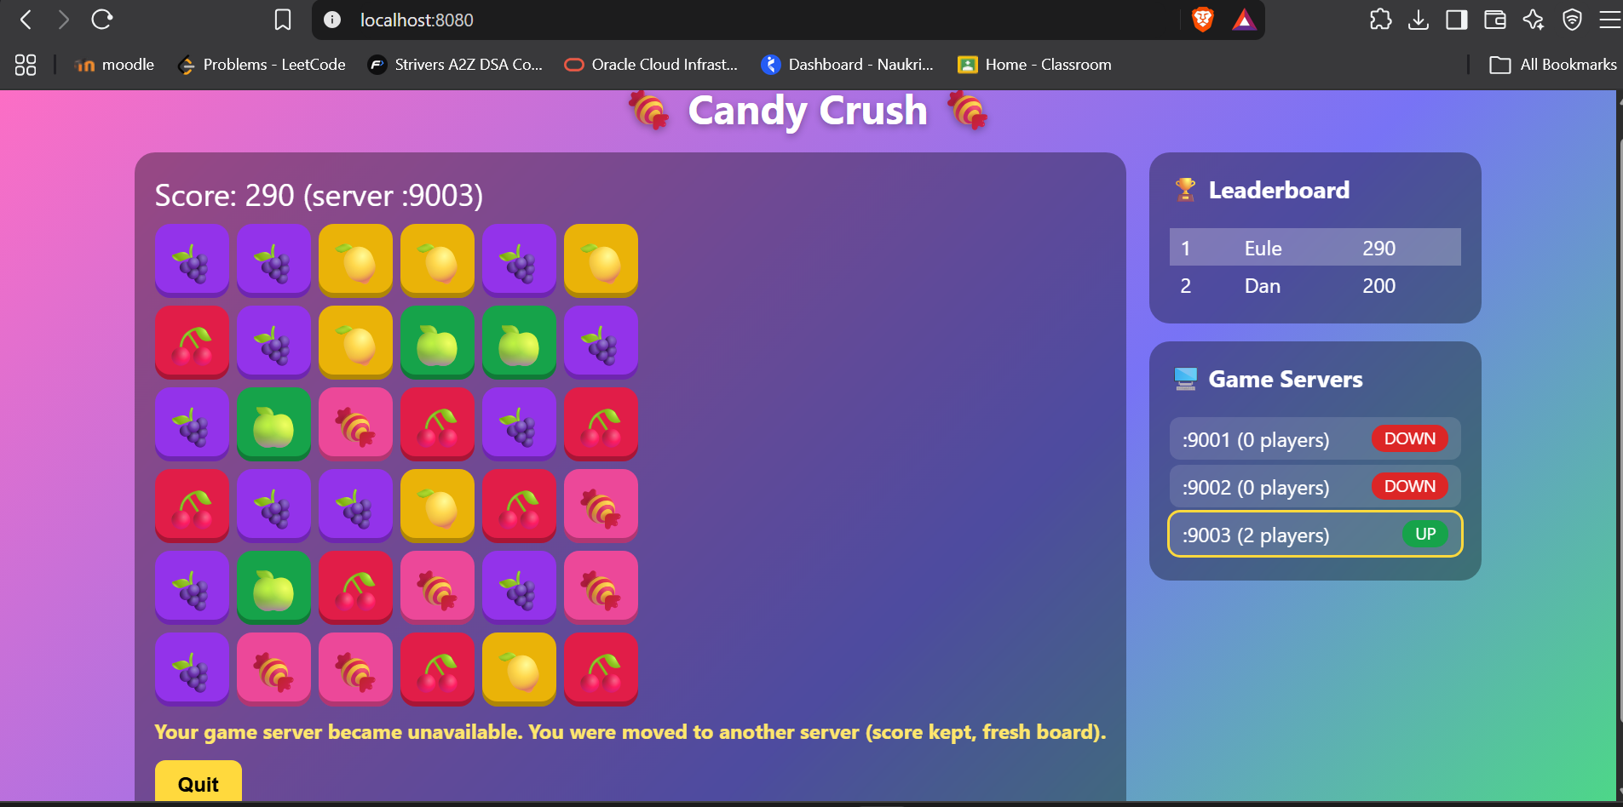
It redistributes players to other game servers though a server goes down.
We can play this on a second device as well by the below steps
1.connect the device to the same wifi network
2. get the ip address where the loadbalancer is running, just do an ipconfig in the terminal(I use windows), get the ip address and when playing in the second device, we can just type in http://<ipaddr_where_loadbalancer_is_running>:8080
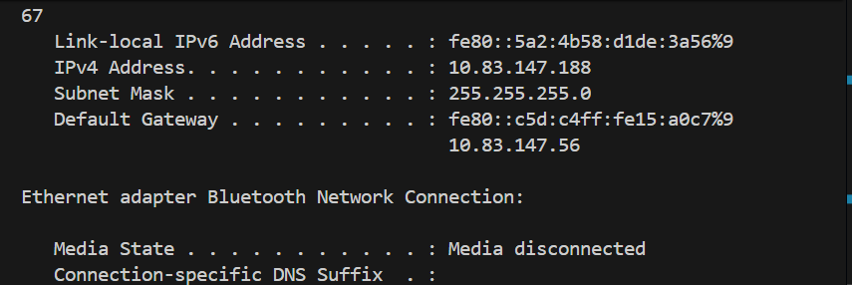
The ipv4 address is the one to type

