Soft errors and reliability
Nanditha Rao
Dept of Electrical Engineering, IIT Bombay
nanditha@ee.iitb.ac.in

Abstract— Soft errors are a major reliability concern for
today’s nanometer technologies. The errors in register files in Application Specific Integrated Circuits (ASIC) can quickly spread to various parts of the system and result in data corruption which may go unnoticed. Single Error Correction (SEC) Hamming code and Triple Modular Redundancy (TMR) provide a high-level mitigation solution for soft errors. The experimental results presented in this work for a 64-bit wide, 32-word entry register file, synthesized for IBM Cu-08 (90nm) standard cell ASIC technology, show that TMR is a better solution for latency sensitive ASIC applications.

Keywords—processor, evolution, architecture, technology
- Background of soft errors and reliability
- Introduction
Technology scaling has made today’s designs much more susceptible to soft errors. The ever decreasing supply voltages and nodal capacitances (required for constraining the power and making circuit transition faster) results in reduced critical charge (Qcrit) required to upset a node in digital circuits. The problem becomes more acute for aircraft and space electronics where high-energy neutrons at higher altitudes and heavy ions in space are more abundant. Because of the prevailing predictions that soft error rate is increasing exponentially [1], there is a growing trend in the community to adopt soft error rate as a design parameter along with speed, area and power requirements. Furthermore, for the high-end server market, networking switches and database applications, the reliability of the computing machine is even more important along with its performance. Single Event Upsets (SEU) have long been a reliability concern for space electronics. There are a number of solutions employed for mitigating radiation effects ranging from specialized processes to architecture and circuit-level techniques. The micro-architectural solutions to mitigate SEU employ fault tolerant techniques such as Triple Modular Redundancy (TMR) and Error Detection and Correction (EDAC) codes [2] for regular memory structures. Specialized storage structures have been presented as an alternative to mitigate SEU as well as Single Event Transients (SET)
- Soft errors
Soft errors in memory devices were first mentioned by May and Woods in 1978 [1]. A soft error is an event in a microelectronic circuit that does not
result in permanent damage or change in physical characteristics of
the device. The frequency at which these events occur is the soft
error rate (SER). In memory circuits or sequential logic, soft errors
are caused by energetic particles that generate enough free charge to
upset the state of a latch or memory cell. In combinational logic, soft
errors are caused by transient current or voltage spikes that can upset
clock timing or propagate and are latched at the output of the logic
chain. A 5 MeV alpha particle impinging on a memory cell will produce 1.4 million electron-hole pairs in silicon to a depth of 25 μm. Minority carriers are collected by the voltage across the depletion layer. If the number of collected carriers is greater than the Qcrit (critical charge -- charge necessary to determine cell state), the cell state will change resulting in a "soft" (reversible) error. A tutorial [2] in the IEEE Transactions on Reliability provides an excellent introduction to the subject. To accurately determine the sensitivity of integrated circuits to radiation-induced soft errors or single event upsets (SEU), all sources of radiation must be accounted for. At terrestrial, Earth-based altitudes, the predominant sources of radiation include both cosmic radiation and alpha particle radiation from radioisotopic impurities in the package and chip materials. An overall assessment of a device’s sensitivity to SEU/SER is complete ONLY when the alpha particle component AND the cosmic radiation component have been considered. Cosmic rays (mainly high energy neutrons) at sea level are typically of little concern. CPUs in desktop computers run at a high enough Vcc that the Qcrit value is rarely exceeded by cosmic ray induced ionization. Cosmic ray intensity is 10 times worse at 2 Km above sea level and reaches a peak of approximately 300 times sea level at 10 Km [3]. Laptop computers are at risk in use durning flights on commercial airlines, which typically fly at ~10 Km. The hazard to devices in laptop computers is further exacerbated by the smaller Qcrit value resulting from a low Vcc voltage used to reduce power consumption . We define "soft errors" to be random, non-recurring, single-bit errors in memory devices. The errors are not permanent, i.e., no physical defects are associated with the failed bit. In fact, a bit showing a soft error is completely recovered by the following write cycle with no greater chance of showing an error than any other bit in the device.
- History and timelines:
In 1961, Wallmark and Marcus [1] postulated that the lower limit
of device geometries without redundant elements would be ~10μm
due to (among other effects) the influence of cosmic rays. Device
geometries are now headed towards 20nm in the near future [2].
Redundancy is found in widespread use for memory circuits in the
form of parity protection and error correction codes (ECC), but not
necessarily logic circuits. In 1975, Binder, Smith and Holman
demonstrated that electronic anomalies in communication satellite
operation were due to cosmic ray particles with GeV energies and
atomic numbers around 26 [3]. In 1976, the Cray-1 supercomputer
installed at Los Alamos displayed ~25 non-permanent memory parity
errors per month. At the time, the source of these errors was not
known, but in 2010, Normand and co-workers published a study
showing the likely explanation was high energy neutrons from the
cosmic ray background [4]. In 1978, May and Wood studied the effects of alpha particles on
RAM and CCD memory [5]. In 1979, Ziegler and Lanford published heir study detailing the mechanisms whereby terrestrial level cosmic
rays (or more properly, the particles near sea level resulting from the
interactions of galactic cosmic rays) could cause upsets in
microelectronics [6]. In the same year, Guenzer, Wolicki and Allas
experimentally confirmed single event upsets (SEU) by irradiating
16K DRAM devices with 6.5 to 14 MeV neutrons and 32 MeV
protons [7]. They concluded that the protons and neutrons were
incapable of generating sufficient direct ionization to account for the
observed upset rates, but had sufficient cross sections to produce
energetic alpha particles through nuclear reactions at the observed
upset rates.
In 1995, Baumann and co-workers studied the effects of thermal
neutron capture by 10B in boro-phospho-silicate glass (BPSG) [8].
The thermal neutron capture results in the fission of the 10B nucleus
into a 1.47 MeV alpha particle, a 7Li nucleus with and energy of 0.84
or 1.014 MeV and a 478 keV gamma photon. Their measurements
showed a typical 600nm thick later of BPSG would generate ~0.02
events cm-2 hr-1.
Until 2000, discussion of soft errors was primarily the subject of
technical journals and conferences. Then, cosmic ray soft errors in
SRAM cache modules used in Sun Microsystems servers caused
excessive outages at various customer sites and the topic moved to
non-technical publications [9].

—Records of bit ﬂips in the Cray-1 computer installed
at Los Alamos, NM, in 1976 lead to an upset rate in the Cray-1’s
bipolar SRAMs that correlates with the single-event upsets (SEUs)
being induced by the atmospheric neutrons. Anomalies in communication satellite operation 014
have been caused by the unexpected triggering of 215
digital circuits. Interactions with galactic cosmic i 0
rays were investigated as a mechanism for a number of Hi O
these events. The mechanism assumed was the charging 12
of the base-emitter capacitance of sensitive transistors to the turn-on voltage.

- Modes of testing soft error rate: Accelerated Alpha Particle SER

- Importance with shrinking geometries: It is well known that as device voltage is reduced, the soft error rate increases due to the decrease in Qcrit [45]. This would imply that ultra-low power devices would suffer from higher soft error rates. However, initial studies on 130nm CMOS designs indicate that the energy required to upset a circuit saturates at sub-threshold voltages [46]. The SER increases as voltage is scaled down to a point and then the SER saturates as voltage is scaled further. Possible explanations are carrier recombination competing with drift and diffusion mechanisms or pulse widening at the expense of decreasing transient peak height.

As devices scale below 100 nm, the assumption that a neutron or alpha strike will only impact one node
or device is no longer valid.

- Redundancy
- The primitive technology:
In 1949 a single-growth technique, first used by J. Czochralski, was adapted and improved by J. B. Little and Gordon K. Teal. They modified the original system for growth of a single crystal by controlling the impurity concentration in the melt during crystal growth. After pulling the crystal, the rod containing the P-N junction was polished and processed as desired. The same method was used to produce an NPN transistor (Figure 8). The equipments were, however, very primitive in nature.
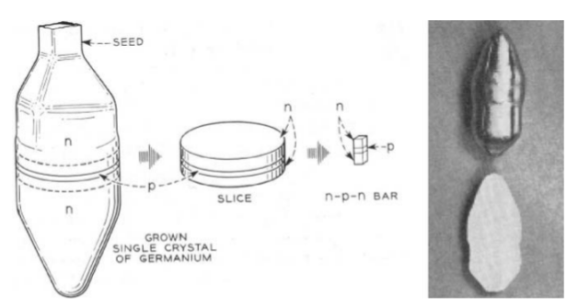

Figure 5: Fabrication of grown junction transistors on a Ge rod [12]

However, there were several issues related to process technology. There was a drastic decrease in lifetime of the semiconductor, which happened when silicon was heated to high temperatures. This was found to be as a result of metallic contamination and Silicon nitride was later discovered to act as a barrier against mobile ions. It was found that oxidizing atmosphere could protect the silicon surface. The discovery of wet oxidation of silicon happened when Carl Frosch forgot to close a hydrogen valve during one of the experiments. Pitting of the semiconductor surface during diffusion resulted in non-uniform junction depth. There was no “clean room etiquette”. The main cause of loss of yield was the poor alignment of masks.

- The planar process:
The planar process was, after the invention of the junction transistor, the most important invention of microelectronics. Jean Hoerni found that the problems associated with the approach pursued by Bell Laboratories were mainly due to pinholes in oxide film. Planar process was developed in which the oxide layer was left on the silicon wafer to protect the p-n junctions underneath. Oxide passivation improved several electrical parameters such as reverse leakage current and breakdown voltage. It eliminated the main disadvantage of the mesa transistor – an exposed collector-base junction, which was very vulnerable to contamination during assembling. Producing such a device in primitive conditions, was very difficult. The new device had a poor yield of ~ 2–5%. Most of the devices had mechanical defects (mostly scratches).
Poor device yield drove the need for a clean manufacturing environment. One of the first clean room setups is shown in Figure 6.
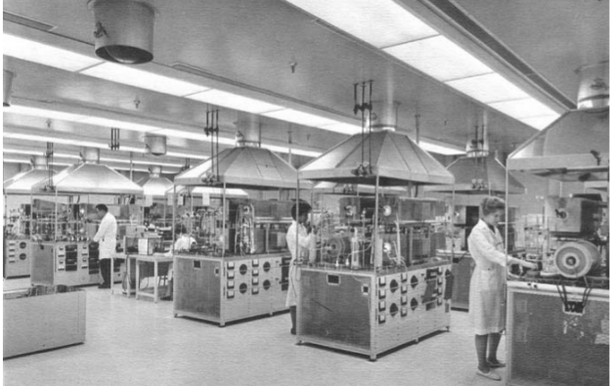
Figure 6: Initial clean room setup [12]
- Towards an integrated circuit:
The idea that multiple transistors, resistors and capacitors could be formed on the same piece of silicon substrate developed during 1960's (Figure 7).
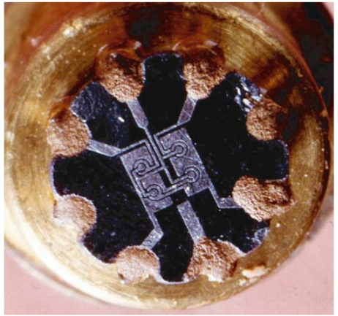

Figure 7: The first planar integrated circuit [12]

The key motivation was to reduce the size and cost of the integrated circuit. However, majority of electronic circuits required an electrical isolation of the individual components. The second problem, equally important was the interconnection of individual isolated components.
Simple logic circuits began to be designed- like the flip-flops, registers and shift registers. Floor-planning, placement and routing were being done manually.
- Towards MOS:
In 1945 Shockley and Pearson envisioned a device which would change the conductivity by modulation of the surface charge by electrical field. Several features of this device are the same as what would become the MOS transistor. The device consisted of a thin layer of N-type semiconductor placed on an insulating support. In close proximity of semiconductor was a metal plate forming a capacitor. It was assumed that if the metal plate was charged positively, the additional charge on the semiconductor would be represented by an increase in free electrons which should contribute to the conductivity. It was recognized that MOS technology would be the one most widely used because: the gate oxide, the most critical portion of an MOS transistor, is covered up immediately after it is grown, thereby eliminating contamination. Also, MOS devices could be more dense than bipolar transistors.
It was in 1964 when the first commercially available MOS transistors, got into production. Key issues were high threshold voltage, and stability of the device. The next major contribution was made by Critchlow and Dennard when they shrank the existing 8 μm technology to 1 μm. They observed that if the electric field was kept constant, performance of the scaled device, infact, improved. This, subsequently, came to be known as the constant electric field scaling theory.
- The architecture
- Primitive architecture: A Japanese company named Busicom had designed their own special purpose chipset for use in their calculator and commissioned Intel to develop it for production. However, Intel figured out that it was too complex and proposed that a new design be produced with standard 16-pin DIP packaging. They did a four-chip design: a ROM for custom application programs, a RAM for processing data, an I/O device, and an unnamed 4-bit central processing unit which would become known as a ‘microprocessor’ named the 4004. The primary motivation behind doing a single chip solution was, to reduce the cost. Its architecture had very basic building blocks like the accumulator, registers, ALU, instruction register, program counter and control unit. It was designed to perform the functions of a calculator. It ran at 740kHz and consisted of 46 instructions with 2,300 transistors. The Intel 4004 was designed by physically cutting sheets of Rubylith into thin strips to layout the circuits to be printed.
Intel created development tools, software, and peripherals which were design aids that proved crucial to the microprocessor's acceptance and the growth of its customer base. More controls like the interrupt and serial I/O control were added in the 8085. During this time, Intel built a lot of support chips which were used along with the 8086 processor, like the DMA controller, interrupt controller, RAM controller, CRT controller, EPROM, to name a few. An off-chip cache was introduced is 80386, to store most recent instructions and data, and reduce memory latency. The 80486 had an on-chip cache- 8kB unified instruction and data cache, an on-chip faster floating-point unit (FPU) and an enhanced bus interface unit.
At this point, we note that there were a few key functional units in a microprocessor. They were- the bus interface unit (accesses memory and I/O), code prefetch unit (receives object code from the bus unit), instruction decode unit (decodes object code from the prefetch unit into microcode), execution unit (executes the microcode), segment unit (translates logical addresses to linear addresses), and the paging unit (translates linear addresses to physical addresses).
- Pipelining explained: An instruction pipeline is a technique to increase the instruction. For example, a classic RISC (reduced instruction set computer) pipeline is broken into five stages: Instruction fetch, Instruction decode, Execute, Memory access and Register write back. When programmers write assembly code, they assume that each instruction is executed before the execution of the subsequent instruction. Pipelines allow overlapping/parallel execution of multiple instructions with the same circuitry which improves program execution significantly as shown in Figure 8.
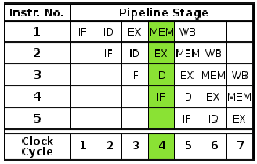

Figure 8: An example pipeline [14]
In the Figure 11, in clock cycle 4, four different modules are working on four different instructions at different stages, reducing the idle time of the components. Pentium had two datapaths (pipelines) that allowed it to complete two instructions per clock cycle and was called the Superscalar architecture.

- P6 and Netburst architectures: With each new generation, the process technology was scaled. This improved the transistor density and hence more features got built into the processor such as the following.
Speculative execution/Branch prediction- This refers to the processor’s ability to speculate and execute instructions that lie beyond a conditional branch that has not yet been resolved, and ultimately to commit results in the order of the original instruction stream.
Out-of-order completion: The processor executes instructions in an order governed by the availability of input data, rather than by their original program order.
Superpipelining, that is, deeper pipeline stages, increased from Pentium's 5-stage pipeline to 10-stage pipeline in the Pentium III and 12- to 14-stage pipeline in the Pentium M.
Register renaming- refers to a technique used to avoid serialization of program operations imposed by the reuse of registers by those operations. Reservation stations permit the CPU to fetch and re-use a data value as soon as it has been computed, rather than waiting for it to be stored in a register and re-read.
The Reorder Buffer (ROB) is a unit which buffers completed micro-operations, updates the architectural state in order, and manages the ordering of exceptions.
Single instruction, multiple data (SIMD) instruction set enables the processing elements to perform the same operation on multiple data simultaneously exploiting data level parallelism.
- Core and Nehalem architectures: Core and Nehalem architectures represent multi-core processors which are more focussed on power saving techniques, deeper pipelines, more cache and integrating features like memory/graphics on the chip. The following features got introduced into this architecture.
Turbo boost technology enables dynamic frequency scaling of individual cores based on the workload.
Hyper-threading works by duplicating certain sections of the processor, that store the architectural state. This allows a hyper-threading processor to appear as two logical processors to the operating system, allowing two threads to be scheduled simultaneously.
Loop Stream Detector detects small loops in the program code and saves the decoded loops in a special buffer. Hence, the CPU does not have to fetch them from the cache repeatedly.
Power Control Unit (PCU) adjusts the frequency and voltage of individual cores after sensing the temperatures, voltage and current from all cores. PCU analyzes these data and switches the cores that are not being used, to power-saving mode by adjusting their frequency and voltage.
- Architecture- Summary: Thus, if we were to summarize the evolution of micro-architecture, we notice three distinct timeframes depending on the trends and focus of the architecture.

- The initial period till around the 80486, focussed mainly on lowering the cost and improving the computation speed. It had a basic instruction set and process technology. The key feature enhancements were caches, paging units, floating point units etc. Technology scaling was the key enabler in improving clock speeds.
- The second period from Pentium to P6 focussed mainly on improving the performance by improving the hardware through introduction of pipelining and out of order execution. The number of applications that used these processors also greatly improved. Scaling continued to help improve clock speeds.
- The third period from Netburst to Nehalem has seen a drastic change in the trends. Scaling has almost hit a limit due to short channel effects; and power dissipation has become a major concern. Interconnect delays are not scaling and hence, clock speeds are no longer improving. New device structures are being envisioned. Parallelism and multi-core concepts have been used to improve performance. In this phase, we see that programming is dominated, more than the logic design.
- Architecture model
- PIC16F84A Architecture
CMOS devices have been scaled for more than 30 years to achieve higher density, higher performance, reduce power consumption and reduce the cost per transistor. Transistor delay times have decreased by more than 30% per generation resulting in doubling of performance. Following are the key challenges:
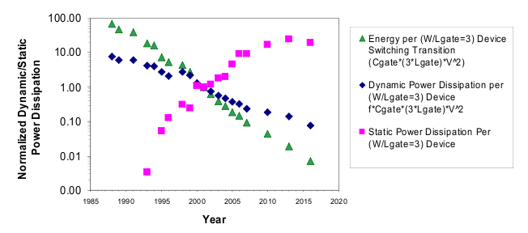
- Power dissipation: As shown in Figure 9, due to the substantial increase in leakage current, the static power consumption is expected to exceed the switching component of the power consumption. .
Figure 9: ITRS projections for transistor scaling trends- power consumption [15]
Supply voltage scaling results in scaling the threshold voltage to maintain a good gate overdrive. However, threshold voltage scaling results in increase in subthreshold leakage [15].
- Latency between processor and memory is ever increasing.
- Reliability: With scaling, we face challenges in process, temperature and voltage variability, manifesting as unreliability in components. These variations result in variation of threshold voltage, leakage and hence frequency between cores and dies.
- Interconnect delays: Interconnect delays are not scaling with the gate delays which are posing a fundamental limitation on the clock speed.

Thus, it seems like the microprocessor is on the verge of undergoing, perhaps, the most signiﬁcant transformation. Continuing increases in transistor count are vital, but the next step is also going to take a good amount of rethinking of basics in process technology, architecture and software.
- Fault model
Future processors and platforms will be an outgrowth of the technological trends existing today described below.
- Efficiency: performance and power:
Pervasive connectivity: Omnipresent connectivity has become a fact of daily life. People expect anytime, anywhere access to information and services which has driven an increase of wireless mobile devices: notebooks and handhelds.
Proactive computing: Computation has become more proactive – capable of automatically anticipating and adapting to the needs of users. Computers are evolving towards more natural interfaces such as speech, handwriting and image recognition.
Internet will grow substantially in bandwidth, and deliver large amounts of intelligent data to the connected devices.
Data growth: The above factors require that devices receive and handle huge amount of data from a wide variety of sources probably in real-time. Soon, we will have terabytes of digital data, requiring huge performance.
Power management: With the rise of mobile computing, devices are becoming smaller and more mobile, which means that platforms must consume less power and produce less heat.
- Special purpose performance and adaptability: Future processors will need fast on-chip circuitry for specialized functions such as media processing and speech recognition. Also, processors will have to be far more adaptable to dynamically match their capabilities to a wide range of changing workloads.
- Security/Reliability: As computing devices are always connected and perform critical functions like– maintaining homes, conducting financial transactions, monitoring and maintaining medical needs – security and reliability are highly critical [4].
- SECDED- Hamming encoding
Identifying efficiency and reliability as the key challenges and looking at the above trends, it is possible to look ahead and identify the key aspects of a future processor.

- Architecture:
Issues with clock frequency: In the past, performance scaling in conventional single-core processors has been accomplished largely through increases in clock frequency. But frequency scaling has run into some fundamental physical barriers. First of all, as chip geometries shrink and clock frequencies rise, the transistor leakage current increases, leading to excess power consumption. Secondly, the advantages of higher clock speeds are in part negated by higher memory latency, since memory access times have not been able to keep pace. Thirdly, the RC delays in signal transmission are growing as feature sizes shrink, imposing an additional bottleneck to scale up frequency
Multicore: Due to the above mentioned issues, performance will have to be increased by other means. Rather than carrying out operations at an extremely high frequency, a multicore processor will achieve high performance at more practical clock rates, by executing many operations in parallel. Few aspects of multicore are as follows.
  - Power-aware multicore: Rather than relying on one huge, heat-producing core, it is possible activate only those cores needed for a given function, while idle cores are powered down.
  - Specialized cores: Various computations, such as graphics, speech recognition algorithms and communication protocol processing could be built into specialized cores [4].
  - Asymmetric multi-cores: A few high-performance complex cores can provide good serial performance at low power, and many low-performance simple cores can provide high parallel performance at a faster rate. Simple cores provide efficient use of transistors for computation in addition to meeting power and thermal budgets. Complex cores, provide computational power for single threads[3].
- Asynchronous circuits: There are several problems with synchronous on-chip communications, namely:
- Modularity and design reuse: A complete redesign of the chip is needed if the frequency of operation is changed, thus making the design non-modular. All components will need to be redesigned at the same new clock frequency.
- Electromagnetic interference (EMI): All switching activity in a synchronous chip takes place at a clock edge, making the circuit prone to EMI effects.
- Worst case performance: The circuit is always designed for worst-case performance, since the critical path in the circuit determines the clock period and hence limits the frequency.
- Clock power consumption: Large clock buffer trees present in current design lead to high power consumption. Studies show that high-speed processors have power consumption dominated by clock and the average clock power consumption is 45% of the total power consumed [17].
- Clock skew: Distributing the global clock in a chip with minimal clock skew is difficult, due to increase in clock frequencies and smaller feature sizes.

Advantage of asynchronous designs:
Owing to the above-mentioned problems in using a synchronous design style, efforts are being made to design chips asynchronously. A significant advantage of asynchronous design is smoother handling of intra-chip variability (it requires only delay matching). Also, issues with distribution of global clock over the entire chips, clock power consumption, clock skew and EMI, are eliminated. Designs become modular since timing assumptions are explicit in the handshaking protocols. Hence no redesign is needed if an asynchronous component is modified. Further, the circuit would work faster, exploiting the average case rather than worst case performance [10].

Challenges with asynchronous designs:
Asynchronous circuits are more difficult to design. Glitch-free circuits have to be generated as against the synchronous design, where the data only has to be stable before the arrival of the clock. Also, asynchronous design suffers from absence of industrial tool support. Lack of a mature tool flow has prevented this methodology from being widely adopted [10].
- Microkernel: Future processors are likely going to need some intelligence to coordinate the complexity with multiple cores: assigning tasks to cores, powering up and powering down cores as needed, dynamic reconfiguring cores to suit changing workloads, and so on. One way to efficiently handle all this is through a built-in microkernel, relieving higher-level software of these complicated hardware management tasks.
Special purpose hardware: Few functions like the following can be moved on chip: wireless radio, 3D graphics, digital signal processing, advanced image processing, security and reliability.
Virtualization is needed to hide the complexity of the hardware from the overlying software. The OS, kernel and software should not have to deal with the intricacies of many cores. Rather it should see the processor as one or more unified virtual machines.
- Large memory subsystems: In order to keep many high-performing cores fed with large amounts of data, it is important to have a large quantity of memory on-chip and closer to the cores to avoid memory latency. These may be gigabytes in size and could replace main memory. Caches will need to be reconfigurable, allowing portions of the caches to be dynamically allocated to various cores.
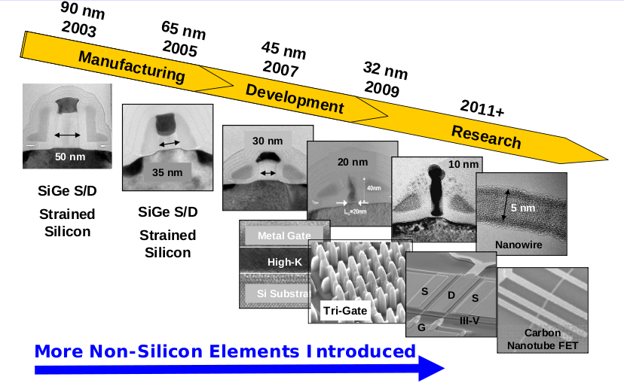
- Process technology: Several attempts to improve the process technology to address the challenges due to scaling are shown in Figure 10.

Figure 10 Evolution of device structures since 90nm technology node [16]
Si/Ge Source/drain was introduced at the 90nm technology node, which induced a large uniaxial compressive strain in the channel, in turn enhancing the mobility. High-k dielectrics were introduced at 45nm to overcome the limitations of the thin gate oxide which had approached the direct tunnelling regime. Metal gate with a suitable work function was introduced to control the threshold voltage and eliminate poly depletion.
As we approach smaller dimensions, fundamental physics will constrain the maximum achievable performance. For example, it will not be possible to expose circuit patterns whose line width is smaller than the wavelength of light, and this will decide the minimum gate thickness achievable. So, beyond the 15nm and 11nm nodes, there will be a major turning point. To continue to improve device density, increase drive currents and speeds and to resolve the scaling limit of planar Si MOS devices, semiconductor manufacturers are going to employ novel approaches like high mobility materials (Ge or III-V) and different transistor architectures- like multi-gate transistors or FinFETs, carbon nanotubes and single electron transistors.
- Reliability:
Sources of reliability issues are:
- Permanent faults: These occur due to malfunctioning of hardware and results in irreversible physical changes. The improvement of semiconductor design and manufacturing techniques has significantly decreased the rate of occurrence of permanent faults.
- Aging: NBTI: Negative bias temperature instability (NBTI) is a major concern in pMOS devices, since they almost always operate with negative gate-to-source voltage. NBTI manifests as an increase in the threshold voltage and consequent decrease in drain current. These effects are also dependent on the total time spent in the 'on' or 'off' state.
Hot carrier injection refers to the effect in MOSFETs, where a hot electron (surpassing the conduction band) is injected from the channel to the gate dielectric showing up as gate/substrate leakage current and change in threshold voltage.
Electromigration: Electromigration occurs when part of the momentum of a moving electron is transferred to a nearby activated ion and occurs especially at grain boundaries and material interfaces. Over time, this force knocks a significant number of atoms far from their original positions creating either an undesired open or short circuit.

- Random dopant fluctuations: Reduction in transistor size each technology reduces its area and the number of dopant atoms. For e.g., in a 32-nm node there are only tens of dopant atoms in the channel. So, two adjacent transistors will have different electrical characteristics due to randomness in the few dopant atoms, resulting in variability [6].
- Sub-wavelength lithography: The wavelength of light used for photolithography reduced from 248-nm to 193 nm for 130- nm technology and has remained constant for even 65-nm transistors. The difference in the wavelength of light and the patterning width will continue to widen until ultra-violet technology (13 nm) becomes available. This sub-wavelength lithography is the primary reason for line edge roughness resulting in variations [6].
- Dynamic temperature and voltage variations: Heat flux across the die varies depending on the functionality of the circuit block. For example, a cache has less heat flux than an execution unit. Higher heat flux puts more demand on the power distribution network resulting in voltage and temperature variations creating hot spots, in turn, affecting circuit performance [6].

Impact due to unreliable components:

Putting it all together, a VLSI chip will have the following characteristics: It will have billions of transistors, but many of them might be unusable because of static variations. Circuits will encounter dynamic variations of voltage and temperature, soft-errors; and transistors that slowly age degrading circuit performance. Process variations will result in dies with variations in threshold voltage, frequency and power. Despite these difficulties, users expect the system to remain reliable and to continue to deliver the rated performance. This challenge will require a major shift in all aspects of VLSI design—fabrication, design, micro-architecture, testing, software, and applications. Also, testing becomes crucial; processors will have to be tested with higher supply voltages and temperatures for long periods to ensure reliability.

Improving reliability:

- Circuit techniques:
Adaptive body bias (ABB): Leakage and frequency for a single die can be controlled to some extent by employing a non-zero body-to-source bias to control the threshold voltage of a transistor. This allows each die to have the optimum threshold voltage which maximizes the die frequency subject to the power constraint [1].
Thermal throttling: When the CPU overheats, the BIOS reduces the speed, so that it can generate less heat and cool down.
Redundancy in circuits: Duplicate/redundant circuits performing the same logic function can be built. A majority voting scheme will choose the result of these multiple blocks.
Error detection and/or correction (EDAC) is done by encoding data by adding extra parity bits.

- Device techniques:
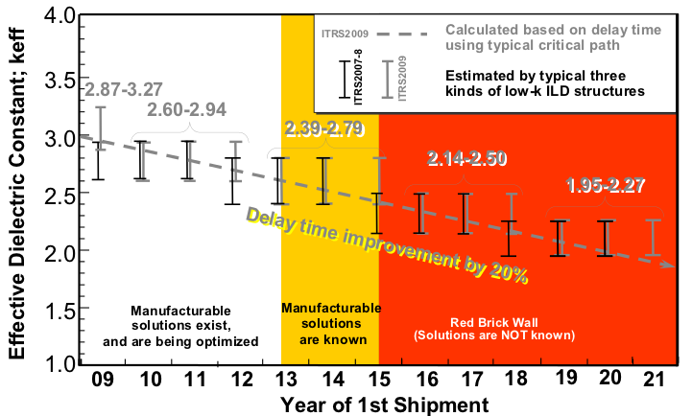
Halo and retrograde doping techniques help in avoiding punch-through of source/drain reions, thereby improving the lifetime and hence reliability of the device. Fault avoidance relies on improved materials and manufacturing processes. For example, low-alpha-emission interconnects and packaging materials contribute to low soft error rates.

- Design techniques:
Core-level redundanc: Some cores can be dynamically configured as standbys and used only when some of the active cores fail. Alternately, all cores can be activated from the beginning and the faulty cores can be eliminated during the system's lifetime. These strategies result in different aging stress on processors [5].
Checkpoint based redundancy: The state of the computation as a checkpoint is periodically saved to a ‘stable’ storage. When a failure occurs, the computation is restarted from one of these previously saved states [7].
Reliability aware task allocation and scheduling: Existing solutions assume that the execution times of tasks done on different processors are statistically independent. Variation-aware schedules could be written and the scheduler can select the right one based on the actual variation for each chip [8].

- High speed interconnects
Interconnect delay:
During the beginning, system performance was limited almost exclusively by transistor delay. Scaling has decreased transistor delay and power while interconnect performance has generally been negatively impacted. Scaling for local interconnects (path lengths which decrease with scaling parameter 'd') results in a constant delay while global interconnect delay (paths with constant length) increases with scaling as 1/d. The resistivity of metals in small dimensions increases much more rapidly due to sidewall and grain boundary scattering, which leads to an increase in RC delay. This has now started to directly impact the system performance. Interconnect delay was being reduced by breaking up long lines into shorter segments using repeaters. In the long term, new design or technology solutions (such as 3D IC, optical or carbon nanotubes) will be needed to overcome the delay, power, and bandwidth limitations of traditional interconnects.

Low-k Dielectrics:
Following the adoption of Cu as the conductor, efforts have been made to minimize the wire capacitance by incorporating low-k dielectrics. The pace of incorporating advanced low-k materials has been slowing down as compared to the earlier ITRS projections because of difficulties in manufacturing, cost, and reliability. The trend towards low-k dielectrics is shown in Figure 11.
Figure 11 Low-k dielectric roadmap [9]

Airgaps:
Figure 12 shows a typical air gap process [9]. A gradual transition from ultra low-k materials to air-gaps is now being considered. Developing air-gap structures with sufficient mechanical strength and with minimal process steps will be a significant challenge.
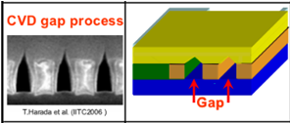

Figure 12: Air gap in interconnects [9]

Optical interconnects/Carbon nanotubes:
For global interconnects, path length reduction solution is the most viable. Clearly multi-core designs reduce the interconnect path. A geometrical solution gaining momentum is the 3D solution which decreases interconnect path lengths by vertically stacking many thinned strata on top of each other.
Another RC alternative is an optical interconnect. The basic advantages are speed-of-light signal propagation, large bandwidth and less crosstalk. The capability for a single optical path to accommodate multiple wavelengths increases the data-carrying capacity, providing bandwidth densities not achievable by electrical means. The primary challenges for optical interconnects are producing cost effective, low power components that are compatible with CMOS fabrication.
Carbon nanotubes (CNT): Rapid increase in resistivity in narrow trenches requires the consideration of new, one-dimensional conduction systems which do not suffer from either sidewall or grain boundary scattering. Ballistic transport in systems, such as silicides, carbon nanotubes, nanowires, or graphene nanoribbons, offers potential solutions. Carbon nanotubes offer high conductivity compared to Cu/low-k interconnects because of their one dimensional nature, peculiar band-structure and strong covalent bonds among carbon atoms. Although CNT interconnects (Figure 13) have shown to be promising, there are several process and reliability related challenges that need to be addressed before CNT-based devices and interconnects can enter mainstream VLSI processing.
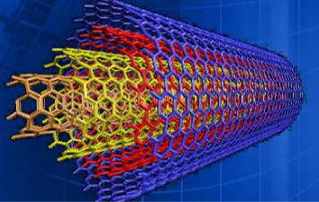

Figure 13: A hypothetical CNT Interconnect

- Simulation results

- Conclusions

In this article, an ambitious vision has been outlined for future processors, which, in some aspects, is a wide departure from present-day processors. This vision is based on the current challenges and driven by what people want from technology. It is likely that processor and platforms will move towards a virtualized, reconfigurable or adaptable multicore architecture with a large number of cores, a rich set of built-in processing, large on-chip memory subsystems and a well-equipped microkernel. New device structures are certainly going to be implemented; but, whether Silicon will be completely replaced by other materials, remains to be seen. If this happens, it would need significant changes in the technology and in turn investment cost. It also remains to be seen, how far we can continue to scale transistors. We need to be able to build reliable devices, which also poses a limit on scaling. It is also worth looking at how efficiently the existing gates are being utilised in a processor. If half the number of gates is only resulting in leakage, there might be no point in further increasing transistor density through scaling, unless leakage is checked. Asynchronous design might be worth investigating, if eliminating clock really results in enhanced efficiency. Considerable work also is needed to improve the interconnect performance. Finally, it might be possible that new market segments emerge, which might change the direction of future computing needs and trends. Overall, all or atleast some of these factors are likely going to drive the design of processors in the coming decade.
References
- James W. Tschanz, Member, IEEE, James T. Kao, Member, IEEE, Siva G. Narendra, Member, IEEE, Raj Nair, Member, IEEE, Dimitri A. Antoniadis, Fellow, IEEE, Anantha P. Chandrakasan, Senior Member, IEEE, and Vivek De, Member, IEEE: “ Adaptive Body Bias for Reducing Impacts of Die-to-Die and Within-Die Parameter Variations on Microprocessor Frequency and Leakage ” IEEE JOURNAL OF SOLID-STATE CIRCUITS, VOL. 37, NO. 11, NOVEMBER 2002
- Eric Humenay, David Tarjan, Kevin Skadron , “Impact of Process Variations on Multicore Performance Symmetry ”, 978-3-9810801-2-4/DATE07 © 2007 EDAA
- Saisanthosh Balakrishnan, Ravi Rajwar, Mike Upton, Konrad Lai, “ The Impact of Performance Asymmetry in Emerging Multicore Architectures ”, Proceedings of the 32nd International Symposium on Computer Architecture (ISCA’05)
- Shekhar Y. Borkar , “Platform 2015: Intel Processor and Platform Evolution for the Next Decade ”, White Paper
- Lin Huang and Qiang Xu , “Characterizing the Lifetime Reliability of Manycore Processors with Core-Level Redundancy ”, Computer-Aided Design (ICCAD), 2010 IEEE/ACM
- Shekhar Borkar , “Designing reliable systems from unreliable components: The challenges of transistor variability and degradation ”, Published by the IEEE Computer Society , 2005
- Gengbin Zheng, Chao Huang and Laxmikant V. Kale , “Performance Evaluation of Automatic Checkpoint-based Fault Tolerance for AMPI and Charm++ ”, Newsletter, ACM SIGOPS Operating Systems Review, Volume 40 Issue 2, April 2006
- Lin Huang and Qiang Xu , “Performance Yield-Driven Task Allocation and Scheduling for MPSoCs under Process Variation ”, DAC'10, ACM 2010
- International Technology Roadmap For Semiconductors 2009 Edition - Interconnect
- M. Amde, T. Felicijan, A. Efthymiou, D. Edwards and L. Lavagno , “Asynchronous on-chip networks ”, IEE Proc.-Comput. Digit. Tech., Vol. 152, No. 2, March 2005
- An Illustrated History of Computers, John Kopplin © 2002
- History of Semiconductor Engineering- Bo Jolek
- http://en.wikipedia.org/wiki/Intel_4004
- http://en.wikipedia.org/wiki/Instruction_pipeline
- Kaushik Roy, Hamid Mahmoodi-Meimand, and Saibal Mukhopadhyay , “Leakage Control for Deep-Submicron Circuits ”
- Cristian Constantinescu , “Trends and challenges in vlsi circuit reliability” , White paper, Intel
- Vivek Tiwari, Deo Singh, Suresh Rajgopal, Gaurav Mehta, Rakesh Patel, Franklin Baez, “Reducing Power in High-performance Microprocessors”, DAC98, Copyright ©1998 ACM

