**APACHE WEB SERVER**

# **INTRODUCTION:**

* The **Apache HTTP Server**, colloquially called **Apache**.
* Apache is a free and open-source cross platform [web server](https://en.wikipedia.org/wiki/Web_server) software, released under the terms of Apache license 2.0.
* Apache is developed and maintained by an open community of developers under the auspices of the Apache Software Foundation.
* The vast majority of Apache HTTP Server instances run on a Linux Distribution but current versions also run on Microsoft Windows and a wide variety of Unix-like systems
* Originally development of Apache began in early 1995 after work on the NCSA code stalled.
* Apache played a key role in the initial growth of the World Wide Web quickly overtaking NCSA HTTPd as the dominant HTTP server, and has remained most popular since April 1996.
* In 2009, it became the first web server software to serve more than 100 million websites As of February 2020.

## **WHAT IS APACHE?**

* Apache is the most widely used **web server software**.
* Apache is an open source software available for **free**.
* Developed and maintained by **Apache Software Foundation**.
* It runs on 67% of all webservers in the world.
* It is **fast, reliable, and secure**.
* It can be highly customized to meet the needs of many different environments by using extensions and modules.
* Most **WordPress** hosting providers use Apache as their web server software. However, WordPress can run on other web server software as well.

# **Apache Software Foundation**

Software Development Company

# **Description**

The Apache Software Foundation is an American non-profit corporation to support Apache software projects, including the Apache HTTP Server. The ASF was formed from the Apache Group and incorporated on March 25, 1999. The Apache Software Foundation is a decentralized open source community of developers.

**Founded:**25 March 1999, Delaware United States

**Revenue:**9.17 lakhs USD

**Headquarters:**Forest hill, United States, Mary Land.

**Location:**Wakefield, MA 01880

**Type of Business:** 501(c) (3) organization

**Founders:** Sameer Prekh, Roy Fielding.

# **WHAT IS WEB SERVER?**

* File servers, database servers, mail servers, and web servers use different kinds of server software. Each of these applications can access files stored on a physical server and use them for different purposes.
* The job of a web server is to serve websites on the internet. To achieve that goal, it acts as a middleman between the server and client machines. It pulls content from the server on each user request and delivers it to the web.
* The biggest challenge of a web server is to serve many different web users at the same time — each of whom is requesting different pages. Web servers process files written in different programming languages such as PHP, Python, Java, and others.
* They turn them to static HTML files and serve these files in the browser of web users. When you hear the word web server, think of it as the tool responsible for the proper server-client communication.

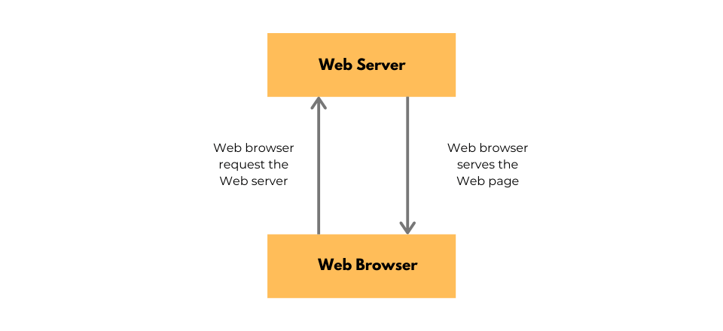

### **HOW DOES APACHE WEB SERVER WORK?**

* Although we call Apache a web server, it is not a physical server, but rather a software that runs on a server.
* Its job is to establish a connection between a server and the browsers of website visitors (Firefox, Google Chrome, Safari, etc.) while delivering files back and forth between them (client-server structure).
* Apache is a cross-platform software, therefore it works on both UNIX and Windows servers.
* When a visitor wants to load a page on your website, for instance, the homepage or your “About Us” page, their browser sends a request to your server and Apache returns a response with all the requested files (text, images, etc.).
* The server and the client communicate through the HTTP protocol and Apache is responsible for the smooth and secure communication between the two machines.
* Apache is highly customizable, as it has a module-based structure. Modules allow server administrators to turn additional functionalities on and off. Apache has modules for security, caching, URL rewriting, password authentication, and more.

##### **APACHE PROS AND CONS:**

An Apache web server can be an excellent choice to run your website on a stable and versatile platform. However, it also comes with some disadvantages you need to pay attention to.

PROS:

1. Open-source and free, even for commercial use.
2. Reliable, stable software.
3. Frequently updated, regular security patches.
4. Flexible due to its module-based structure.
5. Easy to configure, beginner-friendly.
6. Cross-platform (works on both UNIX and Windows servers).
7. Works out of the box with WordPress sites.
8. Huge community and easily available support in case of any problem.

CONS:

1. Ability to modify the configuration offered an invitation to various threats when you meddled with code, insecure gates open.
2. Again, the customization means new bugs and errors. Debugging means time and resources consumption
3. Strict updating policy is necessary that needs to be done at regular intervals
4. Recognizing and disabling unwanted services and modules
5. Performance issues on extremely traffic-heavy websites.

# **APACHE FEATURES:**

* Loadable Dynamic Modules
* Handling of static files, index files, auto-indexing and content negotiation
* .htaccess per-directory configuration support
* Apache is compatible with IPv6
* Apache Server supports HTTP/2
* gzip compression and decompression
* FTP connections are possible with proper module
* Perl, PHP scripts are already build

# **CONCLUSION:**

In spite of these disadvantages, Apache is still considered as one of the best in the world. Apache web server has acted as the main driving force behind the web expansion that we see today. Apache has become the standard for developing other web server platforms. It is dynamic in nature, and it complies fully with the current HTTP standards. These are just a few reasons why Apache is preferred over other web servers.