Pimpri Chinchwad Education Trust’s
PIMPRI CHINCHWAD COLLEGE OF ENGINEERING
(An Autonomous Institute affiliated to Savitribai Phule Pune University)
DEPARTMENT OF INFORMATION TECHNOLOGY
[Insert college logo here — set logo_path in report_config.json]
MINI PROJECT REPORT
on
Analysis of Air Pollution Patterns and Pollution Hotspots Across India Using Big Data Technologies
Submitted by
Name of Student | PRN
[Student Name 1] | [PRN 1]
[Student Name 2] | [PRN 2]
[Student Name 3] | [PRN 3]
[Student Name 4] | [PRN 4]

Div: [Div]
Academic Year: 2026-27

TABLE OF CONTENTS

1. Introduction | –
1.1 Background | –
1.2 Problem Statement | –
1.3 Objectives | –
1.4 Scope | –
2. Dataset and Preprocessing | –
2.1 Dataset Source and Collection | –
2.2 Important Attributes | –
2.3 Observed Dataset Coverage | –
2.4 Schema-Aware Loading | –
2.5 Cleaning and Standardisation | –
2.6 Cleaning Counts and Provenance | –
2.7 Collection Limitations | –
3. System Architecture and Technologies | –
3.1 Overall Architecture | –
3.2 Layer Responsibilities | –
3.3 Technology Roles | –
3.4 Execution and Storage Boundaries | –
3.5 Result Data Contract | –
4. Batch Analysis Using Apache Spark | –
4.1 Transformations and Actions | –
4.2 Counting Rules and Denominators | –
4.3 Output Preparation | –
4.4 Pollutant Coverage | –
4.5 City Comparison | –
4.6 State Comparison | –
4.7 Monthly Trend | –
4.8 Seasonal Pattern | –
4.9 Hourly Pattern | –
4.10 Pollution Hotspots | –
4.11 Abnormal Pollution Levels | –
4.12 Air Quality Index | –
4.13 Insights and Recommendations | –
5. Dashboard and Visualization | –
5.1 Streamlit Application | –
5.2 Metric Cards | –
5.3 Filters | –
5.4 Dashboard Screenshots | –
5.5 Downloads | –
5.6 Visualization Provenance | –
6. Storage and Integration | –
6.1 Parquet Storage Layout | –
6.2 Why Parquet | –
6.3 Apache Cassandra (Not Implemented) | –
6.4 Reliability Considerations | –
7. Local Deployment and Execution | –
7.1 Development Environment | –
7.2 Prepare the Data | –
7.3 Run the Spark Pipeline | –
7.4 Start the Dashboard | –
7.5 Build the Report and Run Tests | –
8. Testing and Validation | –
8.1 Validation Approach | –
8.2 Timestamp Handling | –
8.3 Test Results | –
8.4 Data-Quality Checks on Real Data | –
8.5 Limitations of Validation | –
9. Conclusion and Future Scope | –
9.1 Project Summary | –
9.2 Future Scope | –
10. References | –

1. Introduction

1.1 Background
Air pollution is one of India's most significant environmental health risks. The Central Pollution Control Board (CPCB) operates a Continuous Ambient Air Quality Monitoring (CAAQM) network that reports pollutant concentrations hourly. Combined over many years and stations, these readings form a dataset large enough to need distributed processing for cleaning, aggregation and anomaly screening.
This Big Data Analytics mini project uses Apache Spark (PySpark) to ingest the India Air Quality Database, clean it, and compute city, state, seasonal, hourly, hotspot, anomaly and AQI summaries stored as Parquet. A Streamlit dashboard serves the saved results.

1.2 Problem Statement
Develop a reproducible, laptop-runnable pipeline that analyses hourly air-quality readings across India, identifies pollution hotspots and abnormal pollution levels, compares cities and states, characterises monthly, seasonal and diurnal patterns, and presents the results in an interactive dashboard.

1.3 Objectives
- Ingest and validate real CPCB-derived hourly data with Apache Spark using an explicit schema contract.
- Clean, standardise units, handle invalid values and deduplicate readings; report data-quality counts.
- Analyse PM2.5, PM10, NO2, SO2, CO, ozone and the other available pollutants.
- Rank cities/states and flag hotspot stations and abnormal pollution days using documented statistical rules.
- Compute the CPCB National AQI only where its validity rules are met.
- Provide an interactive Streamlit/Plotly dashboard with CSV downloads, plus logging and automated tests.

1.4 Scope
The analysed sample contains 42,925,552 cleaned hourly readings from 538 stations in 245 cities and 30 states between 2024-01-01 and 2024-12-31 (IST). The full database is much larger; the scope here is whatever date range is downloaded and analysed locally. Apache Cassandra was not implemented (Section 6).

2. Dataset and Preprocessing

2.1 Dataset Source and Collection
The data come from the India Air Quality Database published by the XKDR Forum (https://airquality.xkdr.org/). According to the project's site (checked 20 October 2026), it provides hourly readings from every station in CPCB's CAAQM network plus five US Embassy monitors: about 196.5 million readings from 558 stations and 15 pollutants, covering January 2009 to March 2026. Data are distributed through a query API and as one sorted Parquet file per month (under half a gigabyte in total).
Licence: Creative Commons Attribution 4.0 (CC BY 4.0), with credit to the India Air Quality Database (XKDR Forum) and the original sources (CPCB CAAQM; US Department of State via AirNow). The data are provided without warranty and are published as received from the networks, which label readings preliminary and not fully validated.
Download strategy for a student laptop: scripts/download_data.py fetches only the requested year(s)/months. A public demo key published on the site can read the 2024 files; a free personal key (https://airquality.xkdr.org/signup) has no row caps and reads all years. One year of Parquet is a small download relative to the whole archive.

2.2 Important Attributes
Table 1. Source schema (per the project's API documentation) and use in this project.
Attribute | Type | Analytical purpose
station_id | text | Station key (CPCB site number or embassy id); identifies series and station counts.
station_name, state_name, city_name | text | Geography for city/state comparison and hotspot labels.
parameter_name | text | Pollutant (PM2.5, PM10, NO, NO2, NOx, NH3, SO2, CO, Ozone, Benzene, Toluene, Xylene, O_Xylene, MP-Xylene, Eth-Benzene).
unit | text | Harmonised units (µg/m³, mg/m³, ppb); standardised in cleaning.
collected_at | timestamp | Naive timestamp in Indian Standard Time; CPCB readings sit on the hour.
value | double | Measured concentration, as received (no gap filling, outlier removal or calibration).
source | text | cpcb_caaqm or us_embassy.
year, month | int | Hive partition columns of the bulk files; used for partition pruning.
latitude, longitude (stations.parquet) | double | Station coordinates for the hotspot map; some decommissioned stations have none.

2.3 Observed Dataset Coverage
Spark read 46,937,170 rows. After cleaning, 42,925,552 unique station-pollutant-hour readings remain from 538 stations, 245 cities and 30 states, spanning 2024-01-01 00:00:00 to 2024-12-31 23:30:00 IST. The year filter applied was [2024].

2.4 Schema-Aware Loading
read_raw() reads the monthly Parquet files with partition discovery, then enforces a schema contract: required columns (station_id, parameter_name, unit, collected_at, value) must exist or a SchemaError is raised; all columns are cast to canonical types (strings trimmed, value as double, collected_at as timestamp); optional columns that are absent become nulls. Parquet carries its own physical schema, so no inference over the data is needed. The Spark session timezone is Asia/Kolkata because the source timestamps are naive IST, so hour-of-day and date derivations are IST.
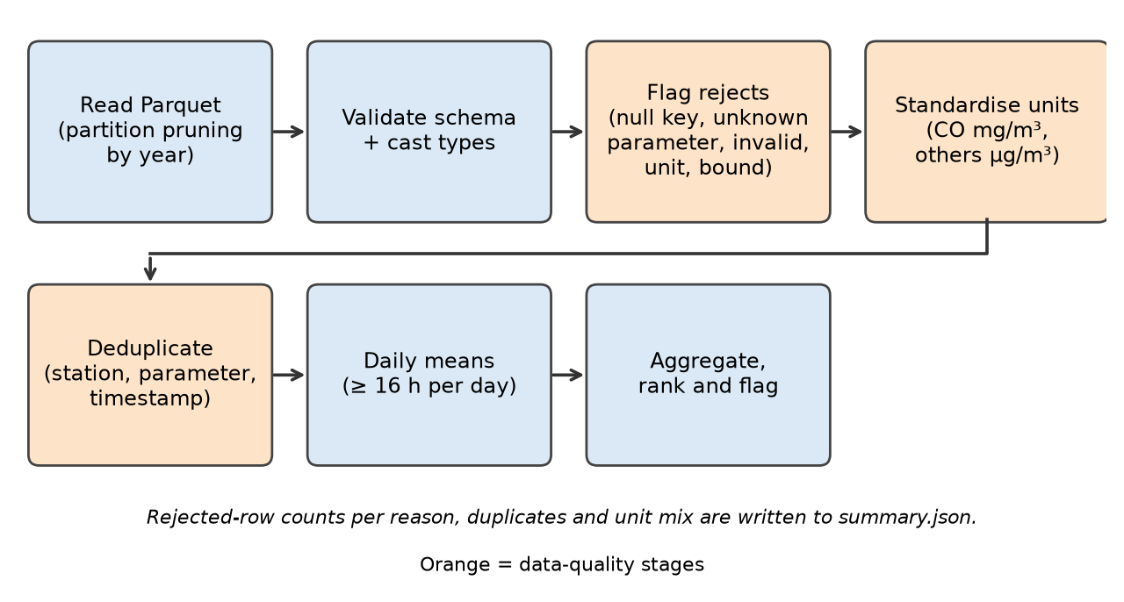
Fig. 1. Spark cleaning and aggregation stages (data-quality stages in orange).

2.5 Cleaning and Standardisation
- Rejected: missing station/parameter/timestamp (null_key_field); parameters outside the known list (unknown_parameter); null, NaN or negative values (invalid_value).
- Units normalised to µg/m³ (CO in mg/m³); µg↔mg conversions applied; ppb/ppm rows are quarantined (unit_not_convertible) rather than converted with assumed temperature/pressure.
- Rejected when above a physical plausibility bound per pollutant (above_physical_bound); bounds are configurable assumptions in src/aq/config.py, not standards.
- Deduplicated on (station_id, parameter_name, collected_at); conflicting duplicates are averaged and counted.
- Daily means require ≥ 16 hourly readings (CPCB rule); 8-hour windows for CO and ozone require ≥ 6 readings.
- No gap filling or outlier removal is applied; extreme-but-plausible values are kept and handled by the anomaly module.

2.6 Cleaning Counts and Provenance
Table 2. Data-quality counts from summary.json.
Check | Observed value
Rows read | 46,937,170
Rejected: unit_not_convertible | 4,011,594
Rejected: invalid_value | 24
Rows kept before deduplication | 42,925,552
Duplicate keys removed | 0
Conflicting duplicate keys (values differ) | 0
Clean unique hourly readings | 42,925,552
Stations / cities / states | 538 / 245 / 30
Valid station-days (≥16 h) | 1,768,362
Station-days with valid CPCB AQI | 165,652

Table 3. Unit codes observed per parameter (raw rows).
Parameter | Unit code | Rows
Benzene | ug/m3 | 3,495,052
CO | mg/m3 | 3,982,313
Eth-Benzene | ug/m3 | 2,399,595
MP-Xylene | ug/m3 | 2,409,879
NH3 | ug/m3 | 3,593,165
NO | ug/m3 | 3,927,785
NO2 | ug/m3 | 3,983,789
NOx | ppb | 4,011,594
Ozone | ug/m3 | 3,840,559
PM10 | ug/m3 | 3,864,549
PM2.5 | ug/m3 | 3,932,416
SO2 | ug/m3 | 3,865,493
Toluene | ug/m3 | 2,773,396
Xylene | ug/m3 | 857,585

2.7 Collection Limitations
Monitoring stations are not uniformly distributed and are concentrated in cities; readings are preliminary and not fully validated by the networks; station availability varies over time; and aggregates are not population-weighted. Findings describe monitored locations in the analysed period only.

3. System Architecture and Technologies

3.1 Overall Architecture
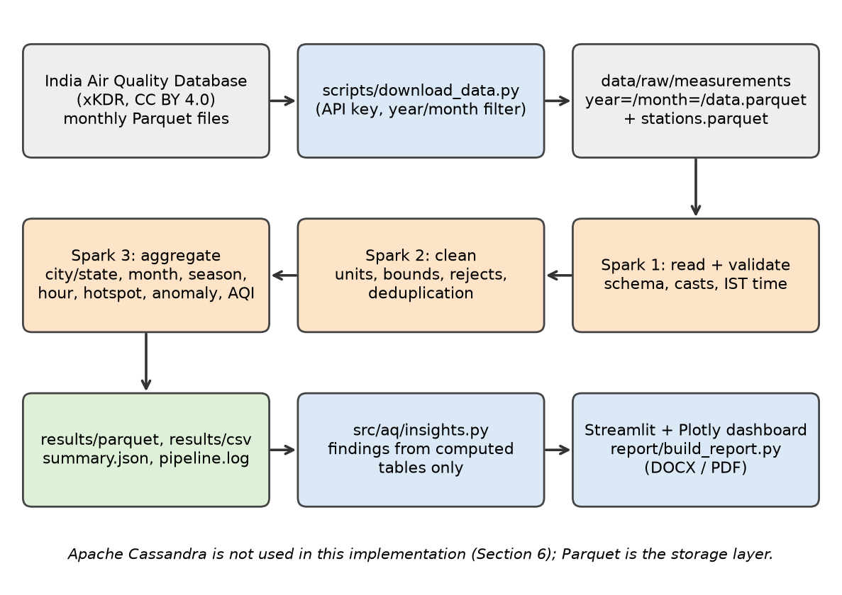
Fig. 2. Architecture: download → Spark validation, cleaning and aggregation → Parquet/CSV → dashboard and report.

3.2 Layer Responsibilities
- Acquisition: scripts/download_data.py (year/month filter, retries, resume by size).
- Processing: src/aq/spark_pipeline.py — all cleaning and aggregation run as Spark DataFrame jobs.
- Storage: Parquet (clean hourly data partitioned by year/month; one Parquet dataset per aggregate) plus CSV exports and summary.json.
- Insights: src/aq/insights.py derives text only from computed tables.
- Presentation: app.py (Streamlit/Plotly) reads the aggregates only; Spark is not run per interaction.

3.3 Technology Roles
Table 4. Technology roles.
Technology | Role
Apache Spark / PySpark 4 | Schema enforcement, cleaning, window functions (8-hour averages, ranking), group-by aggregations, percentiles.
Parquet (pyarrow) | Columnar input/output; partition pruning by year.
pandas | Reading small aggregate tables for the dashboard, report and insights.
Streamlit + Plotly | Interactive dashboard, filters, maps, downloads.
Matplotlib + python-docx | Static report charts and the DOCX report.
pytest | Automated unit, integration and dashboard smoke tests.

3.4 Execution and Storage Boundaries
Spark runs in local mode (default local[2], 8 shuffle partitions, 2 GB driver memory; adjustable by command-line flags). Local threads demonstrate Spark's APIs and lazy execution on a laptop; they do not demonstrate cluster scalability, and no throughput benchmark is claimed. Aggregate tables are small and converted to pandas only after Spark has reduced them.

3.5 Result Data Contract
Each aggregate is stored as results/parquet/<name>/ and results/csv/<name>.csv: city_summary, state_summary, monthly_city, monthly_national, seasonal_city, hourly_pattern, hotspots, anomaly_days, anomaly_summary, aqi_station_daily (Parquet only), aqi_city_monthly, aqi_category_city, aqi_dominant_city, data_coverage. summary.json holds run metadata and data-quality counts.

4. Batch Analysis Using Apache Spark

4.1 Transformations and Actions
Transformations (select, filter, withColumn, groupBy, window functions, join) build a lazy plan; actions (write, count, first, collect, toPandas on aggregates) trigger execution. Key operations: groupBy().agg() for daily means with hour counts; percentile_approx for medians and 95th percentiles; Window.rangeBetween(-7h, 0) for 8-hour rolling means of CO and ozone; percent_rank and row_number windows for hotspot ranking; max_by for the dominant AQI pollutant.

4.2 Counting Rules and Denominators
City/state statistics are means of valid station-day means, so every station-day has equal weight; they are not population-weighted and not hourly-reading weighted. Cities and states are ranked only with at least the minimum station-days set in the dashboard (default 30); hotspot ranking needs at least 60 valid days per station. Exceedance percentages use NAAQS 24-hour limits (PM2.5 60, PM10 100, NO2 80, SO2 80, NH3 400 µg/m³) applied to valid daily means only.

4.3 Output Preparation
Every aggregate is written once as Parquet by Spark and exported to CSV for downloads; summary.json and pipeline.log record the run.

4.4 Pollutant Coverage
Table 5. Valid station-days and station counts per pollutant.
Parameter | Stations | Station-days | First | Last
CO | 528 | 164,436 | 2024-01-01 | 2024-12-31
NO2 | 533 | 164,151 | 2024-01-01 | 2024-12-31
PM2.5 | 534 | 162,649 | 2024-01-01 | 2024-12-31
NO | 526 | 161,872 | 2024-01-01 | 2024-12-31
SO2 | 512 | 159,788 | 2024-01-01 | 2024-12-31
PM10 | 525 | 159,770 | 2024-01-01 | 2024-12-31
Ozone | 513 | 158,223 | 2024-01-01 | 2024-12-31
NH3 | 476 | 148,185 | 2024-01-01 | 2024-12-31
Benzene | 466 | 143,971 | 2024-01-01 | 2024-12-31
Toluene | 375 | 114,568 | 2024-01-01 | 2024-12-31
MP-Xylene | 350 | 97,958 | 2024-01-01 | 2024-12-31
Eth-Benzene | 350 | 97,597 | 2024-01-01 | 2024-12-31
Xylene | 128 | 35,194 | 2024-01-01 | 2024-12-31

Interpretation. Pollutants with few stations or station-days should not be compared with widely monitored ones; the parameter set available depends on station instrumentation.

4.5 City Comparison
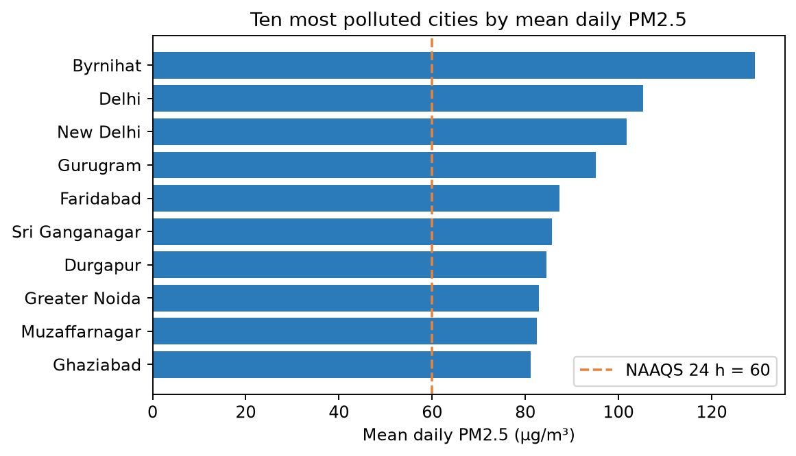
Fig. 3. City ranking by mean daily PM2.5 (cities with ≥ 30 valid station-days).
Table 6. Top ten cities by mean daily PM2.5.
State | City | Mean | Median | P95 | Stations | Station-days | % > NAAQS
Assam | Byrnihat | 129.26 | 131.71 | 237.99 | 1 | 295 | 81.69
Delhi | Delhi | 105.29 | 76 | 273.5 | 39 | 13,208 | 62.42
Delhi | New Delhi | 101.76 | 70.71 | 278.42 | 1 | 366 | 60.38
Haryana | Gurugram | 95.16 | 84.16 | 198.35 | 4 | 1,149 | 71.19
Haryana | Faridabad | 87.38 | 73.9 | 192.59 | 4 | 1,176 | 61.9
Rajasthan | Sri Ganganagar | 85.67 | 78 | 161.01 | 1 | 321 | 69.47
West Bengal | Durgapur | 84.47 | 68.11 | 207.7 | 2 | 339 | 58.11
Uttar Pradesh | Greater Noida | 82.86 | 70.9 | 189.84 | 2 | 683 | 60.91
Uttar Pradesh | Muzaffarnagar | 82.46 | 78.84 | 156.68 | 1 | 350 | 66
Uttar Pradesh | Ghaziabad | 81.17 | 64.19 | 187.67 | 3 | 1,056 | 53.31

Interpretation. Most polluted cities by mean daily PM2.5: Byrnihat (129.3 µg/m³); Delhi (105.3 µg/m³); New Delhi (101.8 µg/m³); Gurugram (95.2 µg/m³); Faridabad (87.4 µg/m³). Cleanest of 246 ranked cities: Gangtok (13.1). PM2.5: 27.9% of valid station-days exceeded the NAAQS 24-hour limit of 60 µg/m³. PM10: 43.6% of valid station-days exceeded the NAAQS 24-hour limit of 100 µg/m³.

4.6 State Comparison
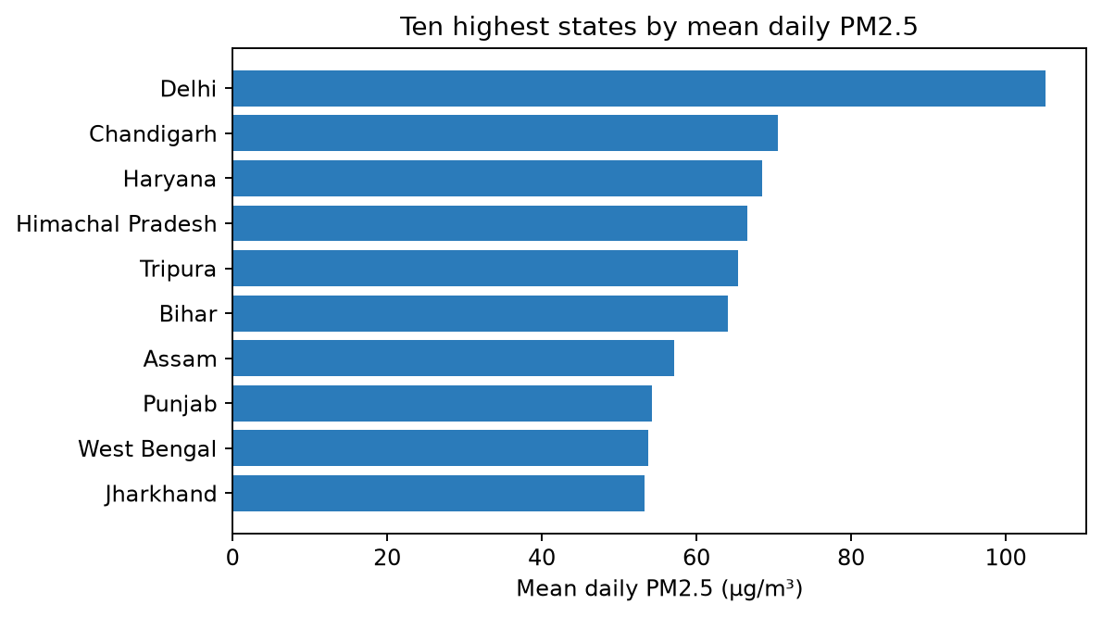
Fig. 4. State ranking by mean daily PM2.5.
Interpretation. Highest-PM2.5 states: Delhi (105.2); Chandigarh (70.6); Haryana (68.5).

4.7 Monthly Trend
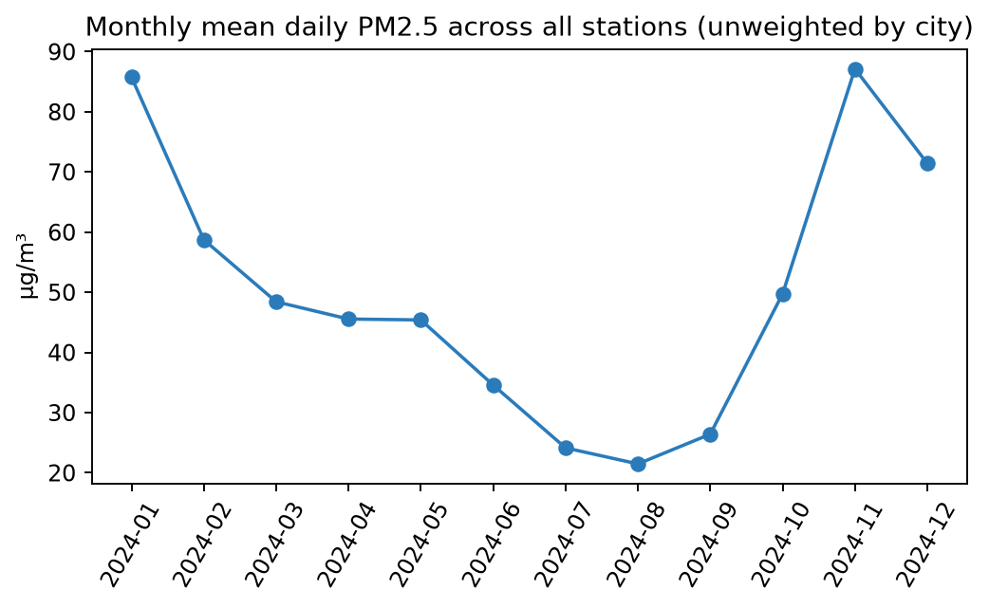
Fig. 5. Monthly mean of valid daily PM2.5 across stations.
Interpretation. The monthly mean is lowest in 2024-08 (21.5 µg/m³) and highest in 2024-11 (87.2 µg/m³) across 12 month(s). The station set can change from month to month, so month-to-month changes combine real change with changing station coverage.

4.8 Seasonal Pattern
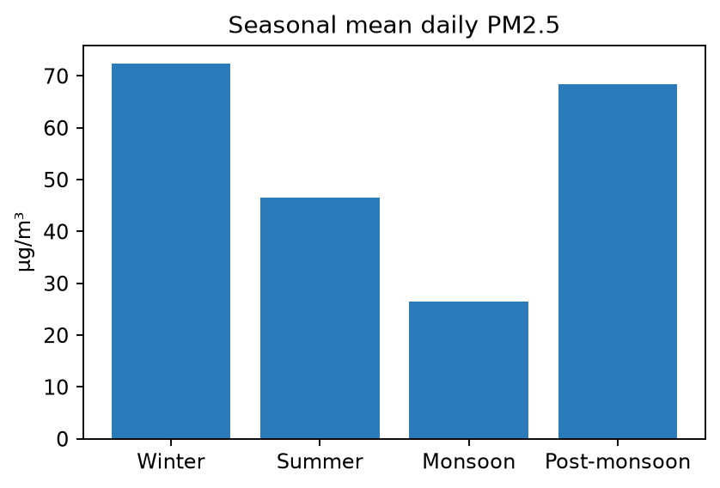
Fig. 6. Seasonal mean daily PM2.5 (Winter Dec–Feb, Summer Mar–May, Monsoon Jun–Sep, Post-monsoon Oct–Nov).
Interpretation. Seasonality of PM2.5 (station-day weighted): Winter 72.3, Summer 46.5, Monsoon 26.6, Post-monsoon 68.5. Peak season is Winter, 2.7x the lowest (Monsoon). Seasons missing from the chart were not covered by the downloaded period.

4.9 Hourly Pattern
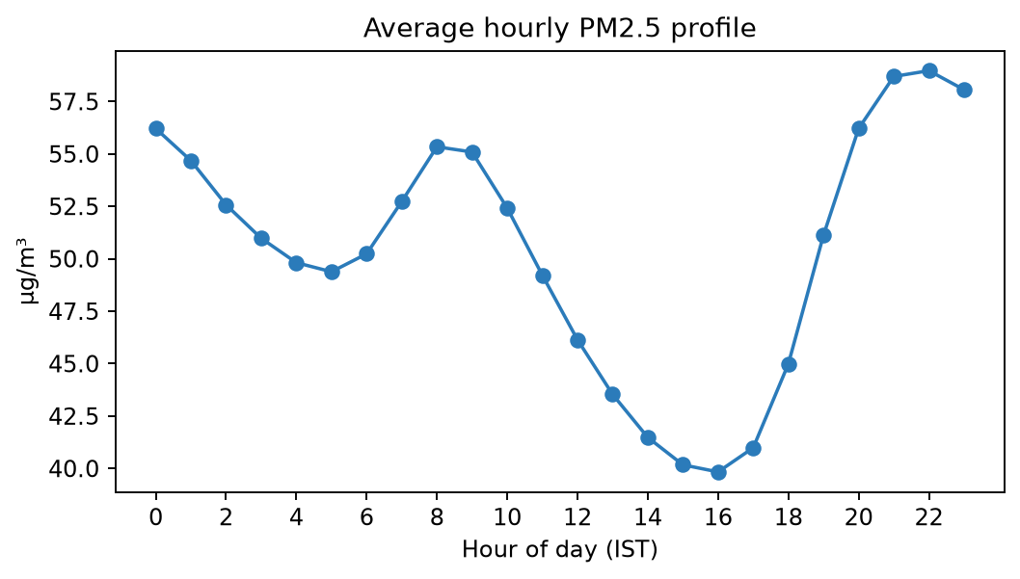
Fig. 7. Average PM2.5 by hour of day (IST), reading-weighted across selected cities.
Interpretation. Daily cycle of PM2.5 (IST): highest around 22:00 (59.0 µg/m³), lowest around 16:00 (39.8).

4.10 Pollution Hotspots
A station is a hotspot for a pollutant when its mean valid daily value is in the top 9% of eligible stations (≥ 60 valid days). This is a statistical definition for screening, not an official designation.
Table 7. Ten highest-ranked PM2.5 stations.
rank | Station | City | State | Mean | P95 | Days | % > NAAQS | Hotspot
1 | Anand Vihar, Delhi - DPCC | Delhi | Delhi | 142.29 | 338.04 | 300 | 77.67 | 1
2 | Jahangirpuri, Delhi - DPCC | Delhi | Delhi | 131.61 | 335.08 | 351 | 73.5 | 1
3 | Central Academy for SFS, Byrnihat - PCBA | Byrnihat | Assam | 129.26 | 237.99 | 295 | 81.69 | 1
4 | Wazirpur, Delhi - DPCC | Delhi | Delhi | 126.13 | 343.46 | 355 | 71.27 | 1
5 | Bawana, Delhi - DPCC | Delhi | Delhi | 125.91 | 312.54 | 361 | 72.85 | 1
6 | Shadipur, Delhi - CPCB | Delhi | Delhi | 125.56 | 264.16 | 359 | 75.77 | 1
7 | Mundka, Delhi - DPCC | Delhi | Delhi | 124.85 | 318.42 | 349 | 68.77 | 1
8 | Punjabi Bagh, Delhi - DPCC | Delhi | Delhi | 121.48 | 320.58 | 357 | 70.03 | 1
9 | Nehru Nagar, Delhi - DPCC | Delhi | Delhi | 119.76 | 324.83 | 357 | 62.18 | 1
10 | Vivek Vihar, Delhi - DPCC | Delhi | Delhi | 119.45 | 320.38 | 353 | 63.17 | 1

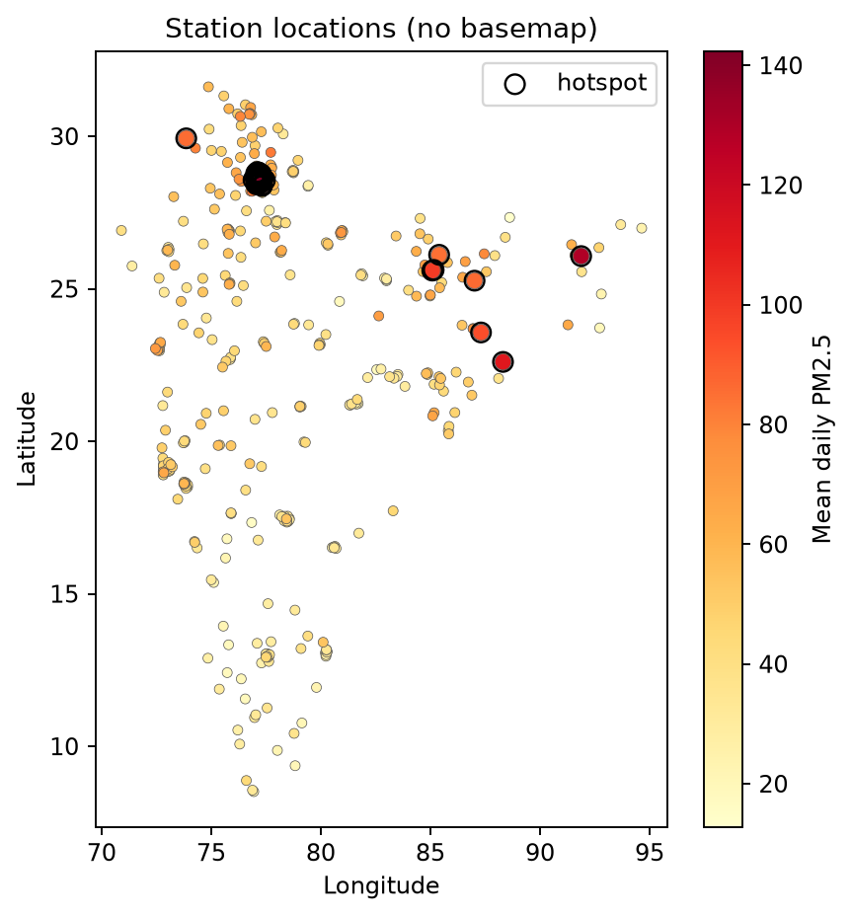
Fig. 8. Station locations coloured by mean daily PM2.5; hotspots circled.
Interpretation. Hotspots: 53 of 525 eligible stations are in the top 9% for mean PM2.5; the highest are Anand Vihar, Delhi - DPCC, Delhi (142.3); Jahangirpuri, Delhi - DPCC, Delhi (131.6); Central Academy for SFS, Byrnihat - PCBA, Byrnihat (129.3). States hosting most hotspots: Delhi (36), Haryana (6), Bihar (4).

4.11 Abnormal Pollution Levels
For each station and pollutant (≥ 30 valid days) the modified z-score 0.6745·(x − median)/MAD is computed on daily means; days with z > 3.5 (Iglewicz–Hoaglin cut-off) are flagged as positive anomalies.
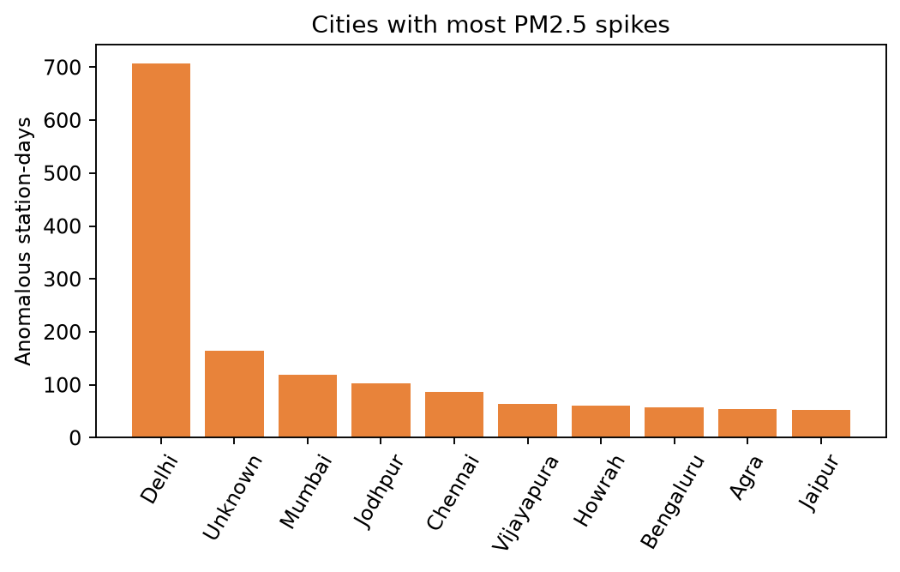
Fig. 9. Cities with the most PM2.5 spike days.
Interpretation. Anomalies: 3,521 station-days (2.17%) had PM2.5 spikes with modified z-score > 3.5; most in Delhi (707), Unknown (165), Mumbai (119). Flagged days may reflect real events (burning, dust, festivals) or sensor faults; they are screening results.

4.12 Air Quality Index
The database has no AQI column, so the CPCB National AQI is computed: sub-index linear within each band, 24-hour means for PM2.5, PM10, NO2, SO2, NH3 and 8-hour means for CO and ozone; overall AQI = highest sub-index; a station-day needs ≥ 16 hours per pollutant, ≥ 3 pollutants including PM2.5 or PM10. Band tables are implemented from the CPCB NAQI summary; CPCB does not publish the upper bound of the last band, so it is extended by the previous band's width and capped at 500 (assumption).
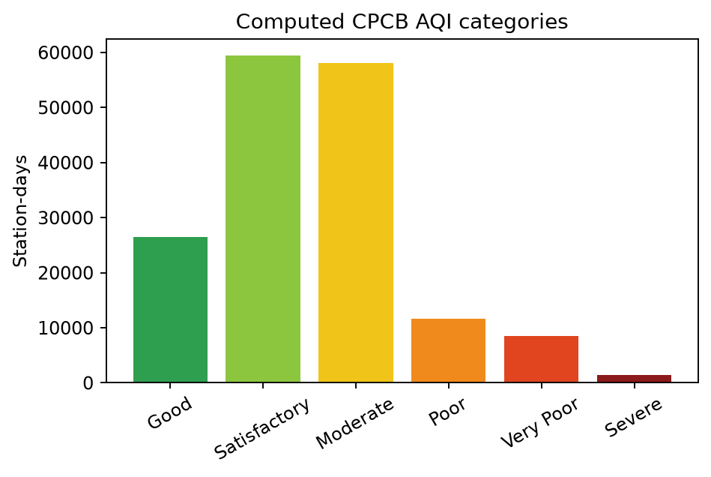
Fig. 10. Computed CPCB AQI categories (station-days).
Interpretation. Computed CPCB AQI on 165,652 station-days: Good 16.0%, Satisfactory 35.9%, Moderate 35.0%, Poor 7.1%, Very Poor 5.1%, Severe 0.9%. Dominant pollutant behind the AQI: PM10 (49.6% of station-days).

4.13 Insights and Recommendations
Generated from computed tables by src/aq/insights.py:
- Prioritise PM2.5 control: 28% of station-days breach the 24-hour standard.
- Time interventions and public advisories for the Winter season, when PM2.5 peaks in this sample.
- Deploy source-apportionment studies first at hotspot stations in Delhi.
- Review flagged spike days against local events (biomass burning, festivals, dust) before treating them as sensor faults.

5. Dashboard and Visualization

5.1 Streamlit Application
app.py reads the Parquet aggregates and presents eight tabs: Cities & states, Trends, Hourly, Hotspots, Anomalies, AQI, Insights and Data quality. Plotly provides interactive charts; every table has a CSV download button.

5.2 Metric Cards
Cards show stations, cities/states, clean hourly readings, mean daily value of the selected pollutant, most polluted city, percentage of days above NAAQS, hotspot stations, anomalous station-days and valid-AQI station-days.

5.3 Filters
Sidebar filters: pollutant, state, city, month range, season, top-N and minimum station-days. Aggregates are independent marginal tables, so a filter applies only to tables that carry that dimension (for example, the season filter applies to the seasonal view).

5.4 Dashboard Screenshots
[Screenshot pending: capture the dashboard tab and save as docs/screenshots/01_overview.png] — Dashboard overview: metric cards and city/state rankings.
[Screenshot pending: capture the dashboard tab and save as docs/screenshots/02_trends.png] — Dashboard trends: monthly series and seasonal comparison.
[Screenshot pending: capture the dashboard tab and save as docs/screenshots/03_hourly.png] — Dashboard hourly (diurnal) pattern for selected cities.
[Screenshot pending: capture the dashboard tab and save as docs/screenshots/04_hotspots.png] — Dashboard hotspot map and ranked station table.
[Screenshot pending: capture the dashboard tab and save as docs/screenshots/05_anomalies.png] — Dashboard anomaly view.
[Screenshot pending: capture the dashboard tab and save as docs/screenshots/06_aqi.png] — Dashboard AQI categories and dominant pollutants.
[Screenshot pending: capture the dashboard tab and save as docs/screenshots/07_data_quality.png] — Dashboard data-quality tab.

5.5 Downloads
Each table can be downloaded as CSV; the Data-quality tab also offers summary.json. The pipeline additionally writes all aggregates to results/csv/.

5.6 Visualization Provenance
Figures in Section 4 are rendered by report/build_report.py from results/parquet; dashboard screenshots are taken from the running application. Diagrams are drawn by report/diagrams.py.

6. Storage and Integration

6.1 Parquet Storage Layout
Table 8. Storage layout.
Path | Content
data/raw/measurements/year=/month= | Downloaded source Parquet (read-only).
results/parquet/clean_hourly/year=/month= | Cleaned, deduplicated hourly readings in canonical units.
results/parquet/<aggregate>/ | One Parquet dataset per aggregate table.
results/csv/<aggregate>.csv | CSV exports for download and the report.
results/summary.json, pipeline.log, insights.md/json | Run metadata, logs, generated insights.

6.2 Why Parquet
Parquet is columnar, compressed and natively read/written by Spark and pandas, which keeps the project runnable on a laptop without a database server.

6.3 Apache Cassandra (Not Implemented)
Cassandra was optional and is not part of this implementation. The workload is batch analytics over a static historical dataset, for which Parquet is sufficient. Cassandra would be appropriate for serving low-latency lookups (for example, latest readings per station) in a future streaming extension; this is future scope only.

6.4 Reliability Considerations
Aggregate tables are overwritten on each run (not versioned), so an interrupted run can leave a mix of old and new tables; re-run the pipeline to restore consistency. The pipeline exits with a non-zero code and a logged message for missing input, schema errors or no valid rows.

7. Local Deployment and Execution

7.1 Development Environment
Python 3.10+, Java 17 or later (required by Spark), 8 GB RAM recommended. Dependencies are in requirements.txt (PySpark 4.0.1, pandas, pyarrow, Streamlit, Plotly, python-docx, matplotlib, pytest).

7.2 Prepare the Data
python -m venv .venv && source .venv/bin/activate # Windows: .venv\Scripts\activate
pip install -r requirements.txt
python scripts/download_data.py --years 2024

7.3 Run the Spark Pipeline
python -m src.aq.spark_pipeline --years 2024 --master local[4] --driver-memory 4g
python -m src.aq.insights results

7.4 Start the Dashboard
streamlit run app.py

7.5 Build the Report and Run Tests
pytest --junitxml=docs/pytest_report.xml
python report/build_report.py --results results

8. Testing and Validation

8.1 Validation Approach
Automated pytest tests verify cleaning rules, unit conversion, deduplication, schema errors, AQI maths (including Spark/Python parity), end-to-end aggregates against hand-computed expectations, hotspot and anomaly detection, insights generation and a Streamlit smoke test (AppTest). The end-to-end tests run on a small deterministic synthetic fixture created in tests/conftest.py, chosen so every expected value can be computed by hand; it is used for testing only and never for reported findings.

8.2 Timestamp Handling
During development, a test exposed a timezone defect: collecting a Spark timestamp into Python shifted it by the machine's UTC offset (5 h 30 min relative to IST). Timestamp bounds in summary.json are therefore formatted inside Spark in the IST session timezone, and the regression test asserts the expected bound.

8.3 Test Results
The suite was executed on 2026-10-20T08:27:56 (development sandbox, Linux): 29 tests, 0 failed, in 99 s.
Table 9. Automated test results (from docs/pytest_report.xml).
Module | Test | Result
test_aqi | test_sub_index_known_values | passed
test_aqi | test_sub_index_invalid_and_cap | passed
test_aqi | test_bands_monotonic | passed
test_aqi | test_categories | passed
test_aqi | test_overall_rules | passed
test_aqi | test_spark_matches_python | passed
test_cleaning | test_unit_code | passed
test_cleaning | test_reject_reasons_and_dedup | passed
test_cleaning | test_co_converted_to_mg | passed
test_cleaning | test_year_filter | passed
test_cleaning | test_schema_error | passed
test_cleaning | test_missing_path | passed
test_cleaning | test_cli_returns_error_code_on_bad_input | passed
test_downloader_and_app | test_download_plan_filters_and_maps | passed
test_downloader_and_app | test_dashboard_runs_without_exception | passed
test_downloader_and_app | test_dashboard_shows_helpful_error_without_results | passed
test_pipeline | test_summary_counts | passed
test_pipeline | test_city_means | passed
test_pipeline | test_state_summary_and_coverage | passed
test_pipeline | test_seasons_and_months | passed
test_pipeline | test_hourly_pattern | passed
test_pipeline | test_hotspots | passed
test_pipeline | test_anomaly_detected | passed
test_pipeline | test_aqi_rules_and_values | passed
test_pipeline | test_outputs_written | passed
test_pipeline | test_insights_from_results | passed
test_report | test_full_report_uses_computed_values | passed
test_report | test_template_marks_results_pending | passed
test_report | test_missing_results_returns_error | passed

These results come from the synthetic test fixture. They validate code logic, not the real dataset; re-run pytest on your machine.

8.4 Data-Quality Checks on Real Data
Every pipeline run records rejected-row counts, duplicates and unit mix (Section 2.6).

8.5 Limitations of Validation
- Download from airquality.xkdr.org was not possible in the development sandbox (network policy); the downloader was written from the published API documentation and unit-tested only for file selection.
- Real-data runtime, memory use and scalability were not measured there; local[2] results on a small fixture do not predict full-year performance.
- AQI band tables and NAAQS values were taken from public summaries of CPCB documents and should be confirmed against the official notifications for formal use.

9. Conclusion and Future Scope

9.1 Project Summary
Key computed findings:
- Coverage: 42,925,552 cleaned hourly readings from 538 stations in 245 cities / 30 states, 2024-01-01 to 2024-12-31 (IST).
- Data quality: 4,011,618 of 46,937,170 rows (8.55%) were rejected and 0 duplicate keys removed.
- Most polluted cities by mean daily PM2.5: Byrnihat (129.3 µg/m³); Delhi (105.3 µg/m³); New Delhi (101.8 µg/m³); Gurugram (95.2 µg/m³); Faridabad (87.4 µg/m³). Cleanest of 246 ranked cities: Gangtok (13.1).
- Highest-PM2.5 states: Delhi (105.2); Chandigarh (70.6); Haryana (68.5).
- PM2.5: 27.9% of valid station-days exceeded the NAAQS 24-hour limit of 60 µg/m³.
- PM10: 43.6% of valid station-days exceeded the NAAQS 24-hour limit of 100 µg/m³.
- Seasonality of PM2.5 (station-day weighted): Winter 72.3, Summer 46.5, Monsoon 26.6, Post-monsoon 68.5. Peak season is Winter, 2.7x the lowest (Monsoon).
- Daily cycle of PM2.5 (IST): highest around 22:00 (59.0 µg/m³), lowest around 16:00 (39.8).
- Hotspots: 53 of 525 eligible stations are in the top 9% for mean PM2.5; the highest are Anand Vihar, Delhi - DPCC, Delhi (142.3); Jahangirpuri, Delhi - DPCC, Delhi (131.6); Central Academy for SFS, Byrnihat - PCBA, Byrnihat (129.3).
- States hosting most hotspots: Delhi (36), Haryana (6), Bihar (4).
- Anomalies: 3,521 station-days (2.17%) had PM2.5 spikes with modified z-score > 3.5; most in Delhi (707), Unknown (165), Mumbai (119).
- Computed CPCB AQI on 165,652 station-days: Good 16.0%, Satisfactory 35.9%, Moderate 35.0%, Poor 7.1%, Very Poor 5.1%, Severe 0.9%.
- Dominant pollutant behind the AQI: PM10 (49.6% of station-days).
Limitations of these findings:
- Values are as received from CPCB/US Embassy monitors: no calibration or gap-filling by the source.
- Aggregates describe monitored stations, which are not uniformly distributed; they are not population-weighted.
- Results cover 2024-01-01 to 2024-12-31 only; seasonal claims need full-year coverage.
- Hotspot and anomaly rules are statistical definitions (top decile; modified z-score), not regulatory designations.

9.2 Future Scope
- Run on multi-year data and add a cluster/Docker-based Spark profile with measured scalability.
- Add Apache Cassandra or another serving store for near-real-time station lookups.
- Population- or area-weighted aggregation and meteorological covariates.
- Forecasting models and source apportionment for hotspot stations.
- Versioned result snapshots and automated monthly refresh.

10. References
1. XKDR Forum, India Air Quality Database, https://airquality.xkdr.org (CC BY 4.0); source: CPCB CAAQM network and US Department of State via AirNow.
2. xKDR/Air-Quality-Database repository and docs/PUBLIC_API.md, https://github.com/xKDR/Air-Quality-Database.
3. Central Pollution Control Board, National Air Quality Index (summary: https://ies.gov.in/arthapedia/concept/national-air-quality-index).
4. National Ambient Air Quality Standards 2009 (summary: https://ies.gov.in/arthapedia/concept/ambient-air-quality-standards-india).
5. Iglewicz, B. and Hoaglin, D., How to Detect and Handle Outliers, ASQC Quality Press, 1993 (modified z-score).
6. Apache Spark / PySpark documentation; Streamlit and Plotly documentation.

