**Functional Testing book my show**

**1 ) Behavioral Coverage**

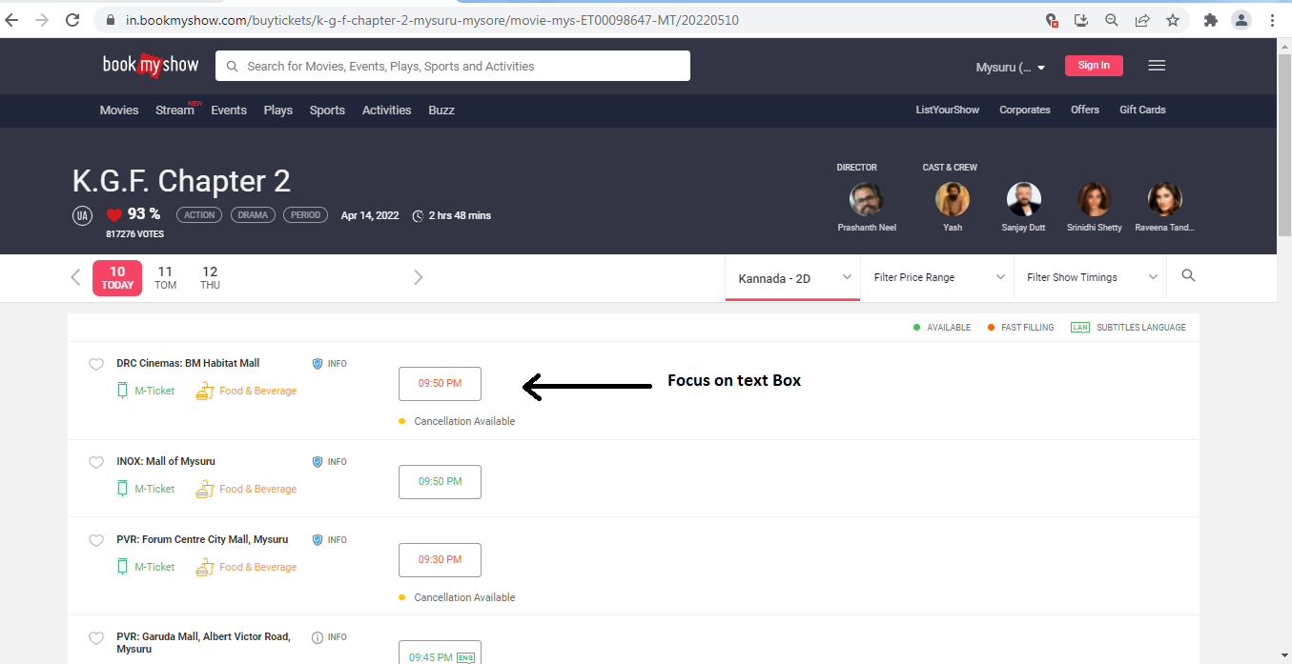

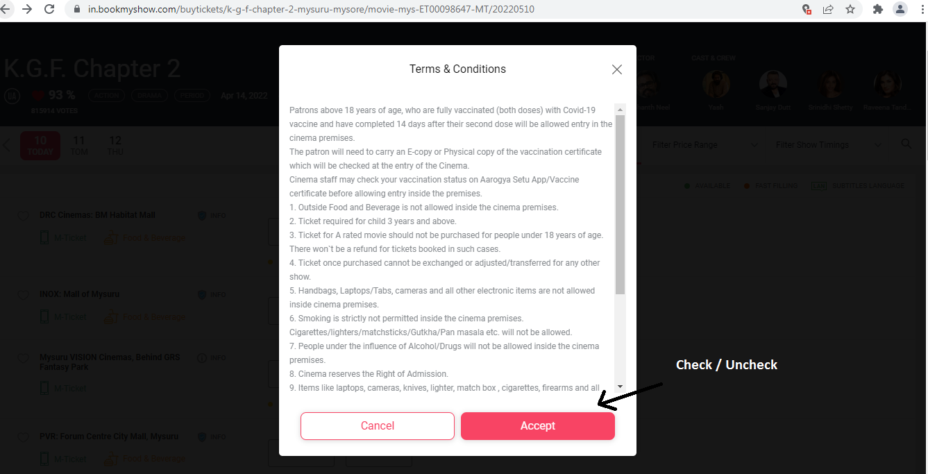

**Property of Test Box: Accepting or Not**

**Behavioral: Focus / Non Focus**

**2) Input Domain Coverage**

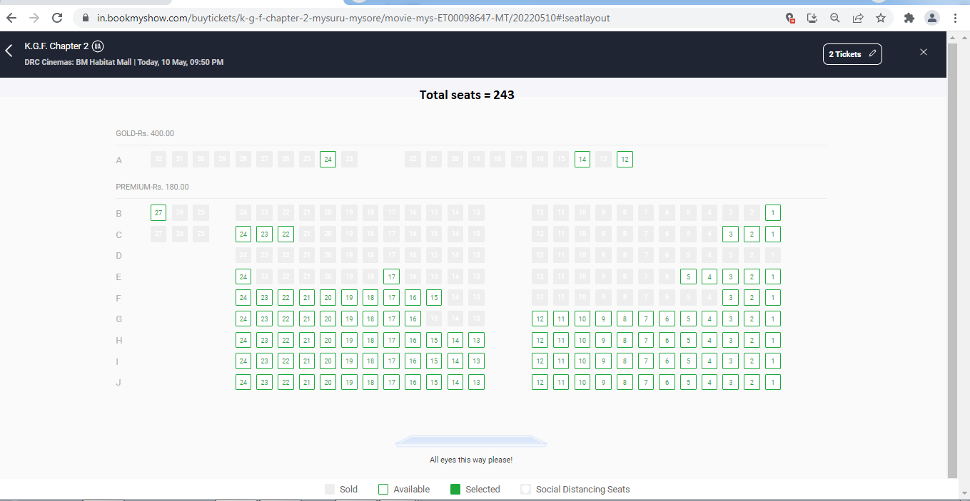

|  |  |  |  |
| --- | --- | --- | --- |
| **BVA** | | **ECP** | |
| **Size** | **Accept/Reject** | **Valid** | **Invalid** |
| **Min=1** | **Accept** | **0-9** | **a-z** |
| **Max=243** | **Accept** | **A-J** | **K-Z** |
| **Min-1=0** | **Reject** |  | **Special symbol** |
| **Max-1=242** | **Accept** |  |  |
| **Min+1=2** | **Accept** |  |  |
| **Max+1=244** | **Reject** |  |  |

**Note: BVA Checks the Size of the Object & ECP Maintains the data type of object**

**3) Error Handling Coverage**

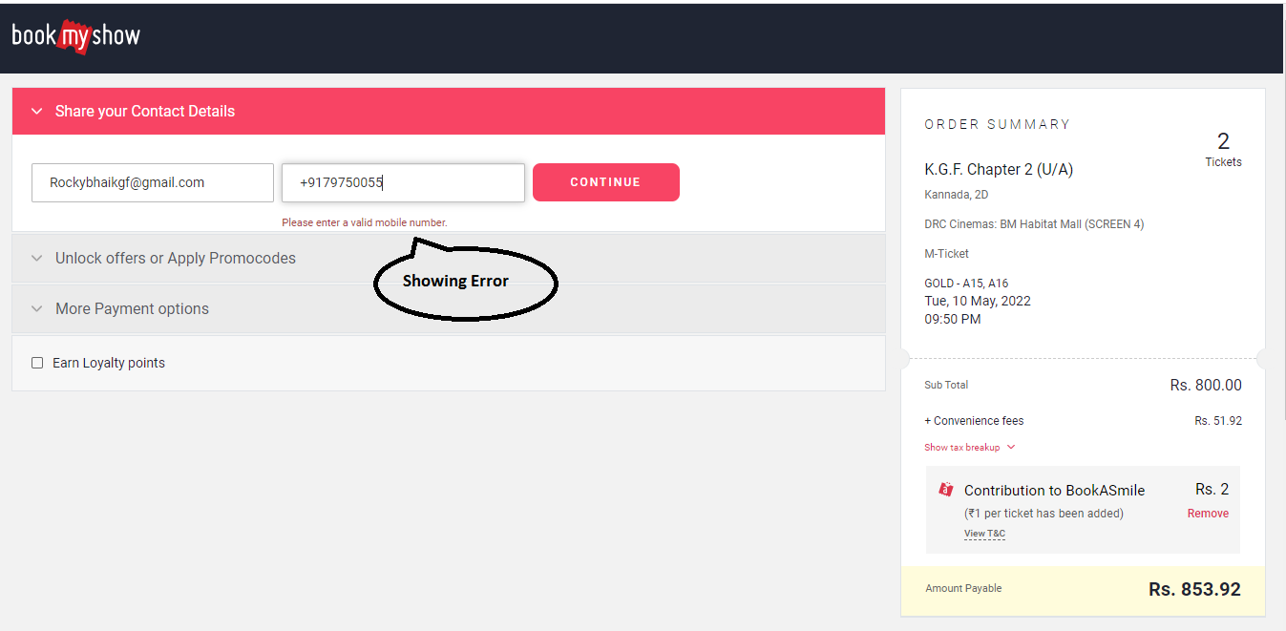

**This Coverage tells about whether the System shows error or not after taking incorrect input.**

**4) Back End Coverage**

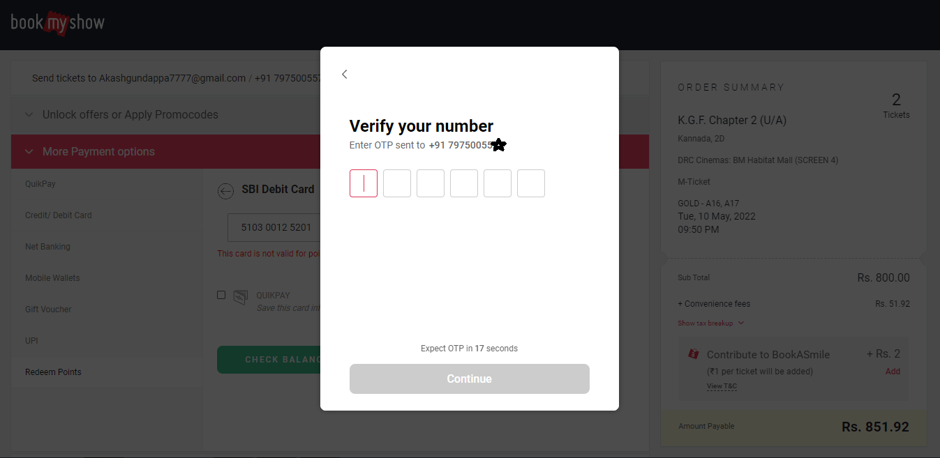

**Back End Coverage tells about whether the entered information from user gets fetch or not.**

**Back End of any Software System is in db.**

**5) Service Level Coverage**

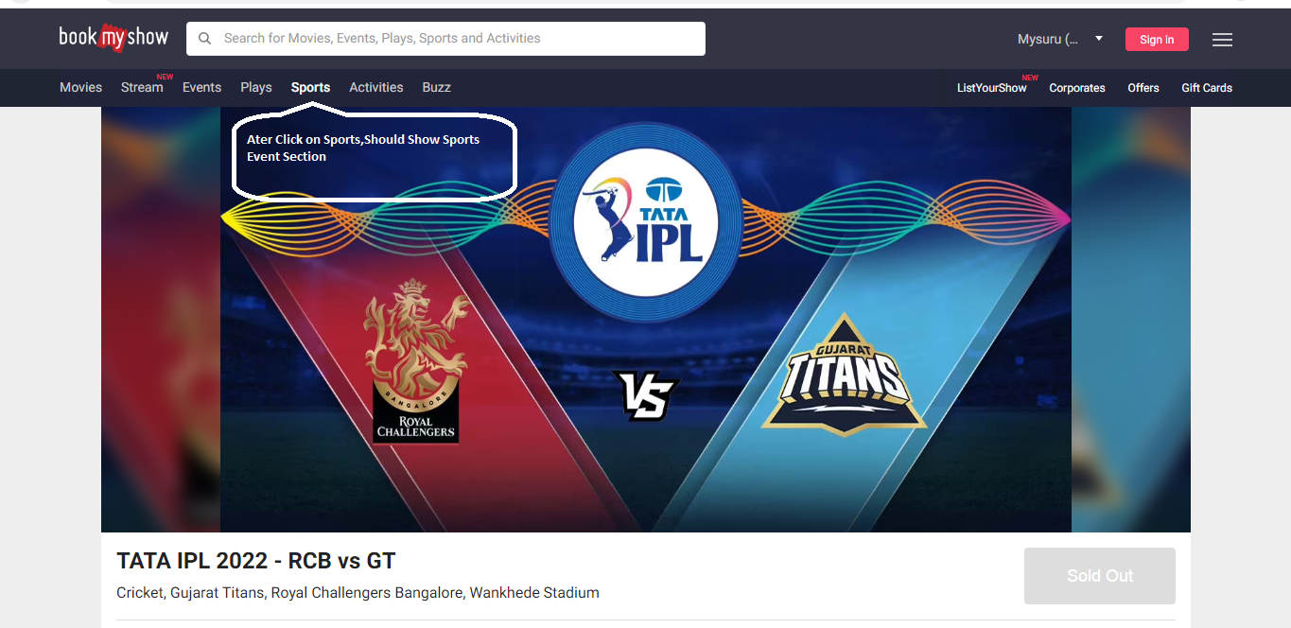

**Service Level Coverage Describes about the Functional Flow Diagram Created by the Product Owner.**

**It Checks the Working of System as per Functional Flow Diagram as mentioned above.**

**6) Calculation Base Coverage**

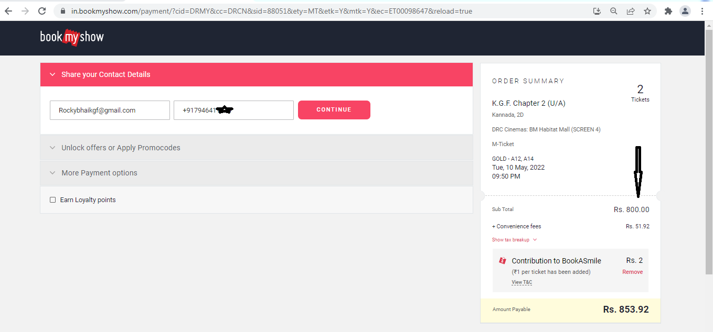

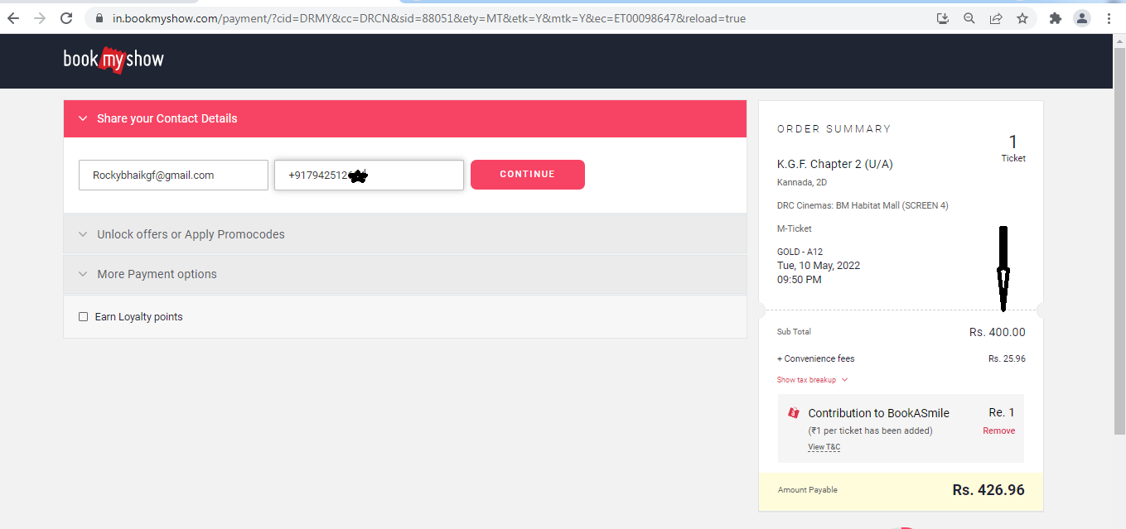

**Calculation Base Coverage Checks the Arithmetic operations, whether the arithmetic operation performed correctly or not, as mentioned above.**