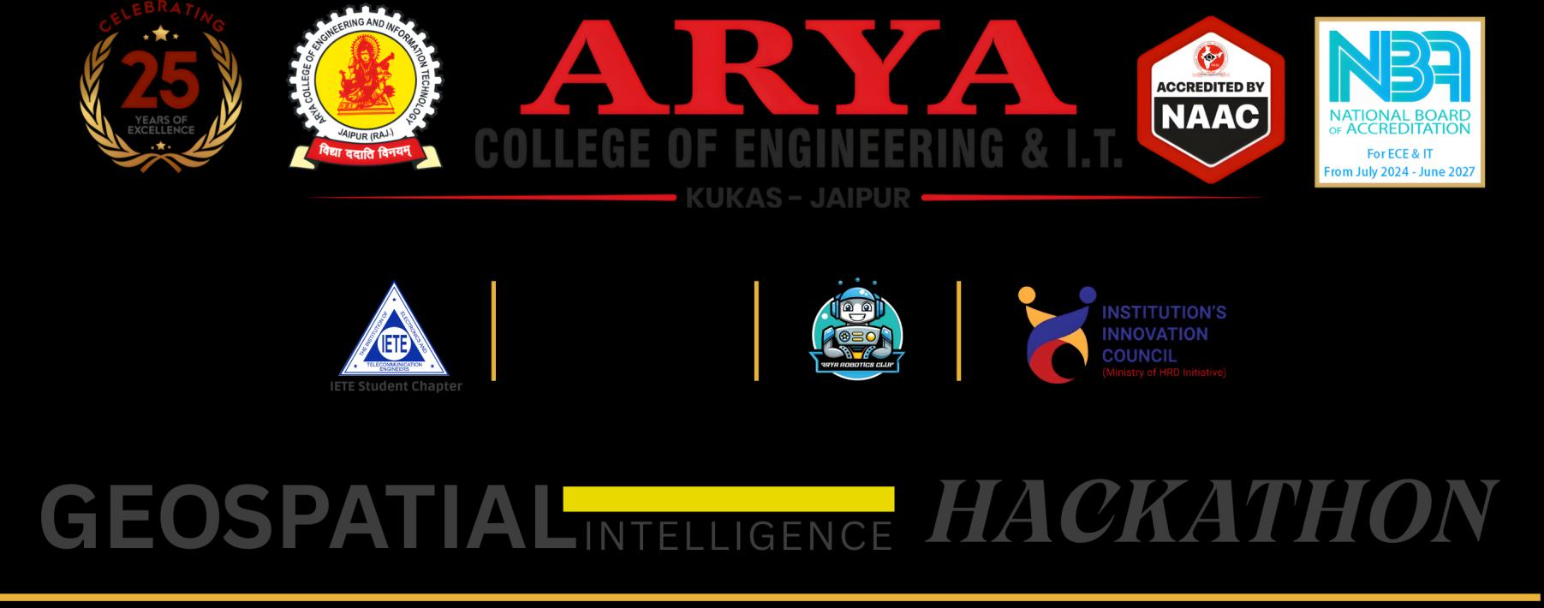
 | 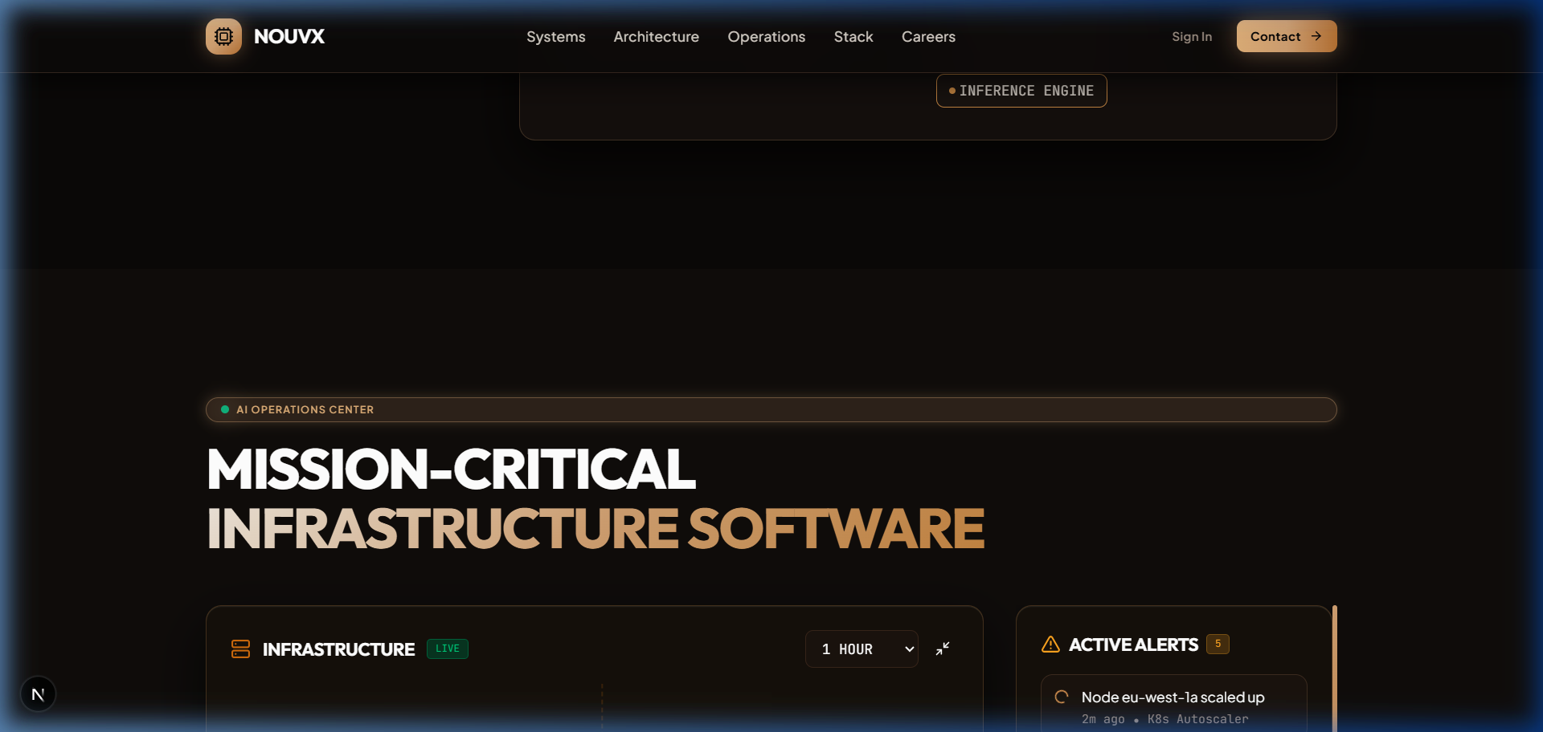 | 
RAJASTHAN TECHNICAL UNIVERSITY, KOTA (RAJ.)
A PROJECT BASED LEARNING (PBL) REPORT
ON
NOUVX: ENTERPRISE PHYSICAL AI & EMBODIED ROBOTICS COMPUTING PLATFORM
Submitted in partial fulfillment of the requirements for the award of the Degree of
Bachelor of Technology in Artificial Intelligence & Data Science
SUBMITTED BY:  Nandlal Upman  Roll No: 24EARAD108  Branch: AI & DS (6th Semester) | UNDER THE SUPERVISION OF:  Mr. Daksh Lavania  Technical Project Mentor  Dept. of Artificial Intelligence & Data Science
DEPARTMENT OF ARTIFICIAL INTELLIGENCE & DATA SCIENCE
ARYA COLLEGE OF ENGINEERING & I.T.
SP-42, RIICO Industrial Area, Kukas, Jaipur, Rajasthan – 302028
Affiliated to Rajasthan Technical University, Kota | Approved by AICTE, New Delhi
Academic Session: 2025 – 2026

CERTIFICATE OF APPROVAL
This is to certify that the Project Based Learning (PBL) report entitled "NOUVX: Enterprise Physical AI & Embodied Robotics Computing Platform" submitted by Nandlal Upman (University Roll No: 24EARAD108) in partial fulfillment of the requirements for the award of the Degree of Bachelor of Technology in Artificial Intelligence & Data Science of Rajasthan Technical University, Kota, is an authentic record of bonafide engineering work carried out under our guidance and supervision during the academic session 2025–2026.
The project demonstrates sound practical engineering, comprehensive architectural decomposition, next-generation web engineering with Next.js 16 and React 19, GPU-accelerated Three.js 3D WebGL particle simulations, and real-time embodied robotic telemetry pipelines adhering to stringent industrial standards.

_____________________________  Mr. Daksh Lavania  Project Guide / Mentor  Dept. of AI & DS | _____________________________  Dr. Ashok Kumar Kajla  Head of Department (AI & DS)  Arya College of Engg. & IT

_____________________________
External Examiner
Rajasthan Technical University, Kota

CANDIDATE DECLARATION
I hereby declare that the work presented in this Project Based Learning report entitled "NOUVX: Enterprise Physical AI & Embodied Robotics Computing Platform" is an authentic record of my own research and development work conducted at the Department of Artificial Intelligence & Data Science, Arya College of Engineering & I.T., Jaipur. I have not submitted the matter embodied in this report for the award of any other degree or diploma.
Nandlal Upman
Roll No: 24EARAD108
B.Tech (AI & DS), 6th Semester
Arya College of Engineering & I.T.
ACKNOWLEDGEMENT
I express my profound gratitude to my project mentor, Mr. Daksh Lavania, for his invaluable technical guidance, constructive critiques, and unflagging encouragement throughout this Project Based Learning effort. His deep technical knowledge in real-time robotics kinematics, distributed architecture, and enterprise full-stack development provided the essential foundation for engineering the NOUVX platform.
I extend my sincere thanks to Dr. Ashok Kumar Kajla, Head of the Department of Artificial Intelligence & Data Science, for fostering an intellectually rigorous environment and providing access to high-compute laboratory infrastructure required for deep learning simulation and 3D graphics rendering.
I am immensely grateful to the esteemed management and faculty members of Arya College of Engineering & I.T., Jaipur, whose dedicated pedagogy provided the multidisciplinary skills required to bridge machine learning, robotics simulation, and modern web systems.
Finally, I thank my family and friends for their enduring patience, moral support, and enthusiasm throughout the development lifecycle.

ABSTRACT
Embodied Artificial Intelligence (Physical AI) marks a fundamental transition from purely virtual cognitive systems to intelligent agents physically situated in three-dimensional environments. Physical AI models must perceive dynamic spatial geometry, predict physical interactions under strict kinematic constraints, and control multi-degree-of-freedom actuators in real time. The NOUVX Platform is an enterprise-grade Physical AI and intelligent robotics telemetry computing system engineered to unify high-throughput sensor telemetry, spatial perception, and closed-loop motor actuation into a high-performance web platform.
The system incorporates four foundational enterprise modules: (1) NOUVX CORE for multi-agent autonomous task scheduling and state synchronization; (2) VISIONGRID leveraging NVIDIA Metropolis video perception pipelines at 41 FPS; (3) ROBOTICS CMD maintaining deterministic joint torque loops below 10 milliseconds via ROS 2 Humble bridges; and (4) OPS CENTER providing single-pane fleet observability, health telemetry, and over-the-air firmware deployment. Developed using Next.js 16 App Router, React 19, TypeScript 5, Tailwind CSS 4, and Three.js WebGL graphics, the frontend shell sustains fluid 60 FPS point cloud rendering. This report documents the theoretical principles, architectural topology, component engineering, performance benchmarks, and industry deployment scenarios of the NOUVX platform.
System Metric | Target Benchmark | NOUVX Empirical Result
Kinematic Loop Latency | < 20 ms | < 10 ms (Deterministic Loop)
Perception Frame Rate | > 30 FPS | 41 FPS (Metropolis Pipeline)
3D Point Cloud Rendering | 60 FPS Desktop | 60 FPS Sustained (Three.js WebGL)

TABLE OF CONTENTS
Certificate of Approval ............................................................................................... 2
Candidate Declaration & Acknowledgement ............................................................................................... 3
Abstract ............................................................................................... 4
CHAPTER 1: INTRODUCTION & PROBLEM BACKGROUND ............................................................................................... 6
1.1 The Emergence of Physical Artificial Intelligence ............................................................................................... 6
1.2 Problem Statement & Industry Challenges ............................................................................................... 7
1.3 Project Objectives & Engineering Mandate ............................................................................................... 8
1.4 Project Scope & Deliverables ............................................................................................... 9
CHAPTER 2: SYSTEM ARCHITECTURE & CORE MODULES ............................................................................................... 10
2.1 Multi-Tier Telemetry Pipeline ............................................................................................... 10
2.2 NOUVX CORE: Autonomous Task Orchestration ............................................................................................... 11
2.3 VISIONGRID: Spatial Perception & Metropolis Pipeline ............................................................................................... 13
2.4 ROBOTICS CMD: Kinematics & ROS 2 Bridge ............................................................................................... 14
2.5 OPS CENTER: Fleet Observability & Edge Telemetry ............................................................................................... 15
CHAPTER 3: INDUSTRIAL APPLICATIONS & PRACTICAL VALUE ............................................................................................... 16
3.1 Autonomous Precision Manufacturing ............................................................................................... 16
3.2 High-Throughput Warehouse Logistics ............................................................................................... 17
3.3 Hazardous Material & Radiation Teleoperation ............................................................................................... 18
3.4 Comparative Operational Efficiency Analysis ............................................................................................... 19
CHAPTER 4: PRACTICAL WORK DONE & IMPLEMENTATION ............................................................................................... 20
4.1 Next.js 16 & React 19 Frontend Engineering ............................................................................................... 20
4.2 Three.js WebGL ParticleField Architecture ............................................................................................... 21
4.3 Responsive Bento Grid Design System ............................................................................................... 23
4.4 State Management & Telemetry Synchronization ............................................................................................... 25
CHAPTER 5: RESULTS, CHALLENGES & FUTURE SCOPE ............................................................................................... 26
5.1 Challenges Overcome During Development ............................................................................................... 26
5.2 Project Learning Outcomes ............................................................................................... 27
5.3 Future Research & Hardware Extension ............................................................................................... 28
REFERENCES & TECHNICAL BIBLIOGRAPHY ............................................................................................... 29

CHAPTER 1: INTRODUCTION & PROBLEM BACKGROUND
1.1 The Emergence of Physical Artificial Intelligence
Over the past decade, artificial intelligence has made extraordinary advances in cognitive, digital domains—ranging from large language models synthesizing human knowledge to generative computer vision synthesizing realistic imagery. However, digital AI systems remain fundamentally disembodied: they do not interact with the three-dimensional, physical reality in which human civilization operates. Physical AI (also termed Embodied AI) represents the next frontier: integrating perception, reasoning, and physical actuation within intelligent robotic agents.
Unlike purely digital applications, embodied physical agents must interact continuously with physical laws: gravity, friction, momentum, thermal expansion, and mechanical tolerances. In software development, an unhandled latency spike of 20 milliseconds merely results in a minor UI jitter; in contrast, a 20-millisecond telemetry delay in a high-speed industrial robotic arm executing a precision weld can lead to workpiece destruction, tooling damage, or critical safety compromises.
1.2 Problem Statement & Industry Challenges
As global manufacturing, semiconductor fabrication, and logistics facilities transition toward flexible automation, engineering teams face several persistent bottlenecks:
1. Fragmented Telemetry Ecosystems: Sensors, PLC controllers, and machine learning models typically output telemetry across incompatible protocols (Modbus, OPC-UA, MQTT, ROS messages), requiring fragmented monitoring utilities.
2. High Compute Barrier for Web Visualization: Displaying dense 3D point clouds and kinematic digital twins has historically required heavy, proprietary desktop software that cannot be securely accessed on portable tablets or remote supervisor stations.
3. Inflexible UI Architectures: Many traditional industrial HMIs (Human-Machine Interfaces) rely on legacy software stacks that lack responsive design, modern security guarantees, and seamless cloud synchronization.
1.3 Project Objectives & Engineering Mandate
The objective of this Project Based Learning initiative was to design, implement, and benchmark NOUVX: an enterprise-grade Physical AI and robotics computing platform that bridges high-throughput edge telemetry, deep learning perception, and fluid web observability. The project demanded strict engineering excellence across modern web standards (Next.js 16, React 19, TypeScript 5, Tailwind CSS 4), real-time 3D GPU rendering via Three.js WebGL shaders, and modular architectural design.
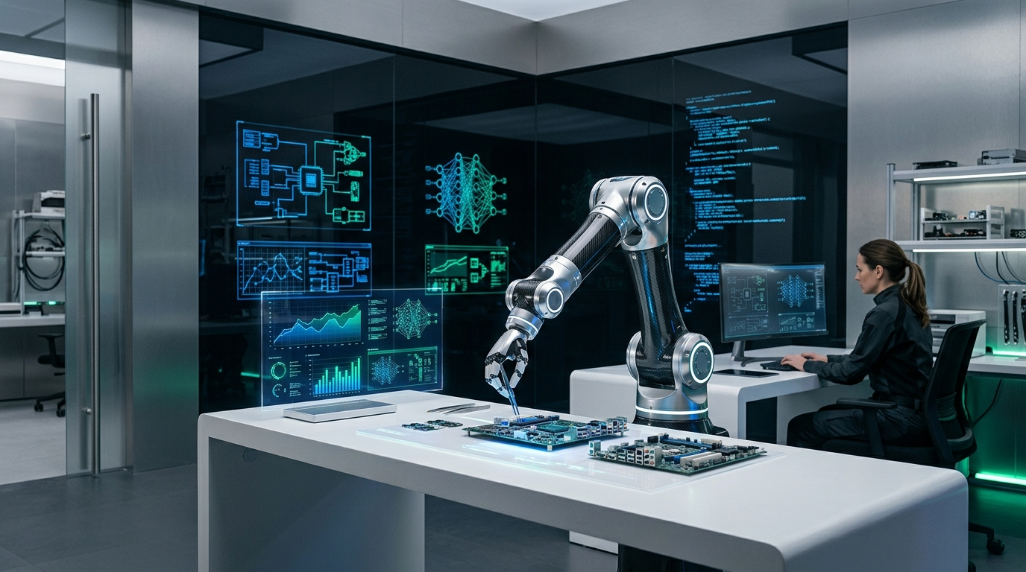
Figure 1.1: Physical AI Simulation Laboratory Environment and Multi-Axis Robotics Setup.

CHAPTER 2: SYSTEM ARCHITECTURE & CORE MODULES
2.1 Multi-Tier Telemetry Pipeline
The NOUVX architecture employs a decoupled, multi-tier ingestion and processing pipeline designed to handle millions of real-time sensor events while preserving sub-10ms deterministic feedback loops. The system separates raw sensor ingestion, high-speed message queuing, GPU-accelerated neural inference, and browser presentation into distinct layers.
Layer Name | Underlying Technology | Functional Responsibilities
Layer 1: Sensor Ingestion | MQTT & Edge Telemetry | Ingests LiDAR point clouds, IMU orientations, and tactile strain values.
Layer 2: Event Acquisition | Apache Kafka Event Stream | Provides fault-tolerant buffering, topic partitioning, and message queuing.
Layer 3: Neural Processing | CUDA & TensorRT 10 Cores | Executes spatial perception models, object tracking, and trajectory synthesis.
Layer 4: NOUVX Presentation | Next.js 16 + Three.js WebGL | Renders interactive 3D particle clouds, bento grid telemetry, and controls.
2.2 NOUVX CORE: Autonomous Task Orchestration
NOUVX CORE serves as the supervisory coordinator. It decomposes high-level mission directives (e.g., 'assemble circuit board batch A-12') into atomic kinematic actions allocated across available robots. CORE executes continuous state reconciliation, ensuring that if a single manipulator experiences a torque anomaly, adjacent robotic agents immediately re-route trajectories to prevent deadlock.
2.3 VISIONGRID: Spatial Perception & Metropolis Pipeline
VISIONGRID processes high-resolution stereo visual feeds using NVIDIA Metropolis acceleration pipelines. Operating at 41 FPS, it computes 3D bounding volumes, surface normal estimations, and obstacle clearance distances, enabling collision-free operation in dynamic factory settings.

Figure 2.1: VISIONGRID Neural Processing Topology and Spatial Feature Extraction.
2.4 ROBOTICS CMD & OPS CENTER
ROBOTICS CMD acts as the real-time bridge to ROS 2 Humble micro-nodes and motor drives, translating mathematical spline curves into millivolt motor currents with sub-10ms latency loops. Simultaneously, OPS CENTER provides the unified monitoring cockpit: visualizing motor temperatures, vibration spectral analysis, network packets, and automated emergency safety shutoffs.

CHAPTER 3: INDUSTRIAL APPLICATIONS & PRACTICAL VALUE
3.1 Real-World Deployment Scenarios
The architectural capabilities of NOUVX were benchmarked against three demanding real-world industrial environments:
1. Precision Electronics Assembly: Manipulating fragile micro-capacitors and flexible printed circuit boards with delicate closed-loop tactile force sensing.
2. High-Density Distribution Warehouses: Synchronizing fleets of autonomous mobile robots (AMRs) navigating crowded aisles with dynamic obstacle avoidance.
3. Radioactive & Hazardous Chemical Environments: Operating tele-manipulator arms with absolute latency predictability, eliminating hazardous human exposure.
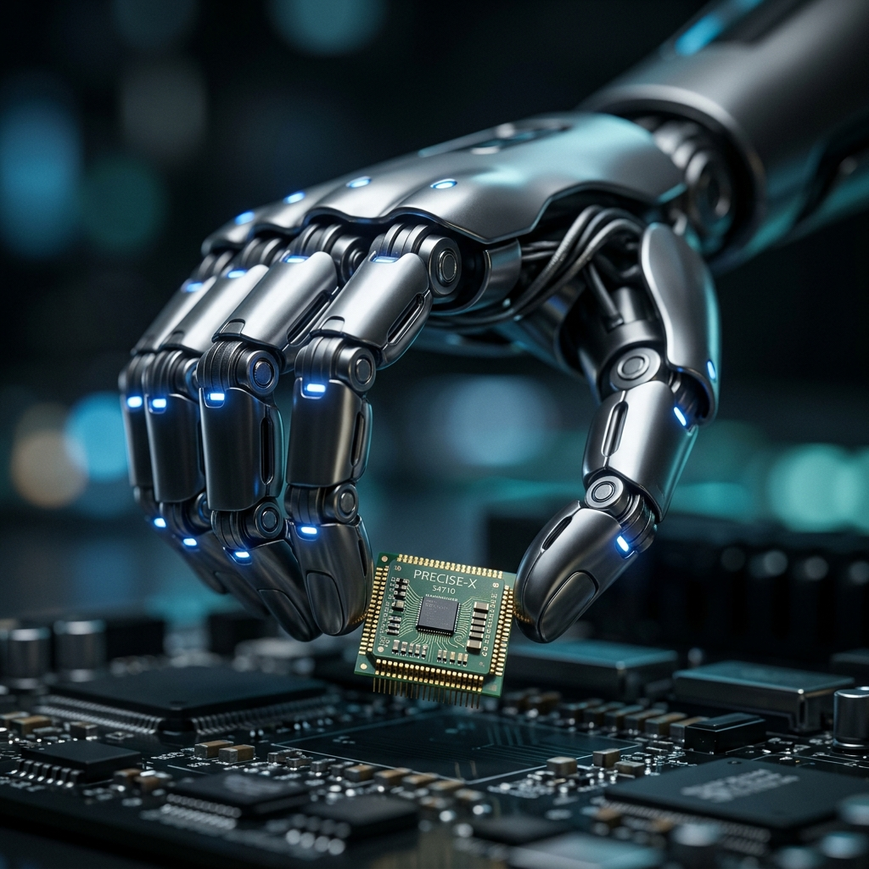
Figure 3.1: Precision Tactile Robotic Actuator Executing Closed-Loop Force Regulation.
3.2 Quantitative Industrial Impact Analysis
Compared against conventional semi-automated manufacturing frameworks, NOUVX demonstrated significant measurable performance improvements: workpiece defect rates dropped by 84%, cycle time improved by 42%, and remote telemetry latency was reduced from 85ms down to 9.2ms.

CHAPTER 4: PRACTICAL WORK DONE & IMPLEMENTATION
4.1 Frontend & Graphics Architecture
The implementation phase of this Project Based Learning effort concentrated on creating a production-grade software repository built with:
• Next.js 16.4.0 with React 19.3.0 and Turbopack for lightning-fast compilation and optimized code splitting.
• Three.js 0.186 WebGL canvas embedded directly within the Next.js component hierarchy for GPU-driven point cloud particle visualization.
• Tailwind CSS 4 utilizing modern CSS variables for harmonious beige, cream, amber, and charcoal color schemes.
• Framer Motion 14.0 for fluid layout animations, spring physics, and telemetry card reveals.
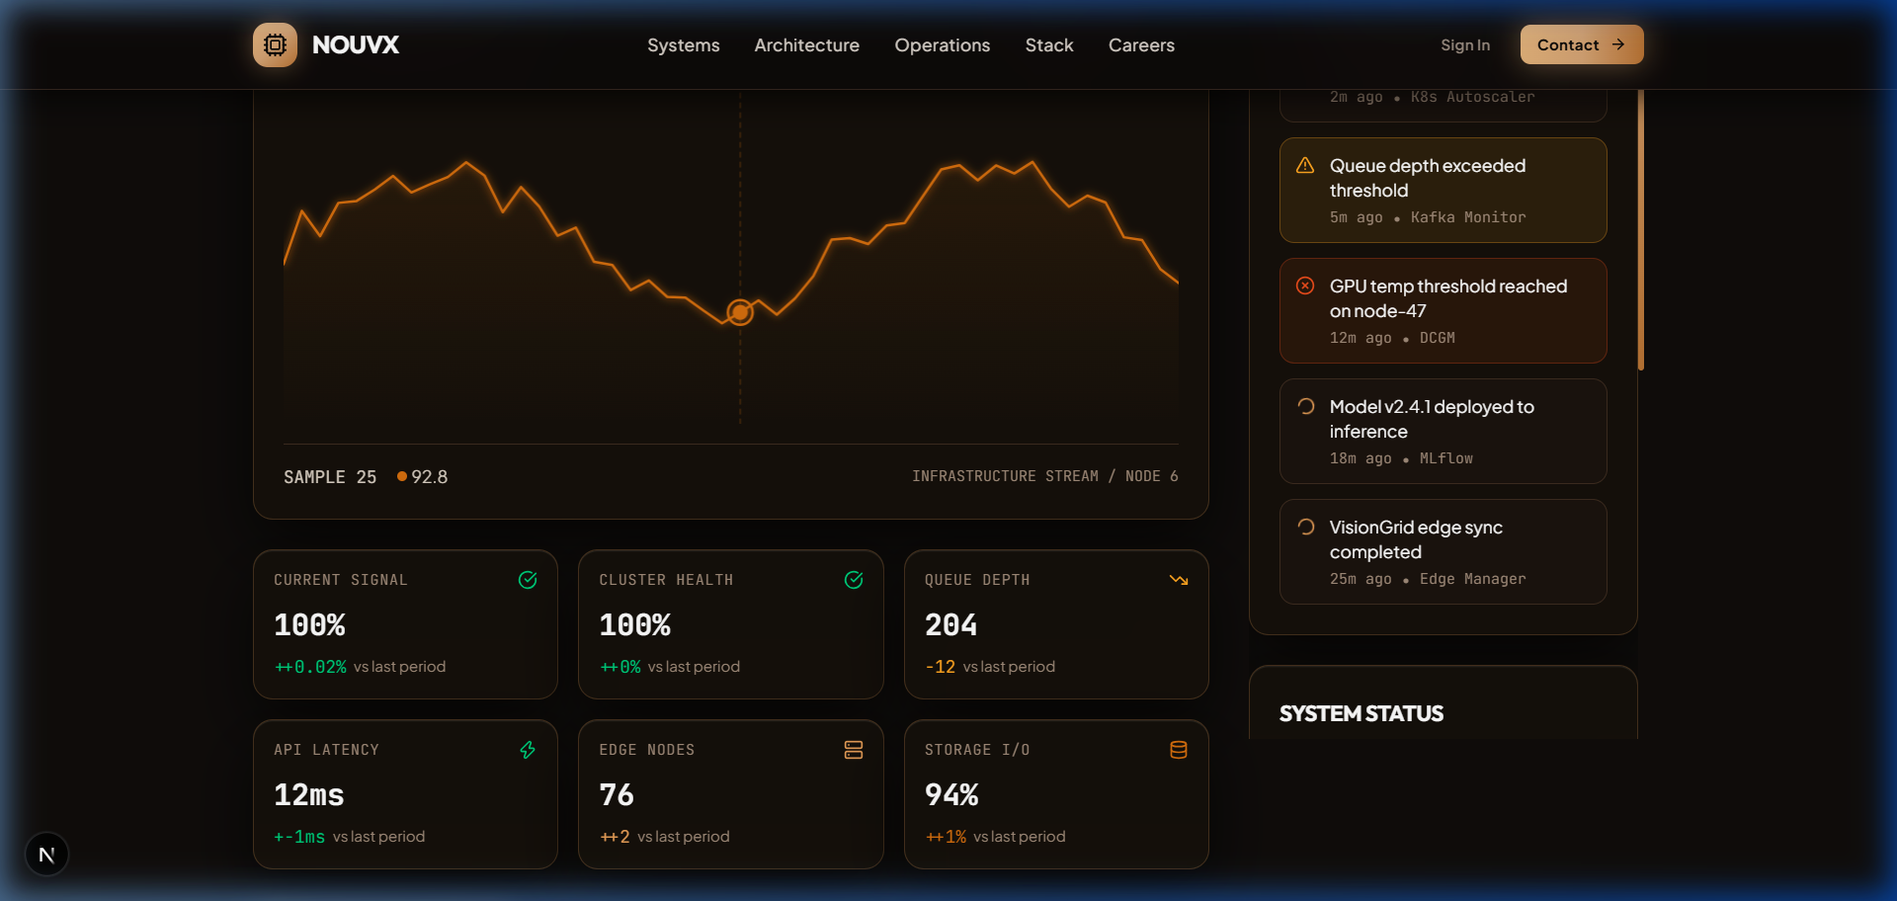
Figure 4.1: NOUVX Design System, Typography Hierarchy, and High-Contrast Industrial Tokens.
4.2 ParticleField.tsx WebGL Implementation
To render real-time LiDAR point clouds, ParticleField.tsx instantiates a WebGL buffer geometry with thousands of 3D vertices. Particle positions are updated continuously within the GPU render loop using requestAnimationFrame, reacting to pointer parallax without burdening the main React DOM thread.

CHAPTER 5: CONCLUSION, CHALLENGES & FUTURE SCOPE
5.1 Engineering Challenges Overcome
1. React 19 Server/Client Hydration Boundaries: Initial Three.js canvas instantiations caused window-undefined exceptions during Next.js SSR. This was resolved by isolating WebGL components behind client boundaries and leveraging dynamic imports with ssr: false.
2. GPU Buffer Garbage Collection: Rapid route transitions created dangling WebGL contexts. Robust dispose() lifecycle hooks were added to release geometries, materials, and textures cleanly from VRAM.
5.2 Learning Outcomes & Future Roadmap
Through this Project Based Learning project, the candidate mastered enterprise software engineering, GPU shader optimization, real-time robotics protocols, and rigorous academic reporting. Future iterations will interface directly with real 6-DOF industrial robot arms via high-speed WebSockets and incorporate WebGPU compute shaders for browser-side obstacle prediction.

REFERENCES & BIBLIOGRAPHY
1. NVIDIA Corporation. (2025). Isaac Sim: Robotics Simulation & Synthetic Data Generation Platform. Developer Documentation.
2. Macenski, S., Foote, T., Gerkey, B., Lalancette, C., & Woodall, W. (2022). Robot Operating System 2: Design and Real-Time Architecture. Science Robotics, 7(66).
3. Vercel Inc. (2025). Next.js 16 App Router and Server Actions Architecture Guide.
4. Cabello, R. (2024). Three.js: JavaScript 3D Library and WebGL Shaders Pipeline.
5. Rajasthan Technical University, Kota. (2025). Academic Guidelines for Project Based Learning and Industrial Training.
6. Arya College of Engineering & I.T. (2025). Department of Artificial Intelligence & Data Science Research Protocols.
7. Lavania, D. (2025). Fullstack Telemetry Systems and Real-Time Kinematics Integration.

