**LAPORAN TUGAS KECIL 1 IF2211**



**Raden Haryosatyo Wisjnunandono**

**13520070**

**BAB I**

**ALGORITMA BRUTE FORCE**

**BAB II**

**SOURCE CODE**

*Disclaimer:*

Untuk menghemat tempat, yang akan dilampirkan hanya file implementasinya saja (.cpp) untuk file header (.hpp) dapat dilihat pada link drive yang berisi source code yang lengkap

**solver.cpp (algoritma brute force utama)**

**fileinput.cpp (untuk membaca file input dalam folder ../test)**

**main.cpp (Program utama)**

**BAB III**

**INPUT DAN OUTPUT**

**1. small1.txt**

**Input: Output:**



**Output:**

**2. small_2.txt**

**Input: Output:**

**Output:**

**3. small_3.txt**

**Input Output:**



**Output:**

**4. medium_1.txt**

**Input: Output:**

**Output:**



**5. medium_2.txt**

**Input: Output:**

**Output:**



**6. medium_3.txt**

**Input: Output:**

**Output:**



**7. large_1.txt**

**Input:**

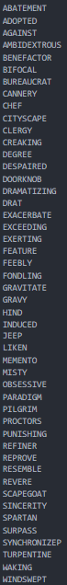

**Output:**

**8. large_2.txt**

**Input:**

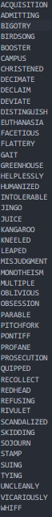

**Output:**



**BAB IV**

**KESIMPULAN**

|  |  |  |
| --- | --- | --- |
| **Poin** | **Ya** | **Tidak** |
| 1. Program berhasil dikompilasi tanpa kesalahan (no syntax error) |  |  |
| 2. Program berhasil running |  |  |
| 3. Program dapat membaca file masukan dan menuliskan luaran. |  |  |
| 4. Program berhasil menemukan semua kata di dalam puzzle. |  |  |

Link drive:

<https://drive.google.com/drive/folders/1yZhQ7oUrIyqsDA30q60BwIdxex0HdvSF?usp=sharing>

(buka dengan akun std)