MD2201 Data Science
Course Project
S.NoDivBatch NoGroup NoRoll NoGr.NoName of Student1CB2102912110599Vedant Arvind Mude23212110525Rutuj Naresh Nagrale33312110041Hetan Hemant Nandre43812110699Aarya Sunil Nirgude53912110007Tejashri Sampat NirmalScience

Date of performance:

Project Title: Water Potability Prediction

Data Set Name: "water_potability.csv"

Data set Link: https://www.kaggle.com/datasets/adityakadiwal/water-potability

Data Set Description:

Total Rows – 3276, Total Columns – 10

Missing values are present in pH, Sulfate, Trihalomethanes

Objective: The objective of this data science project is to develop a predictive model that can accurately predict the potability of water based on various water quality parameters. The model should be able to classify water samples as either potable (1) or non-potable (0) with a high degree of accuracy, sensitivity, and specificity.

Data Preprocessing (if any):

Using KNN - KNN imputation works by using the KNN algorithm to find the K nearest neighbors of a data point with missing values. The missing values are then imputed with the average (for numerical data) or mode (for categorical data) of the corresponding feature values in the K nearest neighbors.

We have followed below mentioned steps for KNN imputation in our project –
- Identified the features in the dataset that have missing values.
- Split the dataset into a training set (with no missing values) and a test set (with missing values). In our dataset, Missing values are present in pH, Sulfate, Trihalomethanes
- Used the training set to train a KNN model.
- For each data point in the test set with missing values, used the KNN model to find the K nearest neighbors.
- Imputed the missing values with the average/mode of the corresponding feature values

in the K nearest neighbors.

- Used the imputed dataset for further analysis or modeling.

- RF Imputation - RF impute works by treating the rows with missing values as the target variable, and the columns without missing values as the input variables. The RF model is trained to predict the missing values based on the other features in the dataset. One advantage of RF impute over other imputation techniques is that it can handle non-linear relationships between the features, which can be difficult to capture with simpler imputation methods like mean or median imputation.

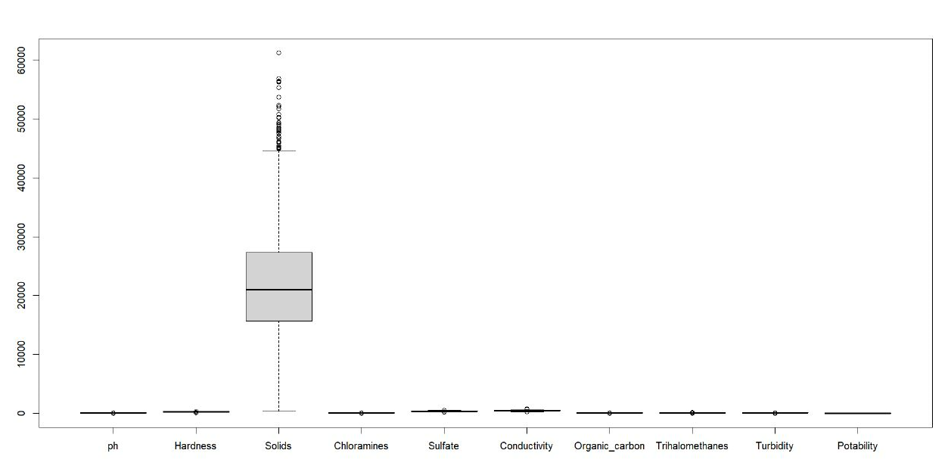
Figure 1 - Data visualization before removing outliers
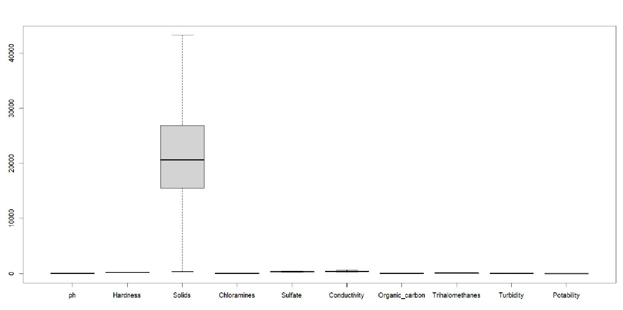
Figure 2 - Data visualization after removing outliers

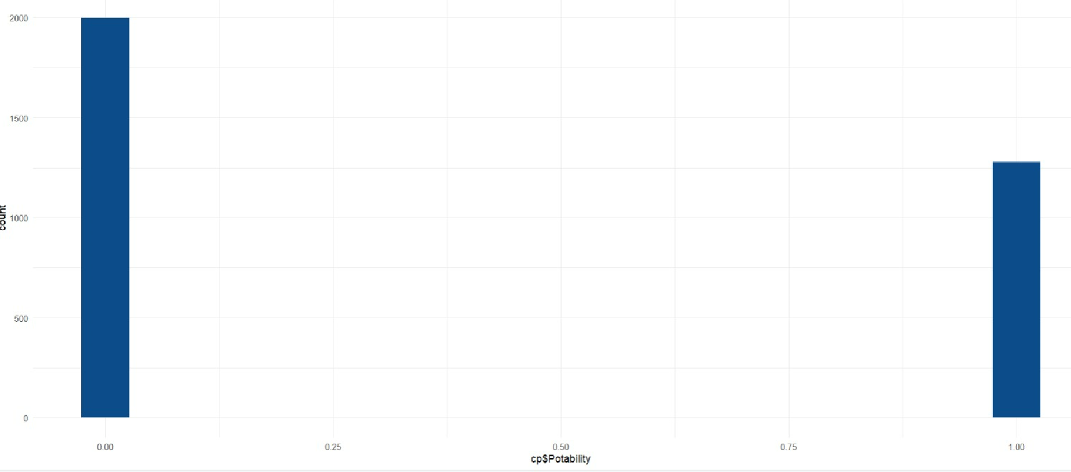
Figure 3 - Class Imbalance before Ovun Sampling
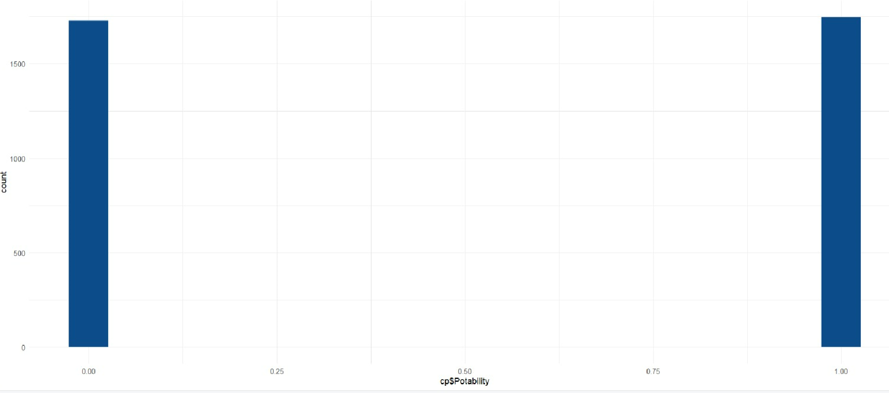
Figure 4 - Class Imbalance after Ovun Sampling

Feature Selection (if any):

Principal Component Analysis (PCA) - PCA is a technique that transforms a dataset into a new coordinate system by finding the principal components (or directions of highest variance) in the original data. These principal components can then be used as new features, which can potentially reduce the dimensionality of the dataset while retaining most of the information.

Algorithms Implemented: Explain algorithms with default arguments values or set hyperparameters value.

Decision Tree – The decision tree is implemented to train a model with "Potability" as the target variable and all other variables as predictors. The "set.seed(9999)" function sets a random seed value to ensure the reproducibility of the results. The "train" function trains the model using the specified hyperparameters, in this case using cross-validation with the "trControl" parameter and tuning the "cp" hyperparameter using the "tuneGrid" parameter. The resulting model is then used

to predict the target variable ("Potability") for the dataset using the "predict" function, and a confusion matrix is created using the predicted values and the actual values of "Potability".

Random Forest – The Random Forest is implemented to train a model with “Potability” as the

target variable and all other variables as predictors. The "set.seed(9999)" function sets a random seed value to ensure the reproducibility of the results. The "train" function trains the model using the specified hyperparameters, in this case using cross-validation with the "trControl" parameter and tuning the "mtry" hyperparameter using the "tuneGrid" parameter. The resulting model is then used to predict the target variable ("Potability") for the "tst" dataset using the "predict" function, and a confusion matrix is created using the predicted values and the actual values of "Potability".

Xgb Linear – The gradient boosting algorithm is implemented using the “XgbLinear” method to train a model with "Potability" as the target variable and all other variables as predictors. The "set.seed(9999)" function sets a random seed value to ensure reproducibility of the results. The "train" function trains the model using the specified hyperparameters, in this case using cross-validation with the "trControl" parameter and tuning the "eta", "nrounds", "lambda", and "alpha" hyperparameters using the "tuneGrid" parameter. The resulting model is then used to predict the target variable ("Potability") for the dataset using the "predict" function, and a confusion matrix is created using the predicted values and the actual values of "Potability".

Xgb Tree – The gradient boosting algorithm is implemented using the “XgbTree” method to

train a model with "Potability" as the target variable and all other variables as predictors. The "set.seed(9999)" function sets a random seed value to ensure reproducibility of the results. The "expand.grid" function creates a grid of hyperparameters to be tested during the training process. In this case, the "xgb_grid_1" grid includes different values for "nrounds", "eta", "gamma", "max_depth", "min_child_weight", "subsample", and "colsample_bytree". The "train" function trains the model using the specified hyperparameters, in this case using cross-validation with the "trControl" parameter and tuning the hyperparameters using the "xgb_grid_1" parameter. The resulting model is then used to predict the target variable ("Potability") for the dataset using the "predict" function.

SVM Radial – Support Vector Machine algorithm is implemented using the "svmRinear" method to train a model with "Potability" as the target variable and all other variables as predictors. The "set.seed(9999)" function sets a random seed value to ensure reproducibility of the results. The "expand.grid" function creates a grid of hyperparameters to be tested during the training process. In this case, the "svm_r_grid" grid includes different values for "sigma" and "C". The "train" function trains the model using the specified hyperparameters, in this case using cross-validation with the "trControl" parameter and tuning the hyperparameters using the "svm_r_grid" parameter. The model is then used to predict the target variable ("Potability") for the dataset using the "predict" function.

SVM Polynomial – Support Vector Machine algorithm is implemented using the "svmPoly" method to train a model with "Potability" as the target variable and all other variables as predictors. The "set.seed(9999)" function sets a random seed value to ensure reproducibility of the results. The "expand.grid" function creates a grid of hyperparameters to be tested during the training process. In this case, the "svm_p_grid" grid includes different values for "degree", "scale", and "C". The "train" function trains the model using the specified hyperparameters, in

this case using cross-validation with the "trControl" parameter and tuning the hyperparameters using the "svm_p_grid" parameter. The model is then used to predict the target variable ("Potability") for the dataset using the "predict" function.

AdaBoost – The AdaBoost algorithm is implemented using the "AdaBoost.M1" method to train a model on the "trn" dataset with "Potability" as the target variable and all other variables as predictors. The "set.seed(9999)" function sets a random seed value to ensure reproducibility of the results. The "expand.grid" function is used to create a grid of hyperparameters to be searched over during the training process. In this case, the grid specifies a fixed value of "mfinal" (the number of iterations) of 100, and a range of values for "coeflearn" (the coefficient for the learning rate), and "maxdepth" (the maximum depth of the decision trees). The "train" function trains the model using the specified hyperparameters, in this case using cross-validation with the "trControl" parameter.

Principal Component Analysis (PCA) –The PCA is implemented on the given dataset using the “prcomp” function in R. First, the code selects the numerical variables for the PCA analysis using “water[, 1:10]”. Then, it applies PCA to the selected variables using “prcomp”, with the parameters “center = TRUE” and “scale. = TRUE” indicating that the data should be centered and scaled before the analysis. The resulting PCA object is saved to “pca_result”.

Next, the code uses the “predict” function to transform the original data (“mydata”) into the principal component space defined by the PCA object (“pca_result”). The transformed data is saved to “mydata_pca”.

The “data.frame” function is used to create a new data frame (“data_pca”) from the

transformed data (“mydata_pca”) and the “Potability” column of the original dataset. The column names of the new data frame correspond to the principal component scores (PC1-PC5).

Finally, the “as.factor” function is used to convert the “Potability” column to a factor variable.

CODE:
#COURSE PROJ----
cp<- read.csv("water_potability.csv")

#NA values
str(cp)
summary(cp)

#impute missing values using knn
library(DMwR2)
cp<-knnImputation(cp, k = 3, scale = TRUE, meth = "weighAvg",distData = NULL)

#impute missing values using rf
library(randomForest)
cp <- rfImpute(Potability ~ ., cp, ntree = 100,type="classification")

#remove outliers using boxplot
for (i in 2:10) {
cp<-cp[!cp$ph %in% boxplot.stats(cp$ph)$out,]
cp<-cp[!cp$Hardness %in% boxplot.stats(cp$Hardness)$out,]
cp<-cp[!cp$Solids %in% boxplot.stats(cp$Solids)$out,]
cp<-cp[!cp$Chloramines %in% boxplot.stats(cp$Chloramines)$out,]
cp<-cp[!cp$Sulfate %in% boxplot.stats(cp$Sulfate)$out,]
cp<-cp[!cp$Conductivity %in% boxplot.stats(cp$Conductivity)$out,]
cp<-cp[!cp$Organic_carbon %in% boxplot.stats(cp$Organic_carbon)$out,]
cp<-cp[!cp$Trihalomethanes %in% boxplot.stats(cp$Trihalomethanes)$out,]
cp<-cp[!cp$Turbidity %in% boxplot.stats(cp$Turbidity)$out,]

}

#class imbalance
dim(cp)
head(cp)
table(cp$Potability)
prop.table(table(cp$Potability))

#smote
library(smotefamily)
smote_out=SMOTE(X=cp,target=cp$Potability,K=3,dup_size =1)
cp=smote_out$data
cp<-cp[,-11]

#ovun-over
library(ROSE)
library(smotefamily)
over=ovun.sample(Potability~.,cp,method="over")
cp=over$data

table(cp$Potability)
prop.table(table(cp$Potability))

cp$Potability=as.factor(cp$Potability)

#create training and testing data partitions
library(caret)
set.seed(9999)
cp<-cp[sample(1:nrow(cp)), ]
train <- createDataPartition(cp[,"Potability"],p=0.8,list=FALSE)
trn <- cp[train,]
tst <- cp[-train,]

#Algorithms applying

ctrl<-trainControl(method = "cv",number = 10)

#Decision Trees
set.seed(9999)
dec1<-train(Potability~.,data = trn,method="rpart",trControl=ctrl,tuneGrid = expand.grid(cp = 0.001))#cp - hyperparameter
pred_1<-predict(dec1,tst)
confusionMatrix(table(tst[,"Potability"],pred_1))

#Random forest
set.seed(9999)
rand1<-train(Potability~.,data = trn,method="rf",trControl=ctrl,tuneGrid = expand.grid(mtry = 3.16))#hyperparameter - mtry
pred_2<-predict(rand1,tst)
confusionMatrix(table(tst[,"Potability"],pred_2))

#Xgb linear
set.seed(9999)
xgb_lin<-train(Potability~.,data=trn,method="xgbLinear",trControl=ctrl,tuneGrid=expand.grid(eta = 0.3,nrounds=150,lambda=0.1,alpha=0.1))
pred_3<-predict(xgb_lin,tst)
confusionMatrix(table(tst[,"Potability"],pred_3))

#XGboost tree
set.seed(9999)
xgb_grid_1 = expand.grid(nrounds=150,eta=0.3, gamma=0.2, max_depth=6, min_child_weight=1, subsample=1, colsample_bytree=1)
xgbTree1<-train(Potability~.,data=trn,method="xgbTree",trControl=ctrl,tuneGrid = xgb_grid_1)
pred_4<-predict(xgbTree1,tst)
confusionMatrix(table(tst[,"Potability"],pred_4))

#SVM Radial
set.seed(9999)
svm_r_grid =expand.grid(sigma = c(0.01, 0.015, 0.2),C = c(0.75, 0.9, 1, 1.1, 1.25))
svm_r<-train(Potability~.,data=trn,method="svmRadial",trControl=ctrl,tuneGrid = svm_r_grid)
pred_6<-predict(svm_r,tst)
confusionMatrix(table(tst[,"Potability"],pred_6))

#SVM Polynomial
set.seed(9999)
svm_p_grid =expand.grid(degree=2, scale=5, C=5)

svm_p<-train(Potability~.,data=trn,method="svmPoly",trControl=ctrl,tuneGrid = svm_p_grid)
pred_7<-predict(svm_p,tst)
confusionMatrix(table(tst[,"Potability"],pred_7))

#Adaboost
set.seed(9999)
adagrid = expand.grid( mfinal = 100,coeflearn = c("Breiman", "Freund", "Zhu"),maxdepth = 30)
ada<-train(Potability~.,data=trn,method="AdaBoost.M1",trControl=ctrl, tuneGrid = adagrid)
pred_9<-predict(ada,tst)
confusionMatrix(table(tst[,"Potability"],pred_9))

#PRINCIPAL COMPONENT ANALYSIS----

# Load the water dataset
water<- read.csv("water_potability.csv")

# Prepare the data
# Remove rows with missing values by using na.omit
water <- na.omit(water)

# Removing missing values by kNN imputation
library(VIM)
water<-kNN(water,k=5)

# Removing missing values by rf imputation
library(randomForest)
na.roughfix(water)
water<-randomForest::rfImpute(Potability ~ .,ntree=200,iter=5,data=water)

boxplot(water)

#remove outliers using boxplot
for (i in 1:9) {
water<-water[!water$ph %in% boxplot.stats(water$ph)$out,]
water<-water[!water$Hardness %in% boxplot.stats(water$Hardness)$out,]
water<-water[!water$Solids %in% boxplot.stats(water$Solids)$out,]
water<-water[!water$Chloramines %in% boxplot.stats(water$Chloramines)$out,]
water<-water[!water$Sulfate %in% boxplot.stats(water$Sulfate)$out,]
water<-water[!water$Conductivity %in% boxplot.stats(water$Conductivity)$out,]
water<-water[!water$Organic_carbon %in% boxplot.stats(water$Organic_carbon)$out,]

water<-water[!water$Trihalomethanes %in% boxplot.stats(water$Trihalomethanes)$out,]
water<-water[!water$Turbidity %in% boxplot.stats(water$Turbidity)$out,]
}

boxplot(water)

#class imbalance
table(water$Potability)
prop.table(table(water$Potability))

#smote
library(smotefamily)
smote_out=SMOTE(X=water,target=water$Potability,K=3,dup_size =1)
water=smote_out$data

# ovun over sampling
over=ovun.sample(Potability~.,water,method="over")
water=over$data
table(water$Potability)
prop.table(table(water$Potability))
water$Potability=as.factor(water$Potability)

#pca
mydata <- water[, 1:10] # Select the numerical variables to apply PCA to
pca_result <- prcomp(mydata, center = TRUE, scale. = TRUE) # Apply PCA and save the results to res.pca

mydata_pca <- predict(pca_result, newdata = mydata)

data_pca<-data.frame (PC1=mydata_pca[,1],PC2=mydata_pca[,2],PC3=mydata_pca[,3],PC4=mydata_pca[,4],PC5=mydata_pca[,5],Potability=water$Potability)

data_pca$Potability<-as.factor(data_pca$Potability)

library(caret)
#create training and testing data partitions
set.seed(9999)
train <- createDataPartition(data_pca[,"Potability"],p=0.8,list=FALSE)
trn <- data_pca[train,]
tst <- data_pca[-train,]

#Algorithms applying
ctrl<-trainControl(method = "cv",number = 10)

#Decision Trees

set.seed(9999)
dec1<-train(Potability~.,data = trn,method="rpart",trControl=ctrl,tuneGrid = expand.grid(cp = 0.001))#cp - hyperparameter
pred_1<-predict(dec1,tst)
confusionMatrix(table(tst[,"Potability"],pred_1))

#Random forest
set.seed(9999)
rand1<-train(Potability~.,data = trn,method="rf",trControl=ctrl,tuneGrid = expand.grid(mtry = 2))#hyperparameter - mtry
pred_2<-predict(rand1,tst)
confusionMatrix(table(tst[,"Potability"],pred_2))

#Xgb linear
set.seed(9999)
xgb_lin<-train(Potability~.,data=trn,method="xgbLinear",trControl=ctrl,tuneGrid=expand.grid(eta = 0.1,nrounds=150,lambda=0.5,alpha=0.5))
pred_3<-predict(xgb_lin,tst)
confusionMatrix(table(tst[,"Potability"],pred_3))

#XGboost tree
set.seed(9999)
xgb_grid_1 = expand.grid(nrounds = 150,max_depth = 10,eta = 0.3,gamma = 5,colsample_bytree = 0.9,min_child_weight = 10,subsample = 0.8)
xgbTree1<-train(Potability~.,data=trn,method="xgbTree",trControl=ctrl,tuneGrid = xgb_grid_1)
pred_4<-predict(xgbTree1,tst)
confusionMatrix(table(tst[,"Potability"],pred_4))

#SVM Radial
set.seed(9999)
svm_r_grid =expand.grid(sigma = c(0.01, 0.015, 0.2),C = c(0.75, 0.9, 1, 1.1, 1.25))
svm_r<-train(Potability~.,data=trn,method="svmRadial",trControl=ctrl,tuneGrid = svm_r_grid)
pred_6<-predict(svm_r,tst)
confusionMatrix(table(tst[,"Potability"],pred_6))

#SVM Polynomial
set.seed(9999)
svm_p_grid =expand.grid(degree=2, scale=5, C=5)
svm_p<-train(Potability~.,data=trn,method="svmPoly",trControl=ctrl,tuneGrid = svm_p_grid)

pred_7<-predict(svm_p,tst)
confusionMatrix(table(tst[,"Potability"],pred_7))

#Adaboost
set.seed(9999)
adagrid = expand.grid( mfinal = 100,coeflearn = c("Breiman", "Freund", "Zhu"),maxdepth = 30)
ada<-train(Potability~.,data=trn,method="AdaBoost.M1",trControl=ctrl, tuneGrid = adagrid)
pred_9<-predict(ada,tst)
confusionMatrix(table(tst[,"Potability"],pred_9))

Evaluation Parameters used: Accuracy, Specificity, Sensitivity, Precision

Accuracy – Highest Accuracy – 83.76%(Without using PCA)

Highest Accuracy – 96.25%(With PCA)

Specificity - Highest Specificity – 85.75%(Without using PCA)

Highest Specificity – 96.21%(With PCA)

Sensitivity - Highest Sensitivity – 82.59%(Without using PCA)

Highest Specificity – 96.63%(With PCA)

Precision - Highest Precision – 85.32%(Without using PCA)

Highest Precision – 96.21%(With PCA)

Results:

Imputation: KNN, Class Imbalance: SMOTE

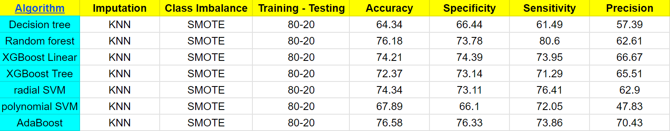

Imputation: KNN, Class Imbalance: Ovun - Over

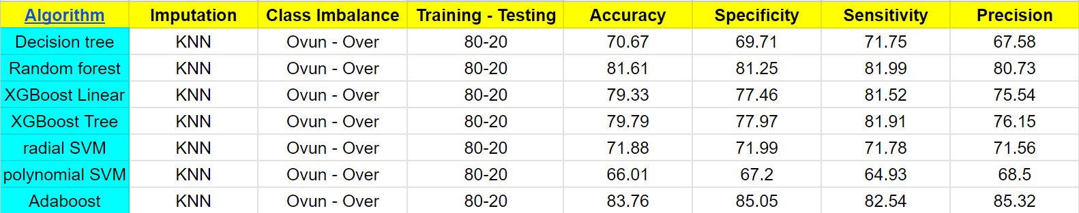

Imputation: RF Impute, Class Imbalance: SMOTE

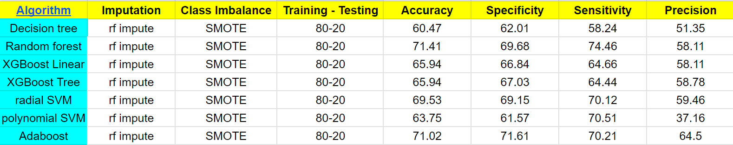

Imputation: RF Impute, Class Imbalance: Ovun - Over

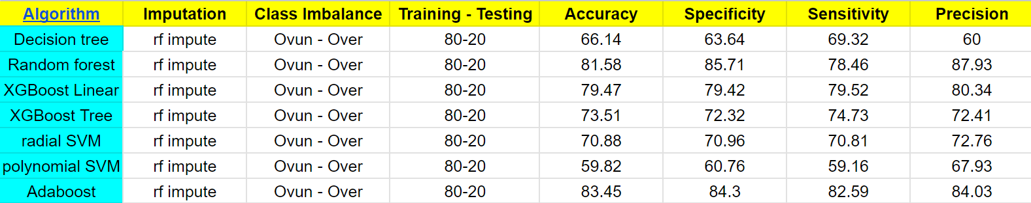

PCA (All Variations)

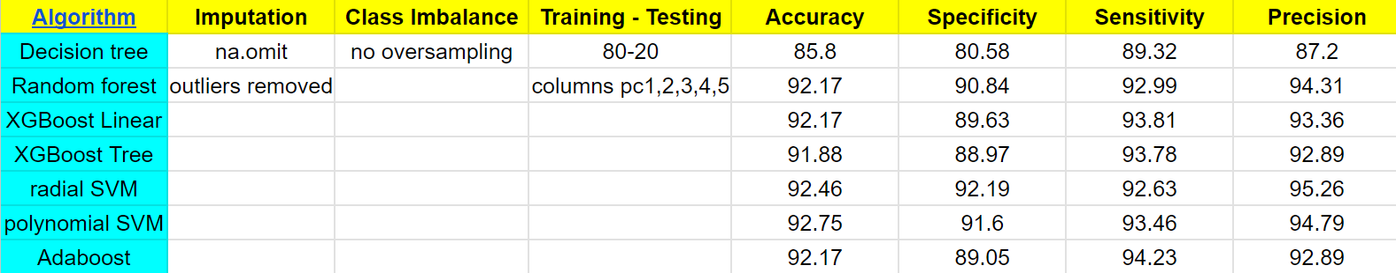

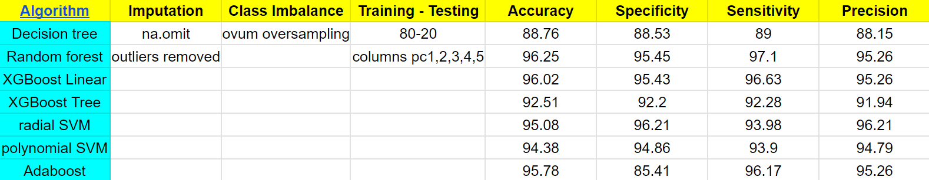

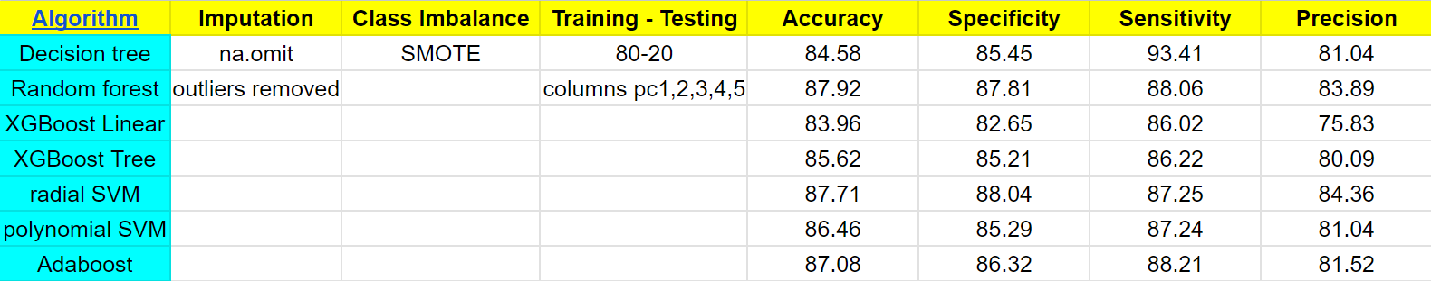

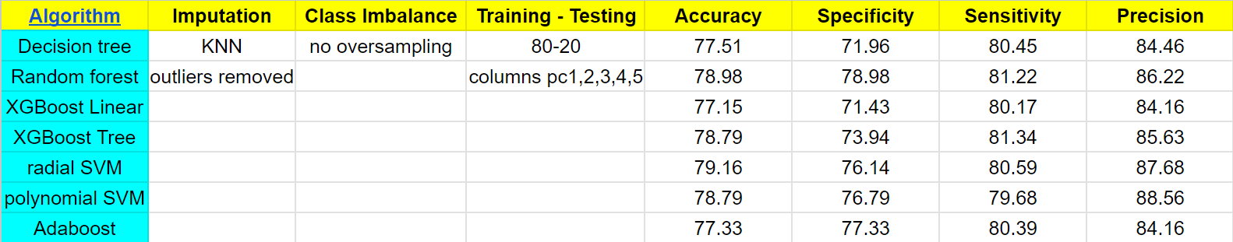

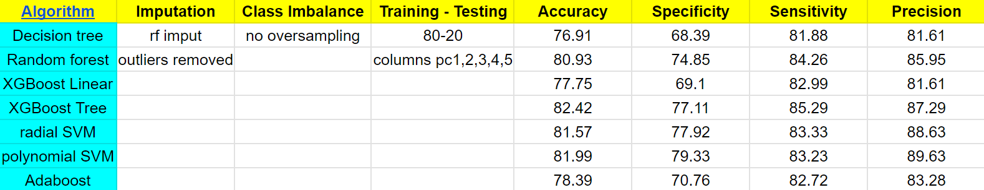

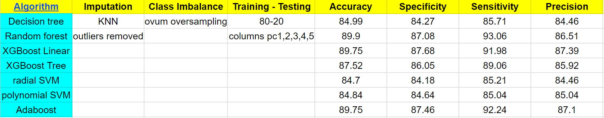

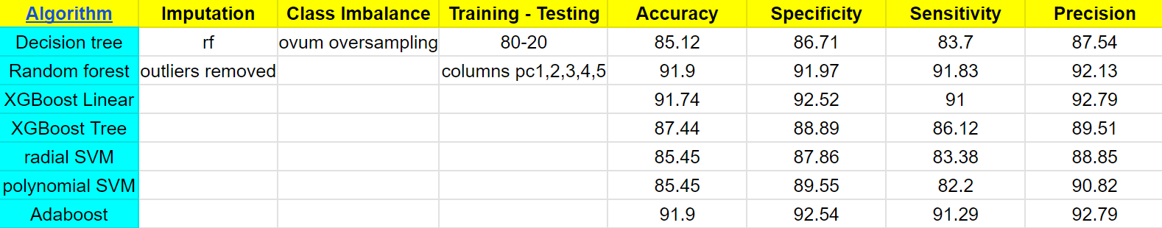

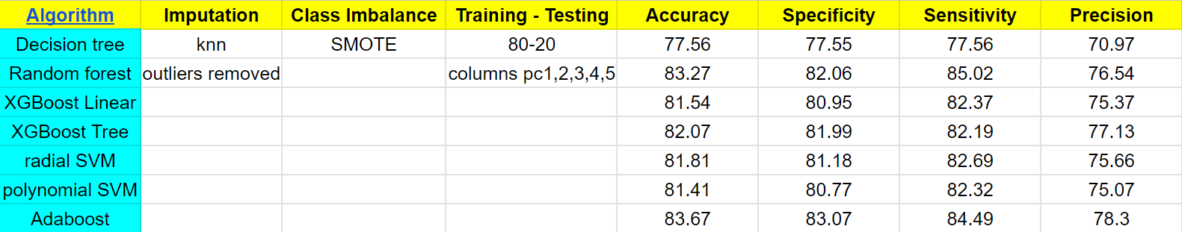

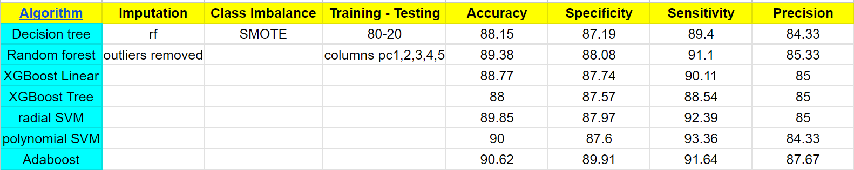

Conclusions: This Water Potability prediction project involved preprocessing the data, exploring the data to gain insights, and selecting appropriate features for modeling. Various classification algorithms were tested, and the performance was evaluated using relevant metrics.

The results showed that it is possible to accurately predict water potability using machine learning techniques.

The best-performing model was AdaBoost without using PCA(Accuracy – 83.76%). Here, imputation is done using KNN and class imbalance is removed using Ovun-over.

The best-performing model was Random Forest using PCA(Accuracy – 96.25%) with feature columns 1,2,3,4, and 5. Here, imputation is done by removing outliers using na.omit() and class imbalance is removed using Ovun-oversampling.

