PROTOCOLS

Protocols :

A protocol is a set of rules and conventions that govern how devices and systems communicate and exchange data across a network.

PROTOCOL

(RULES)

PROTOCOL

(RULES)

TRANSMISSION

MEDIA

SENDER RECEIVER

Data Transmission Process in Networking :

1. Initiate Data Transmission
2. Apply Protocol Rules
3. Transmit Data
4. Receive Data
5. Apply Error- Checking
6. Ensure Reliable Communication

Types of Protocols :

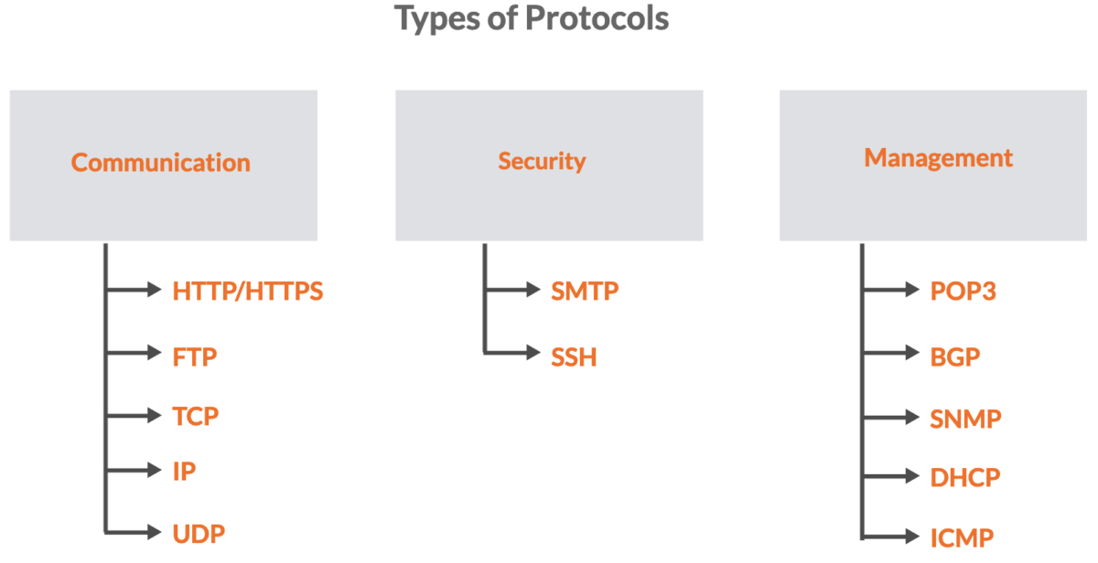

Communication Protocols :

These protocols focus on enabling the exchange of data & information between devices on a network. They determine how data is formatted, transmitted, and received, which ensures effective communication.

Examples are HTTP/HTTPS, FTP, TCP, and UDP.

HTTP

* HTTP stands for Hypertext Transfer Protocol.
* It is a fundamental protocol used for communication between a web browser and a server.
* It is an application layer protocol that operates on top of the [OSI model](https://geekflare.com/guide/common-network-protocols/).

HTTPS

* HTTPS stands for Hypertext Transfer Protocol Secure.
* It is an extension of the HTTP protocol used for secure communication over computer networks.

FTP

* File Transfer Protocol (FTP) is a standard network protocol used for transferring files between a client and a server on a computer network.
* FTP operates on the client-server model.

TCP

* Transmission Control Protocol (TCP) is one of the main transport layer protocols in the IP suite.
* It plays a major role in providing reliable and ordered data transmission between devices over IP networks.

IP

* IP stands for Internet Protocol.
* It is a core protocol that enables communication & data exchange in computer networks, including the global network we know as the Internet.

UDP

* UDP stands for User Datagram Protocol.
* It is a connectionless & lightweight protocol that provides a way to send data over a network without establishing a formal connection.

Security Protocols :

Security protocols are designed to protect the confidentiality & authenticity of data as it traverses a network.

Examples include SSL/TLS for encryption, SSH for secure remote access, and secure variants of email protocols like SMTPS and POP3S.

SSH

* SSH stands for Secure Shell. It is a network protocol used for secure communication between a client and a server over an unsecured network.

SMTP

* SMTP stands for Simple Mail Transfer Protocol.
* It is a standard protocol responsible for sending outgoing email messages from a client or email server to an email server on the recipient’s end.

Management Protocols :

Management protocols are used for the administration, monitoring, and control of network devices/resources.

Some examples are DHCP for dynamic IP address allocation, SNMP for network device management, ICMP for diagnostic purposes, and BGP for routing & reachability information.

POP3

* POP3 stands for Post Office Protocol version 3.
* It is one of the most common email retrieval protocols used for fetching email messages from a mail server to an email client application.
* POP3 is designed to work in a “store-and-forward” manner. It retrieves emails from the server and then typically deletes them from the server after storing a copy on the client’s device.

BGP

* BGP stands for Border Gateway Protocol.
* It is a standardized exterior gateway protocol used in networking to exchange routing & reachability information between autonomous systems (ASes).

DHCP

* [DHCP](https://geekflare.com/cloud/dhcp-vs-static-ip/) stands for Dynamic Host Configuration Protocol.
* It is used to automatically assign IP addresses & other network configuration settings to devices on a TCP/IP network.

ICMP

* Internet Control Message Protocol (ICMP) is a network layer protocol that is used in the IP suite to enable communication & provide feedback about the status of network operations.
* ICMP is mainly used for reporting errors and providing diagnostic information related to IP packet processing.

SNMP

* [SNMP](https://geekflare.com/cloud/introduction-to-snmp-for-beginners/) stands for Simple Network Management Protocol.
* It is an application layer protocol for managing and monitoring network devices/systems.
* SNMP operates using a manager-agent model.