SUBNETTING

Subnetting :

Subnetting is the process of dividing a large computer network into smaller, more efficient subnetworks, or "subnets". It works by borrowing bits from the host portion of an IP address and adding them to the network portion.

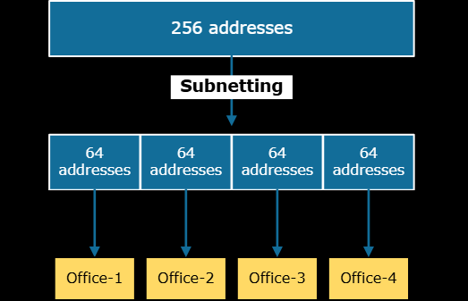

How subnetting works ?

Every IP address consists of two parts: a network address and a host address. The subnet mask is used by a router to determine which part of an IP address refers to the network and which refers to the specific host.

* Original IP Address: An original IP address, like 192.168.1.0, comes with a default subnet mask based on its address class.
* Borrowing Host Bits: To create subnets, a network administrator borrows bits from the host portion of the IP address and uses them to create new network addresses.
* Modified Subnet Mask: The subnet mask is changed to reflect the borrowed bits, defining the new, smaller network and increasing the number of network bits.
* Creating Subnets: This process creates multiple smaller networks. Communication within a single subnet is managed by a network switch, while communication between different subnets requires a router.

Advantages :

* Improved network performance and speed
* Enhanced security
* Efficient IP address utilization
* Facilitated network management
* Better network organization
* Increased scalability

Subnetting Table :

