**CHATBOT APPLICATION USING JAVA**

**INTERN INFORMATION:**

**Name:** Nandu Sasapu

**ID:** ICOD6928

**INTRODUCTION**

In the realm of computer science and artificial intelligence, chatbots have emerged as interactive tools capable of engaging in conversations with users, mimicking human-like interaction. The Java Chatbot Application presented here harnesses the power of Java programming language along with the Abstract Window Toolkit (AWT) for graphical user interface (GUI) development to create a responsive and user-friendly chatbot experience.

This project aims to showcase the implementation of a chatbot that can interpret natural language input, process user queries, and generate contextually relevant responses within a GUI environment. By leveraging Java's event-driven architecture and AWT's GUI components, the chatbot provides an intuitive platform for users to interact and converse seamlessly.

The primary goal of this Java Chatbot Application is to demonstrate:

**Natural Language Processing (NLP):** Implementing basic rule-based techniques to understand and respond to user queries.

**Graphical User Interface (GUI):** Using AWT to design an interactive interface for the chatbot, enhancing user engagement and experience.

**Event Handling:** Employing ActionListener interface to capture and process user interactions (e.g., button clicks, text input).

**Scope of the Project**: The project aims to create a user-friendly chatbot that can interpret natural language input, respond appropriately, and provide a seamless conversational experience within a GUI environment.

**Importance and Advantages**

This chatbot project provides several advantages over previous command-line or text-based chatbots:

**Improved User Experience**: The AWT GUI interface offers a visually appealing and intuitive way for users to interact with the chatbot, making the conversation more engaging and accessible.

**Enhanced Interactivity:** The graphical interface allows for easier input and output, enabling seamless conversation flow and interaction compared to traditional text-based interfaces.

**Scalability and Customization:** The use of Java with AWT provides a robust foundation for building scalable and customizable GUI applications, making it easier to extend and enhance the chatbot's functionality.

**Main Advantage of Using AWT in Java**

The main advantage of using AWT (Abstract Window Toolkit) in Java for this project is its simplicity and platform independence. AWT provides a basic set of GUI components that can be used to build graphical applications across different operating systems without external dependencies. This makes it ideal for developing lightweight and portable applications like our chatbot.

**TECHNICAL SKILLS USED**

Programming Language: Java

GUI Library: AWT (Abstract Window Toolkit)

Development Environment: VS Code

Natural Language Processing (NLP): Techniques employed to process and understand user input for generating appropriate responses.

Version Control: Git for managing and tracking project changes

**IMPLEMENTATION**

**GUI Design:** AWT components (Frame, Panel, TextArea, TextField, Button) used to create the graphical interface.

**Event Handling:** ActionListener interface employed to handle user input events (e.g., button clicks, text field actions).

**Response Generation:** Rule-based approach used to generate chatbot responses based on user input.

**CODE EXPLAINATION**

The chatbot code is structured into:

* Main Class: Initializes the chatbot GUI and handles user interactions.
* Event Handling Methods: ActionListener implemented to respond to user input events (e.g., button clicks, text field actions).
* Response Generation Logic: Implements simple rule-based responses based on user queries.

**GUI Deployment and Styling**

* The chatbot GUI is deployed using AWT components arranged within a Frame and Panels to create a user-friendly interface.
* Styling includes setting font sizes, layout configurations, and interaction components (e.g., buttons, text fields).

**FUNCTIONALITY OF THE TECHNOLOGIES**

AWT Components: Used to create and manage GUI elements (e.g., buttons, text fields) for user interaction.

ActionListener Interface: Handles user input events and triggers corresponding actions.

String Manipulation: Utilized for processing and analyzing user queries to generate appropriate responses.

**USAGE**

**Adding a Task:** Typing queries in the input text field.

**Marking a Task as Completed:** Clicking the "Send" button to submit queries for processing.

**Close the task:** Observing chatbot responses displayed in the chat area of the GUI.

**CONCLUSION**

In conclusion, the Java chatbot project with an AWT GUI interface demonstrates the power and versatility of using Java for developing interactive applications. By leveraging the Abstract Window Toolkit (AWT) and natural language processing (NLP) techniques, this chatbot provides a user-friendly platform for engaging in conversational interactions.

**EXECUTION AND OUTPUT**

**Running the Calculator:**

1. Compile and run the `Chatbot_AWT.java` file in VS Code or your preferred Java IDE.

2. use the send button to get responses from bot.

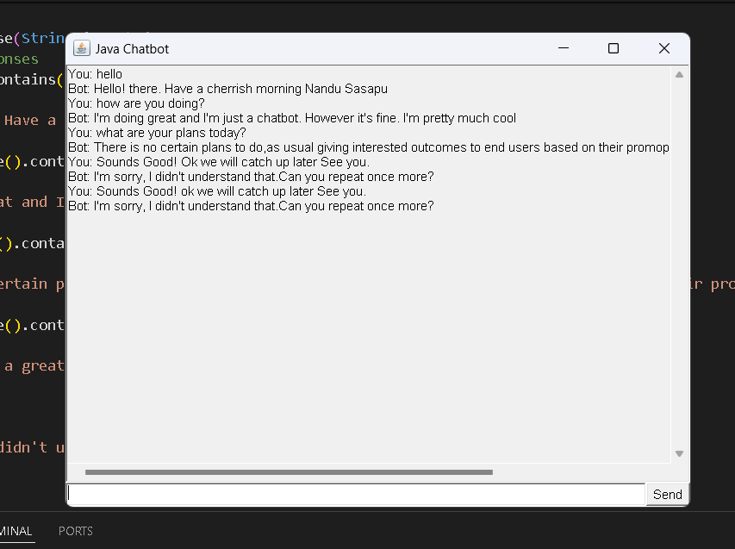3. Observe the display area for input, output, and error messages.

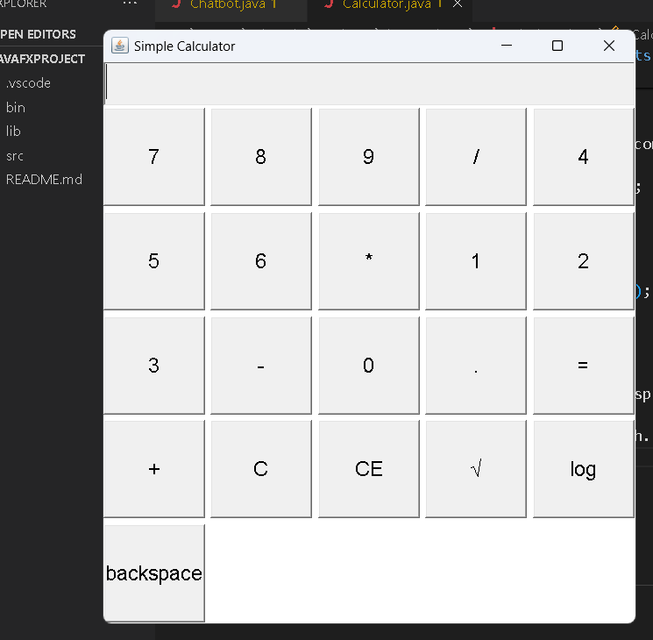

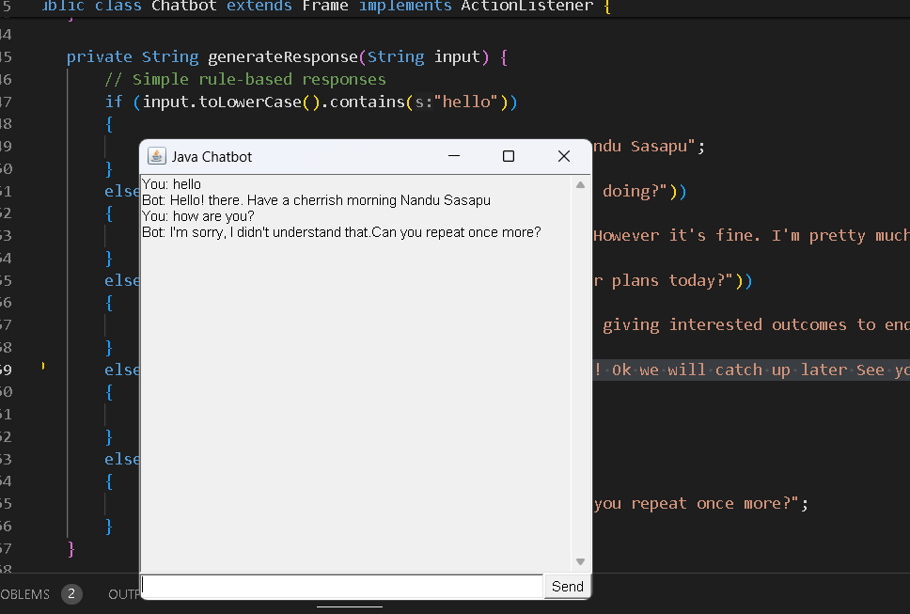

**Output:**

* Capture screenshots during Chatbot usage, showing different input scenarios and corresponding outputs.
* Include screenshots to illustrate the Chatbot interface and user interactions.
* Chatbot.jpg image displayed above
* Screenshot demonstrating the Simple Chatbot with AWT GUI during execution, showcasing user interactions and Chatbot interaction functionality.