EduTutor AI: Personalized Learning with Generative AI and LMS Integration

1. Introduction
• Project Title: EduTutor AI – Personalized Learning with Generative AI
• Team Members:
- M Sriram Koteswrao Rao – Frontend & Quiz Generator
- D Pujitha – Learning Modules & Library
- Inguva Siva Rajanna Padal – AI Integration & Storage
- Ramanam Satya Trinath – Educator Dashboard & Charts

2. Project Overview
• Purpose:
EduTutor AI offers personalized learning experiences using IBM’s Granite LLM. It helps students take adaptive quizzes, track progress, and allows educators to monitor performance.
• Features:
- AI-generated quizzes and learning modules
- Role-based user interface (student/educator)
- Dashboard analytics
- Quiz history and personalized feedback

3. Architecture
• Frontend: Built with Streamlit for real-time interaction and modular navigation.
• Backend: Python logic integrates IBM Granite models and handles user roles.
• Database: Local JSON-based file system for storing users and quiz results.

4. Setup Instructions
• Prerequisites:
- Python 3.10+
- Streamlit
- Huggingface Transformers
- IBM Granite API access
• Installation:
- Clone repo
- Run `pip install -r requirements.txt`
- Set API keys in `.env`
- Run `streamlit run app.py`

5. Folder Structure
• /Edututor_ai_project
- app.py (main app)
- core/quiz_generator.py
- model_setup.py
- users.json / quiz_results.json
- .env

6. Running the Application
• Run the application using: `streamlit run app.py`

7. API Documentation
• Uses IBM Granite through `transformers` pipeline. Main interaction is via prompt generation for quizzes and modules.
• Local file-based APIs for saving/loading results.

8. Authentication
• Role-based login (Student/Educator) using session state in Streamlit.
• Stored credentials in users.json

9. User Interface
• Interactive tabs for login, quiz, modules, and dashboard.
• Sidebar navigation for quick access.
• Educator view shows analytics using Plotly.

10. Testing
• Manual testing on quiz generation latency and role navigation.
• Unit test functions used for model input/output validation.

11. Screenshots or Demo
- Login/Register
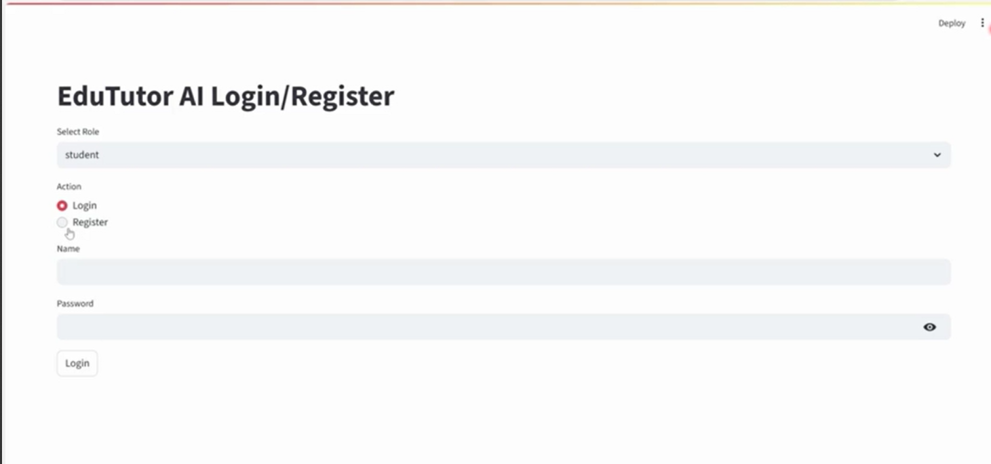
Dashboard
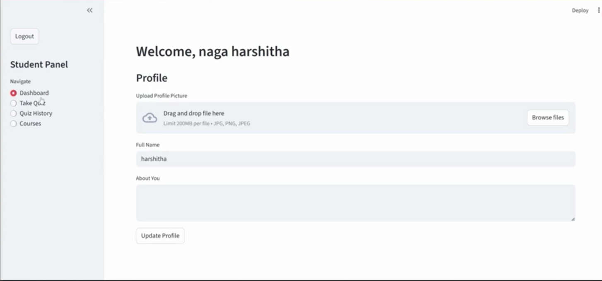
- Quiz Generation
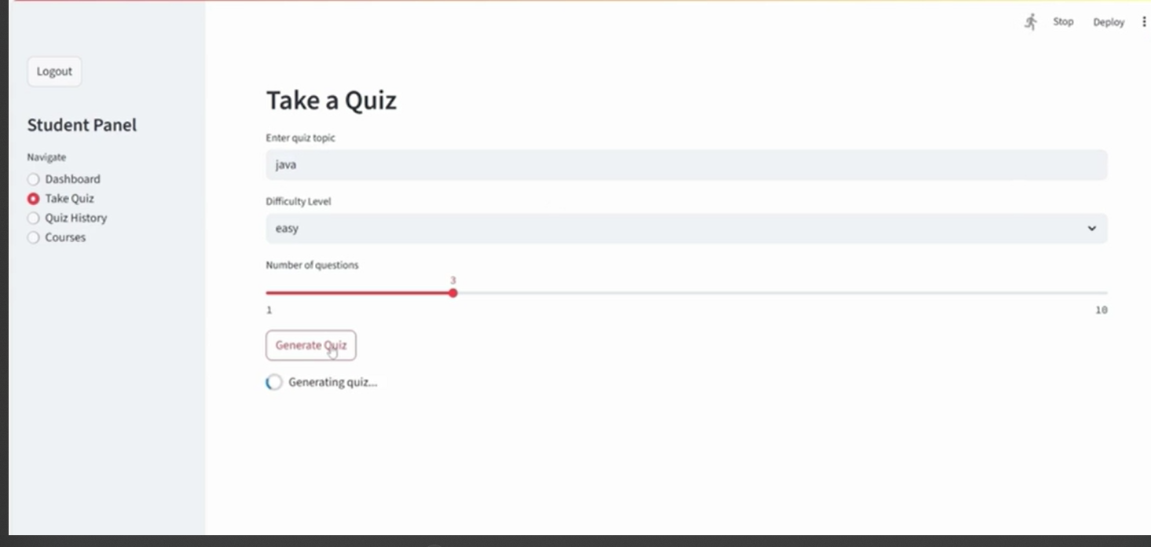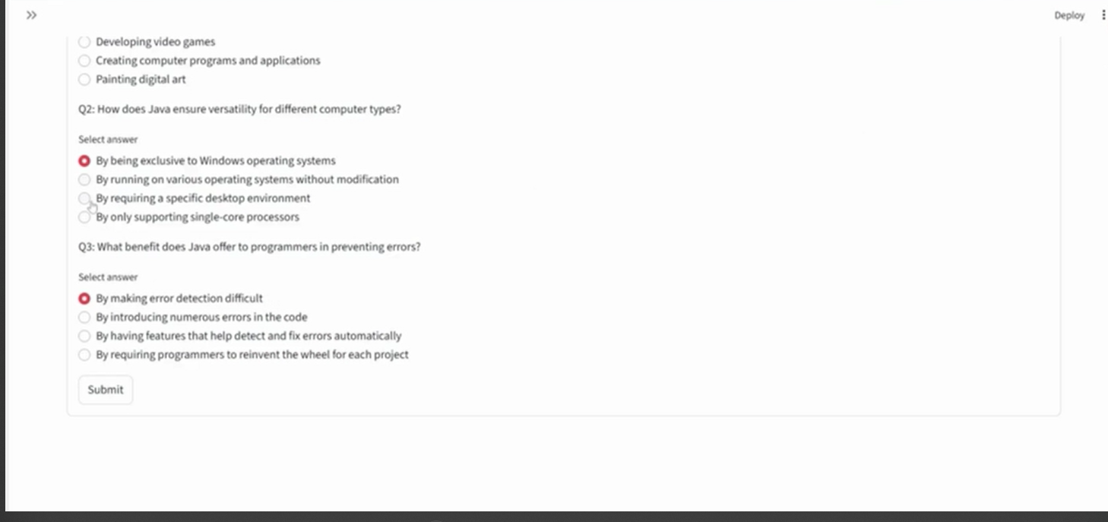

-Quiz History
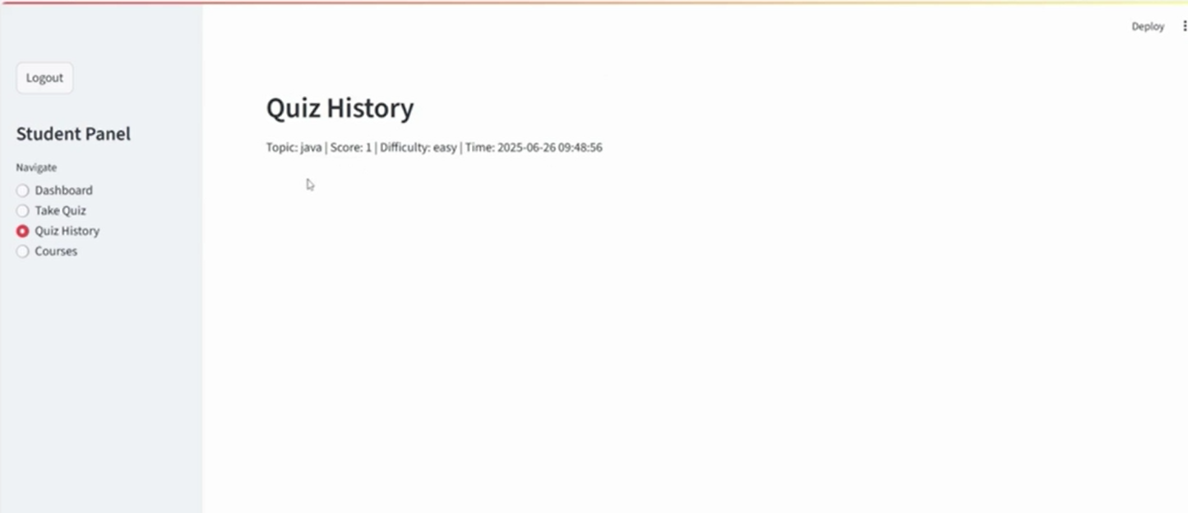
Courses
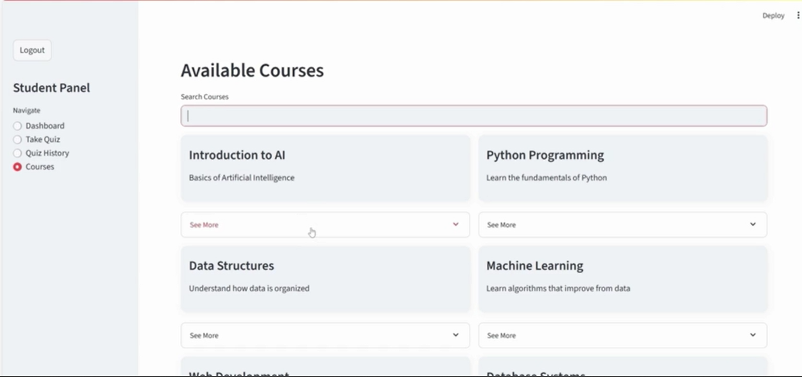

12. Known Issues
• Large model loading time
• JSON storage not scalable for large teams
• Occasional Streamlit rerender glitches

13. Future Enhancements
• Migrate to Firebase/PostgreSQL
• Add voice-based interaction
• Admin dashboard for class monitoring
• Deploy on Hugging Face Spaces

