1.What are the two values of the Boolean data type? How do you write them?

**Answer:**

**Two values of the Boolean data type are True (1) and False (0).**

**These are written as True and False only.**

2. What are the three different types of Boolean operators?

**Answer:**

**AND operator (and), OR operator (or) and NOT operator (not)**

3. Make a list of each Boolean operator's truth tables (i.e. every possible combination of Boolean values for the operator and what it evaluate).

**Answer:**

|  |  |  |  |  |  |
| --- | --- | --- | --- | --- | --- |
|  |  | **OPERATOR** | | | |
| **INPUT 1** | **INPUT 2** | **AND OPERATOR** | **OR OPERATOR** | **NOT OPERATOR ON INPUT 1** | **NOT OPERATOR ON INPUT 2** |
| TRUE | FALSE | FALSE | TRUE | FALSE | TRUE |
| TRUE | TRUE | TRUE | TRUE | FALSE | FALSE |
| FALSE | FALSE | FALSE | FALSE | TRUE | TRUE |
| FALSE | TRUE | FALSE | TRUE | TRUE | FALSE |

4. What are the values of the following expressions?

(5 > 4) and (3 == 5) **🡺 False / 0**

not (5 > 4) **🡺 False / 0**

(5 > 4) or (3 == 5) **🡺 True / 1**

not ((5 > 4) or (3 == 5)) **🡺 False / 0**

(True and True) and (True == False) **🡺 False / 0**

(not False) or (not True) **🡺 True / 1**

5. What are the six comparison operators?

**Answer:**

|  |  |
| --- | --- |
| **Equal to** | **==** |
| **Not Equal to** | **!=** |
| **Greater than** | **>** |
| **Less than** | **<** |
| **Greater than or equal to** | **>=** |
| **Less than or equal to** | **<=** |

6. How do you tell the difference between the equal to and assignment operators? Describe a condition and when you would use one.

**Answer:**

|  |  |
| --- | --- |
| **Equal to (==)** | **Assignment Operator (=)** |
| **This is comparison operator used to compare two variables, if their values are equal or not** | **This is assignment operator used to assign value to a variable** |
| **It should be used when we want to get conditional output or Boolean output (True/False) of the expression like used in if else statement etc.** | **It should be used to store value or output of the expression to a variable in expression/statement** |
| **Ex. if (5==23) 🡺 Output is False** | **Ex. a=5 🡺 Output is value 5stored in a** |

7. Identify the three blocks in this code:

spam = 0

if spam == 10:

print('eggs')

if spam > 5:

print('bacon')

else:

print('ham')

print('spam')

print('spam')

**Answer:**

**Blocks can be identified using indentation which is missing in question, But assuming them without syntax error, we can defined them as follows:**

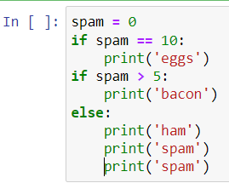

|  |  |
| --- | --- |
| **Block 1** | **if spam == 10:**  **print('eggs')** |
| **Block 2** | **if spam > 5:**  **print('bacon')** |
| **Block 3** | **else:**  **print('ham')**  **print('spam')**  **print('spam')** |

8. Write code that prints Hello if 1 is stored in spam, prints Howdy if 2 is stored in spam, and prints Greetings! if anything else is stored in spam.

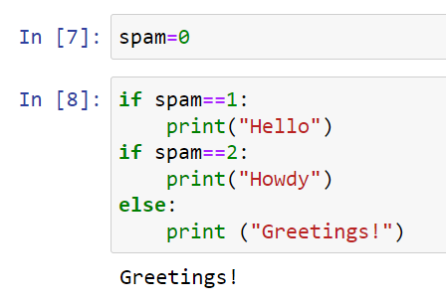

9. If your programme is stuck in an endless loop, what keys you’ll press?

**Answer: Ctrl + C**

10. How can you tell the difference between break and continue?

**Answer:**

**If a break statement is found at any point during the execution of the loop, the loop stops immediately whereas continue statement is used to skip remaining part of the code inside the loop for given iteration and move on to the next iteration.**

**Example:**

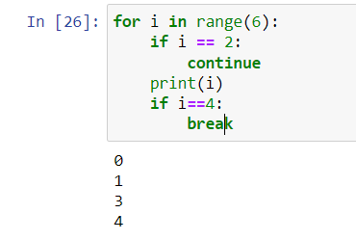

**As shown in above image of code, when i == 2 is true it skips print statement and so 2 is missing from output whereas when i == 4 is true it terminates the for loop and i == 5 is not validated or checked in for loop.**

11. In a for loop, what is the difference between range(10), range(0, 10), and range(0, 10, 1)?

**Answer:**

|  |  |  |
| --- | --- | --- |
| **range(10)** | **range(0, 10)** | **range(0, 10, 1)** |
| * **For loop initiated with start value = 0, will ends at (10-1=) 9 with difference of 1. So For loop iterated or operated for 10times from 0 to 9.** * **Initial value and difference are taken by default that is 0 and 1 resp.** | * **For loop initiated with start value = 0, will ends at (10-1=) 9 with difference of 1. So For loop iterated or operated for 10times from 0 to 9.** * **Here initial value is given as 0** * **Difference is taken be default as 1** | * **For loop initiated with start value = 0, will ends at (10-1=) 9 with difference of 1. So For loop iterated or operated for 10times from 0 to 9.** * **Here initial value along with difference is given as 0 and 1 respectively** |
| **Output of all above expressions is same as 🡺 0,1,2,3,4,5,6,7,8,9** | | |

12. Write a short program that prints the numbers 1 to 10 using a for loop. Then write an equivalent program that prints the numbers 1 to 10 using a while loop.

**Answer:**

1. **Using for loop:**

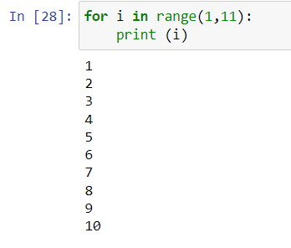

1. **Using While loop:**

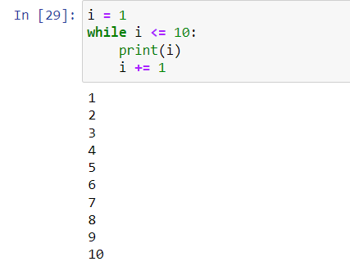

13. If you had a function named bacon() inside a module named spam, how would you call it after importing spam?

**Answer:**

**spam.bacon()**