### How To Scan QR Code and Store in an Excel File

Open the script and pass the Excel sheet name where you want to store the data as below,

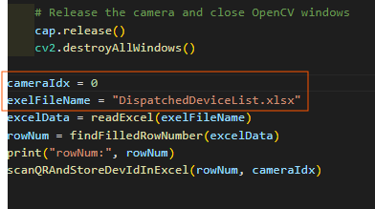

If the given name file does not exist then it will create a new file else it will append the data to the existing sheet.

#Note:

1. Pass camera index 0 for external camera.
2. Press q for stop/end camera frame