## PORTABLE RPI-BASED PROGRAMMER DOCUMENTATION

It has three LED’s for indication and two switches for operation,

* Orange LED indicates the Wi-Fi connectivity of RPI.
  + Blinking – Wi-Fi not connected.
  + Constant ON – Wi-Fi Connected
  + Connected on RPI GPIO 4
* Green LED indicates the successful operation.
  + Connected on RPI GPIO 2
* RED LED indicates the unsuccessful operation.
  + Connected on RPI GPIO 3
* Code Upload Switch.
  + Press the button for 2-3 seconds and wait to glow the LED
    - RED LED Glow – failed to upload the code.
    - GREEN LED Glow – successfully code upload.
* Shutdown Switch.
  + Press the button for 5 seconds to shut down the RPI.
    - RPI is a power fluctuation-sensitive device, so whenever you want to turn it off first shut it down.
    - The successful Shutdown indication is –
      * LEDs will blink in the following sequence in 0.5 seconds interval
        + GREEN
        + RED
        + GREEN
        + RED

## WIFI CREDENTIALS

If you want to update the new code in the device you need to update it in RPI first wirelessly and its too simple.

* Turn ON your mobile hotspot with the following credentials
  + SSID – evoluzn_ota
  + PASSWORD – 123456789
    - Wait for 5 to 10 seconds to connect RPI on your network
* Flask Service Setup
  + You need to set up flask service which will return the file on RPI

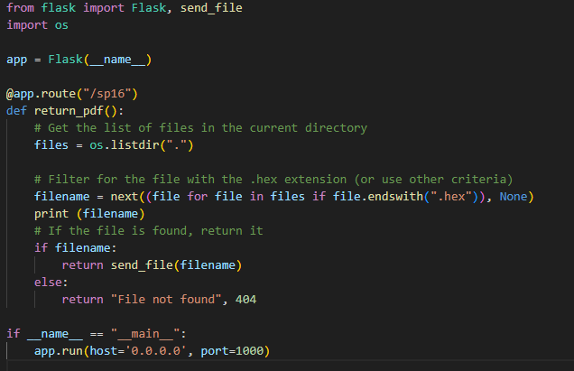

* + Run this file in your system where you are generating the .bin file of your code.
  + MQTT commands to upload the code,
    - Send 100 on evoluzn_ota/control to update the code in RPI
      * Once the file is received and saved in RPI it will blink the GREEN LED
      * In case of failure to download the file in RPI it will blink the RED LED