Production QR Code Generator

This code generates the sticker for the final product. We need to pass the mac address or unit ID of the device in the excel sheet in below format,

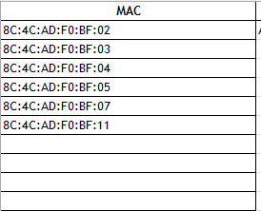

Pass the excel file name in code to read data, as below,

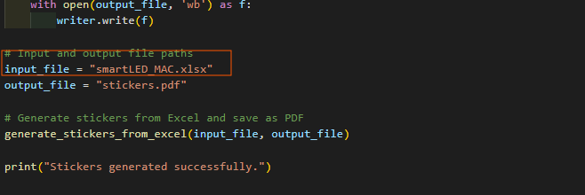

Output_file where are generated stickers stored in pdf format.

You need to enter the sticker content in code as below,

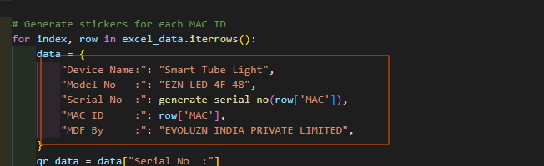

Basically in the sticker, we keep the data of the device are Device Name, Model Number, Serial Number, MAC ID, Manufactured By.  
  
Once the right data is entered, run the script, and as per the number of devices data available in Excel,   
automatically that much number of stickers will be generated. The final sticker will be generated in below format.

