**CO224 – Computer Architecture**

**Lab 5 – Building a Simple Processor**

**Part 5 – Extended ISA – Report**

**Group 27**

**E/19/170 - JAYAWARDHANA K.N.N.**

**E/19/432 - WICKRAMAARACHCHI U.I.**

The instruction set of the CPU was extended to include following five new instructions.

* **mult <r1> <r2> <r3>** : Multiplies the values in r2 and r3 and stores result in r1
* **sll <r1> <r2> <offset>** : Logically left shifts r2 by offset value and stores result in r1
* **srl <r1> <r2> <offset>** : Logically right shifts r2 by offset value and stores result in r1
* **sra <r1> <r2> <offset>** : Arithmetically right shifts r2 by offset value and stores result in r1
* **ror <r1> <r2> <offset>** : Rotates r2 right by offset value and stores result in r1
* **bne <offset> <r1> <r2>** : Branches based on offset if values in r1 and r2 are not equal

To implement these new instructions, a minor modification was made to the Branch/Jump hardware and some additional functional units were implemented within the ALU of the CPU as shown in the following modified block diagram.

**Modified CPU Block Diagram**

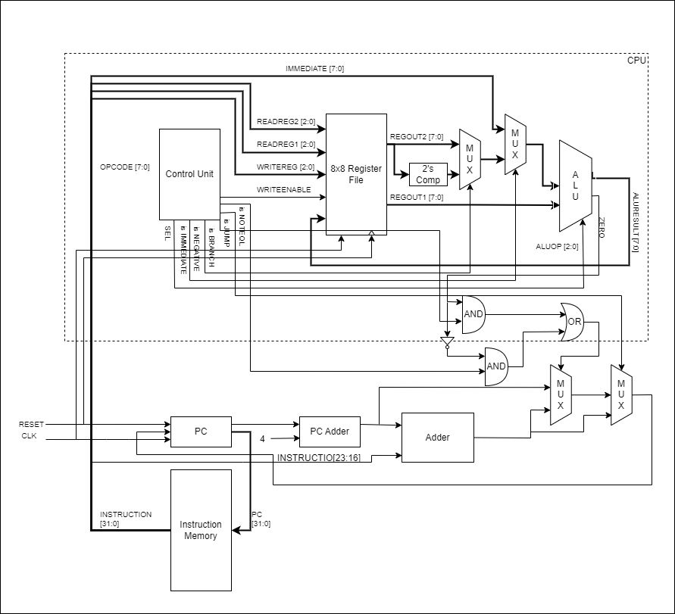

**ALU Functions**

|  |  |  |  |  |  |
| --- | --- | --- | --- | --- | --- |
| **SELECT** | **Function** | **Description** | **Supported Instructions** | | **Unit’s**  **Delay** |
| 000 | FORWARD | DATA2→RESULT | loadi, mov | | #1 |
| 001 | ADD | DATA1+DATA2→RESULT | add, sub, beq, bne | | #2 |
| 010 | AND | DATA1&DATA2→RESULT | and | | #1 |
| 011 | OR | DATA1|DATA2→RESULT | or | | #1 |
| 100 | SHIFT | (Logical Shift left)  DATA1<<DATA2→RESULT | **shift**  **select** | sll | #1 |
| 01 |
| (Logical Shift right)  DATA1>>DATA2→RESULT | 00 | srl |
| (Arithmetic Shift right)  DATA1>>>DATA2→RESULT | 10 | sra |
| Rotate Right DATA1 by DATA2 times | 11 | ror |
| 101 | MULT | DATA1*DATA2→RESULT | mult | | #2 |

**CPU OPCODEs for Instruction Set**

|  |  |
| --- | --- |
| **Instruction** | **OPCODE** |
| loadi | 00000000 |
| mov | 00000001 |
| add | 00000010 |
| sub | 00000011 |
| and | 00000100 |
| or | 00000101 |
| j | 00000110 |
| beq | 00000111 |
| bne | 00010000 |
| mult | 00010001 |
| sll | 00001100 |
| srl | 00001101 |
| sra | 00001110 |
| ror | 00001111 |

**Test assembly code :**

loadi 0 0x05 // r0 = 5

loadi 1 0x09 // r1 = 9

loadi 5 0x01 //r5 =1

or 7 0 1 //r7 = r0 | r1 = 13

mov 2 1 // r2 = r1=9

mov 6 1 //r6 = r1 = 9

beq 0x03 2 6 //branch to 3 ins forward

add 4 2 0 // r3 = r2 + r1 //skip

sub 4 3 1 // r4 = r3 - r1 //skip

add 3 2 5 // r3 = r2 +r5 = 9 +1 //skip

add 3 0 1 //5+9 =14

j 0x02 //jump 2 ins forward

loadi 0 0x75 // r0 = 0x75 //skip

loadi 1 0x92 // r1 = 0x92 //skip

loadi 0 0x02 //r0 =2

loadi 1 0x01 //r1 =1

and 5 1 0 // r5 = r1 & r0 0

or 7 0 1 // r7 = r1 | r2 3

sub 4 3 5 // r4 = 14-0

mult 4 3 0 //r4 = r3*r0 14*2 = 28

sll 4 1 0x02 // 1 << 2 = 4

srl 4 3 0x02 // 14 >>2 = 3

loadi 3 0x92 // r3 = -110

sra 4 3 0x02 // -28

loadi 0 0x7C // r0 = 124

ror 4 0 0x02 // 31

bne 0x02 0 3 // 124 != -110

loadi 7 0x01 //skip

loadi 7 0x02 //skip

loadi 7 0x04 //r7 = 4

**Timing Diagram For test code :**

