**Start backend**

**Use .env file to store environmental variables**



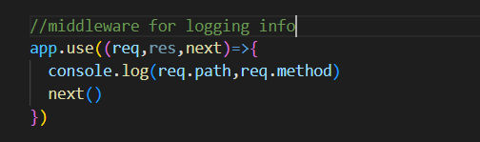

**Create routes folder and routes**

**Setup db**



**Set up model and schema**

**Set up controllers**

**Front End**

**Install react router dom**

**Front end and backend can’t be on different servers**

**Add proxy to package.json file** "proxy":"http://localhost:4000",

npm install date-fns FORMAT DATE